Table of contents

# Introduction............................................................................................................6

1.1 Research aim and objectives..........................................................................7

1.2 Outline of study......................................................................................8

# Literature Review and Theoretical Framework......................................................9

2.1 Basic concept of corporate image...................................................................9

2.2 Basic dimensions of corporate image...........................................................11

2.3 Corporate image in terms of corporate personality,

corporate identity and the change towards corporate distinctiveness.................15

2.4 Corporate Image in the Indian IT industry.....................................................20

# Research Methodology.......................................................................................25

3.1 General perspective......................................................................................25

3.2 Qualitative versus Quantitative research methodology.................................25

3.3 Reliability and validity of data........................................................................27

3.4 Justification of the research methods............................................................27

3.5 research Approach........................................................................................28

3.5.1 Research participants............................................................................29

3.5.2 Piloting the questionnaire.......................................................................30

3.5.3 Secondary Information...........................................................................31

3.6 Ethical considerations...................................................................................32

3.7 Summary of methodology.............................................................................33

# Research Findings..............................................................................................34

4.1 Analysis of research responses....................................................................34

4.2 Summary of research findings......................................................................46

# Research Analysis...............................................................................................48

5.1 How does a company obtain its image..........................................................48

5.2 How does an organisation maintain its image..............................................52

5.3 What is the role played by the employees and

the management towards the success of corporate image ................................55

# Conclusion...........................................................................................................58

## Limitations...................................................................................................60

## Recommendations......................................................................................61

## Future development....................................................................................62

List of figures

# Fig 1: Importance of corporate image........................................................................35

# Fig 2: Reasons for having a good corporate image...................................................36

# Fig 3: Factors that help promoting corporate image..................................................38

# Fig 4: Existence of corporate image in the company.................................................39

# Fig 5: Participants involvement in promoting corporate image..................................39

# Fig 6: Satisfied employees of corporate image..........................................................40

# Fig 7: Employees satisfaction of corporate image.....................................................41

# Fig 8: Companies maintaining the image..................................................................41

# Fig 9: Factors that help in maintaining of corporate image........................................42

# Fig 10: Corporate image is beneficial........................................................................43

***Chapter 1: Introduction***

Corporate Image is necessary for an organisation. In order to compete with the rivals, an organisation has to maintain its corporate image. Organisations are made of people and function through the people. It is through the combined efforts of the people that material and monetary resources are utilised effectively for attaining the common objectives. Without the human power no organisation can achieve its goals. All the activities and operations of an organisation are initiated and completed by its co-workers who make up an organisation. Therefore people are the most significant resources of an organisation (Jucius, 1973).

The concept of corporate image was dominantly perceived as corporate distinctiveness, the diametric positioning of corporate image as corporate personality and corporate identity. A corporate image refers to all the methods of conveying a firm`s corporate personality. It is thus the reflective of the use of the corporate image as a means of expressing the corporate personality (Antonoff, 1985). The concept of corporate image reflects the degree to which a firm achieves distinct and coherent image(Schmidt,1995). conceived the concept of corporate image not only as a measure of a firm`s distinctiveness and identifiability but also a reflection of its specificity, stability (endurance) and coherence (Moingeon and Ramanantsoa, 1997).

The construction of corporate image as a distinctive phenomenon (Albert and Whetten, 1985), several authors has presented different definitions that appear to construct corporate image as a distinctive phenomenon. The unique history of corporations and core competencies can be use as critical factors which distinguish corporations from others with similar business inclinations. Thus, corporate image is the total summation of factors that characterise and convey strategic messages and relates about the firm, where is it going, business history and business mix, approach taken by management, corporate communication policies and practices, nomenclature, core competencies, market conditions and competitive distinction (Downey, 1986).

Firms and organisations hopes to develop a positive “image/brand” which helps them to draw and retain consumers. An image means a set of practices, products and marketing which creates a unique awareness in the public mind with a particular business. Advertising about that brand educates the consumer and reinforces its association with the particular business is critical to the success of image. A good image helps a corporation in increasing its profit margin. Customers will pay much more for a strong brand and stock prices are considerably stronger for popular brands (Aaker, 1997).

1.1) Research aim and objectives:

This study looks at in-depth issues relating to Corporate Image with particular reference to the employees in the Indian Information Technology industry. It mainly discusses the areas of image building in the IT industry. It tries to analyse the major Indian IT industry with the basic issues relating to corporate image. The whole study involves collection of primary and secondary data. Both quantitative and qualitative research method is been used to make the research strong enough to arrive at a particular conclusion. The main aims of the project are:

1. To discuss about the importance of corporate image in today`s world.
2. To study and find out how the corporate image is obtained and maintained.
3. To discuss the factors involved in promoting corporate image.
4. To analyse the role played by the employees and management of a company towards the success of corporate image.
5. To discuss the implications involved with corporate image.

1.2) Outline of Study

This study consists of 6 chapters in total. The structure of the study is shown below:

Chapter 1 gives a brief introduction. It mentions about the main aim and objectives of the research and the study outline.

Chapter 2 presents the literature review of the issues related to the project. It incorporates the review of previous studies that mainly concentrates on corporate image. It is thus believed that this chapter will provide the reader with general information like theories and issues related to corporate image.

Chapter 3 describes about the methodology that has been used to achieve the project aims and objectives. It gives a description of research design, reliability and validity of data.

Chapter 4 shows all the data and information obtained through the means of primary data. It mainly shows the results collected from the participants of the Indian Information Technology industry.

Chapter 5 is the research analysis chapter. In this chapter the three research questions has been answered with the help of primary and secondary data. All the data and information collected has been analysed properly and tried to answer in-depth the aims and objectives.

Chapter 6 is the conclusion and recommendation. It tries to draw conclusion on the data and findings achieved. Implications towards corporate image and research limitations are also included here. A couple of recommendations also have been included such that it would provide some directions for further studies.

***Chapter 2: Literature Review and theoretical framework***

2.1) Basic concept of corporate image

A corporate image refers to how a particular company promotes a positive image to the outside world. It is a generally accepted image about what a company actually stands for. It is mainly created by marketing experts who uses different strategies for promoting the company`s image. They uses public relations and also various other forms for the promotion of the company`s image. They actually provide a mental picture of the company to the public. Generally a corporate image is designed to be appealing to the people such that the company can create an interest among the consumers. It is basically an impression about a company that creates in the mind of people when they hear the name of the company.

Corporate Image plays an important role in an organisation. It is very essential in today’s competitive world. It helps a company to compete with their rivals. It can also be called as the reputation that a company has to maintain in order to survive in the market. According to Markham (1972), a favourable image of the company encourages its stakeholders to invest in the company and it also attracts good staffs, retain customers and correlates with superior overall returns. Though corporate image is still relatively new as an academic subject, it is becoming a paradigm in its own right, a coherent way of looking at an organisation and performing in business (Alsof, 2004).

Corporate image can be considered as observers` general impression of a corporation`s distinct collection of symbols, whether that observer is internal or external to the firm. Image is one which comes into mind when one hears the name or sees the logo of a particular organisation (Gray & Balmer, 1998). Image is nothing but the impression people have of the firm. Corporate Image can be shaped but cannot be controlled by an organisation as factors such as media coverage, government regulation and surveillance, industry dynamics and other macro forces also influence impressions of the firm.

Corporate Image is also considered as a tool for marketing concept. It is based on the recognition that clients buy only branded products not only because of their inherent qualities but also because of a bias, a disposition towards the product of selected manufacturers. People develop a certain attitude towards a particular manufacturer and perceive him to have certain characteristics, some which they admire and appreciate. Others may look at the same manufacturer in a different way, perceiving him to have negative characteristics. In either event, the image of the manufacturer affects people`s selection or rejection of his product. Whether sales are increased more by a favourable image than they are impeded by a negative is a subject for conjecture, although there are reasonable grounds for believing the negative image to be the more potent determinant of consumer`s choices (Spector, 1961).

Bayton (1959) has pointed out that people tend to “humanize” companies to attribute personality characteristics to them, to see them as much as they do in human beings in terms of being mature, liberal, friendly and others. In total the perception of the corporation`s personality characteristics is what we refer to as the corporate image. However two people might perceive the same characteristics about a particular company, they does not always follow that they had the same experience with it. Example can be taken as both people may consider the company to be conservative, one because of the design of its packages and the other because of the company`s sales practices. The fact is that any number of diverse experiences might lead different people to the same conclusion. Thus they might have opposite opinions as to whether conservatism is to be admired or frowned upon (Baker and Balmer, 1997).

2.2) Basic dimensions of corporate image

Spector (1961) in his article mentioned about the different dimensions of the corporate image that peoples look into it while choosing to do business or any other operations. These factors or dimensions play a very vital role while keeping in mind about the company they are going to work for or they have already working with it. They are:

1. **Dynamic:**

This dimension is accounted for most of the variance which dominated their image of the corporation was dynamic. They ask among themselves, as is this corporation pioneering, does it attract attention to itself, is it flexible enough and active, goal-oriented, their opinions on these and similar questions can be summed up simply by asking only one question, is it dynamic. Thus this dimension explains more about the corporate image than any other.

1. **Co-operative:**

Co-operative is also one of the important factors while considering for corporate image. This includes personality characteristics such as friendly, well-liked, which maintains self-respect, eager to please etc.

1. **Business-wise:**

It is one another aspect of corporate image which centres on business characteristics and includes traits such as shrewd, persuasive, well-organised etc.

1. **Character:**

Most of the organisations jealously guard their fair name, and well they might, since an important dimension of corporate image revolves about perceptions of it as having a character that is ethical, reputable, respectful, etc.

1. **Successful:**

Successful is a very important dimension. It includes characteristics referring to finances, self confidence etc.

1. **Withdrawn:**

An aloof, secretive and cautious firm would be sure to have a high withdrawn score. This is the weakest of the six factors in the image but, nevertheless, enters into the evaluation of the organisation.

Margulies (1977) defines that corporate image reflects the way a firm chooses to identify itself to all its stakeholders, towards the community, customers, employers, the press, present and potential stakeholders, security analysts and investment bankers. Corporate Image is the tangible expression of a corporate personality. It is thus which is projected to reflect the real status of a firm`s personality and its strategic intent (Balmer, 2001).

Taylor (2008) mentioned that there may be many reasons for the employees to stay or leave a particular organisation. There can be four categories: organisation issues, job issues, leader issues and team issues. Retention is just one part of the several components that combine to create an organisation`s approach to talent management. As an organisation leader, the organisation need to pay attention to each component in order to assure that it is attracting, developing and retaining talent at the organisation (Dutton and Dukerich, 1991). Thus in order to fully integrate retention practices into the organisation, it is very essential to map the employee experience to determine where targeted actions may add to the organisation strategy.

The three basic ingredients for a successful corporate image:

1. FOCUS: has the company done the necessary research to define the corporate mission, to set the right goals, to identify the audiences they must influence, and to select the media to best reach the target publics?
2. CREATIVITY: will the marketing really cut through the clutter, be noticed, be remembered, and be acted on?
3. CONSISTENCY: will the company`s campaign run long enough to have real impact? Will all the company`s advertising carry the same theme and support the same message, even abroad?

Hannebohn and Blocker`s (1983) work on corporate image presents a different approach for the understanding of the concept, stressing its role in corporate efficiency, economic performance, business integration and the conceptualisation of values. They believe that image is the strategy applied by the firms which helps them to enhance the economic performance and also corporate efficiency. It is a phenomenon that co-ordinates a firm`s achievement, policies, goals, objectives, mission, culture, information and values. It helps them to lead to the integration of all the corporate activities and operations (Doyle, 1992).

Topalian (1984) addresses the concept of corporate image from three basic angles. Firstly, corporate image is `what the firm is`. Secondly, corporate image is `what the firm stands for`. Thirdly, corporate image is `what the firm does`. Topalian (1984) queries the innate, actual and the basic traits of a firm as well as other phenomenon that makes up, signify and define the firm. His notion and conception of `what the firm stands for` refers to a set of principles, values, system of ethics commonly shared by members of a firm. He also mentions that corporate image can be defined as the nature of the business of a firm.

The literatures mentioned above mainly reveals the dominant views on the meaning of corporate image were stable but dichotometrically divided between corporate personality and corporate identity. The dichotometric conceptualisation of corporate image is founded on author`s overarching recognition of the concept as an expression of corporate personality (which includes `what the firm is`, `what it stands for` ) and corporate identity (i.e. symbols, corporate communications and behaviour – the vehicles that convey corporate personality) (Bromley, 1993; Brown, 1995).

The basic mission of image for an organisation is same for almost all of them. However a certain companies may have different strategies and goals to perform. But nevertheless there are some main mission statements in a company (Gregory and Wiechmann, 1999).

Scholars and experts might disagree as to the exact number but there are at least seven basic missions for making a good image of an organisation. They are:

1. To build public awareness and acceptance and also to establish a more favourable market position.
2. To redefine the company after a merger, takeover, acquisition, divestiture or name change.
3. Pre-sell target markets to support the product marketing.
4. Influence the shareholders and the financial community.
5. To establish the company`s position on timely basis.
6. Assisting in managing a crisis situation.
7. Attracting and holding quality employees, while creating a cooperative environment in their communities.

2.3) Corporate Image in terms of corporate personality, corporate identity and the change towards corporate distinctiveness

The theoretical construction of the meaning of corporate image has witnessed a movement from corporate personality and corporate identity. Albert and Whetten`s (1985) notion of enduring or stability refers to those corporate characteristics which are stable over a very long period of time. Same as individuals, the corporate history can also be traced and scrutinised. The history of firms may display various set of values, philosophies, behaviour, style and culture. Although literature may have positioned Albert and Whetten (1985) as the originators of the enduring or stability concept, it is observed, however that this theory may have been drawn from the earlier work of Topalian (1984) whose perception of the concept of corporate image is akin to corporate philosophy. Thus Albert and Whetten (1985) has the notion of distinctiveness which addresses issues relating to what employees consider as being unique about their own firm.

Abratt (1989) mentions about the role played by corporate image as a tool commonly used which helps in differentiating firms from competitors. Corporate image is an assembly of visual cues which includes physical as well as behavioural that makes a firm recognisable from others. These cues are used to represent or symbolise the company.

Davies et al. (2003) drew attention to corporate personality, bonding among employees and the emergence of corporate image through the interaction among employees. Corporate Image is the one which holds a firm together and it is the corporate glue which binds the firm and provides a sense of belongings to employees (Chun, 2005). Corporate image is constructed socially through formal and informal business guidelines that employees abide by. Davies et al. (2003) argues that corporate image does not exist. It is just a phenomena which is created through continued interaction among employees. They opined that corporate image is formalised partly through the articulation of corporate history, business policies, terms and conditions of employment, corporate literature as well as through mission and vision statements (Christen et al., 2008).

Burton et al. (2001) pointed out that the notion of identity symbolises what is to be done and also provides opportunities explaining self-expression. It enables customers and other stakeholders who wish to identify with these identities the opportunity to express their personalities. In Melewar and Jenkins`s (2002) view, corporate image conveys what the firm is about to its stakeholders and what makes the firm distinct. Corporate image is the presentation of a firm to every stakeholder. It thus makes a firm unique and it incorporates the firm`s communication, design, culture, behaviour, structure, strategy and industry identity. It is intrinsically related to both corporate personality and identity (Chernatony, 1999).

One of the unique attributes of service work in an organisation is its “emotional labour” component which plays a very important role in maintaining the image of organisation. The emotional state of service-sector workers is quite different from the manufacturing workers. An unhappy, alienated factory worker may not be fond of the employer or the day to day tasks that it performs, but he is still be able to perform them competently with a frown in the face (Balmer and Gray, 1999). But this cannot be said for the service workers, whose jobs require face-to-face or at least voice-to-voice interaction with customers. These service sector workers must convey the impression that they will provide willing service to satisfy the customers. These workers main goal is to produce a particular feeling state in the customer (i.e. satisfaction, impression, pleasure) which requires that they suppress any contradictory feelings to maintain the outward appearance of a cheerful demeanour style of offering the service is part of the service itself. Service businesses have developed two primary strategies for minimizing their dependence on workers` natural feelings states and controlling and standardizing the service sector work processes. First one is the production line approach which is oriented towards scripting and routinizing customer interactions, substituting technology and patterns of interaction for skill and motivation. The technique helps the management in hiring fungible, low cost labour and to tolerate high turnover rates (Barich and Kotler, 1991).

The second method can be called as transformation or empowerment approach which tells about controlling the work process by the transformation of the worker into one whose personal characteristics, appearance and values which matches the image that the company is seeking to project and market and which allows the workers to make their own judgements in interactions with the customers (Fombrun and Shanley, 1990). These self–regulation techniques seek to create valuable workers who act like managers without sharing managerial control or receiving managerial pay. The management control over these self-regulated and empowered workers is considered inevitably more invasive of the private lives of workers than supervision. As worker identification is important with the company and its image about the company in consumers mind is critical, workers` demographic characteristics for example: age, sex, race, education level, class status, etc., presentation, dress, grooming and the behaviour must very much fit the prescribed corporate image (Boulding, 1956). The main benefits for using this transformative approach includes cost savings realized from reduced middle management, increases productivity and reduced union activities as the participatory management technique tends to engage the workers in a way that their hunger for respect and voice is diminished (Gray and Smeltzer, 1985).

The management in an organisation sponsors very costly advertising, publicity campaigns, stockholder relations programs, charitable giving, making changes in their product packaging and many other things in the hope of attaining corporate objectives like high growth in sales volumes, increased market share, improved brand loyalty and others (Easton, 1966).

Corporate image is not only about the individual, it is completely based upon the collective impressions of the people in the firm. These impressions are derived partly from an individual`s personal contacts with the firm, some from hearsay, partly from mass communication media and also from psychological predispositions not controlled by the firm.

Every organisation is considered as unique in its own way. However there can be at least two kinds of uniqueness: 1) a specific kind that stems from the purely idiosyncratic details about the firm, 2) a more abstract uniqueness, based on a set of attributes with which all firms are endowed in varying degrees. But the typical corporate image study is based on first type.

Corporate Image plays a very important role in job choice decisions. This job choice can be characterised as a series of decisions made by an applicant as to which jobs to apply for and also which organisations to choose for possible employment. According to Schwab, Rynes, and Aldag`s (1987) model, a survey was done where they considered the job choice process which begins with an individual`s evaluation of information that obtained from the recruitment sources, which includes printed advertisements, media messages and friends. And from the survey they found that the individuals use the sources available from recruitment resources to decide whether or not to pursue possible employment with a particular organisation. These decisions are the initial ones and thus it affects all subsequent decision alternatives and the outcomes of the search process. Rynes (1991) mentions that almost all the studies says that the job choice processes entirely depend on the decisions made on the initial decisions. Herriot and Rothwell (1981) have found out from a study that explicitly examined about recruitment resources and initial decisions, which concludes that the brochures provided by recruitment sources influences much of the potential applicants` intention for applying to the organisation.

According to Dowling (2001), corporate image refers to the stakeholder`s overall evaluation of the associated qualities with an organisation and also the emotional reaction those qualities produce. This evaluation which includes the awareness must be linked to the company`s perceived ability to meet the stakeholders needs.

Fombrun (1996) mentions about realizing the value from the corporate image which examines how the managers and companies compete with each other. They not only compete for market share through the classic strategies but also for the esteem of their key constituents’ i.e. for reputation and image. Thus the companies struggle very much in order to achieve prestige and this requires a long term outlook towards building competitive advantage. Companies develop winning reputations and image both by creation and projection of a set of skills that their constituents recognize as unique. This means that some companies differentiate themselves from others through innovation- nurturing good ideas, translating them into products, and marketing them very well. And for other companies, this uniqueness comes from developing operational excellence – a low-cost position with excellent distribution systems – or closeness to the customers- distinct strength in servicing customers and problem solving, in short they gives much stress on customer satisfaction. Whatever the differentiation form these corporations apply, these require excellent routine actions which demonstrate credibility and earn the trust of key constituents (Kotler and Mindak, 1978; Locke, 1976).

Fombrun and Van Riel (1997) also mentions that better recognised companies’ tries to build their image by developing practices that integrates social and economic considerations into their competitive advantage strategies. These organisations not only do things right but they do the right things at the right moment. Thus by doing so, they act like good citizens. They try to initiate policies which reflects their basic core values; that considers the joint welfare of investors, customers, and also their employees; which helps to invoke concern for the development of the local communities and thus ensure the quality and environmental soundness of their technologies, services and their products (Maathuis, 1999).

Good image confers clear-cut advantages and privileges on corporations. People trust those companies that they respect, so they grant them the benefit of doubt in ambiguous situations (Margulies, 1970). People often pay handsomely for their products, by believing that those products are more likely to fulfil their expectations than the products from lesser known companies. A good image thus builds a competitive advantage against rivals. A good image of a company also creates responsibilities. This raised expectations of a particular company`s from their constituents increases. It becomes a responsibility for the management of the company to maintain it. To be held in high esteem creates obligations for the management that managers and employees must live up to, whether in meeting the personal standards of employees, the quality standards of customers, the ethical standards of the community, or the profitability of standards of investors. Thus companies which become well regard sustain their good image by building a strong and supportive relationship with all their constituents.

Therefore the image of a company helps in building its reputation. It can be traced to managerial practices which make a company a very beautiful workplace for its employees, a good provider of products and services for its customers, a good investment for its shareholders and a good citizen in its local communities.

2.4) Corporate Image in the Indian IT Industry

The Indian IT industry constitutes one of the most rapid and dynamic growth areas contributing to the nation`s economy. It plays a very major role in the country`s growth and development. Most of the organisations have focused for decades on customer care and satisfaction to maintain their reputation. But only in the recent years have they realised that the employees who work with those customers are also very important and plays a major role for the success of a business. So with the increasing competition globally, Indian IT companies are trying to focus on a more mature working environment.

Branding and building the corporate image in employees` is all about a company`s value in the market. It is a combination of the reputation of the company, the career offered and also the existing corporate culture in the organisation (Huang, 2001). There might exist two types of employer branding: first one is for prospective employees who will be the future employees and the other for the current set of employees who are already working in the organisation. Speaking about the first type, the branding and building of corporate image initiatives are targeted at building a mind share in potential recruits about the company as a preferred place to work for, which can be done in the form of good communication media like advertisements, third party endorsements through the media or visiting the campus speaking about the perks available in the company. While about the second type the employees who are already working with the company should be well treated and make them aware of the benefits they are going to get. The internal employees might not be aware about all the products or solution offerings of the company and it is very essential to inform and educate them. Thus the company has to treat both the prospective employees and the employees who are already working equally and thus they can obtain a good corporate image (Hannington, 2004).

A good image is very much essential for the employees in today`s life as almost all the professionals are looking for a stable position and establishing career which lasts long with the company. According to K Srivastava, the vice president and HR at HCL Comnet, an Indian IT company, speaks that, an unsatisfied customer tells only ten people about his experience with the company, whereas an unsatisfied employee of the organisation tells a hundred other about his life and work experience in the company. So it is utmost necessary to keep the employees satisfied. They are the actual image builder of a company. Corporate Image reflects the working culture in a company. Therefore it is of much significance. Through proper branding, the company can recruit the best talent and reinforce its position amongst its employees*.*

The Information Technology (IT) services industry in India has been growing increasingly growing in the last couple of decades. Information Technology in India has become one of the highly visible nodes of the global economy, also attracting substantial attention from international media and business interests as a prime destination for outsourcing and also off shoring. The success of the IT industries has provided a new image of India globally as a rising economic power. In fact IT can be considered as a model for India`s future economic growth and development which is based on the policies of liberalisation and globalisation. Software engineers, BPO and Call Centre workers, and others employed in the IT related occupations can be said to constitute a new kind of workforce, they are highly educated, gets well paid which closely links into the global service economy. This rise in the IT sector has led to the globalisation, stimulating significant transformations in the Indian society. These include changes in the lifestyles, form of sociality, family structure and self identity.

The Indian IT industry focuses mainly on the services which are considered to be low value adding. However as time passes India establish itself as suppliers of the services, Indian IT companies are now making an effort to increase its exports of high-end consulting with the development of domain expertise and export of packaged software. IT giants like Infosys has also focused on the export of end-to-end services. Also the other IT companies like TCS, HCL Technologies, WIPRO and many others are providing high end programming solutions to their clients nationally and internationally.

Information Technology in the recent years has come to the world as a backbone of the economy of the counties. India is developing day by day in the Information technology services. India entered into global competition in the mid eighties. Though the contribution at the national and international varies from time to time. The share of the Indian IT industry in the global IT market is quite visible. The government of India has also shown much interest in this sector. IT plays a vital role in every occupation may it be in education, agriculture, arts, medicine, communication and many others. We can tell that IT has become necessity in our everyday life. We can also tell that during the coming years IT would be considered as necessary as water, food and air. IT has been considered as a driving factor for the country`s economy. It is contributing to the country’s GDP. At present the Indian IT industry alone can offers more than 50,000 jobs in the country.

The internet first came to India during the year 1986 through a government funded network linking the country`s academic institutions. However commercial use of the internet became successful only in 1995. India`s IT hub is based in Bangalore which is also called as the Silicon Valley of India. It boosts and enhances the economy of the country. The world`s largest democracy India and the home to more than a billion people is also emerging as a leader in the IT sector. It has become the new mantra for the Indian economy. During the last two decades, software engineering and e-commerce solutions have emerged as the new jewels of the Indian economy.

The Indian IT industry mainly consists of a broad spectrum of software development enterprises. The numbers in the software exports shows an astonishing annual growth of roughly 50% for the year 1990. India entered the IT market with the basic programming services. But now India delivers high end services and products on a globally competitive level that has not been seen in any other industry since the Indian independence. The Indian government has also played a major role. It gives importance and supports the software sector and the exports in general.

The Indian IT plays a major role in the economic development. Many IT giants like Tata Consultancy Services, Infosys, Wipro has very much to do with the development of India. The main story behind the success of Indian IT industries like TCS, Infosys were the attention paid to the corporate image and corporate governance. Infosys tech has mentioned about its various “firsts” in its annual reports (Kuemmerle & Coughline, 2000). The interesting thing is that eight of twelve such firsts had to do with adopting corporate governance and corporate image practices in their organisation which are far beyond mandated by the Indian corporate governance and corporate image standards.

The top Indian Information Technology firms, Tata Consultancy Services, Infosys, and Wipro are taking up steps for investing in image building activities. They are giving much more importance to image building as these firms were till now busy with such mundane matters like sales support and brochures or simply on logo changing and other issues. In-fact these IT firms has doubled their budget for spending in image building of the company over the last two to three years. According to company sources it can be said that TCS has launched its global branding campaign ***“Experience Certainty”*** last year. TCS main rivals IBM and Accenture are also way ahead in the image building. All the IT firms believe that image plays a crucial role in the business operations and so as the marketing peoples. They think that the company logo, relationships with analysts are very important in order to survive in this global competition. Wipro another IT firm had also launched its ***“Applied Innovation Campaign”.*** The company had also increased its spending on marketing and branding by almost 70 percent over the past year. They think that image building is very necessary as only the companies having good image helps in competing with others. They tell that they want to showcase their uniqueness and be known as a global company and for that they are trying to build a good corporate image. Infosys spent around INR 70 crore last year on its image building exercise. The company tells that they are trying to focus on earning the respect from all its stakeholders. One of the senior executive from Infosys also said that the building of the image is all about doing the unusual thing, about staking a position in the market place and also in the minds of the employee and then reinforcing that image. He also said that the company has been doing this branding exercise and will continue doing it and it will be a priority for Infosys.

Infosys is the first ever Indian company to follow the US GAAP (Generally Accepted Accounting Principles) to value the human resources and also voluntarily disclose such type of valuation with the statements of accounts, to value its brand image and also discloses this information with the balance sheets. Infosys also distribute audited quarterly reports to all investors, and guarantee publication of audited annual balance sheets as soon as the close of the fiscal year(generally by April 15 for a March 31 year - end). It even provides the audited balance sheet in a soft copy format to investors and also makes it available in the internet.

Infosys was one of the first few companies in India which offer stock option benefits to all qualified employees (Kuemmerle & Coughlin, 2000). The main motive behind this to provide appropriate incentives to the employees to create shareholder values and also for sharing a part of the value creation with the employees. Pay-for-performance was not highly recognised in India and was also not adopted widely. In fact, Indian rules and regulations prohibit companies from distributing of employee stock options. Infosys however with some other software industry broke the new ground in this respect by lobbying the government in changing the regulations.

Infosys has topped the Corporate Reputation Index. It sustains the momentum that it has built over the years. During the year 2006, Infosys maintain to hold its Corporate Reputation Index continuously for the fourth time. The other two IT giants in India – Wipro and Tata Consultancy Services followed behind. According to ACNielsen Corporate Image Monitor, an annual syndicated study report conducted by ACNielsen ORG-MARG, Infosys tops the list. The study is conducted and designed to measure key perceptions of the performance of leading corporations in India.

Thus it can be seen that the Indian IT industry has been doing quite well with the corporate image. Almost the major companies have used different types of strategies for corporate image. They have increased their budget for obtaining of corporate image. These companies came to know that not only they have to look after their employees but also they have to look at the image they are promoting to the outside world. Therefore keeping this in mind these companies are maintaining the corporate image which helps them to become a good company with a good image.

***Chapter 3: Research Methodology***

3.1) General Perspective

This chapter will focus on the various methods that are used for the collection of data and information in order to achieve the research aim and objectives of the research project. Both primary as well as secondary data collection method are used. Only secondary data is not enough to arrive at a particular conclusion. Thus primary data are also used such that the research becomes quite strong enough to answer the research questions.

The secondary data is used for the better understanding of the research background of the issues and the problems. The literature review chapter includes most of the information that is found through the secondary research.

While the primary data is been used such that the views, opinions and thoughts of the people can be find which relates to the research topic. Therefore, questionnaires are used which is considered as a perfect tool for collecting of successful primary data and results.

Keeping in mind about the research to be done, both qualitative and quantitative research methods have been used for gathering and analysing of data in order to arrive and achieve the necessary objectives and to answer the research questions. By applying these methods, peoples` opinions, attitudes, thoughts and perceptions have been discovered which helped a lot in writing up this research project.

3.2) Qualitative versus Quantitative research analysis

The research methods can always be classified in a dichotomy between the quantitative and qualitative research. The quantitative research helps in analyzing the numerical data whereas qualitative research focuses on meanings; it explains the attitudes, feelings and also motivations of the people (Babbie, 2004; Dey, 1993). Easterby-Smith et al. (2002) mentions that all the research needs the partnership of methods and it helps if it collaborates rather than compete between the various types of research methods.

Research methods may it be quantitative or qualitative have their own position and enjoys their advantages as well as disadvantages. Quantitative research method surpasses qualitative method as it can analyze the data based on a representative samples from a population having a full set of categorisation for the events. It helps in carrying out surveys where the statistics can be collected. From this point of view, quantitative analysis is considered stronger than qualitative analysis as it can persuade readers with large-scale, numeric data (Curwin and Slater, 1991).

On the other hand, qualitative research looks more into people`s in-depth feelings like views, opinions, thoughts and opinions (Kirk and Miller, 1986). Unlike quantitative research, where variables and numeric data are defined, qualitative research more focuses on describing the process of how people use to define and measure variables in their daily life (Silverman, 2000). Qualitative method helps in explaining the results in-depth. It helps in the analysing the subject to the core.

Patton (2002) mentions that qualitative research uses a naturalistic approach which seeks to understand the phenomena in context-specific settings like real world setting where the researcher does not attempt to manipulate the phenomena of interest. Strauss and Corbin (1990) also describes that qualitative research is a kind of research which produces findings not arrived at by any means of statistical procedures or any other means of quantification instead by the kind of research which produces findings arrived from real world settings (Brymen and Burges, 1994).

Thus quantitative and qualitative research approach together is a very useful approach for carrying out the research. Combination of both the methods helps the researcher to come at a particular conclusion of the research.

3.3) Reliability and validity of data

The reliability and validity of data and findings are of utmost important while conducting the research. These determine the research can endanger whether the data are useful or not.

Hammersley (1992) explains that reliability is nothing but the consistency on the research results which are scrutinised by various observers or else by the same observer on different occasions. As also pointed out by Davis and Bremmer (2006), to justify the reliability of the data, one can replicate the same research to find out whether the same outcomes have been received on other occasions. Reliability is related to consistency while validity is all about truth which gives an exact account to social phenomenon (Silverman, 2000). But according to Davis and Bremmer (2006), reliable research is not always attributable to valid outcomes.

This study makes use of the quantitative and qualitative research method for data collection. Data collection process is important in order to carry out the research. Like other self-report methods, questionnaires depend on the respondents` accurate and complete responses, which might result in the possibility of unreliable and invalid data. Breakwell (2006) tells that it is very important to develop a systematic set of questions and help the participants to understand the questions exactly. This will help the participants in filing up the questionnaire and there might be the hope of getting an ample number of responses which in turn will be beneficial for the researcher. And hence the reliability of data can be enhanced.

3.4) Justification of the research method

There are different types of research methods which can be used for carrying out the research. Based on the nature of research, many different methods can be applied. This study aims at finding out about corporate image in the Indian IT industry and the perception of the employees who are already working in the IT industry. So the main aim behind this study will entirely depend on what is the importance of corporate image, is it necessary for every company to have corporate image, how the corporate image is obtained and about how the corporate image is maintained, what are the benefits of having a good corporate image.

3.5) Research Approach:

As mentioned above that using both the methods is very beneficial for the research, so both quantitative and qualitative research has been used in this study. The approach adopted for this research is considered to be an explanatory one. This research process is adopted as it is felt that this would give much scope in identifying the issues which also act as antecedents to employees’ evaluation of the image offered to them by the organisation.

This study is aimed at gaining a better understanding of the concept of Corporate Image. In this process it also tries to answer a current interesting topic, Information Technology Industry with the perception of employees. Some of the existing literatures on corporate image points out the concept to some extent. However, the corporate image on the Indian IT industry is a tough challenge, with so many factors to be considered and has to analyze in-depth clearly. From the secondary reading that has been gathered for the research, the knowledge gained from it as: a corporate image which must be a positive one is very much essential for the success of the company. Corporate Image can be described as the overall impression made on the minds of the public about a particular company. It can also be related to various physical and behavioural attributes of the company. Corporate Image thus plays a vital role for the company`s success. This also clearly reflects that a good image for doing business is very much important for an organisation as it displays the company`s brand to the outside world. As the growing competition in the IT industry, corporate image is a good way for the organisation to have a unique position over the competitors and also to create a different place for them. This research involves both quantitative and qualitative research as arriving to the conclusion required a lot more understanding. This research revolves around many questions like what, how and why the corporate image is important, obtained and maintained. The data collections are some primary and some secondary. Primary data is collected for the research which helped a lot in order to arrive at the final decision on the topic. Secondary data has also being collected.

This research involved a detailed study on the Corporate Image and also about the employee perception in the Indian IT Industry. It mainly speaks about the impressions that employee has towards its organisation. It focuses on the employees. How the management which includes the employees (higher level as well as the lower level) tries to obtain an image of the company they are working for. How does they obtain it and after obtaining the image of the company how they maintain it. What are measures taken by them to maintain the corporate image. And also what are the roles played by the employees and the management towards the corporate image. This study tries to find out how the company maintains its image among its competitors and how the employees help it. Although there is much amount of literature available on corporate image, but some of the primary information has been collected from the employees of some IT companies in India. I wanted to get the details of the employee perception in the Indian IT industry. I collected the primary data about the IT employees from the companies in India. Therefore the research involves mostly on the issues of the employees`. What is the impression that the employees` about their organisation.

3.5.1) Research Participants

The sampling technique is really necessary. It is based on what research has to be performed. There are two types of sampling techniques: probability and non – probability. In this research, simple random sampling technique is been used which is part of the probability sampling technique (see appendix 1). The simple random sampling is used as it is not much tough to carry out. The questionnaire has been sent to a simple random group of people. The sampling size is very important for this research as the whole result depends on these peoples who are already working in the industry. The data and information collected from them can clearly tell exactly about the corporate image that they are having about their company. I was aware of the employees emotion related to their work for their company. I wanted to gain an in-depth knowledge about the image of the company from them. In this research, the research participants involved are the employees of the IT industries in India. The employees mostly are HR personnel. Other participants involved are Team Leaders, Project Leaders and also some of them are marketing peoples of the organisations. As the topic is related to image building, the general employees could not be able to participate. Only the high level executives who actually promote the image of the company were invited for participating. The main reason behind choosing this sample size is that as they worked in the IT industry for such a long time and they will have a basic knowledge about the company and its operation and how the company maintain its image. The participants in India were contacted initially, who helped me with their views and opinions and finally helped me completing my questionnaires and provided with some detailed information as well. As per my promise to them, the data collected from them are kept strictly confidential. The information gained from them helped greatly in carrying out the research topic of the employee perception of the Indian IT industry.

While carrying out the research, several procedures were used with the hope that the whole process becomes utmost professional and also for the convenience of the participants. Questionnaires were used to collect data in large amount in the IT field.

3.5.2) Piloting the questionnaire:

Churchill and Iacobucci (2002) first described about the importance of piloting the questionnaire. They described that the main advantage of questionnaire is that the questions will not be confusing, ambiguous, and offensive to the participants or it would not include any bias. They also mentioned that answering the questions is easy. Following this only, the final questionnaires were designed and were ready to send to the participants for collection of responses.

After the questionnaire is prepared, it was sent to the employees who were already working in the Indian IT industry. McCormack and Hill (1997) mentions that questionnaires are a cost effective method for finding out about large populations and is also considered a good vehicle for data collection.

The questionnaires were sent across through email. They received it and filled up and submitted online. The questionnaire consisted of 12 questions. First ten questions were multiple choice and checkboxes. And the last two questions were open ended questions. Two open-ended questions were put with the hope that the participants will be able to provide their views and opinions about the survey. The main aim of the questionnaire was to find the detailed information on the corporate image on the Indian IT industry and also about the employee perception. It was hoped that by using this kind of method for collecting data will result in ample number of responses. While sending the questionnaires through email, the employees were assured that utmost confidentiality will be kept in mind and the information gained from them will not be disclosed to anyone. This led to employees providing some confidential information regarding operations, plans and any other work, without any fear of disclosure. Finally a cover letter was attached with the questionnaire explaining the purpose of the survey also along with brief instructions which guided the participants on how to answer the questionnaire (see appendix 4).

3.5.3) Secondary Information:

Secondary information is very essential for this research. The facilities provided by the business school are used fully. This involves lots of literature readings like electronic journals, text books, news articles, magazine articles, newspapers etc. Also the online databases like : ABI/Inform Global, Business Source Premier, Science Direct and many others are also been used. Moreover online resources like Google Scholar, Wikipedia, Infoseek, Proquest and JSTOR helped very much in the research which has ample number of information. All the detailed information gained from these resources helped in getting a clear picture as well as a clear understanding of the topic and also helped to come to a certain conclusion of the research. All the secondary data has been collected from the resources around me are used very carefully and usefully and the data has been given its due respect, with the references given to the respective authors.

3.5.4) Limitations and problems

Many thanks to all the employees of the company who in-spite of their very busy schedule took a little time out to fill up the questionnaires. Although there was not a very positive response from them but it helped a lot in gathering some information. The information gathered from them definitely has helped in this research. The design of questionnaire was fine. It has even been tested on some of the friends to see if it could be navigated without problems before sending to the companies. But it can be found that the companies were not much helpful in filling up the questionnaire. Even five stamped addressed envelope were sent to the employees with the hope that they would be returned in time, but only two has been received. In total 70 questionnaires had been sent out. And there was only 38 responses had been received. Although not happy with the few responses but still the minimum responses collected is very valuable. So from the questionnaires received as it is also less, it is clearly not possible to generalise but an indication can be gained about the issues dealing with the corporate image in the IT industry. The percentage of responses is only 54.28%. This amount of responses does not help much to arrive at a particular conclusion, but some knowledge has been gained from it and it will definitely help in carrying out the research (see appendix 5).

3.6) Ethical considerations

Ethics is important while doing the research. It plays a major role and issues that arises at some parts of the process (Bryman and Bell, 2003). Ethics can also be defined as the norms or the rules and regulations of the society. While carrying out the study, a lot of elements has to be considered in order to have a good research which involves: will the research harm anybody (may it be physical, self-esteem, career prospects, employments, family etc.); lack of improper consent; exposing privacy and deception (Brymen and Bell, 2003). While doing the research individual consent for participation is highly necessary. Riordan et al. (1997) mentioned few ethical considerations which are necessary while carrying out business research. They are:

* If there is any harm to participant.
* If there is any invasion of privacy.
* Is there any deception being involved.
* If there is a lack of informed consent.

So all these things has been kept in mind while working on the research. Full assurance has been given to the participants that the data and information collected will purely be used only for academic purpose only. And therefore the amount of collected gathered will not harm anybody and anywhere. Also the acknowledge of all data sources and authors are provided for the data which has been used. Thus an ethical issue has been kept in mind while carrying out the research (see appendix 2 and 3).

3.7) Summary of Methodology

The above mentioned model of research work was done in order to gain more knowledge and also to have a better understanding of the subject in contention. This research tried to explore about the company`s image in-depth. In this type of research, where a deeper understanding and reasoning is required, this methodology proved to be appropriate and provided fruitful insights. Through this type of methodology a substantial amount of primary data has been collected to supplement the knowledge and information obtained from secondary resources. This methodology helped in gaining a lot more knowledge about the research and in-depth information has been collected.

***Chapter 4: Research Findings***

This chapter will mainly focus on the findings and the data collection of this research. In the research methodology chapter, it was mentioned that both primary and secondary data are used for this research. Also in the literature review chapter, secondary data was analysed in detail. Therefore here all the primary data which has been collected through questionnaires will be analysed properly.

The main method used for collecting primary data is the survey questionnaire. Many company employees from the Indian IT industry were invited for participation. They have helped in carrying out this research by answering the questionnaire and also by providing with their knowledge opinions and suggestions.

4.1) Analysis of research responses

The survey questionnaire has 12 questions. Out of them 10 are multiple and checkbox questions. The last two questions are open-ended questions where the participants can express in details about their views and opinions about how the corporate image is obtained in the organisation and also what is the importance of corporate image to the success of the company. The questions are much simple and easier. The questionnaire was made in the Google Documents. The main reason behind creating of the questionnaire is that it’s an online survey and the participants just have to fill up the questionnaire online. As soon as they submit online, the response comes directly to Google Spreadsheet and from there the results and data can be collected easily.

The questions involved in the survey are:

1) Is corporate image really necessary for a company?

This question tries to find out about the corporate image of the organisations. It is used to find out if it really important for the corporations to have a corporate image.

The responses collected from the participants’ shows that all the respondents have agreed that yes corporate image is very essential for a company. All the respondents are very much positive that corporate image is really necessary for a company.

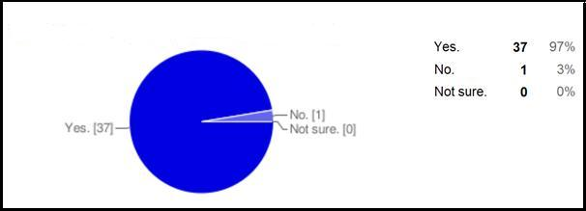

Fig 1: Importance of corporate image.

2) Which are the reasons that the company is having a corporate image?

This question tries to find the reasons behind the company having a corporate image. The answer to this question involved the option of checkboxes where participants can answer by selecting more than one options. The options provided to answer this question are: to attract skilled employees, to attract customers, to attract investors. The participant can select any one or all of them. In fact the “other” option has also been put where the participant can write down their own ideas.

The responses collected are quite similar to one another. Most of the participants agreed that the main reason behind the company having corporate image is to attract skilled employees, to attract customers and to attract investors. While the option “to attract customers” tops the list. And the “to attract skilled employees” and “to attract investors” options followed it. From the responses it can be quite sure that corporate image is really important and each and every company tries to keep their corporate image for hiring skilled employees. They try to attract customers and also to attract investors by their image building.

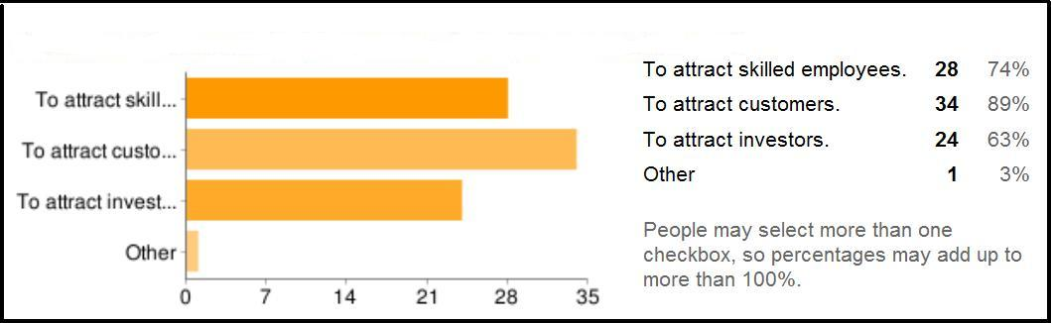

Fig 2: Reasons for having a good corporate image.

3) How does the company promote its corporate image?

This question asked the people of the Indian IT industry about how a company promotes its corporate image to their prospective employees, to their customers and also to their investors. Because in order to maintain that corporate image, the company has to promote first their corporate image.

The response gathered varies from one another. From the responses it can be said that companies try to promote its corporate image either by advertisements or media. While merchandising also plays a role in promoting of image. Company offers also helps in promoting image of the company. These are the responses collected from the participants. Other than that the “other” option has been used where participants can write their own knowledge and ideas apart from the given options. The responses collected are pretty good. According to some of them, corporate image in the Indian IT industry promotes its corporate image by the successful closure of the business undertaken. They mentioned that the companies used to get various business projects from clients. They should complete these works for the clients within the deadline. In doing so they did the work in a disciplined order and also the reputation of the company remains good. Thus it can be said that this helped them maintaining their image and the client will also approach next time only this company for their future work.

Another good response from the respondent mentioned that the company can promote its corporate image by delivering something more than what it had promised and winning a place in the informed public`s space of corporate recall. The participant tells that the company should put something more to their work other than what it has promised. In today`s competitive world it is utmost necessary for a company to maintain its image, and for that they should promote the image first in a very good way. Thus by delivering something more to the employees like giving some extra help while dealing the operations, giving extra incentives, bonuses etc can make the employees happy and in turn the company will be benefitted. One respondent mentioned that providing skilled work to the employees can help in promoting corporate image. Corporate image depends fully on the employee job satisfaction so the company should keep the employees happy such that it would not have much difficulty in promoting the image of the company. Also word to mouth by its employees can help promoting image. Another response collected is that the successful references given by the clients. Some respondents also mention that CSR initiatives can also be useful for promoting corporate image.

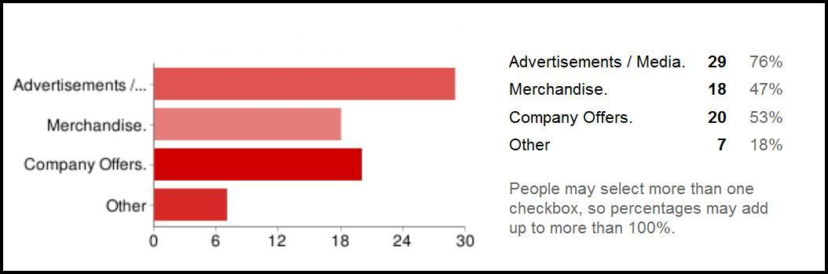

Fig 3: Factors that help promoting corporate image.

4) Do you believe that your company has a corporate image?

This question in the questionnaire tries to find out if the employees working in the organisation have a corporate image. The employees are asked through this question if they believe that the company they are working has a corporate image. The information collected from the responses shows that all the employees believe that the organisation they are working has a corporate image. All the employees show a positive response that corporate image is there in their company. But some respondents also replied that they do not think that their company have a corporate image.

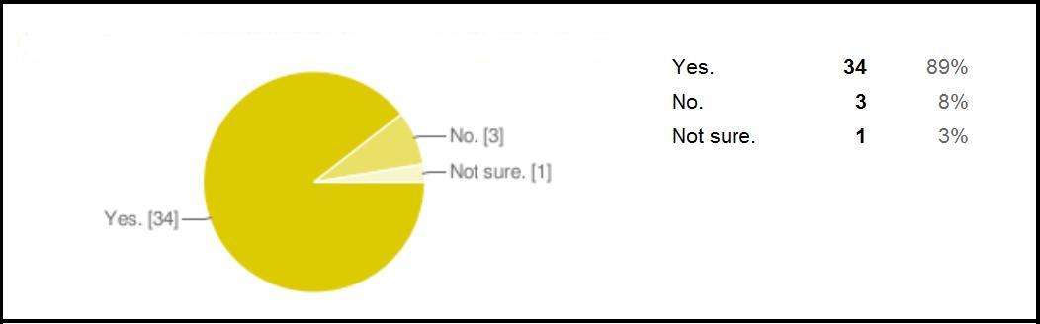

Fig 4: Existence of corporate image in the company.

5) Are you involved in promoting the company`s corporate image?

The questionnaires were sent only to a selected few. The participants are either HR, team leaders, project leaders or some of the marketing people. These are the only few people who could actually answer the questionnaire. These people has ample number of work experience and that they are promoted in a high position and they are now involved in the company`s corporate image. So this question is for them. And the responses collected helped in getting a clear idea that yes they are involved in promoting their companies corporate image. Although a selected few also mentioned that they are not involved in promoting their company`s image till now.

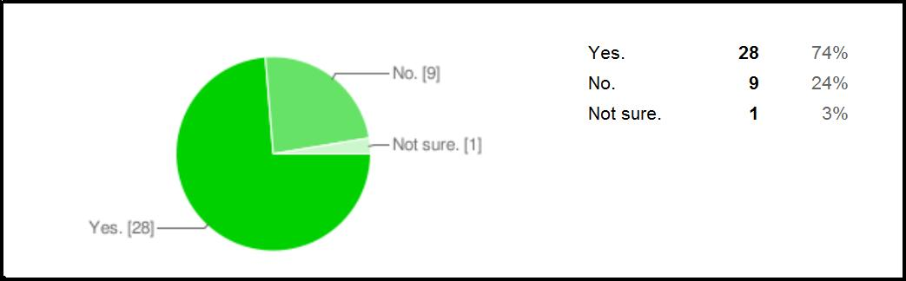

Fig 5: Participants involvement in promoting corporate image.

6) Are you satisfied with the company`s image?

The main aim behind asking this question is to find out if the employees already working on the organisation are satisfied with their companies’ corporate image. This is really necessary. It has already been mentioned that the employee satisfaction is very necessary for the success of a company. Moreover the employee should be satisfied with the company`s image then only there can be success. So from the information collected from the respondents, it can be found that most of them are satisfied with their corporate image, however some of them are not satisfied with the image of the company and some of the respondents are not sure about their satisfaction of the image of the company.

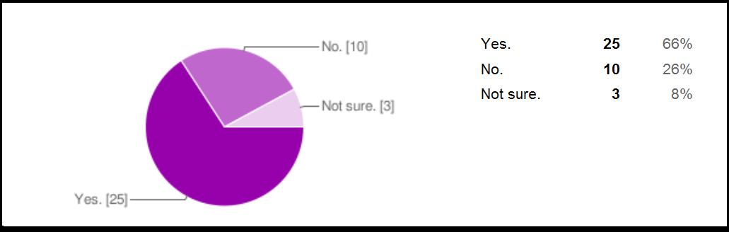

Fig 6: Satisfied employees of corporate image.

7) Do you want to change your company`s image?

The responses collected for this question varies differently. Some participants mentioned that they want to change the corporate image of the company they are working, while some of them are quite happy with the image the company is having. So the responses collected are of mixed view. However, more than fifty percentages agrees that they do not want to change the corporate image. Thus it can be said that the employees in the Indian IT industry is satisfied and they do not want to change their company`s image.

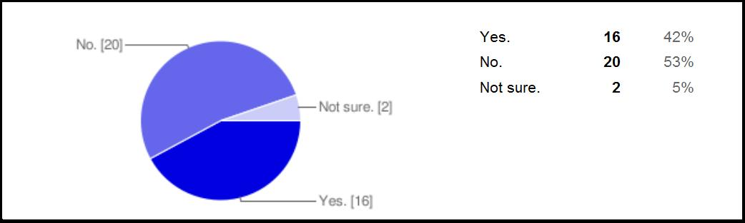

Fig 7: Employees satisfaction of corporate image.

8) Is the company maintaining its image?

The above two questions are asked to the employees about their satisfaction with their company`s image and also if they want to change the image their company is having in the market. Now in this question the employees are asked if the company they are working for is really maintaining the image of the company. Most of the responses collected mentioned that their company is maintaining the corporate image. Only a selected few tells that their company is not maintaining the corporate image and some of them are not sure exactly if their company is maintaining the corporate image or not.

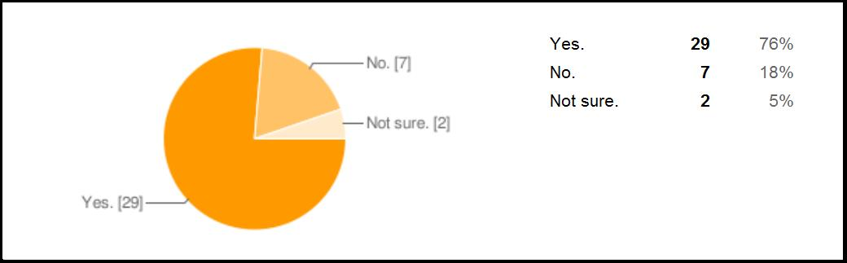

Fig 8: Companies maintaining the image.

9) How does the company maintain its image?

After asking the participants the questions of satisfaction and maintaining of corporate image in the organisation, the question arises how exactly the company maintain its corporate image. This question gives answer to that. The checkboxes options are used for the answers. The options included company logo, company tagline. One box is left open for the employees where they can put their own ideas and opinions. So many responses are found for this question. While most of the respondents mention that the company maintain its corporate image through company logo as well as company tagline. Most of them also gave their own views on maintaining the company`s image. They mentioned like successful referrals from existing clients can be helpful in maintaining the corporate image. Good performance is also necessary for corporate image. Another response is by ensuring its employees lives, promote and exhibit the essence and attributes of its corporate image. One response answer is how the company`s employees say about the company, which means the employees can also maintain the company`s good corporate image by mentioning it to their friends or colleagues. Also by delighting all its stakeholders can be helpful for maintain the corporate image. Successful references by clients can play a vital role for the image. Good performance is also quite important. By its services also a company can invite good corporate image. So these are the responses collected from the employees of the IT industry in India. Most of them has given their views and opinions on maintaining the corporate image of the organisation.

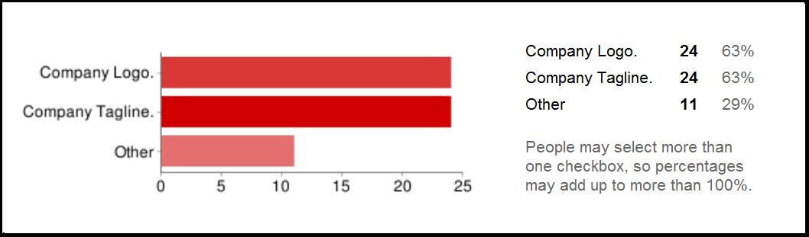

Fig 9: Factors that help in maintaining of corporate image.

10) Is the company getting benefit from its corporate image?

The next important question is about the company getting benefit from its corporate image. Almost all the responses are positive telling that yes corporate image is very important for the company`s success. Almost all the respondents from the Indian IT industry agree that corporate image is very beneficial for organisations they are working with. Thus the company maintain its corporate image and the company is getting benefit from the image it has created.

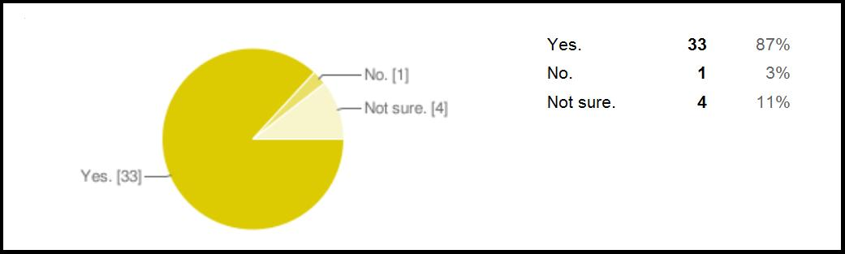

Fig 10: Corporate image is beneficial.

11) Do you know how the company obtain its image?

This question is an open ended question. It is very important to put at least two open ended questions in the questionnaire. It helps the participants to express their views, opinions etc. So this question asks the participants if they know how the company maintain its corporate image. The responses collected gives a very detailed information. The answers are: the company can obtain its corporate image by corporate web presence, effective and reachable communications, medium and physical presence of the office location, also the area of service being provided or offered by the company aligning to the mission and vision of the actual company are all the factors that is to be considered for maintaining its corporate image.

The company can obtain image by its consistent performance, meeting the deadlines, attracting more customers, satisfying its employees also creating a better working environment all can help in getting a good image.

Another respondent answers that by the extensive period the company has existed globally for more than 100 years and also being a firm that has pioneered some of the best and innovative practices globally in its fields of work. The company has always delivered value to its stakeholders it associated with and thus it has maintained its image.

Through branding and promotion of its core business operations and niche products a company used to obtain its corporate image. The media plays a vital role for obtaining the corporate image. The company spends money in advertisements. Employee benefits like high salary, skilled and challenging work are also helpful. One employee who is the participant of this questionnaire says that employee satisfaction index is important. According to him when an employee is satisfied and the way he is treated by the company, he would propagate it word to mouth. This would lead his friends, colleagues to try for that company and in the long run the company gets all the skilled employees trying to get hired by it. Thus the company will have sufficient workforce and in turn the performance of the operations of the company improves and thus the clients also gets satisfied promoting the overall corporate image of the company.

A good corporate image can be achieved through good use of perception management which involves marketing, PR, promotions and public reach. The company should also be professionally and socially responsible. A company should also maintain its standards in its product quality, price fixation, sales promotion and after sales services.

These are all the information gathered from the participants. All the participants are given full freedom to express their views and opinions about the obtaining of corporate image. Thus they have provided me with enough data for this question.

12) What are your views on the importance of corporate image to the success of the company?

This is also another open ended question. This is the last question to the participants. Through this question the participants are asked to provide their information and knowledge on the importance of corporate image for the success of the company.

The responses are as follows:

One of the respondents says that according to his view on the importance of the corporate image for the company`s success, it always depends on the area of service being provided by the company. It is also important for the growth of the company. If the image is better, more customers will get attracted and hence the revenue of the company will also increase. After all money is what matters. Moreover, ample number of skilled labours will also be attracted which will result in good performance. It is also important to attain new customers and also to retain existing customers.

Corporate image is essential for the long term success of the company. As all knows that no company starts with an image, it grows in the operating market over time taking over its competitors and providing cutting edge solution to its consumers. Also it is used as a tool to attract clients and skilled workforce into the corporation. So in a nutshell it’s a reason-de tre for the company`s existence in the market.

Corporate image and success is somewhat directly proportional but that not at the cost of ethics. Corporate image is very important in today`s market what is observed as nice is demanded more. One of the responses is that the corporate image is important as it is the ability to communicate a favourable and progressive image to as many clients and reach out in the easiest possible way to stay ahead of its competitors and subsequently has a profound effect on the bottom line. And thus helps them to stay ahead from its competitors. The corporate image helps the company to perform excellently with the limited resources.

The corporate image of the company reflects in its work culture. It is very much important to attract new talents as well as retaining the existing skilled resources. It also helps in getting new business as customers really look forward to the company`s customer satisfaction, professionalism in their work, commitment and delivery of valuable services.

One participant explains this question by giving some good examples. He mentioned that there are many firms like Sony, Microsoft, HP, BMW, Toyota, Mercedes and many others has created good corporate image and they are quite successful in their field. Similar example can be given of Hyundai motors that came to India a long time ago. In fact they had invested lot of capital in their product. But at last they came to know that they have not spent anything for promotion of their products. After that they assign a brand ambassador for their product and started promoting through advertisement and now they are way ahead in the motor industries. Similarly the IT giants in India like TCS, Infosys, Wipro, HCL etc are now spending lots in the image building process. And they are surely getting benefit from it.

Corporate image is very important. It gives credibility in consumers for building a good relationship.

Thus these are the all responses collected from the respondents. The participants expressed their full views and knowledge in this question. They answered the questions fully and in turn it helped me getting some more knowledge in depth.

4.2) Summary of the research findings

The responses collected are quite useful. So many data and information has been collected. It helped very much in carrying out this research. These are the primary data that has been gathered through questionnaires. I am very much grateful to the respondents who in-spite of their very busy schedule, took out some time to help me by filling up the questionnaire. I really appreciate their help and support.

The information collected helped me to gain so much knowledge and it also helped me in answering my research questions. From the respondents answer it can be found that corporate image is really necessary in today`s competitive world. Corporate image plays a major role for the survival of the company. All the participants agreed that yes corporate image is really necessary for a company and also each company has their own corporate image. Each company tries to obtain a positive image for their company and after that they try to maintain that image. The main reason for obtaining the image is obviously to compete with the rivals. All the companies want to have a very good market share and also want to have a good name. Competition is very much in today`s world thus each of these companies tries to have a very good corporate image such that they can do very well in the long run. Almost all the participants who are working in the Indian IT industry mentioned that they believe that their company has a corporate image and the company is doing very well with the image. Most of the respondents are involved in obtaining the company`s image while a selected few are still on their way. All the respondents are quite happy with the image. Though, a selected few wants to change it.

Thus in total it can be found out clearly that the employees in the Indian It industry believe that their company is having a very good market presence and they have a good corporate image and almost all of them are happy with the image.

***Chapter 5: Research Analysis***

This chapter aims to present, discuss and analyse the three main research questions. In the last chapter, the primary data has been analysed and discussed which has been gathered from through the questionnaire. Here both the primary and secondary data will be used to answer the questions. But mostly secondary data will be used.

This chapter consists of three sections. In each section one research question will be answered.

5.1) How does a company obtain its corporate image?

As there is not much literature about corporate image in the Indian IT industry, the little amount of information that has been collected will be used in this research.

The very first research question in this study is to find out about corporate image and how the company tries to obtain it.

The answer to this question can be answered from the responses collected from the questionnaire. The responses collected mentions that corporate image can be obtained through advertisements/media, merchandising of products also play a major role in corporate image, company offers is also important for obtaining of corporate image.

Corporate image can be described as the overall impression made on the minds of the public about a particular firm (Nguyen and Leblanc, 2001). It can be related to the various physical and behavioural attributes of the firm, like business name, architecture, products/services varieties, tradition, ideology, and the impression of quality communicated by each person interacting with the firm`s clients. As such, corporate image has two principal components: the functional and the emotional. The functional component speaks about tangible characteristics which can be easily measured, while the emotional components are associated with the psychological dimensions which are revealed by feelings and attitudes towards a company. These are the feelings which are derived from an individual`s experiences with a company and from the processing of information on the attributes which constitutes functional indicators of image. Corporate image is, therefore, the result of an aggregate process by which the public compares and contrasts the various attributes of the company (Kennedy, 1977).

There can be many ways for obtaining of corporate image. In terms of nutritional circles, it can be said that: you are what you eat. So same can be considered in the corporate world. In the corporate entity it can be find that the company is all about what the people think about it. This means that whatever a company provides to the people, they will believe in that only. That`s why a good corporate image is very important. From a study report of Opinion Research Corporation, it shows that corporate image is a major part of what sells a company and also its products. According to the study conducted, around 97 percent of the responding senior and middle managers said image accounts for a significant measure of a company`s success and failures.

People and employees like doing business and work with a particular firm for more than the quality of the goods and services. The collective knowledge of customers, stockholders, bankers, brokerage houses, dealers, distributors and the media regarding a company can affect greatly in its sales and earnings, valuations and mainly to attract quality employees (Selame and Selame, 1975).

A company itself does not project a unique image. Rather, it possess various images which differs according to different specific groups like clients, employees, and shareholders, where each of them has its types of experiences and contacts with the firm (Dowling, 1986, 1988; Gray, 1986). Since incongruent perceptions of individual`s can counteract favourable impressions related to a company`s image, the harmonization of activities is mostly important. The building of a corporate image is a lengthy process is often related to symbols and values which can be improved rapidly by technological breakthroughs and unexpected achievements on the contrary, the image of a particular firm gets destroyed if they neglects the needs and expectations of the various groups who interact with the company for business and operations (Van Riel and Balmer, 1997).

There can be various ways stakeholders perceive an organization's image and identity which is formed in their minds (Bernstein, 1984; Margulies, 1977). Corporate Image can be said to be the totality of a stakeholder's perceptions of the way an organization presents itself, either it is done deliberately (for example, through proper planning of public relational activities) or by accidentally, (for example, through comments and words spoken by staff or media). Images of companies thus form through encounters with the characteristics of an organization, the net result of the interaction and the experiences, beliefs, feelings, knowledge and impressions that each stakeholder has about the organization (Spector, 1961; Topalian, 1984).

As organizations have various stakeholders, where each has its own backgrounds, objectives and levels of dependency, it cannot be expected that there will only be a single, uniform and consistent image. In reality these stakeholders have different images of the same organization, all shaped by their distinct exposures to the identity cues presented. This multiplicity of images is the fundamental principle used by the management for building of the corporate image Dowling (1993).

Therefore there is one way in which these multiple images can be formed and this is through the employees who are already working in the organization. If the views and expectations of the employees are fragmented and do not match with each other, then this may lead to multiple identities and creates confusion amongst interested parties. Thus the lesson to be learned from this is that it is important to establish a consistent and sustainable internal image among all the employees of the organisation such that this consistency is projected as a positive cue to the other stakeholders. Corporate Image, therefore, exists in the mind of each stakeholder and it cannot be managed directly. The management of an organisation seeking to influence the images of their organization can only do so through managing the corporate identity. Through presenting orchestrated cues, image of an organisation may be repositioned or altered in the minds of the recipients (Balmer, 1988).

So the various ways that involves in obtaining corporate image in an organisation is by promoting and publicity. An organisation can promote the corporate image through merchandising, advertisements and media, through communications, by company offers and so on. Advertising is all about publicity. It is the impression made to the people around. Through advertising the organisation spread the news about the company, job vacancy, company benefits and many other things. For example the Infosys, Wipro all these Indian IT companies wants large amount of employees for performing their operations. They use to recruit employees which can help them performing their operations. Thus these industries need highly skilled employees. These industries advertise about their available job positions through newspaper, recruitment agencies and other media. Merchandising about the company’s products and operations also play a major role in obtaining of corporate image. Through merchandising only they can tell to the outside world about their performance, their work, their products, and among others, it is thus one of the main important means of obtaining an image about the company. Also offers i.e. the company offers are really important. People always want something more. In that case when these companies provide some good offers people will always come and try to grab it. Companies use to offer benefits to the employees as well. When they offer something new to the employees, the employees get satisfied. The main aim of the company is to keep the employees satisfied. If the employees are satisfied they will be more concentrated on their work and in turn they will perform well in their job and operations and thus the company will get benefit. And we know that if the employees are satisfied they will tell about their company to some hundred others outside and that way the company can gain a very good positive image. Obtaining of corporate image involves lot amount of time and money. But once achieved a good corporate image, it is fruitful for all of them. These are the things that an IT industry should always keep in mind while working towards a good corporate image. It will definitely help the company in the long run.

5.2) How does an organisation maintain its image?

When a company obtains a good corporate image it takes much effort to achieve it and after achieving the image it is very essential to maintain its image.  
For maintaining of corporate image, a different management approach is necessary. It requires greater emphasis on the internal factors of the organisation and also to give greater attention to the roles of employees for building a good corporate image process (Harris and Chernatony, 2001). We can find that a better management approach is necessary for a good corporate image, as it requires greater focus compared with others in the organisation. The role of employees in the organisation is changing rapidly, as they are considered as brand “ambassadors”. Employees constitutes the interface between a company`s internal and external environments and can also have a powerful impact on consumers` perceptions of both the brand and the organisation (Balmer, 1995).

These companies use a certain set of communication devices for maintaining their image. These includes the name of the organisation, the logo or symbol that used by the company for its identification, the company tagline that appears under the company name and logo and also the company`s colour. While maintaining the corporate image, the company has to give attention to all these things. They have to maintain all these things properly for maintaining a good corporate image (Marwick, 1999).

A company`s corporate image are communicated not only by advertising, but also through the employees` interactions with different stakeholders. Employees represent a source of customer information and action needs to be taken to ensure this it is compatible with the way management wishes the organisation to be perceived. Employees are thus becoming important to the process of image building and thus their behaviour can either reinforce an organisation`s image values or if inconsistent can undermine the credibility of the image promoted. It is thus very important to look inside the organisation and to consider how employees` values and behaviour can be aligned with a company`s image and values. While image focuses on consumers` perceptions of image differentiation, identity is more focused with how managers and employees make the company`s image a unique one. Management first defines a particular image and values for the organisation and that image and values should be maintained by the employees. The employees’ values and ideas and image should be consistent with them. Management thus need to examine that proper image is delivered constantly. Managers of the organisations has to agree on the few core corporate values which will remain unchanged and also the less central values that need to adapt to changing circumstances (Martineau, 1958).

The answers collected from the questionnaire gives an in-depth knowledge about how the Indian IT industries maintain their corporate image. They mentioned that company logo and company tagline helps a company to maintain its image. Successful referrals from existing clients of a company can be beneficial, as these clients will speak about their experience with the company. Performing well in the operations of the client is important. Keeping these clients satisfied is thus very essential. Also the employees of the company can maintain the company`s image. As these employees will speak about their work and benefits they use to get from the company. Thus the company should satisfy their employees as well for the image maintenance.

As the company`s image and values is established, a relationship between the image and the consumer evolves which is characterised by the values inherent in the company`s image. Managers need to help the employees understand the types of relationship which are appropriate with other employees, consumers and stakeholders which are all related with the company`s image. Successful management of the internal image resources will result in a good image of the company. Management therefore need to work with staff members to reduce gaps between them and also eliminate sources of incongruity. Thus if the management gets hold of all these they can maintain a good corporate image. Though corporate image encompasses the perceptions of various stakeholders, but employees of an organisation are the most important stakeholders. Corporate image formation heavily relies on an organisation`s members who holds a congruent perceptions about the nature of the company. However as corporate image becomes an essential part of the organisation, the teams responsible for promoting the corporate image are also becoming large and the composition of their members becoming more diverse. Perception depends entirely on a person`s expectation and previous knowledge and also the information provided by the stimulus, in this case is the image (Otubanjo et al., 2008).

Organisation peoples who are at different seniority levels and also from different departments tend to have different information and decision criteria. So managers and employees are likely to differ in their perceptions of the company`s image. Also manager’s functional backgrounds can result in selective perception and interception. And the perceptions of managers differ from the perceptions of sales staffs. Thus it can be said that there is a positive correlation between the company`s image performance and the congruence of the employees perceptions about the organisation.

There are many advantages of having a good corporate image (Pomaret and Monrog, 2008). A good corporate image is very beneficial and it can lead to competitive advantage, mostly, when there are too many competitions to be considered. There can be many advantages for having a good corporate image. It is always helpful to the company, its employees, its consumers and also to all its stakeholders (Smith and Taylor 2006). Especially, it can help the organisation and its stakeholders in the following ways:

**a) Improvement in sales:** Customers will definitely prefer a well-known company, with a good reputation, instead of one that they do not have any information or have a bad reputation.

**b) Supports new product development:** A well-known company will have fewer problems while launching and introducing a new product. From the beginning only, customers and clients will have confidence with the company`s new products and operations.

**c) Strengthens the financial relations:** Positively communicated corporate image will help to make the organization’s presence known to many influential players. It might also increase the awareness, understanding and support.

**d) Harmonize employee relations:** Effectively managed corporate image will create a sense of common purpose within organizations. The most important and valuable audience and communicators are the employees. Employees are the ones who are in contact with the rest of the audiences. Thus the better they perceives a positive image and perception of the company, the better communication of the company will be sent out to the rest of the audiences (Ind, 1992).

**e) High boost of recruitment:** A positive image helps the company in attracting and maintaining skilled work forces.

**f) Managing crises:** In hard times, a company having a good image always enjoys a presumption of innocence.

Therefore it can be find that obtaining of corporate image is essential and after that maintaining of corporate image also requires very much effort. Companies who maintain a good corporate image will be very successful and they will have a good market place and can compete with their rivals. They always will get respect from its employees and also from its stakeholders.

5.3) What is the role played by the employees and the management towards the success of corporate image?

Corporate Image consists of multiple stakeholders who interact with numerous staff across various departments in an organisation. An effective corporate image for an organisation requires consistent promotion of the image of the company among all the stakeholders. Internal consistency and congruence inside the organisation is vital to the successful external communication of the company`s image. It is thus important that managers identify the mechanisms for surfacing diverse perceptions for dissolving inconsistencies. The members who are involved in promoting corporate image first need to surface their own perceptions and clarify their image towards the organisation, after that they should work with the employees and ensure that their perceptions align with the intended image of the organisation. Also for a further coherency check, employees should be encouraged to provide feedback about the consumers perceive about the company`s image.

Building of corporate image in an organisation is very essential and it can be build through the internal mechanisms of the organisation. There are three key factors which affect the perceptual congruity which are: similarity of image building team members, shared values and communication. These factors mainly affect the employees’ perceptions and also the image performance (Newman, 1953).

The role of image becomes more significant when competing services are perceived as virtually identical may it be on performance, price and availability (Andreassen & Lindestad, 1998). Thus in the case of services, Corporate Image serves as an important factor influencing the perception of quality, consumer`s evaluation of satisfaction with the services and also customer loyalty. A good image of a company may attract good labour force. The role played by the employees and management for a positive image of a company is really important. They are the ones who actually run the operations and the business. In fact they only promote the image of the company.

The idea behind image building of corporations started in the United States of America in the late 1950s. One great personality named David Ogilvy, the founding father of modern advertising. He uses to specialise in providing a personality to the products he was advertising. And thus the image creation started. His main principle was that consumers actually do not buy products, but they buy brands. This total personality also called it as the image was designed to fit the self-image of the target market.

So to manage a corporation`s image, it thus requires understanding of how these images are formed first. Maintaining a corporation`s image is usually dependent on knowing the current image scenario and also to change some of the factors which are actually based upon (Dowling, 1994).

The questionnaire answered all the research questions. While answering the third research question the data and information collected is very useful. The participants of the questionnaire are very high level officers in the Indian IT industry. They are HR, Team Leaders, Project Leaders and they have been in this IT industry from the last 5 to 10 years. Most of the respondents are quite involved in promoting the image of the company. They made strategies to obtain and maintain the corporate image of their company. And they are quite happy with the company`s image. Moreover they mentioned that the company is doing quite well with having the corporate image. The company they are working is maintaining the corporate image and they are quite successful.

This study tried to answer the importance of corporate image in the Indian IT industry and also the perception of employees towards a better corporate image. It also tried to find out exactly how these IT industries obtain the corporate image for a company. And after obtaining the corporate image how they try to maintain it. What all the things necessary for obtaining of corporate image. What efforts needed for maintaining of corporate image for their company. Also the role played by the employees, the management and its stakeholders help in achieving a good corporate image for the organisation is also been looked at. Therefore the primary and secondary data has been analysed properly and the entire three research question has been answered.

*Chapter 6: Conclusion*

This chapter will give a summary of the whole research. Some limitations will also be mentioned. The recommendations and future development for this research will also be provided. The main objective of this study is to develop a theoretically and empirically well founded concept of corporate image.

The construct of corporate image is often referred to in the literature with varying views. This study tried to distinguish the meaning of corporate image and its key elements. Corporate image can be considered as an umbrella construct, which refers to the cumulative impressions of internal and external stakeholders. It tried to distinguish the three important factors for corporate image: obtaining of corporate image, maintaining the corporate image and the role played by the employees and management towards a successful corporate image. In summary, it can be said that corporate image as the total view of the perceptions held by its relevant stakeholders: employees, customers, investors. Image can also be related to reputation.

The discussion of this study mentioned about the growing body of evidence that corporate image is really important. It says about understanding how important is the construct in management of an organisation and its social environment which greatly affects the lives of employees which also affects their behaviour and attitude. This study mentioned about the empirical study about corporate image. Employees` perception of corporate image influences their job satisfaction and also the intention of leaving the job. Thus a good corporate image is related to the employee’s job satisfaction while a negative image will relate to leave the company. If the employees find that the company has a poor corporate image they have less job satisfaction and the possibility of leaving the company is very much, and if the employee finds that their company has a very good image their job satisfaction is quite more and they do not think of quitting.

It can be find that in order to project a corporate image campaign directly to the firm's public, the most effective way is to project the reality of the firm's actual style of behaviour; in that case it becomes much easier for creation of image. It also can be said that non-correspondence may unintentionally lead to a mixed, confusing or totally misleading image of the firm which may result in self-defeating and also wasteful of the resources (Argenti, 1998). However, before undertaking a costly campaign to project the company`s image, it would be wise to first study the objectives of the firm's characteristics and attributes.If these please the firm's management, the outcome of results could provide a rational basis for the campaign process. On the other hand, if the outcome of results reveals a character attribute make-up that is not satisfactory, the action to be taken could be made clear by examining the discrepancies. If management decides that they wish to manipulate the firm's character attribute make-up (let`s assume that this was feasible), the technique used for identifying the style could be usefully employed to monitor the changes over time. Firms who wish to acquire new products or expand their markets always seek a suitable merger or corporate acquisition. Although evidence is rare at this moment, but it is always interesting to speculate about what combination of corporate styles and strategies would make for the greatest probability of success. In that case a company having a good corporate image always play a competitive advantage over others. As we can see that companies use various image building process for maintaining the image and it is going to exceed more in the coming years. Corporate image building process however requires a lot of effort form the top management who actually helps in promoting the company`s image. Research showed that each and every company, big or small, new or old, all wants to have a good image and they want to serve the people very well. So the competition will be more intense amongst all these players to get their image they wanted. These companies will introduce many innovative methods to stay ahead from its competitors. These methods might include hiring of image building experts to enhance their company`s image, also providing competitive compensation, giving the employees foreign postings with dollar salaries and also to invest in stock options, providing challenging work environment in cutting edge technology areas.

6.1) Limitations

Although the data and findings from this research are quite interesting and useful, there are some limitations for this research.

1. Time period: The time period allotted for completing this research was 3 months, which is a little bit insufficient to gain an in-depth understanding of the whole research topic.
2. Primary data: The primary data which includes the questionnaire is not sufficient enough to arrive at a particular conclusion.
3. Data distortion: The primary data which has been collected from the employees of the Indian IT industry could be biases with officials concealing some unfair facts.
4. This study topic is an upcoming one with new researches being initiated each and every day. As a limited amount of time was involved and also less wordings involved, there might be the possibility of some recent and new trends were left behind, which means more in-depth research could have been performed.

It is thus very much important to make some improvement in the further research which will provide more fruitful and representative findings. Further researches could also be done to find the corporate image of Indian IT industry comparing with other countries; in that case it will help to arrive at a proper conclusion.

6.2) Recommendation

The study tried to find the basic reason why the companies have a corporate image. It also tried to answer how the companies obtain the image and maintain it. Also mentioned here is the role played by the employees and the management for the corporate image and also the benefits of having corporate image. Through this research all these questions have been explained and discussed.

Although the results showed that these Indian IT companies has a corporate image, but it can be find that there are still very small and medium size companies in India who does the IT work, do not have a corporate image. They do not want to spend enough money for promoting their companies image. But according to research that has been made, it says that corporate image is very essential. It helps the organisation very much for its survival.

The Indian IT giants like TCS, Infosys, Wipro and many others has their corporate image and they are doing very well with it. But it is not the same for the other. Although most of them possess corporate image, some do not want to carry out further as they do not want to spend money and time in it. Some might think that it is not necessary to have an image for their company and they are doing quite well enough without the image. But corporate image plays a big role and if they spend a little amount of time and money maintaining the corporate image, it will be very beneficial for them. It might not be beneficial now but it can be very useful and will be worth in the near future.

The results collected from the respondents of my questionnaire mentioned that they are quite happy with the company`s image. But it can be find that while maintaining the corporate image the employees might get harm mentally in the sense that they have to work very hard in order to maintain that image. IT industry jobs are not that easy ones. The employees have to work for at least 8 hours per day and five days a week. Also it can be find that some employees work around 10 hours a day. And they have to perform very well and have to maintain it constantly. So the stress level can be very high for these employees working in the Indian IT industry. Although corporate image is necessary for an organisation but in order to maintain the image the people who works in the company has to go through a hard time doing hard labour managing clients, managing their operations, looking after all the necessary things that are important for corporate image.

Corporate image is important for an organisation and it plays a vital role while competing with others. But it is really very hard to obtain a corporate image for the company. A lot amount of time, money and effort is needed for obtaining of the corporate image. The employees and the management who manages the company have to set their minds and they should be prepared enough for doing hard labour, as for obtaining and maintaining of the corporate image needs a lot of hard work, mental preparation and sacrifice. The image of a company cannot be made or obtained in a single day. To have a very good image of the company, the people working inside the company has to work very hard. They have to work every day for having a good image. In fact the company should have some marketing people in the company or they can hire some of the professionals who can help them obtaining the corporate image of the company.

6.3) Future development

The companies have to maintain their corporate image. It is very essential as the competition is increasing every day. The companies have to come up with new strategies in order to survive in this huge competition. They have to keep in mind: survival of the fittest. Thus in order to compete with its competitors, they has to keep thinking and has to involve certain strategies which will help them. Indian IT industry is very huge and the competition is growing every day. The IT market in India comprises of the large companies and also the small and medium size enterprises. TCS, Infosys, Wipro, HCL and many others are considered as the IT giants who play a major role in the development of the country. While there are also many small and medium scale IT companies who are doing quite well. But in order to compete with these giants, they have to struggle a lot. Each and every company has corporate image of their own. They have to maintain it properly such that they are not left behind in the competition.

Thus these companies have started making strategies for their corporate image. Infosys Technology tops the list in the corporate image rankings, TCS and Wipro followed. These companies are now investing lots of money and time. They now realised that they has to maintain the image of the company as well.

In fact TCS is trying to maintain its image and have introduced a global branding program. Wipro launched a program named applied innovation campaign to maintain their corporate image. These are the strategies introduced by these IT industries and this will help them in future developments and also to compete with others. Infosys on the other hand use to give its employees the stock option benefits where the employees can invest in the shares of the companies. This strategy helps the Infosys very much as it keeps the employees happy. They knows that in order to maintain the good image of the company, it has to keep the employees satisfied and thus it will help the company keep growing. So all the principles and strategies have been used by the Indian IT industries to have a very good corporate image and this will help them in their future growth and development.

List of references

1. Aaker, J. L., (1997), `Dimensions of brand personality’, *Journal of Marketing Research,* Vol. 34, August, pp. 347-56.
2. Abratt, R., (1989), `A new approach to the corporate image management process`, *Journal of Marketing Management,* Vol. 5, No. 1, pp. 63-76.
3. Albert, S. & Whetten, D. A., (1985), `Organisational identity`, in Cummings, L. L. and Staw, B. M. (Eds), `Research in organisational behaviour`, Jai Press, Greenwich, CT, Vol. 7, pp. 263-295.
4. Alsop, J. R., (2004), `The 18 Immutable Laws of Corporate Reputation- Creating, Protecting, and Repairing Your Most Valuable Asset `, *A Wall Street Journal Book,* Free Press: New York.
5. Andreassen, T.W. & Lindestad, B., (1998), `The effect of corporate image in the formation of customer loyalty`, *Journal of Service Research* 1 (1), 82-92.
6. Andreassen, T. W., & Lindestad, B. (1998), `Customer loyalty and complex services `, *International Journal of Service Industry Management,* 9 (1), 7-23.
7. Andrews, K.R., (1980), `The Concept of Corporate Strategy`, (Revised ed.), Dow Jones Irwin, Homewood, IL.
8. Antonoff, R. (1985), `CI-Report 85: identittat und image excellenter, Unternehmen,Verbande, Stdte: Analyse-Projekte`, Trench, Frankfurt.

Argenti, P.A. (1998), `Corporate Communications`, McGraw-Hill, Boston, MA.

1. Baker, M. J. & Balmer, J. M. T., (1997), `Visual identity: trappings or substance`, special edition on Corporate Identity of the *European Journal of Marketing*, Vol. 5 and 6, No 3, pp. 366-82.
2. Babbie, E., (2004), `The practice of social research`, Belmont: Thomson Wadsworth.

Balmer, J. (1988), `Corporate Identity and the advent of corporate marketing`, *Journal of Marketing Management*, Vol. 14, pp. 963 – 96

1. Balmer, J.M.T. (1995), `Corporate branding and connoisseurship`, *Journal of General Management*,Vol. 21, No. 1, pp. 24-46.
2. Balmer, J. M. T. & Gray, E. R., (1999), `Corporate identity and corporate communication: creating a strategic advantage`, *Corporate Communications: An International Journal*, Vol. 4 No. 4, pp. 171-6.
3. Balmer, M. T. J., (2001), `Corporate identity, corporate branding and corporate marketing seeing through Fog`, *European Journal of Marketing*, Vol. 35, No. 3/4, pp. 248 – 291.
4. Barich, H., & Kotler, P., (1991), ` A framework for marketing image management `, *Sloan Management Review (Winter)*, 94-104.

Bayton, A. J., (1959), `Researching the Corporate Image`, PR, Vol. 4, October, pp. 3-8.

Bernstein, D., (1984), `Company Image and Reality`, Rinehart and Winston, Eastbourne.

1. Boulding, K.E. (1956), `The Image`, University of Michigan Press, Ann Arbor, MI.
2. Breakwell, G. M., (2006). `Interviewing methods`. In G. M. Breakwell, S. Hammond, C. Fife-Schaw, J. A. Smith, `Research methods in psychology`,(pp. 232-253), SAGE Publications Ltd: London.
3. Bristol, L.H., (1960), `Developing the Corporate Image: A Management Guide to Public Relations`, Scribner, New York, NY.
4. Bromley, D.B., (1993), `Reputation, Image and Impression Management`, John Wiley & Sons, Chichester, Sussex.

Brown, A., (1995), `Organisational Culture`, Pitman Publishing, London.

1. Bryman, A. & Burgess, G. R., (1994), ` Analyzing qualitative data`, London, Routledge.
2. Bryman, A. & Bell, E., (2003), `Business Research Methods `, New York, Oxford University Press.
3. Budd, J., (1969), `A mirror on the corporate image`, *SAM Advanced Management Journal*, Vol. 34, January, pp. 45-50.
4. Burton, J., Easingwood, C. and Murphy, J., (2001), `Using qualitative research to refine service quality models`, *Qualitative Market Research: An International Journal*, Vol. 4, No. 4, pp. 217-223.
5. Chernatony, de. L., (1999), `Brand management through narrowing the gap between brand identity and brand reputation`, *Journal of Marketing Management*, Vol. 15 Nos 1-3, pp. 157-80.
6. Christen, T. L., Morsing, M. and Cheney, G., (2008), `Corporate Communications- Convention, Complexity, and Critique `, Sage Publications.
7. Churchill, G. A., & Iacobucci, D., (2002), ` Marketing Research: Methodical Foundations`, 8th Edition, South Western Thomas Learning, USA.
8. Chun, R., (2005), `Corporate reputation: Meaning and measurement`, *International Journal of Management Reviews*, Vol. 7, Issue 2, pp. 91-109, Blackwell Publishing Ltd.
9. Curwin, J. & Slater, R., (1991), `Quantitative methods for business decisions`,3rd ed. London, Chapman and Hall.
10. Stewart, W. D. & Shamdasani, N. P., (1990), ` Focus groups theory and practice`*,* Newbury Park, Calif., Sage Publications.
11. Davies, G., Chun, R., Da Silva, R.V., and Roper, S., (2003), `Corporate reputation and competitiveness`, Routledge, London.
12. Davis, A. & Bremner, G., (2006), `Research methods in psychology`. In G. M. Breakwell, S. Hammond, C. Fife-Schaw, J. A. Smith `The experimental method in psychology`, (pp. 64-87), SAGE Publications Ltd., London.
13. Daymon, C. & Holloway, I., (2002), `Qualitative research methods in public relations and marketing communications`, Routledge, London.
14. Dey, I., (1993), `Qualitative data analysis: A user-friendly guide for social scientists`, Routledge, London.
15. Dowling, R. G., (1986), `Managing your corporate images`, *Industrial Marketing Management*, Vol. 15, No. 2, May.
16. Dowling, G., (1988), `Measuring corporate images: a review of alternative approaches `, *Journal of Business Research*,17, 27-34.
17. Dowling, R. G., (1993), `Developing Your Company Image into a Corporate Asset`, Vol. 26, No. 2, pp. 101 to 109, Pergamon Press Ltd, Great Britain.
18. Dowling, R. G., (1994), `Corporate Reputations, Strategies for Developing the Corporate Brand`, Kogan Page, London.

Dowling, R. G., (2001), `Creating corporate reputations: identity, image, and performance`, Oxford University Press, US.

1. Downey, S. M., (1986), `The relationship between corporate culture and corporate Identity`, *Public Relations Quarterly*, Winter, pp. 7-12.
2. Doyle, P., (1992), `What are the excellent companies?`, *Journal of Marketing Management*, Vol. 18 No. 2,pp. 101-16.
3. Dutton, J. E. & Dukerich, M. J., (1991), ‘Keeping an Eye on the Mirror: Image and Identity in Organizational Adaption ’, *Academy of Management Journal*, 34, 517–554
4. Easterby-Smith, M., Thorpe, R. and Lowe, A., (2002), ` Management research: An introduction `, London: SAGE Publications Ltd.

Easton, A., (1966), ‘Corporate Style versus Corporate Image’, *Journal of Marketing Research*, Vol. 3, No. 2, American Marketing Association.

1. .Fombrun, C. and Shanley, M., (1990), ‘ What’s in a Name? Reputation Building and Corporate Strategy ’, *Academy of Management Journal*, 33, 233–258.
2. Fombrun, C., (1996), `Reputation: Realising Value from the Corporate Image`, Harvard Business School Press, Boston, MA.
3. Fombrun, C. and Van Riel, C. B. M., (1997), `The reputational landscape`, *Corporate Reputation Review*, Vol. 1 No. 1 and 2, pp. 5-13.
4. Gray, E.R. & Smeltzer, L.R., (1985), `Corporate image: an integral part of strategy`, *Sloan Management Review*, Vol. 26 No. 4, pp. 73-8.

Gray, J., (1986), `Managing the Corporate Image`, Quorum Books, London.

Gray, E. R. & Balmer, J. M. T., (1998), `Managing Corporate image and Corporate Reputation`, Long Range Planning, Vol. 31 No. 5, pp. 695-702.

Gregory, R. J. & Wiechmann, G. J., (1999), `Marketing corporate image: the company as your number one product `, McGraw-Hill Professional.

1. Hammersley, M., (1992), `What's wrong with ethnography? Methodological explorations`, Routledge: London.
2. Hannebohn, O. & Blocker, S., (1983), `Corporate communication in the Praxis`, Weberforum.
3. Hannigngton, T., (2004), ` How to Measure and Manage Your Corporate Reputation `, Gower Publishing Limited.
4. Harris, F. & Chernatony de. L., (2001), `Corporate branding and corporate brand performance`, *European Journal of Marketing*, Vol. 35, No. 3/4, pp. 441-456, MCB University Press.
5. Herman, J. B. & Hulin, L. C., (1972), ‘Studying Organizational Attitudes from Individual and Organizational Frames of Reference ’, Organizational Behavior and Human Performance, 8, 84–108.

Herriot, P. & Rothwell, C., (1981), `Organizational choice and decision theory: Effects of employers' literature and selection interview`, *Journal of Occupational Psychology*, 54: 17-31.

1. Huang, Y. H., (2001), ` OPRA: A cross-cultural, multiple-item scale for measuring organization–public relationships `, *Journal of Public Relations Research*, 13, 61–90.
2. Ind, N., (1992), ` Corporate Image. Strategies for effective identity programs `, Kogan page, London.
3. Jucius, M. J. (1973), Personnel Management, Homewood: Richard D. Irwin, Illinois.
4. Kennedy, S. H., (1977), ‘Nurturing Corporate Images ’, *European Journal of Marketing*, 11, 120–164.
5. Kirk, J. & Miller, M., (1986), `Reliability and validity in qualitative research`, London: Sage.
6. Kotler, P. & Mindak, W., (1978), `Marketing and public relations- should they be partners or rivals? `, *Journal of Marketing*, Vol. 42, October, pp. 13-20.

Kuemmerle, W. & Coughlin, J. W., (2000), `Infosys: Financing and Indian Software Start-Up`, Case No. N9-800-103, Harvard Business School.

1. Locke, E. A., (1976), ‘The Nature and Consequences of Job Satisfaction ’, in M. D. Dunnette (ed.), *Handbook of Industrial Organization Psychology* (Rand McNally, Chicago).
2. Maathuis, O., (1999), `Corporate branding: the value of the corporate brand to customers and managers`, unpublished PhD thesis, Erasmus University, Rotterdam.
3. Margulies, W. P., (1970), `Custom control of corporate identity`, Business Horizons, February, pp. 31-36.
4. Margulies, W. P., (1977), `Make the most of your corporate image`, *Harvard Business Review*, Vol. 55, July/August, pp. 66-74.
5. Margulies, W. P., (1978), `More to name than meets the eye`, *Advertising Age*, August, Vol. 49 No. 33, p. 47.
6. Markham, V., (1972) ,`Planning The Corporate Reputation`, George Allen & Unwin, London.
7. Martineau, P., (1958), `Sharper focus for the corporate image `, *Harvard Business Review*, 36, 49-58November/December.
8. Marwick, N. & Fill, C., (1997), `Towards a framework for managing corporate identity`, *European Journal of Marketing*, Vol. 31, 5/6, MCB University Press.
9. McCormack, B. & Hill, E**.,** (1997), `Conducting a Survey`, International Thomson Business Press: London, England.
10. Melewar, T.C. & Jenkins, E., (2002), `Defining the corporate identity construct`, *Corporate Reputation Review*, 5(1), 76–90.
11. Moingeon, B. & Ramanantsoa, D., (1997), `Corporate identity: understanding the French school of thought`, European Journal of Marketing, special edition on Corporate identity. Vol. 31, No. 5 and 6, pp. 383-95.

Newman, H. W., (1953), `Basic Objectives Which Shape the Character of a Company `, *The Journal of Business*, 211-23.

1. Nguyen, N. & Leblanc, G., (2001), `Corporate image and corporate reputation in customers' retention decisions in services`, *Journal of Retailing and Consumer Services*.
2. Otubanjo, O. B., Melewar, C. T. and Cornelius, N., (2008), `Corporate Identity: A Paradigmatic Shift In The Theoretical Construction of Its Meaning`.

Patton, M. Q., (2002), `Qualitative evaluation and research methods`, (3rd ed.), Thousand Oaks, CA: Sage Publications, Inc.

Pomaret, P. & Monrog, R. G., (2008), `Differentation through Corporate Image – A comparison between Hemkop and Ica-Maxi-`, University of Halmstad.

1. Riordan, M. C., Gatewood, D. R. and Barnes Bill, B. J., (1997), ` Corporate Image: Employee Reactions and implications for Managing Corporate Social Performance `, *Journal of Business Ethics*, 16, 401–412, Kluwer Academic Publishers: The Netherlands.

Rynes, S. L., (1991), `Recruitment, job choice, and post-hire consequences: A call for new research directions`. In M. D. Dunnette & L. M. Hough (Eds.), `Handbook of industrial and organizational psychology`, vol. 2 (2d ed.): 399-444. Palo Alto, CA: Consulting Psychologists.

1. Ruyter, de. K. & Wetzels, M., (2000), `The role of corporate image and extension similarity in service brand extensions`, *Journal of Economic Psychology*, 21, 639-659.

Schmidt, C. (1995), `The Quest for Identity`, Cassell, London.

Schwab, D. P., Rynes, S. L., and Aldag, R. J., (1987), `Theories and research on job search and choice`. In K. Rowland & G. Ferris (Eds.), Research in personnel and human resources management, vol. 5: 129-166. Greenwich, CT: JAI Press.

Selame, E. & Selame, J., (1975), `The Company Image`, John Wiley &Sons, New York, NY.

1. Selame, E. & Selame, J.,(1988) `The Company Image `**,** p. 2, John Wiley & Sons, New York.
2. Silverman, D., (2000), `Doing qualitative research`, London: SAGE Publications Ltd.
3. Smith & Taylor., (2006), `Marketing Communications. An integrated approach`, Kogan page, Philadelphia and London.

Spector, J. A., (1961), `Basic Dimensions of the Corporate Image’, *The Journal of Marketing*, Vol. 25, No. 6, pp. 47-51, American Marketing Association.

1. Steidl, P. & Emory, G., (1997), `Corporate Image and Identity Strategies: Designing the Corporate Future`, Business &Professional Publishing, Warriewood, Australia.

Strauss, A., & Corbin, J., (1990), ` Basics of qualitative research: Grounded theory procedures and techniques`, Newbury Park, CA: Sage Publications, Inc.

1. Taylor, C. R., (2008), `Employee Retention Strategies: Learning and Development’s Vital Role in Keeping Great Talent`, Maitland Center Parkway Maitland, FL: TalentKeepers 1060.
2. Topalian, A., (1984), `Corporate identity: beyond the visual overstatements`, *International Journal of Advertising*, No. 3 No. 1, pp. 55-62.

Van Riel, C. & Balmer, J., (1997), `Corporate Identity: the concept, its measurement and management`, *European Journal of Marketing*, Vol. 31, No. 5-6, May – June, pp. 340(16).

List of appendices

Appendix 1: Sampling Techniques.

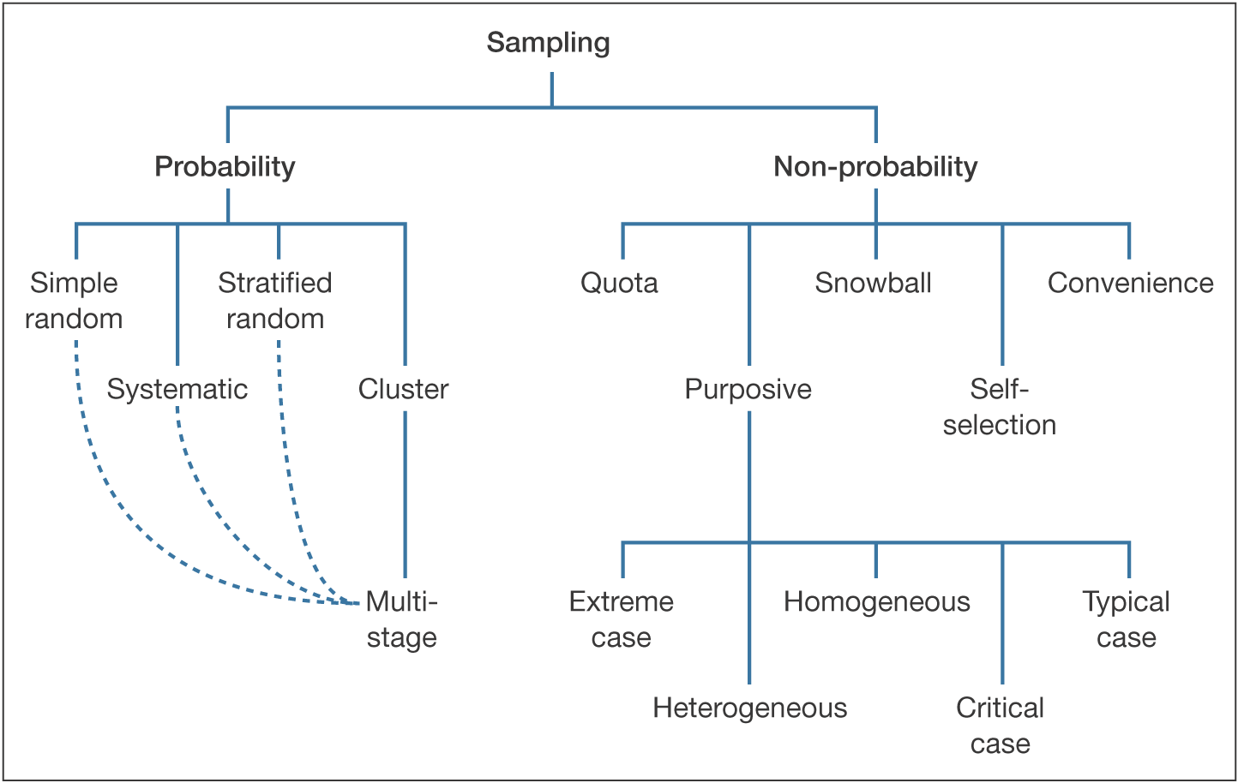

Appendix 2: Consent of participation.

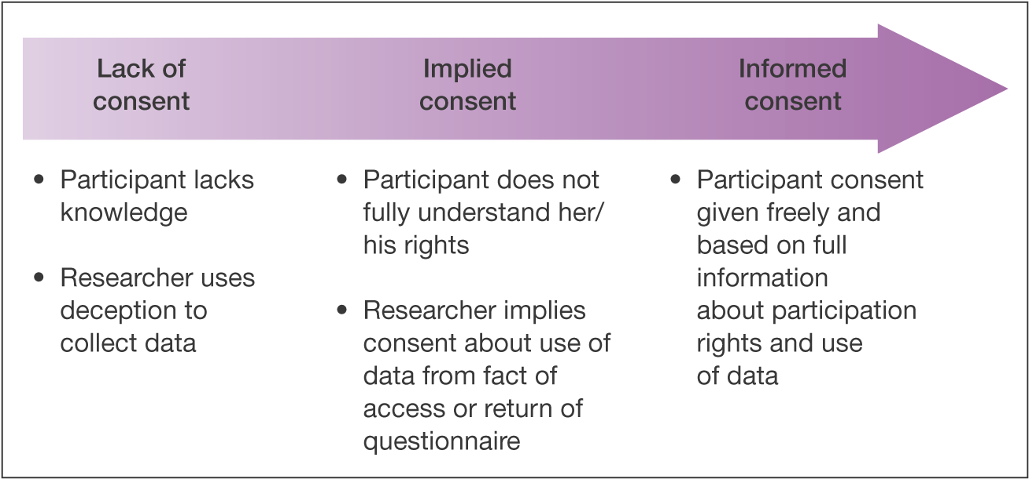

Appendix 3: Ethical issues considered at different stages.

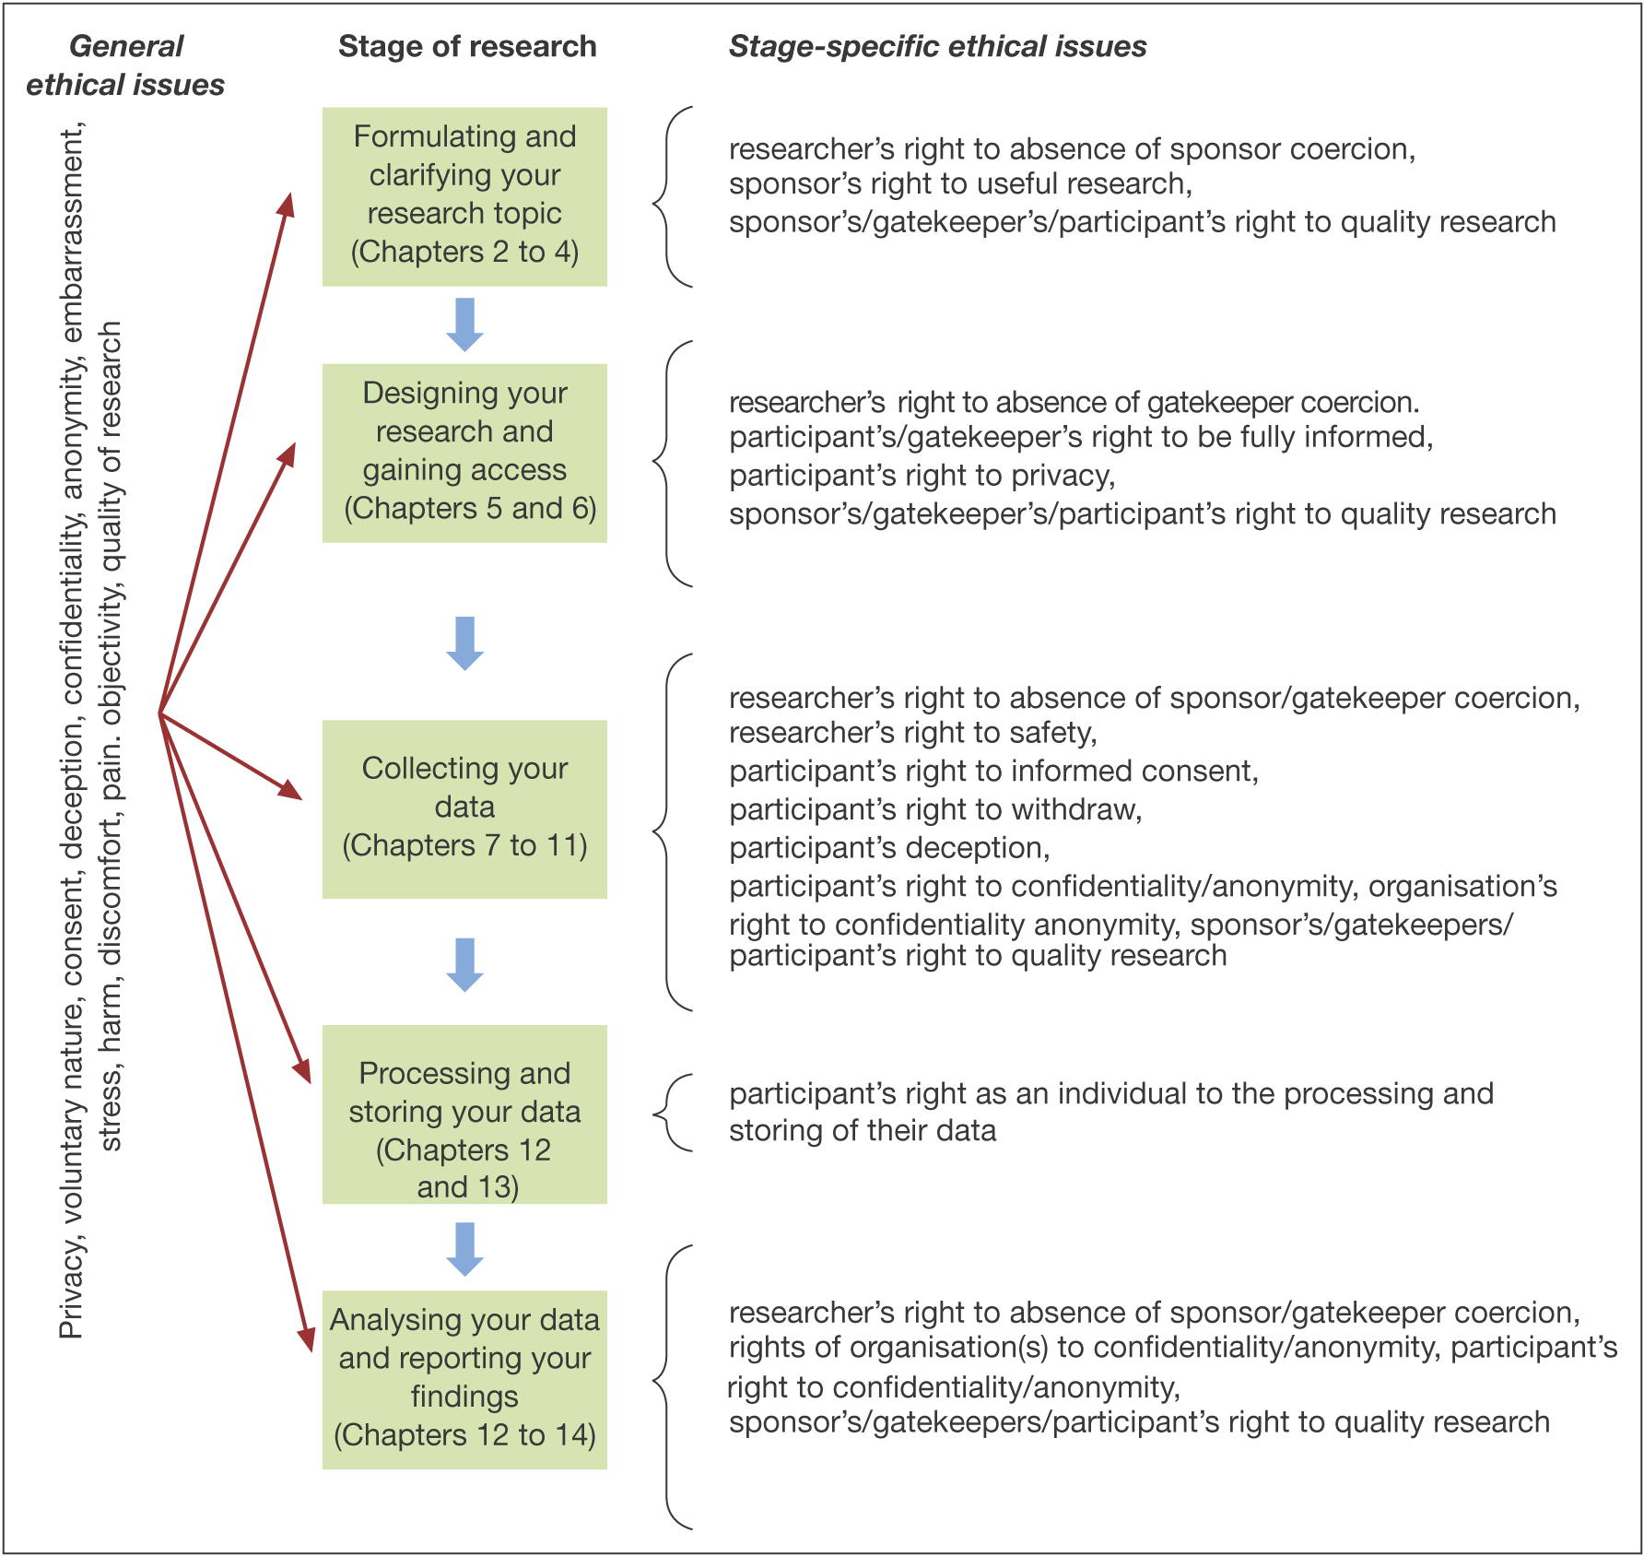

Appendix 4: Cover letter for the participants.

Dear Sir / Madam,

I am inviting you to take part in a research project. I am sending you the detailed questionnaire. It is thus important for me to explain it to you why the research is being done and also what it will involve. I want some of your valuable time to complete my questionnaire. But before completing it please have a look at the detailed information.

I am an MSc student in the University of Hull and I am doing my final semester research project. I am doing a survey on Corporate Image in the Indian IT industry which is entirely based on the perception of employees. I want to know in details about how the company obtain its image. How does the company maintain its image and also what are its benefits. So I want some of your valuable time. I want your contribution which is utmost necessary for me to carry out this research project.

As a participant, you just have to complete the questionnaire which is based on the image of a company. It is also estimated that the total amount of time spent on filling up the questionnaires will be 5 to 10 minutes. All the data and information collected during the course of the research will be kept strictly confidential.

I would be very grateful to you if you could complete my survey questionnaire online as soon as possible.

Thank you very much in advance for your help and support.

Yours faithfully,

Bhabajyoti Saikia.