***Unit-1: Introduction to Distributed System***

*Distributed System is a collection of autonomous computer systems that are physically separated but are connected by a centralized computer network that is equipped with distributed system software. The autonomous computers will communicate among each system by sharing resources and files and performing the tasks assigned to them.*

***Example of Distributed System:***

*Any Social Media can have its Centralized Computer Network as its Headquarters and computer systems that can be accessed by any user and using their services will be the Autonomous Systems in the Distributed System Architecture.*

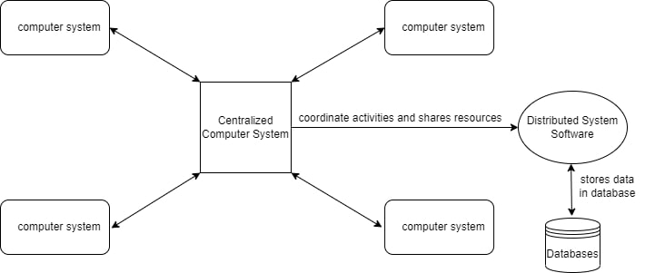

* ***Distributed System Software:****This Software enables computers to coordinate their activities and to share the resources such as Hardware, Software, Data, etc.*
* ***Database:****It is used to store the processed data that are processed by each Node/System of the Distributed systems that are connected to the                      Centralized network.*

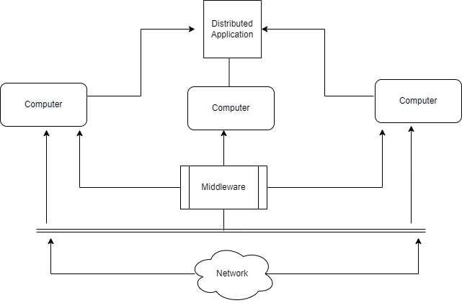

* *As we can see that each Autonomous System has a common Application that can have its own data that is shared by the Centralized Database System.*
* *To Transfer the Data to Autonomous Systems, Centralized System should be having a Middleware Service and should be connected to a Network.*
* *Middleware Services enables some services which are not present in the local systems or centralized system default by acting as an interface between the Centralized System and the local systems. By using components of Middleware Services systems communicate and manage data.*
* *The Data which is been transferred through the database will be divided into segments or modules and shared with Autonomous systems for processing.*
* *The Data will be processed and then will be transferred to the Centralized system through the network and will be stored in the database.*

***Characteristics of Distributed System:***

* ***Resource Sharing:****It is the ability to use any Hardware, Software, or Data anywhere in the System.*
* ***Openness:****It is concerned with Extensions and improvements in the system (i.e., How openly the software is developed and shared with                                others)*