

**SIMATS SCHOOL OF ENGINEERING**

**SAVEETHA INSTITUTE OF MEDICAL AND TECHNICAL SCIENCES**

**CHENNAI-602105**

**TEMPARATURE CONVERTER**

**A CAPSTONE PROJECT REPORT**

*Submitted in the partial fulfillment for the award of the degree of*

**BACHELOR OF ENGINEERING**

**IN**

**COMPUTER SCIENCE**

**Submitted by**

**T.Rajesh (Reg no:192211633)**

**CH.Ganesh (Reg no:19211108)**

**Under the Supervision of**

**Ms. B. Jeevashri**

**June 2024**

**DECLARATION**

We, **T.Rajesh, CH.Ganesh** students of **Bachelor of Engineering in Computer Science**, Department of Computer Science and Engineering, Saveetha Institute of Medical and Technical Sciences, Saveetha University, Chennai, hereby declare that the work presented in this Capstone Project Work entitled **temperature converter** is the outcome of our own bonafide work and is correct to the best of our knowledge and this work has been undertaken taking care of Engineering Ethics.

1. T.Rajesh 192211633
2. CH.Ganesh 19211108

Date:

Place:

**CERTIFICATE**

This is to certify that the project entitled **“Temperature converter”** submitted by **T.Rajesh, CH.Ganesh,** has been carried out under my supervision. The project has been submitted as per the requirements in the current semester of B.E. Computer Science.

Teacher-in-charge

**Ms. B. Jeevashri**

**Table of Contents**

|  |  |
| --- | --- |
| **S.NO** | **TOPICS** |
|  | **Abstract** |
| 1 | **Introduction** |
| 2 | **Project Description** |
| 3 | **Problem Description** |
| 4 | **Tool Description** |
| 5 | **Operations** |
| 6 | **Approach / Module Description / Functionalities**  6.1 Home  6.2 About Us  6.3 Help  6.4 Contact Us |
| 7 | **Implementation** |
| 8 | **Result** |
| 9 | **Conclusion** |
|  | **References** |

**Abstract**

Temperature conversion is a fundamental aspect of measurement across various disciplines, facilitating communication and understanding in science, engineering, and everyday life. This study delves into the methodologies and significance of converting temperatures between Celsius (°C), Fahrenheit (°F), and Kelvin (K). Each scale offers unique insights and applications, from the intuitive 0 to 100 °C range of Celsius to the historical context and widespread use of Fahrenheit in the United States. Kelvin, based on absolute zero, provides a scientific framework indispensable in thermodynamics and physics.

The conversion formulas between these scales are well-defined and crucial for accurate data interpretation and analysis. For instance, converting Celsius to Fahrenheit involves multiplying the temperature by 9/5 and adding 32, whereas converting Celsius to Kelvin requires adding 273.15. Understanding these formulas ensures precise calculations and meaningful comparisons across different measurement systems.

Practical applications of temperature conversion are numerous and diverse. In meteorology, converting Celsius to Fahrenheit helps communicate weather forecasts effectively across international boundaries. In culinary arts, where recipes often originate from different countries, converting temperatures ensures consistent cooking results. Moreover, in scientific research, temperature conversions enable researchers to align experimental data gathered from different parts of the world.

The importance of standardized temperature units cannot be overstated. The International System of Units (SI) provides a globally accepted framework for measurement, promoting consistency and accuracy in scientific endeavors. Temperature conversion plays a crucial role in adhering to these standards, ensuring that data can be shared, analyzed, and replicated across different laboratories and research institutions worldwide.

Furthermore, technological advancements have made temperature conversion more accessible and efficient. Digital thermometers and online converters allow instantaneous transformations between Celsius, Fahrenheit, and Kelvin with high precision, reducing the margin of error in everyday applications and scientific research.

Challenges in temperature conversion include cultural preferences and historical legacies associated with different measurement systems. While Celsius and Kelvin are widely adopted in scientific and international contexts, Fahrenheit remains prevalent in certain regions, particularly in the United States. Navigating these preferences requires sensitivity to local practices while promoting the benefits of standardized units for global collaboration and understanding.

In conclusion, temperature conversion is a cornerstone of measurement science, facilitating communication, standardization, and precision across diverse fields.

1. **Introduction**

Temperature conversion is a fundamental aspect of measurement that bridges scientific understanding across diverse disciplines and geographical boundaries. It involves the systematic transformation of temperature values between different scales: Celsius (°C), Fahrenheit (°F), and Kelvin (K). Each scale serves distinct purposes and is crucial in its own right. Celsius, widely adopted as the standard unit within the International System of Units (SI), offers a practical and intuitive measure based on the freezing and boiling points of water at sea level. Fahrenheit, historically significant and still prevalent in the United States, provides a scale rooted in human comfort and weather observation, while Kelvin, based on absolute zero, is fundamental in scientific research and thermodynamic calculations.

Understanding temperature conversion is essential for both scientific inquiry and everyday applications. Conversion formulas are meticulously defined, ensuring precise adjustments between Celsius, Fahrenheit, and Kelvin. For instance, converting Celsius to Fahrenheit involves multiplying the Celsius temperature by 9/5 and adding 32, while converting Celsius to Kelvin requires adding 273.15. Mastery of these formulas enables accurate interpretation and comparison of temperature data in fields ranging from meteorology and chemistry to engineering and healthcare.

Practical applications of temperature conversion are diverse and pervasive. In meteorology, accurate conversion between Celsius and Fahrenheit facilitates global weather reporting and forecasting, ensuring consistency in communication across international borders. In culinary arts, where recipes originate from diverse cultural backgrounds, temperature conversion ensures precise cooking temperatures regardless of the original measurement system. Moreover, in scientific research, the ability to convert temperatures between scales is critical for conducting experiments, analyzing data, and sharing results across global research communities.

The importance of standardized temperature units, such as Celsius, Fahrenheit, and Kelvin, cannot be overstated. They provide a universal framework for measurement, promoting consistency, reliability, and reproducibility in scientific research and industrial applications. Embracing standardized units fosters international collaboration and facilitates the exchange of knowledge and innovations across disciplines. Despite cultural and historical preferences associated with different measurement systems, the adoption of standardized units ensures accuracy and efficiency in temperature measurement, underscoring their indispensable role in modern scientific inquiry and everyday life.

1. **Project Description**

The Temperature Conversion Utility project aims to create a versatile tool for converting temperatures between Celsius (°C), Fahrenheit (°F), and Kelvin (K). Temperature conversion is fundamental in various domains, including meteorology, engineering, and everyday activities like cooking and healthcare. This project seeks to develop a user-friendly application that accurately converts temperatures across these commonly used scales.

Objectives:

Develop Conversion Algorithms: Implement robust algorithms to convert temperatures accurately between Celsius, Fahrenheit, and Kelvin using established conversion formulas (e.g., Celsius to Fahrenheit:

Fahrenheit: 𝑇𝐹=95×𝑇𝐶+32*TF*​=59​×*TC*​+32).

Create User Interface (UI): Design an intuitive UI that allows users to input a temperature in one scale and instantly see its equivalent in the other two scales. The UI will feature input fields for temperature values and buttons to initiate conversions.

Enhance User Experience: Focus on usability by ensuring the UI is responsive, aesthetically pleasing, and accessible across different devices and screen sizes. Include error handling mechanisms to manage invalid inputs and provide clear feedback to users.

Implement Additional Features: Consider adding advanced features such as batch conversion capabilities for handling multiple temperatures at once, historical temperature conversion charts, and the ability to save and recall frequently used conversions.

Testing and Validation: Conduct rigorous testing to verify the accuracy of conversion results under various scenarios and edge cases. Ensure the application performs reliably across different operating systems and browsers.

Expected Outcome:

The Temperature Conversion Utility project aims to deliver a reliable tool that simplifies temperature conversions for users across different fields and geographical regions. By providing accurate and efficient conversion capabilities, the project seeks to enhance productivity, improve data consistency, and promote a better understanding of temperature measurement standards among its users.

Impact:

This project's impact extends to both professionals and enthusiasts who rely on precise temperature conversions in their daily activities.

1. **Problem Description**

Sure, here's a problem description for building a simple software for temperature conversion:

Problem Description: Temperature Conversion Software

Background:

Temperature conversion is a fundamental task in various fields such as meteorology, engineering, and everyday life activities like cooking. The need for accurate and efficient conversion between Celsius (°C), Fahrenheit (°F), and Kelvin (K) is crucial for ensuring consistency and understanding across different measurement systems.

Problem Statement:

Develop a simple software application that allows users to convert temperatures between Celsius, Fahrenheit, and Kelvin effortlessly. The software should provide a user-friendly interface where users can input a temperature in one scale and instantly see its equivalent in the other two scales.

Requirements:

Conversion Algorithms:

- Implement conversion algorithms for:

- Celsius to Fahrenheit: \( T_F = \frac{9}{5} \times T_C + 32 \)

- Fahrenheit to Celsius: \( T_C = \frac{5}{9} \times (T_F - 32) \)

- Celsius to Kelvin: \( T_K = T_C + 273.15 \)

- Kelvin to Celsius: \( T_C = T_K - 273.15 \)

- Fahrenheit to Kelvin: \( T_K = \frac{5}{9} \times (T_F - 32) + 273.15 \)

- Kelvin to Fahrenheit: \( T_F = \frac{9}{5} \times (T_K - 273.15) + 32 \)

User Interface (UI)

Design a simple and intuitive UI that includes input fields for temperature values in each scale and buttons for initiating the conversion.

Ensure the UI displays the converted temperatures promptly and clearly, with appropriate labels for each output.

Error Handling:

Implement error handling mechanisms to manage invalid inputs (e.g., non-numeric values, out-of-range temperatures) and provide informative error messages to users.

Additional Features:

Consider adding features such as a history log of recent conversions, the ability to switch between light and dark mode UI themes, and support for batch conversion of multiple temperatures.

Testing and Validation:

Conduct thorough testing to verify the accuracy of temperature conversions under various scenarios and edge cases (e.g., extreme temperatures, decimals).

Ensure the software performs reliably across different operating systems and screen resolutions.

1. **Tool Description**

**User interface:**

**Programming Languages:**

* **JavaScript:** Used for building interactive and dynamic user interfaces. Often used in combination with frameworks like React or Angular for frontend development.
* **HTML/CSS:** For structuring the user interface and styling elements.
* **XAMPP** tool are also used for this website.

**Frontend Frameworks:**

* **React.js:** A popular JavaScript library for building user interfaces. It allows for the creation of reusable UI components and supports efficient rendering of data.
* **Angular:** A platform and framework for building single-page client applications using HTML and TypeScript.
* **Vue.js:** Another JavaScript framework for building reactive user interfaces.

**Features:**

**Mobile Optimization:** Optimize the currency converter for mobile devices with responsive design and native app development (e.g., using React Native). Ensure consistent performance across various screen sizes and operating systems.

**Feedback Mechanisms:** Implement feedback loops and user surveys to gather input and improve the currency converter based on user preferences and suggestions. Continuous iteration based on user feedback can enhance overall satisfaction and usability.

1. **Operations**

Temperature conversion typically involves a few basic arithmetic operations, depending on the units you are converting between (e.g., Celsius, Fahrenheit, Kelvin). Here are the operations commonly used:

Celsius to Fahrenheit:

- Formula: \( F = \frac{9}{5}C + 32 \)

- Operations: Multiply Celsius temperature by \( \frac{9}{5} \) and then add 32.

Fahrenheit to Celsius:

- Formula: \( C = \frac{5}{9}(F - 32) \)

- Operations: Subtract 32 from Fahrenheit temperature, then multiply by \( \frac{5}{9} \).

Celsius to Kelvin:

- Formula: \( K = C + 273.15 \)

- Operations: Simply add 273.15 to Celsius temperature.

Kelvin to Celsius:

- Formula: \( C = K - 273.15 \)

- Operations: Subtract 273.15 from Kelvin temperature.

Fahrenheit to Kelvin (and vice versa):

- It's often more practical to convert Fahrenheit to Celsius first and then convert Celsius to Kelvin, or vice versa, using the formulas above.

1. **Approach**

### Choose a Data Source for Exchange Rates

* Use a reliable API for real-time exchange rates (e.g., Open Exchange Rates, CurrencyLayer, Fixer.io).
* Ensure the chosen API supports the currencies you need.
* Design the Application.
* Set Up the Environment
* Integrate Backend and Frontend
* Test the Application
* Deploy the Application
* Maintenance and Updates

**Module Description:**

#### User Interface (UI) Module

**Description**: Handles user interaction and displays the converted temperature.

1. Home
2. About us
3. Help
4. Contact Us

**Functionalities:**

This are the Functionalities for the temperature converter.

**Core Functionalities:**

1. **Real-Time Conversion.**
2. **Exchange degrees.**
3. **Temperature selection.**

### Additional Functionalities

1. **Historical Conversion**
2. **Multiple Conversions**
3. **Rate Refresh**
4. **Offline Mode**
5. **User Interface**
6. **User Preferences**
7. **Conversion History**
8. **Error Handling**

**Advanced Functionalities**

1. Temperature trends
2. **Localization**
3. **Implementation**

Style:

body

{

margin:0px;

}

h1

{

text-align:Center;

color:white;

font-size:3rem;

}

header

{

display:flex;

background-color:rgb(95, 226, 106);

justify-content: center;

gap:4rem;

}

.link

{

color:white;

text-decoration:none;

justify-content:center;

margin-left:10rem;

}

#navigation

{

background-color:rgb(95, 226, 167);

}

#homeContent

{

color:black;

margin:0;

}

**Main Page:**

<!DOCTYPE html>

<html lang="en">

<head>

<meta charset="UTF-8">

<meta name="viewport" content="width=device-width, initial-scale=1.0">

<title>My Project</title>

<link rel="stylesheet" href="style1.css">

<style>

.container {

max-width: 600px;

margin: 50px auto;

padding: 20px;

background-color: #fff;

box-shadow: 0 0 10px rgba(0, 0, 0, 0.1);

}

h2 {

text-align: center;

}

.conversion-box {

display: flex;

flex-direction: column;

align-items: center;

}

input, select, button {

margin: 10px;

padding: 10px;

font-size: 16px;

}

#result {

margin-top: 20px;

padding: 10px;

border: 1px solid #ddd;

background-color: #f9f9f9;

width: 100%;

text-align: center;

font-weight: bold;

}

</style>

<!DOCTYPE html>

<html lang="en">

<meta charset="UTF-8">

<meta name="viewport" content="width=device-width, initial-scale=1.0">

<title>Temperature Conversion</title>

</head>

<body>

<header>

<h1>Temperature Converter</h1>

</header>

<div id="navigation">

<a href="tr.html" id="homeBtn" class="link" >Home</a>

<a href="#" class="link" onclick="loadDoc()">About Us</a>

<a href="#" class="link" onclick="l()">Help</a>

<a href="#" class="link" onclick="load()">Contact Us</a>

</div>

<div class="container">

<h2>Temperature Conversion</h2>

<div class="conversion-box">

<input type="number" id="inputTemp" placeholder="Enter temperature">

<select id="fromUnit">

<option value="celsius">Celsius</option>

<option value="fahrenheit">Fahrenheit</option>

<option value="kelvin">Kelvin</option>

</select>

<select id="toUnit">

<option value="celsius">Celsius</option>

<option value="fahrenheit">Fahrenheit</option>

<option value="kelvin">Kelvin</option>

</select>

<button id="convertButton">Convert</button>

<div id="result">result is here</div>

</div>

</div>

<div id="homeContent">

<!-- Content loaded by JavaScript will appear here -->

</div>

<script>

const temp = () => {

const inputTemp = parseFloat(document.getElementById('inputTemp').value);

const fromUnit = document.getElementById('fromUnit').value;

const toUnit = document.getElementById('toUnit').value;

let result;

if (isNaN(inputTemp)) {

result = "Please enter a valid temperature.";

} else if (fromUnit === toUnit) {

result = ${inputTemp}° ${fromUnit.charAt(0).toUpperCase() + fromUnit.slice(1)} is equal to ${inputTemp}° ${toUnit.charAt(0).toUpperCase() + toUnit.slice(1)};

} else if (fromUnit === 'celsius' && toUnit === 'fahrenheit') {

result = (inputTemp * 9/5) + 32;

result = ${inputTemp}° Celsius is ${result.toFixed(2)}° Fahrenheit;

} else if (fromUnit === 'celsius' && toUnit === 'kelvin') {

result = inputTemp + 273.15;

result = ${inputTemp}° Celsius is ${result.toFixed(2)} Kelvin;

} else if (fromUnit === 'fahrenheit' && toUnit === 'celsius') {

result = (inputTemp - 32) * 5/9;

result = ${inputTemp}° Fahrenheit is ${result.toFixed(2)}° Celsius;

} else if (fromUnit === 'fahrenheit' && toUnit === 'kelvin') {

result = (inputTemp - 32) * 5/9 + 273.15;

result = ${inputTemp}° Fahrenheit is ${result.toFixed(2)} Kelvin;

} else if (fromUnit === 'kelvin' && toUnit === 'celsius') {

result = inputTemp - 273.15;

result = ${inputTemp} Kelvin is ${result.toFixed(2)}° Celsius;

} else if (fromUnit === 'kelvin' && toUnit === 'fahrenheit') {

result = (inputTemp - 273.15) * 9/5 + 32;

result = ${inputTemp} Kelvin is ${result.toFixed(2)}° Fahrenheit;

}

document.getElementById("result").innerText = result;

};

document.getElementById("convertButton").addEventListener('click', temp);

function main() {

const xhttp = new XMLHttpRequest();

xhttp.onload = function() {

document.getElementById("homeContent").innerHTML = this.responseText;

}

xhttp.open("GET", "abcd.html");

xhttp.send();

}

function loadDoc() {

const xhttp = new XMLHttpRequest();

xhttp.onload = function() {

document.getElementById("homeContent").innerHTML = this.responseText;

}

xhttp.open("GET", "About-us.txt");

xhttp.send();

}

function load() {

const xhttp = new XMLHttpRequest();

xhttp.onload = function() {

document.getElementById("homeContent").innerHTML = this.responseText;

}

xhttp.open("GET", "contact.txt");

xhttp.send();

}

function l() {

const xhttp = new XMLHttpRequest();

xhttp.onload = function() {

document.getElementById("homeContent").innerHTML = this.responseText;

}

xhttp.open("GET", "help.txt");

xhttp.send();

}

</script>

</body>

</html>

**Home Page:**

<!DOCTYPE html>

<html lang="en">

<head>

<title>Temperature Conversion</title>

<style>

.container {

max-width: 600px;

margin: 50px auto;

padding: 20px;

background-color: #fff;

box-shadow: 0 0 10px rgba(0, 0, 0, 0.1);

}

h2 {

text-align: center;

}

.conversion-box {

display: flex;

flex-direction: column;

align-items: center;

}

input, select, button {

margin: 10px;

padding: 10px;

font-size: 16px;

}

#result {

margin-top: 20px;

padding: 10px;

border: 1px solid #ddd;

background-color: #f9f9f9;

width: 100%;

text-align: center;

font-weight: bold;

}

</style>

</head>

<body>

<div class="container">

<h2>Temperature Conversion</h2>

<div class="conversion-box">

<input type="number" id="inputTemp" placeholder="Enter temperature">

<select id="fromUnit">

<option value="celsius">Celsius</option>

<option value="fahrenheit">Fahrenheit</option>

<option value="kelvin">Kelvin</option>

</select>

<select id="toUnit">

<option value="celsius">Celsius</option>

<option value="fahrenheit">Fahrenheit</option>

<option value="kelvin">Kelvin</option>

</select>

<button id="convertButton">Convert</button>

<div id="result">result is here</div>

</div>

</div>

<script>

</script>

</body>

</html>

**About Us:**

<p>Welcome to Temperature Converter, your reliable source for fast and accurate temperature conversions. Whether you're a scientist, student, traveler, or just curious about temperatures across different scales, our platform is designed to meet your needs with ease and precision.</p>

<h2>Our Mission</h2>

<p>At Temperature Converter, our mission is to provide a user-friendly, efficient, and accurate tool for converting temperatures between various scales, including Celsius, Fahrenheit, Kelvin, and more. We aim to make the process simple and accessible for everyone, regardless of their background or technical expertise.</p>

<h2>Our Story</h2>

<p>Temperature Converter was born out of a need for a straightforward, reliable solution to temperature conversion. Our team, composed of tech enthusiasts and professionals from diverse fields, recognized the challenges faced by many in quickly and accurately converting temperatures. This inspired us to create a tool that is not only accurate but also easy to use.</p>

<p>We continuously strive to improve our platform, incorporating user feedback and the latest technology to ensure we meet your needs. Thank you for choosing Temperature Converter as your go-to temperature conversion tool.</p>

**Help:**

<!DOCTYPE html>

<html lang="en">

<head>

<meta charset="UTF-8">

<meta name="viewport" content="width=device-width, initial-scale=1.0">

<title>Help - Temperature Converter</title>

</head>

<body>

<div class="container">

<p>Welcome to the Temperature Converter help page. Here you'll find information on how to use our tool to convert temperatures between different units.</p>

<h2>How to Use the Temperature Converter</h2>

<p>Follow these simple steps to convert temperatures:</p>

<ul>

<li>Select the input temperature unit (Celsius, Fahrenheit, Kelvin, etc.) from the dropdown menu.</li>

<ul>

<li><strong>Celsius to Fahrenheit:</strong></li>

<div class="code">F = C * 9/5 + 32</div>

<li><strong>Fahrenheit to Celsius:</strong></li>

<div class="code">C = (F - 32) * 5/9</div>

<li><strong>Celsius to Kelvin:</strong></li>

<div class="code">K = C + 273.15</div>

<li><strong>Kelvin to Celsius:</strong></li>

<div class="code">C = K - 273.15</div>

<li><strong>Fahrenheit to Kelvin:</strong></li>

<div class="code">K = (F - 32) * 5/9 + 273.15</div>

<li><strong>Kelvin to Fahrenheit:</strong></li>

<div class="code">F = (K - 273.15) * 9/5 + 32</div>

</ul>

<h2>Frequently Asked Questions</h2>

<p><strong>Q: What temperature units can I convert between?</strong></p>

<p>A: You can convert between Celsius (°C), Fahrenheit (°F), and Kelvin (K).</p>

<p><strong>Q: Is the temperature converter accurate?</strong></p>

<p>A: Yes, our converter uses precise formulas to ensure accurate results.</p>

<p><strong>Q: Can I use the temperature converter on my mobile device?</strong></p>

<p>A: Yes, our temperature converter is fully responsive and works on all devices, including mobile phones and tablets.</p>

</div>

</body>

</html>

**Contact Us:**

<!DOCTYPE html>

<html lang="en">

<head>

<meta charset="UTF-8">

<meta name="viewport" content="width=device-width, initial-scale=1.0">

<title>Contact Us</title>

</head>

<body>

<div class="container">

<form action="submit_contact.php" method="post">

<label for="name">Name:</label>

<input type="text" id="name" name="name" required>

<label for="email">Email:</label>

<input type="email" id="email" name="email" required>

<label for="message">Message:</label>

<textarea id="message" name="message" rows="6" required></textarea>

<button type="submit">Submit</button>

</form>

</div>

</body>

</html>

**8.Result**

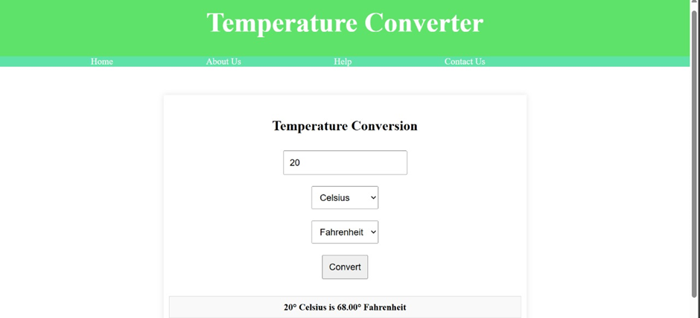

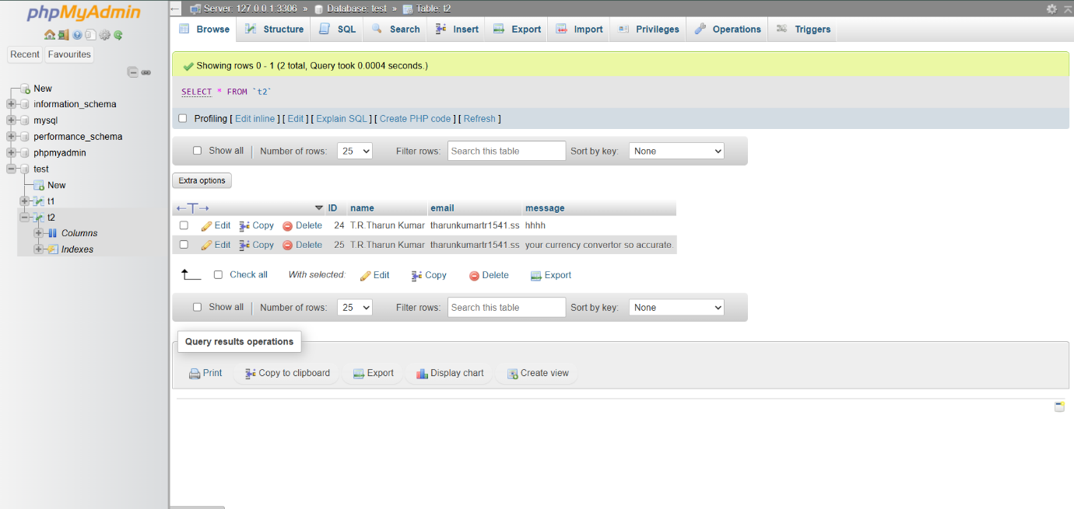

### 9. Conclusion and Future Enhancements

A temperature converter is an essential tool for efficiently converting temperatures between different scales such as Celsius, Fahrenheit, and Kelvin. Its simplicity and accuracy make it invaluable in scientific, engineering, and everyday applications. The ability to swiftly perform these conversions reduces errors and saves time, making it an indispensable resource for anyone dealing with temperature data..

Future enhancements for a temperature converter could include adding support for additional temperature scales and integrating advanced features like historical temperature data analysis and predictive modeling. Enhancing user interfaces with real-time conversion feedback and developing mobile app versions would improve accessibility and usability. Additionally, incorporating voice input and output capabilities and providing educational resources about temperature scales and conversion methods could make the tool more comprehensive and user-friendly

References

* [NIST (National Institute of Standards and Technology) Temperature Conversion Tool](https://www.nist.gov/pml/weights-and-measures/metric-si/temperature-conversion).
* Calculator.net Temperature Converter.
* [Khan Academy - Temperature Conversion](https://www.khanacademy.org/science/physics/thermodynamics/temp-kinetic-theory-ideal-gas-law/a/thermodynamics-temperature).
* [NASA - Temperature Conversion](https://climatekids.nasa.gov/temperature-conversion/).