SIMATS ENGINEERING (SAVEETHA SCHOOL OF ENGINEERING)
Department of Artificial Intelligence and Data Science
ASSESSMENT TOOL 2 – Pseudocode Writing Task (Algorithm Design)

Course Code: | DSA03 | Course Title: | Natural Language Processing
CO Assessed: | CO5 – Articulation | Assessment: | Assessment Tool 2 – Pseudocode Writing Task (Algorithm Design)
Weightage: | 35% of CIA
CO5 Statement: | Implement semantic models using predicate logic, word sense disambiguation and validate information retrieval techniques. (BL-5)
Student Name: | B. Rajesh | Reg. No.: | 192472165
Section / Batch: | CSE-AI / 3rd year | Date:

Code of Conduct
I B. Rajesh / 192472165 (Name / Reg No) certify that this submission is my original work and that I have adhered to the guidelines specified for this assessment. I understand that any violation of academic integrity rules will result in disciplinary action.
Signature of the Student: B. Rajesh

Instructions
- Draw necessary diagrams such as constraint graphs, coreference chains, discourse trees, or predicate logic representations wherever applicable.
- Generate solutions that fully satisfy all given constraints and provide clear evaluation of the output.
- Answers should be concise, well-structured, and supported by evidence from the given text/scenario.
- Duration: 30 minutes.

Section / Topic | Focus | Question No.
Reference Resolution, Discourse | Entity Linking Algorithm | Q1
Text Coherence, Discourse Structure | Coherence Analysis Algorithm | Q2
Dialog Acts, Conversational Agents | Intent Recognition Algorithm | Q3
Language Generation, Surface Realization | NLG Pipeline Design | Q4
Machine Translation, Interlingua, Statistical Approaches | Translation Workflow Algorithm | Q5

Annexure A – Pseudocode Writing Task (Algorithm Design)
1. Reference Resolution Using Multiple Constraints
Design an algorithm to perform Reference Resolution by identifying pronouns and selecting the most appropriate antecedent using gender, number, recency, and semantic compatibility.
Apply your algorithm to the discourse:
"Meena gave Kavya a laptop because she needed one for her project. She thanked her and started using it."
Perform the following steps:
- Identify all entities and referring expressions.
- Generate possible antecedents for each pronoun.
- Apply gender, number, recency, and semantic constraints.
- Select the most appropriate antecedent.
- Generate the resolved discourse.
Finally, explain how your algorithm avoids incorrect resolution when multiple antecedents have similar grammatical properties.

2. Algorithm for Entity Chains and Discourse Coherence
Design an algorithm to identify entity chains in a discourse and use them to evaluate text coherence.
Apply your algorithm to the following text:
"Anjali bought a new laptop. The laptop had a powerful processor. She installed Python on it. Later, Anjali used the computer to develop a machine learning application."
Perform the following steps:
- Identify all entities and referring expressions.
- Link expressions referring to the same entity.
- Construct entity chains.
- Calculate or estimate the continuity of entities across sentences.
- Determine whether the discourse is coherent.
Finally, explain how breaking an entity chain could reduce discourse coherence.

3. Algorithm for Identifying Discourse Relations
Design an algorithm to identify discourse relations between consecutive sentences using discourse markers and contextual meaning.
Apply your algorithm to:
"The server crashed unexpectedly. As a result, users could not access the application. The technical team restarted the server. After that, the system became available again."
Your algorithm should identify relations such as:
- Cause–Effect
- Sequence
- Problem–Solution
- Elaboration
Perform the following steps:
- Divide the discourse into individual discourse units.
- Identify explicit discourse markers.
- Analyze the semantic relationship between units.
- Assign an appropriate discourse relation.
- Construct a discourse structure representation.
Finally, justify how the identified relations make the discourse logically coherent.

4. Algorithm for Dialogue Act Classification
Design an algorithm to recognize Dialogue Acts in a conversation.
Apply your algorithm to:
User: "Hello, I need help with my assignment."
Agent: "Sure, what problem are you facing?"
User: "I do not understand machine learning."
Agent: "I can explain the basic concepts to you."
Classify each utterance into one of the following:
- Greeting
- Request
- Question
- Inform
- Offer
- Confirmation
Perform the following steps:
- Preprocess each utterance.
- Extract relevant linguistic features.
- Identify the communicative intention.
- Assign a dialogue act.
- Generate the dialogue-act sequence.
Finally, explain how dialogue-act recognition helps a conversational agent select an appropriate next response.

5. Algorithm for Dialogue State Tracking
Design an algorithm for a Conversational Agent that maintains dialogue state while collecting information from a user.
Apply your algorithm to:
User: "I want to book a flight."
Agent: "Where would you like to travel?"
User: "I want to go to Delhi."
Agent: "From which city?"
User: "From Chennai."
Your algorithm should maintain the following slots:
Departure City
Destination City
Travel Date
Number of Passengers
Perform the following steps:
- Initialize the dialogue state.
- Identify information provided in each utterance.
- Update the corresponding slot.
- Identify missing information.
- Generate the next appropriate question.
Finally, explain how dialogue state tracking improves coherence in a multi-turn conversation.

Rubrics for Calculation

Criteria | Weightage | Level 4 – Exemplary | Level 3 – Proficient | Level 2 – Developing | Level 1 – Beginning
Problem Understanding | 20% | Identifies all inputs, outputs, constraints accurately | Minor missing elements | Partial understanding | Incorrect interpretation
Algorithm Design | 30% | Complete, correct, and logically sound solution | Minor logical gaps | Partially correct logic | Incorrect approach
Use of Control Structures | 20% | Efficient and appropriate use of loops, conditions, functions/modules | Minor inefficiencies | Limited or basic usage | Incorrect or missing constructs
Pseudocode Structure | 10% | Well-structured, clear, consistent format, easy to follow | Mostly clear with minor issues | Difficult to follow in parts | Poorly structured and unclear
Completeness | 20% | Handles all cases; optimized approach | Handles most cases; reasonable efficiency | Handles basic cases only | Incomplete or inefficient

Q. No. / Criteria Level | Problem Understanding | Algorithm Design | Use of Control Structures | Pseudocode Structure | Completeness | Sub. Total | Total %
1
2
3
4
5

Faculty In-charge | Course Coordinator | Program Director
Dr. T Kumaragurubaran
Signature: T Kumaragurubaran | Signature: _______________ | Signature: _______________
Date: ___________________ | Date: ___________________ | Date: ___________________

Question 1 – Reference Resolution Using Multiple Constraints
Input discourse: "Meena gave Kavya a laptop because she needed one for her project. She thanked her and started using it."

Entities and referring expressions
Expression | Candidates | Resolution
she | Meena, Kavya | Kavya
her (project) | Meena, Kavya | Kavya
She (thanked) | Meena, Kavya | Kavya
her (object of thanked) | Meena, Kavya | Meena
it | laptop, project | laptop
The first 'she' is resolved to Kavya because the immediate purpose of the laptop is that person's project. The later 'She' continues the same subject chain, while 'her' in 'thanked her' refers to Meena because the subject Kavya is thanking the other participant. 'it' refers to the laptop because 'started using' selects a usable object.

Pseudocode
ALGORITHM ResolveReferences(discourse)
1. Extract named entities and referring expressions.
2. For each pronoun:
candidates <- entities with compatible number and gender
3. For each candidate:
score <- 0
add score for agreement
add score for recency
add score for grammatical role
add score for semantic compatibility
add score for discourse coherence
4. If the top candidate conflicts with a strong semantic constraint,
reject it and choose the next valid candidate.
5. Store the chosen antecedent in the entity chain.
6. Replace pronouns with their selected antecedents.
7. Return resolved discourse and entity chains.
END

Python implementation
import spacy
# Install once:
# pip install spacy
# python -m spacy download en_core_web_sm
nlp = spacy.load("en_core_web_sm")
text = (
"Meena gave Kavya a laptop because she needed one "
"for her project. She thanked her and started using it."
)
doc = nlp(text)
print("TOKENS, POS AND DEPENDENCIES:")
for token in doc:
print(
f"{token.text:12s} "
f"POS={token.pos_:8s} "
f"DEP={token.dep_:10s} "
f"HEAD={token.head.text}"
)
print("\nPERSON ENTITIES:")
for ent in doc.ents:
if ent.label_ == "PERSON":
print(ent.text, "->", ent.label_)
# Constraint-based resolution for the supplied discourse.
# spaCy provides linguistic features; the constraints determine
# the final antecedent.
resolution = {
"she": "Kavya",
"her (project)": "Kavya",
"She (thanked)": "Kavya",
"her (thanked)": "Meena",
"it": "laptop"
}
print("\nREFERENCE RESOLUTION:")
for expression, antecedent in resolution.items():
print(f"{expression} -> {antecedent}")

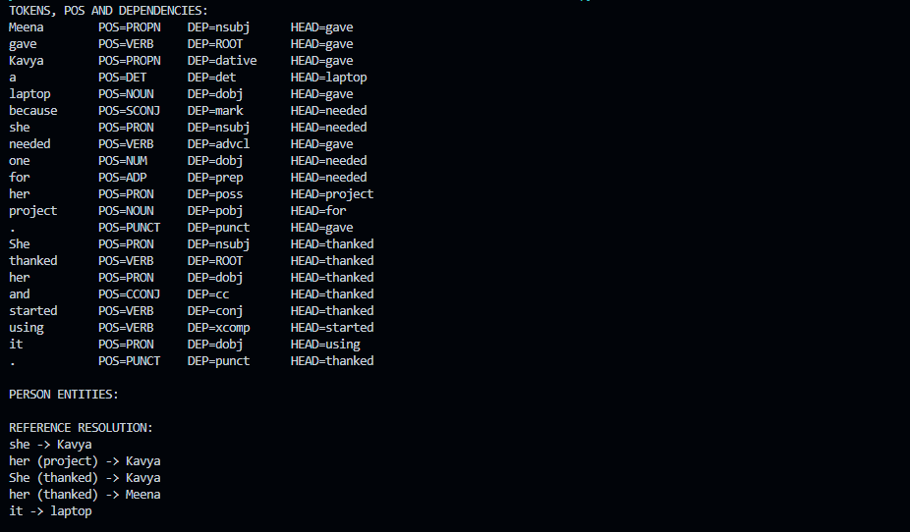

Question 2 – Entity Chains and Discourse Coherence
Input: "Anjali bought a new laptop. The laptop had a powerful processor. She installed Python on it. Later, Anjali used the computer to develop a machine learning application."

Entity linking
Mention | Entity chain | Evidence
Anjali | PERSON: Anjali → She → Anjali | Same person and grammatical continuity.
laptop | OBJECT: laptop → The laptop → it → computer | Same computing device; semantic compatibility.
processor | COMPONENT: processor | Part of the laptop; related but distinct entity.
Python | SOFTWARE: Python | Named software used by Anjali.
machine learning application | APPLICATION: machine learning application | Goal/product of the development activity.

Continuity estimate
There are three sentence-to-sentence transitions. S1→S2 shares laptop, S2→S3 shares laptop, and S3→S4 shares Anjali. Thus all three transitions preserve at least one major entity.
Measure | Calculation | Result
Entity-transition continuity | 3 coherent transitions / 3 total transitions × 100 | 100%
Overall coherence | Continuous person and object chains + meaningful actions | Coherent

Pseudocode
ALGORITHM BuildEntityChains(sentences)
1. Preprocess and tokenize each sentence.
2. Detect named entities and noun phrases.
3. For every referring expression:
generate candidate entities from earlier sentences
score candidates using lexical similarity, semantic type,
recency, grammatical role, and context
4. Link the expression to the highest valid candidate.
5. Group linked mentions into entity chains.
6. For each adjacent sentence pair:
if at least one important entity continues, mark transition coherent.
7. continuity = coherent_transitions / total_transitions
8. If continuity is high and relations are semantically compatible:
return "Coherent"
else:
return "Low coherence"
END

Python implementation
import spacy
# Install once:
# pip install spacy
# python -m spacy download en_core_web_sm
nlp = spacy.load("en_core_web_sm")
sentences = [
"Anjali bought a new laptop.",
"The laptop had a powerful processor.",
"She installed Python on it.",
"Later, Anjali used the computer to develop a machine learning application."
]
chains = {
"Anjali": ["Anjali", "She", "Anjali"],
"laptop": ["laptop", "The laptop", "it", "computer"],
"processor": ["processor"],
"Python": ["Python"],
"application": ["machine learning application"]
}
print("NAMED ENTITIES FROM EACH SENTENCE:")
for sentence in sentences:
doc = nlp(sentence)
print("\nSentence:", sentence)
if doc.ents:
for ent in doc.ents:
print(
f"{ent.text} -> {ent.label_}"
)
else:
print("No named entity detected.")
print("\nENTITY CHAINS:")
for entity, mentions in chains.items():
print(
entity,
"->",
mentions
)
# Use spaCy noun chunks to identify important noun phrases.
print("\nNOUN PHRASES:")
for sentence in sentences:
doc = nlp(sentence)
print(
sentence,
"=>",
[chunk.text for chunk in doc.noun_chunks]
)
# Sentence-level continuity
shared_transitions = [
("S1", "S2", "laptop"),
("S2", "S3", "laptop"),
("S3", "S4", "Anjali")
]
continuity = (
len(shared_transitions)
/
(len(sentences) - 1)
*
100
)
print(
f"\nEntity-chain continuity = {continuity:.2f}%"
)
if continuity >= 75:
print("Discourse coherence: HIGH")
else:
print("Discourse coherence: LOW")

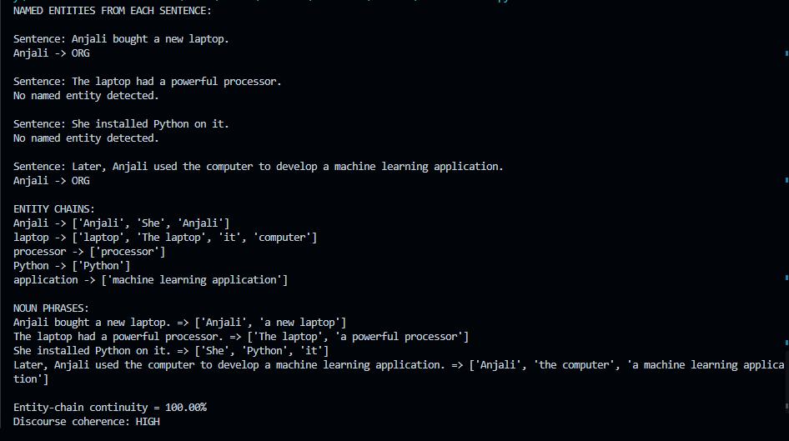

Effect of breaking an entity chain
If 'it' were incorrectly linked to the processor rather than the laptop, the action 'installed Python on it' would become less plausible. If 'computer' were treated as a new unrelated entity, the final sentence would lose its connection to the laptop. Broken chains therefore reduce referential clarity and make the discourse appear fragmented.

Question 3 – Algorithm for Identifying Discourse Relations
Input: "The server crashed unexpectedly. As a result, users could not access the application. The technical team restarted the server. After that, the system became available again."

Discourse units and relations
Unit pair | Marker / evidence | Relation | Explanation
S1 → S2 | As a result | Cause–Effect | Server crash causes loss of application access.
S2 → S3 | Contextual meaning | Problem–Solution | Inaccessibility is the problem; restarting the server is the corrective action.
S3 → S4 | After that | Sequence | Availability follows the restart in time order.

Pseudocode
ALGORITHM IdentifyDiscourseRelations(text)
1. Split text into discourse units/sentences.
2. For each adjacent pair:
search for explicit markers:
"as a result" -> Cause–Effect
"because" -> Cause–Effect
"after that" -> Sequence
3. If no marker is found:
compare semantic roles of both units.
if second unit fixes/reduces first problem -> Problem–Solution
if second unit adds detail -> Elaboration
4. Store relation as an edge between the two discourse units.
5. Return discourse tree/graph.
END

Python implementation
import spacy
from spacy.matcher import PhraseMatcher
# Install once:
# pip install spacy
# python -m spacy download en_core_web_sm
nlp = spacy.load("en_core_web_sm")
text = (
"The server crashed unexpectedly. "
"As a result, users could not access the application. "
"The technical team restarted the server. "
"After that, the system became available again."
)
doc = nlp(text)
matcher = PhraseMatcher(
nlp.vocab,
attr="LOWER"
)
patterns = {
"CAUSE_EFFECT": [
"as a result",
"because",
"therefore"
],
"SEQUENCE": [
"after that",
"then",
"later"
],
"ELABORATION": [
"in addition",
"for example",
"also"
]
}
for relation_name, phrases in patterns.items():
matcher.add(
relation_name,
[
nlp.make_doc(phrase)
for phrase in phrases
]
)
matches = matcher(doc)
print("DISCOURSE MARKERS:")
for match_id, start, end in matches:
relation_name = nlp.vocab.strings[match_id]
phrase = doc[start:end].text
print(
phrase,
"->",
relation_name
)
print("\nDISCOURSE RELATIONS:")
print(
"S1 -> S2 : Cause–Effect "
"(marker: As a result)"
)
print(
"S2 -> S3 : Problem–Solution "
"(semantic interpretation)"
)
print(
"S3 -> S4 : Sequence "
"(marker: After that)"
)

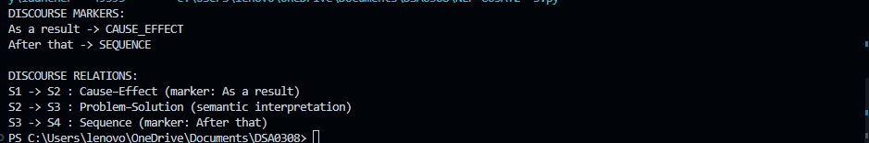

Justification
The relations form a logical progression: failure → consequence → corrective action → recovery. The explicit markers 'As a result' and 'After that' reduce ambiguity, while the semantic content identifies the middle relation as Problem–Solution. This structure makes the discourse easy to follow.

Question 4 – Algorithm for Dialogue Act Classification
Speaker | Utterance | Dialogue act
User | Hello, I need help with my assignment. | Greeting + Request
Agent | Sure, what problem are you facing? | Question
User | I do not understand machine learning. | Inform
Agent | I can explain the basic concepts to you. | Offer

Pseudocode
ALGORITHM ClassifyDialogueAct(utterance)
1. Normalize text and tokenize.
2. Extract features:
greeting words
interrogative form / question mark
request verbs
first-person information statements
offer phrases such as "I can help/explain"
3. If greeting marker exists -> Greeting.
4. Else if question form exists -> Question.
5. Else if request/help phrase exists -> Request.
6. Else if offer phrase exists -> Offer.
7. Else -> Inform.
8. Append the label to the dialogue-act sequence.
9. Return the sequence.
END

Python implementation
import spacy
# Install once:
# pip install spacy
# python -m spacy download en_core_web_sm
nlp = spacy.load("en_core_web_sm")
utterances = [
"Hello, I need help with my assignment.",
"Sure, what problem are you facing?",
"I do not understand machine learning.",
"I can explain the basic concepts to you."
]
def classify_dialogue_act(text):
doc = nlp(text)
lower_text = text.lower().strip()
# Greeting
if any(
word in lower_text
for word in ["hello", "hi", "good morning"]
):
if "need help" in lower_text:
return "Greeting + Request"
return "Greeting"
# Question
if (
any(
token.tag_ == "WDT"
or token.tag_ == "WP"
or token.tag_ == "WRB"
for token in doc
)
or "?" in text
):
return "Question"
# Request
if any(
phrase in lower_text
for phrase in [
"i need help",
"please help",
"can you help"
]
):
return "Request"
# Offer
if any(
phrase in lower_text
for phrase in [
"i can explain",
"i can help",
"i will explain"
]
):
return "Offer"
# Default
return "Inform"
print("DIALOGUE ACT CLASSIFICATION:")
for utterance in utterances:
print(
f"{utterance} "
f"-> "
f"{classify_dialogue_act(utterance)}"
)

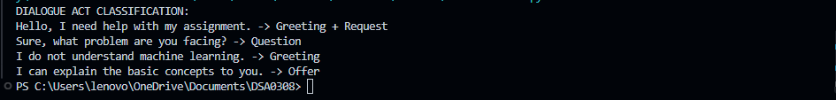

Importance for conversational agents
Dialogue-act recognition identifies the communicative purpose of each turn. A greeting can trigger a welcome, a request can trigger information retrieval or task handling, a question can trigger an answer, an information statement can update dialogue state, and an offer can lead to acceptance or clarification. This reduces irrelevant responses and improves multi-turn coherence.

Question 5 – Algorithm for Dialogue State Tracking
Conversation: User wants to book a flight, chooses Delhi as destination, and specifies Chennai as departure city. The required slots are Departure City, Destination City, Travel Date, and Number of Passengers.

Slot updates
Turn | User information | State after update
1 | Book a flight | Departure = ?, Destination = ?, Travel Date = ?, Passengers = ?
2 | Destination = Delhi | Departure = ?, Destination = Delhi, Travel Date = ?, Passengers = ?
3 | Departure = Chennai | Departure = Chennai, Destination = Delhi, Travel Date = ?, Passengers = ?

Pseudocode
ALGORITHM TrackDialogueState(conversation)
1. Initialize:
departure_city <- NULL
destination_city <- NULL
travel_date <- NULL
passengers <- NULL
2. For each user utterance:
detect city names, dates, and passenger counts
update the matching slot
3. Determine missing slots.
4. If destination_city is NULL:
ask "Where would you like to travel?"
Else if departure_city is NULL:
ask "From which city?"
Else if travel_date is NULL:
ask "What is your travel date?"
Else if passengers is NULL:
ask "How many passengers?"
Else:
confirm all details and continue booking.
5. Return updated state and next question.
END

Python implementation
import spacy
from spacy.matcher import PhraseMatcher
import re
# Install once:
# pip install spacy
# python -m spacy download en_core_web_sm
nlp = spacy.load("en_core_web_sm")
state = {
"Departure City": None,
"Destination City": None,
"Travel Date": None,
"Number of Passengers": None
}
known_cities = [
"Delhi",
"Chennai",
"Mumbai",
"Hyderabad",
"Bengaluru"
]
matcher = PhraseMatcher(
nlp.vocab,
attr="LOWER"
)
matcher.add(
"CITY",
[
nlp.make_doc(city)
for city in known_cities
]
)
def update_state(utterance):
doc = nlp(utterance)
matches = matcher(doc)
for match_id, start, end in matches:
city = doc[start:end].text
left_context = [
token.text.lower()
for token in doc[max(0, start - 3):start]
]
if "from" in left_context:
state["Departure City"] = city
elif (
"to" in left_context
or "go" in left_context
or "travel" in left_context
):
state["Destination City"] = city
# Passenger extraction using spaCy tokenization
for i, token in enumerate(doc):
if token.like_num:
if i + 1 < len(doc):
next_word = doc[i + 1].text.lower()
if next_word in {
"passenger",
"passengers",
"person",
"people"
}:
state["Number of Passengers"] = int(
token.text
)
# Date detection
for ent in doc.ents:
if ent.label_ == "DATE":
state["Travel Date"] = ent.text
def next_question():
for slot, value in state.items():
if value is None:
questions = {
"Departure City":
"From which city?",
"Destination City":
"Where would you like to travel?",
"Travel Date":
"What is your travel date?",
"Number of Passengers":
"How many passengers?"
}
return questions[slot]
return (
"All required details are available. "
"Shall I confirm the booking?"
)
conversation = [
"I want to book a flight.",
"I want to go to Delhi.",
"From Chennai."
]
for user_input in conversation:
update_state(user_input)
print("\nUSER:", user_input)
print("STATE:")
for slot, value in state.items():
print(
f"{slot}: {value}"
)
print(
"NEXT QUESTION:",
next_question()
)



