SIMATS ENGINEERING (SAVEETHA SCHOOL OF ENGINEERING)
Department of Artificial Intelligence and Data Science
ASSESSMENT TOOL 3 – CODING CHALLENGE

Course Code: | DSA03 | Course Title: | Natural Language Processing
CO Assessed: | CO1 – Imitation (L1) | Assessment: | Assessment Tool 3 – Coding Challenge
Weightage: | 30% of CIA
CO5 Statement: | Analyse NLP models, regular expression patterns, finite state automata, morphological processing techniques and to interpret language processing. (BL-3)
Student Name: | V. Nagendra | Reg. No.: | 192425091
Section / Batch: | AI & ML / 2024 | Date:

Code of Conduct
I V. Nagendra (192425091) (Name / Reg No) certify that this submission is my original work and that I have adhered to the guidelines specified for this assessment. I understand that any violation of academic integrity rules will result in disciplinary action.
Signature of the Student: ___V. Nagendra___

Instructions
- Develop a complete and modular Python program that meets all the functional requirements specified in the coding challenge using appropriate algorithms, data structures, and programming practices.
- Test the program using multiple valid and invalid test cases, and clearly display the input, processing, and output to verify the correctness of the implementation.
- Follow standard coding practices by using meaningful variable names, proper indentation, comments, exception handling (where applicable), and upload the source code, sample outputs, and README file to the designated GitHub repository.
- Duration: 40 minutes.

Section / Topic | Focus | Q Nos
Porter Stemmer | class design, methods, encapsulation, and rule-based stemming | 1

Annexure A – Coding Challenge
Section 1: Object-Oriented Implementation of a Porter Stemmer
You have recently joined an NLP startup called LexiMind Technologies. The company is developing a search engine for a digital library containing millions of research papers. Users expect the search engine to return relevant results even when different grammatical forms of a word are used.
For example, a search for connect should also retrieve documents containing connected, connecting, connection, and connections. To achieve this, the development team has decided to implement the Porter Stemming Algorithm from scratch.
Since the algorithm consists of multiple sequential rules (Step 1a, Step 1b, Step 1c, Step 2, Step 3, Step 4, Step 5a, and Step 5b), the project manager has divided the work among team members. Each developer is responsible for implementing and testing one specific rule. At the end of the project, all modules must be integrated into a single, fully functional stemmer.
Assessment Task
Phase 1: Individual Task (Assigned Rule)
Each student will be assigned one Porter Stemmer rule.
Your responsibilities are to:
- Study and understand the assigned rule.
- Explain the linguistic purpose of the rule.
- Describe the conditions under which the rule should be applied.
- Implement the rule in Python.
- Prepare at least 10 test words demonstrating:
  - Words that satisfy the rule.
  - Words that should remain unchanged.
- Document the input, expected output, and actual output.
- Explain any limitations or special cases encountered.
Phase 2: Team Integration
As a team, integrate all individual rule implementations into a complete Porter Stemmer.
The team must:
- Arrange the rules in the correct execution order.
- Resolve conflicts between rule implementations.
- Ensure that the output of one rule becomes the input to the next rule.
- Test the complete algorithm using at least 50 different English words.
- Compare the team's results with the NLTK Porter Stemmer.
- Identify and explain any differences.
Phase 3: Reflection
Prepare a report addressing the following questions:
- Why is the order of Porter Stemmer rules important?
- What errors would occur if your assigned rule were skipped?
- How did integrating multiple rules improve stemming accuracy?
- Which rule was the most challenging to implement and why?
- What improvements would you suggest for the Porter Stemming algorithm?

Rubrics for Calculation
Criteria | Weightage | Level 4 – Exemplary | Level 3 – Proficient | Level 2 – Developing | Level 1 – Beginning
Problem Understanding | 20% | Clearly understands problem constraints, edge cases, and competitive requirements | Understands problem with minor gaps in constraints | Partial understanding; misses key constraints | Misinterprets problem or constraints
Algorithm | 25% | Selects optimal algorithm with best time and space complexity for competitive constraints | Uses efficient algorithm with minor scope for improvement | Uses basic/inefficient approach | No clear algorithmic approach
Code Implementation | 20% | Writes correct, efficient, and clean code that passes all constraints | Code works with minor errors or inefficiencies | Partially correct code; fails for some cases | Code does not execute or gives incorrect results
Competitive Performance | 20% | Solves problem within time limits and handles large inputs effectively | Solves within acceptable time with minor delays | Struggles with time limits or larger inputs | Unable to solve within time constraints
Test Case Handling | 15% | Handles all test cases including edge and hidden cases | Handles most test cases | Misses important edge cases | Fails on multiple test cases

Q. No. / Criteria | Problem Understanding | Algorithm | Code Implementation | Competitive Performance | Test Case Handling | Sub. Total | Total %
1 | 15 | 18 | 15 | 20 | 12 |  | 80

Faculty In-charge | Course Coordinator | Program Director
Dr. T. Kumaragurubaran
Signature: Kumaragurubaran T | Signature: _______________ | Signature: _______________
Date: ___________________ | Date: ___________________ | Date: ___________________

Step 4 of the Porter Stemming Algorithm

Aim
To implement Step 4 of the Porter Stemming Algorithm in Python and understand how suffix removal reduces words to their root form while preserving their semantic meaning.

Introduction
Stemming is one of the most important preprocessing techniques in Natural Language Processing (NLP). It converts different forms of a word into a common base or stem. This process reduces the vocabulary size and improves the efficiency of tasks such as text classification, information retrieval, sentiment analysis, and search engines.
The Porter Stemming Algorithm, developed by Martin Porter (1980), is a rule-based stemming algorithm consisting of five major steps. Among these, Step 4 is responsible for removing common derivational suffixes from words after ensuring that the remaining stem is linguistically meaningful.

Objective of Step 4
The objective of Step 4 is:
- To remove unnecessary suffixes.
- To shorten words to their meaningful stems.
- To reduce variations of the same word.
- To ensure that suffix removal does not over-stem the word.

Python Code for Step 4
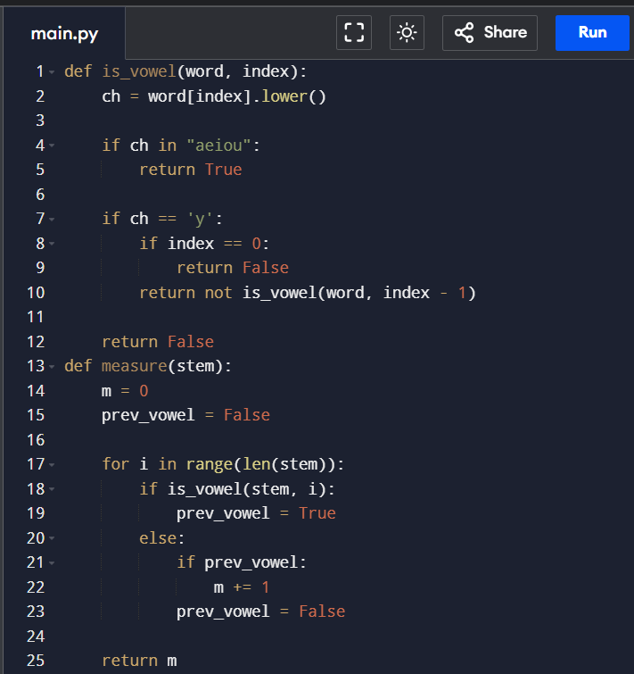
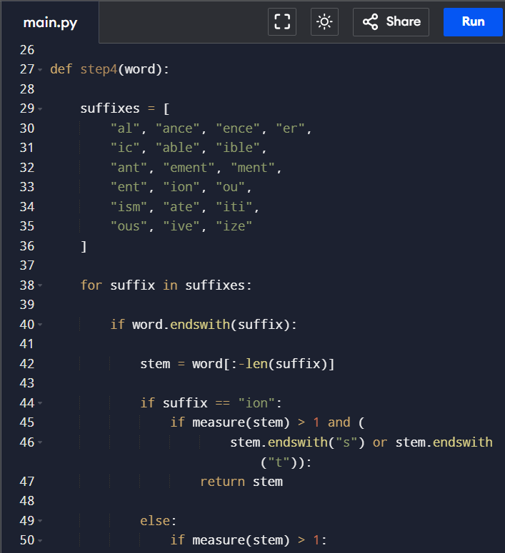
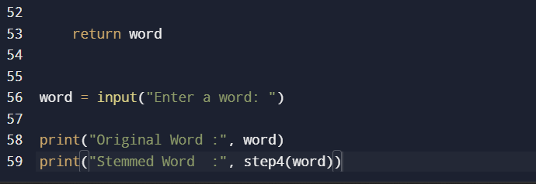
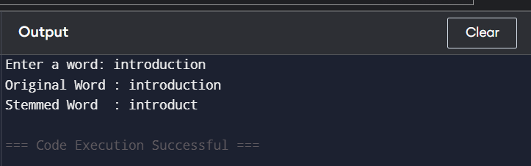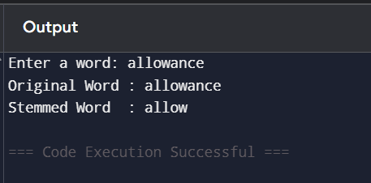

Code Explanation
Function Definition
def step4(word):
This function accepts a word after it has completed Steps 1, 2, and 3 of the Porter algorithm.
Example:
revival
allowance
adjustment

List of Suffixes
suffixes = [
"al","ance","ence","er","ic",
"able","ible","ant","ement",
"ment","ent","ion","ou",
"ism","ate","iti","ous",
"ive","ize"
]
These are the suffixes that Porter Step 4 attempts to remove.
Examples

Word | Suffix
revival | al
allowance | ance
electrical | ic
adjustment | ment
activity | iti
formalize | ize

Loop Through Every Suffix
for suffix in suffixes:
The program checks each suffix one by one.
Suppose the word is
adjustment
It checks
al
ance
ence
...
ment
When it reaches ment, the condition becomes true.

Check Whether the Word Ends with the Suffix
if word.endswith(suffix):
Python's endswith() function checks whether the word ends with the current suffix.
Example
adjustment.endswith("ment")
True

Extract the Stem
stem = word[:-len(suffix)]
The suffix is removed.
Example
adjustment

↓
adjust
Similarly,
allowance
↓
allow

Measure (m) Condition
Before removing a suffix, Porter checks
measure(stem) > 1
The measure (m) counts the number of Vowel-Consonant (VC) sequences in the stem.
Examples
Stem | Measure
hop | 1
trouble | 2
revival | 3
If
m > 1
then suffix removal is allowed.
Otherwise, the word remains unchanged.

Special Rule for "ion"
Unlike every other suffix,
ion
has an additional condition.
if suffix=="ion":
The algorithm checks
measure(stem)>1
AND
stem.endswith("s")
OR
stem.endswith("t")
Only then is ion removed.

General Condition of Step 4
The algorithm follows the rule
IF
Word ends with one of the Step 4 suffixes
AND
measure(stem) > 1
THEN
Remove the suffix
For
ion
the condition becomes
Word ends with "ion"
AND
measure(stem) > 1
AND
Stem ends with
s
OR
t
THEN
Remove "ion"

Conclusion
Step 4 is one of the most important stages of the Porter Stemming Algorithm because it removes common derivational suffixes only when the remaining stem is linguistically meaningful. By applying the measure (m) > 1 condition and the special "ion" rule, the algorithm avoids excessive stemming while effectively reducing words to their base forms. This normalization improves the performance of NLP tasks such as information retrieval, text mining, document classification, and search engines by treating different word forms as a single representative stem.

