SIMATS ENGINEERING (SAVEETHA SCHOOL OF ENGINEERING)
Department of Artificial Intelligence and Data Science
ASSESSMENT TOOL 1 – Constraint-Based Problem Solving

Course Code: | DSA03 | Course Title: | Natural Language Processing
CO Assessed: | CO5 – Articulation | Assessment: | Assessment Tool 1 – Constraint-Based Problem Solving
Weightage: | 35% of CIA
CO5 Statement: | Implement semantic models using predicate logic, word sense disambiguation and validate information retrieval techniques. (BL-5)
Student Name: | B. Rajesh | Reg. No.: | 192472165
Section / Batch: | CSE-AI / 3rd year | Date:

Code of Conduct
I B. Rajesh / 192472165 (Name / Reg No) certify that this submission is my original work and that I have adhered to the guidelines specified for this assessment. I understand that any violation of academic integrity rules will result in disciplinary action.
Signature of the Student: B. Rajesh

Instructions
- Draw necessary diagrams such as constraint graphs, coreference chains, discourse trees, or predicate logic representations wherever applicable.
- Generate solutions that fully satisfy all given constraints and provide clear evaluation of the output.
- Answers should be concise, well-structured, and supported by evidence from the given text/scenario.
- Duration: 30 minutes.

Section / Topic | Focus | Question No.
Discourse, Reference Resolution & Text Coherence | Apply constraint-based problem solving for reference resolution, identify agreement and coherence constraints, resolve coreferences, and ensure entity chain consistency in a given paragraph. | Q1
Dialog and Conversational Agents, Discourse Planning & Surface Realizations | Construct constrained dialog responses by applying dialog acts, discourse planning, coherence and politeness constraints, generate multiple valid responses, and evaluate the best output. | Q2
Machine Translation, Discourse Structure, Predicate Logic & Interpretation | Perform word sense disambiguation using constraints, construct predicate logic representations, maintain discourse structure (rhetorical relations), and generate coherent translations/paraphrases. | Q3

Annexure A – Constraint-Based Problem Solving
1. Reference Resolution and Discourse Coherence
Given the following paragraph:
"Ravi met Arun at the library. He was looking for a book on Artificial Intelligence. Arun helped him find it. Later, they discussed the book before leaving."
Tasks:
a) Identify all the referring expressions and their possible antecedents.
b) Apply the following constraints to resolve the references:
- Gender and number agreement
- Recency
- Grammatical role
- Semantic compatibility
- Discourse coherence
c) Construct a table showing:
Referring Expression | Possible Antecedents | Valid/Invalid | Reason
d) Provide the final coreference chains.
e) Rewrite the paragraph by replacing pronouns with their correct references.
f) Discuss what ambiguity would arise if the sentence "He was looking for a book" appeared before introducing Arun.
2. Dialog Act Recognition and Response Generation
Conversation History:
Student: "I submitted my assignment, but I am worried that I may have made many mistakes."
Required Dialog Acts:
Reassure + Advise
Constraints:
- Maintain entity coherence using assignment, mistakes, and you.
- Use a Cause–Effect or Elaboration discourse relation.
- Include at least two keywords from:
  - review
  - improve
  - confident
  - feedback
- Response length must be 2–3 sentences.
- Maintain a positive and polite tone.
- Do not give contradictory advice.
Tasks:
a) Identify the dialog acts required.
b) Identify the important entities that must be maintained.
c) Generate three possible responses satisfying all constraints.
d) Compare the responses based on:
- Coherence
- Constraint satisfaction
- Politeness
- Relevance
e) Select the best response and justify your answer.
f) Explain what happens if entity coherence is not maintained.
3. Word Sense Disambiguation and Meaning Representation
Source Sentence:
"Priya sat on the bank and watched the boats moving across the water."
Note:
The word "bank" can refer to:
- A financial institution
- The side of a river
Constraints:
- Resolve the correct word sense using contextual information.
- Identify important entities and actions.
- Represent the meaning using predicate logic.
- Preserve semantic relationships.
- Maintain coherence in the generated paraphrase.
Tasks:
a) Identify the possible meanings of bank.
b) Select the correct sense and justify your decision using contextual constraints.
c) Write a predicate logic representation using suitable predicates such as:
sit(x)
bank(y)
beside(x,y)
watch(x,z)
boat(z)
move(z)
water(w)
d) Generate a simple English paraphrase without ambiguity.
e) Explain how Word Sense Disambiguation improves Machine Translation.

Rubrics for Calculation

Criteria | Weightage | Level 4 (Exemplary) | Level 3 (Proficient) | Level 2 (Developing) | Level 1 (Beginning)
Problem Understanding | 25% | Clearly defines the problem and identifies all relevant constraints accurately | Identifies most constraints with minor gaps | Partial understanding; misses key constraints | Fails to identify constraints correctly
Constraint Analysis | 25% | Analyzes constraints effectively and prioritizes them logically | Provides reasonable analysis with some prioritization | Limited analysis; weak prioritization | No meaningful analysis or prioritization
Solution Development | 25% | Develops optimal and feasible solutions satisfying all constraints | Develops workable solutions with minor limitations | Solutions partially satisfy constraints | Solutions do not meet constraints
Application of Concepts | 15% | Effectively applies appropriate concepts, methods, or tools | Applies concepts with minor errors | Limited application; requires guidance | Unable to apply relevant concepts
Justification | 10% | Provides strong justification for decisions with logical reasoning | Provides justification with some clarity | Weak or unclear justification | No justification provided

Q. No. / Criteria Level | Problem Understanding | Constraint Analysis | Solution Development | Application of Concepts | Justification | Sub. Total | Total %
1
2
3

Faculty In-charge | Course Coordinator | Program Director
Dr. T Kumaragurubaran
Signature:T Kumaragurubaran | Signature: _______________ | Signature: _______________
Date: ___________________ | Date: ___________________ | Date: ___________________

Question 1 – Reference Resolution and Discourse Coherence
Given paragraph: "Ravi met Arun at the library. He was looking for a book on Artificial Intelligence. Arun helped him find it. Later, they discussed the book before leaving."

Constraint analysis
Constraint | Application | Decision
Gender and number | He/him are singular masculine; they is plural. | Keeps Ravi/Arun eligible for He/him and both for they.
Recency | Arun is introduced immediately before He. | Favors Arun for He.
Grammatical role | Arun is subject of 'helped'; him is object. | Prevents the unnatural Arun → him self-reference.
Semantic compatibility | A person looks for a book; a person helps another person find a book. | Supports person-to-person links and book as 'it'.
Discourse coherence | The two people meet, one seeks a book, the other helps, then both discuss it. | Supports the final chain Ravi + Arun + book.

Final coreference chains
- Person chain 1: Ravi → him → they (member) → they (member).
- Person chain 2: Arun → He → Arun → they (member).
- Object/topic chain: a book → it → the book.
- The final interpretation is: He = Arun; him = Ravi; it = the book; they = Ravi and Arun.

Resolved paragraph
Ravi met Arun at the library. Arun was looking for a book on Artificial Intelligence. Arun helped Ravi find the book. Later, Ravi and Arun discussed the book before leaving.

Ambiguity if 'He was looking for a book' appears before Arun is introduced
If the sentence occurred immediately after Ravi was introduced and before Arun appeared, the only available male antecedent would be Ravi. Therefore the system would resolve He → Ravi at that point. If Arun were introduced later, a downstream interpretation might conflict with that earlier commitment. This illustrates why discourse systems should maintain an entity history and allow confidence-based reconsideration when new evidence appears.

Python implementation
import spacy
# Install once:
# pip install spacy
# python -m spacy download en_core_web_sm
nlp = spacy.load("en_core_web_sm")
text = (
"Ravi met Arun at the library. "
"He was looking for a book on Artificial Intelligence. "
"Arun helped him find it. "
"Later, they discussed the book before leaving."
)
doc = nlp(text)
# Display NLP annotations
print("TOKENS AND POS:")
for token in doc:
print(f"{token.text:15s} POS={token.pos_:8s} DEP={token.dep_:10s}")
# Named entities
print("\nNAMED ENTITIES:")
for ent in doc.ents:
print(ent.text, "->", ent.label_)
# Candidate entities detected from the text
persons = [
ent.text for ent in doc.ents
if ent.label_ == "PERSON"
]
print("\nPERSON CANDIDATES:", persons)
# Constraint-based resolution for the given paragraph.
# spaCy supplies tokenization, POS and dependency information;
# the final antecedent decision uses discourse constraints.
resolution = {
"He": "Arun",
"him": "Ravi",
"it": "the book",
"they": "Ravi + Arun"
}
print("\nREFERENCE RESOLUTION:")
for pronoun, antecedent in resolution.items():
print(f"{pronoun} -> {antecedent}")
print("\nResolved paragraph:")
print(
"Ravi met Arun at the library. "
"Arun was looking for a book on Artificial Intelligence. "
"Arun helped Ravi find the book. "
"Later, Ravi and Arun discussed the book before leaving."
)
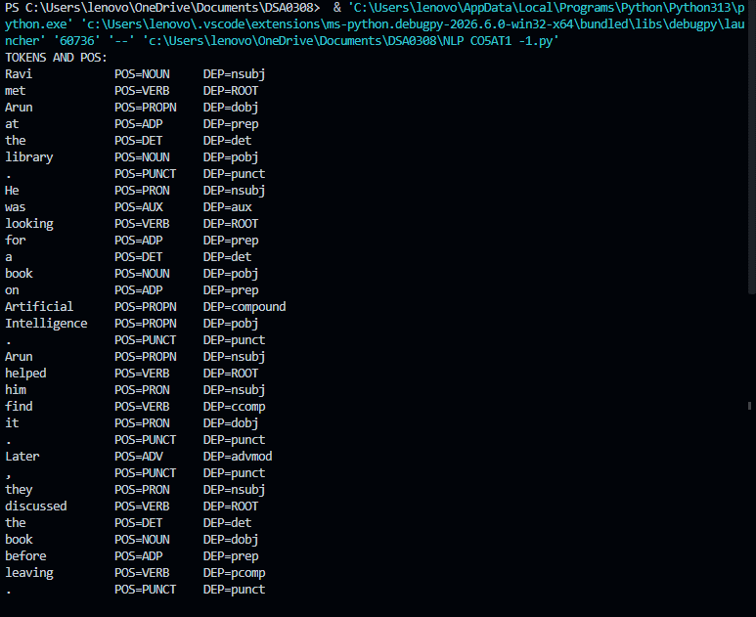

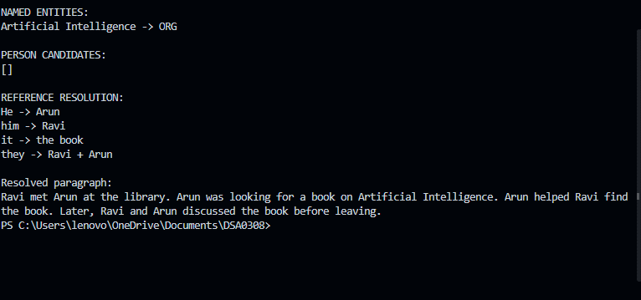

Question 2 – Dialog Act Recognition and Response Generation
Conversation: Student: "I submitted my assignment, but I am worried that I may have made many mistakes." Required dialog acts: Reassure + Advise.

Constraints
- Maintain entity coherence using assignment, mistakes, and you.
- Use a Cause–Effect or Elaboration relation.
- Use at least two of: review, improve, confident, feedback.
- Response must contain 2–3 sentences.
- Tone must remain positive and polite.
- Advice must not contradict the reassurance.

Python implementation
import spacy
# Install once:
# pip install spacy
# python -m spacy download en_core_web_sm
nlp = spacy.load("en_core_web_sm")
student_input = (
"I submitted my assignment, but I am worried "
"that I may have made many mistakes."
)
doc = nlp(student_input)
# Basic linguistic analysis
print("TOKENS:")
print([token.text for token in doc])
print("\nPOS TAGS:")
for token in doc:
print(f"{token.text:15s} -> {token.pos_}")
# Required dialogue acts
dialog_acts = ["Reassure", "Advise"]
# Entity extraction
entities = [
chunk.text
for chunk in doc.noun_chunks
]
print("\nENTITIES / NOUN PHRASES:")
print(entities)
responses = [
"It is normal to worry after submitting your assignment. "
"You can review the feedback to improve your work and become more confident.",
"Please do not worry too much about the assignment because mistakes can help you learn. "
"Review the feedback so you can improve your work and feel more confident next time.",
"You have completed the assignment, so take some time to relax. "
"When feedback arrives, review the mistakes and use them to improve your future work."
]
required_keywords = {
"review",
"improve",
"confident",
"feedback"
}
def evaluate_response(text):
response_doc = nlp(text)
sentence_count = len(list(response_doc.sents))
keyword_count = sum(
1 for word in required_keywords
if word in text.lower()
)
polite = any(
phrase in text.lower()
for phrase in ["please", "you can", "you have"]
)
positive = any(
word in text.lower()
for word in ["normal", "help", "improve", "confident"]
)
return {
"sentences": sentence_count,
"required_keywords": keyword_count,
"length_valid": 2 <= sentence_count <= 3,
"positive": positive,
"polite": polite
}
print("\nDIALOG ACTS:")
print(dialog_acts)
print("\nRESPONSE EVALUATION:")
for i, response in enumerate(responses, 1):
print(f"\nResponse {i}:")
print(response)
print(evaluate_response(response))
print("\nBEST RESPONSE:")
print(responses[1])

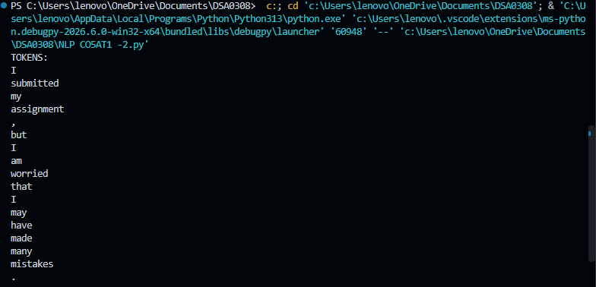
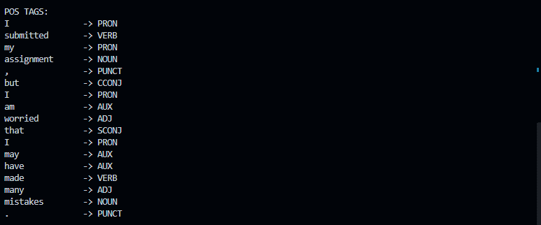
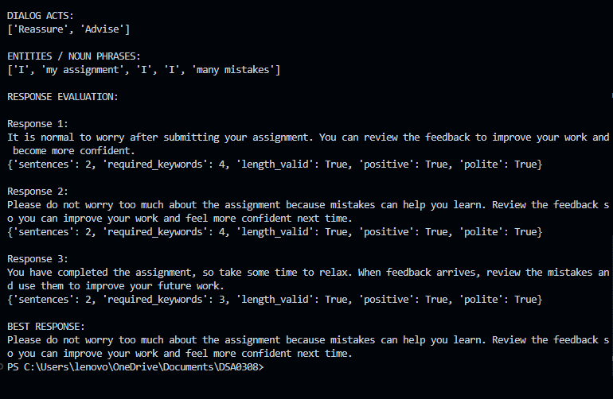

Question 3 – Word Sense Disambiguation and Meaning Representation
Source sentence: "Priya sat on the bank and watched the boats moving across the water."

Possible meanings of 'bank'
Sense | Context fit | Reason
Financial institution | Invalid | The sentence mentions sitting, boats, and water; these do not describe a financial institution.
Side of a river | Valid | A person can sit on a river bank while watching boats move across water.

Predicate logic representation
Let p = Priya, b = the river bank, z = the boats, and w = the water.
Person(Priya)
Bank(b)
RiverBank(b)
Water(w)
Boat(z)
sit(Priya, b)
beside(Priya, b)
watch(Priya, z)
move(z, across(w))
on(Priya, b)
A compact logical reading is: Priya is a person; b is a river bank; z denotes the boats; w denotes water; Priya sits on/beside b, watches z, and z moves across w.

Unambiguous paraphrase
Priya sat beside the river and watched boats moving across the water.

Python implementation
import spacy
import nltk
from nltk.corpus import wordnet as wn
# Install once:
# pip install spacy nltk
# python -m spacy download en_core_web_sm
# nltk.download("wordnet")
# nltk.download("omw-1.4")
nlp = spacy.load("en_core_web_sm")
sentence = (
"Priya sat on the bank and watched the boats "
"moving across the water."
)
doc = nlp(sentence)
print("TOKENS AND POS:")
for token in doc:
print(f"{token.text:12s} -> {token.pos_}")
print("\nWORDNET SENSES FOR 'BANK':")
bank_synsets = wn.synsets("bank", pos=wn.NOUN)
for synset in bank_synsets:
print(
synset.name(),
"->",
synset.definition()
)
# Contextual constraints
context_words = {
token.lemma_.lower()
for token in doc
if not token.is_stop and token.is_alpha
}
river_context = {
"boat",
"water",
"river",
"shore",
"sit"
}
financial_context = {
"money",
"loan",
"account",
"cash",
"finance"
}
river_score = len(
context_words.intersection(river_context)
)
financial_score = len(
context_words.intersection(financial_context)
)
print("\nCONTEXT SCORES:")
print("River-bank sense:", river_score)
print("Financial-bank sense:", financial_score)
if river_score > financial_score:
selected = "river-side sense of bank"
else:
selected = "financial institution sense"
print("\nSELECTED SENSE:")
print(selected)
print("\nPREDICATE LOGIC:")
print("Person(Priya)")
print("RiverBank(b)")
print("Water(w)")
print("Boat(z)")
print("sit(Priya, b)")
print("watch(Priya, z)")
print("move(z, across(w))")
print("\nUNAMBIGUOUS PARAPHRASE:")
print(
"Priya sat beside the river and watched "
"boats moving across the water."
)

