Experience Certificate

Date: 12 Oct, 2025

To Whom It May Concern

This is to confirm that Mr. Sudesh Sutihar worked with IT Home Pvt. Ltd. Kathmandu, as a Web Developer from 15 July 2024 to 30 June 2025. He was part of our Full Stack development team, worked on Web Applications, and delivered high-quality code and scalable systems.
He was a proactive, dependable, and talented team member.

We wish him all the best in his future endeavors.

For IT Home Pvt. Ltd.

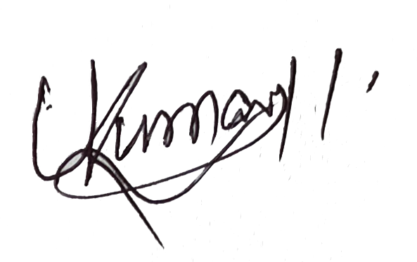


……………………… ………………………
Umesh Kumar Yadav Sanjay Kumar Yadav
CEO Administrator
IT Home Pvt. Ltd. IT Home Pvt. Ltd.
# 9841549777

