**Account Table**

1. Convert the Date attribute into a yyyy-mm-dd by adding 24 in year

format in Excel or SQL

● 1993 -> 2017

● 1994 -> 2018

● 1995 -> 2019

● 1996 -> 2020

● 1997 -> 2021

Ans: First alter the table’s date column datatype length to accommodate changes in its format

**alter table account**

**modify column date varchar(10);**

then, Converting the Date attribute into a yyyy-mm-dd by adding 24 in year

**update account**

**set date = date_format(date_add(date, interval 24 year), '%Y-%m-%d');**

OUTPUT:

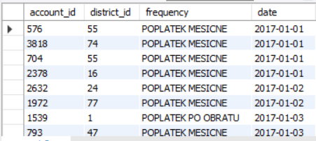

2. Replace in frequency attribute “POPLATEK MESICNE” AS Monthly

Issuance, “POPLATEKTYDNE” AS Weekly Issuance, and

“POPLATEK POBRATU” AS Issuance After a Transaction in Excel or

create a case statement in SQL.

Ans:

**update account**

**set frequency = case**

**when frequency='POPLATEK MESICNE' then 'Monthly Issuance'**

**when frequency = 'POPLATEKTYDNE' then 'Weekly Issuance'**

**else 'Issuance After a Transaction'**

**end;**

OUTPUT:

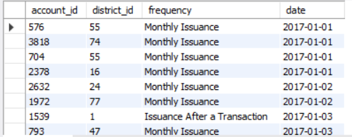

3. Create a Custom Column Card_Assigned and assign below :

● Silver -> Monthly issuance

● Diamond - weekly issuance

● Gold - Issuance after a transaction

Ans: First add the custom column in the table:

**alter table account**

**add Card_Assigned varchar(20);**

then, insert data in it as per the question

**update account**

**set Card_Assigned = case**

**when frequency = 'Monthly issuance' then 'Silver'**

**when frequency = 'weekly issuance' then 'Diamond'**

**when frequency = 'Issuance after a transaction' then 'Gold'**

**end;**

OUTPUT:

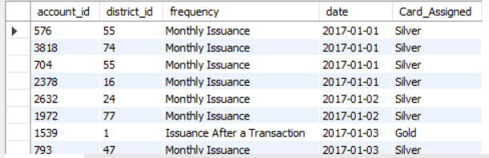

**CARD Table**

1. Replace type attribute value “junior” as Sliver, “Classic” as Gold,

And “Gold” as Diamond by using replace in Excel or by using update

in SQL.

Ans:

**update card**

**set `type` = case**

**when `type` = 'junior' then 'Sliver'**

**when `type` = 'Classic' then 'Gold'**

**when `type` = 'Gold' then 'Diamond'**

**end;**

output:

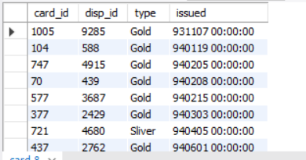

2. Convert issued attribute into yyyy-mm-dd adding 23 in year.

ANS:

First used `**STR_TO_DATE**` to parse the exsting date string, then use `**DATE_FORMAT()`** function to convert it into the desired formet

**update card**

**set issued = date_format(date_add(str_to_date(issued, '%y%m%d %H:%i:%s'), interval 23 year),'%Y-%m-%d');**

OUTPUT:

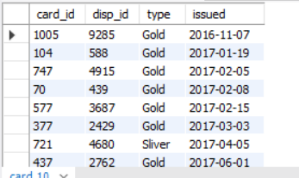

**DISTRICT Table**

1. Change all column names and delete the attributes a12

Ans:

**alter table district**

**drop column A12**

then,

**alter table district**

**change A1 districtCode int,**

**change A2 districtName varchar(20),**

**change A3 region varchar(20),**

**change A4 noOfInhabitants int,**

**change A5 Muncipalities1 int,**

**change A6 Muncipalities2 int,**

**change A7 Muncipalities3 int,**

**change A8 Muncipalities4 int,**

**change A9 NoOfCities int,**

**change A10 ratioUrbanInhabitant decimal(10, 2),**

**change A11 avgSalary int,**

**change A13 Unemployment96 decimal(10,2),**

**change A14 entrepreneurs int,**

**change A15 crimes95 int,**

**change A16 crimes96 int**

**;**

OUTPUT:

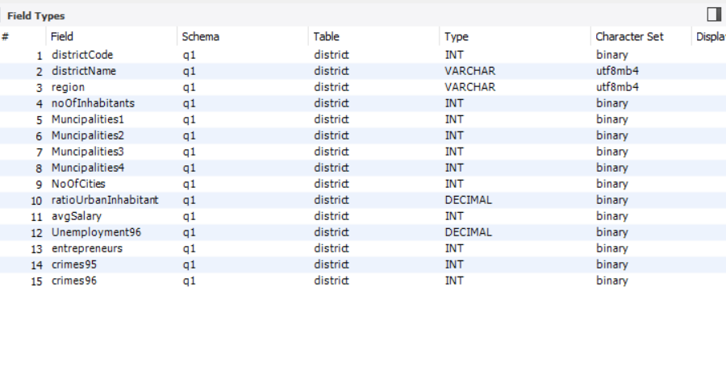

**LOAN Table**

1. Convert the Date Attribute into yyyy-mm-dd format adding 23 in year.

Ans:

**alter table loan**

**modify column `date` date;**

then,

**update loan**

**set `date` = date_add(`date`, interval 23 year);**

2. Convert Status Attribute value “A” as Contract Finished, “B” as Loan

Not Paid, “C” as Running Contract, and “D” Client in debt.

Ans:

**update loan**

**set `status` = case**

**when `status` = 'A' then 'Contract Finished'**

**when `status` = 'B' then ' Loan Not Paid'**

**when `status` = 'C' then 'Running Contract'**

**when `status` = 'D' then 'Client in debt'**

**end;**

In th Transactions Table do the following , whosoever count is highest sort it in

descending order and change the year from 2022,2021,2020 and so on

--DATA TRANSFORMATION

/*

2021 -> 2017

2020 -> 2018

2019 -> 2019 -- NO CHANGE

2018 -> 2020

2017 -> 2021

2016 -> 2022

UPDATE TRANSACTIONS

SET BANK = 'Sky Bank' WHERE BANK IS NULL AND YEAR(DATE) =

2022;

UPDATE TRANSACTIONS

SET BANK = 'DBS Bank' WHERE BANK IS NULL AND YEAR(DATE) =

2021;

UPDATE TRANSACTIONS

SET BANK = 'Northern Bank' WHERE BANK IS NULL AND YEAR(DATE)

= 2019;

UPDATE TRANSACTIONS

SET BANK = 'Southern Bank' WHERE BANK IS NULL AND YEAR(DATE)

= 2018;

Ans: In the Transactions Table, whosoever count is highest sorting it in

descending order:

**select *, count(*) as transactions from trans group by account_id order by transactions desc;**