MariaDB, MySQL & Amazon RDS
EC2 Databases, Migration, Multi-AZ, Backup/Restore & Read Replicas

Tasks Covered
1. Create a MariaDB database on EC2.
2. Insert some dummy data.
3. Take a backup of the dummy data on EC2.
4. Launch a MariaDB RDS instance.
5. Migrate the database from EC2 to RDS.
6. Install MySQL DB on EC2.
7. Launch a MySQL RDS instance.
8. Configure Multi-AZ.
9. Take a backup of the DB and restore the DB.
10. Create a read replica.

Prerequisites
- An AWS account with console access to EC2, RDS, and VPC/Security Groups.
- An existing VPC (the default VPC is fine) with at least two subnets in two Availability Zones — required for RDS Multi-AZ and read replicas.
- An EC2 key pair for SSH access.
- Basic familiarity with SQL and the Linux command line.
Naming plan used throughout this guide:
Resource | Detail
EC2-MariaDB-Instance | Amazon Linux 2023, t2.micro — runs MariaDB server
EC2-MySQL-Instance | Amazon Linux 2023, t2.micro — runs MySQL Community server
MariaDB-RDS-Instance | Amazon RDS, engine MariaDB, db.t3.micro
MySQL-RDS-Instance | Amazon RDS, engine MySQL, db.t3.micro
Database / table used for sample data | appdb.customers

TASK 1: Create a MariaDB Database on EC2

Step 1.1 — Create a Security Group
1. EC2 console → Security Groups → Create security group.
2. Name: DB-EC2-SG. VPC: your lab VPC.
3. Inbound rules: allow SSH (22) from My IP; allow Custom TCP port 3306 from My IP (for testing a remote SQL client connection — optional but useful).
4. Click Create security group.
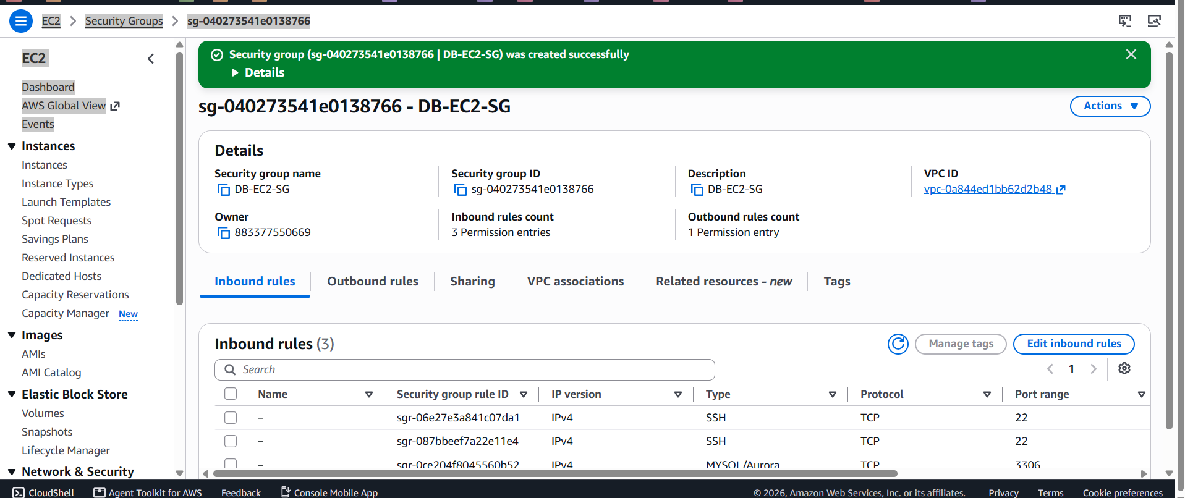

Step 1.2 — Launch the EC2 Instance
1. EC2 console → Instances → Launch instances.
2. Name: EC2-MariaDB-Instance. AMI: Amazon Linux 2023. Instance type: t2.micro. Key pair: select or create one.
3. Network settings: your VPC, any subnet, security group = DB-EC2-SG.
4. Click Launch instance.
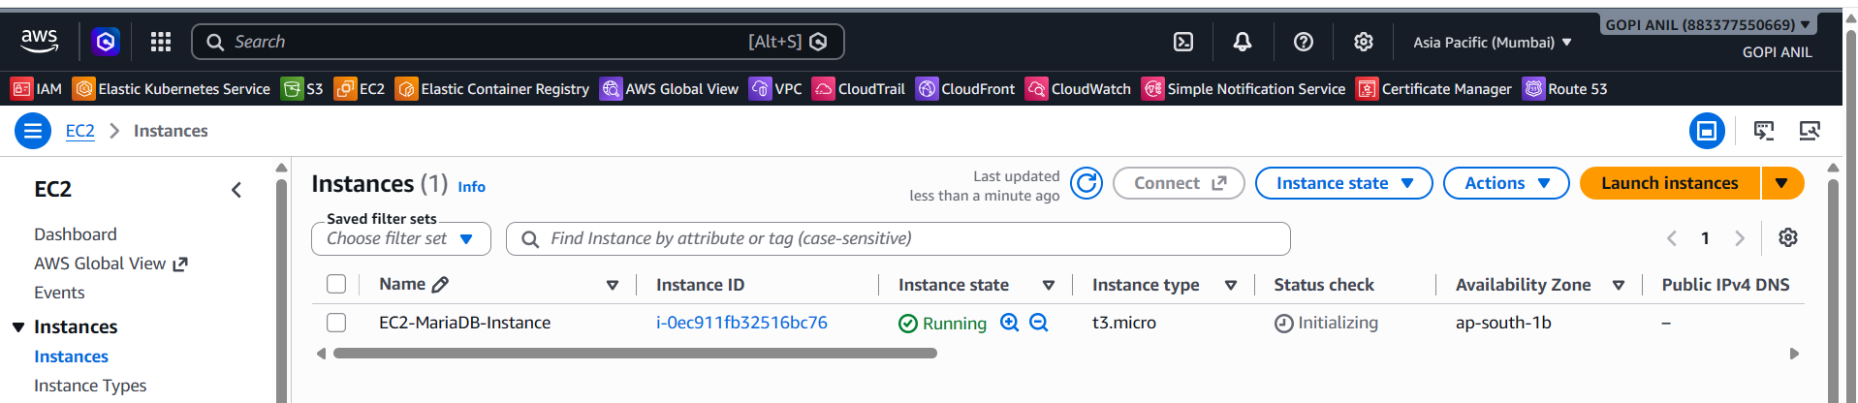

Step 1.3 — Install MariaDB Server
1. Connect via SSH or EC2 Instance Connect, then run:
sudo yum update -y
sudo yum install -y mariadb105-server
sudo systemctl enable --now mariadb
2. Run the included hardening script and answer the prompts (set a root password, remove anonymous users, disallow remote root login, remove the test database, reload privileges):
sudo mysql_secure_installation

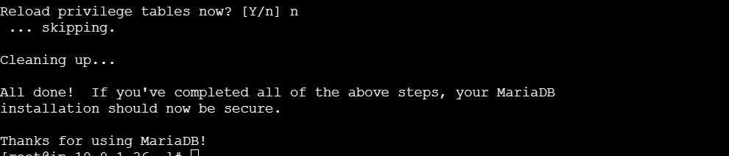

Step 1.4 — Create the Database
1. Log in to the MariaDB shell:
sudo mysql -u root -p
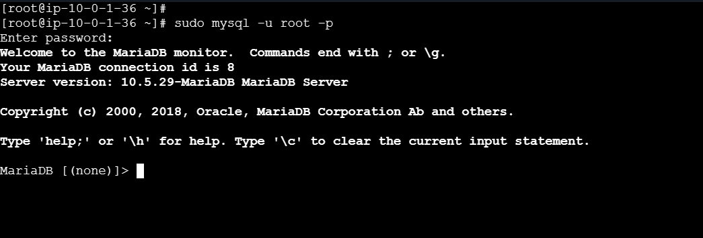
2. Create the database and a table:
CREATE DATABASE appdb;
USE appdb;
CREATE TABLE customers (
id INT AUTO_INCREMENT PRIMARY KEY,
name VARCHAR(100),
email VARCHAR(100),
signup_date DATE
);

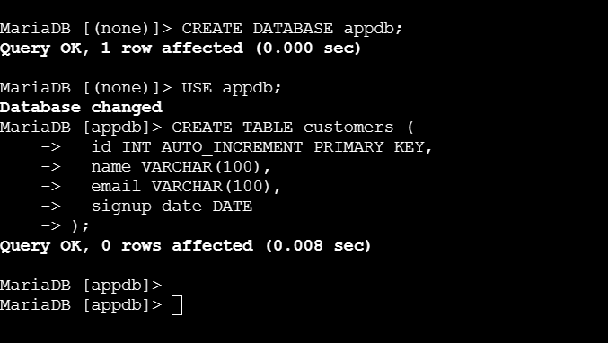

Step 1.5 — Verify
- Run SHOW DATABASES; and confirm appdb is listed.
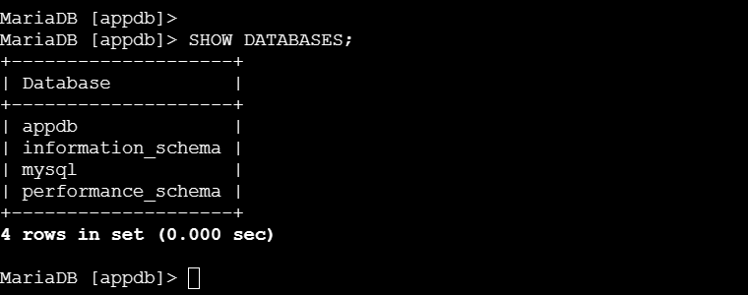
- Run USE appdb; SHOW TABLES; and confirm customers is listed.
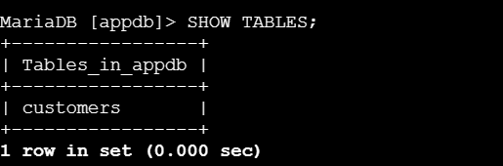

TASK 2: Insert Some Dummy Data

Step 2.1 — Insert Sample Rows
1. From the MariaDB shell (sudo mysql -u root -p, then USE appdb;), run:
INSERT INTO customers (name, email, signup_date) VALUES
('Asha Rao', 'asha.rao@example.com', '2026-01-15'),
('Ben Carter', 'ben.carter@example.com', '2026-02-02'),
('Chen Wei', 'chen.wei@example.com', '2026-03-10'),
('Divya Nair', 'divya.nair@example.com', '2026-04-22'),
('Ethan Brooks', 'ethan.brooks@example.com', '2026-05-30');

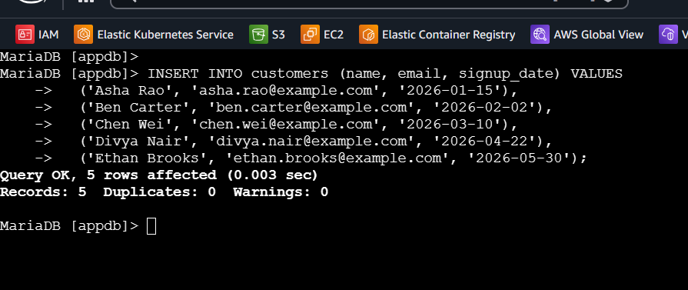

Step 2.2 — Verify
1. Run:
SELECT * FROM customers;
2. Confirm all five rows are returned with their id, name, email, and signup_date values.
3. Run SELECT COUNT(*) FROM customers; and conf irm the count is 5.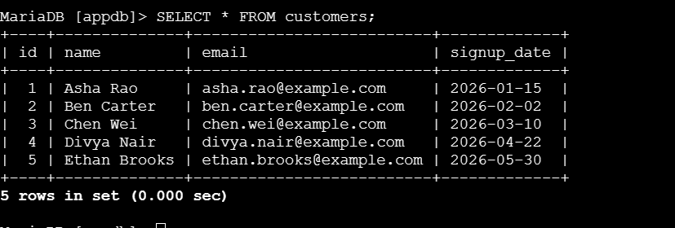

TASK 3: Take a Backup of the Dummy Data on EC2

Step 3.1 — Create a Backup Directory
1. From the EC2 instance's shell (not the MySQL shell):
mkdir -p ~/db-backups

Step 3.2 — Take a Logical Backup with mysqldump
1. Dump the appdb database to a SQL file:
mysqldump -u root -p appdb > ~/db-backups/appdb_backup_$(date +%Y%m%d).sql
- Enter the root password when prompted.
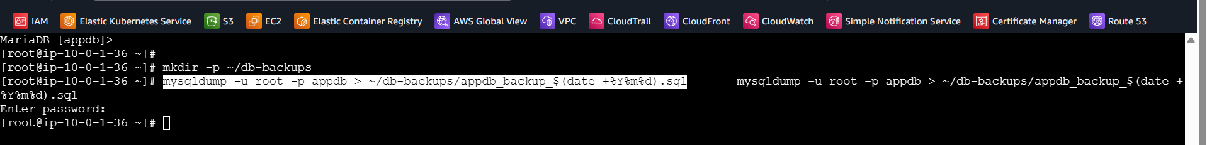

Step 3.3 — Verify the Backup File
1. Confirm the file was created and has content:
ls -lh ~/db-backups/
2. Inspect the first lines to confirm it contains valid SQL (CREATE TABLE and INSERT INTO statements):
head -n 40 ~/db-backups/appdb_backup_*.sql

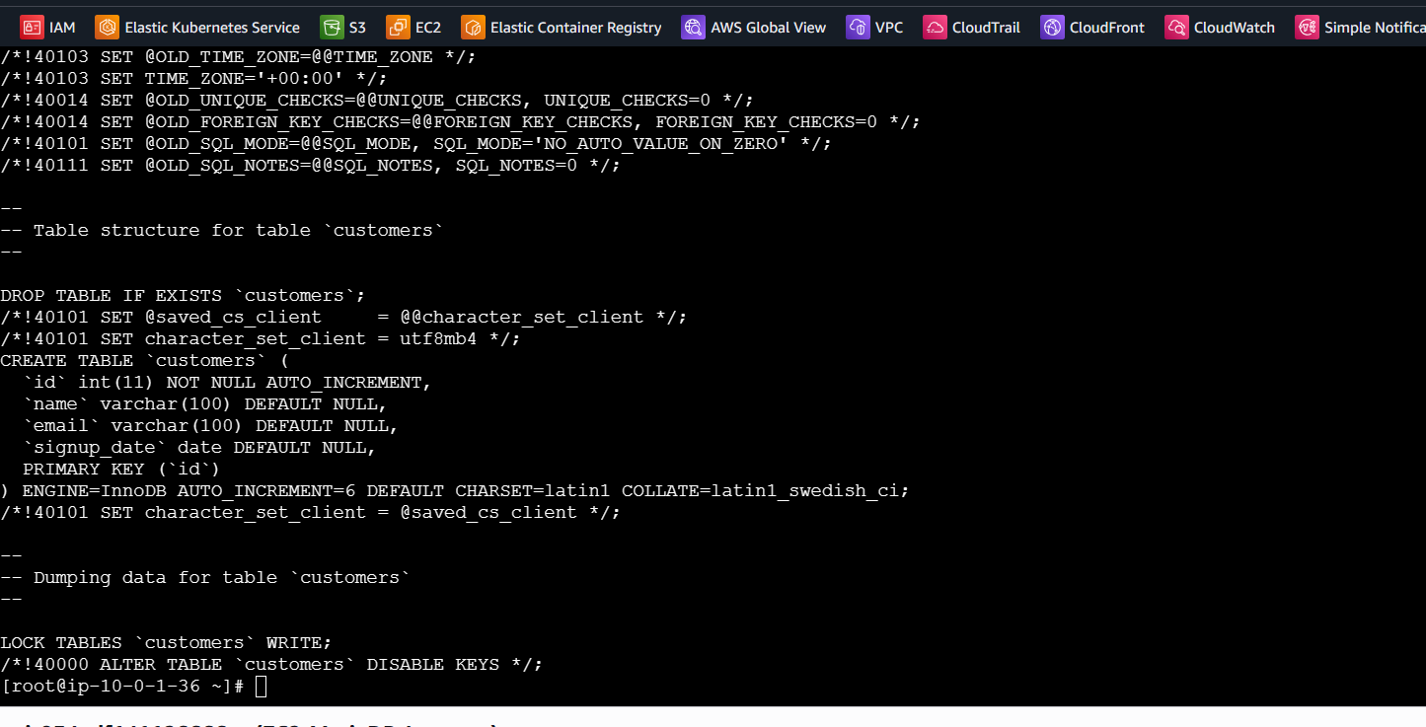

TASK 4: Launch a MariaDB RDS Instance

Step 4.1 — Create a Security Group for RDS
1. EC2 console → Security Groups → Create security group.
2. Name: RDS-MariaDB-SG. VPC: your lab VPC.
3. Inbound rules: allow Custom TCP port 3306 from the source DB-EC2-SG (so only EC2-MariaDB-Instance, and anything else using that SG, can reach the database).
4. Click Create security group.
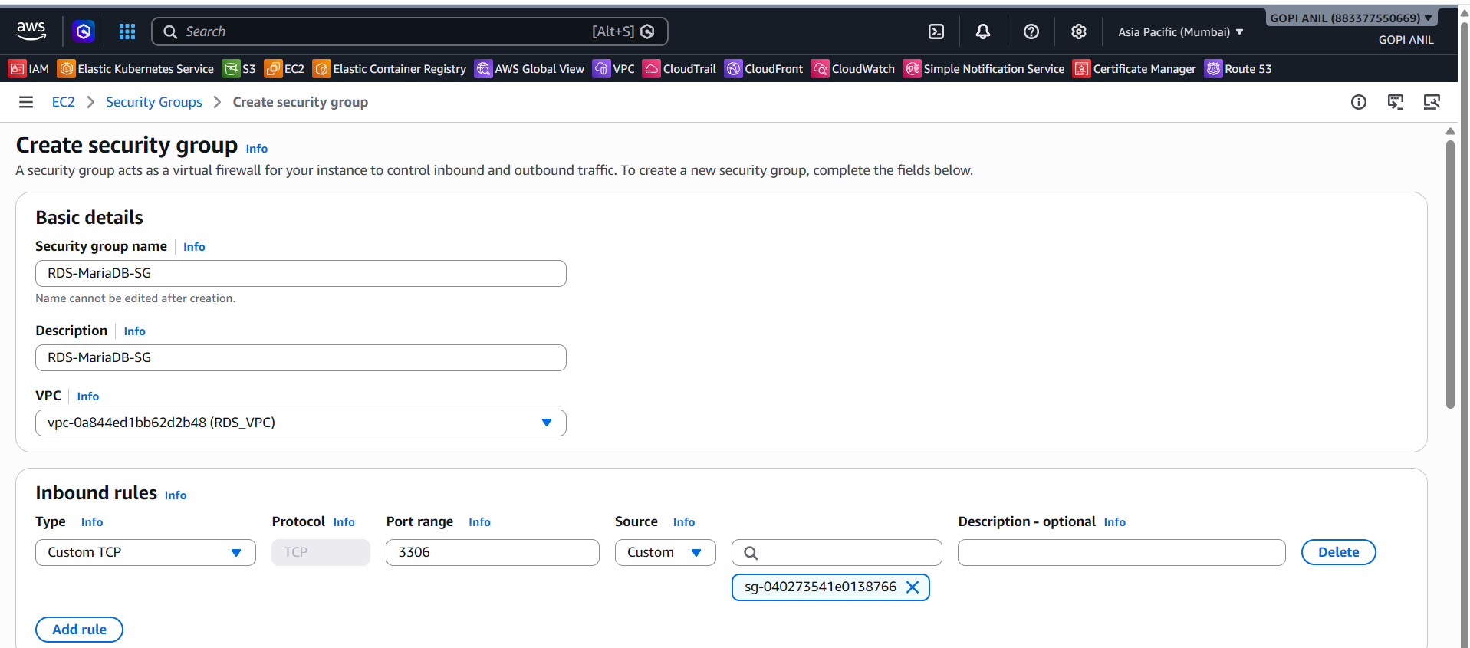

Step 4.2 — Create a DB Subnet Group (if one doesn't already exist)
1. RDS console → Subnet groups → Create DB subnet group.
2. Name: lab-db-subnet-group. VPC: your lab VPC.
3. Add at least two subnets in two different Availability Zones (required even for a Single-AZ instance, since Multi-AZ/read replicas may be added later).
4. Click Create.
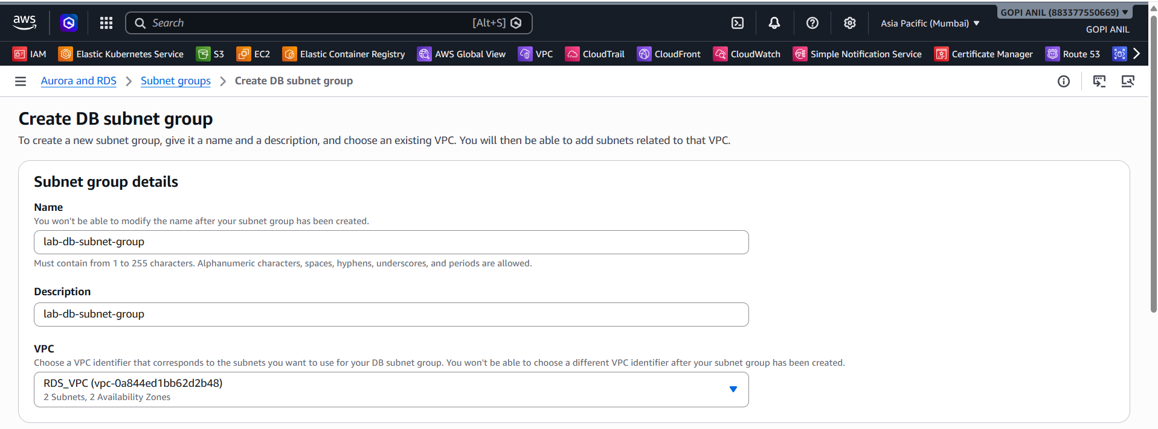
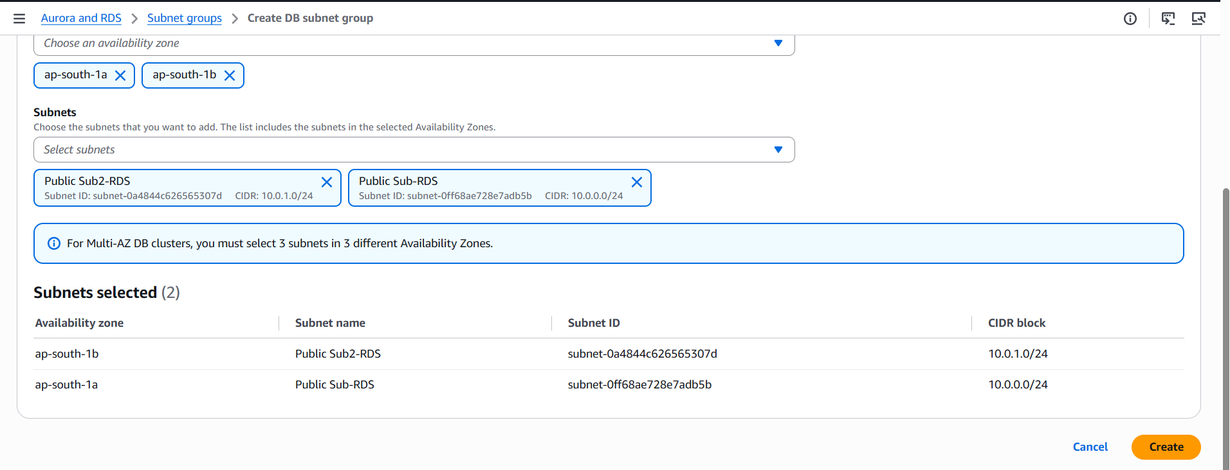

Step 4.3 — Launch the RDS Instance
1. RDS console → Databases → Create database.
2. Choose a database creation method: Standard create.
3. Engine options: MariaDB. Engine version: leave the latest default.
4. Templates: Free tier (or Dev/Test).
5. DB instance identifier: MariaDB-RDS-Instance.
6. Master username: admin. Master password: set and confirm a strong password.
7. DB instance class: db.t3.micro (or the free-tier-eligible default).
8. Storage: General Purpose SSD (gp3), 20 GiB (default).
9. Connectivity: VPC = your lab VPC; DB subnet group = lab-db-subnet-group; Public access = Yes (only for lab simplicity — keep No and use a bastion/VPN in production); VPC security group = choose existing → RDS-MariaDB-SG.
10. Additional configuration → Initial database name: appdb (this pre-creates an empty appdb database on the RDS instance).
11. Leave other settings default and click Create database.
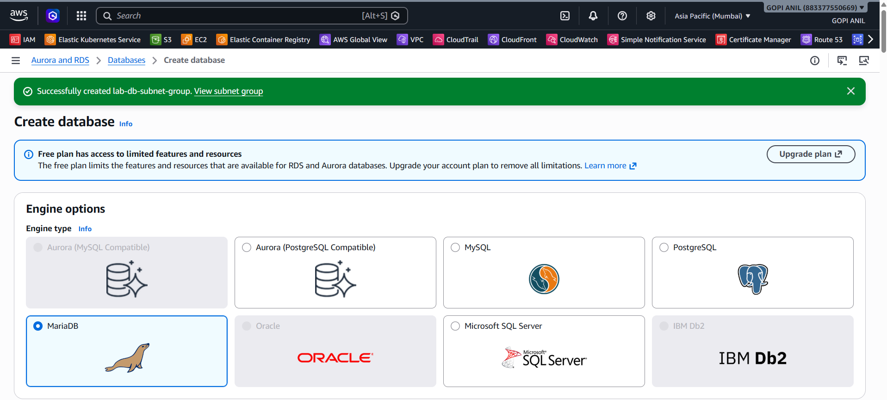
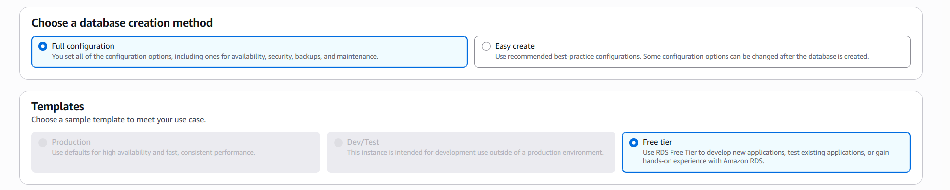
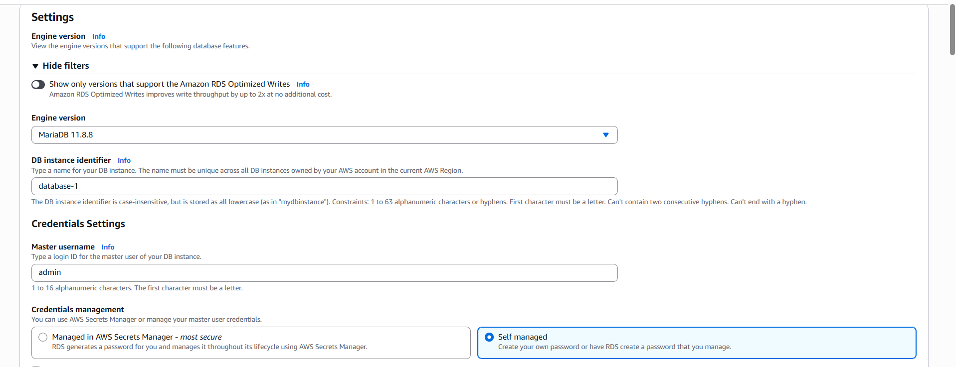
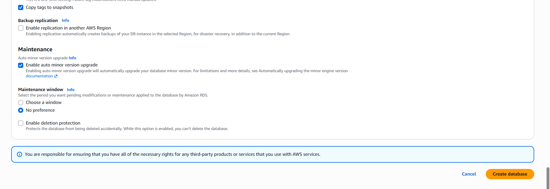

Step 4.4 — Verify
1. Wait for Status to change to Available (5–10 minutes).
2. Open MariaDB-RDS-Instance → note the Endpoint and Port (3306) shown under Connectivity & security.
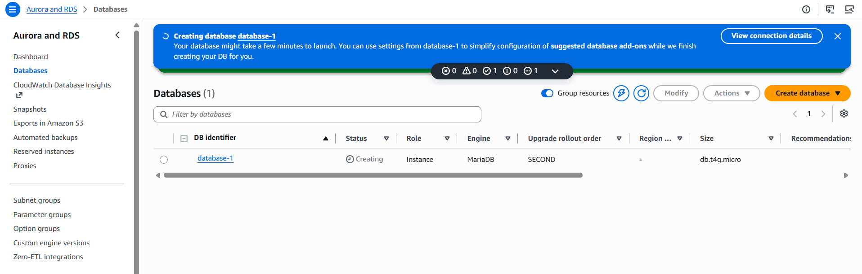

TASK 5: Migrate the Database from EC2 to RDS

Step 5.1 — Confirm Connectivity from EC2 to RDS
1. From EC2-MariaDB-Instance's shell, test the connection using the RDS endpoint from Task 4:
ssssss
2. Confirm appdb is listed among the databases returned.
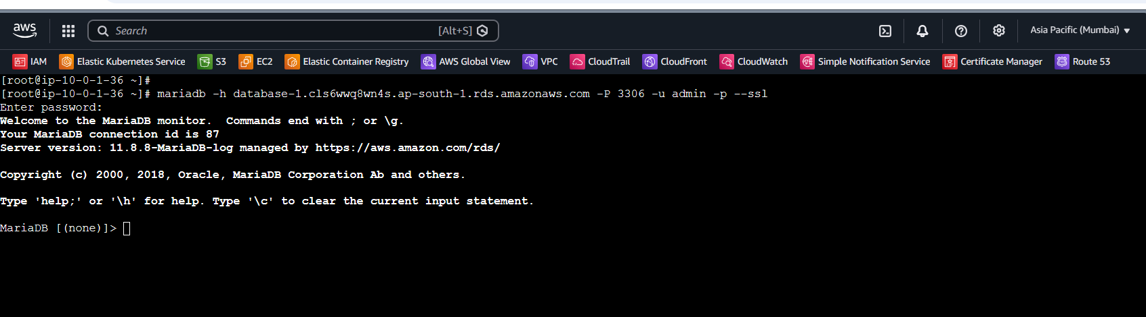
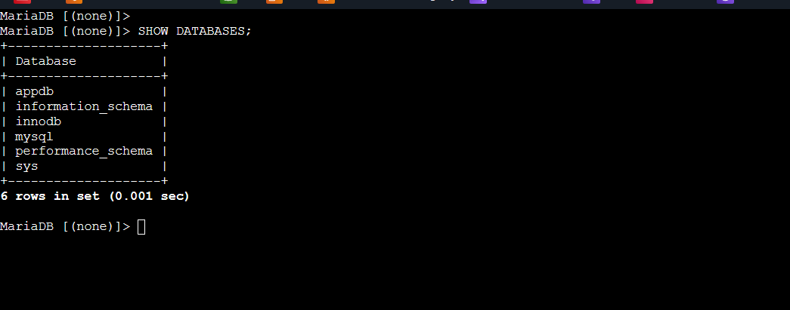

Step 5.2 — Restore the Backup into RDS
1. Using the backup file created in Task 3, load it directly into the RDS endpoint:
mysql -h database-1.cls6wwq8wn4s.ap-south-1.rds.amazonaws.com -u admin -p appdb < ~/db-backups/appdb_backup_*.sql
2. Enter the RDS master password when prompted.

Step 5.3 — Verify the Migration
1. Connect to the RDS instance and check the data:
mysql -h <MariaDB-RDS-Instance-Endpoint> -u admin -p appdb
SELECT * FROM customers;
2. Confirm all five rows from Task 2 are present, with matching id, name, email, and signup_date values.
3. Run SELECT COUNT(*) FROM customers; and confirm the count matches the source (5).


TASK 6: Install MySQL DB on EC2
Amazon Linux 2023's default repositories ship MariaDB (a MySQL-compatible fork), not genuine MySQL Community Server. To install actual MySQL, Oracle's MySQL Yum repository is added first. A separate EC2 instance is used here to avoid a port 3306 conflict with EC2-MariaDB-Instance from Task 1.

Step 6.1 — Launch a New EC2 Instance
1. EC2 console → Instances → Launch instances.
2. Name: EC2-MySQL-Instance. AMI: Amazon Linux 2023. Instance type: t2.micro. Key pair: same as before.
3. Network settings: your VPC, any subnet, security group = DB-EC2-SG (reused from Task 1).
4. Click Launch instance.
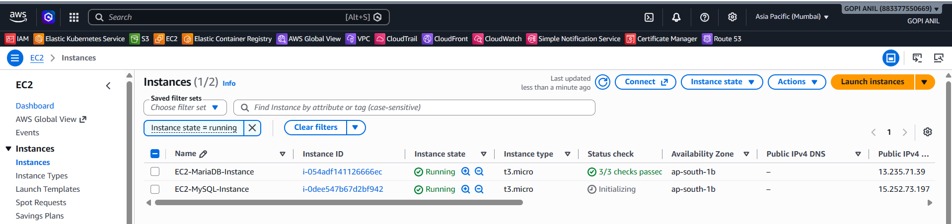

Step 6.2 — Add the MySQL Yum Repository and Install
1. Connect via SSH or EC2 Instance Connect, then run:
sudo yum update -y
sudo yum install -y https://dev.mysql.com/get/mysql80-community-release-el9-1.noarch.rpm
sudo yum install -y mysql-community-server
sudo systemctl enable --now mysqld

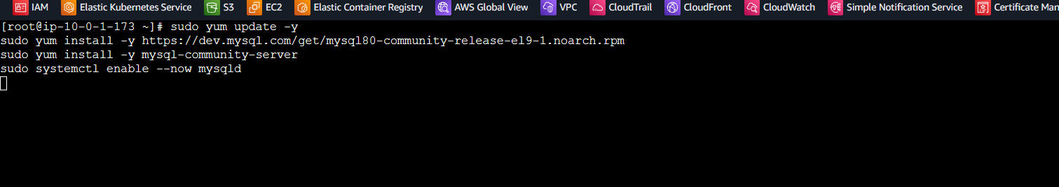

Step 6.3 — Retrieve the Temporary Root Password and Secure the Install
1. MySQL generates a temporary random root password on first start — retrieve it:
sudo grep 'temporary password' /var/log/mysqld.log
2. Log in using that temporary password and set a new one immediately (MySQL requires this before allowing other commands):
mysql -u root -p
ALTER USER 'root'@'localhost' IDENTIFIED BY 'NewStrongPassword#123';
3. Exit and run the hardening script:
sudo mysql_secure_installation

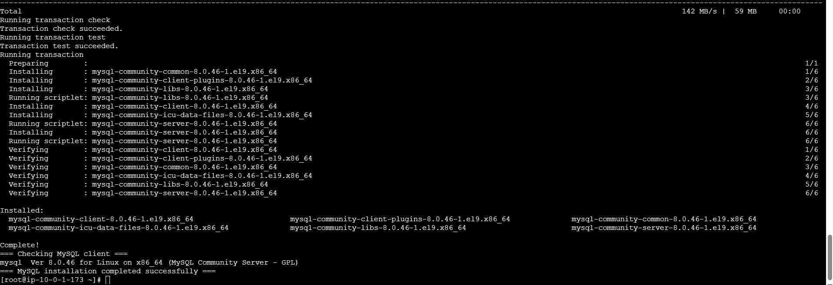

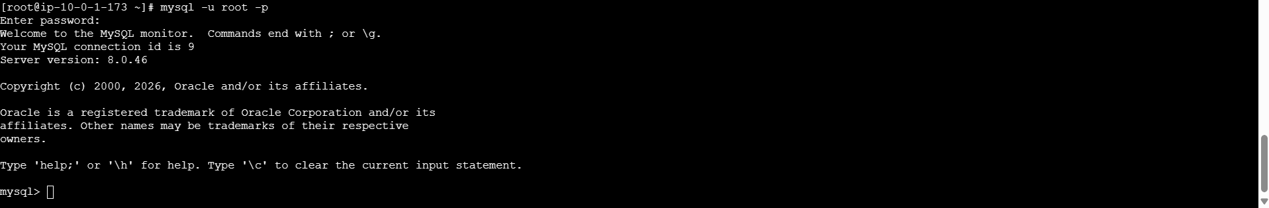

Step 6.4 — Create a Database
1. Log in with the new password and create a matching database/table for consistency with the earlier tasks:
mysql -u root -p
CREATE DATABASE appdb;
USE appdb;
CREATE TABLE customers (
id INT AUTO_INCREMENT PRIMARY KEY,
name VARCHAR(100),
email VARCHAR(100),
signup_date DATE
);

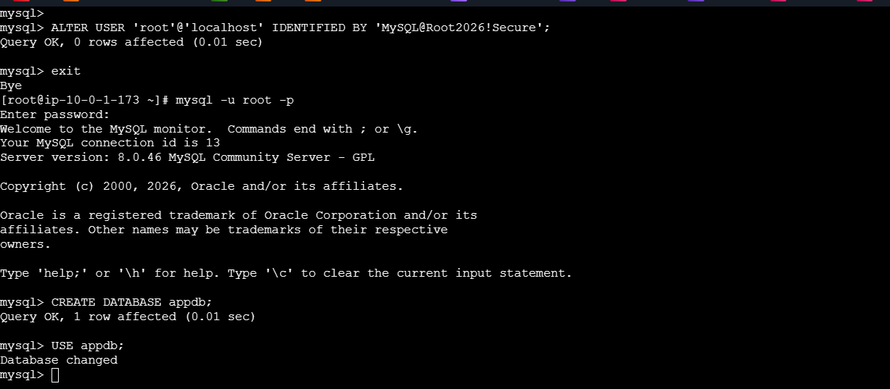

Step 6.5 — Verify
1. Run mysql --version and confirm it reports MySQL (not MariaDB) with the installed version number.
2. Run SHOW DATABASES; and confirm appdb is listed.
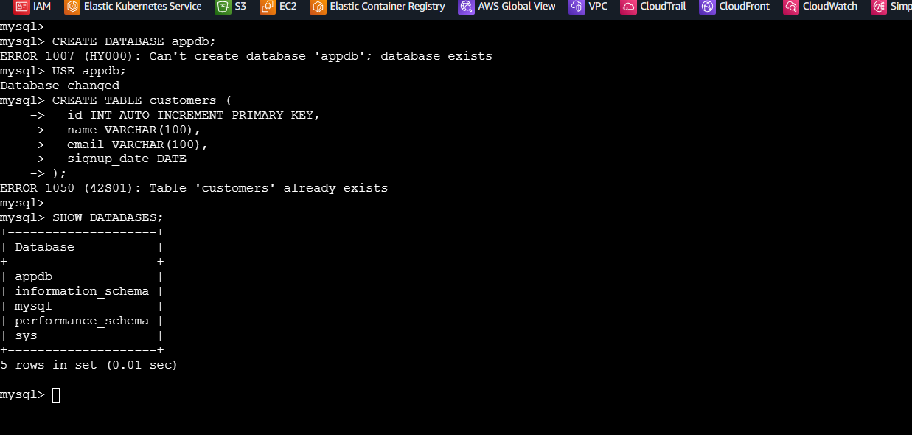

TASK 7: Launch a MySQL RDS Instance

Step 7.1 — Create a Security Group for the MySQL RDS Instance
1. EC2 console → Security Groups → Create security group.
2. Name: RDS-MySQL-SG. VPC: your lab VPC.
3. Inbound rules: allow Custom TCP port 3306 from the source DB-EC2-SG.
4. Click Create security group.
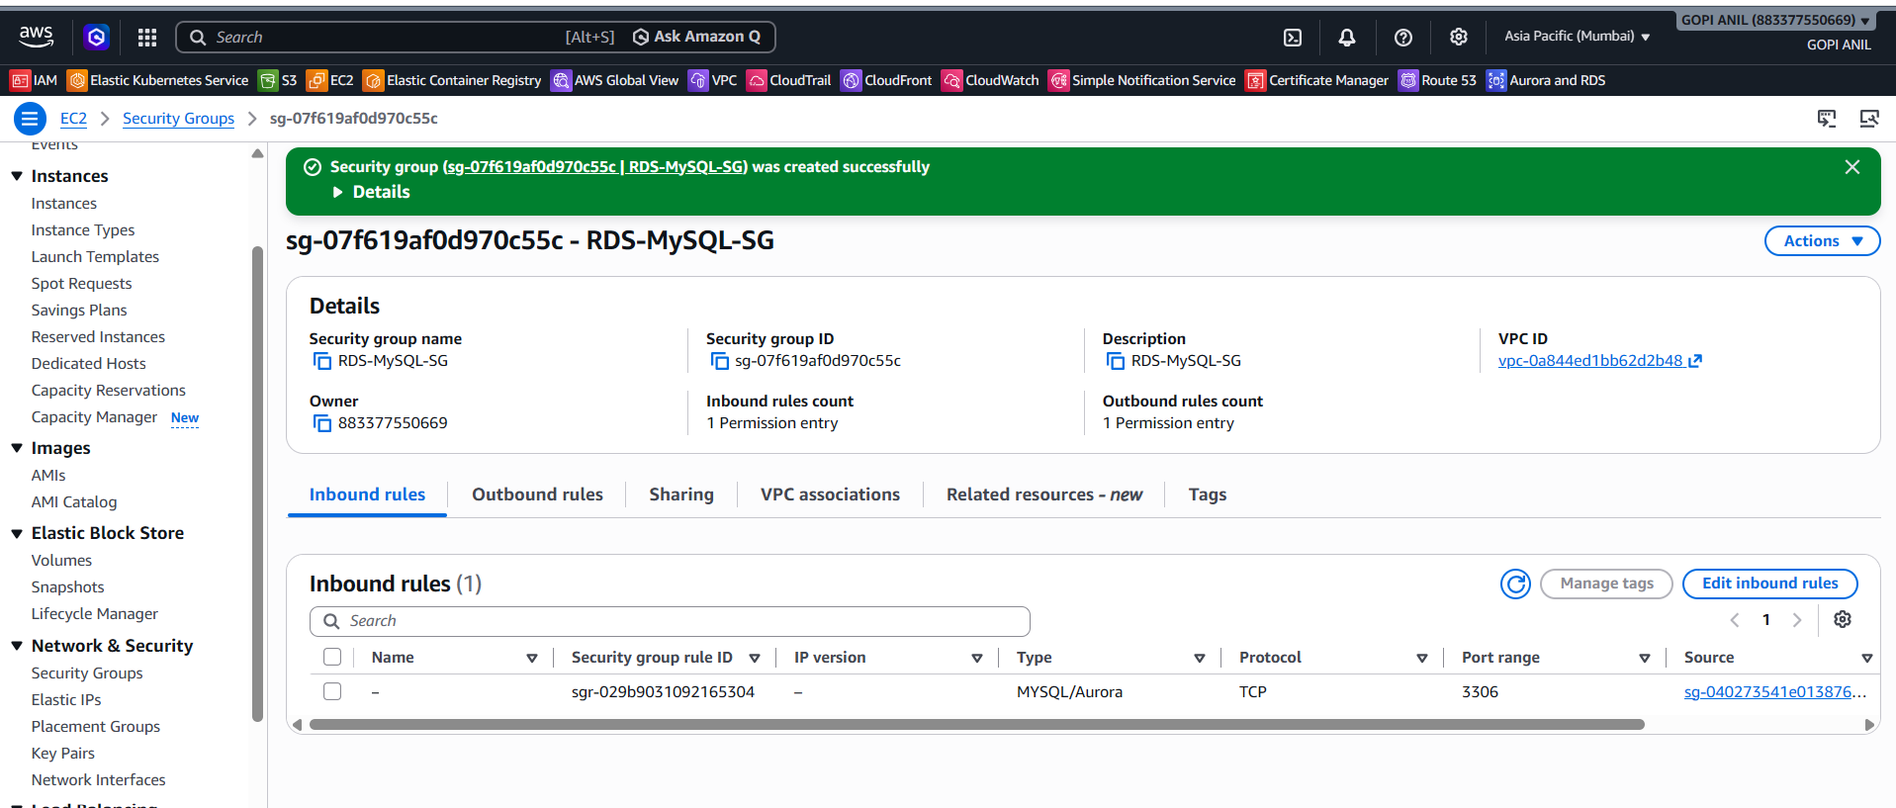

Step 7.2 — Launch the RDS Instance
1. RDS console → Databases → Create database → Standard create.
2. Engine options: MySQL. Engine version: leave the latest default.
3. Templates: Free tier (or Dev/Test).
4. DB instance identifier: MySQL-RDS-Instance.
5. Master username: admin. Master password: set and confirm a strong password.
6. DB instance class: db.t3.micro.
7. Storage: General Purpose SSD (gp3), 20 GiB.
8. Connectivity: VPC = your lab VPC; DB subnet group = lab-db-subnet-group (from Task 4); Public access = Yes (lab only); VPC security group = choose existing → RDS-MySQL-SG.
9. Additional configuration → Initial database name: appdb.
10. Leave the remaining settings default and click Create database.
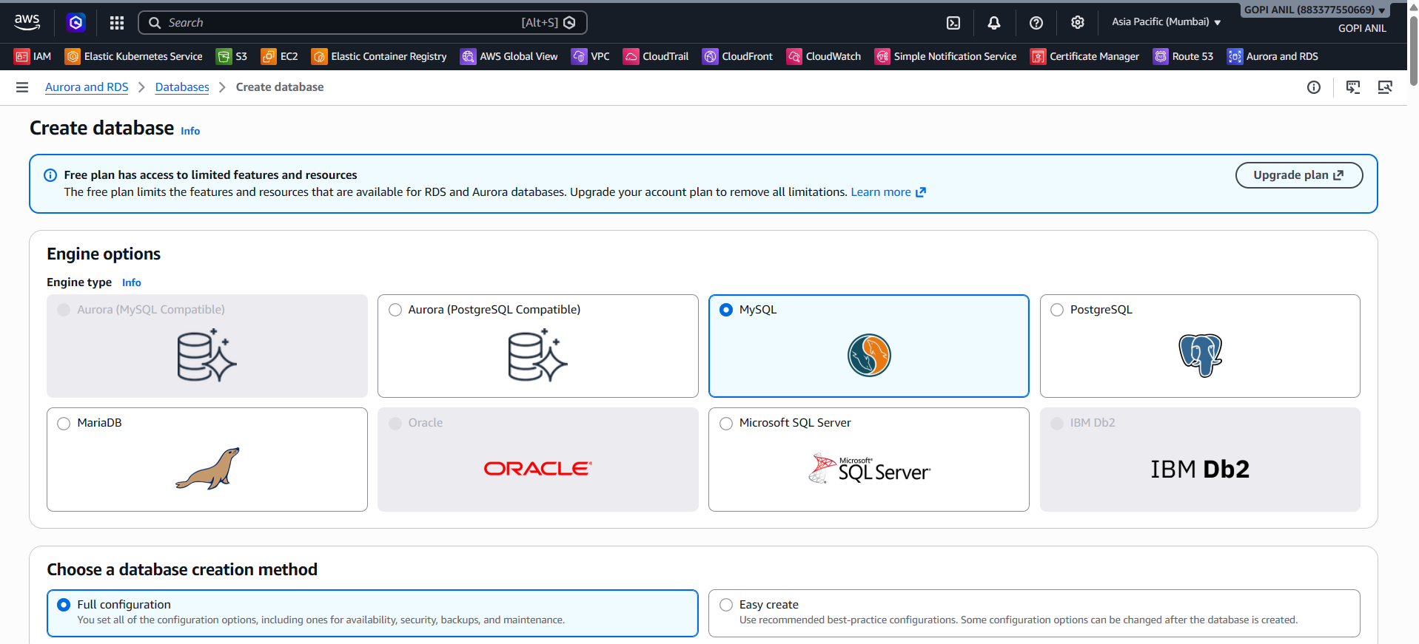
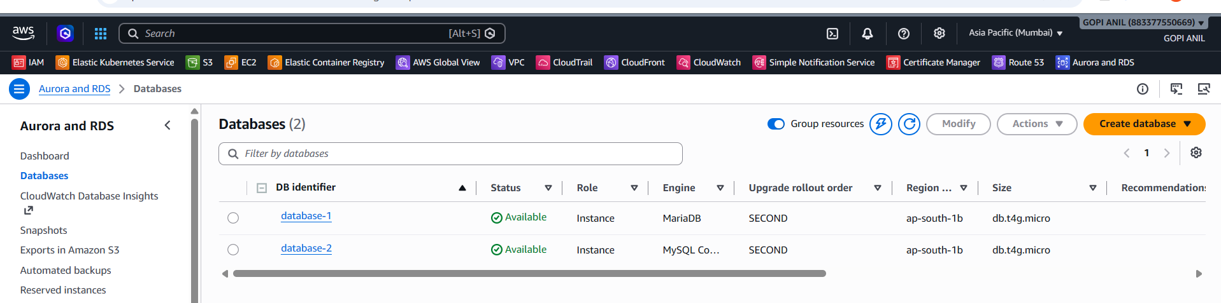

Step 7.3 — Verify
1. Wait for Status to change to Available.
2. Note the Endpoint shown under Connectivity & security.
3. From EC2-MySQL-Instance, confirm connectivity: mysql -h database-2.cls6wwq8wn4s.ap-south-1.rds.amazonaws.com -u admin -p -e "SHOW DATABASES;"
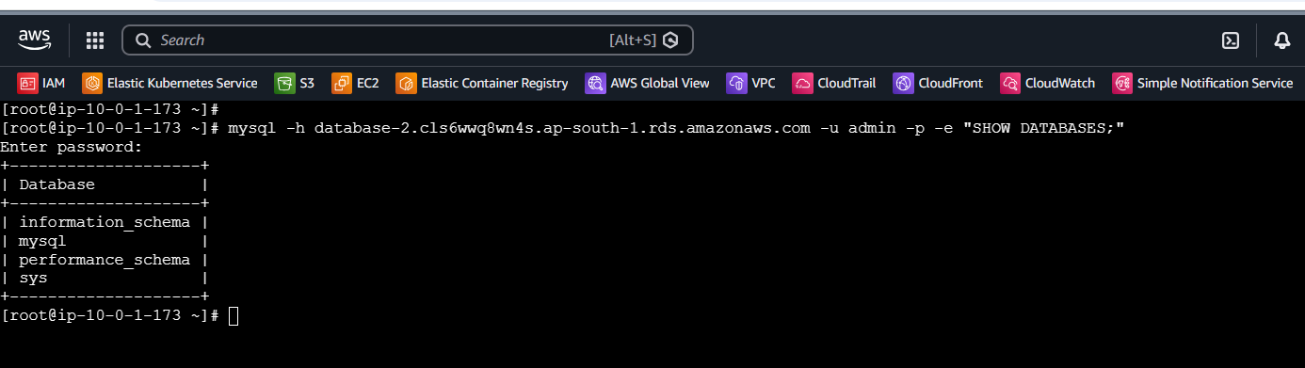

TASK 8: Configure Multi-AZ
Multi-AZ deployments maintain a synchronous standby replica of the database in a second Availability Zone, automatically failing over to it if the primary becomes unavailable — this improves availability, not read scalability (that's what read replicas, Task 10, are for).

Step 8.1 — Modify the RDS Instance
1. RDS console → Databases → select MySQL-RDS-Instance → Modify.
2. Scroll to Availability & durability → Multi-AZ deployment → select Create a standby instance (or Yes).
3. Scroll down → Scheduling of modifications: select Apply immediately (for lab purposes; in production, scheduling this during a maintenance window avoids an unplanned brief failover).
4. Click Continue, review the changes, then click Modify DB instance.

Step 8.2 — Verify
1. The instance's Status shows Modifying while the standby is provisioned and data is synchronized (can take several minutes).
2. Once complete, select MySQL-RDS-Instance → Configuration tab → confirm Multi-AZ shows Yes, and note the Secondary AZ listed.

TASK 9: Take a Backup of the DB and Restore the DB

Step 9.1 — Take a Manual DB Snapshot
1. RDS console → Databases → select MySQL-RDS-Instance → Actions → Take snapshot.
2. Snapshot name: mysql-rds-manual-snapshot-01.
3. Click Take snapshot.
4. Snapshots → wait for mysql-rds-manual-snapshot-01's Status to show Available.

Step 9.2 — Restore the Snapshot as a New DB Instance
1. Select the snapshot mysql-rds-manual-snapshot-01 → Actions → Restore snapshot.
2. DB instance identifier: MySQL-RDS-Restored.
3. DB instance class: db.t3.micro.
4. Connectivity: VPC = your lab VPC; DB subnet group = lab-db-subnet-group; VPC security group = RDS-MySQL-SG.
5. Leave other settings default and click Restore DB instance.
6. Wait for MySQL-RDS-Restored's Status to show Available.

Step 9.3 — Verify the Restore
1. From EC2-MySQL-Instance, connect to the restored instance's new endpoint and confirm the data matches the original:
mysql -h <MySQL-RDS-Restored-Endpoint> -u admin -p appdb
SELECT * FROM customers;
2. Confirm the rows returned match what was present in MySQL-RDS-Instance at the time the snapshot was taken.

TASK 10: Create a Read Replica
A read replica is an asynchronously-updated, separately-connectable copy of the database, used to offload read traffic (reporting, analytics, read-heavy application queries) from the primary instance.

Step 10.1 — Create the Read Replica
1. RDS console → Databases → select MySQL-RDS-Instance (the primary) → Actions → Create read replica.
2. DB instance identifier: MySQL-RDS-ReadReplica.
3. DB instance class: db.t3.micro.
4. Availability Zone: choose a different AZ than the primary's current AZ, or leave No preference.
5. Multi-AZ deployment: No (leave the replica Single-AZ for this lab, to control cost; a replica can independently have its own Multi-AZ standby if needed).
6. VPC security group: RDS-MySQL-SG.
7. Leave other settings default and click Create read replica.
8. Wait for MySQL-RDS-ReadReplica's Status to show Available (Replication status should read Replicating).

Step 10.2 — Verify Replication
1. From EC2-MySQL-Instance, connect to the primary and insert a new row:
mysql -h <MySQL-RDS-Instance-Endpoint> -u admin -p appdb
INSERT INTO customers (name, email, signup_date) VALUES
('Farah Ali', 'farah.ali@example.com', '2026-06-01');
2. Within a few seconds, connect to the read replica's own endpoint and confirm the new row has arrived:
mysql -h <MySQL-RDS-ReadReplica-Endpoint> -u admin -p appdb
SELECT * FROM customers WHERE name = 'Farah Ali';

Step 10.3 — Confirm the Replica Is Read-Only
1. On the read replica's connection, attempt a write and confirm it is rejected:
INSERT INTO customers (name, email, signup_date) VALUES ('Test Write', 'x@example.com', '2026-06-02');
2. Expect an error similar to ERROR 1290: The MySQL server is running with the --read-only option, confirming the replica correctly rejects writes and only accepts them via replication from the primary.

