AWS CloudTrail, SNS & CloudWatch

Tasks Covered
1. Enable CloudTrail monitoring and store events in S3 and CloudWatch Logs.
2. Enable SNS for CloudTrail to send alerts via email.
3. Configure CloudWatch monitoring and record CPU utilization and other metrics of EC2.
4. Create an alarm to send an alert to email if CPU utilization is more than 70 percent.

Prerequisites
- An AWS account with console access to CloudTrail, S3, CloudWatch, SNS, and EC2.
- At least one running EC2 instance (Amazon Linux 2023 assumed) to monitor CPU, Tomcat, and Nginx.
- An email address you can access, to confirm SNS subscriptions and receive alerts.

TASK 1: Enable CloudTrail — Store Events in S3 and CloudWatch Logs

Step 1.1 — Open the CloudTrail Console
1. Log in to the AWS Management Console.
2. Search for and open CloudTrail. CloudTrail trails can be Region-specific or applied to all Regions; this guide creates an all-Region trail.
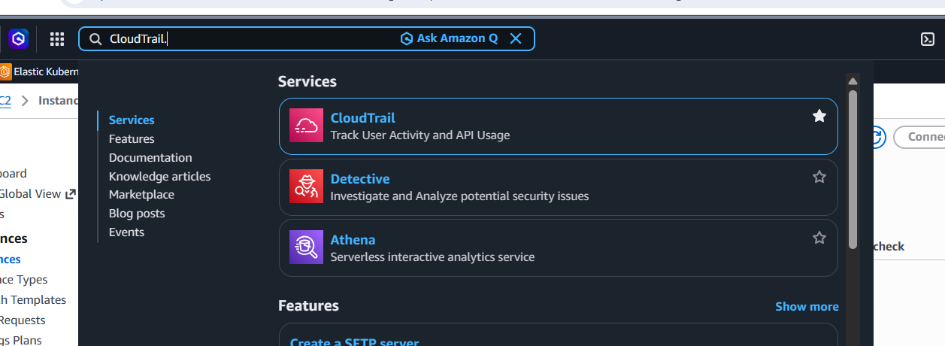

Step 1.2 — Create the Trail
1. Left pane → Trails → Create trail.
2. Trail name: Org-Management-Trail.
3. Enable for all accounts in my organization: leave OFF unless using AWS Organizations.
4. Storage location: Create new S3 bucket → bucket name auto-fills as something like aws-cloudtrail-logs-111122223333-xxxxxxxx (or choose Use existing S3 bucket if one already exists).
5. Log file SSE-KMS encryption: leave enabled (recommended) or disable for a simple lab.
6. Log file validation: Enabled (recommended, allows integrity checking of delivered logs).
7. Click Next.
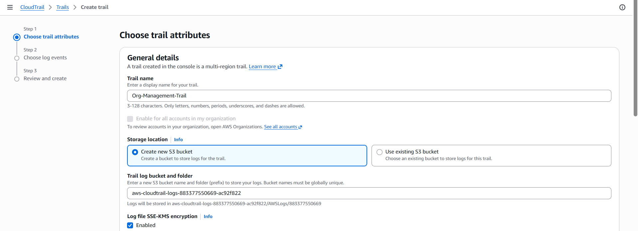

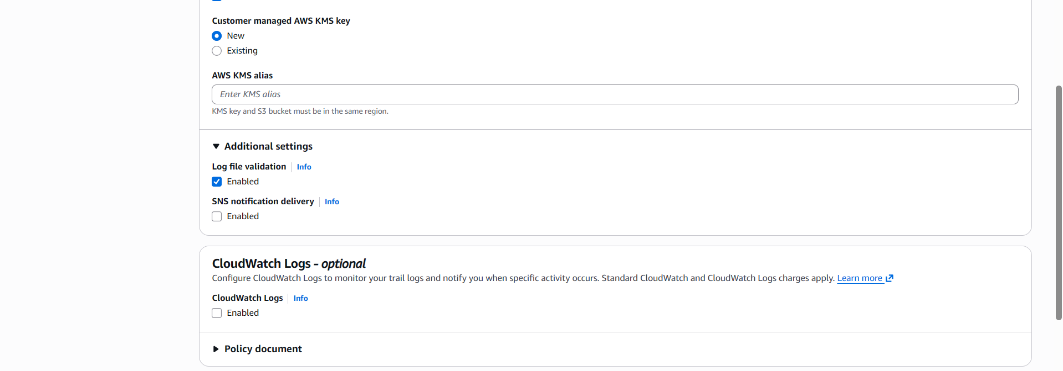
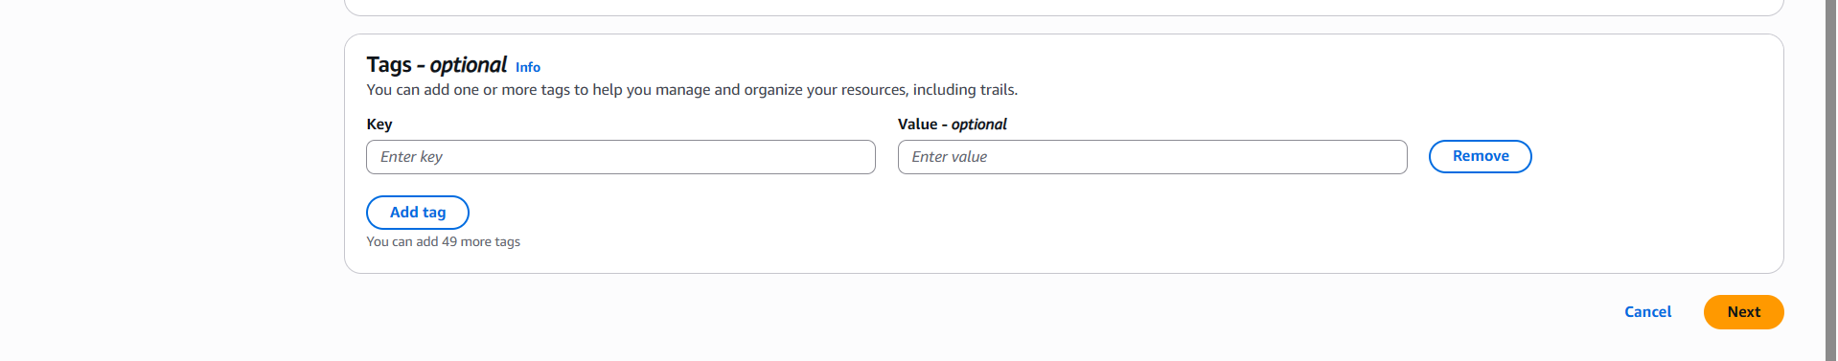

Step 1.3 — Enable CloudWatch Logs Delivery
1. Under CloudWatch Logs, check Enabled.
2. New log group: enter a name, e.g., /aws/cloudtrail/Org-Management-Trail.
3. IAM Role: New role → role name auto-fills, e.g., CloudTrailRole-Org-Management-Trail (this role allows CloudTrail to write to the log group).
4. Click Next.

Step 1.4 — Choose Event Types
1. Management events: check Read and Write (captures control-plane API calls like RunInstances, CreateBucket, etc.).
2. Data events: leave unchecked for this lab (optional; adds S3 object-level and Lambda invocation logging at extra cost).
3. Click Next, review the summary, then click Create trail.
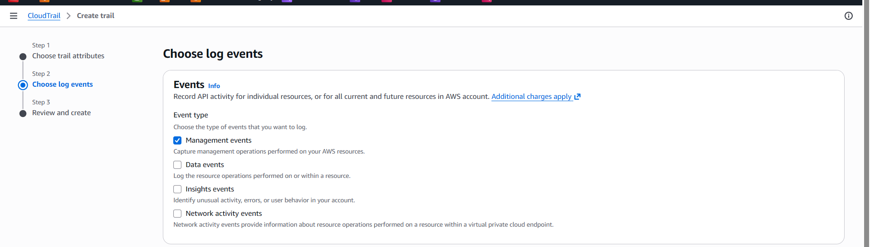
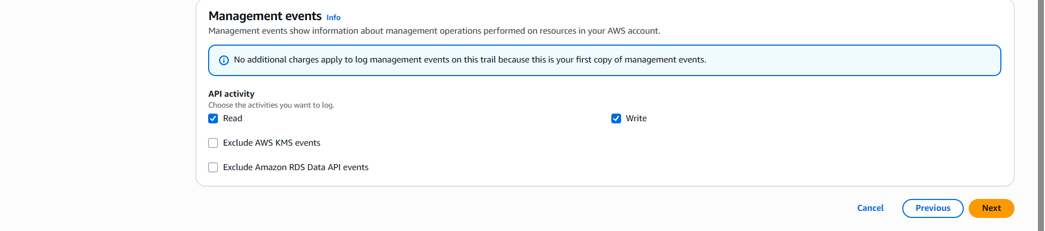

Step 1.5 — Verify Delivery to S3
1. Wait 10–15 minutes for the first log files to be delivered.
2. Open the S3 console → the auto-created bucket → drill into AWSLogs/<account-id>/CloudTrail/<region>/<year>/<month>/<day>/ and confirm .json.gz log files are present.

Step 1.6 — Verify Delivery to CloudWatch Logs
1. Open the CloudWatch console → Log groups → click /aws/cloudtrail/Org-Management-Trail.
2. Confirm log streams are present and contain recent CloudTrail event JSON when opened.
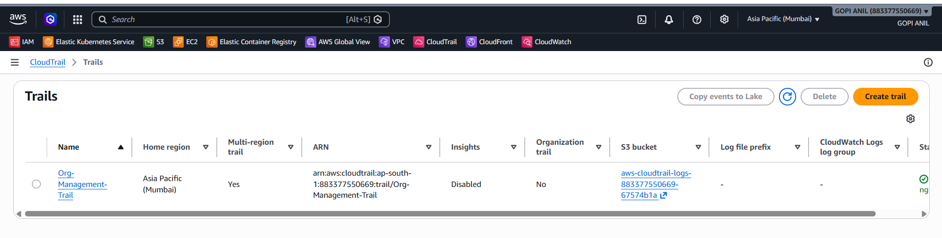
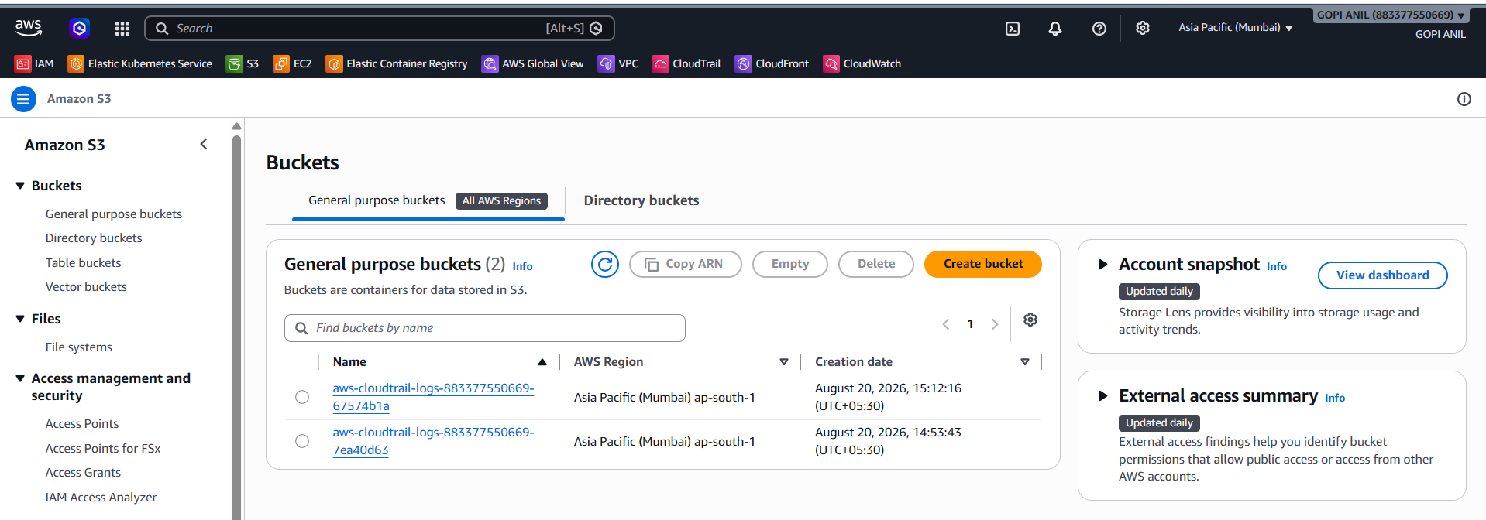

TASK 2: Enable SNS for CloudTrail to Send Email Alerts
Goal: Get an email notification whenever a specific security-relevant event appears in the CloudTrail log — this example alerts on any AWS root account usage, a common security best practice.

Step 2.1 — Create the SNS Topic
1. Open the SNS console → Topics → Create topic.
2. Type: Standard.
3. Name: CloudTrail-Security-Alerts.
4. Leave other settings default and click Create topic.
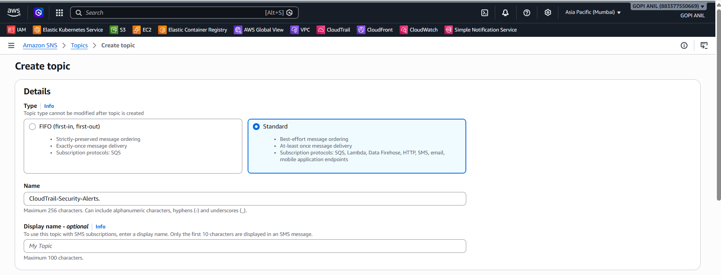
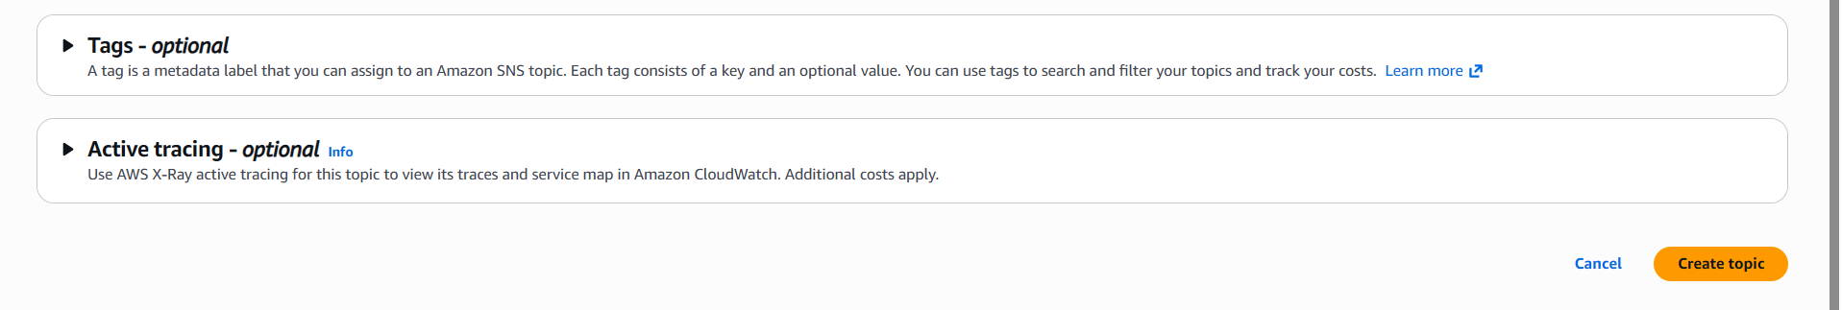

Step 2.2 — Subscribe Your Email to the Topic
1. On the topic's detail page, click Create subscription.
2. Protocol: Email.
3. Endpoint: enter your email address.
4. Click Create subscription.
5. Check your inbox for an email from AWS Notifications and click Confirm subscription — the subscription stays Pending confirmation until this is done.
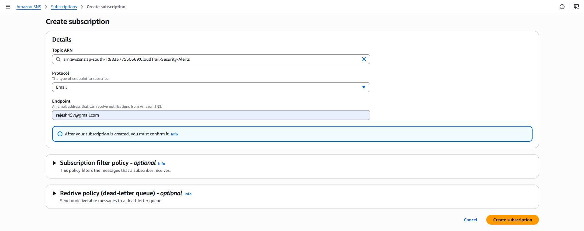
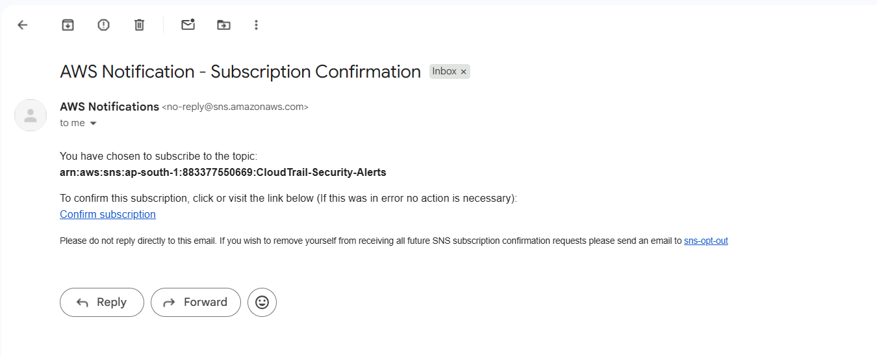
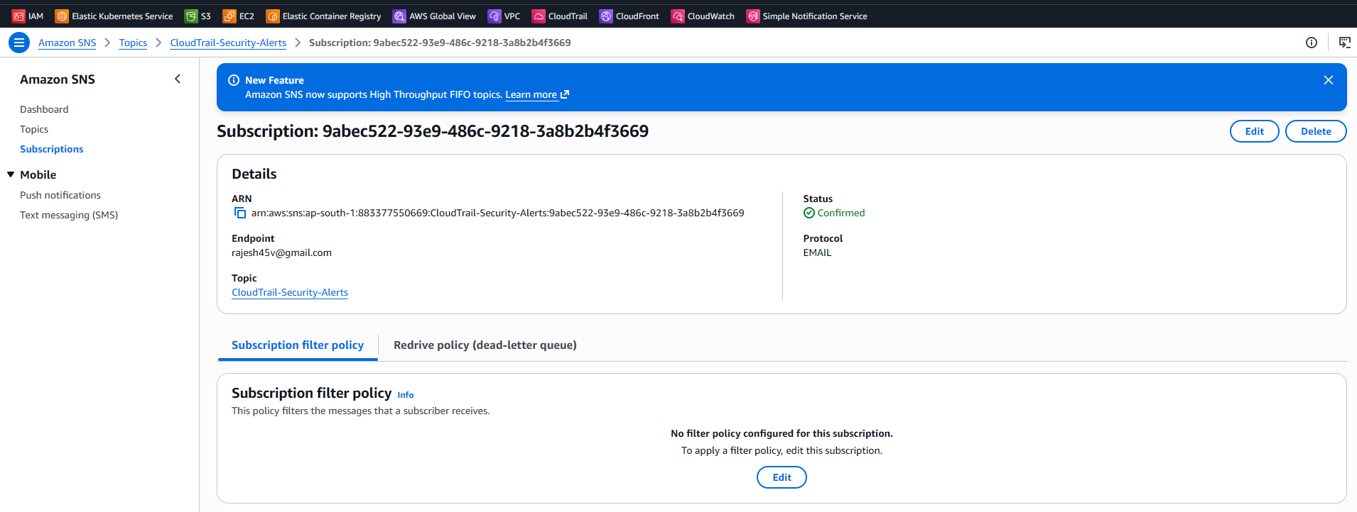

Step 2.3 — Create a Metric Filter on the CloudTrail Log Group
- CloudWatch console → Log groups → open /aws/cloudtrail/Org-Management-Trail.
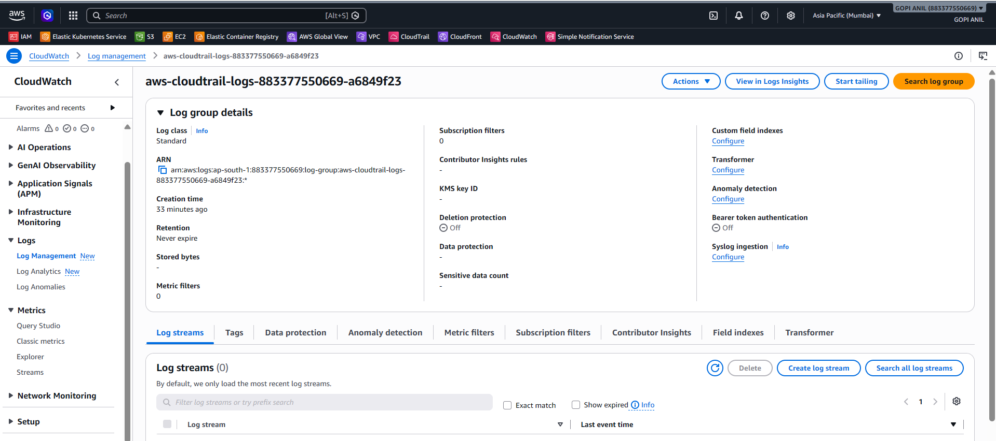
- Metric filters tab → Create metric filter.
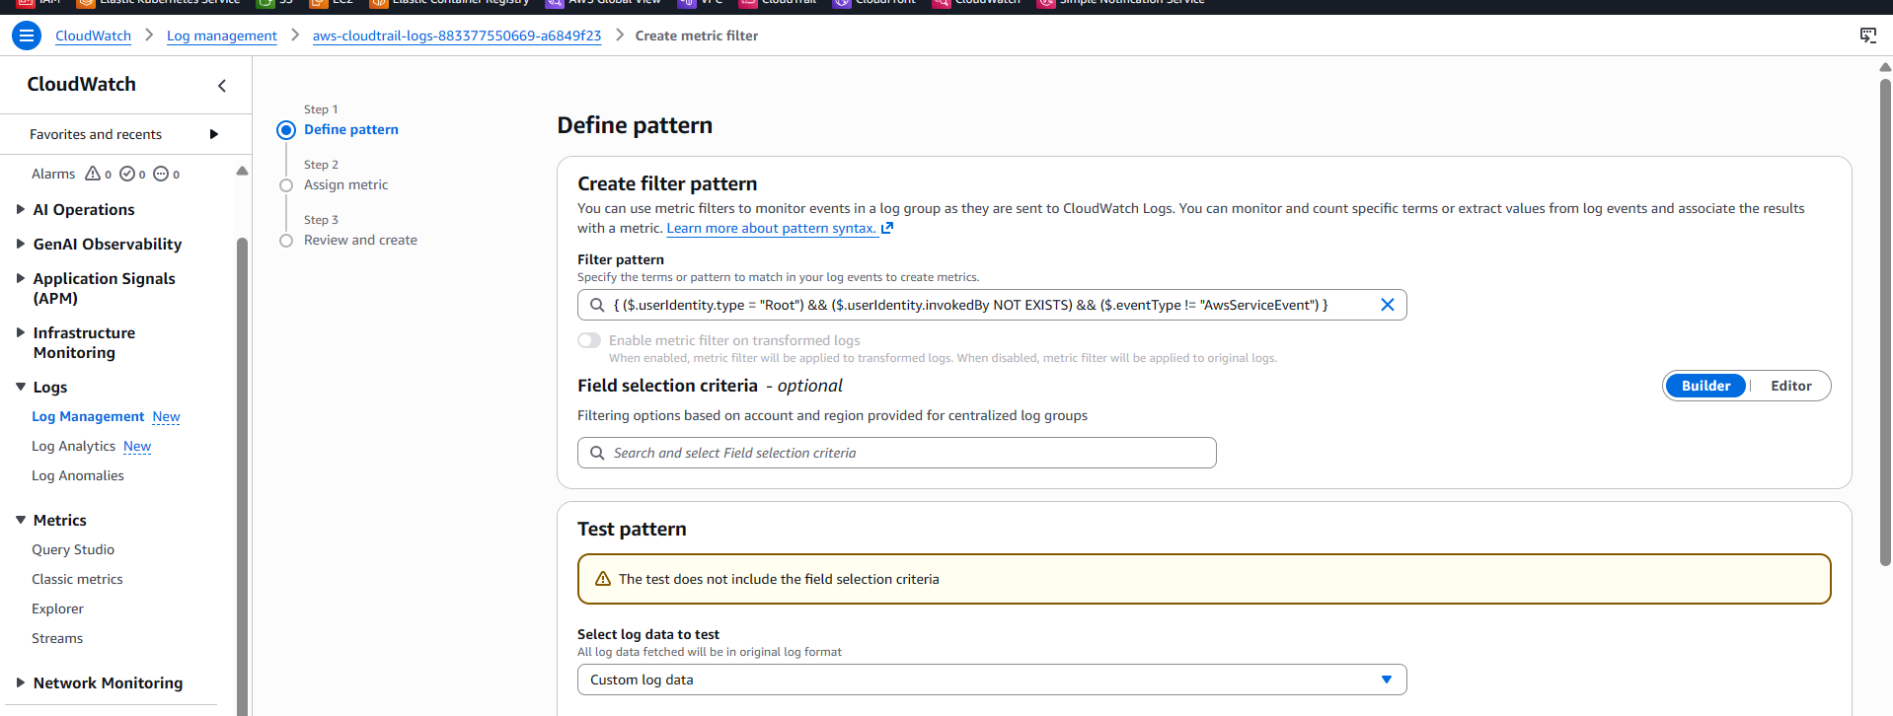

3. Filter pattern:
{ ($.userIdentity.type = "Root") && ($.userIdentity.invokedBy NOT EXISTS) && ($.eventType != "AwsServiceEvent") }
4. Click Next. Filter name: RootAccountUsageFilter. Metric namespace: CloudTrailMetrics. Metric name: RootAccountUsageCount. Metric value: 1.
5. Click Next, review, then Create metric filter.
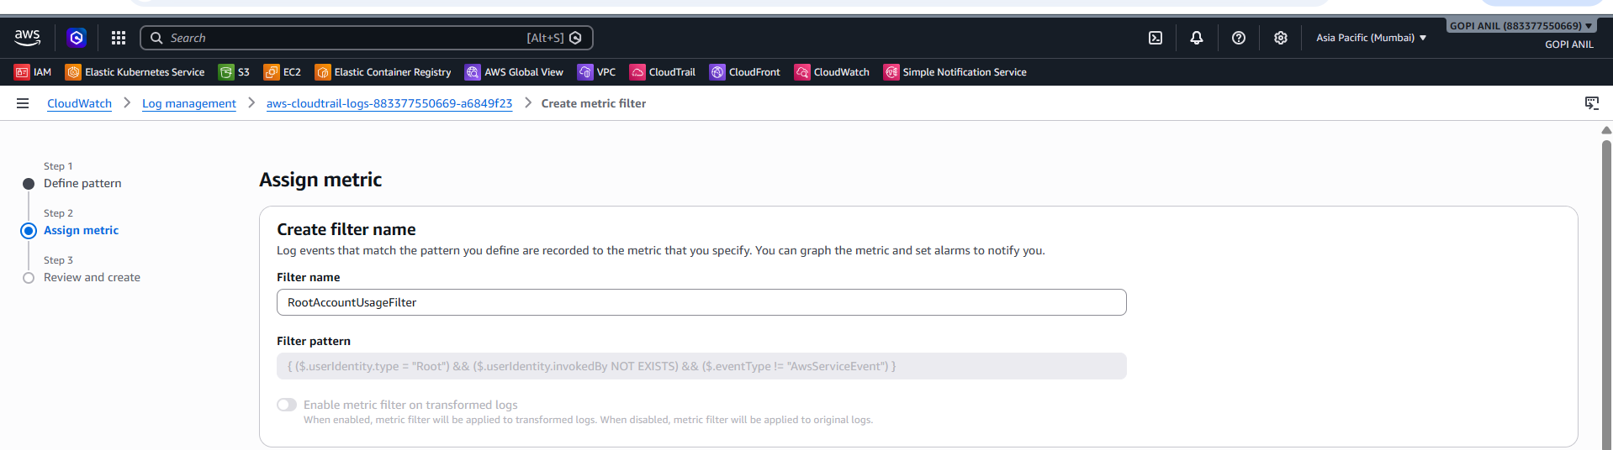
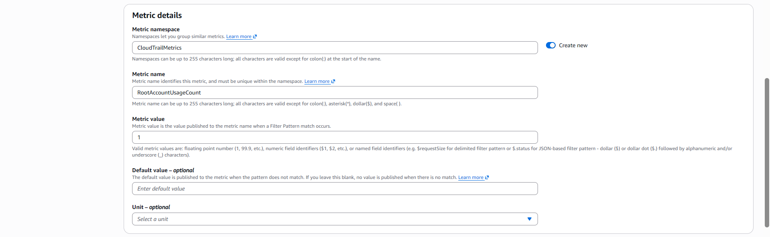
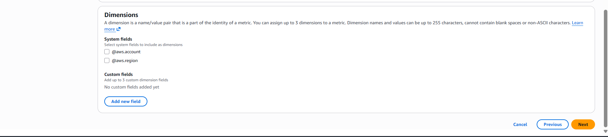
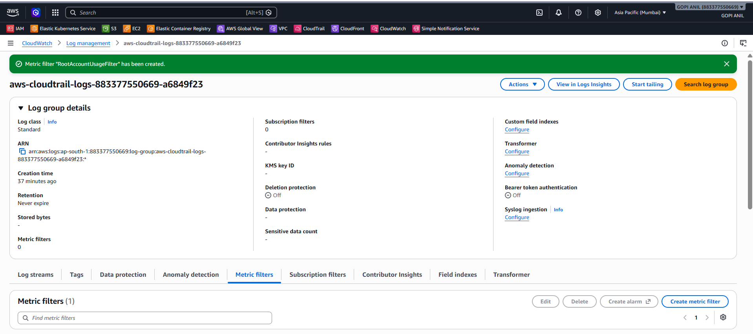

Step 2.4 — Create the Alarm on That Metric
1. Select the new metric filter → Create alarm.
2. Statistic: Sum. Period: 5 minutes.
3. Condition: Greater/Equal → threshold 1.
4. Click Next → In Notification, select the existing SNS topic CloudTrail-Security-Alerts → Next.
5. Alarm name: RootAccountUsageAlarm → Next → Create alarm.
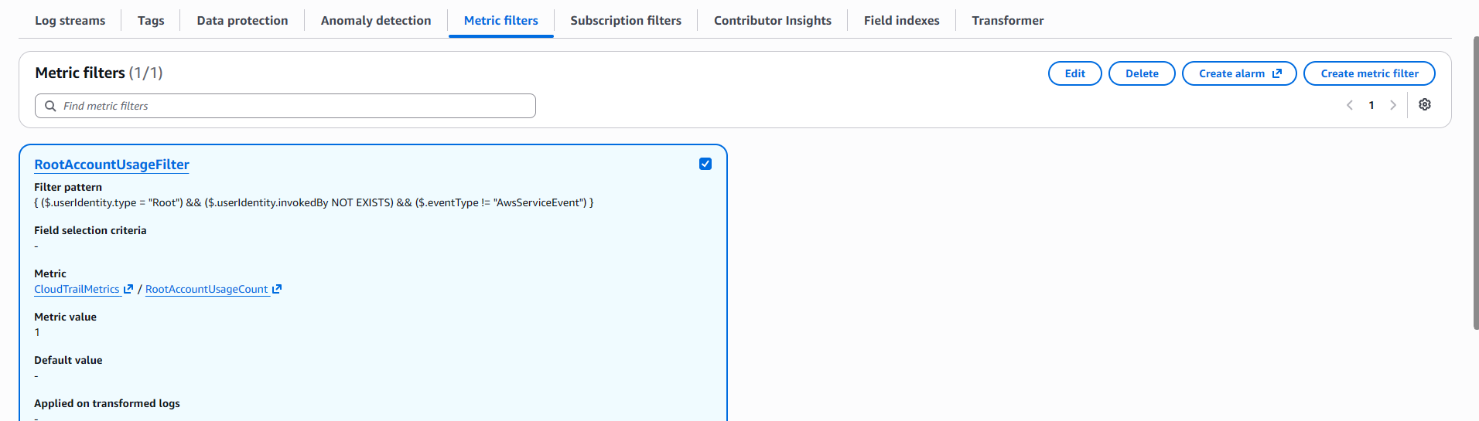
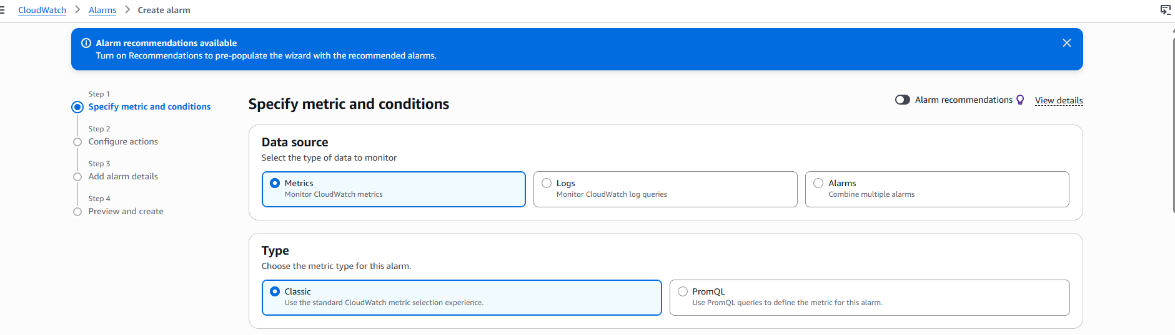
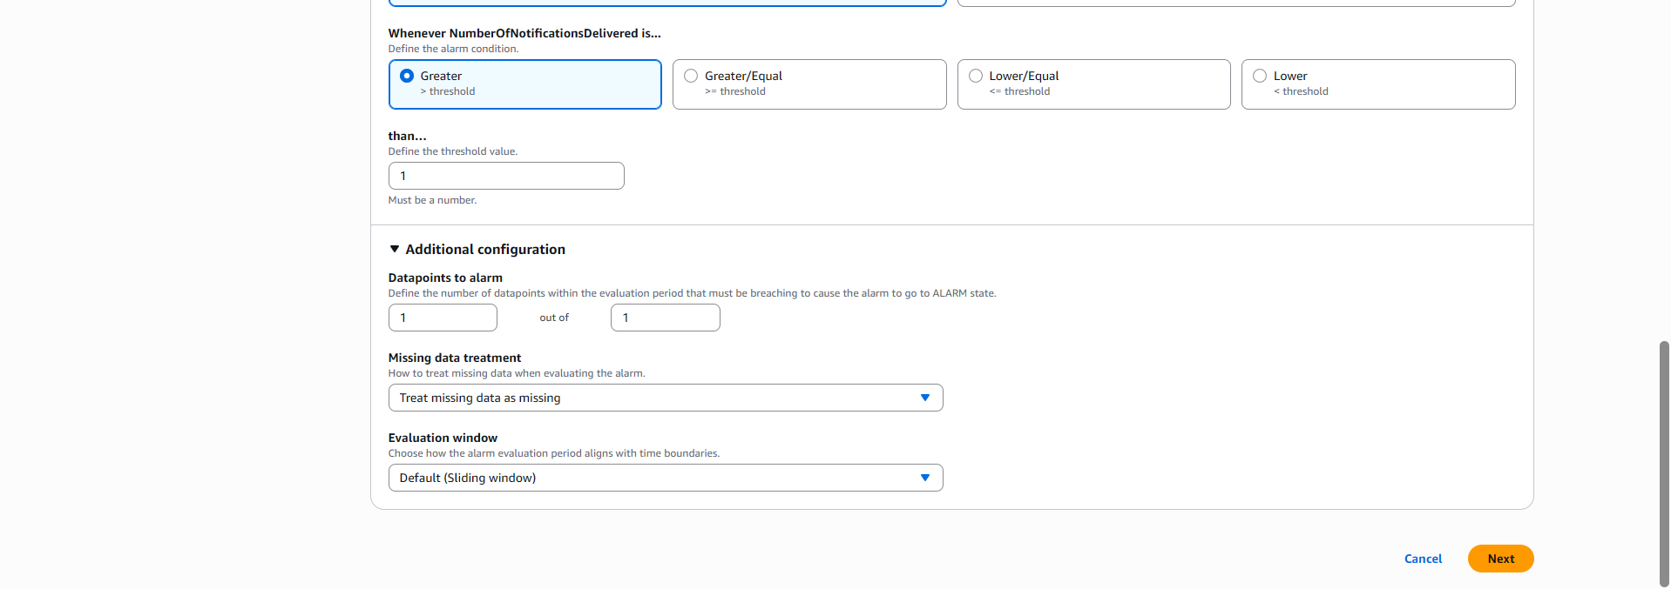

TASK 3: Configure CloudWatch Monitoring for EC2 CPU and Other Metrics

Step 3.1 — View Default (Basic) EC2 Metrics
1. Open the EC2 console → Instances → select the target instance.
2. Monitoring tab → view the built-in graphs already available at 5-minute resolution: CPU Utilization, Network In/Out, Disk Read/Write (Ops and Bytes), and Status Check Failed.
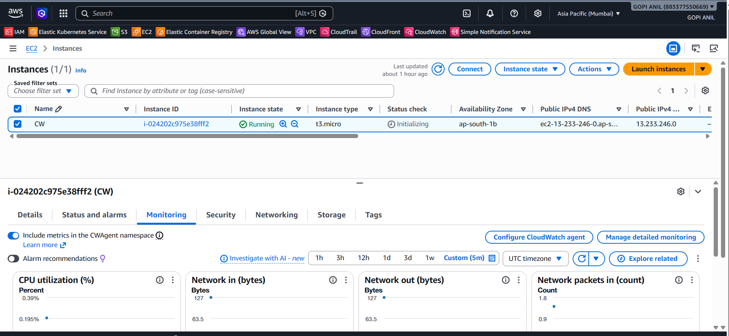

Step 3.2 — Enable Detailed (1-Minute) Monitoring
1. With the instance selected, click Actions → Monitor and troubleshoot → Manage detailed monitoring.
2. Select Enable and click Confirm (this changes CPUUtilization and other basic metrics from 5-minute to 1-minute resolution; a small additional charge applies).
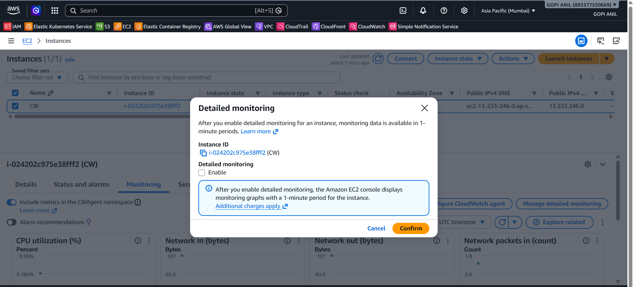

Step 3.3 — Install the CloudWatch Agent for OS-Level Metrics (Memory, Disk Usage)
EC2's default metrics do not include memory or disk space usage from inside the OS — the CloudWatch Agent is required for those.
- Attach an IAM role with the CloudWatchAgentServerPolicy managed policy to the EC2 instance (EC2 console → instance → Actions → Security → Modify IAM role).
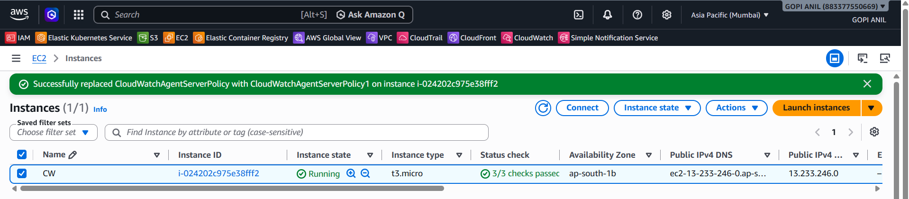
2. SSH into the instance and install the agent (Amazon Linux 2023):
sudo yum install -y amazon-cloudwatch-agent
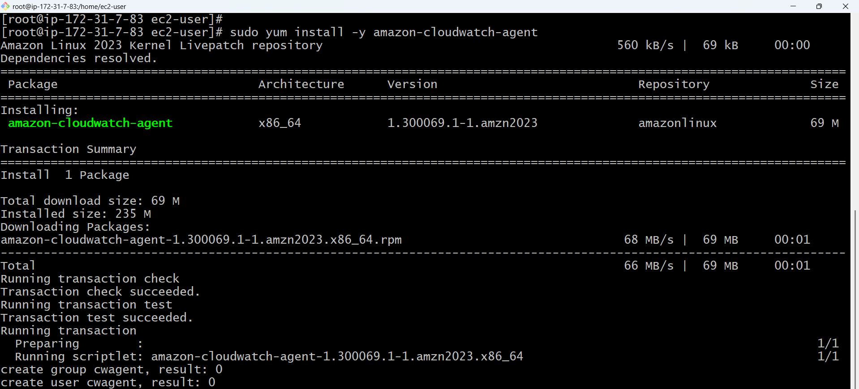
3. Create the agent configuration file:
sudo vim /opt/aws/amazon-cloudwatch-agent/etc/config.json
4. Paste a basic configuration capturing memory and disk usage:
{
"metrics": {
"namespace": "CWAgent",
"metrics_collected": {
"mem": { "measurement": ["mem_used_percent"] },
"disk": {
"measurement": ["used_percent"],
"resources": ["/"]
}
}
}
}
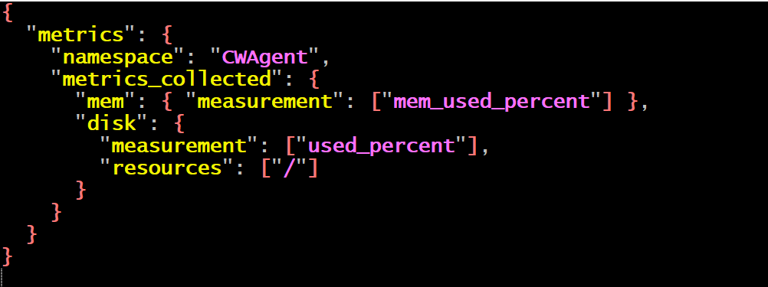
5. Start the agent with this configuration:
sudo /opt/aws/amazon-cloudwatch-agent/bin/amazon-cloudwatch-agent-ctl -a fetch-config -m ec2 -s -c file:/opt/aws/amazon-cloudwatch-agent/etc/config.json

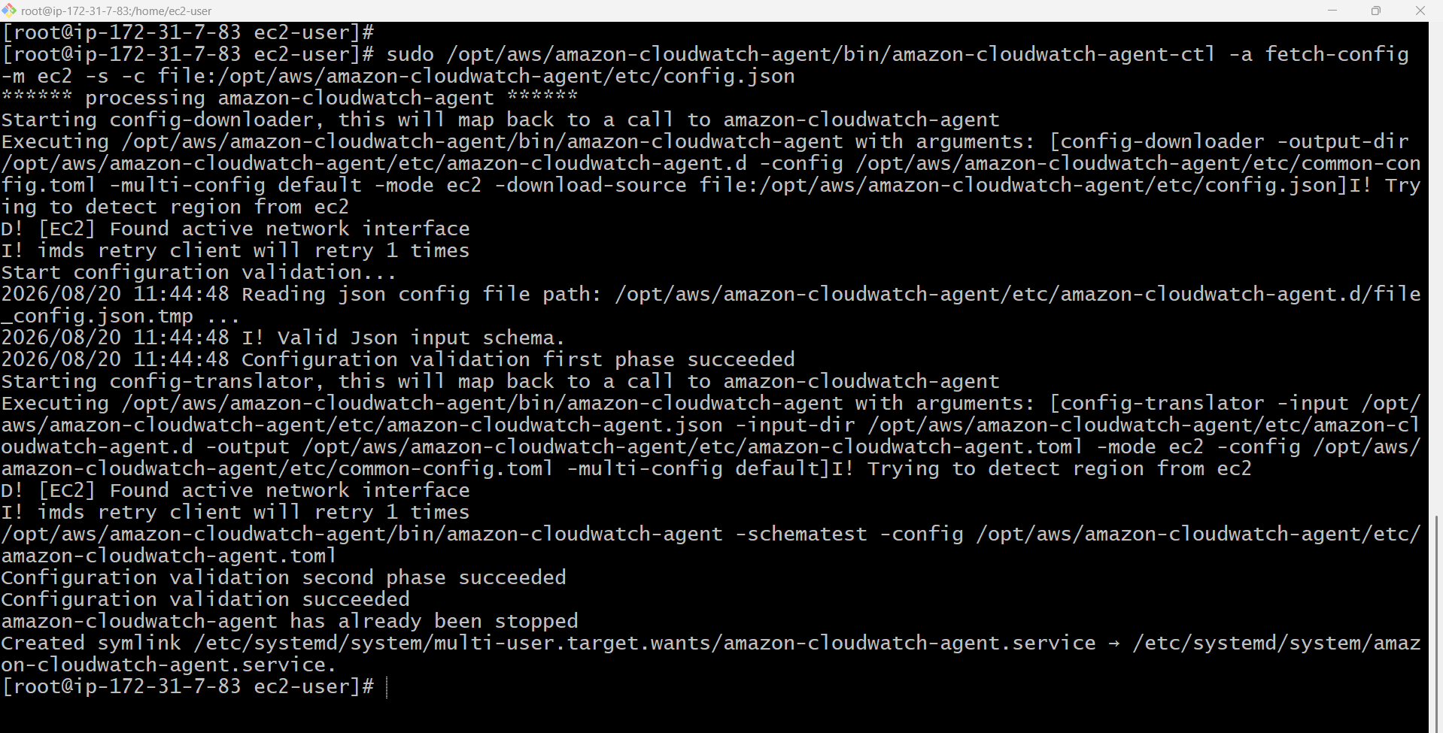

Step 3.4 — View the Metrics in CloudWatch
1. CloudWatch console → Metrics → All metrics.
2. Under EC2 → Per-Instance Metrics, confirm CPUUtilization, NetworkIn, NetworkOut, DiskReadBytes, and DiskWriteBytes are populated for the instance.
3. Under CWAgent, confirm mem_used_percent and disk_used_percent are populated (these appear only after the agent has been running for a few minutes).
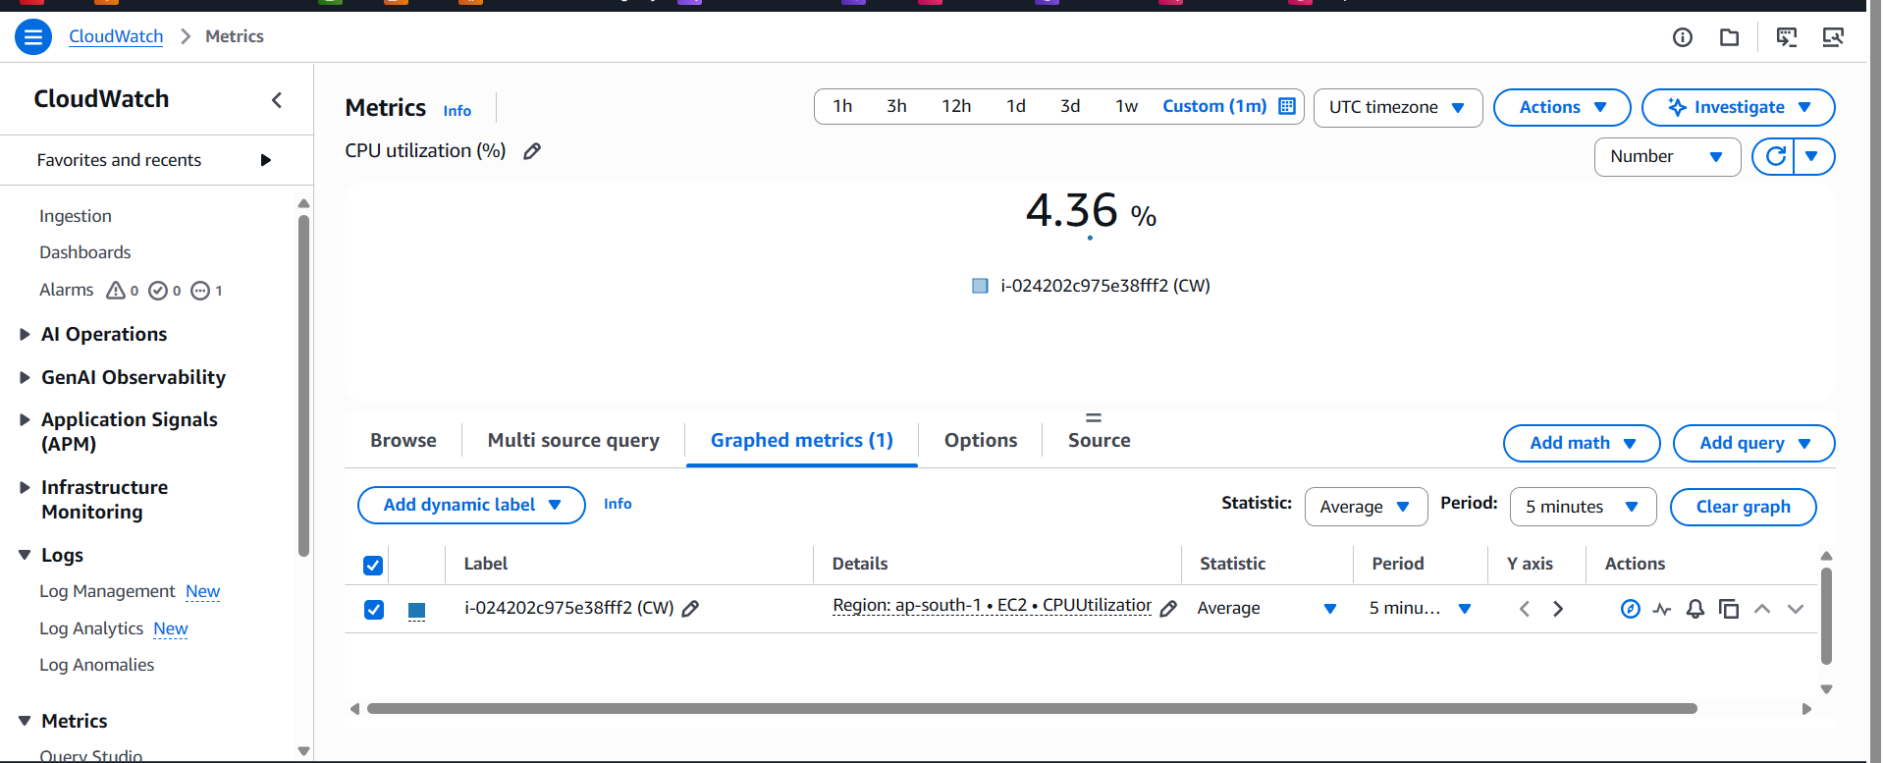.

TASK 4: Alarm: Email Alert When CPU Utilization Exceeds 70%

Step 4.1 — Start Creating the Alarm
1. CloudWatch console → Alarms → All alarms → Create alarm.
2. Click Select metric → EC2 → Per-Instance Metrics → find the target instance → check CPUUtilization → Select metric.
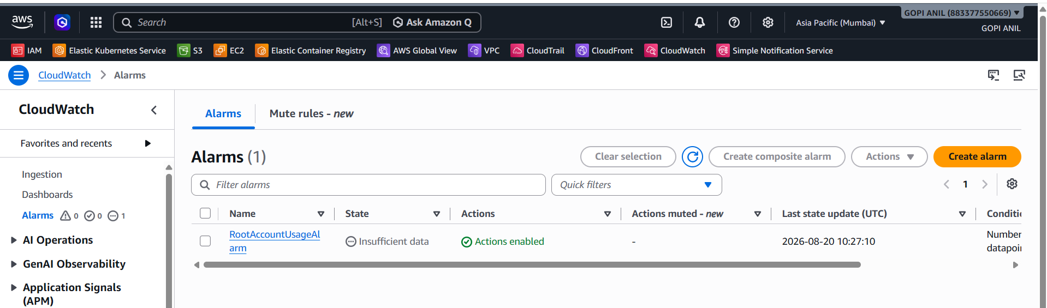
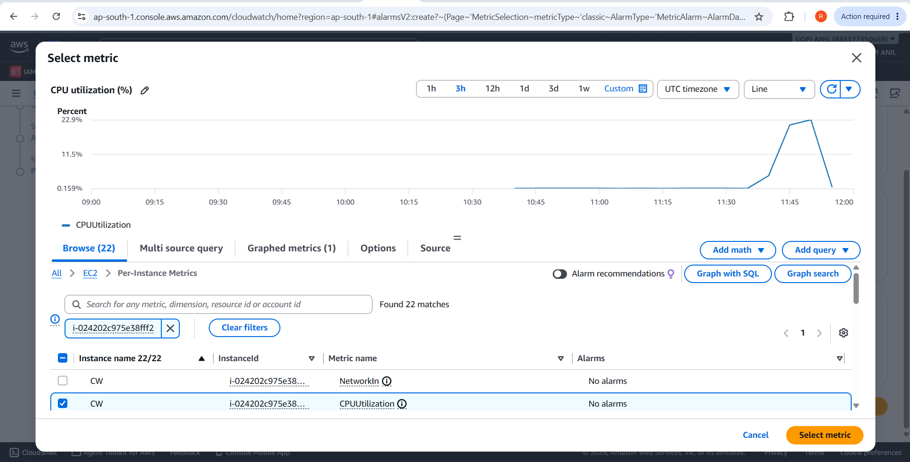

Step 4.2 — Set the Threshold
1. Statistic: Average. Period: 5 minutes.
2. Threshold type: Static.
3. Condition: Greater than 70 (whenever CPUUtilization is Greater than the threshold 70).
4. Additional configuration → Datapoints to alarm: 1 out of 1 (alarm on the very first breaching datapoint; increase to reduce false positives from short spikes).
5. Click Next.
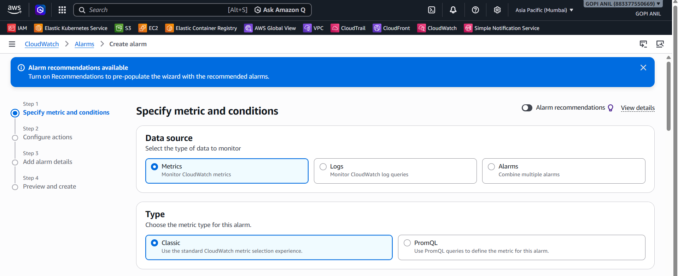
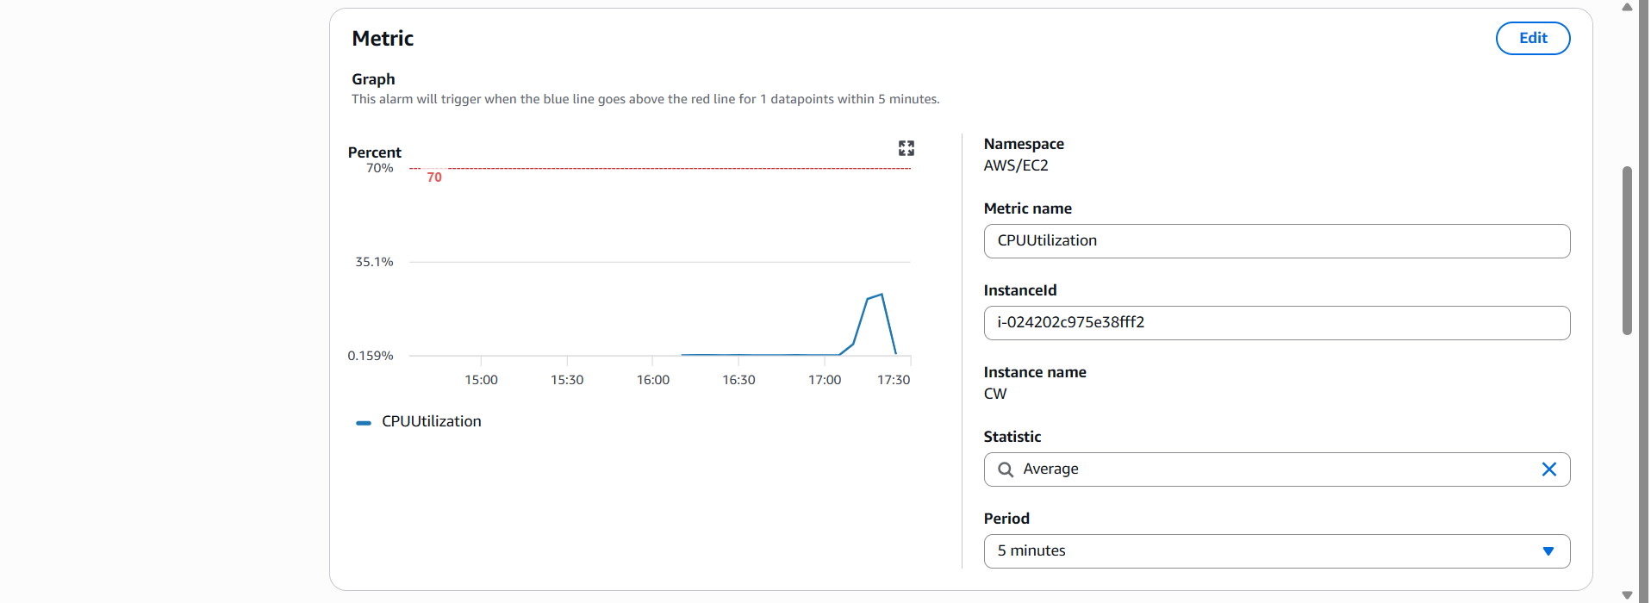
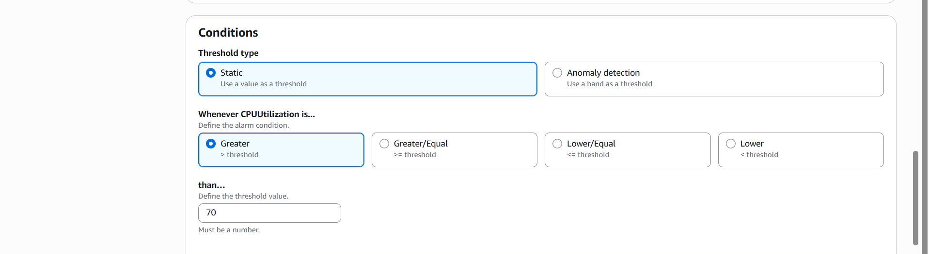
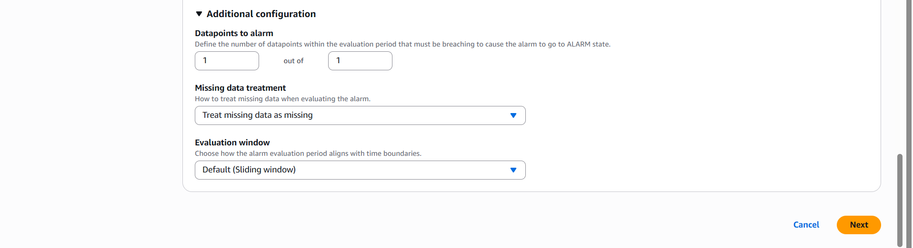

Step 4.3 — Configure the Notification
1. Alarm state trigger: In alarm.
2. Select an SNS topic: choose the existing CloudTrail-Security-Alerts topic, or click Create new topic and name it EC2-CPU-Alerts, adding your email as the endpoint and confirming the subscription (same process as Task 2, Steps 2.1–2.2).
3. (Optional) Add a second notification for OK state so you're told when CPU drops back to normal — Add notification → alarm state trigger: OK → same topic.
4. Click Next.
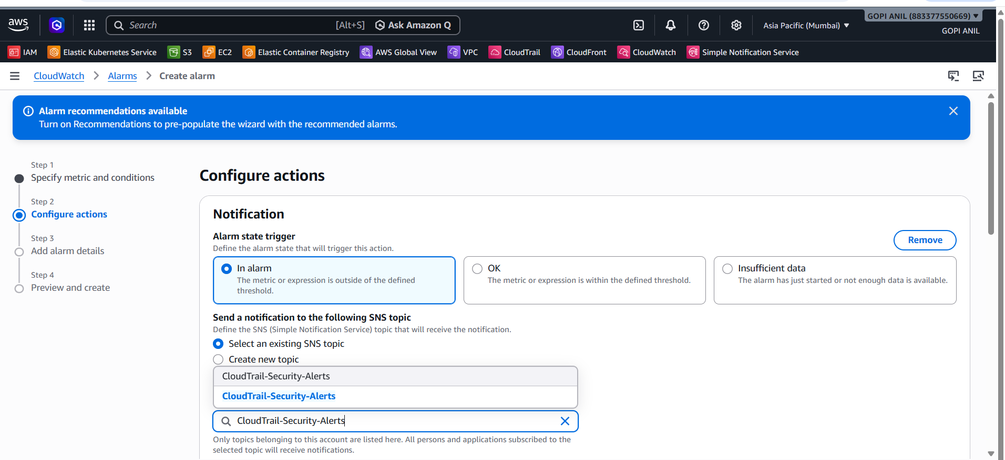
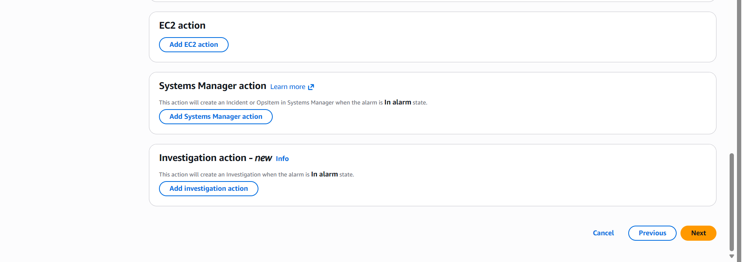

Step 4.4 — Name and Create
1. Alarm name: High-CPU-Utilization-Alarm.
2. Alarm description: Alerts when EC2 CPU utilization exceeds 70% for 5 minutes.
3. Click Next, review the summary, then Create alarm.
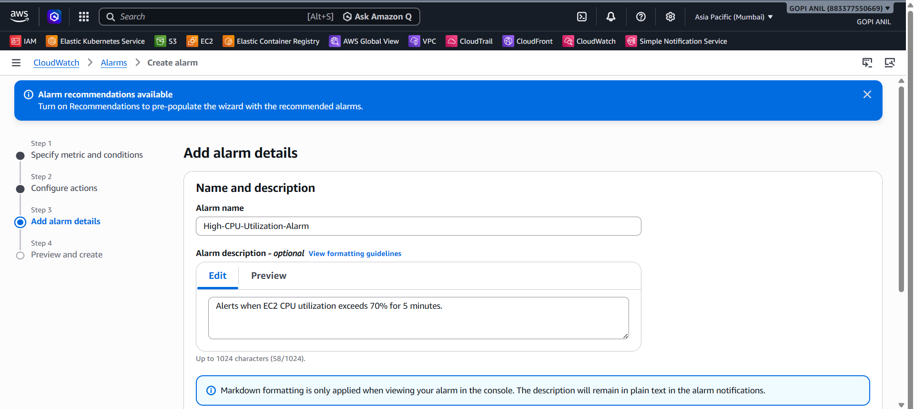
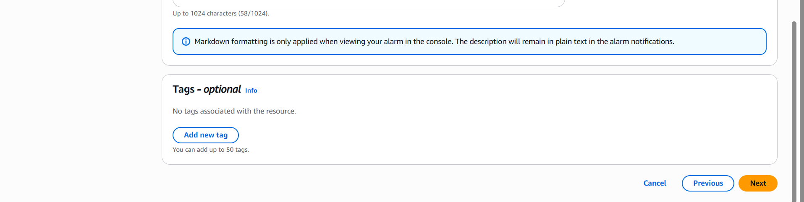

Step 4.5 — Test the Alarm
1. SSH into the instance and generate CPU load, e.g. using the stress tool: sudo amazon-linux-extras install epel -y && sudo yum install -y stress && stress --cpu 4 --timeout 600
2. Watch the alarm in the CloudWatch console — its state should change from OK to In alarm within a few minutes once the average CPU exceeds 70%.
3. Confirm an email alert arrives. Stop the stress command (Ctrl+C) and confirm the alarm returns to OK once CPU drops.
