S3 Bucket Tasks

Tasks Covered
1. Create an S3 bucket and upload some objects to S3.
2. Deploy a static website in the S3 bucket.
3. Enable cross-region replication on S3 buckets.
4. Configure a bucket policy so only the Admin user can see the objects of the S3 bucket.
5. Set up lifecycle policies to automatically transition or delete objects based on specific criteria.
6. Push some objects to S3 using the AWS CLI.
7. Write a Bash script to create an S3 bucket.
8. Upload a 1 GB file to S3 using the CLI.

Prerequisites
- An AWS account with S3 and IAM console access.
- AWS CLI v2 installed and configured (aws configure) with credentials that have s3:* permissions for Tasks 6–8.
- Basic familiarity with a Linux/macOS terminal (or WSL/Git Bash on Windows) for the CLI and bash-script tasks.
Naming/region plan used throughout this guide (bucket names must be globally unique — append your own suffix, e.g., your initials or account ID):
Purpose | Example Bucket Name | Region
Primary bucket (Tasks 1, 4, 5, 6, 8) | my-lab-bucket-primary-2026 | ap-south-1
Static website bucket (Task 2) | my-lab-website-2026 | ap-south-1
Replication source (Task 3) | my-lab-replication-source-2026 | ap-south-1
Replication destination (Task 3) | my-lab-replication-dest-2026 | us-east-1

TASK 1: Create an S3 Bucket and Upload Objects

Step 1.1 — Open the S3 Console
1. Log in to the AWS Management Console.
2. In the top search bar, type S3 and click S3 (under Services). S3 bucket names are global, but you still pick a Region for where the bucket's data is stored.
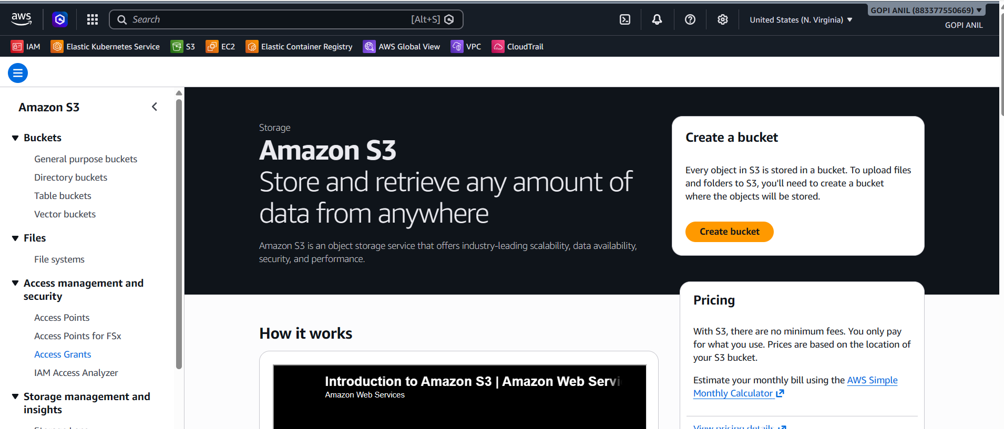

Step 1.2 — Create the Bucket
1. Click Create bucket.
2. Bucket name: my-lab-bucket-primary-2026 (must be globally unique; adjust as needed).
3. AWS Region: Asia Pacific (Mumbai) ap-south-1.
4. Object Ownership: ACLs disabled (recommended, default).
5. Block Public Access settings: leave all four boxes checked (Block all public access) — this bucket is private.
6. Bucket Versioning: Disable for now (Task 3 will enable it on the replication buckets).
7. Leave the remaining defaults (encryption: SSE-S3, no tags) and click Create bucket.
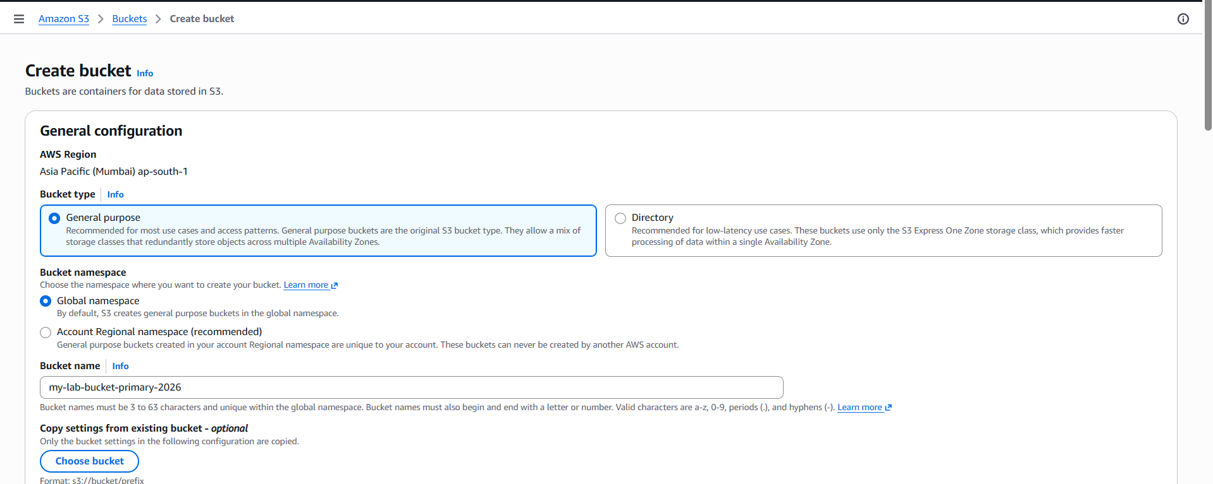
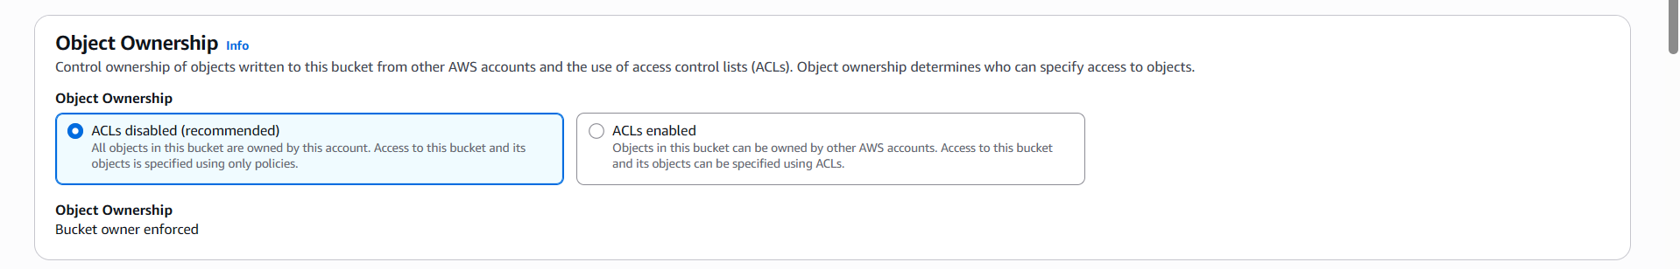
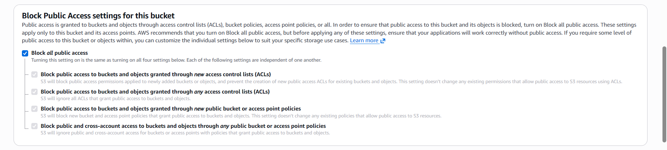
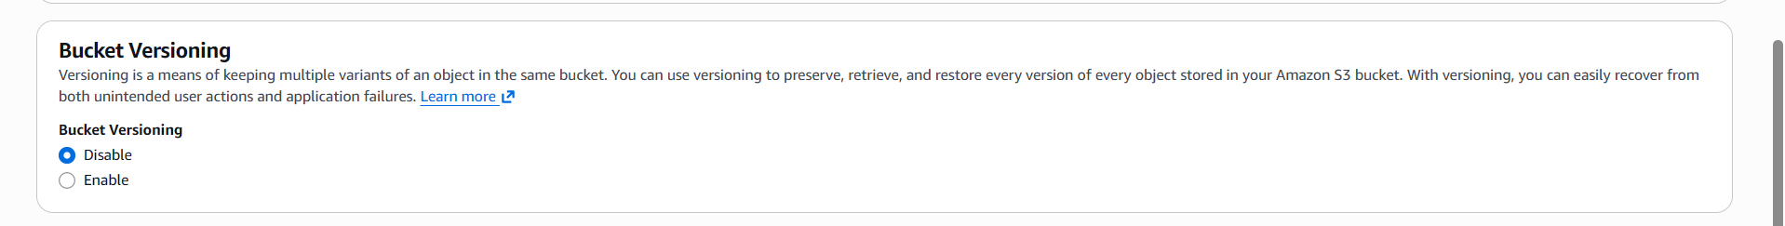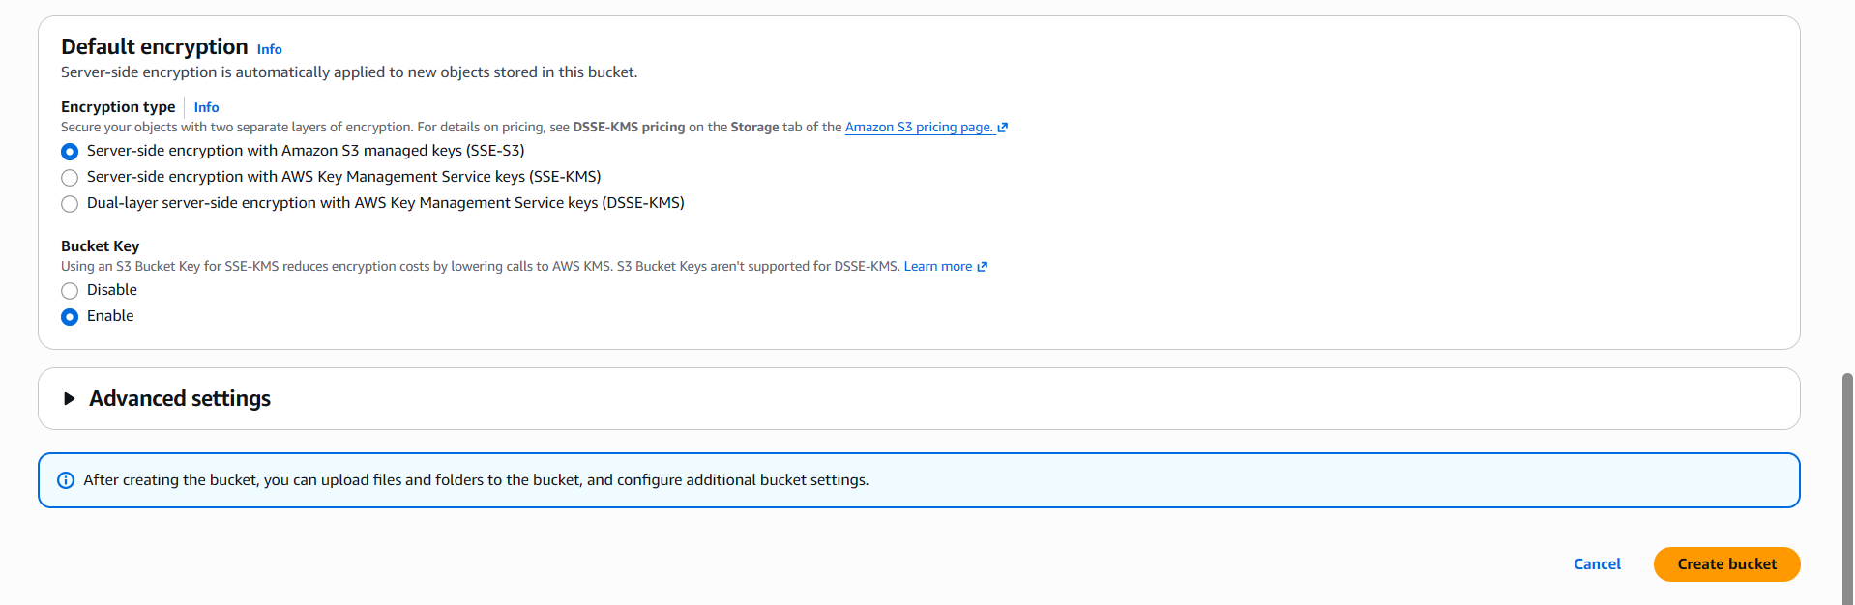
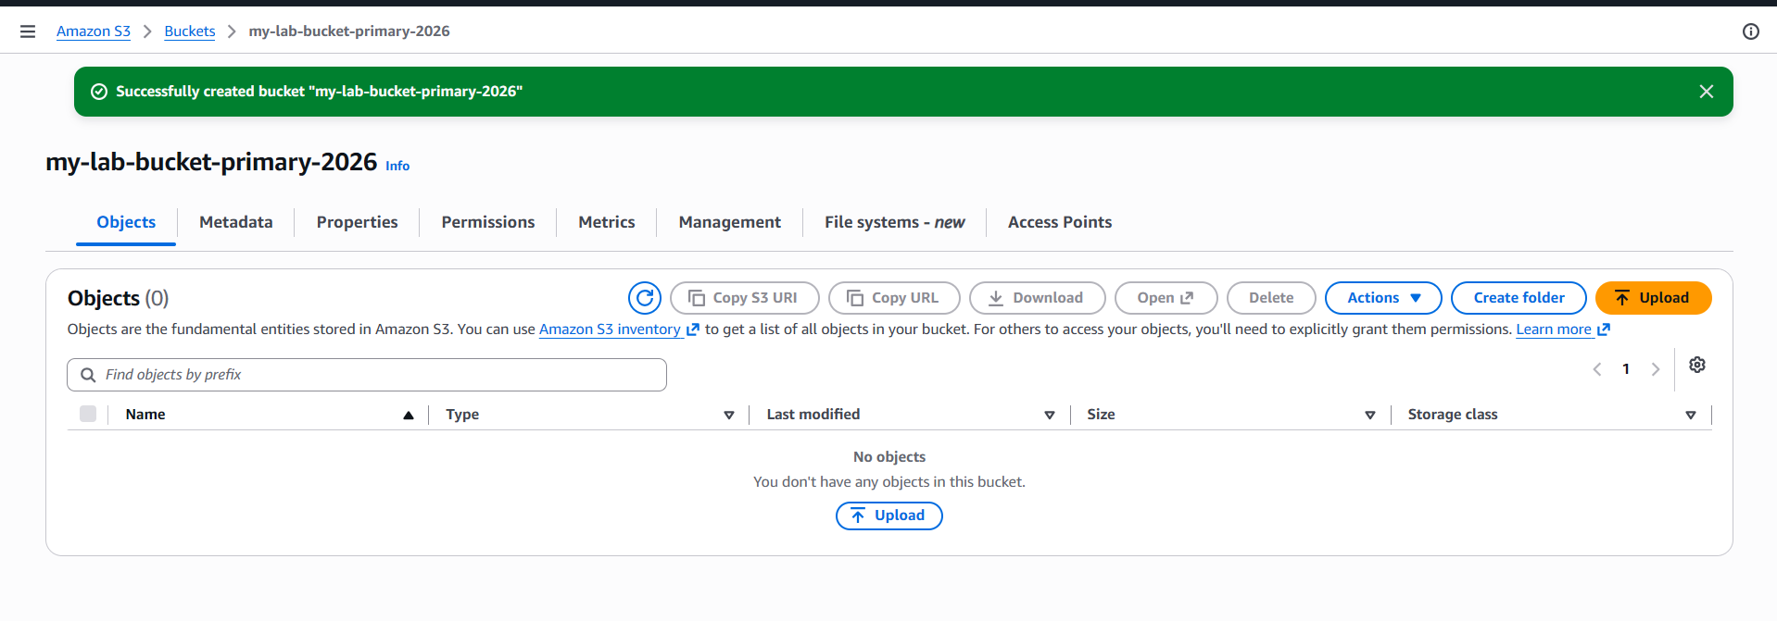

Step 1.3 — Upload Objects via the Console
1. Click into my-lab-bucket-primary-2026 → Upload.
2. Click Add files, select one or more local files (e.g., report.pdf, photo.jpg), then click Upload.
3. Wait for the green “Upload succeeded” banner.
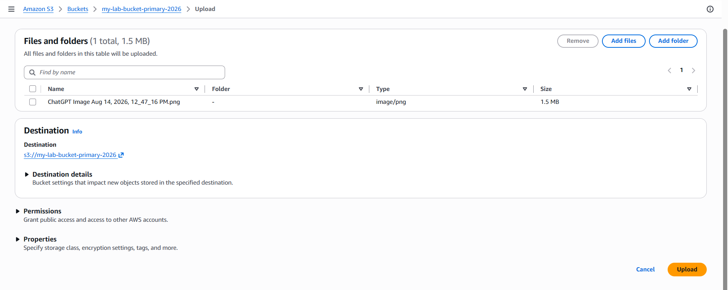
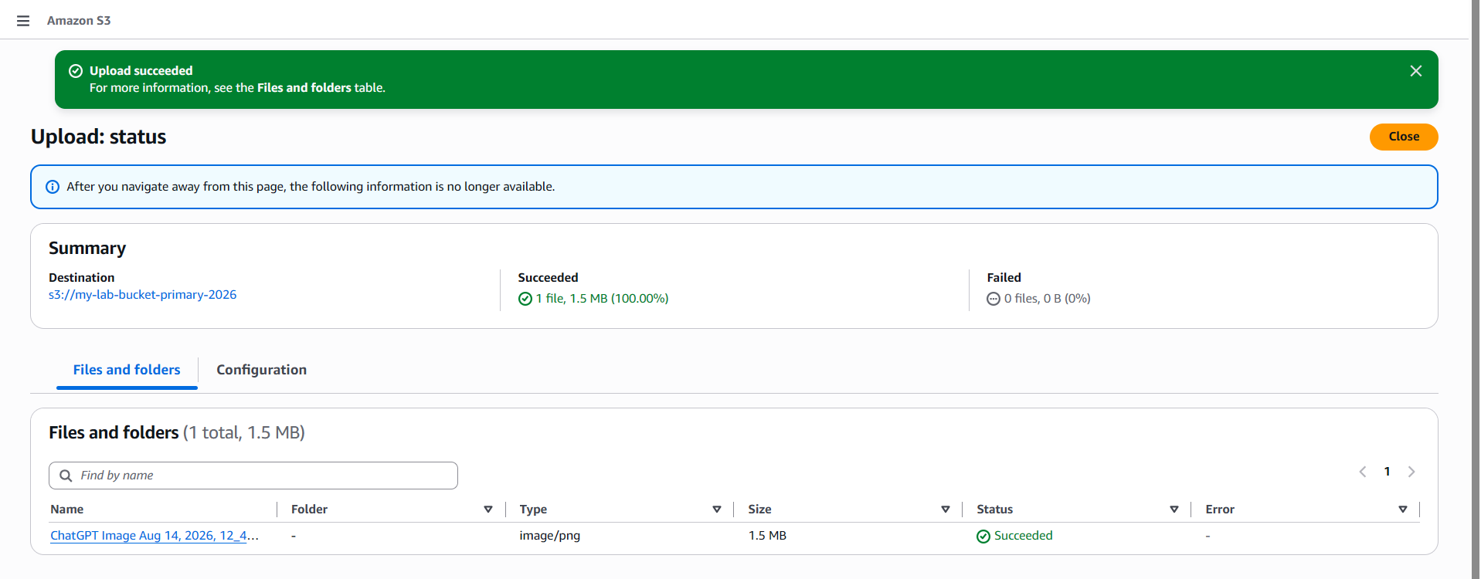

Step 1.4 — Verify
1. Go to the bucket's Objects tab and confirm the uploaded files are listed with their size and last-modified date.
2. Click an object → Object overview to see its S3 URI (e.g., s3://my-lab-bucket-primary-2026/report.pdf) and ARN.
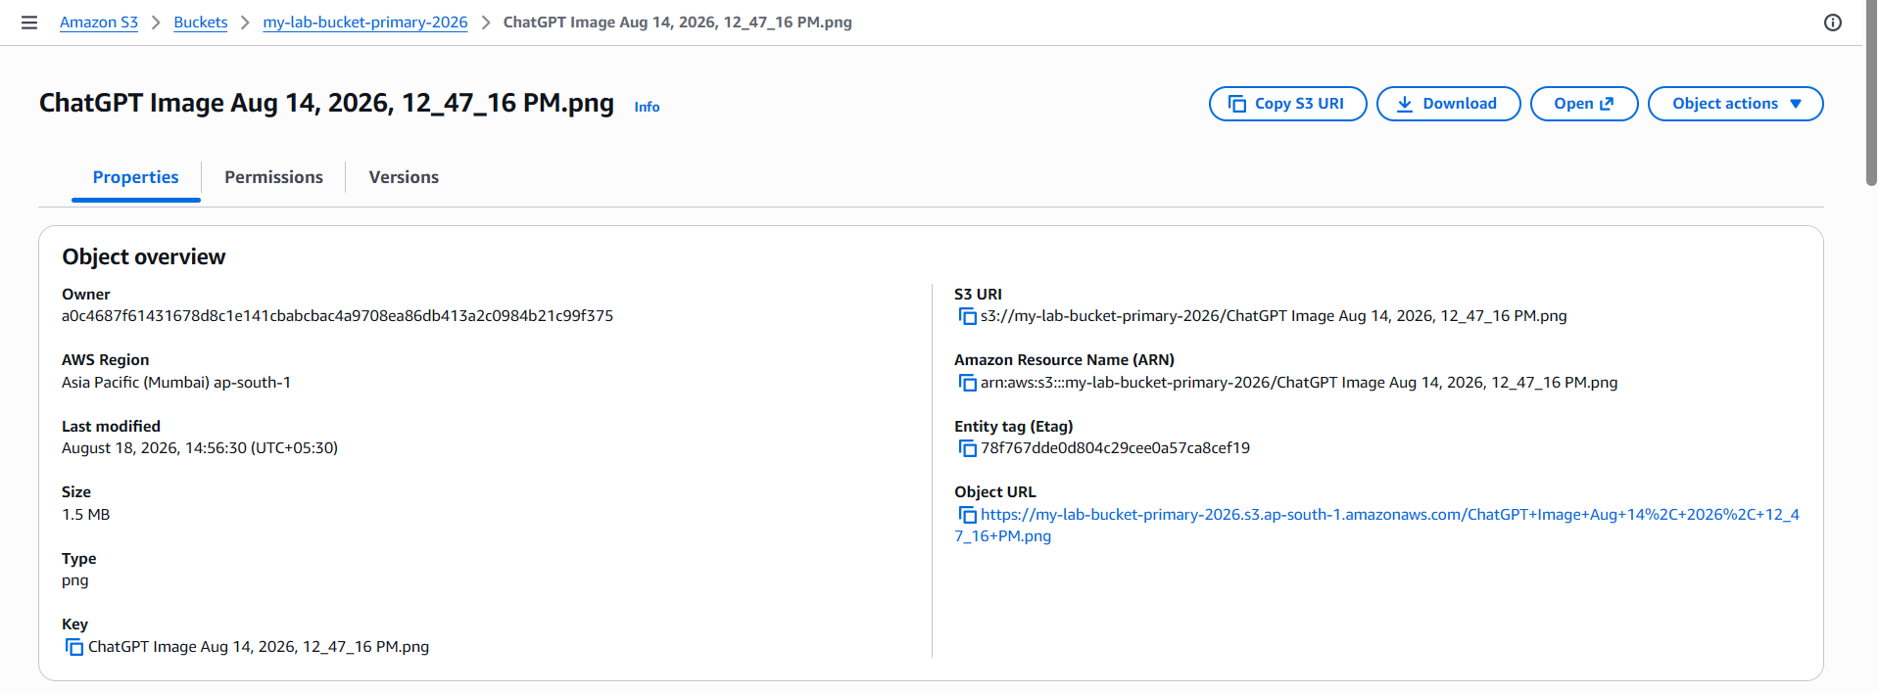

TASK 2: Deploy a Static Website in the S3 Bucket

Step 2.1 — Create a Dedicated Website Bucket
1. S3 Console → Create bucket.
2. Bucket name: my-lab-website-2026 (must exactly match a domain name only if you plan to use Route 53 alias records — otherwise any unique name works for this lab).
3. Region: ap-south-1.
4. Object Ownership: ACLs disabled.
5. Block Public Access settings: UNCHECK Block all public access (a public website bucket must allow public reads) — check the acknowledgement box that appears.
6. Leave other defaults and click Create bucket.
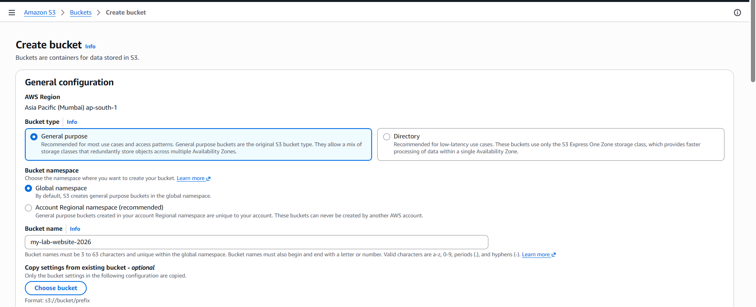
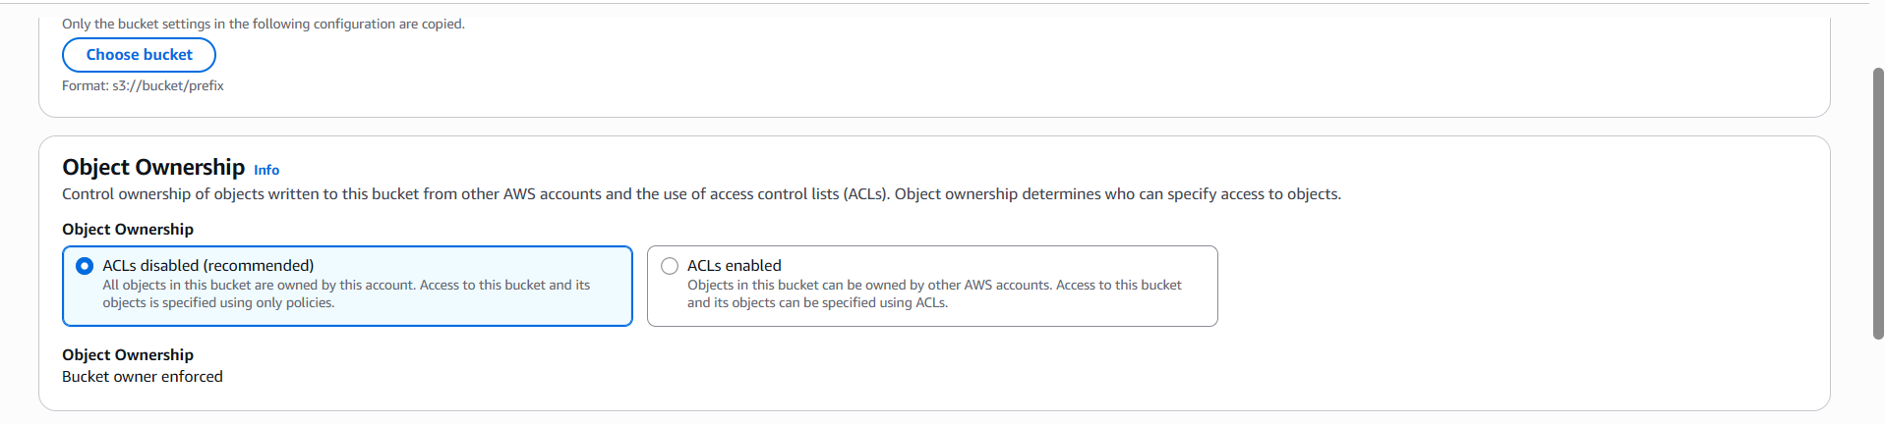
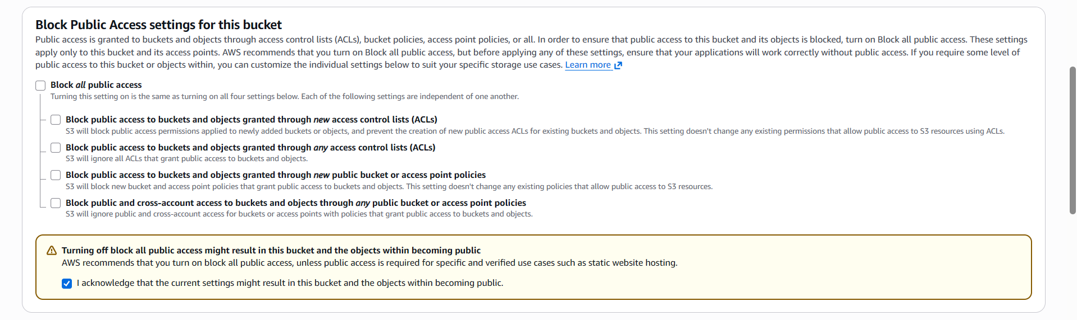
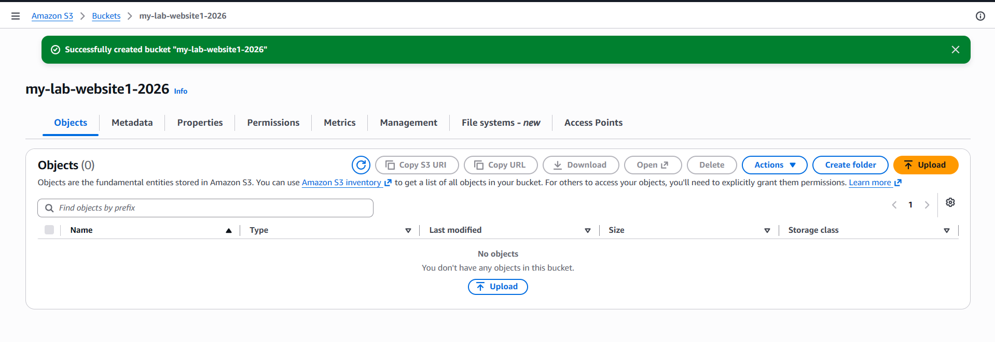

Step 2.2 — Upload the Website Files
1. Open the bucket → Upload → Add files.
2. Upload at minimum an index.html and an error.html (create simple placeholder HTML files locally first if you don't have a site yet).
3. Click Upload.
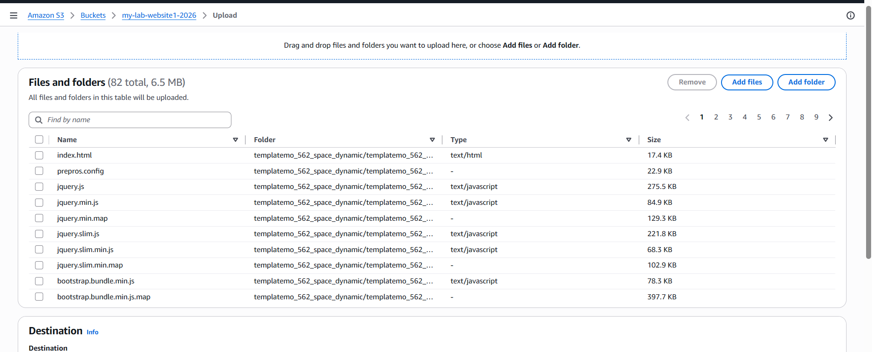

Step 2.3 — Enable Static Website Hosting
1. Select the bucket → Properties tab → scroll to Static website hosting → Edit.
2. Static website hosting: Enable.
3. Hosting type: Host a static website.
4. Index document: index.html.
5. Error document: error.html.
6. Click Save changes.
7. Note the Bucket website endpoint shown afterward, e.g., http://my-lab-website-2026.s3-website.ap-south-1.amazonaws.com.
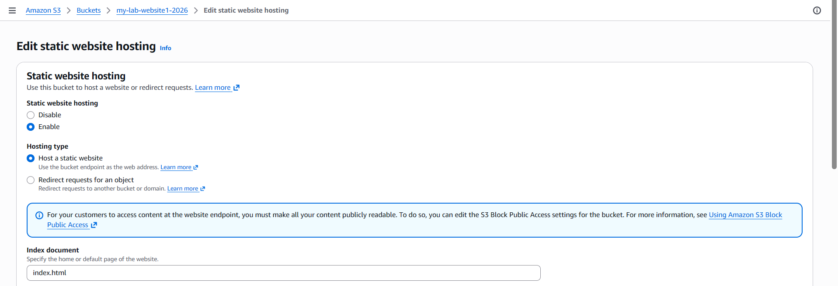
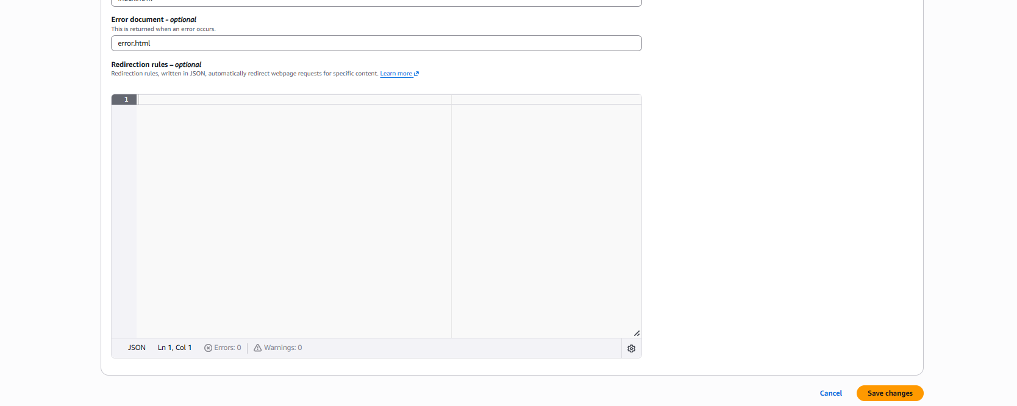

Step 2.4 — Attach a Public-Read Bucket Policy
1. Permissions tab → Bucket policy → Edit.
2. Paste the policy below (replace the bucket name with yours):
{
"Version": "2012-10-17",
"Statement": [
{
"Sid": "PublicReadForWebsite",
"Effect": "Allow",
"Principal": "*",
"Action": "s3:GetObject",
"Resource": "arn:aws:s3:::my-lab-website-2026/*"
}
]
}
3. Click Save changes.

Step 2.5 — Test the Website
1. Open the Bucket website endpoint URL from Step 2.3 in a browser.
2. Confirm index.html renders. Try a non-existent path to confirm error.html renders for 404s.
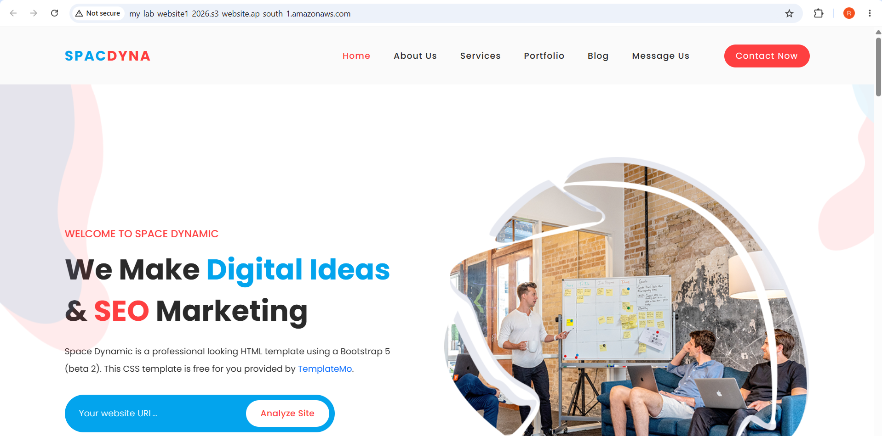

TASK 3: Enable Cross-Region Replication (CRR) on S3 Buckets
Goal: Objects uploaded to a source bucket in ap-south-1 are automatically replicated to a destination bucket in us-east-1. Both buckets must have Versioning enabled — this is a hard requirement for replication.

Step 3.1 — Create the Source Bucket
1. S3 Console → Create bucket.
2. Bucket name: my-lab-replication-source-2026. Region: ap-south-1.
3. Bucket Versioning: Enable.
4. Leave other defaults and click Create bucket.
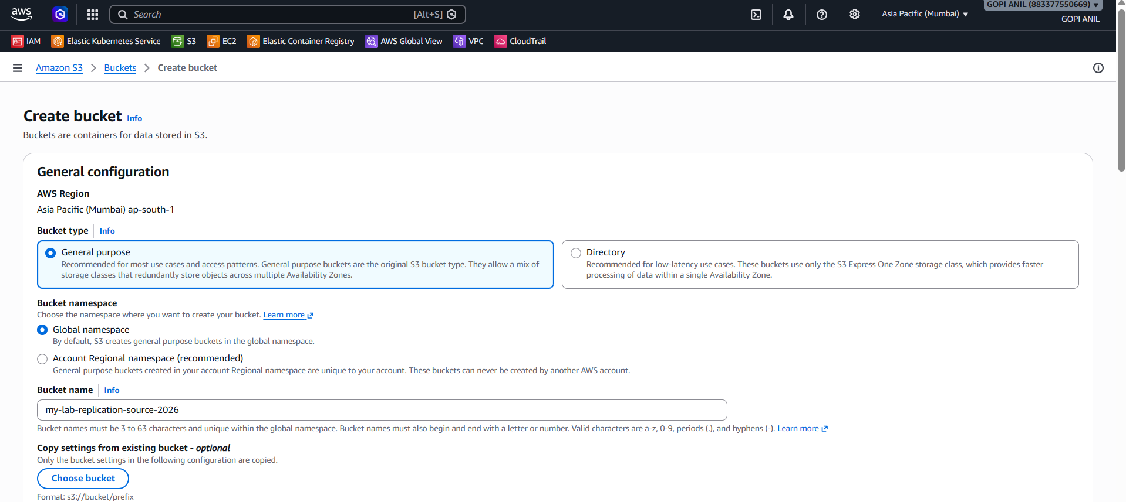
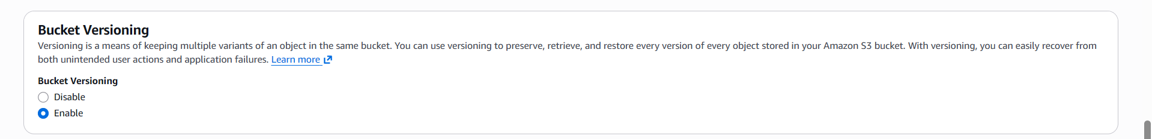
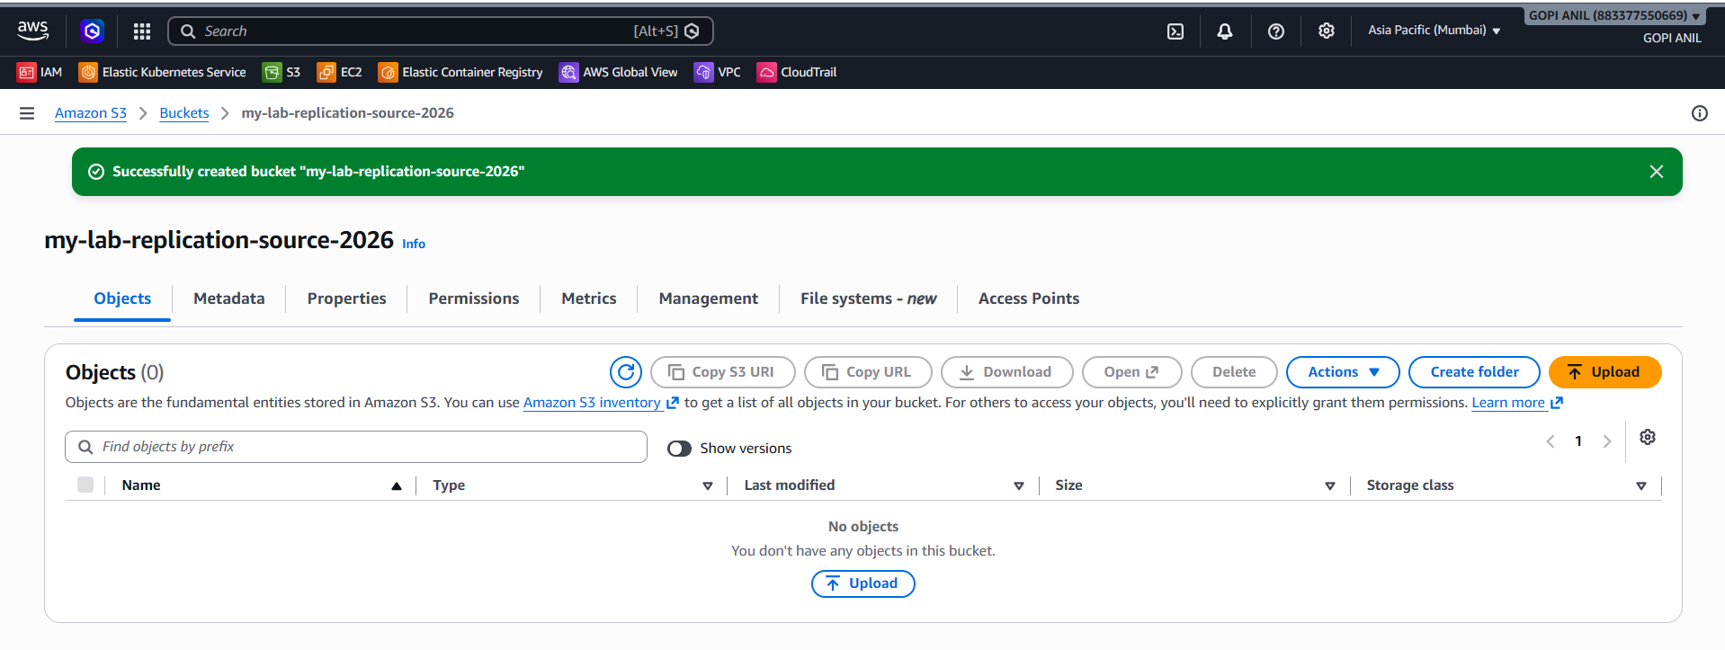

Step 3.2 — Create the Destination Bucket
1. Create bucket again.
2. Bucket name: my-lab-replication-dest-2026. Region: US East (N. Virginia) us-east-1.
3. Bucket Versioning: Enable.
4. Click Create bucket.
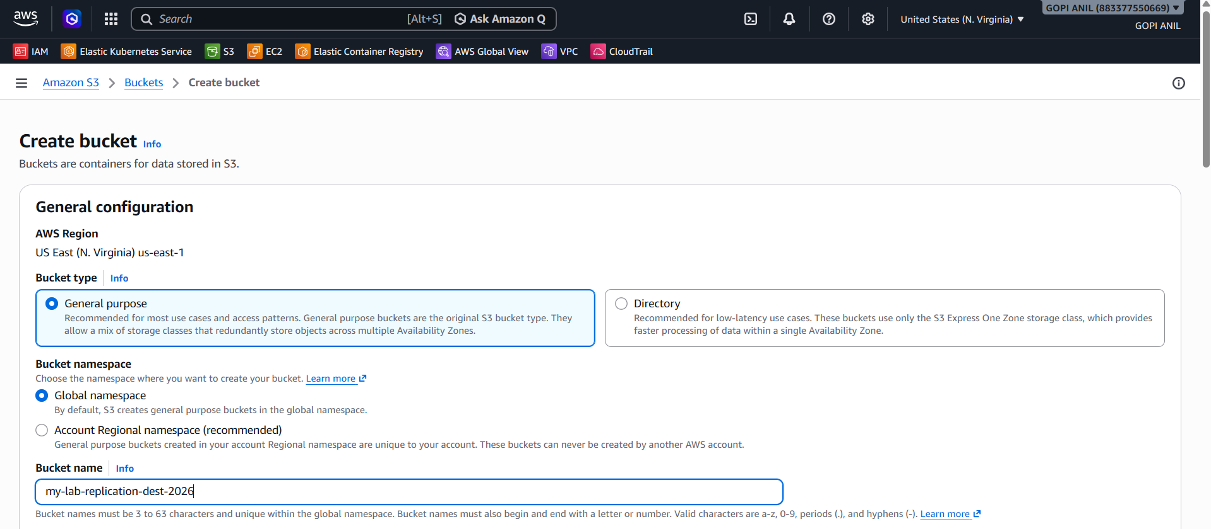
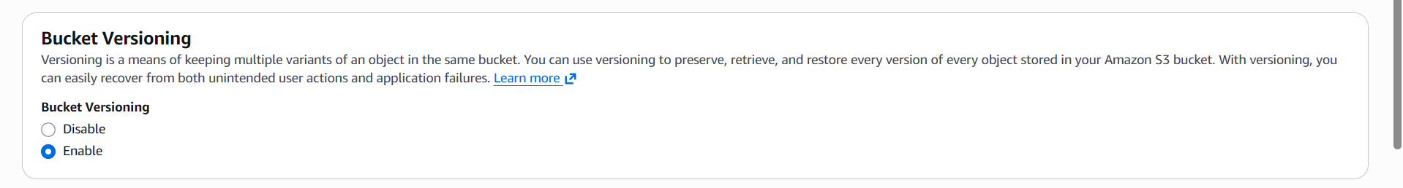
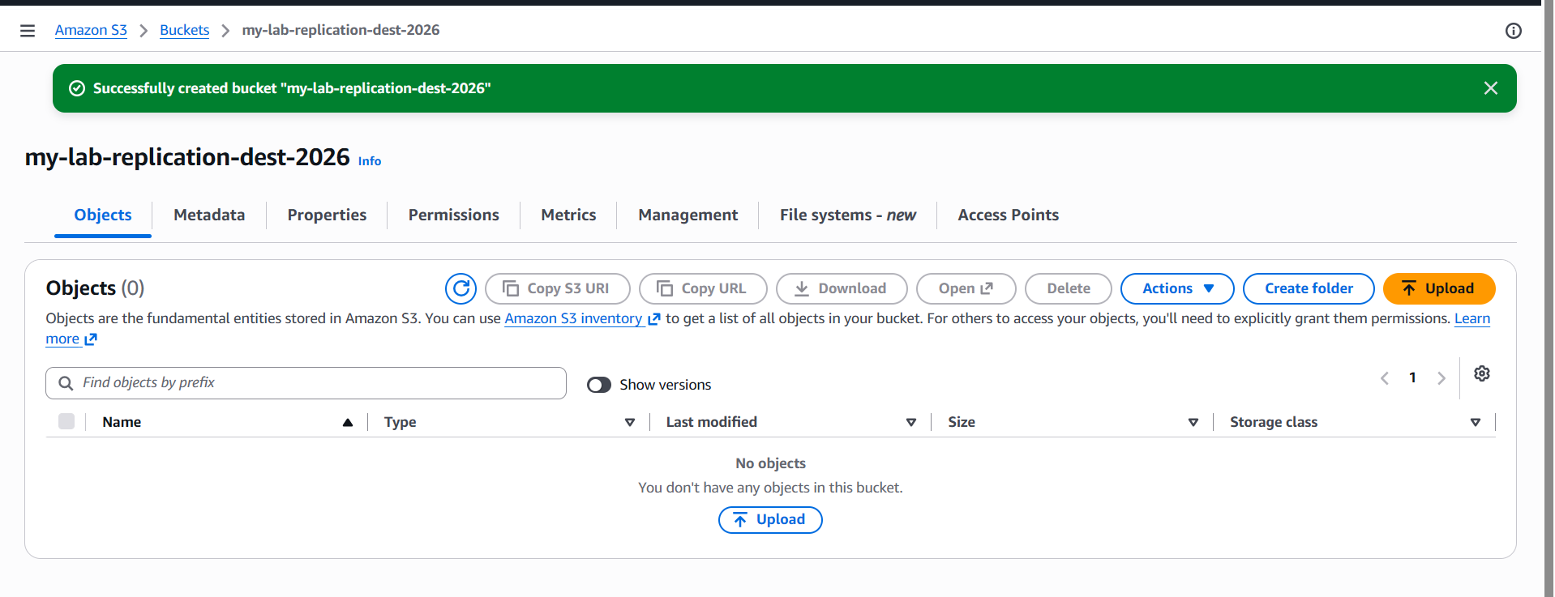

Step 3.3 — Create the Replication Rule
1. Open my-lab-replication-source-2026 → Management tab → Replication rules → Create replication rule.
2. Replication rule name: Replicate-to-us-east-1.
3. Status: Enabled.
4. Scope: Apply to all objects in the bucket (or restrict by prefix/tag if only a subset should replicate).
5. Destination: Choose a bucket in a different AWS Region → Browse S3 → select my-lab-replication-dest-2026.
6. IAM role: Create new role (the console will generate a role with the correct trust policy and permissions) — name it, e.g., s3-crr-role.
7. Encryption: leave default (SSE-S3) unless the source uses KMS, in which case additional KMS key permissions are required.
8. Click Save.
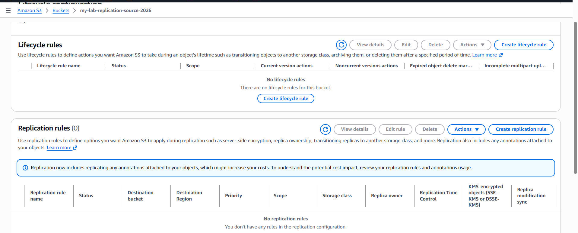
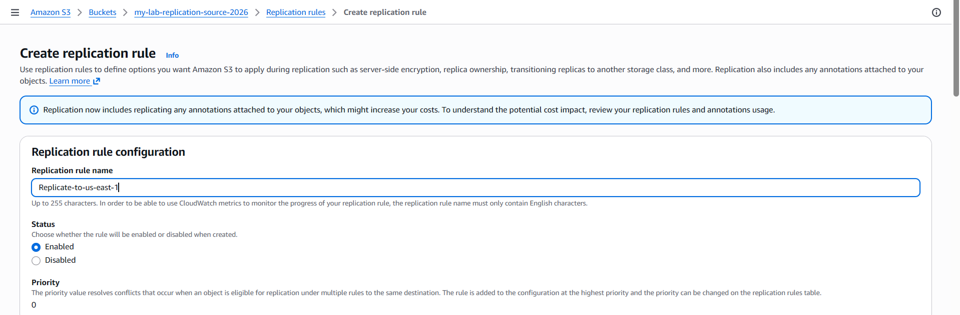
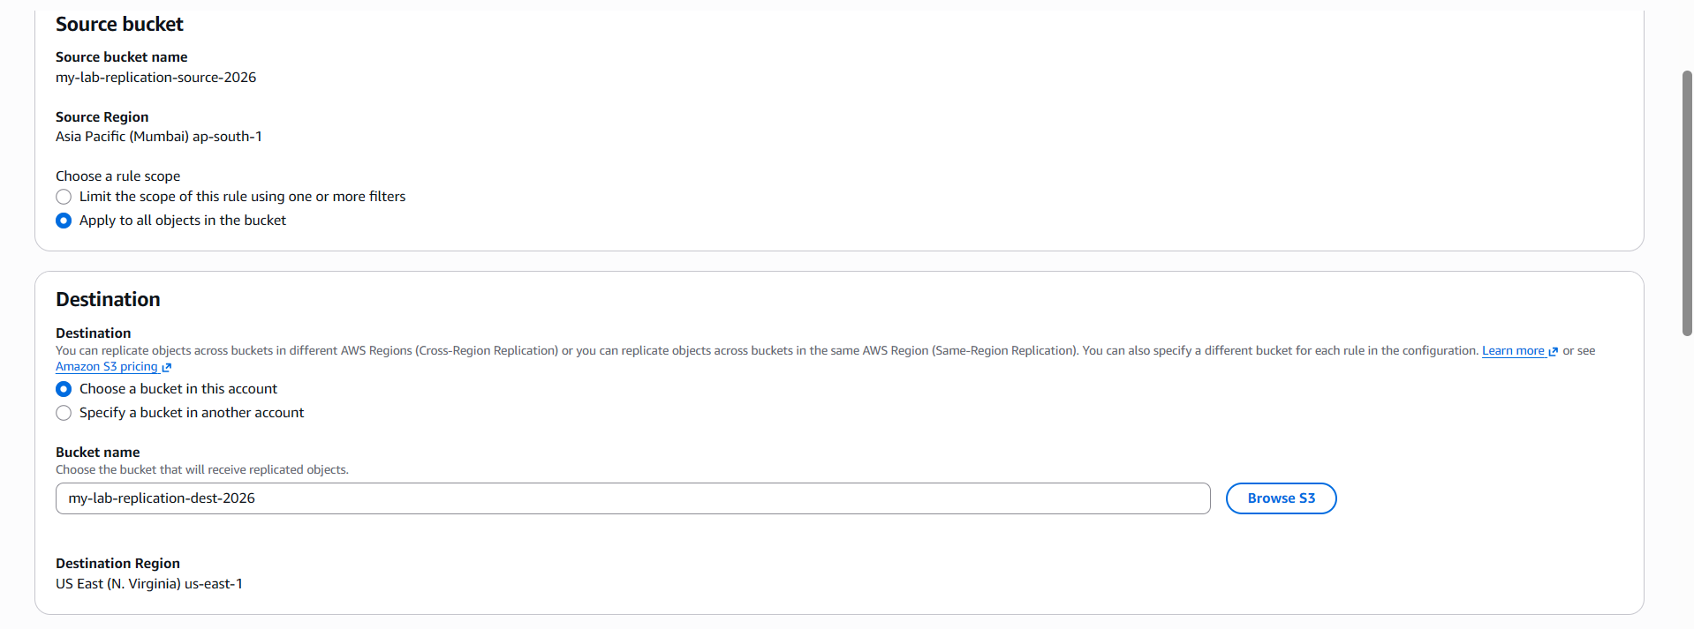

Step 3.4 — Test Replication
1. Upload a new test object to my-lab-replication-source-2026 (Objects tab → Upload).
2. Switch Region to us-east-1 → open my-lab-replication-dest-2026 → Objects tab.
3. Within a few seconds to minutes, confirm the same object appears in the destination bucket.
4. On the source object, open Object overview → check the Replication status field — it should read COMPLETED.
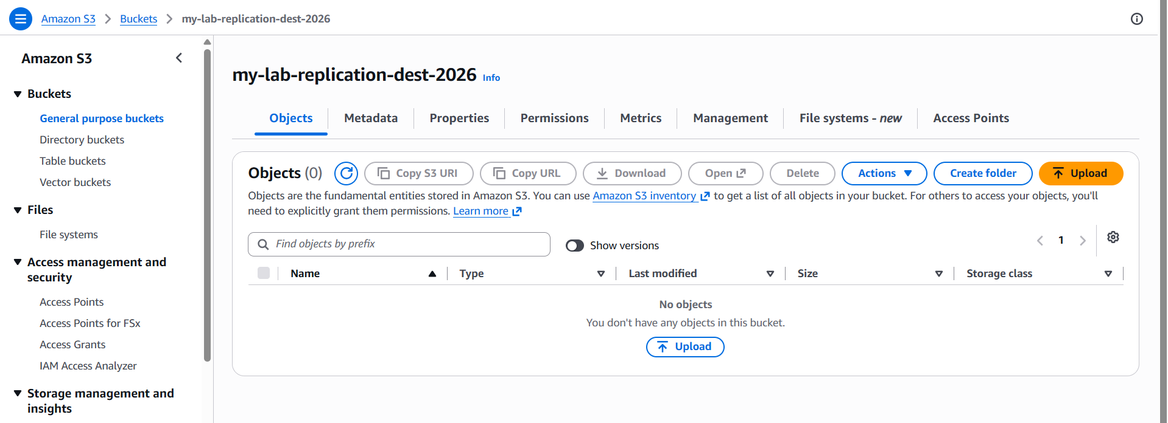
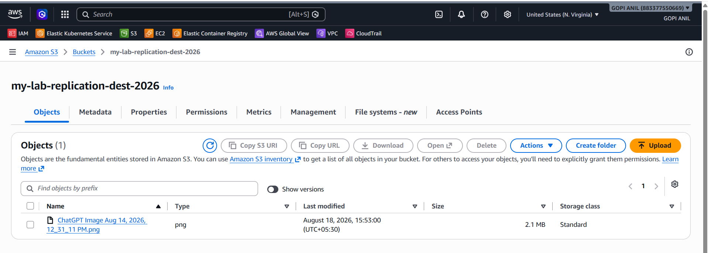

TASK 4: Bucket Policy — Only the Admin User Can See the Objects
Goal: Restrict my-lab-bucket-primary-2026 so that only a specific IAM user (e.g., Admin) can list and read its objects; every other principal, including other users in the same account, is denied.

Step 4.1 — Identify the Admin User's ARN
1. IAM Console → Users → click the target user (e.g., Admin).
2. Copy the User ARN shown at the top, e.g., arn:aws:iam::111122223333:user/Admin.
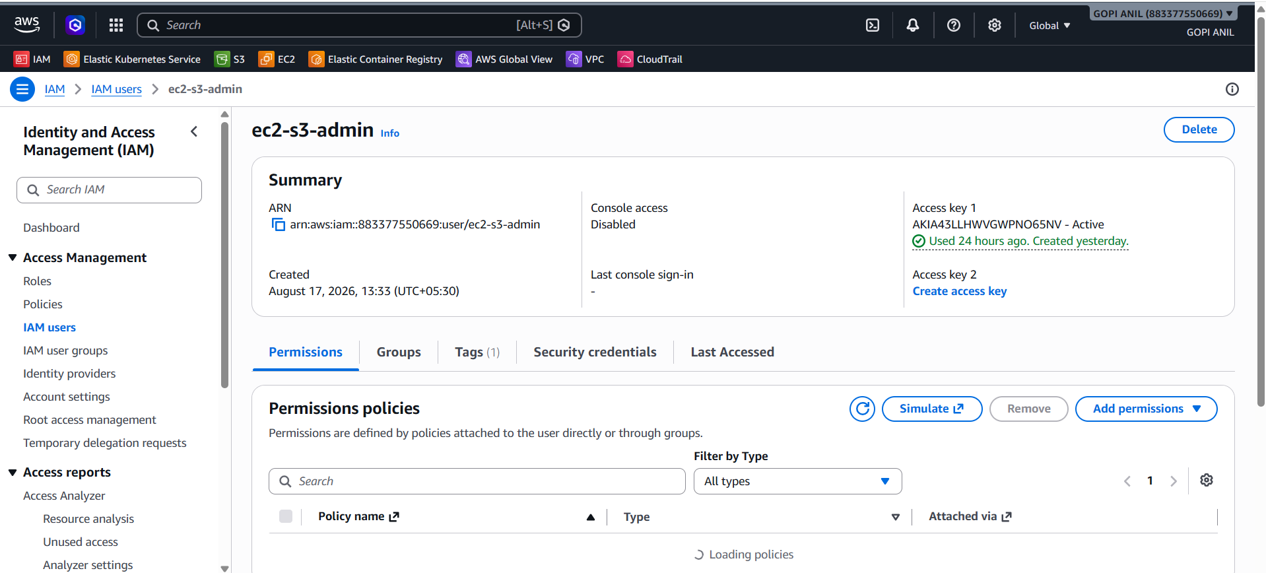

Step 4.2 — Attach a Restrictive Bucket Policy
1. S3 Console → my-lab-bucket-primary-2026 → Permissions tab → Bucket policy → Edit.
2. Paste the policy below, replacing the account ID and user name with your Admin user's actual ARN and the bucket name with yours.
{
"Version": "2012-10-17",
"Statement": [
{
"Sid": "AllowAdminOnly",
"Effect": "Allow",
"Principal": {
"AWS": " arn:aws:iam::883377550669:user/ec2-s3-admin"
},
"Action": [
"s3:GetObject",
"s3:ListBucket"
],
"Resource": [
"arn:aws:s3:::my-lab-bucket-primary-2026",
"arn:aws:s3:::my-lab-bucket-primary-2026/*"
]
},
{
"Sid": "DenyEveryoneElse",
"Effect": "Deny",
"NotPrincipal": {
"AWS": [
" arn:aws:iam::883377550669:user/ec2-s3-admin ",
"arn:aws:iam::883377550669:root"
]
},
"Action": "s3:*",
"Resource": [
"arn:aws:s3:::my-lab-bucket-primary-2026",
"arn:aws:s3:::my-lab-bucket-primary-2026/*"
]
}
]
}
3. Click Save changes.
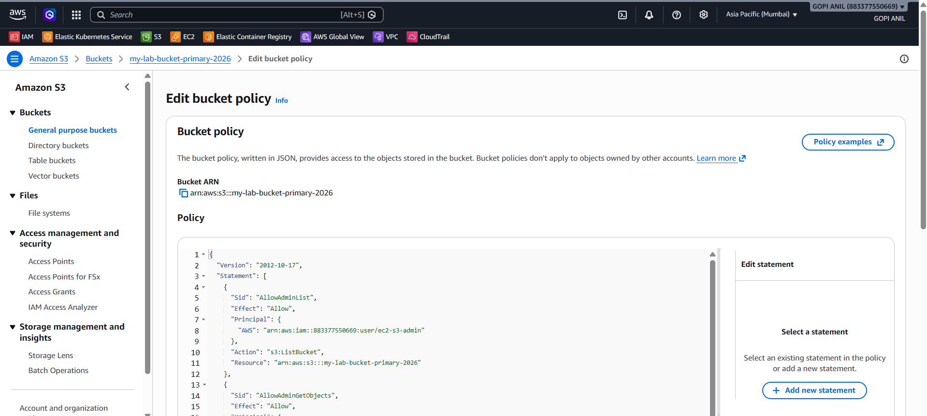
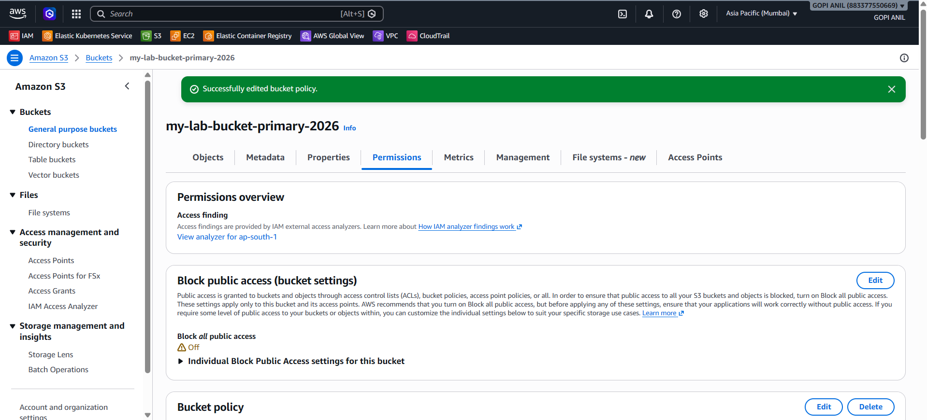

TASK 5: Set Up Lifecycle Policies (Transition and Expiration)
Goal: Automatically move older objects to cheaper storage classes and delete very old objects, without manual intervention.

Step 5.1 — Open the Lifecycle Rules Section
- S3 Console → my-lab-bucket-primary-2026 → Management tab → Lifecycle rules → Create lifecycle rule.
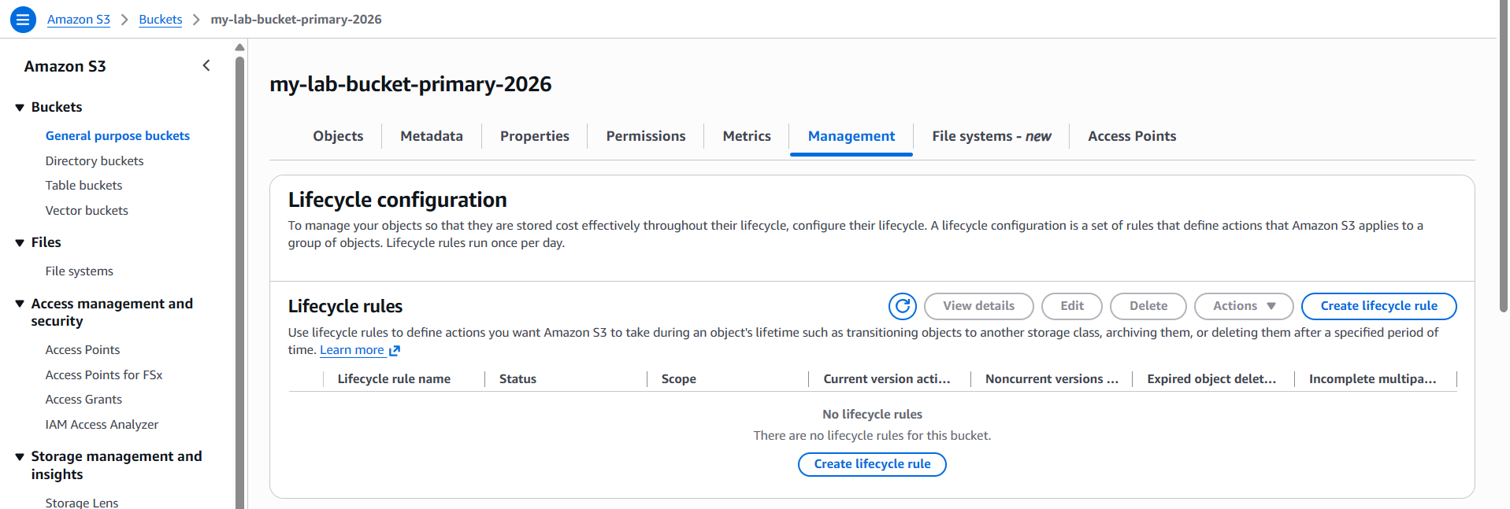

Step 5.2 — Configure Rule Scope
1. Lifecycle rule name: Archive-and-Expire-Rule.
2. Choose a rule scope: Apply to all objects in the bucket (or Limit the scope using a prefix/tag, e.g., only logs/ objects).
3. Acknowledge the warning about the rule applying broadly, if shown.
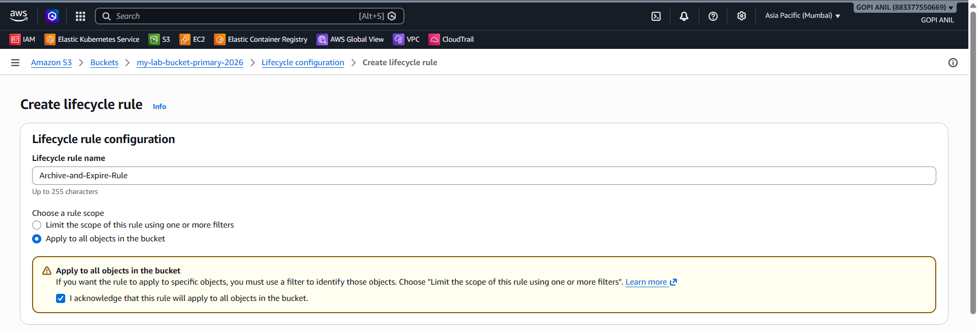

Step 5.3 — Configure Storage Class Transitions
1. Under Lifecycle rule actions, check Move current versions of objects between storage classes.
2. Add a transition: Transition to Standard-IA after 30 days.
3. Add a second transition: Transition to Glacier Flexible Retrieval after 90 days.
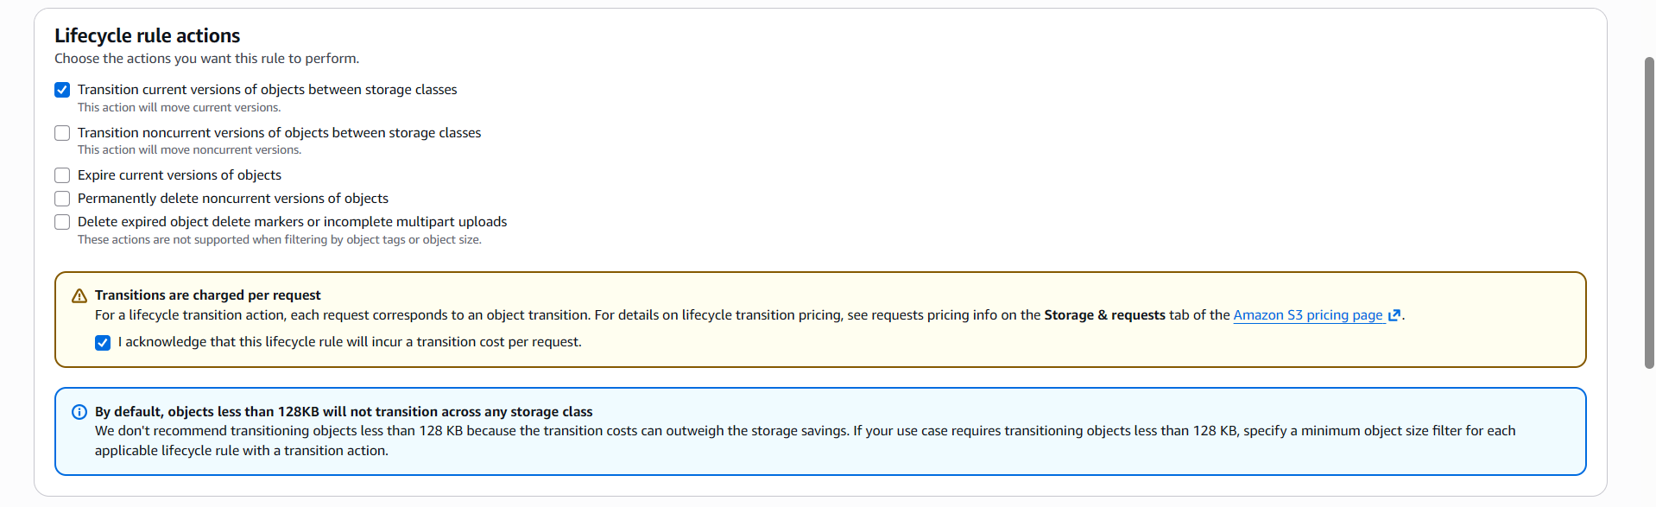
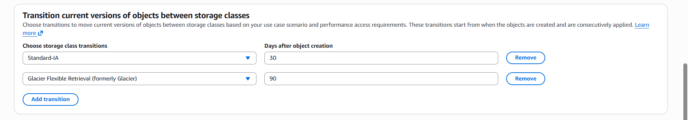

Step 5.4 — Configure Expiration
1. Check Expire current versions of objects.
2. Days after object creation: 365.
3. (If versioning is enabled on this bucket) also check Permanently delete noncurrent versions of objects and set, e.g., 30 days after becoming noncurrent, to avoid paying for orphaned old versions indefinitely.
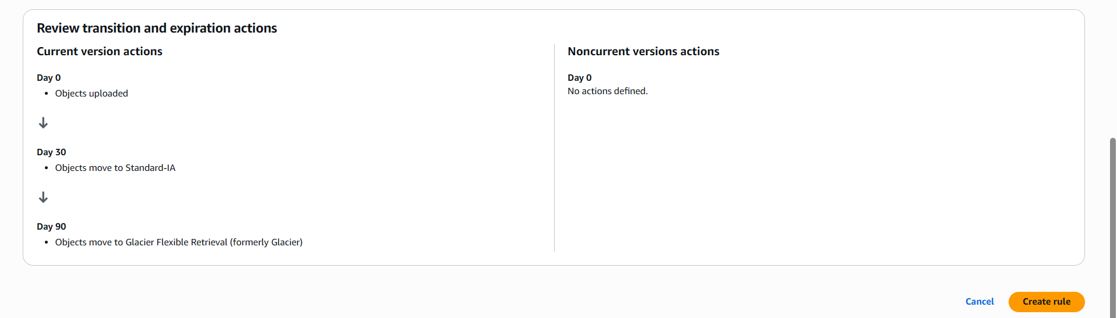

Step 5.5 — Review and Create
1. Review the full timeline shown by the console (Day 0 → Day 30 IA → Day 90 Glacier → Day 365 Expire).
2. Click Create rule.
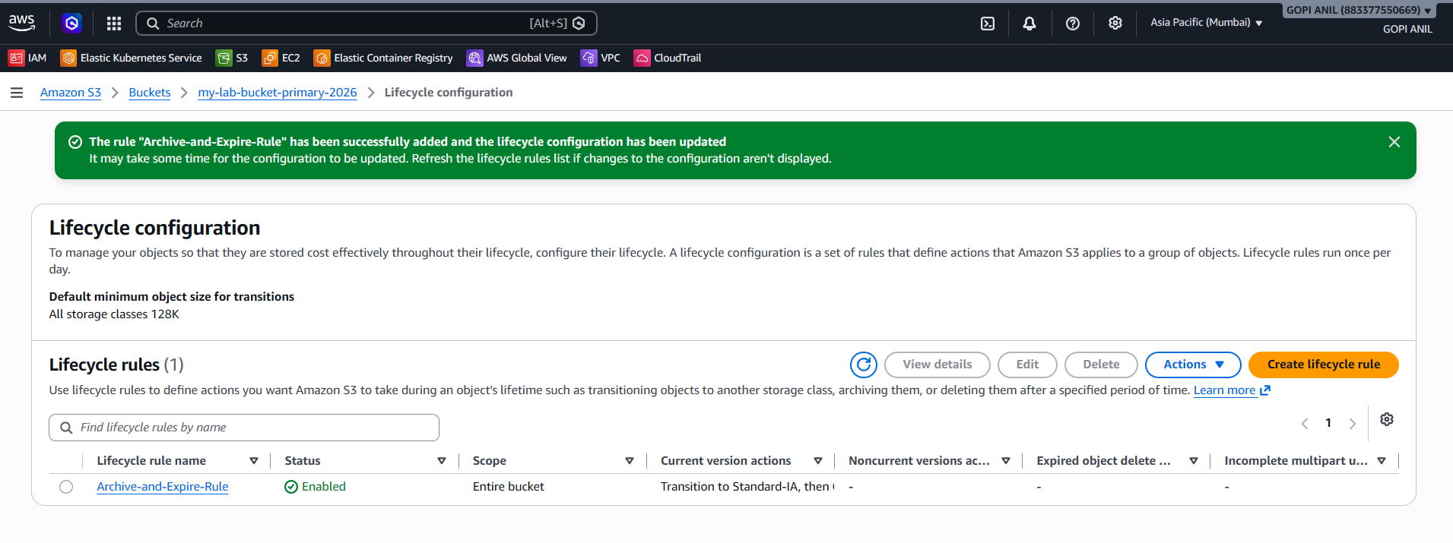

TASK 6: Push Objects to S3 Using the AWS CLI

Step 6.1 — Confirm CLI Access
- Open a terminal and run aws sts get-caller-identity to confirm the CLI is authenticated as the expected user/role.
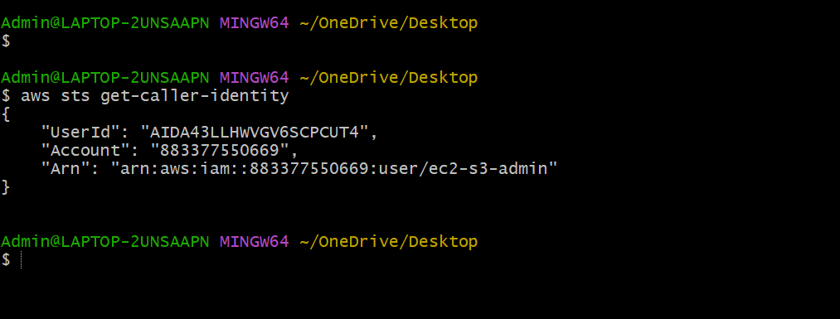

Step 6.2 — Upload a Single File
aws s3 cp ./notes.txt s3://my-lab-bucket-primary-2026/notes.txt

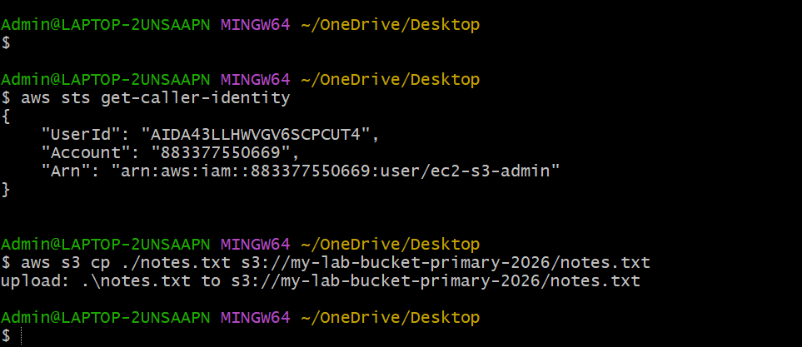

Step 6.3 — Upload an Entire Local Folder (Sync)
aws s3 sync ./local-data-folder s3://my-lab-bucket-primary-2026/data/
aws s3 sync only uploads files that are new or changed since the last sync, making it efficient for repeated runs.

Step 6.4 — Verify from the CLI
aws s3 ls s3://my-lab-bucket-primary-2026/ --recursive --human-readable --summarize
- Confirm the uploaded files are listed with their sizes, and the Total Objects / Total Size summary at the bottom matches what was uploaded.
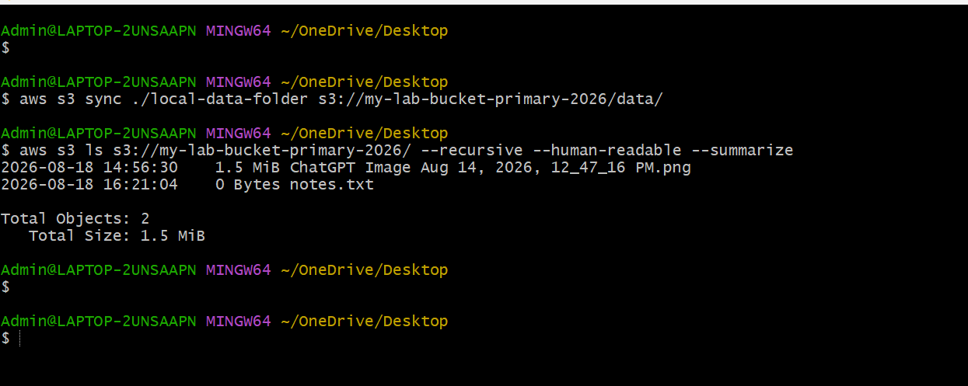
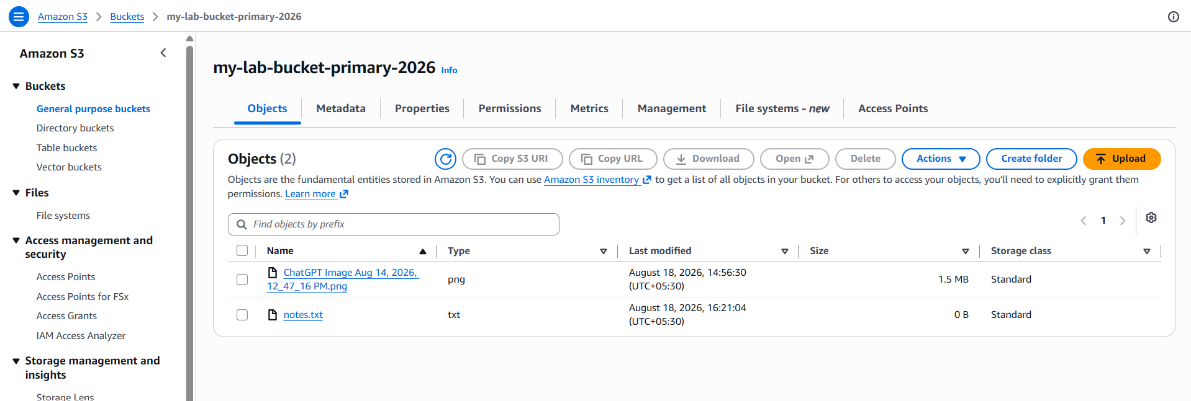

TASK 7: Bash Script to Create an S3 Bucket
This script creates a new S3 bucket in a specified Region, enables versioning, and blocks all public access by default — a safe baseline for a general-purpose bucket.

Step 7.1 — The Script
#!/bin/bash
# create_s3_bucket.sh
# Creates an S3 bucket with versioning enabled and public access blocked.
set -euo pipefail
BUCKET_NAME="$1"
REGION="${2:-ap-south-1}"
if [ -z "$BUCKET_NAME" ]; then
echo "Usage: ./create_s3_bucket.sh <bucket-name> [region]"
exit 1
fi
echo "Creating bucket: $BUCKET_NAME in $REGION"
if [ "$REGION" == "us-east-1" ]; then
aws s3api create-bucket \
--bucket "$BUCKET_NAME" \
--region "$REGION"
else
aws s3api create-bucket \
--bucket "$BUCKET_NAME" \
--region "$REGION" \
--create-bucket-configuration LocationConstraint="$REGION"
fi
echo "Enabling versioning"
aws s3api put-bucket-versioning \
--bucket "$BUCKET_NAME" \
--versioning-configuration Status=Enabled
echo "Blocking all public access"
aws s3api put-public-access-block \
--bucket "$BUCKET_NAME" \
--public-access-block-configuration \
BlockPublicAcls=true,IgnorePublicAcls=true,BlockPublicPolicy=true,RestrictPublicBuckets=true
echo "Done. Bucket $BUCKET_NAME is ready in $REGION."

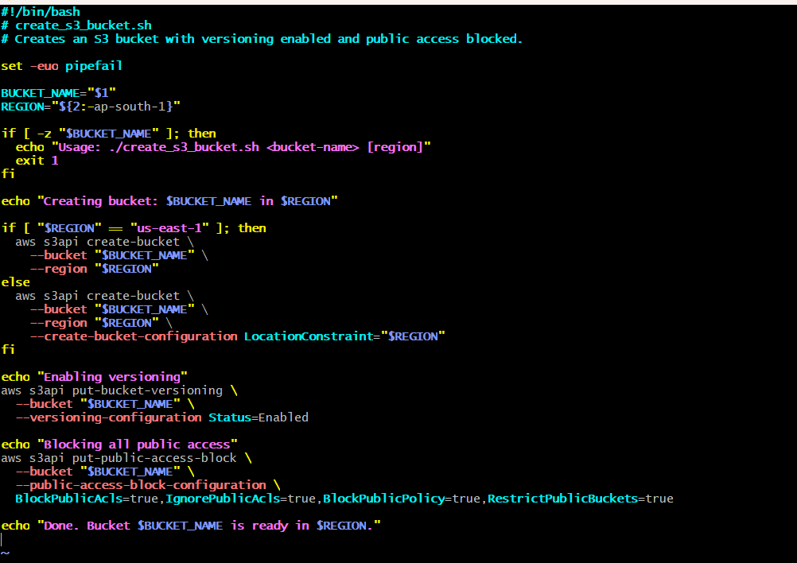

Step 7.2 — Execution Process
1. Save the script as create_s3_bucket.sh.
2. Make it executable: chmod +x create_s3_bucket.sh
3. Run it, passing a unique bucket name and optional region: ./create_s3_bucket.sh my-cli-created-bucket-2026 ap-south-1
4. Expected terminal output:
Creating bucket: my-cli-created-bucket-2026 in ap-south-1
{
"Location": "http://my-cli-created-bucket-2026.s3.amazonaws.com/"
}
Enabling versioning
Blocking all public access
Done. Bucket my-cli-created-bucket-2026 is ready in ap-south-1.

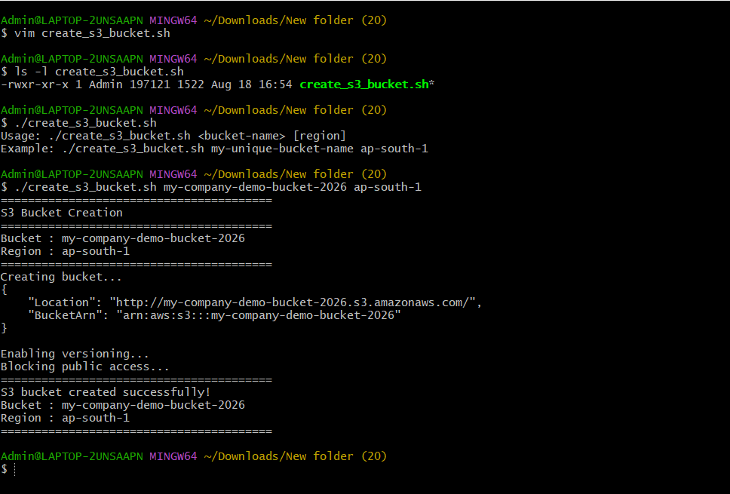

TASK 8: Upload a 1 GB File to S3 Using the CLI

Step 8.1 — Generate a 1 GB Test File (if one isn't already available)
Linux:
fallocate -l 1G bigfile.bin
If fallocate is unavailable, use dd instead:
dd if=/dev/zero of=bigfile.bin bs=1M count=1024

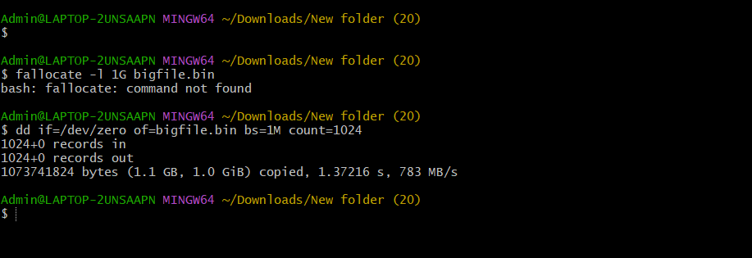

Step 8.2 — Upload Using the CLI
aws s3 cp bigfile.bin s3://my-lab-bucket-primary-2026/bigfile.bin

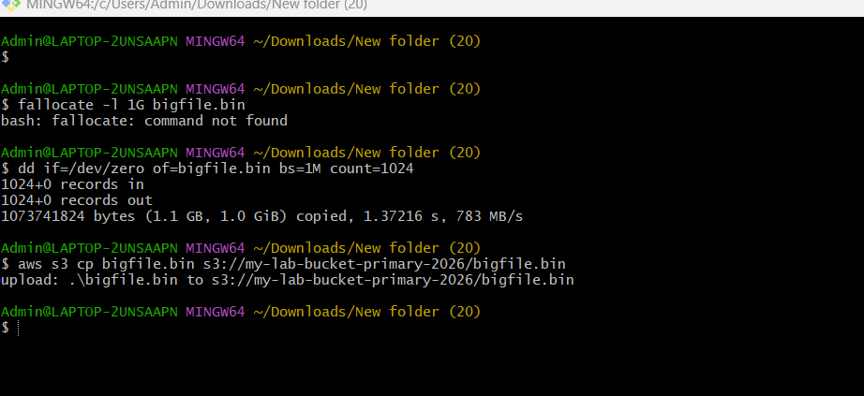

Step 8.3 — Monitor Progress and Verify
1. The CLI prints a live progress line during upload, e.g., Completed 512.0 MiB/1.0 GiB (45.2 MiB/s) with 12s remaining.
2. On completion, verify the object and its size:
aws s3 ls s3://my-lab-bucket-primary-2026/bigfile.bin --human-readable
3. Expected output shows approximately 1.0 GiB as the size, confirming a complete, uncorrupted upload.
