AWS VPC Implementation

1. Create VPC with 2 private and 2 public subnets.

Step 1: Login to AWS Console
Sign in to your AWS Management Console.

Step 2: Open the VPC Service
- In the AWS search bar, type VPC.
- Click VPC.
You should see the VPC Dashboard.

Step 3: Verify the AWS Region
At the top-right corner, ensure your region is US East (N. Virginia) - us-east-1.
Since your assignment specifies us-east-1a and us-east-1b, use the us-east-1 region.

Step 4: Create the VPC
- In the left navigation pane, click Your VPCs.
- Click Create VPC.
Configure the VPC
Choose VPC only. Fill in the details:
Field | Value
Resources to create | VPC only
Name tag | DevOps-VPC
IPv4 CIDR | 10.0.0.0/16
IPv6 CIDR | No IPv6 CIDR Block
Tenancy | Default

Click Create VPC. You should see a success message: “Successfully created VPC”
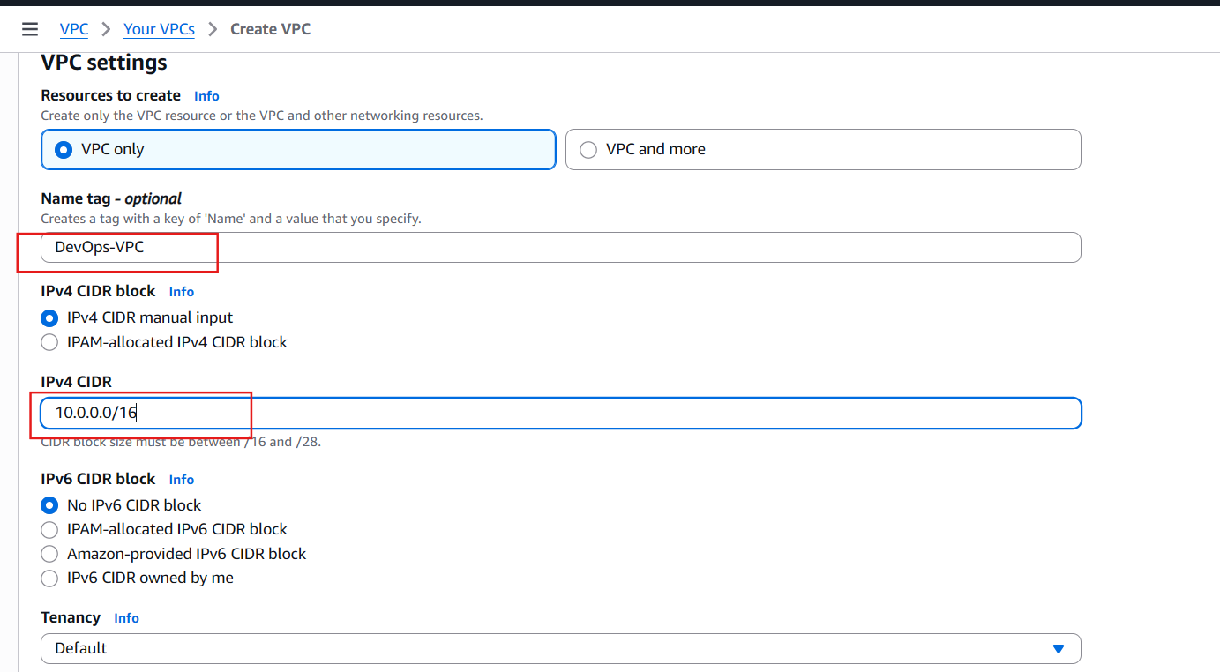

Step 5: Verify the VPC
You should now see something like:
Name | VPC ID | CIDR
DevOps-VPC | vpc-xxxxxxxx | 10.0.0.0/16

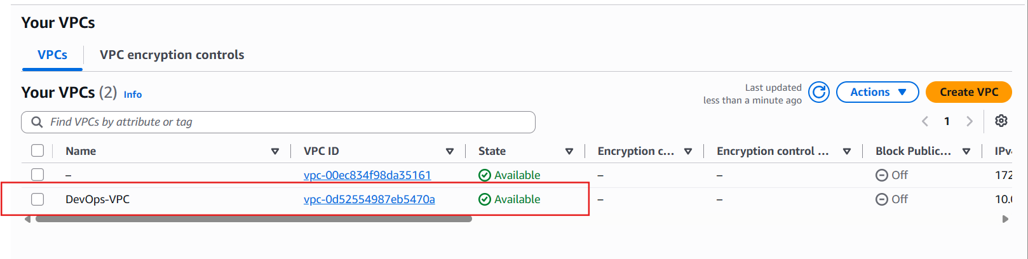

Step 6: Create Public Subnet 1
In the left menu: Subnets → Create subnet
VPC — Select: DevOps-VPC
Fill in:
Field | Value
Subnet name | Public-Subnet-1
Availability Zone | us-east-1a
IPv4 CIDR | 10.0.1.0/24

Click Create subnet.
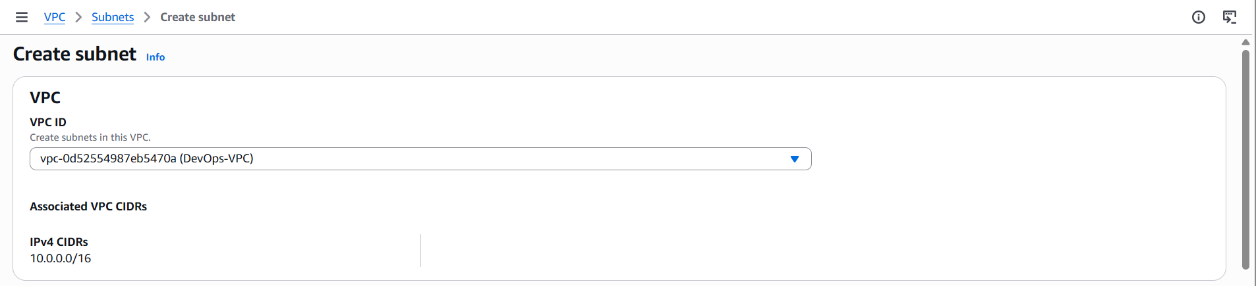
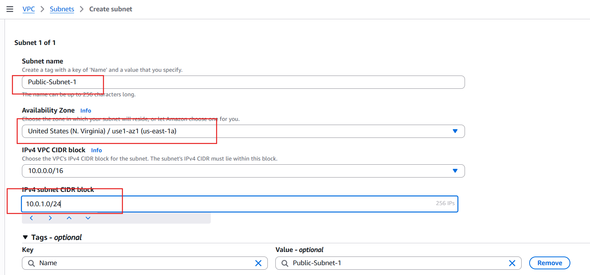
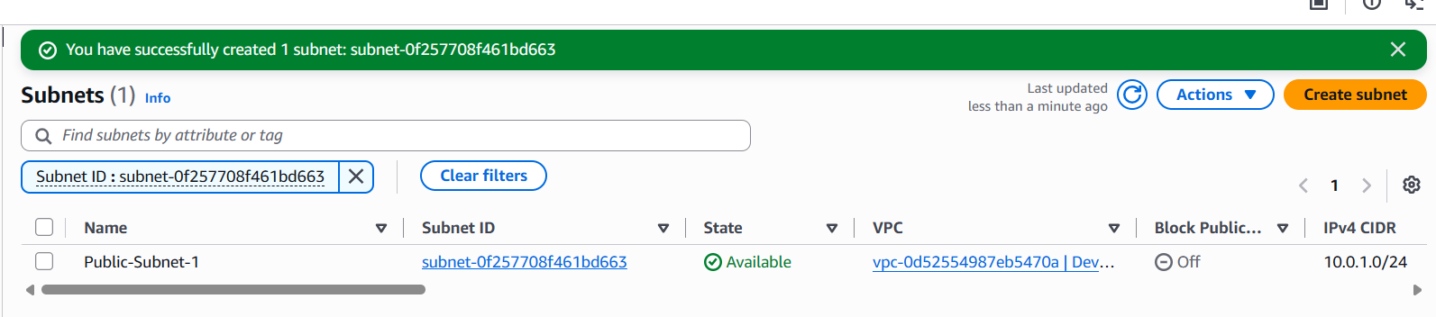

Step 7: Create Public Subnet 2
Again click Create subnet.
Field | Value
Subnet name | Public-Subnet-2
Availability Zone | us-east-1b
IPv4 CIDR | 10.0.2.0/24

Click Create subnet.

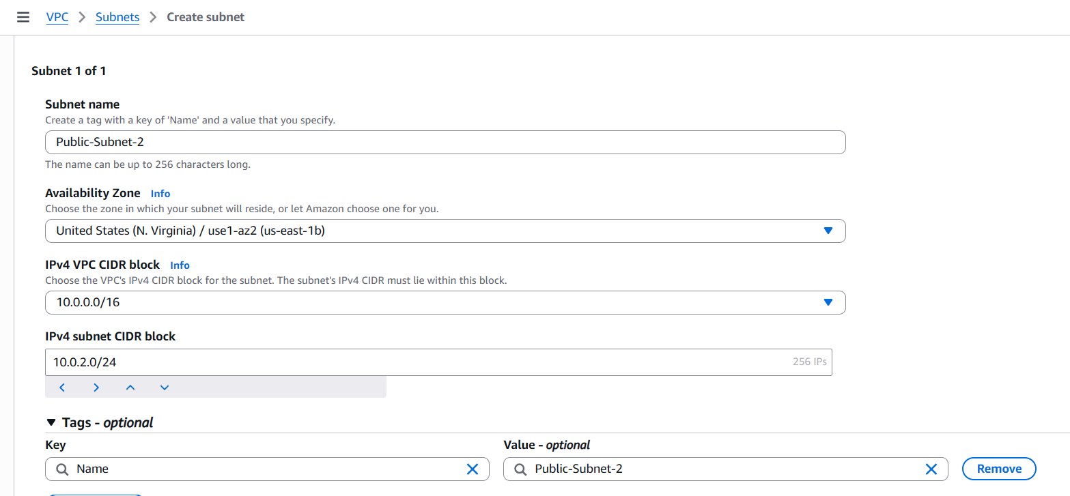
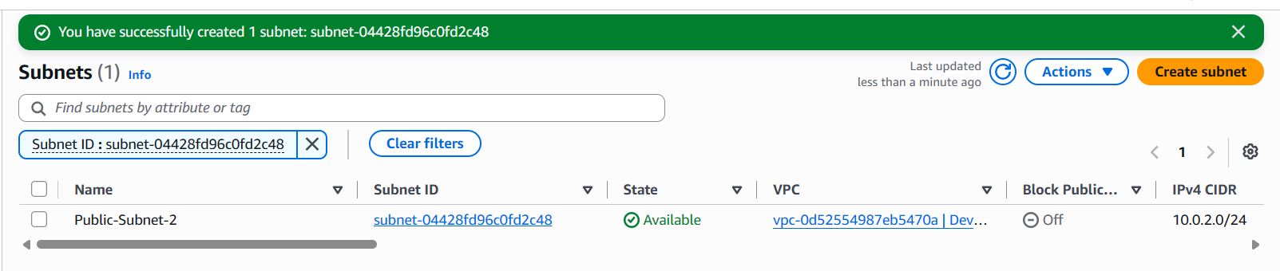

Step 8: Create Private Subnet 1
Click Create subnet.
Field | Value
Subnet name | Private-Subnet-1
Availability Zone | us-east-1a
IPv4 CIDR | 10.0.3.0/24

Click Create subnet.
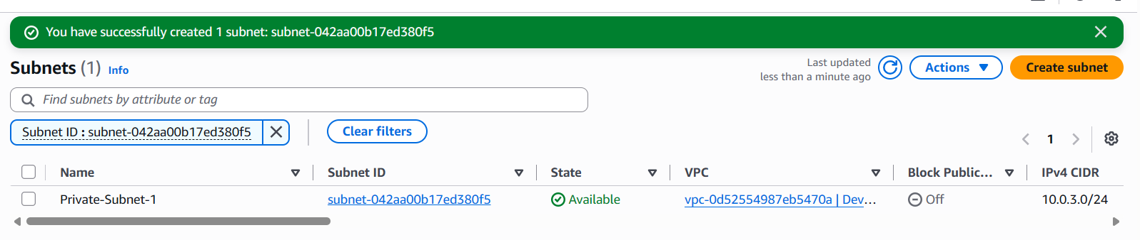

Step 9: Create Private Subnet 2
Click Create subnet.
Field | Value
Subnet name | Private-Subnet-2
Availability Zone | us-east-1b
IPv4 CIDR | 10.0.4.0/24

Click Create subnet.
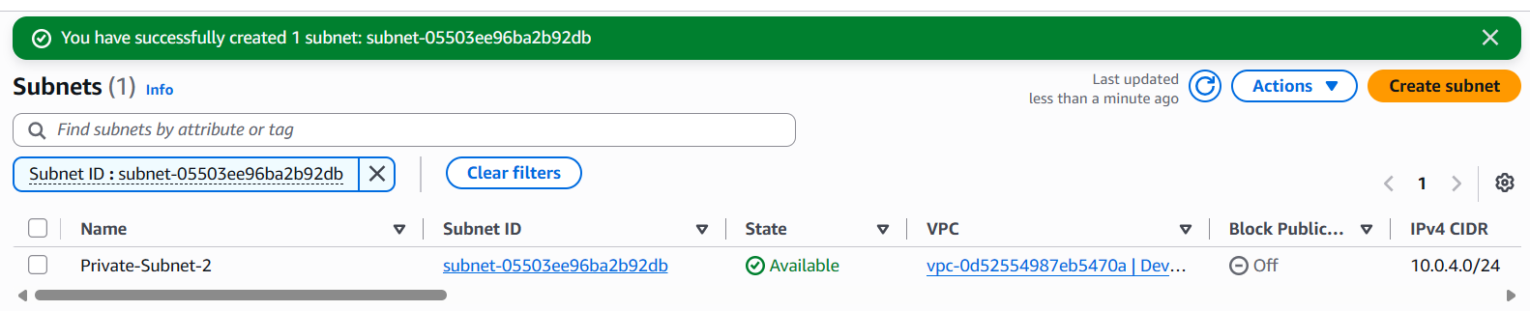

Step 10: Verify All Subnets
Go to Subnets. You should see:
Subnet Name | CIDR | AZ
Public-Subnet-1 | 10.0.1.0/24 | us-east-1a
Public-Subnet-2 | 10.0.2.0/24 | us-east-1b
Private-Subnet-1 | 10.0.3.0/24 | us-east-1a
Private-Subnet-2 | 10.0.4.0/24 | us-east-1b

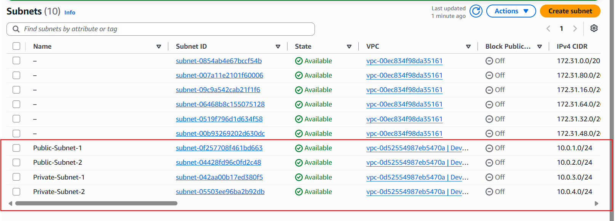

2. Enable DNS Hostname in VPC.

Objective
Enable DNS Resolution and DNS Hostnames for your VPC.

Why is this required?
When you launch EC2 instances:
- DNS Resolution allows the VPC to resolve domain names (for example, google.com).
- DNS Hostnames assigns a public DNS name to EC2 instances that have a public IP.
Without enabling DNS Hostnames, a public EC2 instance may not receive a public DNS name.

Step 1: Open the VPC Dashboard
- Log in to the AWS Management Console.
- Search for VPC.
- Open the VPC service.

Step 2: Navigate to Your VPCs
In the left navigation pane: Virtual Private Cloud → Your VPCs
You should see your VPC, for example:
Name | CIDR
DevOps-VPC | 10.0.0.0/16

Step 3: Select Your VPC
Click on DevOps-VPC. The details pane appears at the bottom of the page.
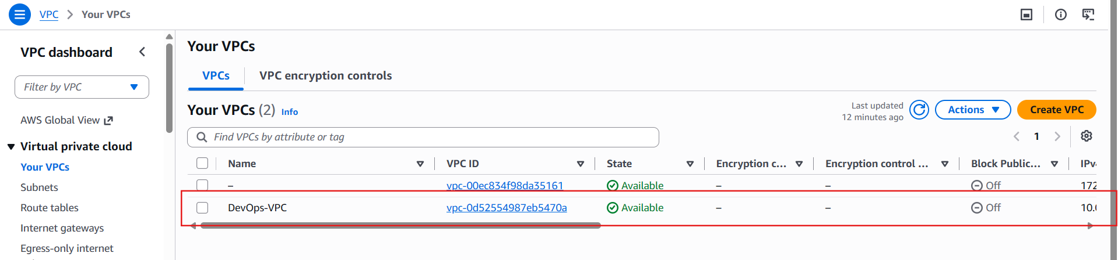

Step 4: Edit VPC Settings
With the VPC selected:
- Click Actions.
- Select Edit VPC settings.
A dialog box opens.

Step 5: Enable DNS Settings
Enable the following options:
- Enable DNS Resolution
- Enable DNS Hostnames
Click Save.
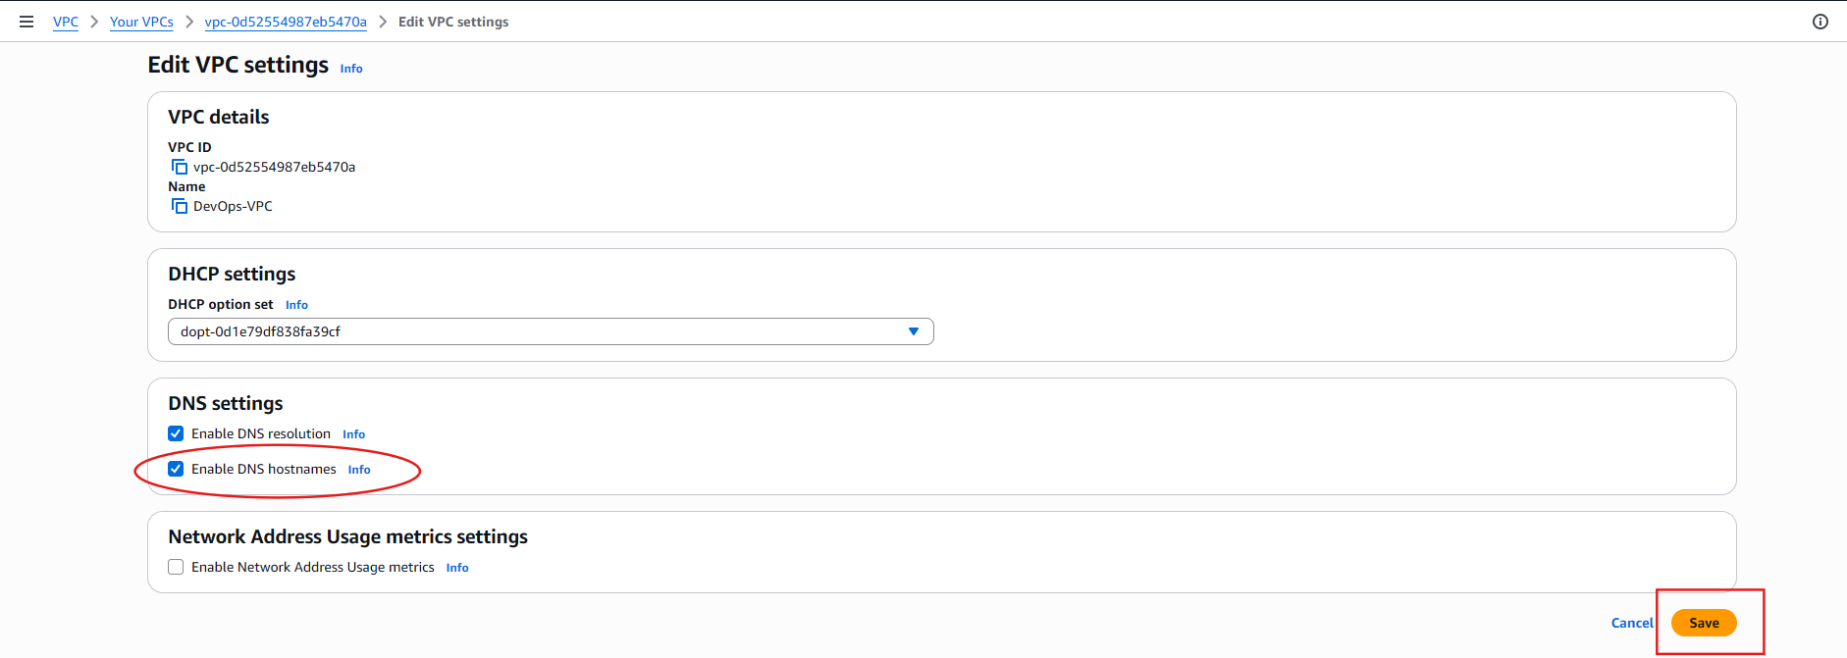

Step 6: Verify the Configuration
Select DevOps-VPC again. In the Details tab, verify:
Setting | Expected Value
DNS Resolution | Enabled
DNS Hostnames | Enabled

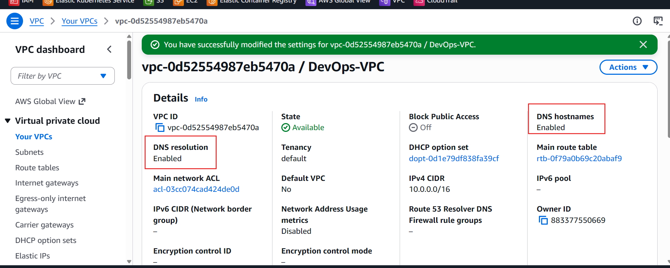

Why This Is Important
If you later launch a public EC2 instance with a public IP, it will automatically receive a public DNS name, such as:
ec2-54-210-100-123.compute-1.amazonaws.com
This makes it easier to access the instance and use services hosted on it.

3. Enable Auto Assign Public IP in 2 public subnets.

Objective
Enable Auto-Assign Public IPv4 Address for both public subnets so that any EC2 instance launched into these subnets automatically receives a public IP address.

Why is this important?
Without a public IP:
- You cannot SSH into the EC2 instance directly from the internet.
- You cannot access web applications (e.g., PHP website) hosted on the EC2 instance.
- Later tasks (installing PHP and testing the website) will not work as expected.

Step 1: Open the VPC Service
- Go to the AWS Management Console.
- Search for VPC.
- Open the VPC service.

Step 2: Open the Subnets Page
In the left navigation pane: Virtual Private Cloud → Subnets
You should see:
Subnet Name | CIDR
Public-Subnet-1 | 10.0.1.0/24
Public-Subnet-2 | 10.0.2.0/24
Private-Subnet-1 | 10.0.3.0/24
Private-Subnet-2 | 10.0.4.0/24


Step 3: Enable Auto-Assign Public IP for Public-Subnet-1
- Select Public-Subnet-1.
- Click Actions.
- Click Edit subnet settings.
Under Auto-assign IP settings, enable: Auto-assign public IPv4 address
Click Save.
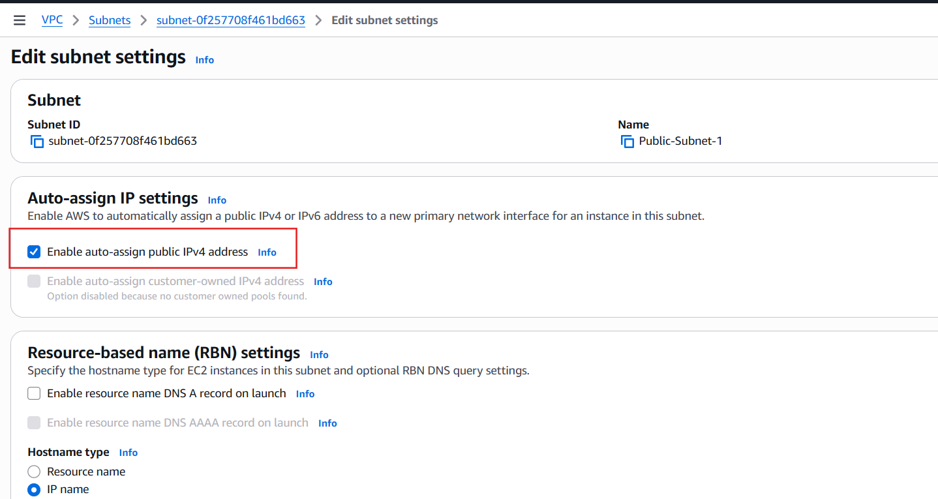

Step 4: Verify the Setting
Select Public-Subnet-1 again. In the Details section, verify:
Property | Value
Auto-assign public IPv4 address | Enabled

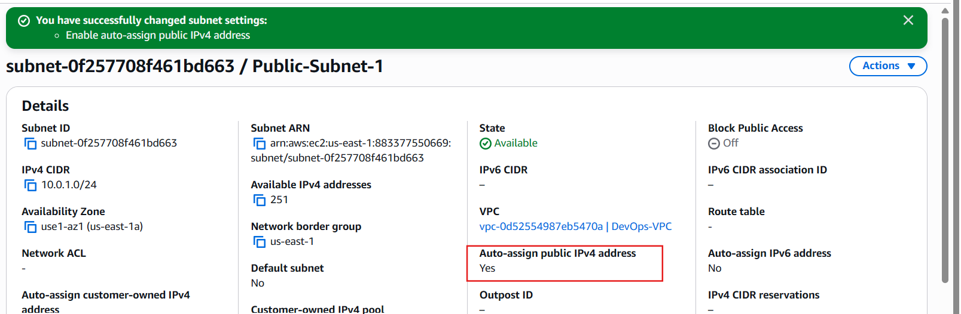

Step 5: Repeat for Public-Subnet-2
Repeat the same steps:
- Select Public-Subnet-2.
- Actions → Edit subnet settings
- Enable: Auto-assign public IPv4 address
- Click Save.

Step 6: Verify Public-Subnet-2
Confirm:
Property | Value
Auto-assign public IPv4 address | Enabled

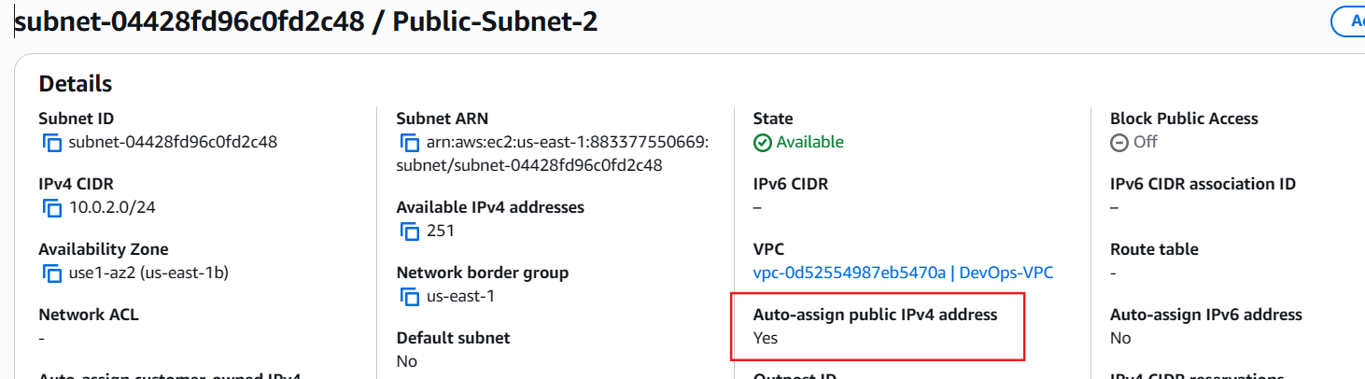

Important Note
Do NOT enable Auto-Assign Public IPv4 on:
- Private-Subnet-1
- Private-Subnet-2
These subnets are intended for private resources and should not automatically receive public IP addresses.

Expected Configuration
Subnet | Auto Public IP
Public-Subnet-1 | Enabled
Public-Subnet-2 | Enabled
Private-Subnet-1 | Disabled
Private-Subnet-2 | Disabled

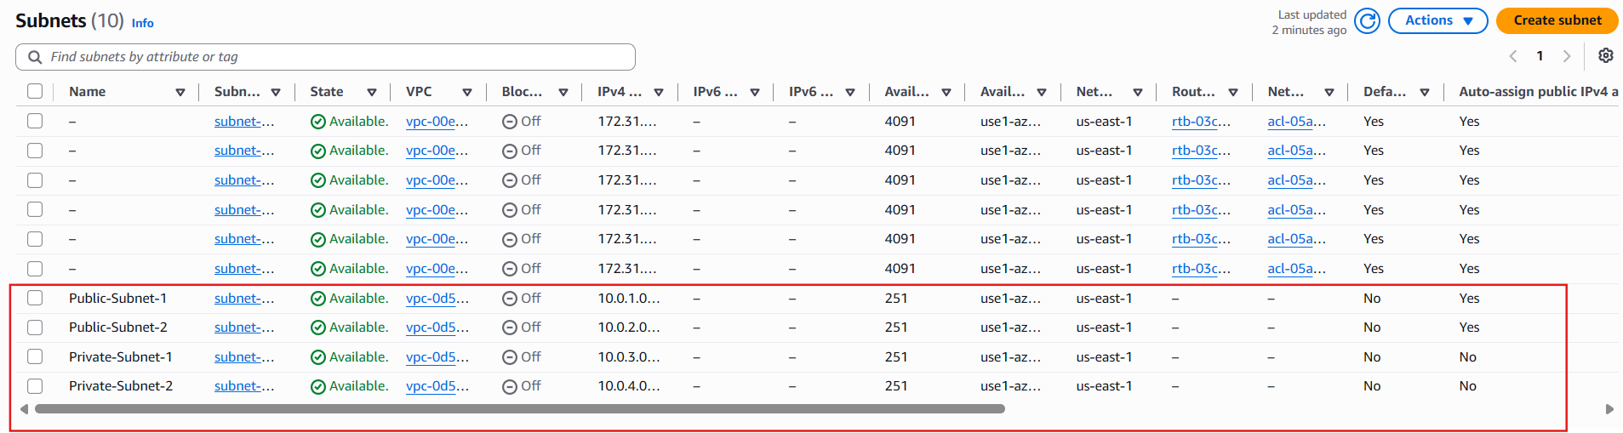

4. Add 2 private subnets in private route table.

Objective
Create a Private Route Table and associate it with:
- Private-Subnet-1
- Private-Subnet-2
At this stage, the route table will contain only the local route. We'll add the NAT Gateway route later in Task 8.

Network Diagram After This Task
DevOps-VPC (10.0.0.0/16)
-------------------------------------------
| |
Public Route Table Private Route Table
(Later) (Create now)
| |
Public-Subnet-1 Private-Subnet-1
Public-Subnet-2 Private-Subnet-2

Step 1: Open the VPC Service
- Log in to the AWS Management Console.
- Search for VPC.
- Open the VPC service.

Step 2: Open Route Tables
In the left navigation pane: Virtual Private Cloud → Route Tables
You will see the main/default route table that AWS created with your VPC.
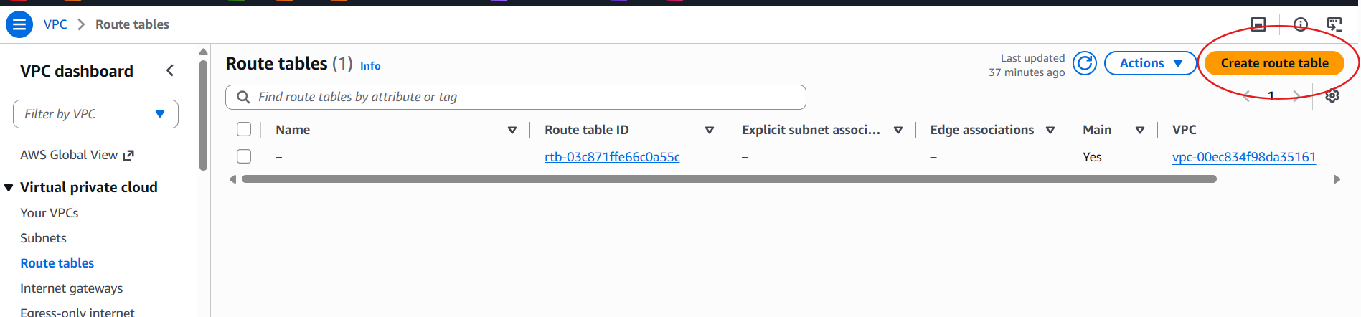

Step 3: Create a New Route Table
Click Create route table. Enter the following:
Field | Value
Name | Private-RT
VPC | DevOps-VPC

Click Create route table. You should see a success message.
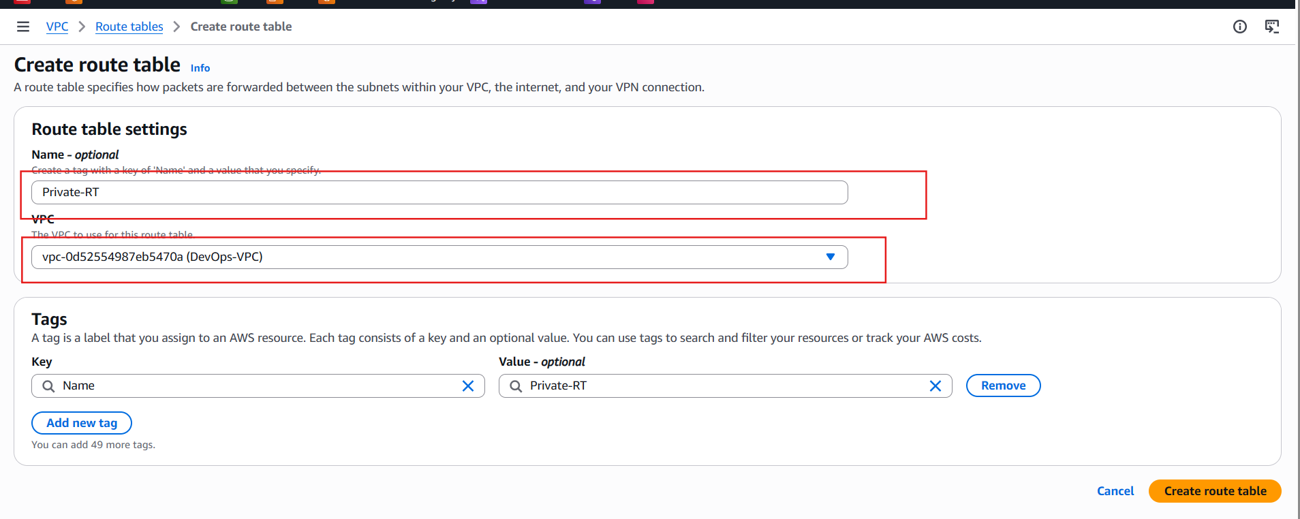

Step 4: Verify the Route Table
Select Private-RT. In the Routes tab, you should see:
Destination | Target
10.0.0.0/16 | Local

Explanation
- 10.0.0.0/16 → Local allows communication between all subnets inside the VPC.
- Do not add 0.0.0.0/0 yet. We'll do that after creating the NAT Gateway in Task 8.
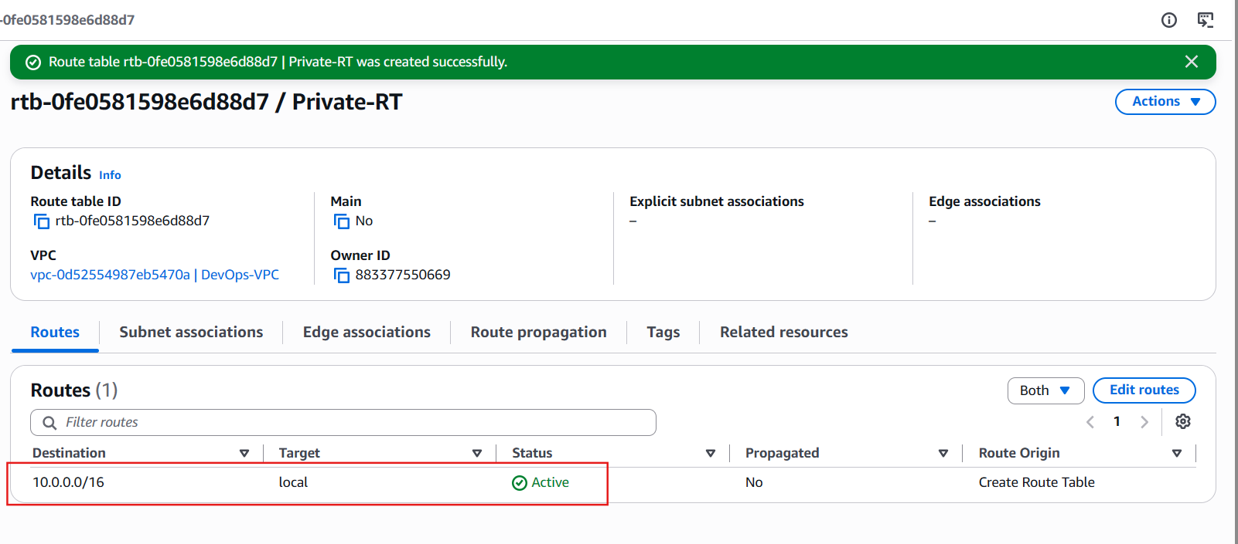

Step 5: Associate Private Subnet 1
With Private-RT selected:
- Open the Subnet associations tab.
- Click Edit subnet associations.
- Select: Private-Subnet-1
- Click Save associations.
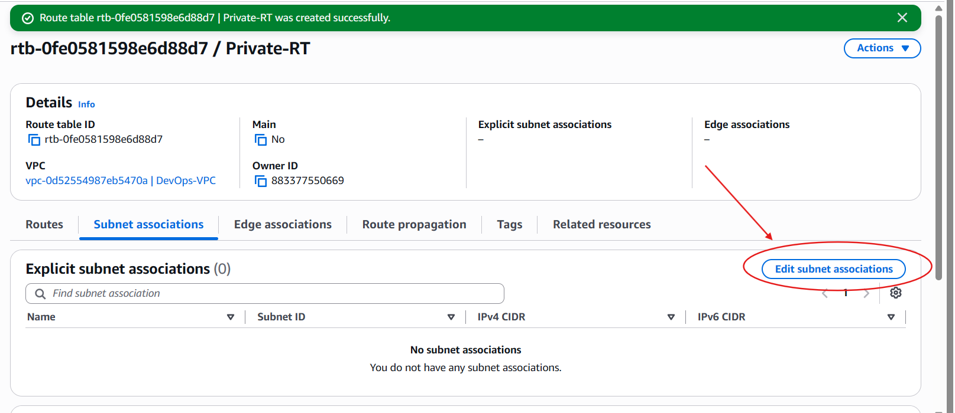

Step 6: Associate Private Subnet 2
Stay in the Subnet associations tab.
- Click Edit subnet associations again (if needed).
- Ensure both are selected: Private-Subnet-1, Private-Subnet-2
- Click Save associations.
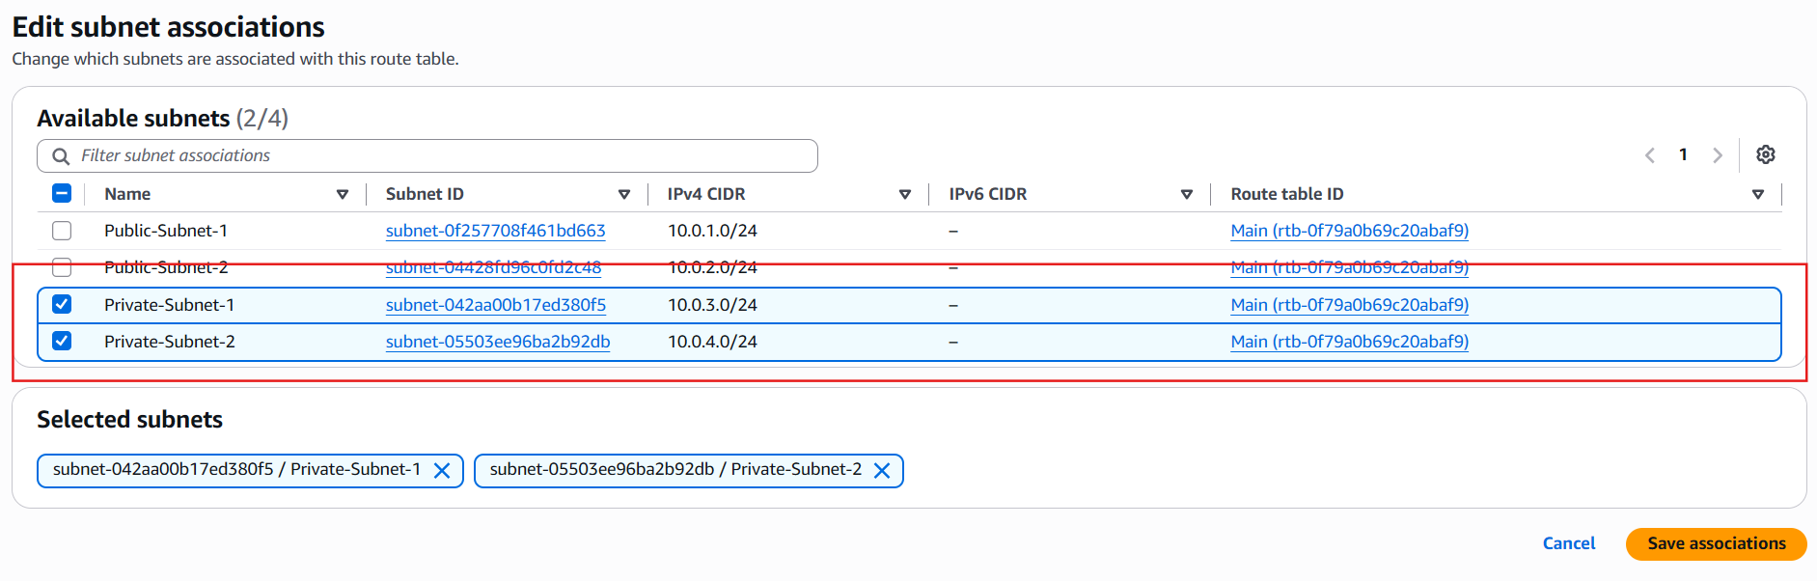

Step 7: Verify Associations
Under Subnet associations, you should see:
Subnet | Associated Route Table
Private-Subnet-1 | Private-RT
Private-Subnet-2 | Private-RT

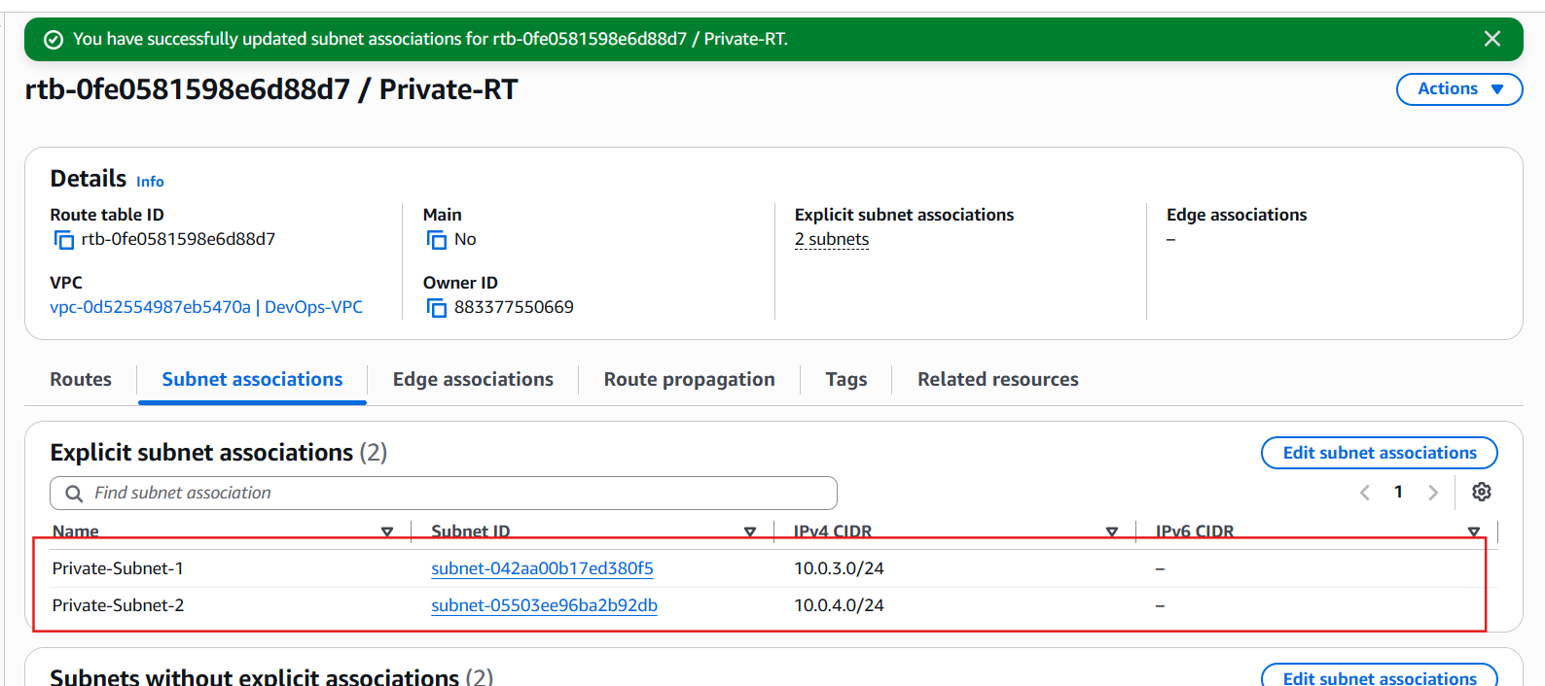

Expected Configuration
Private Route Table (Private-RT)
Routes: 10.0.0.0/16 -> Local
Associated Subnets:
- Private-Subnet-1
- Private-Subnet-2
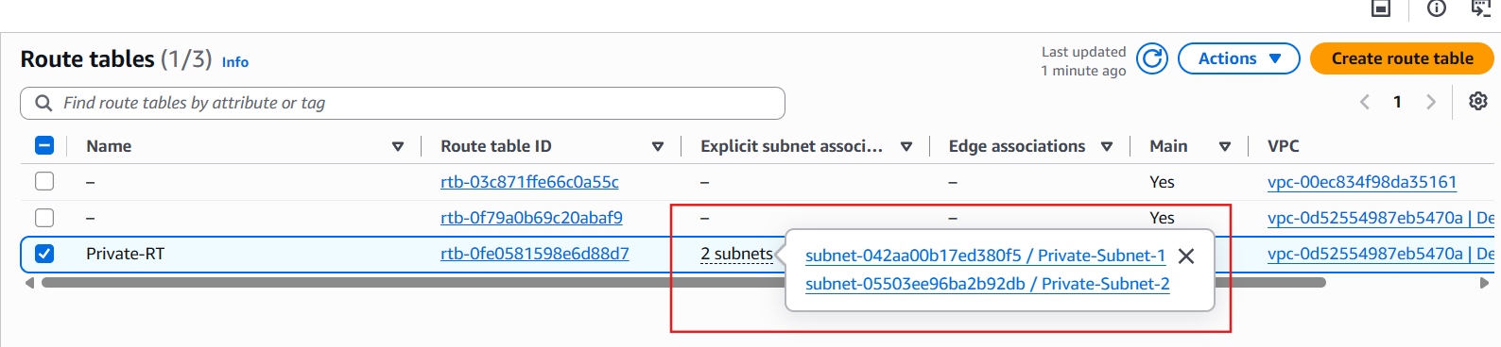

5. Add 2 public subnets in public route table.

Objective
Create a Public Route Table and associate it with:
- Public-Subnet-1
- Public-Subnet-2
We will add the Internet Gateway route (0.0.0.0/0) in Task 6.

Step 1: Open Route Tables
Go to: VPC → Route Tables
Click Create route table.


Step 2: Create the Public Route Table
Enter:
Field | Value
Name | Public-RT
VPC | DevOps-VPC

Click Create route table.
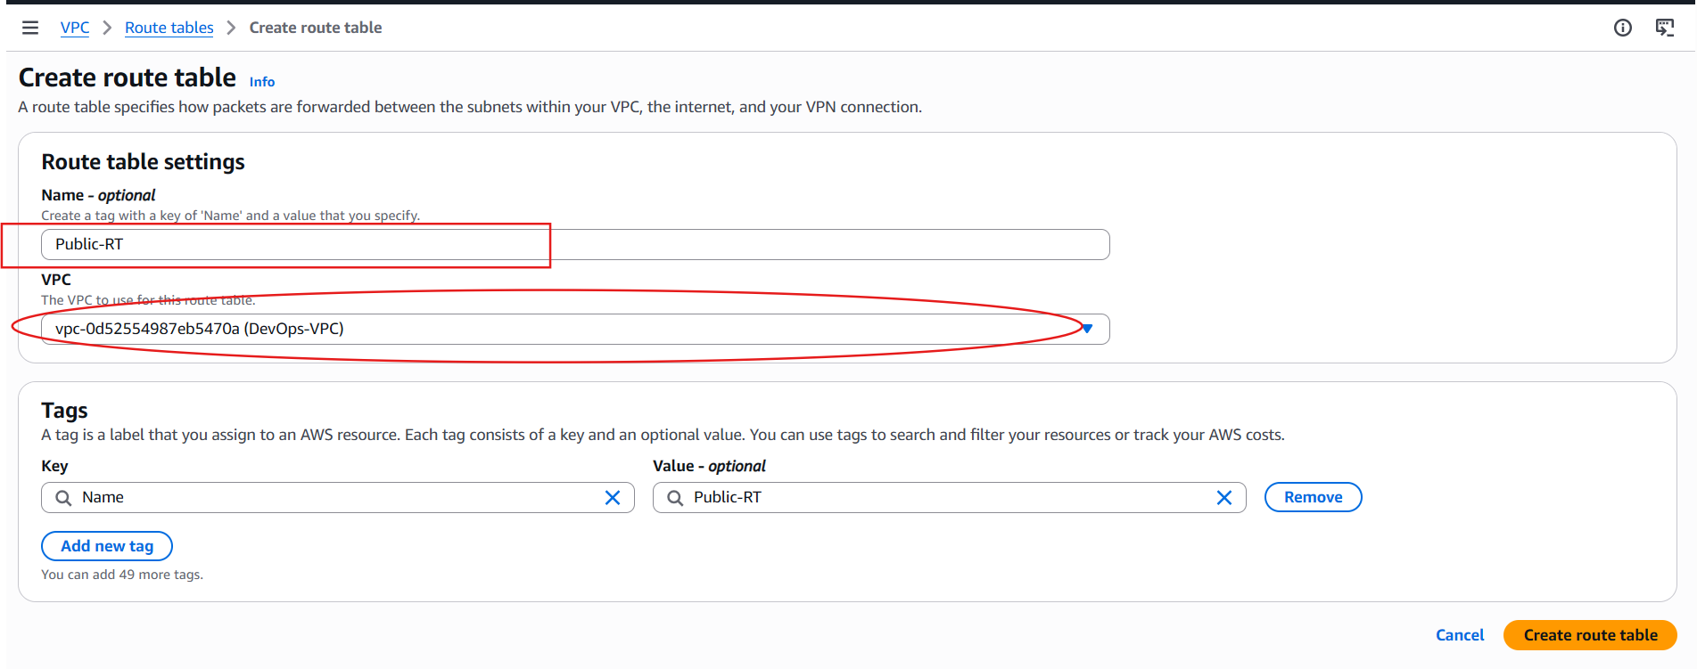

Step 3: Verify the Routes
Select Public-RT. Go to the Routes tab. Initially, you should see only:
Destination | Target
10.0.0.0/16 | Local

This is expected. We'll add the Internet Gateway route in the next task.
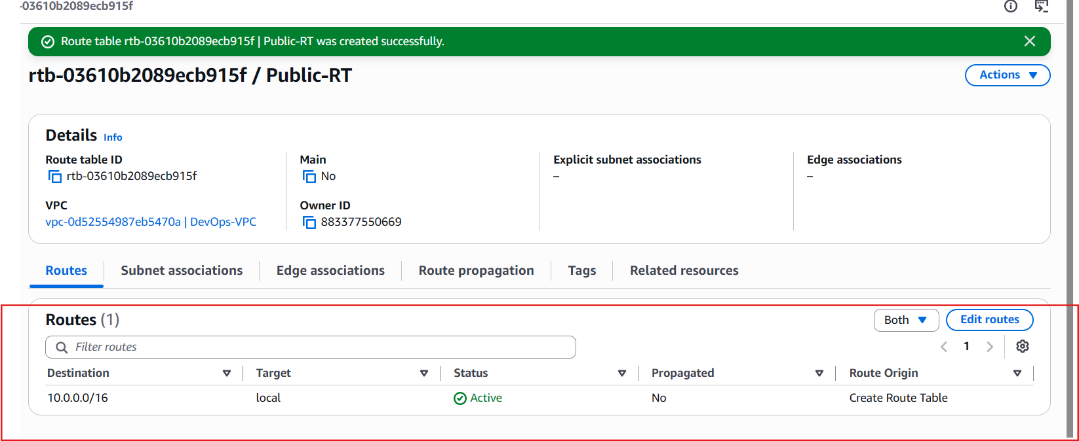

Step 4: Associate the Public Subnets
- Select Public-RT.
- Go to the Subnet associations tab.
- Under Explicit subnet associations, click Edit subnet associations.
- Select: Public-Subnet-1, Public-Subnet-2
- Click Save associations.
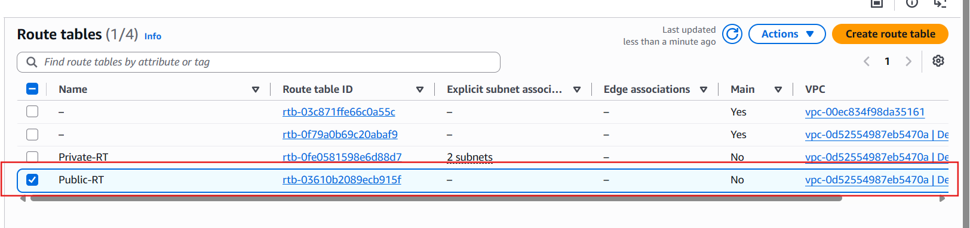

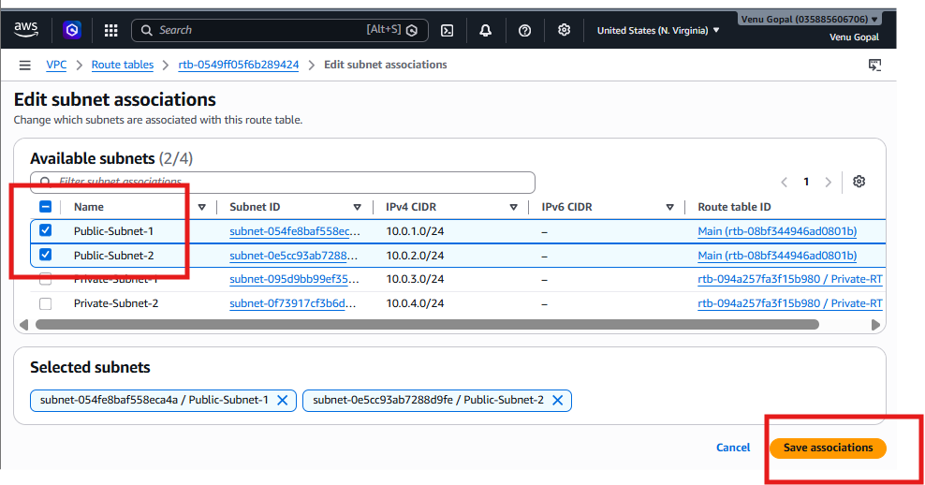

Step 5: Verify
Under Explicit subnet associations, you should now see: Public-Subnet-1, Public-Subnet-2
The Subnets without explicit associations section should now be empty (or only show subnets that are still using the main route table, if any).
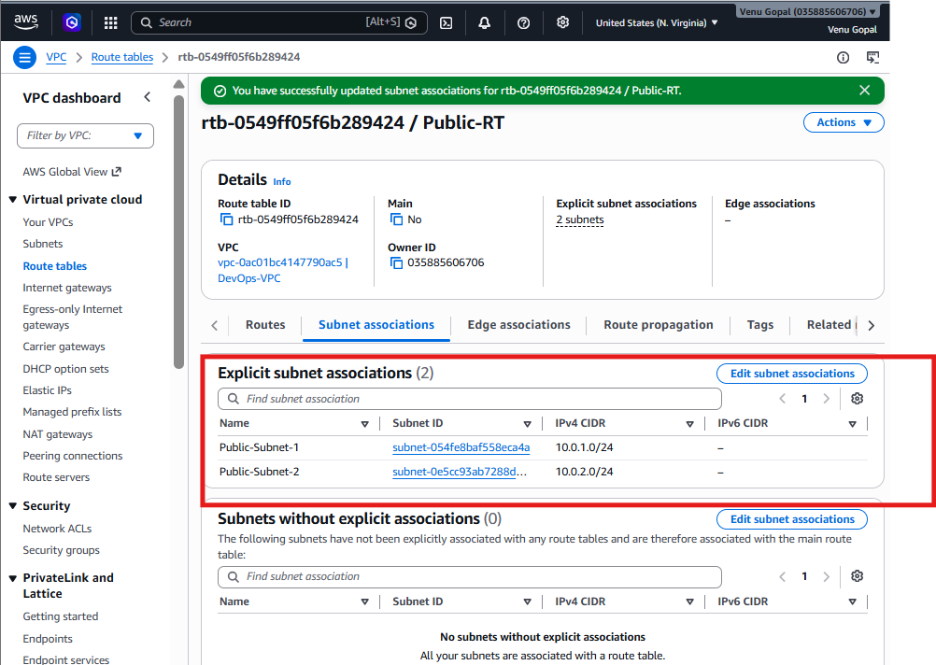

6. Public route table will have the routes to internet and local.

Objective
- Create an Internet Gateway (IGW).
- Attach it to your VPC.
- Add a default route (0.0.0.0/0) in the Public Route Table.
After this task:
- EC2 instances in public subnets can access the internet.
- They can receive inbound traffic (provided Security Groups allow it).

Current Network
Internet
X (Not Connected Yet)
DevOps-VPC
|
|--- Public-RT ---- Public-Subnet-1
| \- Public-Subnet-2
|
`--- Private-RT --- Private-Subnet-1
\- Private-Subnet-2

Step 1: Create an Internet Gateway
- Go to VPC Dashboard.
- In the left menu, click Internet Gateways.
- Click Create internet gateway.
Enter:
Field | Value
Name | DevOps-IGW

Click Create internet gateway. You should see: “Internet Gateway created successfully.”
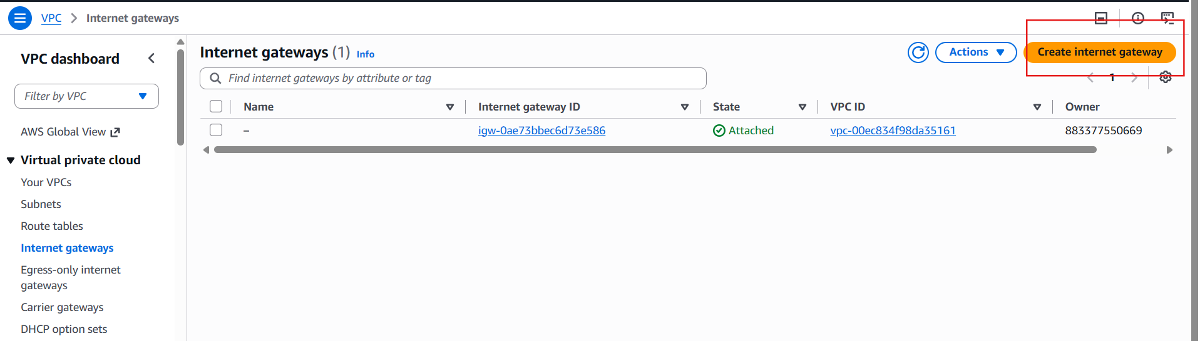
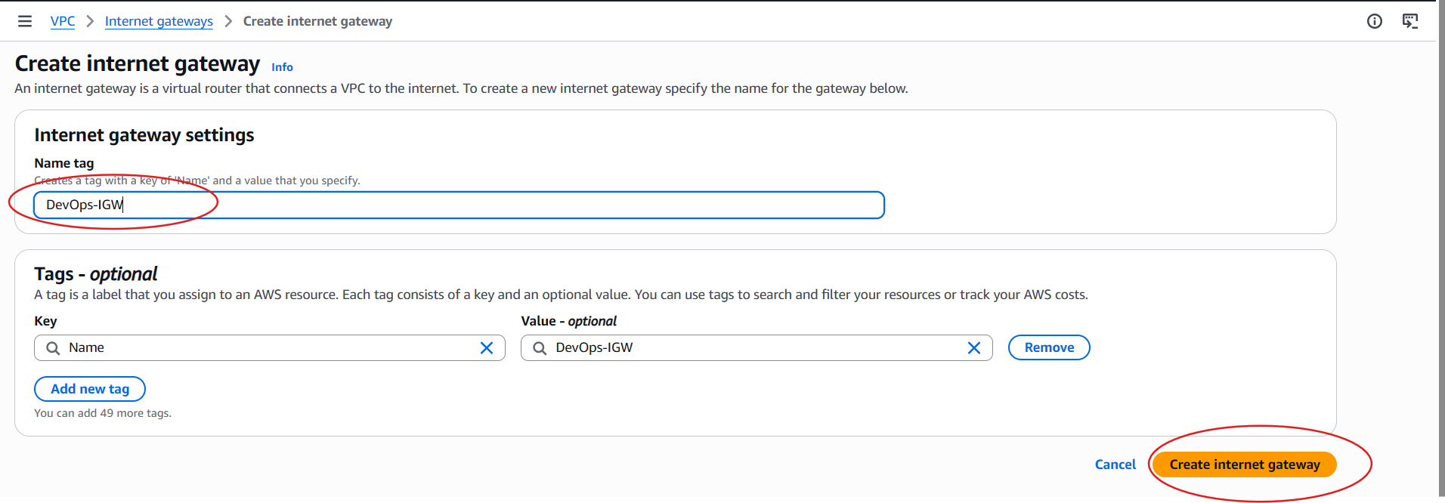

Step 2: Attach the Internet Gateway to the VPC
Select DevOps-IGW. Click: Actions → Attach to VPC
Choose: DevOps-VPC
Click Attach internet gateway.
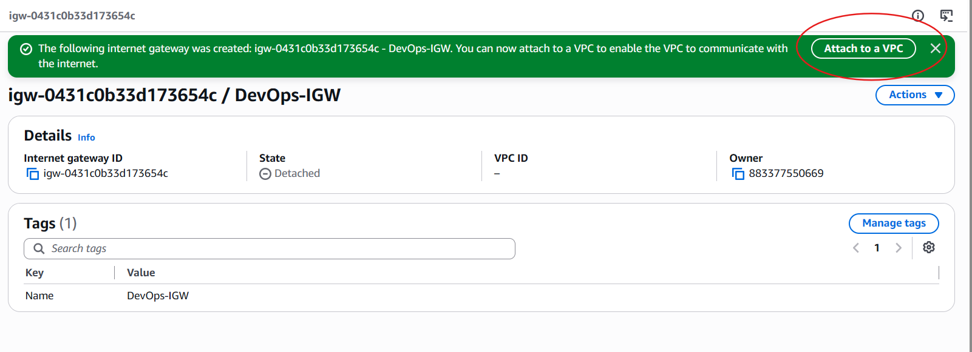

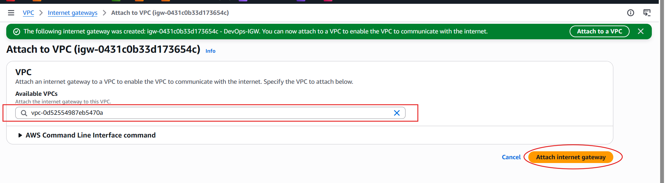

Verify
The Internet Gateway should now show:
Property | Value
State | Attached
VPC | DevOps-VPC

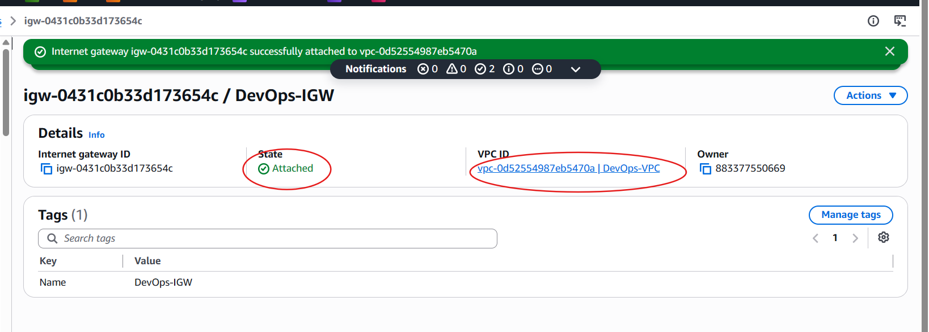

Step 3: Open the Public Route Table
Go to: Route Tables
Select: Public-RT
Open the Routes tab. Click: Edit routes

Step 4: Add the Internet Route
Click Add route. Enter:
Destination | Target
0.0.0.0/0 | Internet Gateway

Choose: DevOps-IGW
Click: Save changes

Step 5: Verify the Routes
Your Public-RT should now contain:
Destination | Target
10.0.0.0/16 | Local
0.0.0.0/0 | Internet Gateway (DevOps-IGW)

This means any internet-bound traffic from instances in the public subnets will be sent to the Internet Gateway.
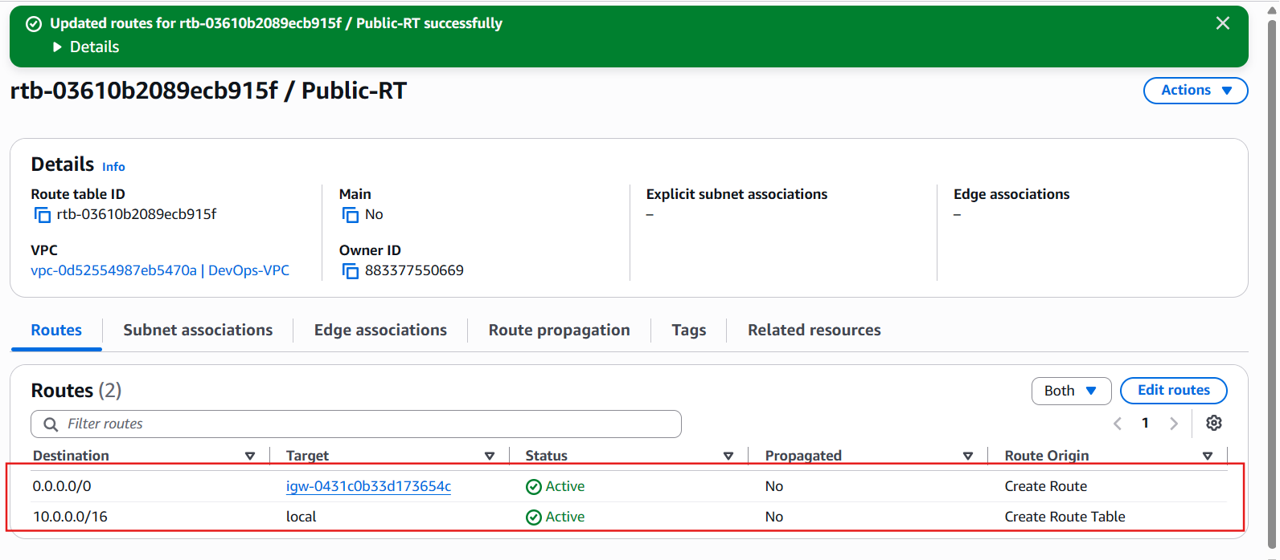

Verification
Internet Gateway
- Name: DevOps-IGW
- State: Attached
- VPC: DevOps-VPC
Public Route Table Routes
Destination | Target
10.0.0.0/16 | Local
0.0.0.0/0 | Internet Gateway

7. Create EC2 in public subnet with t2.micro and install PHP.

Objective
- Launch an Amazon Linux 2023 EC2 instance
- Instance type: t2.micro
- Place it in Public-Subnet-1
- Install Apache HTTP Server and PHP
- Verify the PHP page in your browser

Step 1: Open EC2 Dashboard
- Go to the AWS Management Console.
- Search for EC2.
- Open the EC2 service.
- Click Launch instances.

Step 2: Basic Configuration
Field | Value
Name | PHP-Server
AMI | Amazon Linux 2023
Instance Type | t3.micro

If t2.micro is not available in your account, you can use t3.micro.
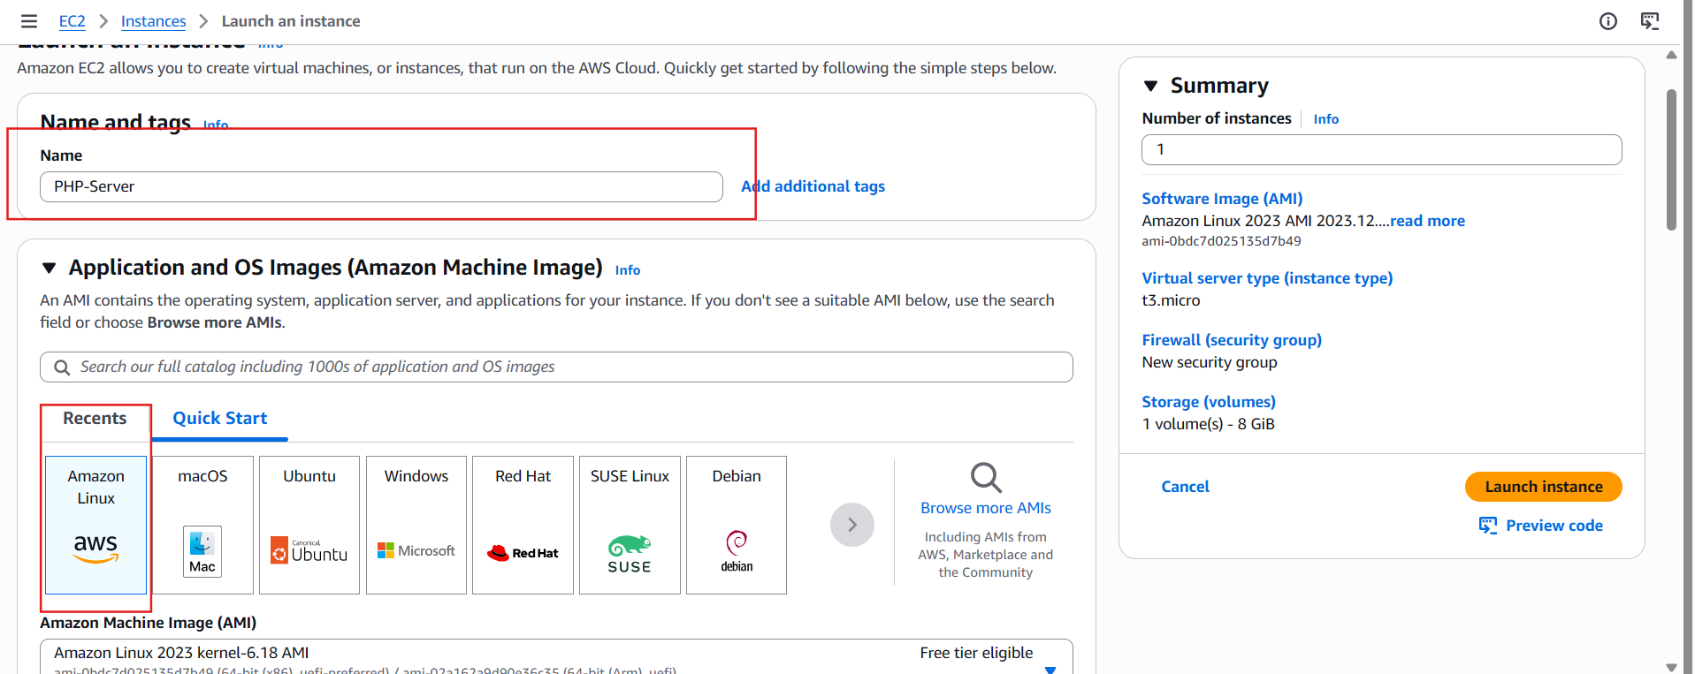

Step 3: Create or Select a Key Pair
If you already have a key pair: select your existing key pair. Otherwise:
- Click Create new key pair.
- Name it devops-key.
- Type: RSA
- Format: .pem
- Download and save it securely.

Step 4: Network Settings
Click Edit under Network settings. Configure:
Setting | Value
VPC | DevOps-VPC
Subnet | Public-Subnet-1
Auto-assign Public IP | Enable
Firewall (Security Group) | Create new

Step 5: Configure Security Group
Create a new Security Group.
Rule | Protocol | Port | Source
SSH | TCP | 22 | My IP (recommended)
HTTP | TCP | 80 | Anywhere (0.0.0.0/0)

My IP for SSH is safer than Anywhere.
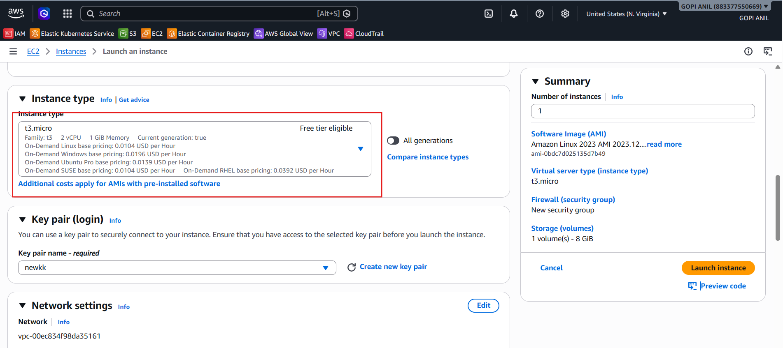
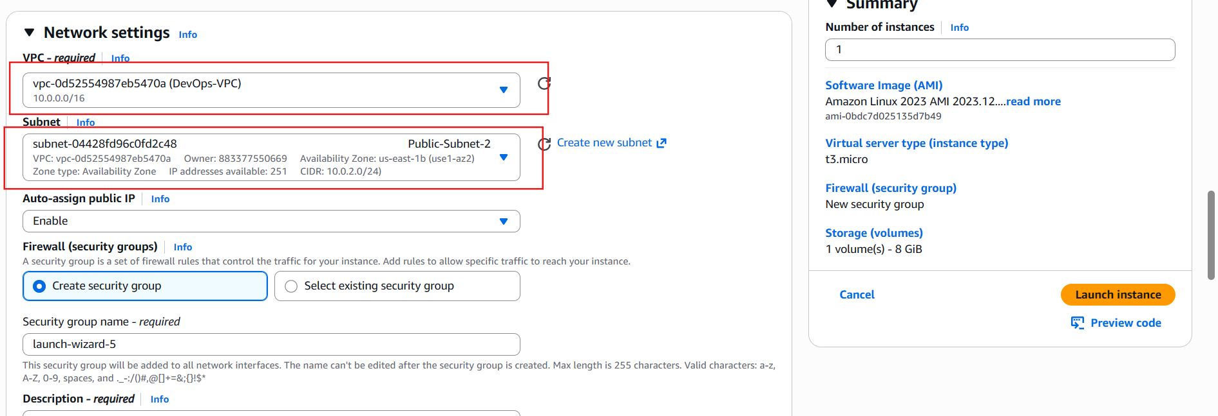

Step 6: Launch the Instance
Click Launch instance. Wait until:
- Instance State: Running
- Status Checks: 2/2 checks passed
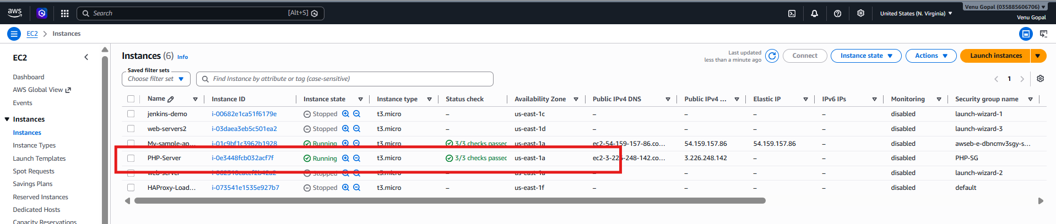

Step 7: Copy the Public IP
In the EC2 Instances page, note the Public IPv4 address, for example:
54.xx.xx.xx
You'll use this to connect via SSH.

Step 8: Connect to the EC2 Instance
From Git Bash (or your terminal):
chmod 400 devops-key.pem
Then connect:
ssh -i devops-key.pem ec2-user@<Public-IP>
Example:
ssh -i "newkk.pem" ec2-user@ec2-3-82-142-188.compute-1.amazonaws.com
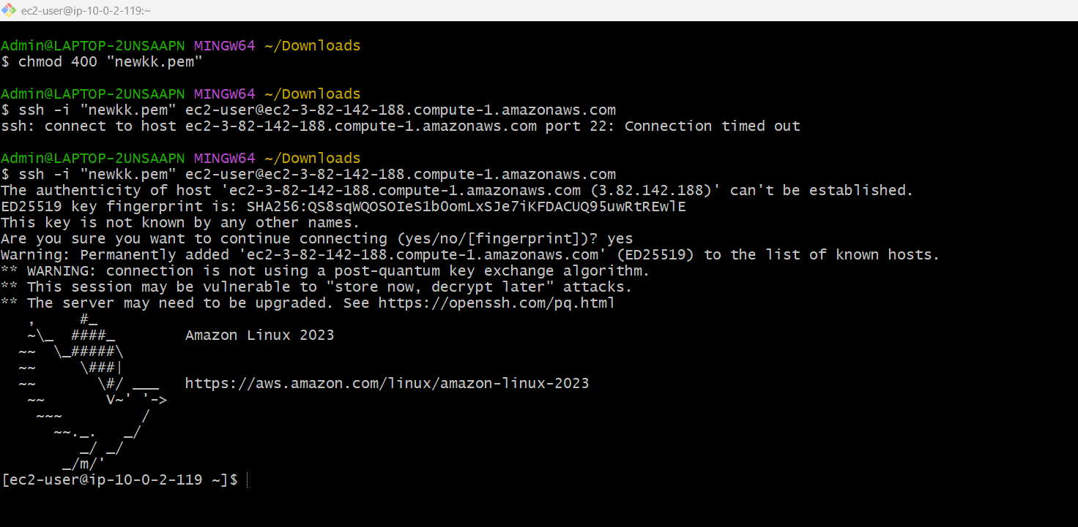
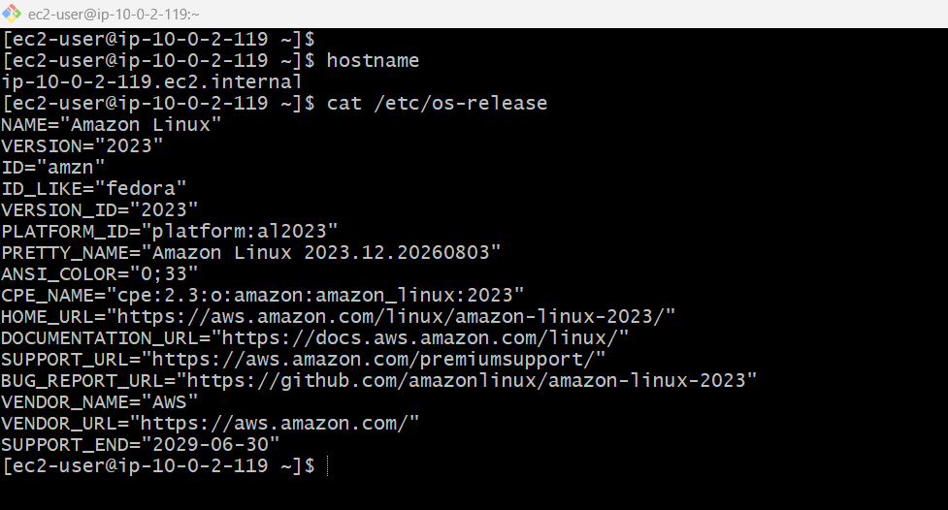

Step 9: Update the Server
sudo dnf update -y

Step 10: Install Apache HTTP Server
sudo dnf install -y httpd
Start and enable Apache:
sudo systemctl enable httpd
sudo systemctl start httpd
Check its status:
sudo systemctl status httpd
It should show:
Active: active (running)
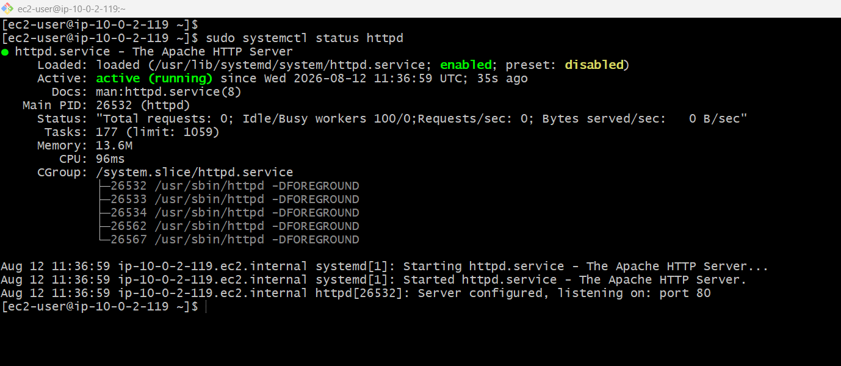

Step 11: Install PHP
sudo dnf install -y php
Verify:
php -v
You should see the installed PHP version.
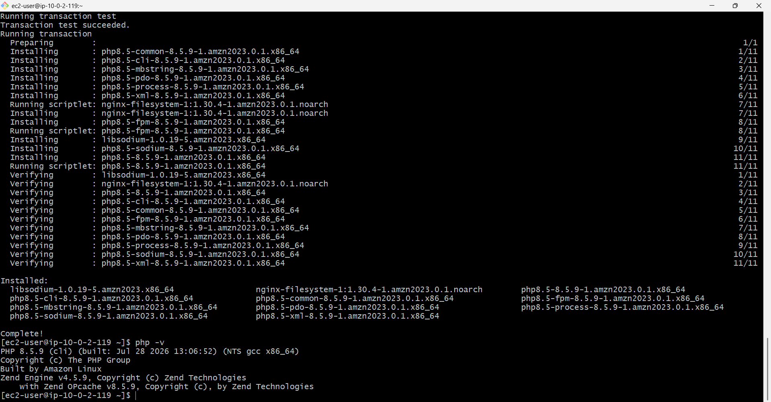

Step 12: Create a PHP Test Page
Create the file:
echo "<?php phpinfo(); ?>" | sudo tee /var/www/html/index.php
Restart Apache:
sudo systemctl restart httpd
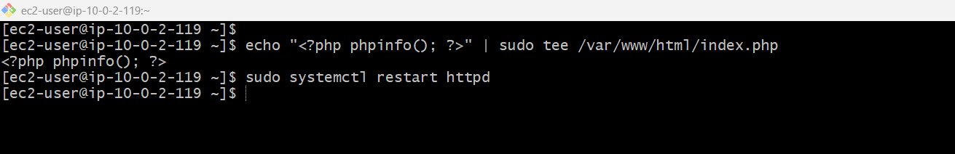

Step 13: Test in the Browser
Open:
http://<Public-IP>/index.php
Example:
http://54.210.123.45/index.php
You should see the PHP Information page.
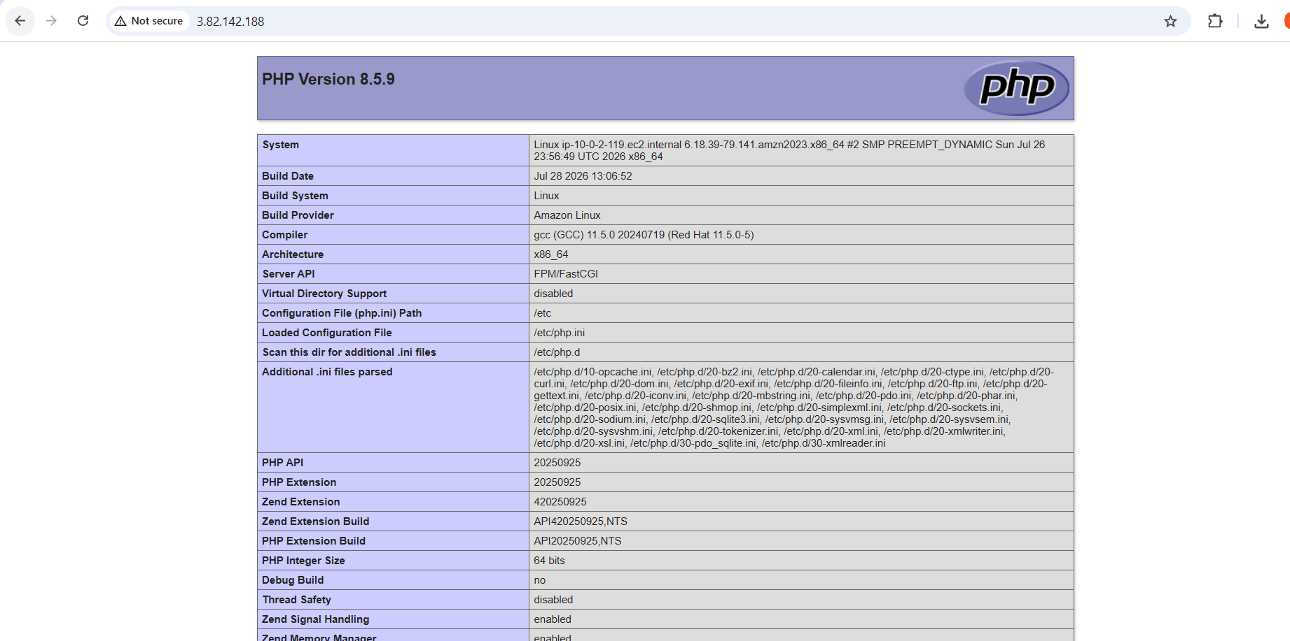

8. Configure NAT gateway in public subnet and connect to private instance.

Objective
We'll perform the following:
- Allocate an Elastic IP
- Create a NAT Gateway in the Public Subnet
- Update the Private Route Table
- Launch a Private EC2 instance
- Connect from the Public EC2 to the Private EC2
- Verify internet access from the Private EC2

Architecture
Internet
|
Internet Gateway
|
Public Route Table
|
+---------+---------+
| |
Public EC2 (PHP) NAT Gateway
| |
+---------+---------+
|
Private Route Table
|
Private EC2 (Tomcat)

Step 1: Allocate an Elastic IP
Navigate to: EC2 → Network & Security → Elastic IPs
Click: Allocate Elastic IP address
Leave all settings as default. Click: Allocate
You will see something like:
Allocation ID | Public IP
eipalloc-xxxxxxxx | 44.xx.xx.xx

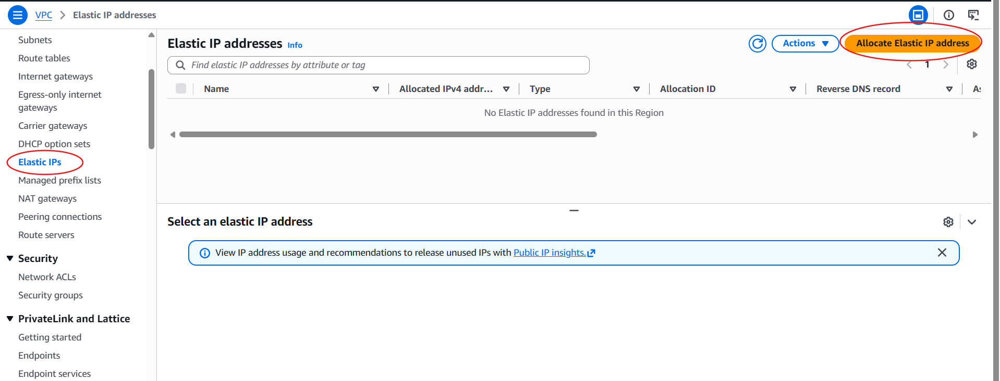
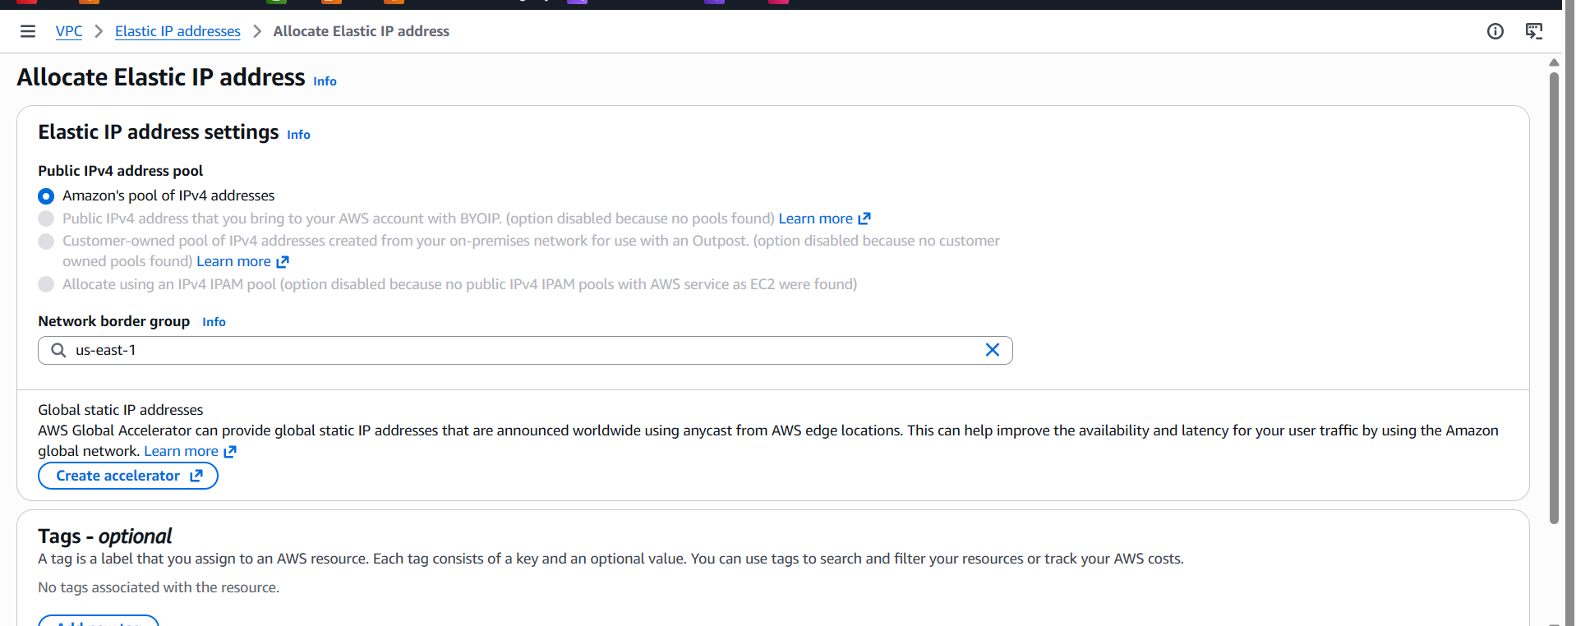
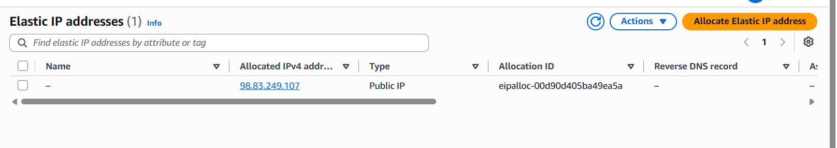

Step 2: Create the NAT Gateway
Navigate to: VPC → NAT Gateways
Click: Create NAT Gateway
Fill in the details:
Field | Value
Name | DevOps-NAT
Subnet | Public-Subnet-1
Connectivity Type | Public
Elastic IP | Select the Elastic IP you allocated

Click: Create NAT Gateway
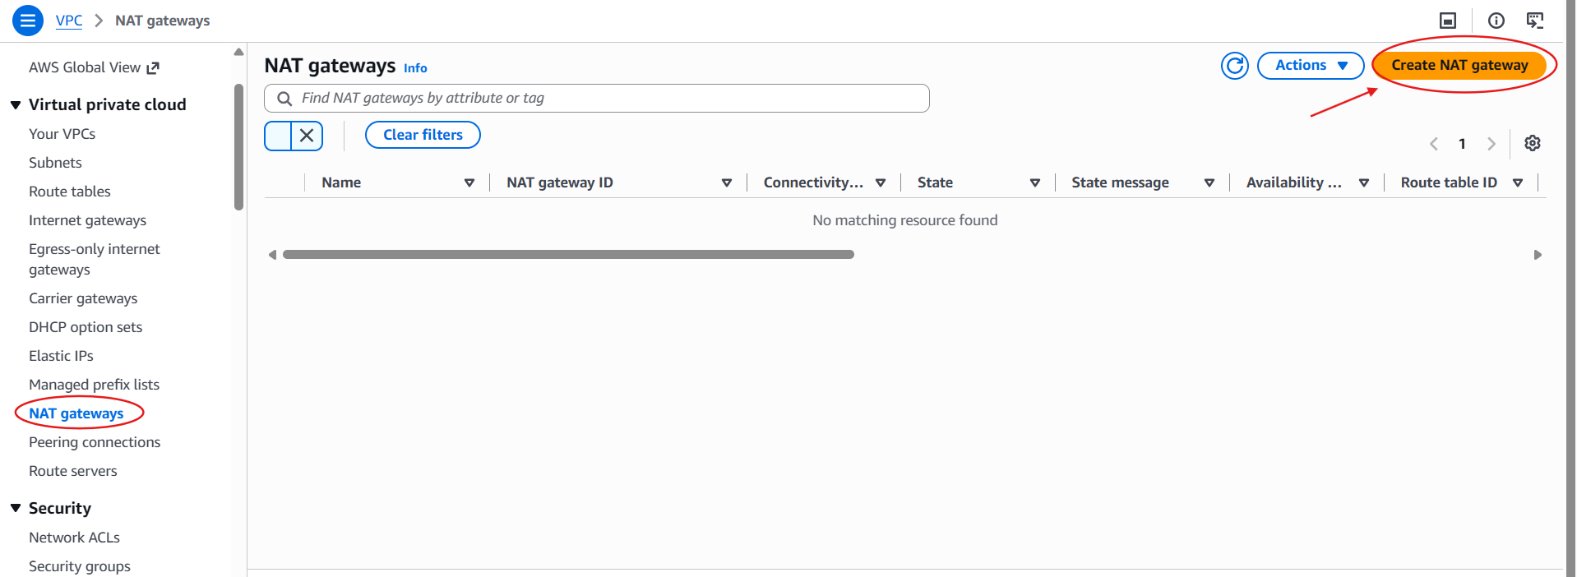

Step 3: Wait for the NAT Gateway
Initially, the status will be: Pending
Wait 2–5 minutes until it changes to: Available
Do not proceed until it is Available.
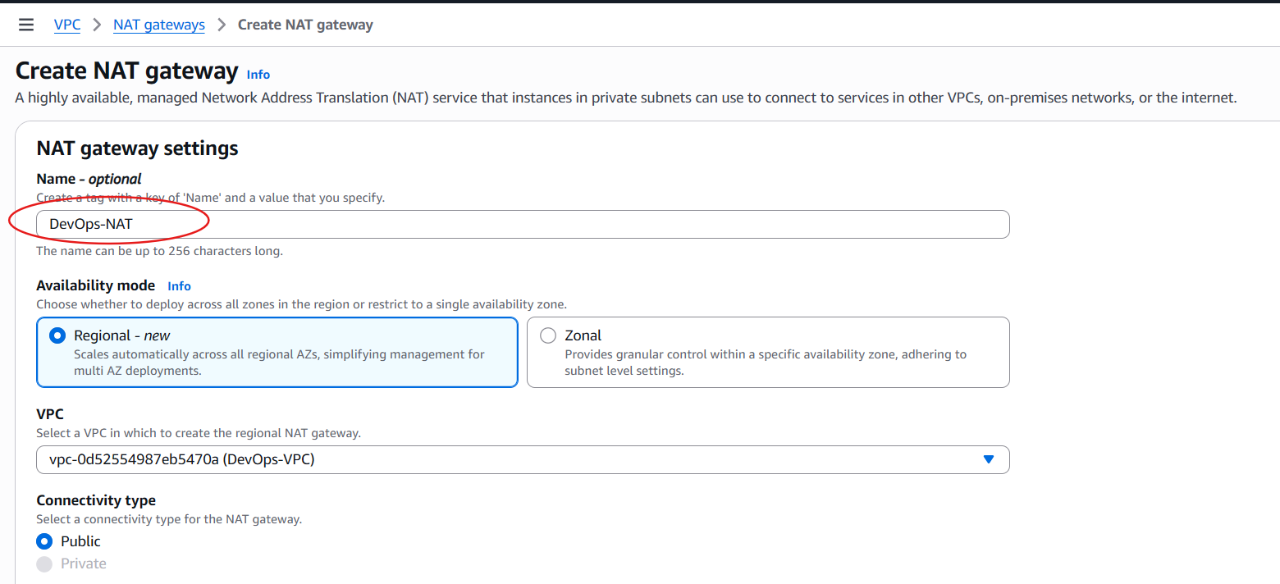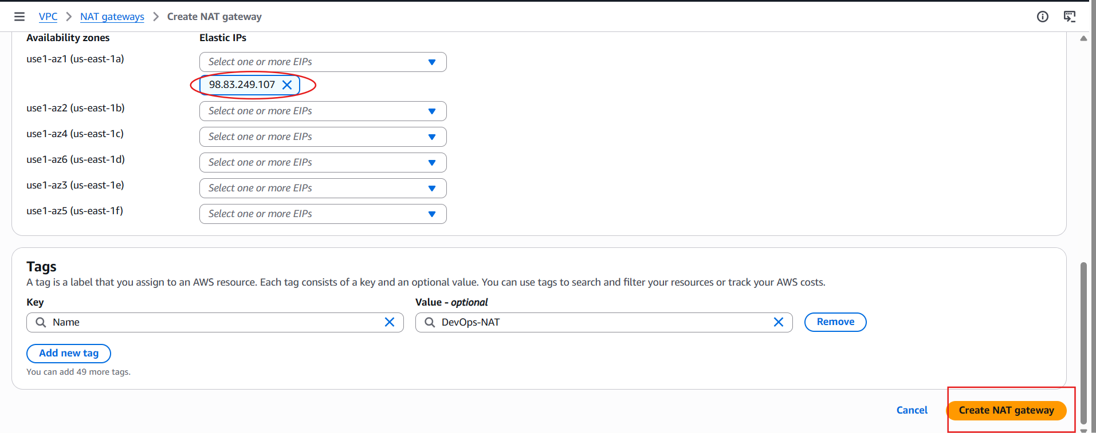
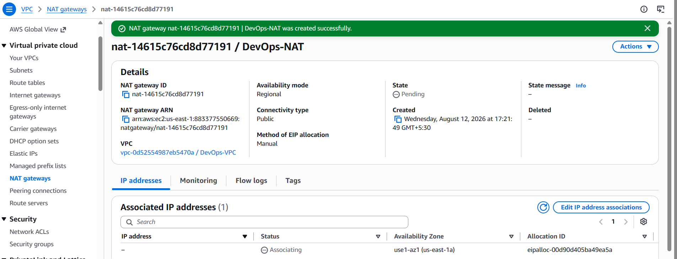

Step 4: Update the Private Route Table
Go to: VPC → Route Tables
Select: Private-RT
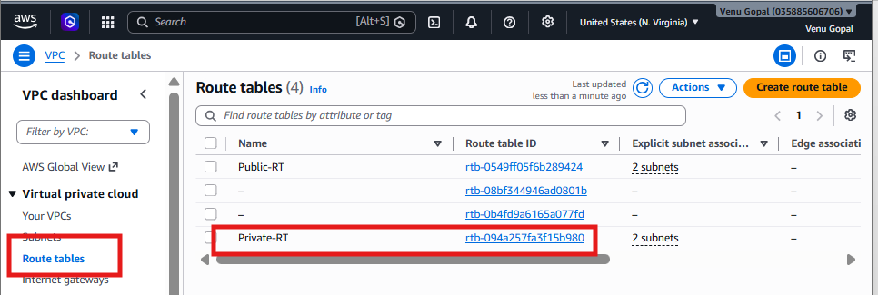
Open the Routes tab. Click: Edit routes. Click: Add route. Enter:
Destination | Target
0.0.0.0/0 | NAT Gateway

Select: DevOps-NAT
Click: Save changes
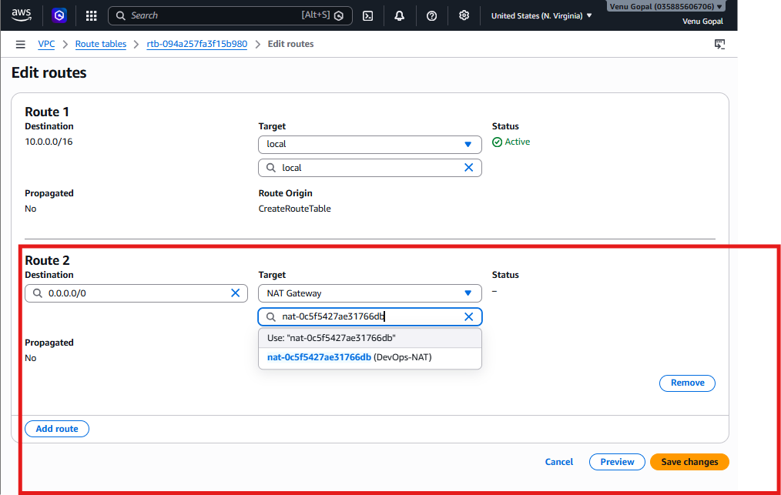

Step 5: Verify Routes
Your Private-RT should now contain:
Destination | Target
10.0.0.0/16 | Local
0.0.0.0/0 | NAT Gateway

This allows instances in the private subnets to initiate outbound internet connections while remaining inaccessible directly from the internet.
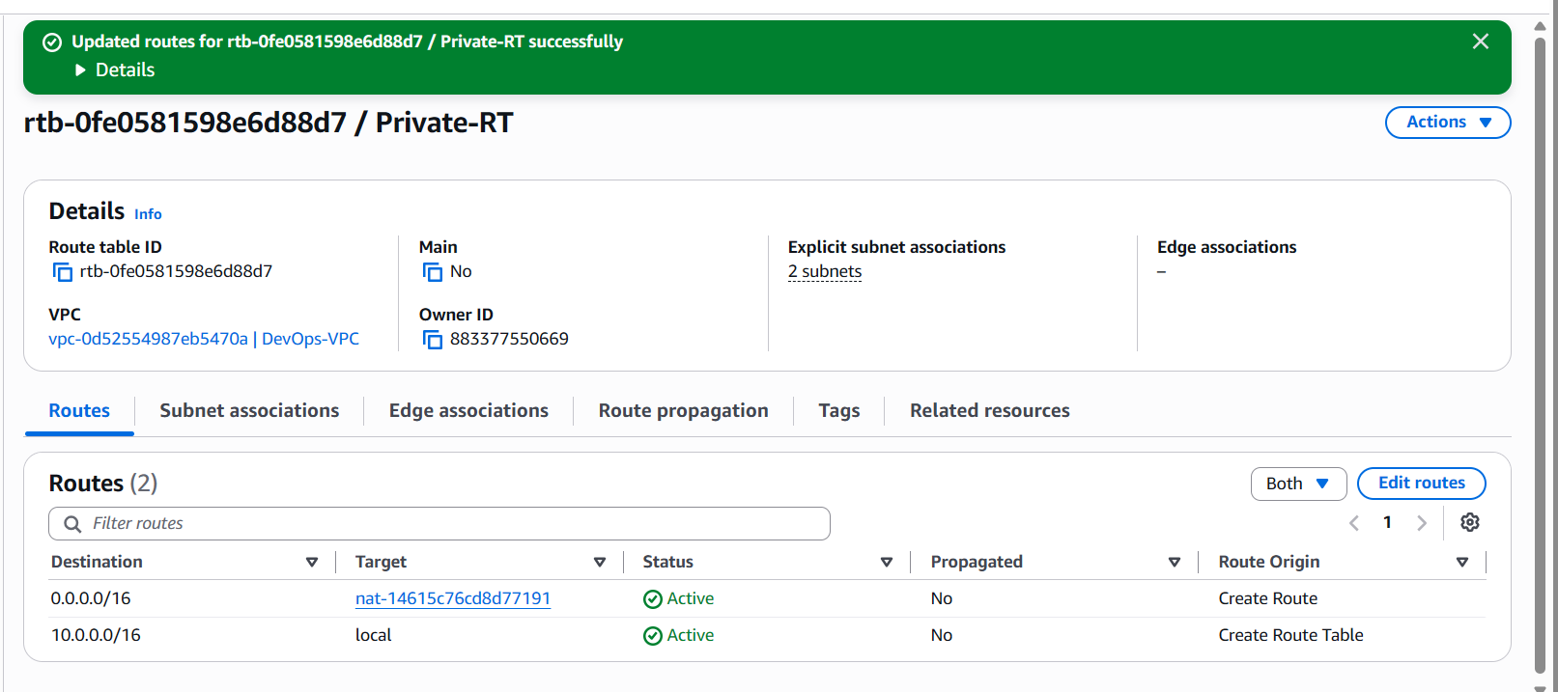

Step 6: Launch a Private EC2 Instance
Go to: EC2 → Launch Instance
Configure:
Field | Value
Name | Tomcat-Private
AMI | Amazon Linux 2023
Instance Type | t2.micro (or t3.micro)
Key Pair | Use the same key pair as the public EC2

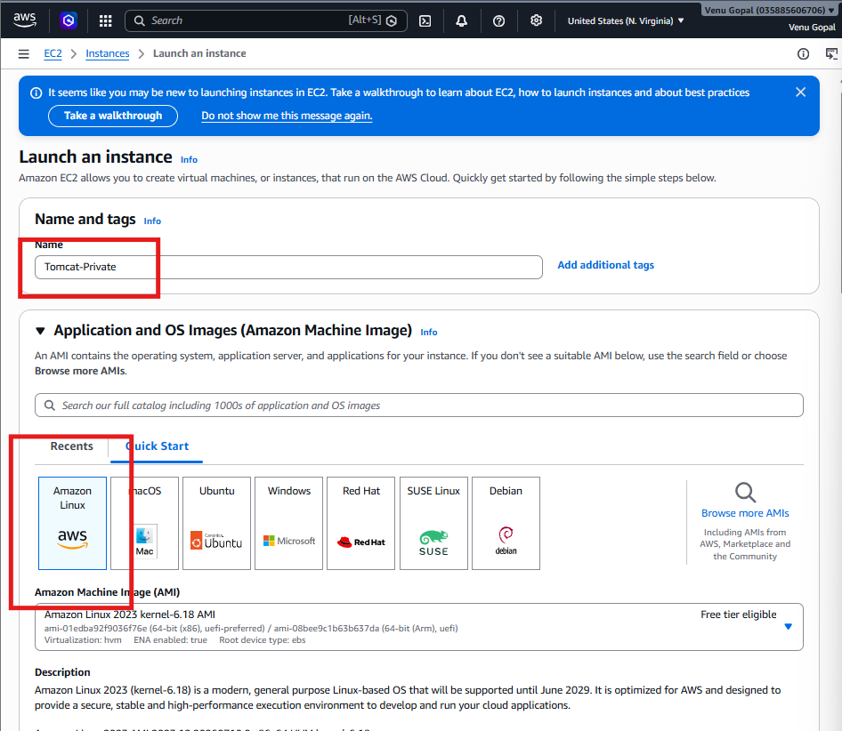
Network Settings
Click Edit. Set:
Field | Value
VPC | DevOps-VPC
Subnet | Private-Subnet-1
Auto-assign Public IP | Disable
Security Group | Create a new one or use an existing one
Security Group Rules
For now, add:
Type | Port | Source
SSH | 22 | 10.0.0.0/16

This allows SSH from within your VPC only.
Launch the instance.
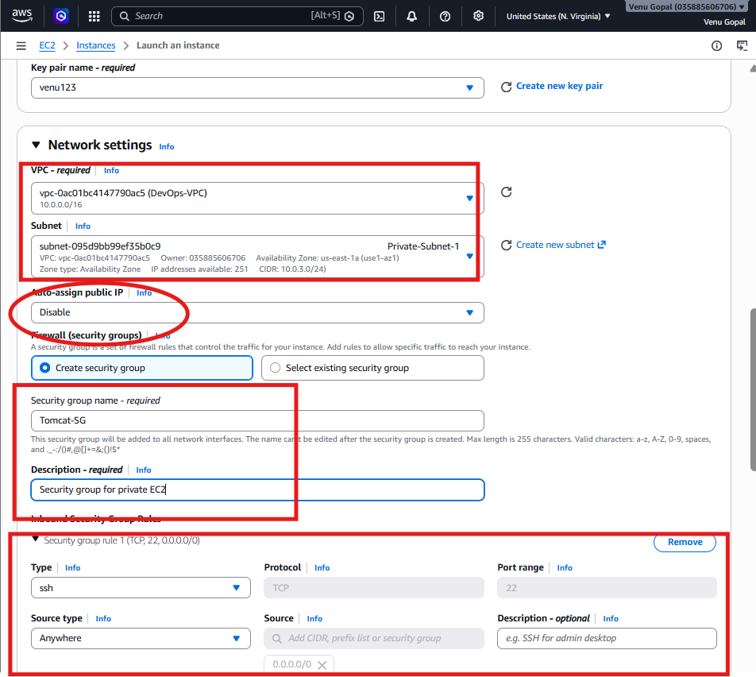

Step 7: Verify the Private EC2
After the instance is running:
- Verify that the Public IPv4 address field is empty.
- Note its Private IPv4 address, for example:
10.0.3.25
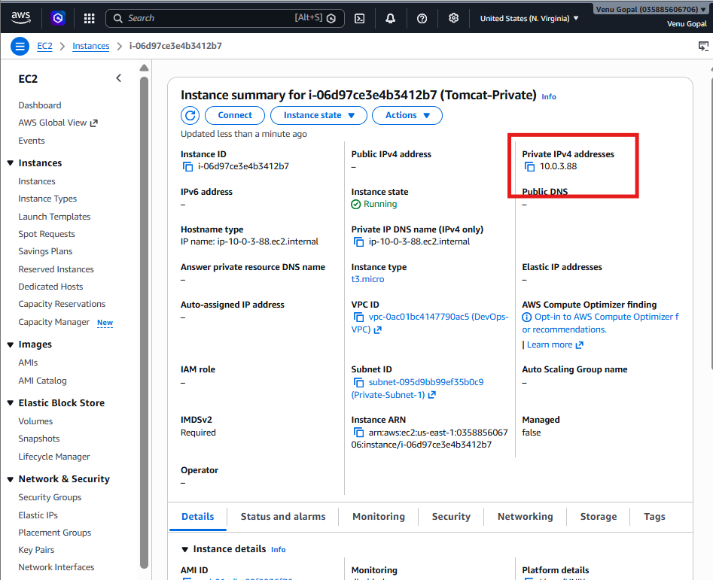

9. Install Apache Tomcat in private EC2 and deploy a sample app.
Since the private EC2 has no public IP, we cannot SSH directly from your laptop. We will use the Public EC2 as a Bastion Host (Jump Server).

Step 1: Get the Private IP
Go to: EC2 → Instances → Tomcat-Private
Copy the Private IPv4 address. Example:
10.0.3.52
We'll use it in the next step.

Step 2: Connect to Public EC2
From your laptop:
ssh -i rajesh123.pem ec2-user@<Public-EC2-Public-IP>
Example:
ssh -i rajesh123.pem ec2-user@54.xxx.xxx.xxx
Verify:
hostname

Step 3: Copy the Key to Public EC2
Since the private EC2 uses the same key pair (rajesh123.pem), copy it to the public EC2. From your laptop:
scp -i rajesh123.pem rajesh123.pem ec2-user@<Public-EC2-Public-IP>:/home/ec2-user/
Example:
scp -i rajesh123.pem rajesh123.pem ec2-user@54.xxx.xxx.xxx:/home/ec2-user/

Step 4: SSH to the Private EC2
On the Public EC2, run:
chmod 400 rajesh123.pem
Then:
ssh -i rajesh123.pem ec2-user@<Private-EC2-Private-IP>
Example:
ssh -i rajesh123.pem ec2-user@10.0.3.52
If asked “Are you sure you want to continue connecting?”, type: yes
You should now be logged into the Private EC2. Verify:
hostname
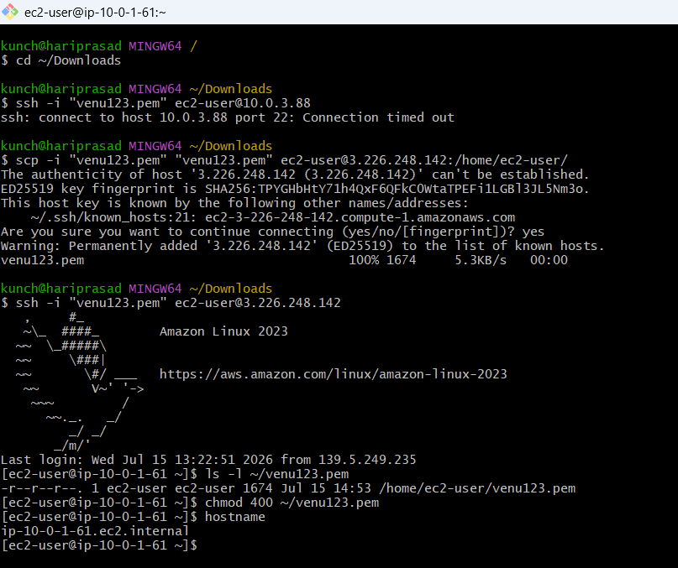

Step 5: Verify NAT Gateway
Run:
ping -c 4 amazon.com
or
sudo dnf update -y
If this works, your NAT Gateway is configured correctly.
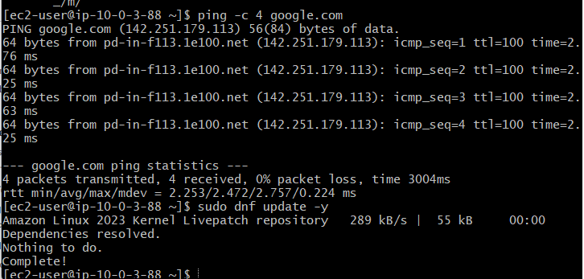

Step 6: Install Java
Install Amazon Corretto 17:
sudo dnf install java-17-amazon-corretto -y
Verify:
java -version
Expected output:
openjdk version "17..."
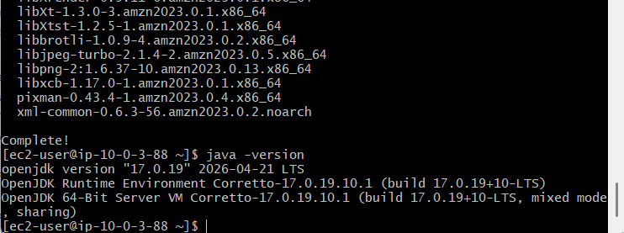

Step 7: Download Apache Tomcat
cd /opt
sudo wget https://downloads.apache.org/tomcat/tomcat-10/v10.1.44/bin/apache-tomcat-10.1.44.tar.gz
Extract it:
sudo tar -xzf apache-tomcat-10.1.44.tar.gz
Rename:
sudo mv apache-tomcat-10.1.44 tomcat

Step 8: Start Tomcat
sudo chmod +x /opt/tomcat/bin/*.sh
Start:
sudo /opt/tomcat/bin/startup.sh
Check:
ps -ef | grep tomcat
or
ss -tulnp | grep 8080
You should see Tomcat listening on 8080.
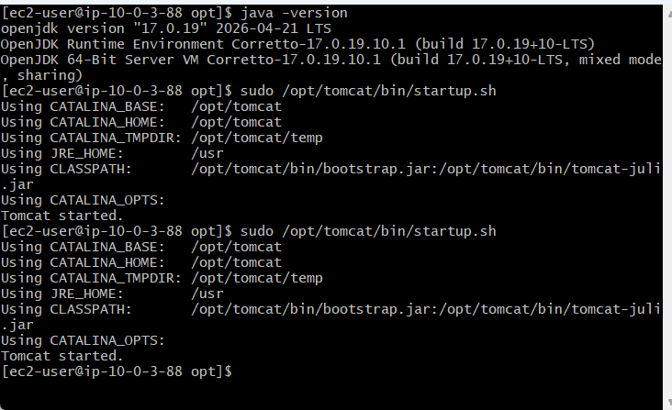
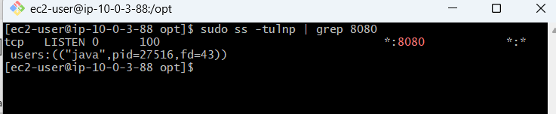

Step 9: Deploy a Sample Application
Create a simple web page:
echo "<h1>Tomcat Running from Private EC2</h1>" | sudo tee /opt/tomcat/webapps/ROOT/index.jsp
Restart Tomcat:
sudo /opt/tomcat/bin/shutdown.sh
sudo /opt/tomcat/bin/startup.sh
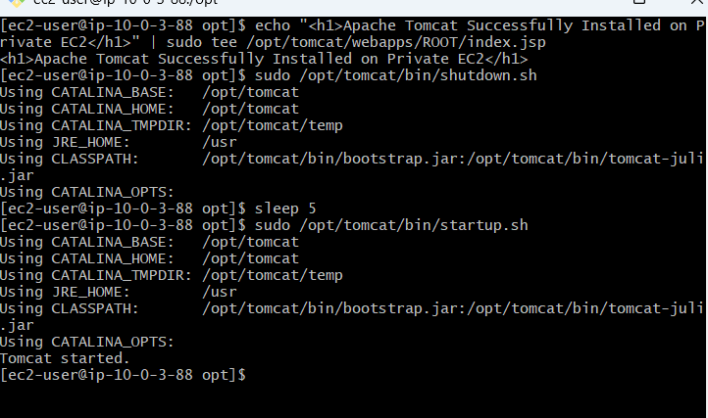

Step 10: Verify
Since Tomcat is in a private subnet, you won't be able to open it directly from your browser. Instead, verify from the private EC2:
curl http://localhost:8080
You should receive the Tomcat page or your sample page.
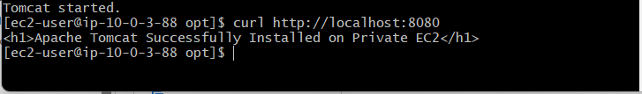

10. Configure VPC flow logs and store the logs in S3 and CloudWatch.

Step 1: Create an S3 Bucket
- Open AWS Console
- Go to S3
- Click Create bucket
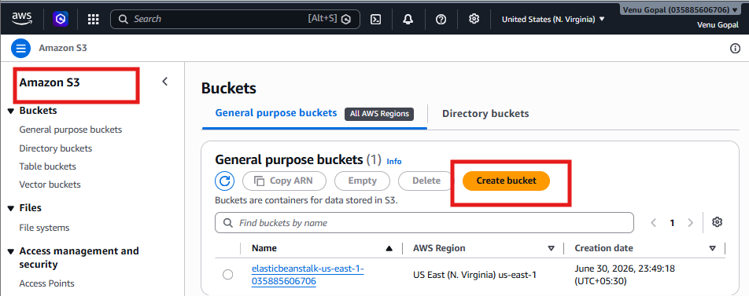
Enter:
Field | Value
Bucket name | devops-vpc-flowlogs-<yourname> (example: devops-vpc-flowlogs-rajesh)
Region | US East (N. Virginia)

Keep everything else as default. Click: Create bucket
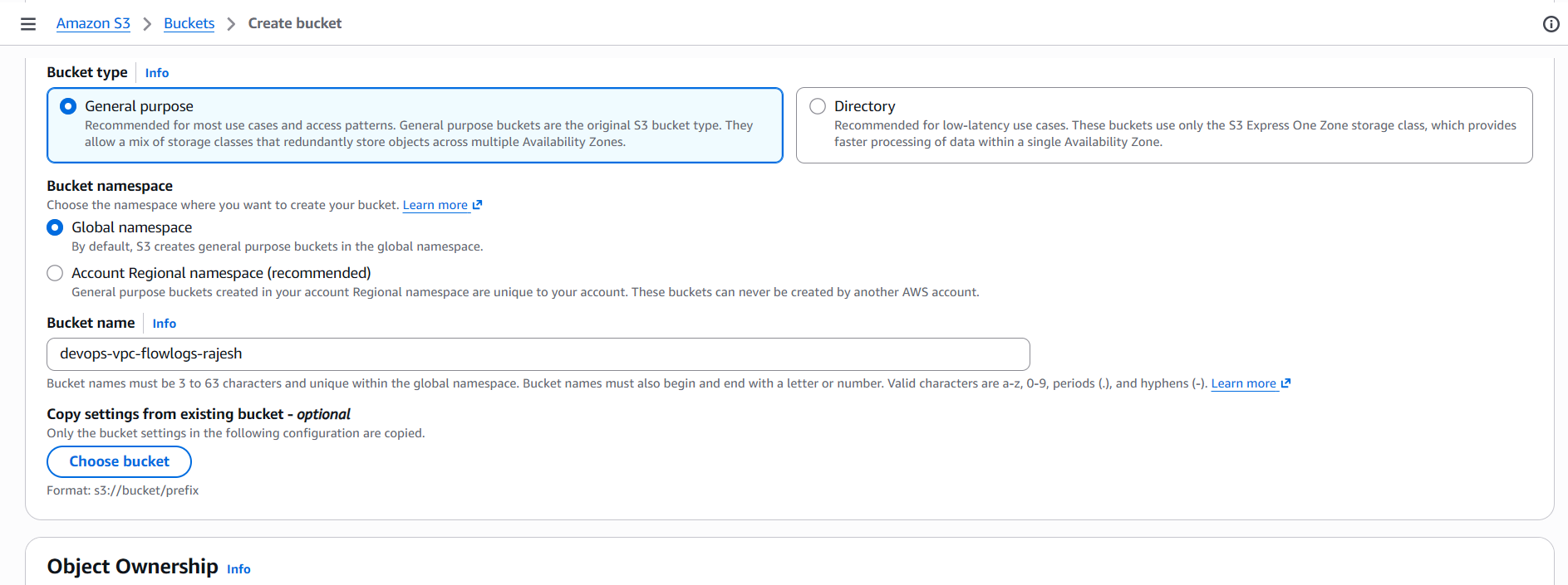
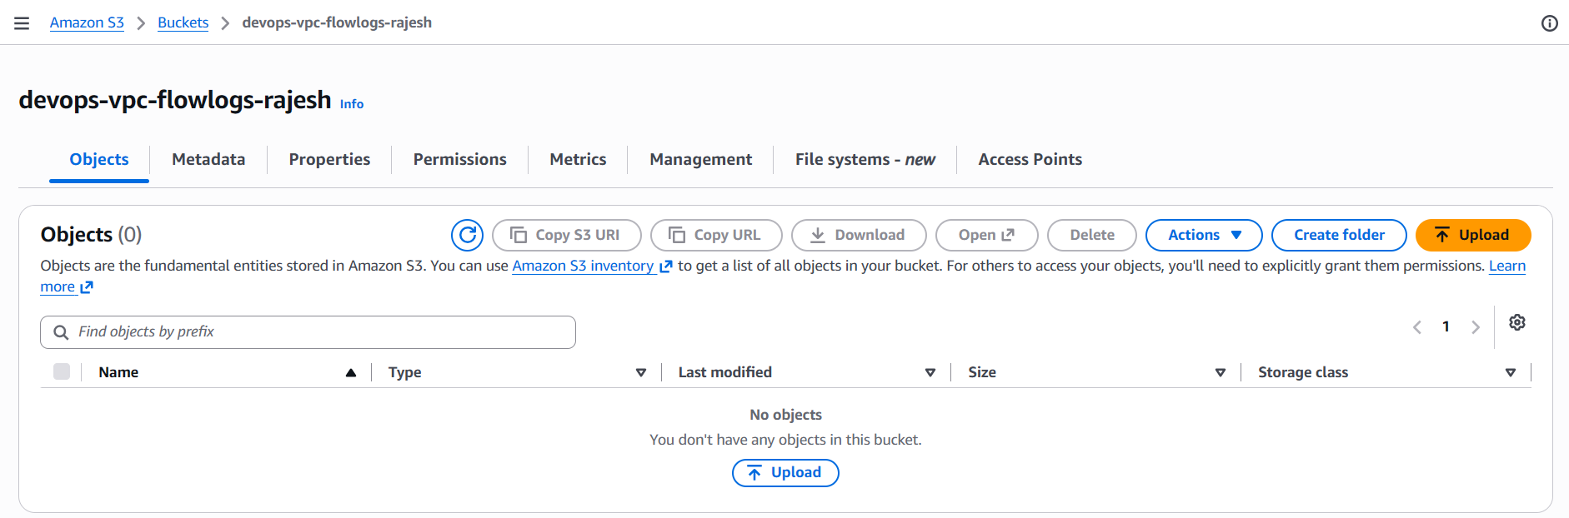

Step 2: Open VPC
Go to: VPC → Your VPC (DevOps-VPC)
Select the VPC. Click: Actions → Create Flow Log
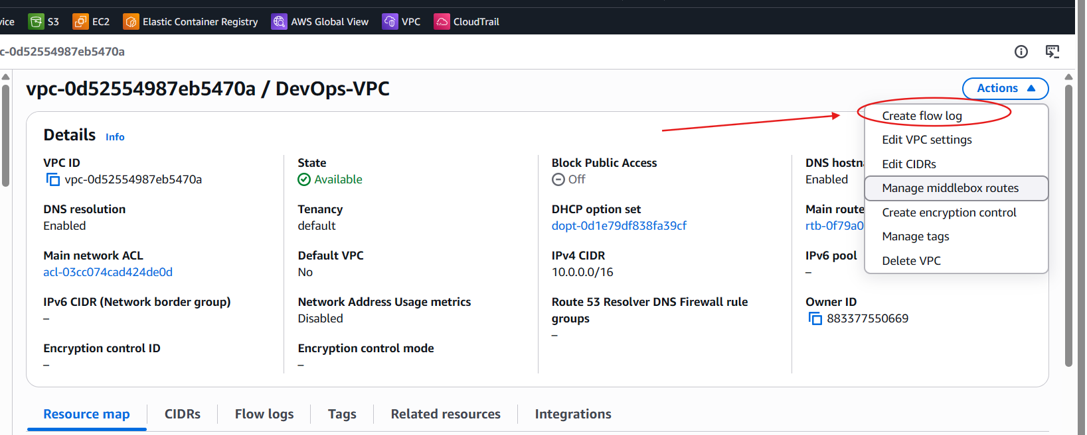

Step 3: Configure Flow Log
Fill in:
Field | Value
Name | DevOps-VPC-FlowLog
Filter | All
Maximum aggregation interval | 1 minute
Destination | Send to Amazon S3
S3 bucket ARN | arn:aws:s3:::devops-vpc-flowlogs-rajesh

Click: Create Flow Log
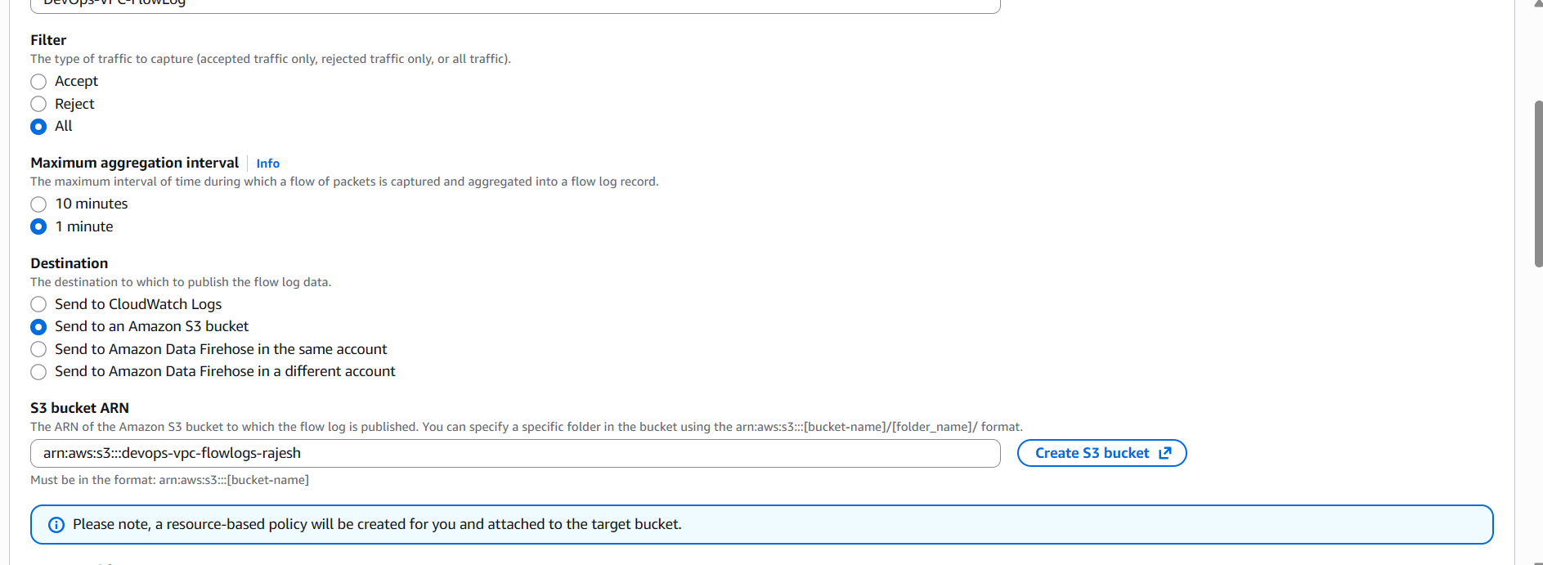
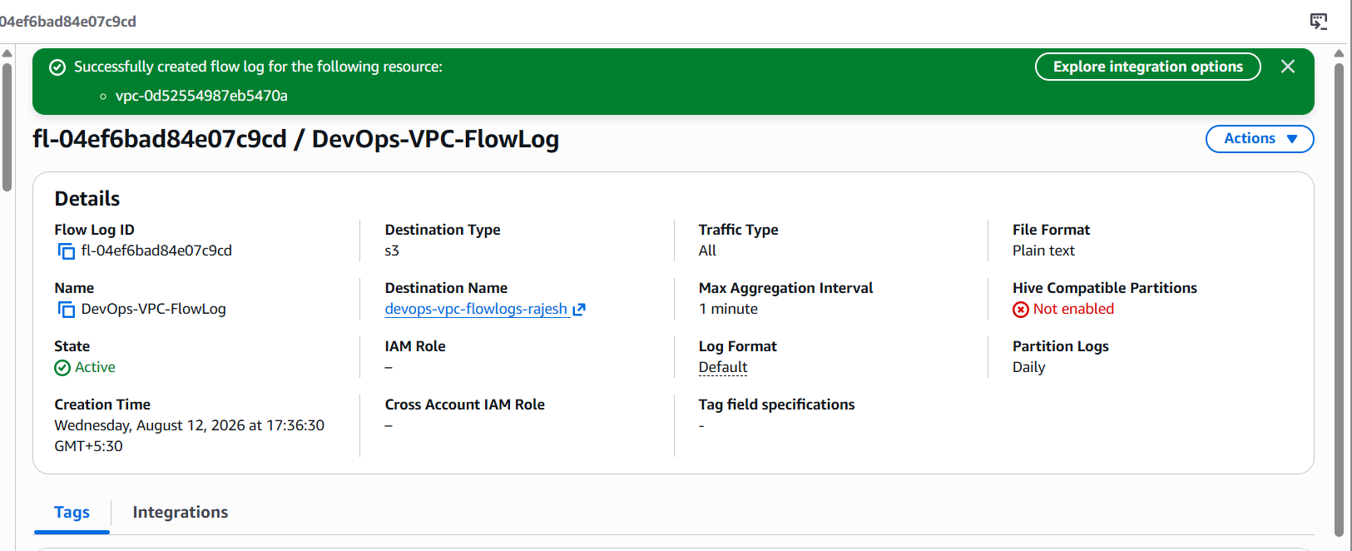

Step 4: Verify
Go to: VPC → Flow Logs
You should see Status: Active

Step 5: Generate Traffic
SSH to either EC2 instance or run:
curl google.com
or
ping google.com
This generates network traffic that the flow log records.
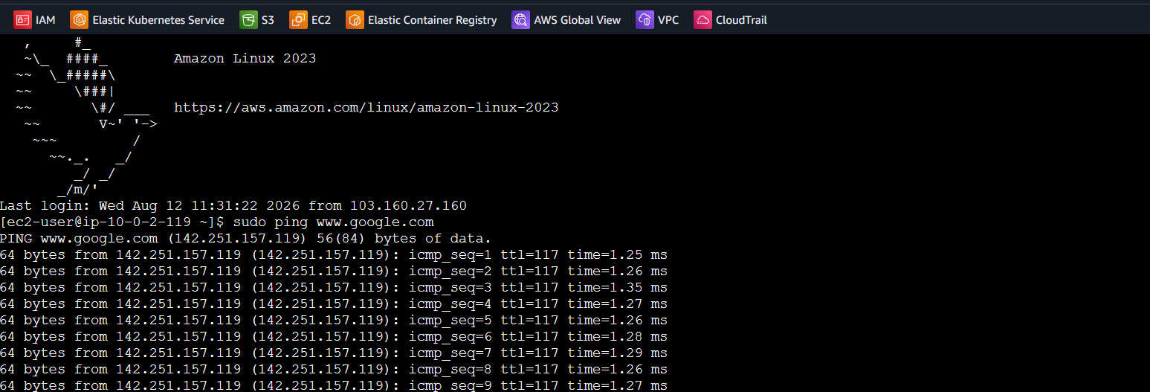

Step 6: Verify Logs
Open: S3 → Your Bucket
After a few minutes, you should see folders similar to:
AWSLogs/
Inside them will be the VPC Flow Log files.
