- Install git.
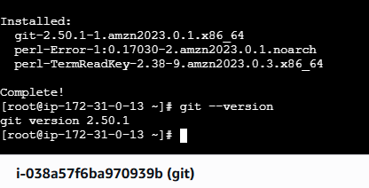
- Create a repo in github with README.md and .ignore file.
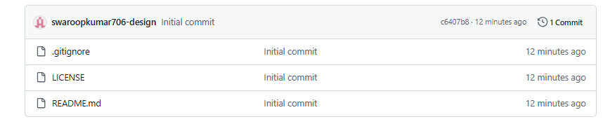
- Clone the created repo to local.
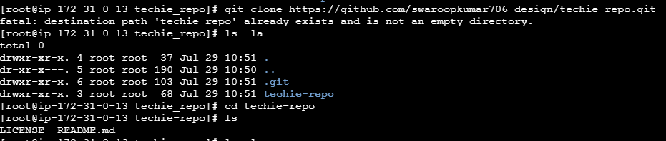
- Create two files in local repo.
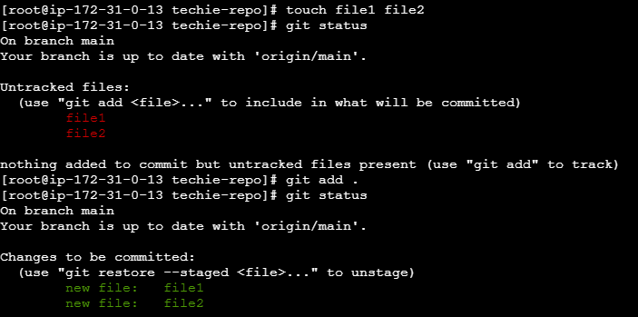
- Commit two files and push to central Repository.
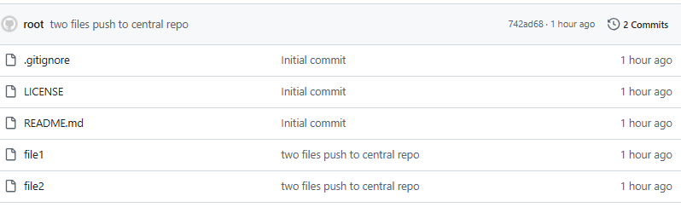
- Create a branch in local and create a sample file and push to central.
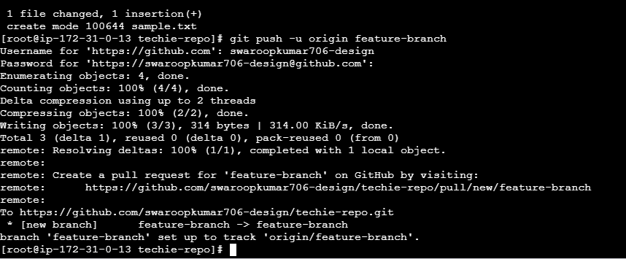
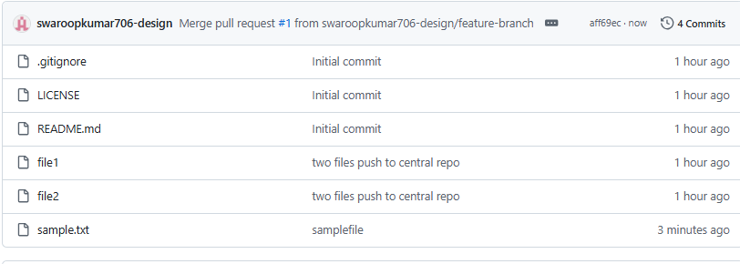
- Create a branch in github and clone that to local.
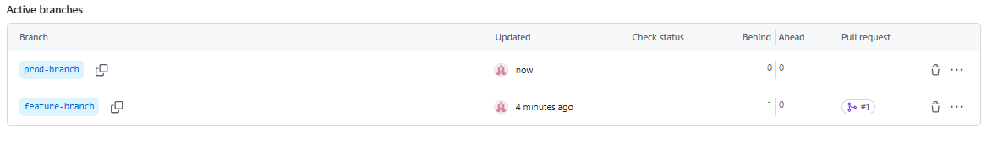
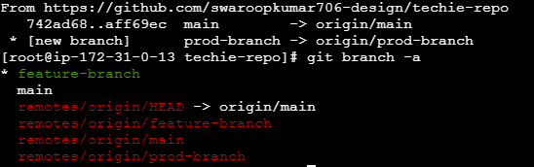
- Merge the created branch with master in git local.
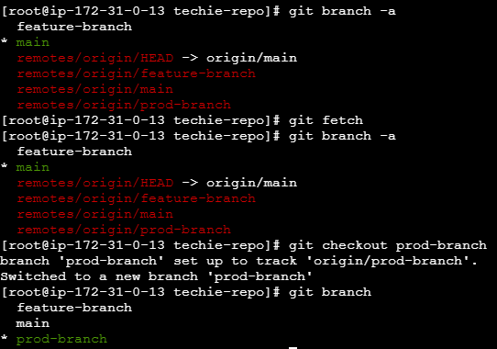
- Merge the created branch with master in github by sending a pull request.
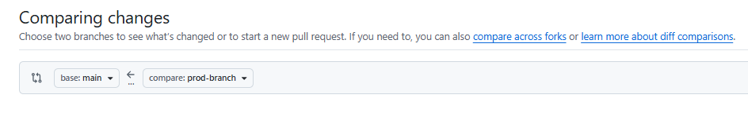
- Create a file in local and send that to branch in github.
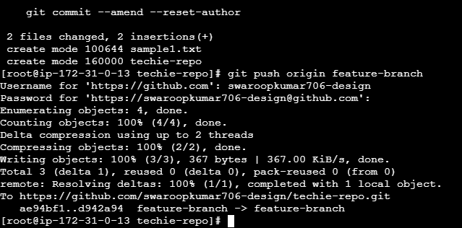
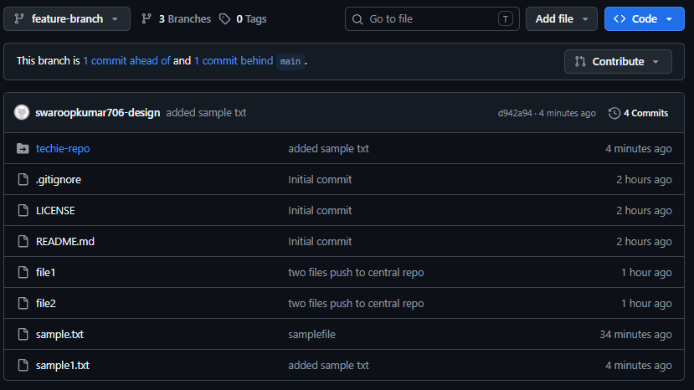

11.Clone only a branch from github to local.
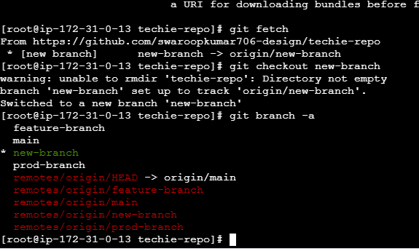
- Create a file with all passwords and make that untrackable with git.
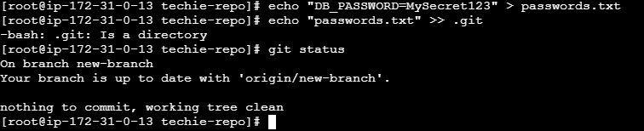

- Make a commit and make that commit reset without savings changes.
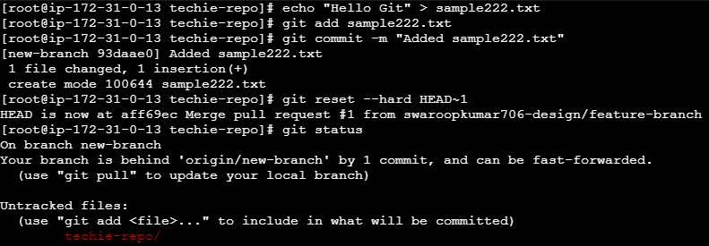

- Revert a commited commit to the older version.
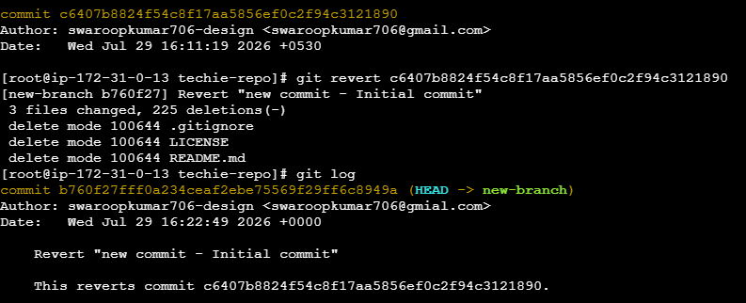
- Push a file to stash without savings the changes and work on another file.
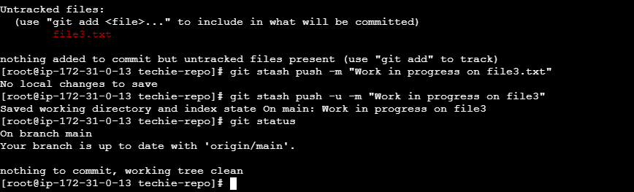
- Undo the stash file and start working on that again.
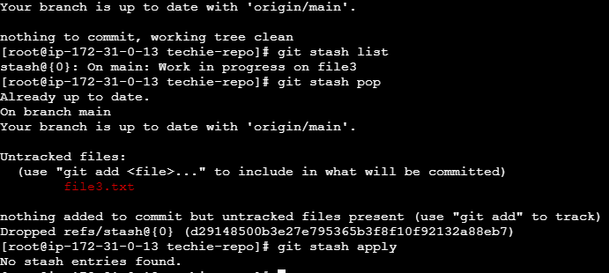

17 Generate a ssh-keygen and configure into github.
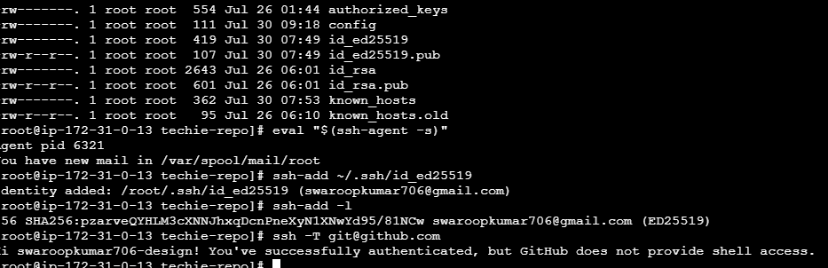
- Configure webhooks to github.
- Basic understanding of .git file.
The .git directory is the heart of a Git repository. It contains all the information Git needs to manage your project's history, branches, commits, tags, and configuration.
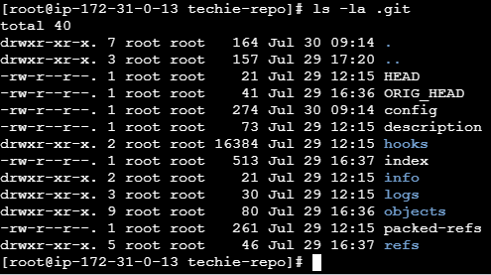

- Check all the logs of git.
Git provides several commands to view the commit history and logs. These logs help you track commits, branch changes, author information, and file modifications…
Cmd : git log
Cmd : git log –oneline
Cmd : git log --oneline --graph –all
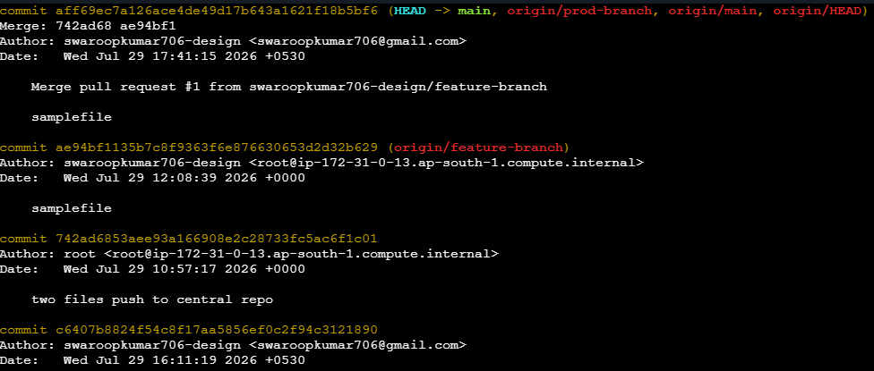
- Rename the commit message.
Cmd : git commit --amend -m "rename the commit"
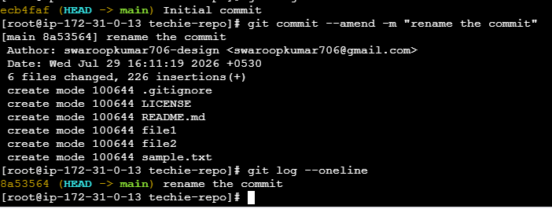
- Merge multiple commits into single commit.


