AWS EC2 Task - 1

1. Launch one EC2 using Amazon Linux 2 image and add a script in user data to install Apache.

Step 1:
- Log in to the AWS Management Console.
- Navigate to EC2.
- Click Launch Instance.
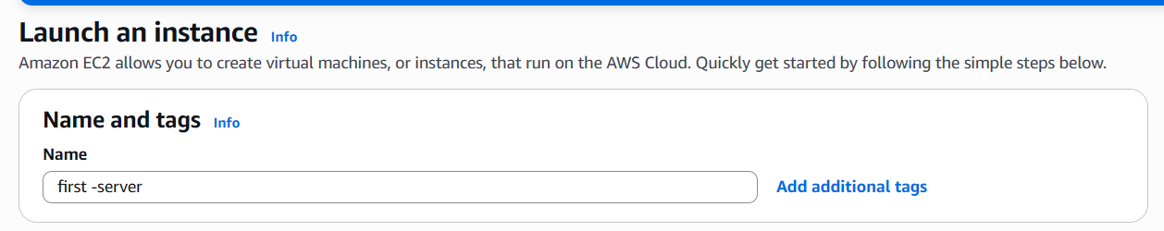

Step 2:
- Enter the Instance Name.
- Select recent one
- Choose the t3.micro (or any supported) instance type.
- Select an existing Key Pair.
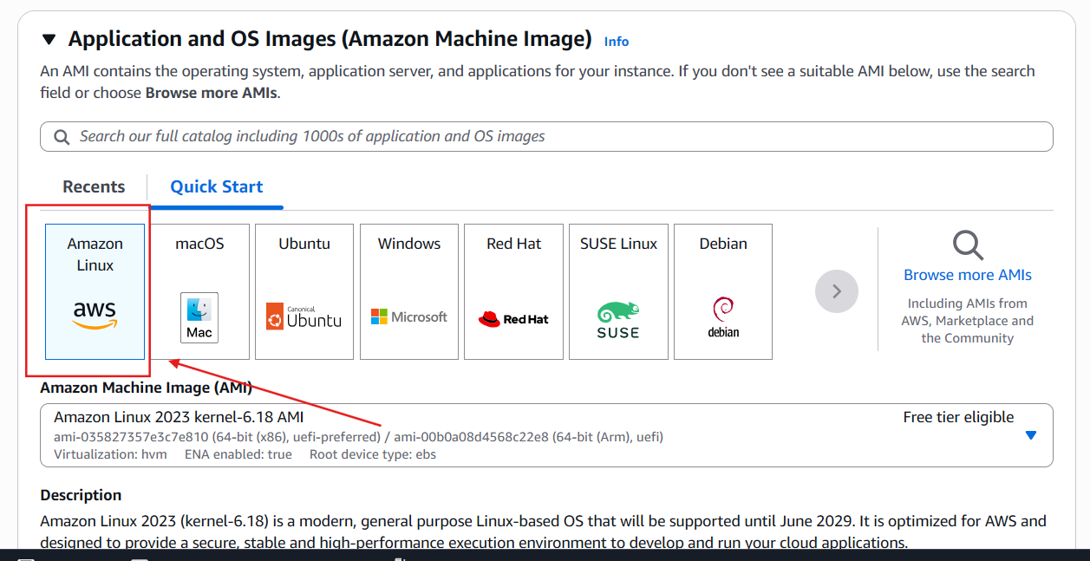
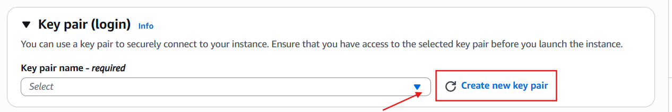
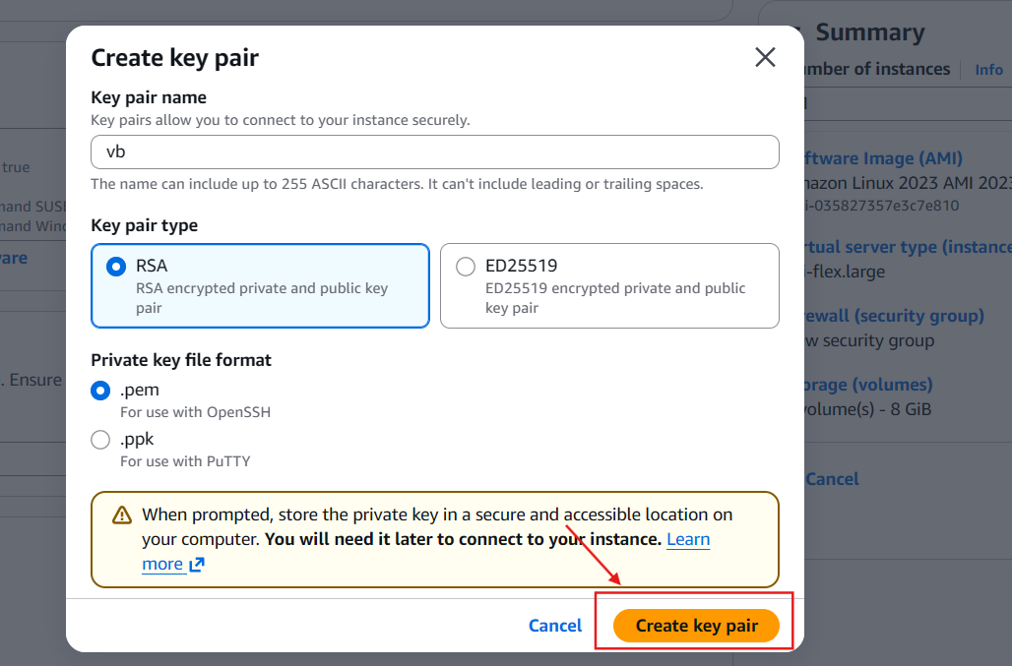

Step 3:
- Configure the Network Settings.
- Enable Auto-assign Public IP.
- Select or create a Security Group.
- Allow SSH (Port 22) from My IP.
- Allow HTTP (Port 80) from Anywhere (0.0.0.0/0).
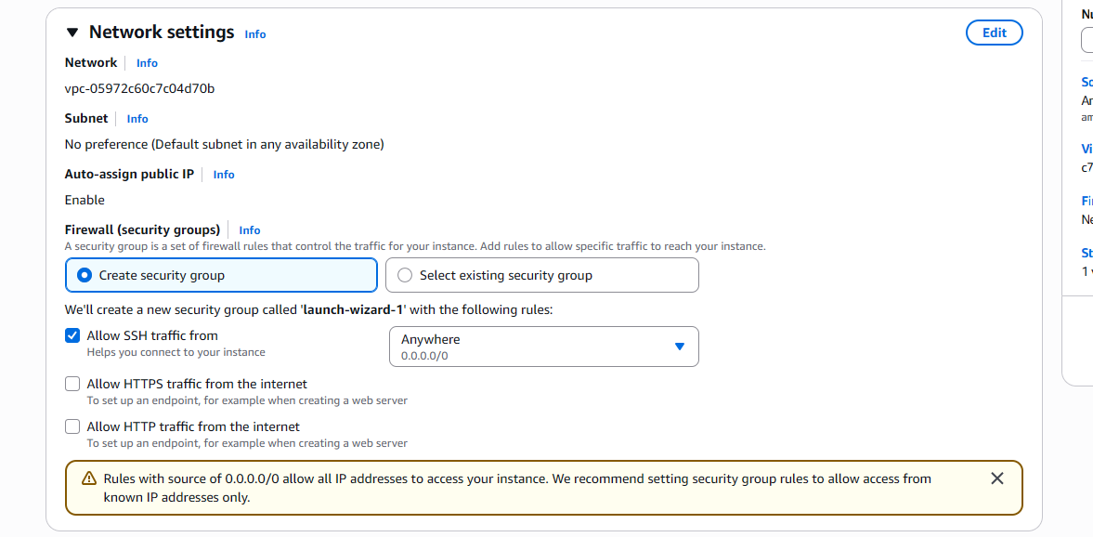

Step 4:
- Expand Advanced Details.
- Scroll down to the User Data section.
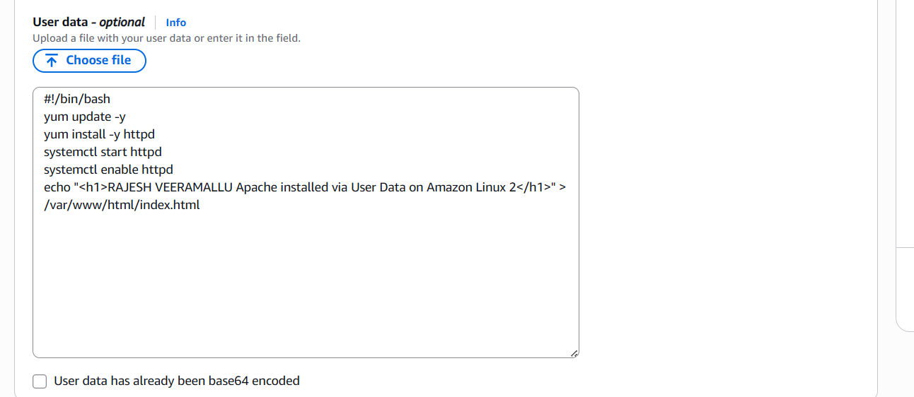

Step 5:
- Click Launch Instance.
- Wait until the instance state changes to Running.
- Copy the Public IPv4 Address.
- Open a web browser and enter http://<Public-IP>.
- Verify that the Apache web page is displayed successfully.
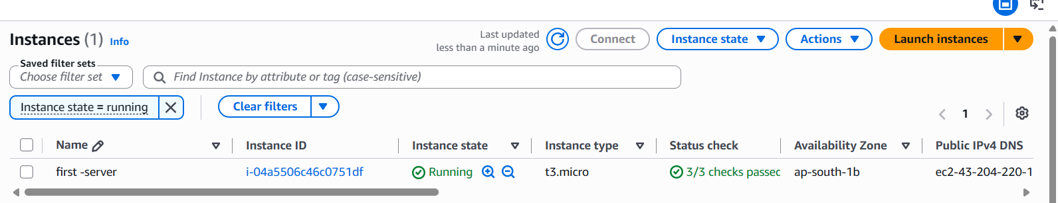
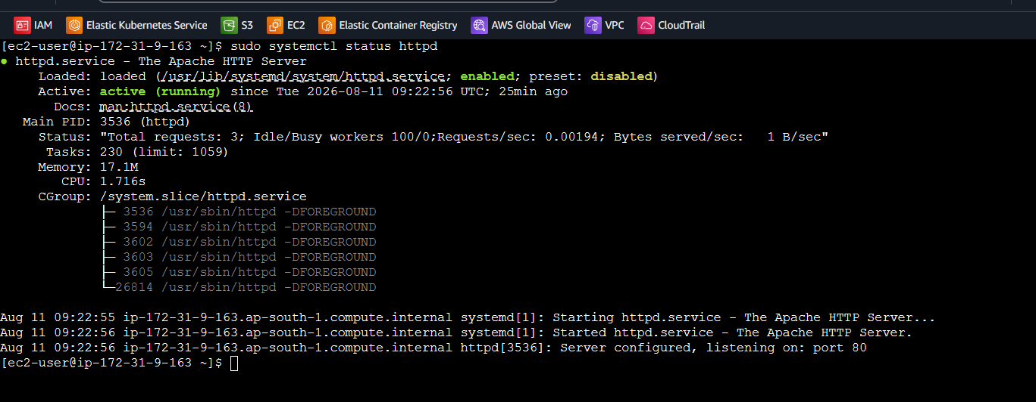
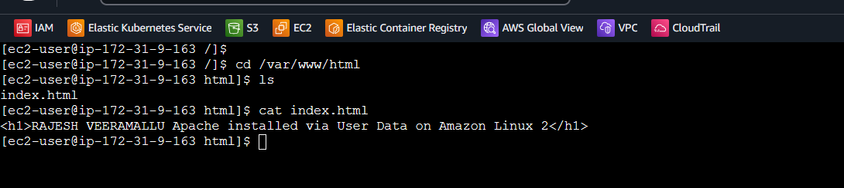
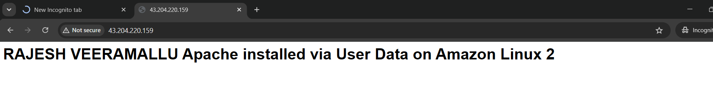

2. Launch one EC2 using Ubuntu image and add a script in user data to install Nginx.

Step 1:
- Log in to the AWS Management Console.
- Navigate to EC2.
- Click Launch Instance.

Step 2:
- Enter the Instance Name.
- Select the Ubuntu Server AMI.
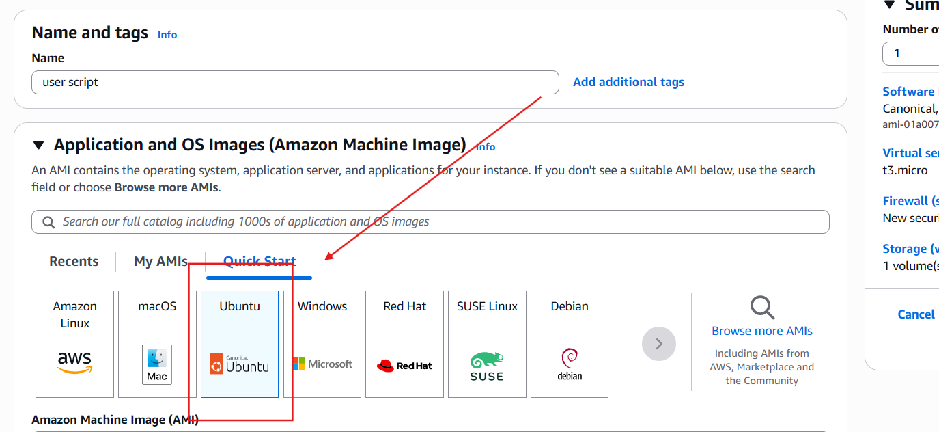
- Choose the t3.micro
- Select an existing Key Pair.

Step 3:
- Configure the Network Settings.
- Enable Auto-assign Public IP.
- Select or create a Security Group.
- Allow SSH (Port 22) from My IP.
- Allow HTTP (Port 80) from Anywhere (0.0.0.0/0).

Step 4:
- Expand Advanced Details.
- Scroll down to the User Data section.
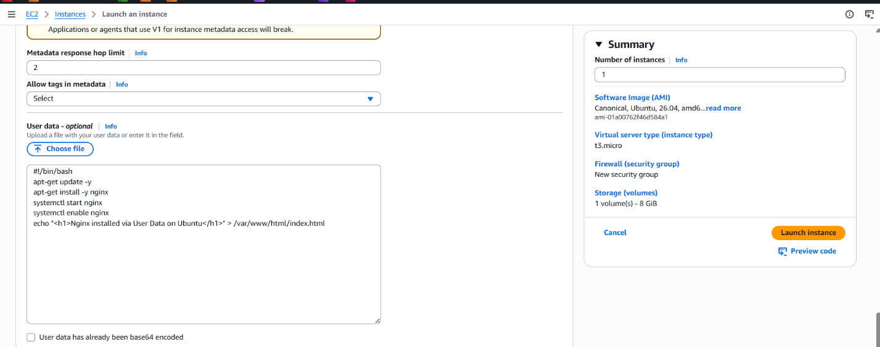

Step 5:
- Click Launch Instance.
- Wait until the instance state changes to Running.
- Copy the Public IPv4 Address.
- Open a web browser and enter http://<Public-IP>
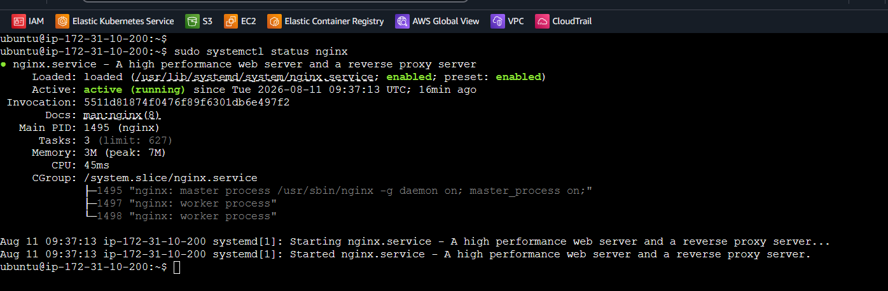
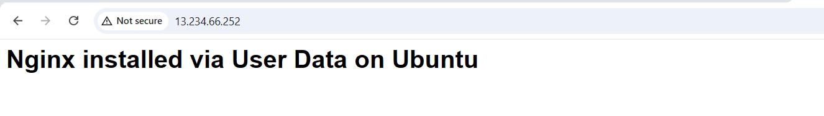

3. Launch one Windows server and install Tomcat on Windows.

Objective
Launch a Windows EC2 instance on AWS and install Apache Tomcat to access the Tomcat web server from a browser.

Step 1:
- Log in to the AWS Management Console.
- Navigate to EC2.
- Click Launch Instance.

Step 2:
- Enter the Instance Name.
- Select the Microsoft Windows Server AMI.
- Choose the t3.micro
- Select an existing Key Pair.
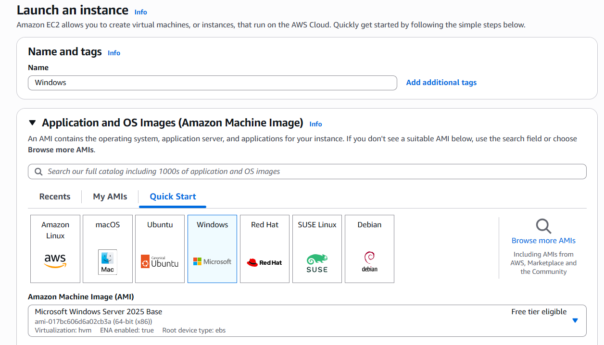

Step 4:
- Click Launch Instance.
- Wait until the instance state changes to Running.
- Select the instance and click Connect → RDP Client.
- Retrieve and decrypt the Windows Administrator password using your .pem key.
- Connect to the instance using Remote Desktop Connection (mstsc)
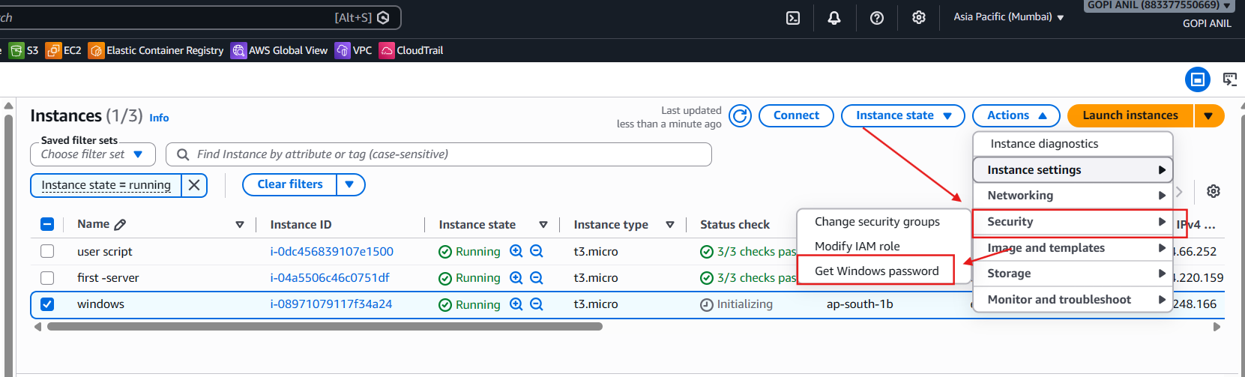
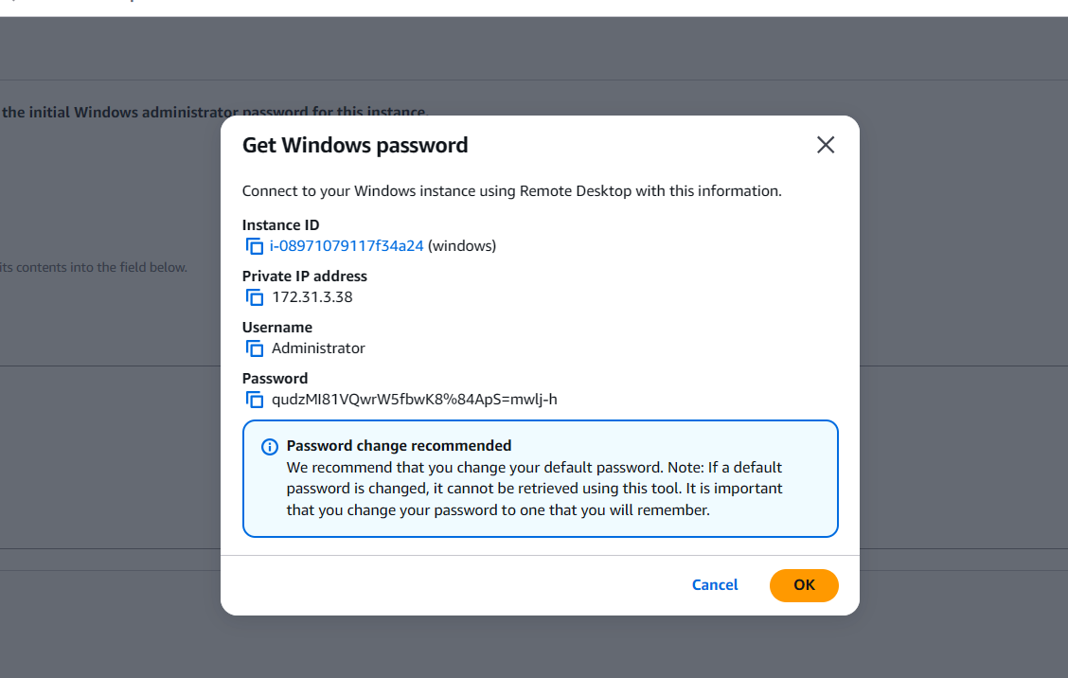
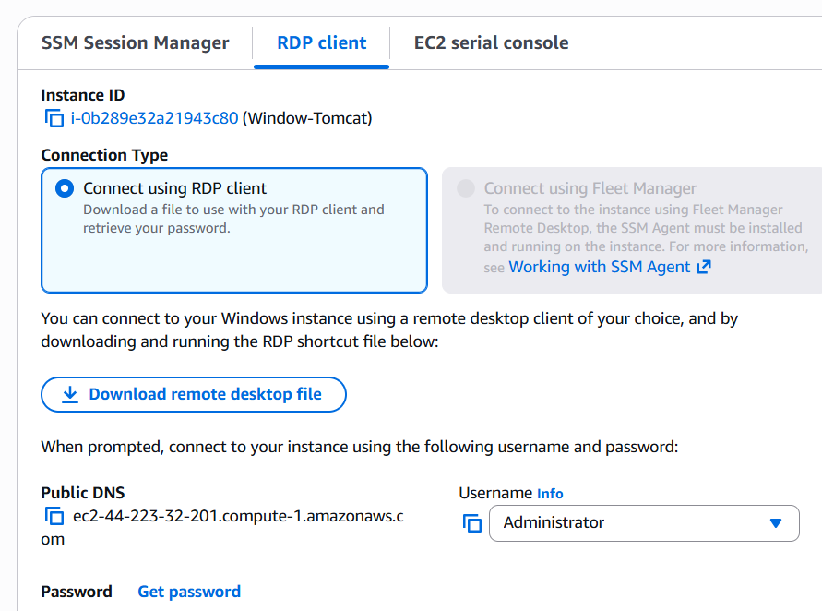
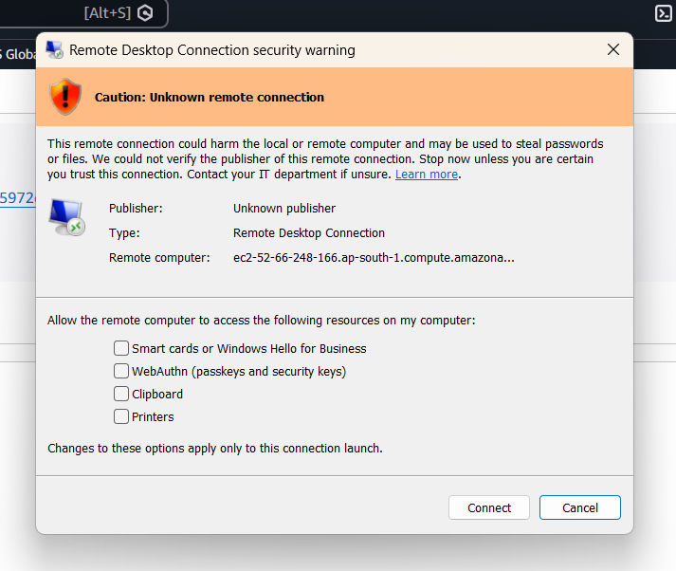
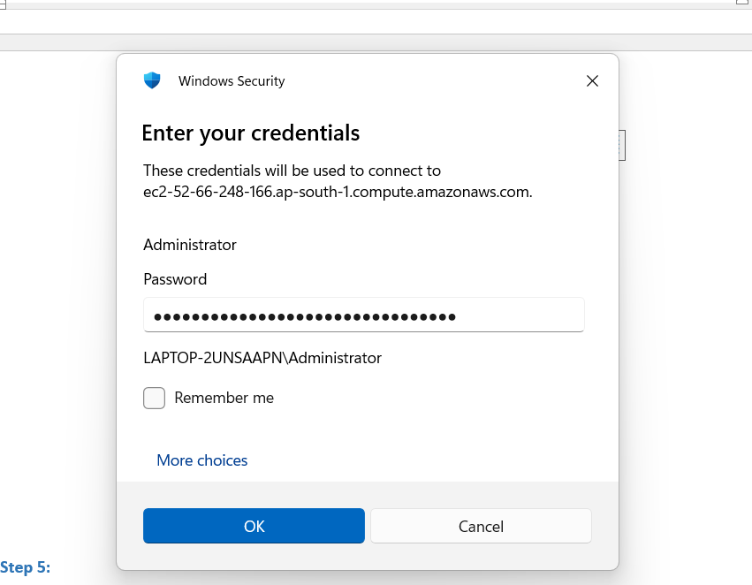

Step 5:
- Download and install Java JDK.
- Set the JAVA_HOME environment variable.
- Download the Apache Tomcat ZIP file from the official website.
- Extract Tomcat (for example, to C:\Apache\apache-tomcat-10.x.x).
- Start Tomcat by running startup.bat from the bin folder.
- Open a web browser and access http://<Public-IP>:8080 to verify that the Tomcat home page is displayed successfully.
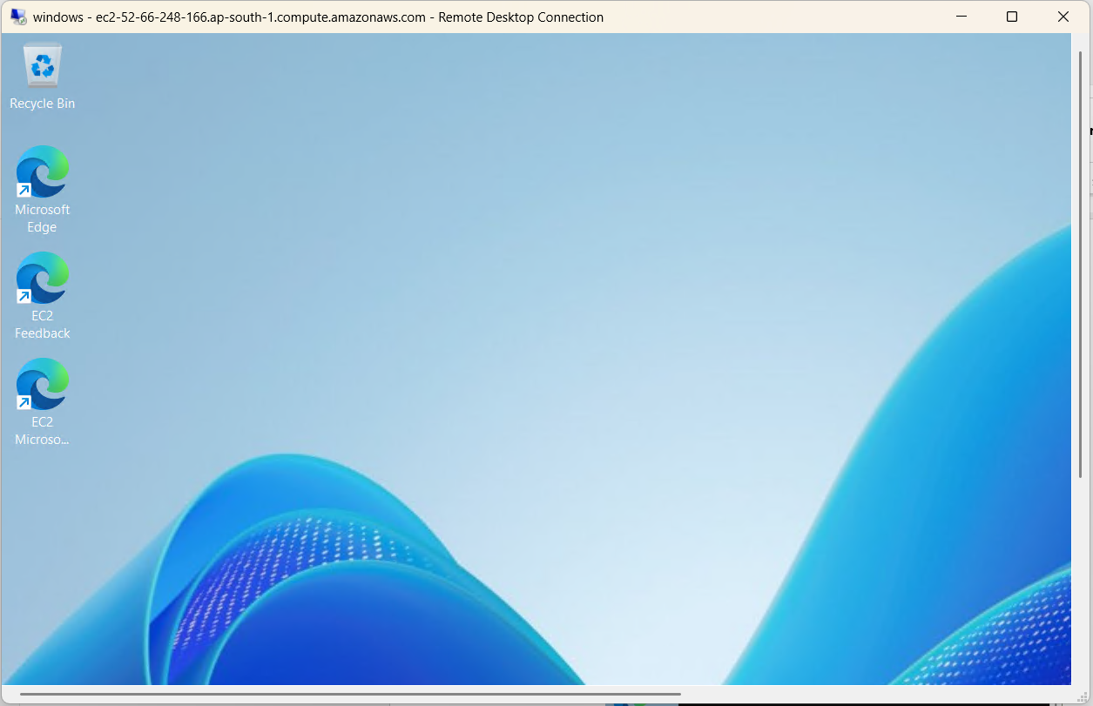
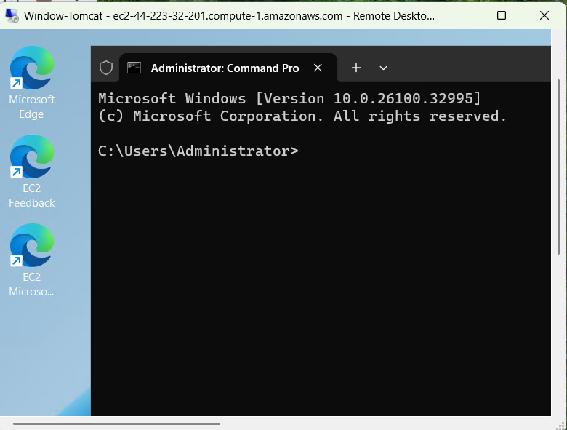
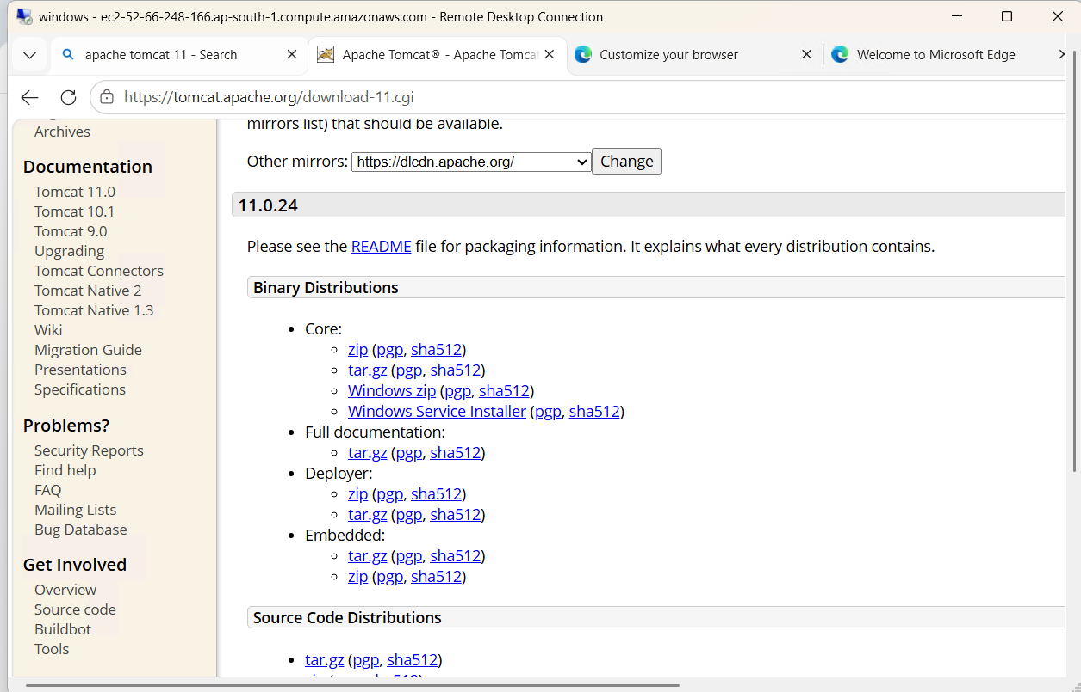
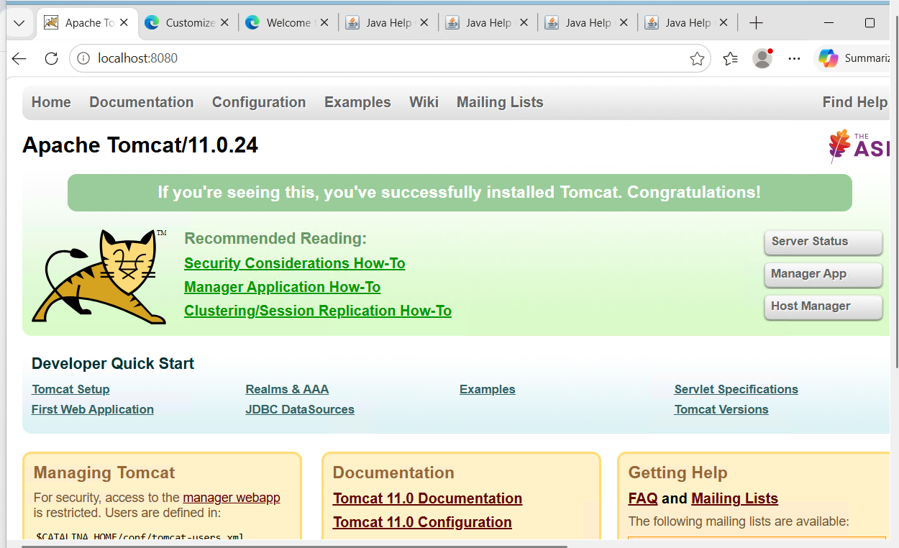

4. Take a snapshot of the instance created in Task 1.
Objective: Create a snapshot (backup) of the EC2 instance's EBS volume.

Step 1:
- Log in to the AWS Management Console.
- Navigate to EC2.
- Select the EC2 instance created in Task 1.
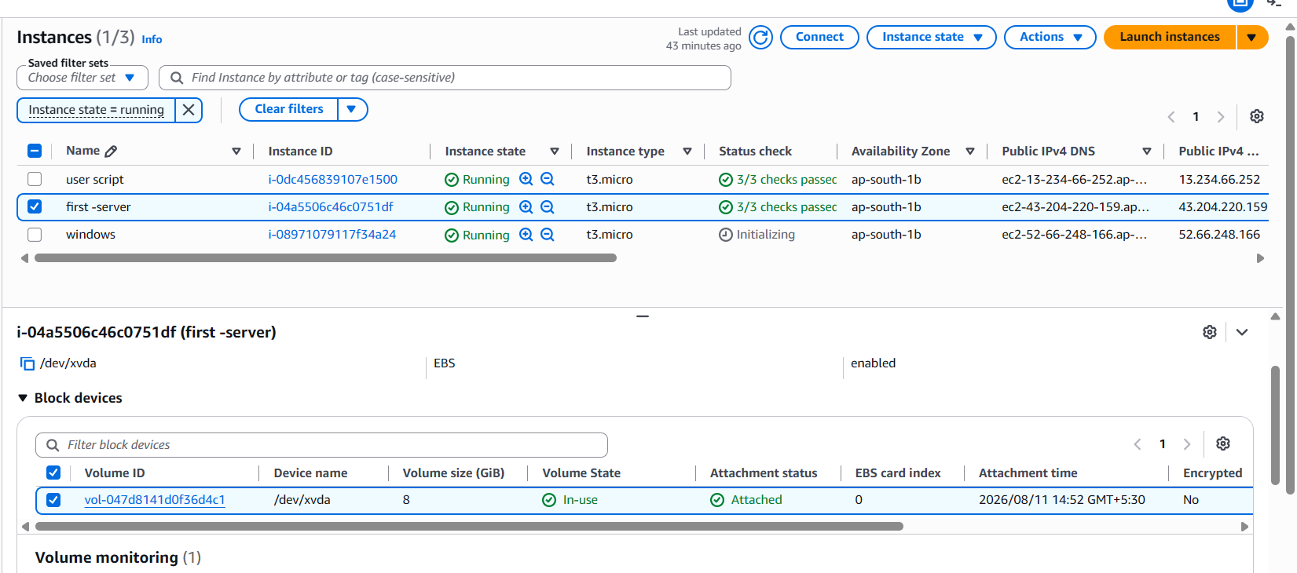

Step 2:
- Go to the Storage tab.
- Select the attached EBS Volume.
- Click on the Volume ID to open the EBS volume details.
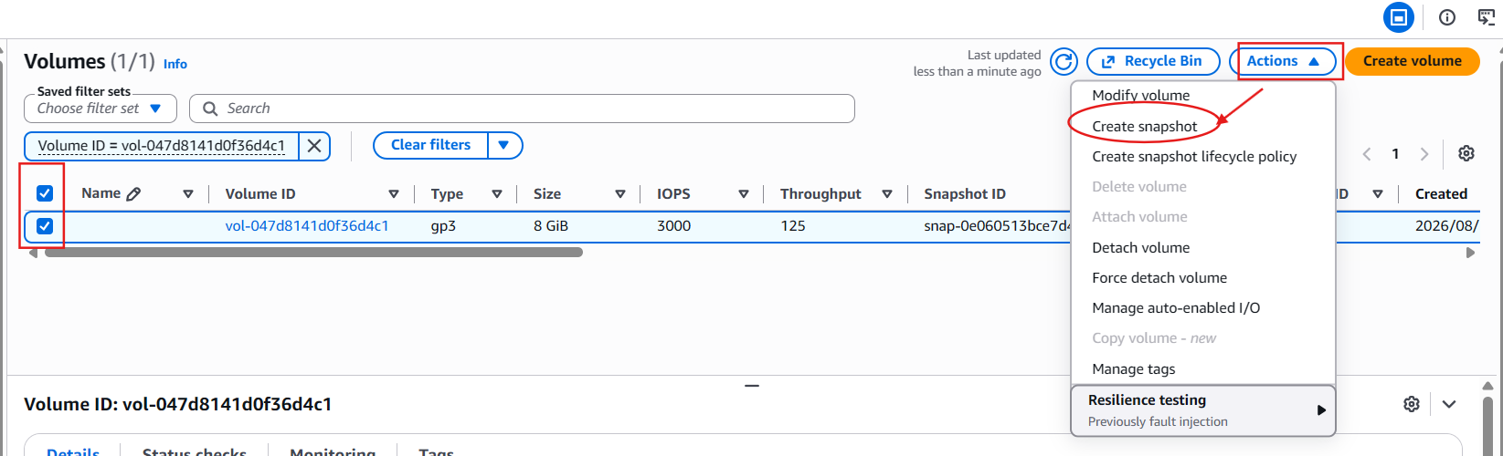

Step 3:
- Select the EBS volume.
- Click Actions → Create Snapshot.

Step 4:
- Enter a Snapshot Name and Description (optional).
- Click Create Snapshot.
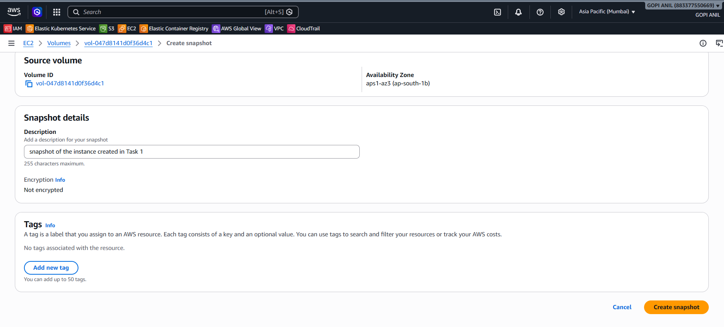

Step 5:
- Navigate to Elastic Block Store → Snapshots.
- Verify that the snapshot status changes to Completed, confirming that the snapshot was created successfully
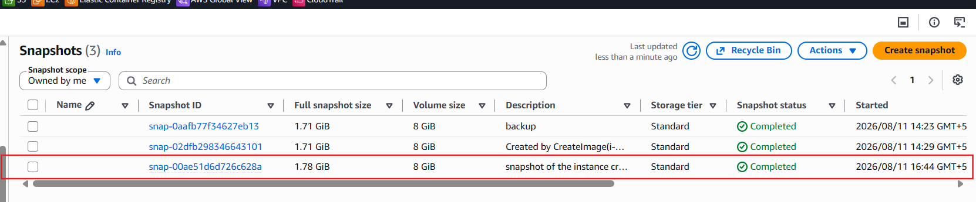

5. Assign passwordless authentication for the EC2 created in Task 2.
Scenario
Assume:
- Server: Ubuntu EC2 (Task 2)
- Client: Your local computer (Git Bash/PowerShell)

Step 1:
- Connect to the Amazon Ubuntu EC2 instance using the existing .pem key.
- Open a terminal on the instance.
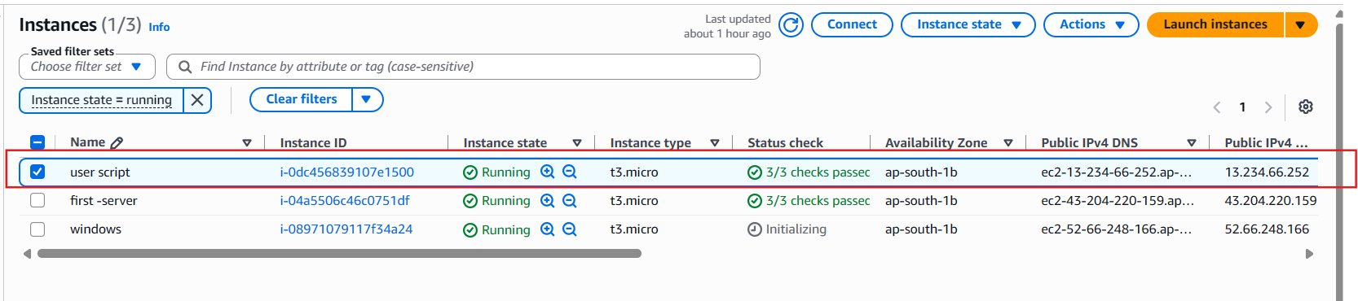

Step 2:
- Generate a new SSH key pair by running ssh-keygen.
- Press Enter to accept the default file location.
- Press Enter twice to leave the passphrase empty.
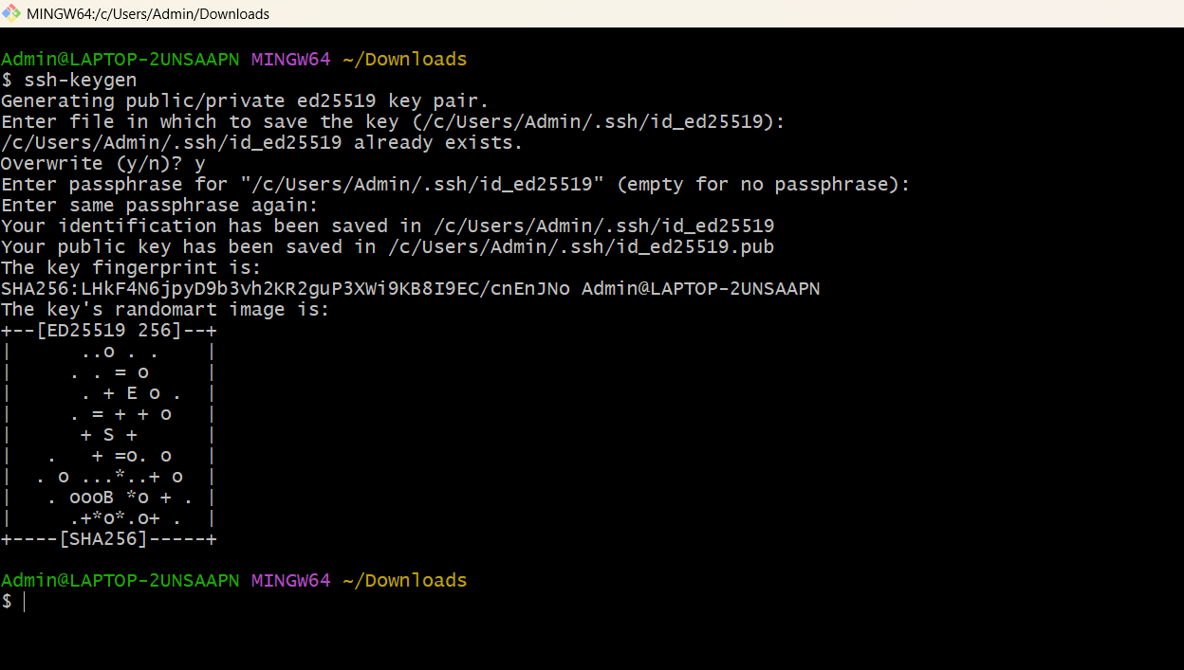

Step 3:
- Display the public key using cat ~/.ssh/id_rsa.pub.
- Append the public key to the ~/.ssh/authorized_keys file
- Set the required permissions:
  - chmod 700 ~/.ssh
  - chmod 600 ~/.ssh/authorized_keys
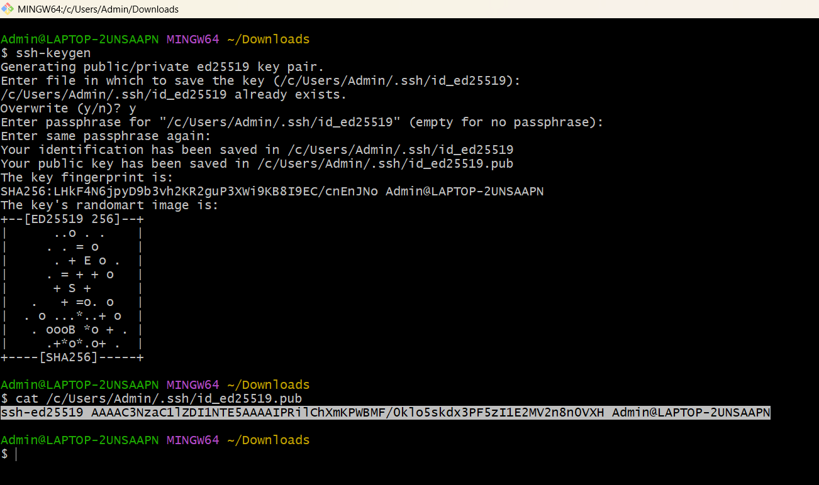

Step 4:
- Display the private key using cat ~/.ssh/id_rsa.
- Copy the entire private key.
- Save it on your local machine as id_rsa inside the ~/.ssh directory (for Windows Git Bash: C:\Users\<username>\.ssh\id_rsa)

Step 5:
- Ensure the private key has the correct permissions on your local machine (if required).
- Connect to the Amazon Linux EC2 instance without using the .pem file:
$ ssh ec2-user@<Public-IP>
- Verify that you can log in successfully without specifying the .pem key, confirming that passwordless authentication has been configured successfully.
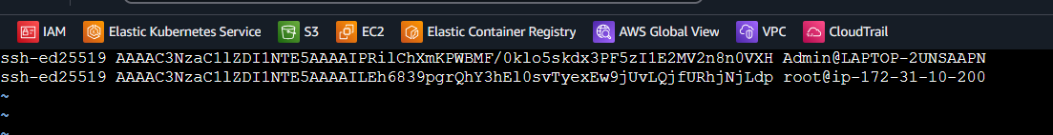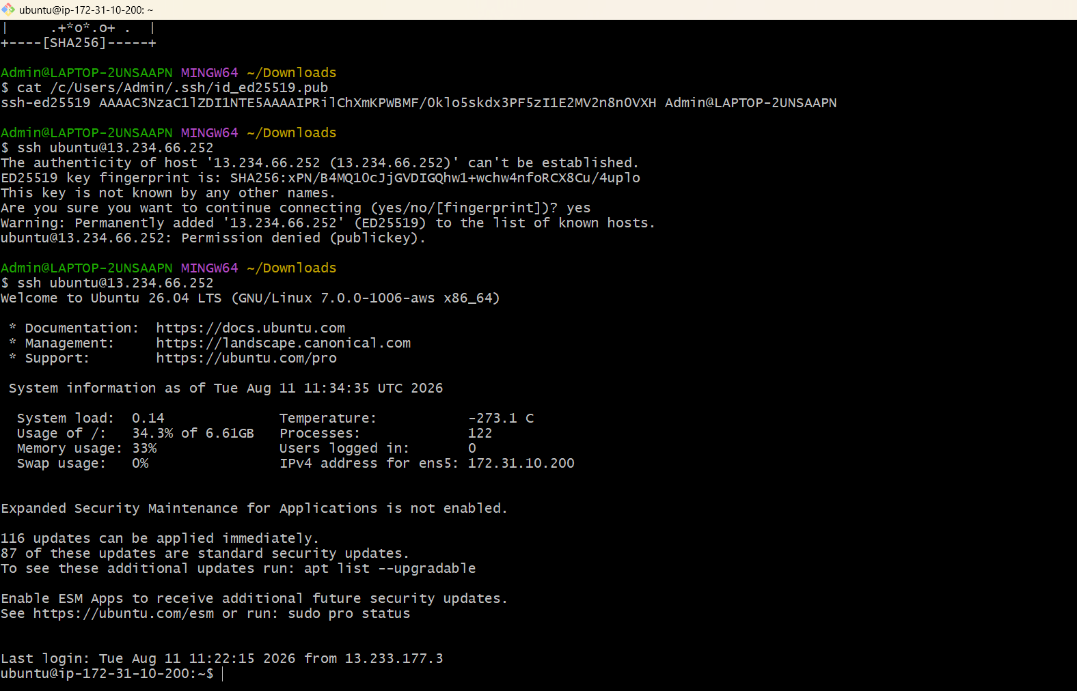

6. Launch any EC2 using the spot purchasing option.

Step 1: Open the EC2 Console
- Sign in to the AWS Management Console.
- Go to EC2.
- Click Launch instance.

Step 2: Enter Instance Details
- Name: Spot-Instance
- AMI: Amazon Linux 2023 (Free Tier eligible)
- Instance type: t3.micro

Step 3: Select the Purchasing Option
In the Instance type section:
- Locate Purchasing option.
- Select: Spot instances
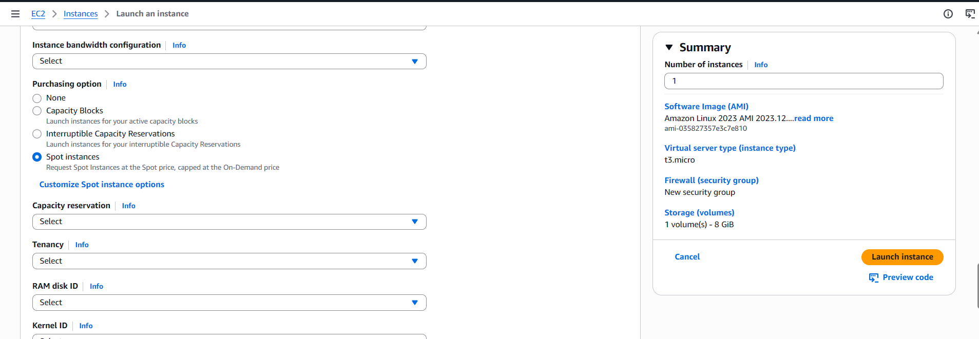

Step 5: Configure Network Settings
- Choose your VPC and subnet (or leave the defaults).
- Enable Auto-assign Public IP.
- Allow SSH (Port 22) from your IP address.

Step 6: Configure Storage

Step 7: Launch the Instance
Click Launch instance.

Step 8: Verify It's a Spot Instance
After the instance is running:
- Go to EC2 → Instances.
- Select your instance.
- In the Details tab, verify:
Lifecycle: Spot
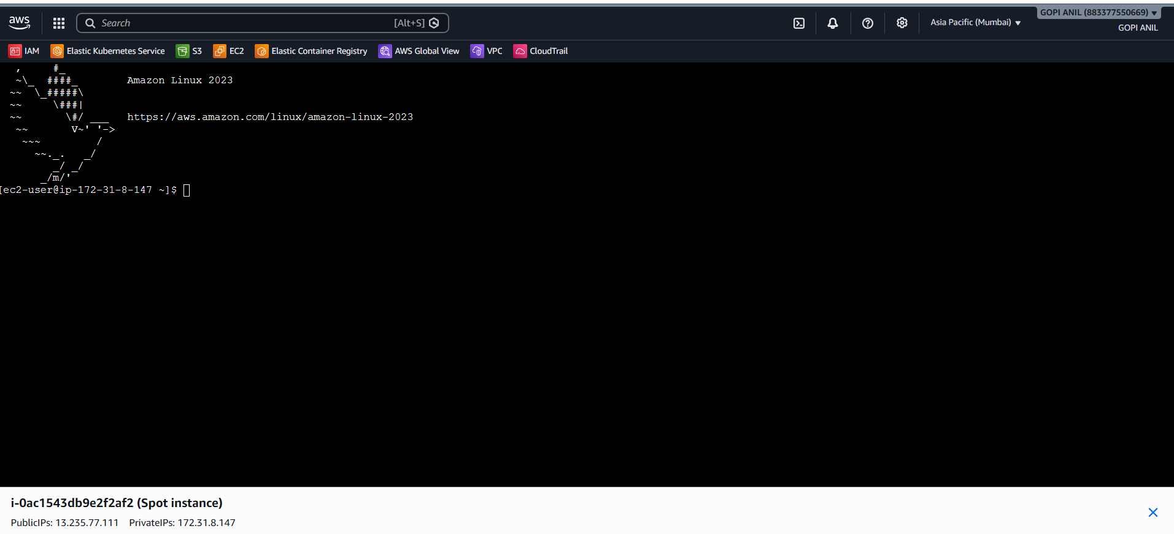

7. Enable termination policy on the EC2 created in Task 2.

Step 1
Go to:
EC2 → Instances

Step 2
Select your Ubuntu EC2 instance (Task 2).

Step 3
Click:
Actions → Instance settings → Change termination protection
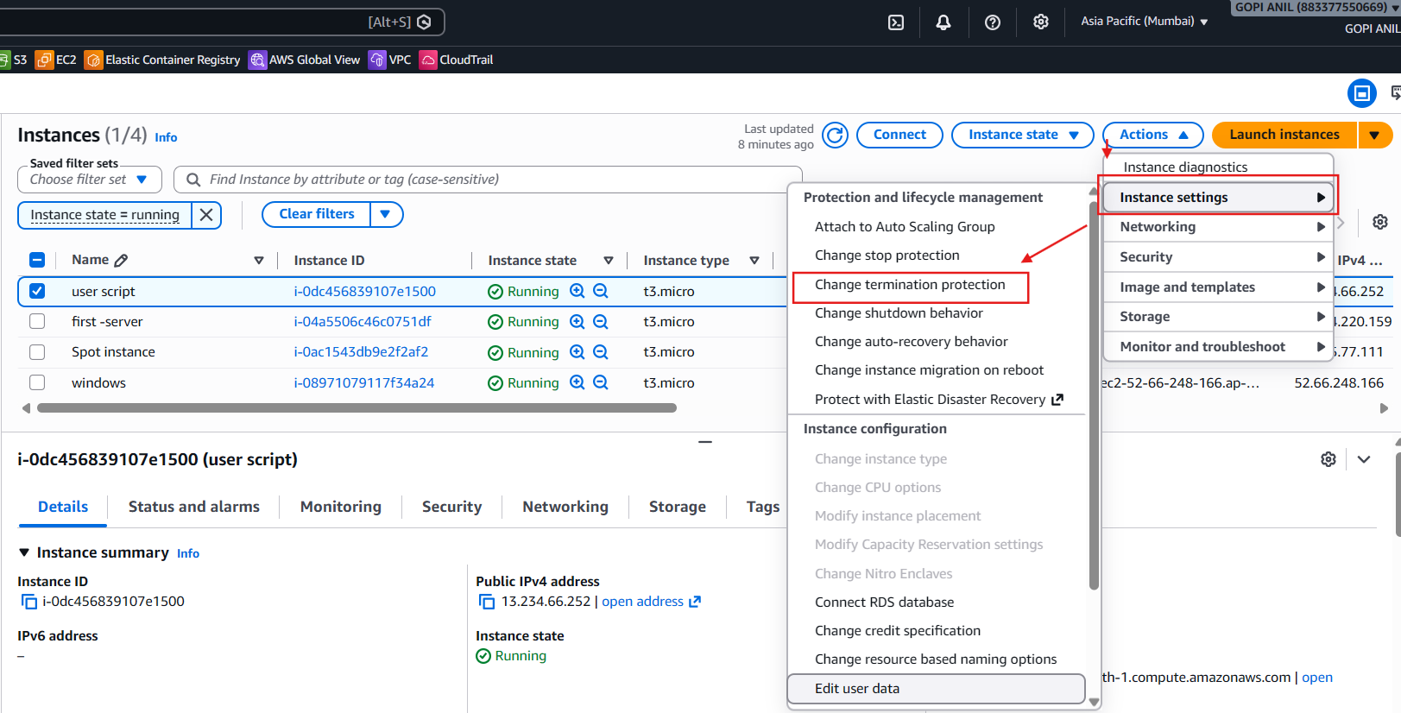

Step 4
Choose:
Enable

Step 5
Click:
Save
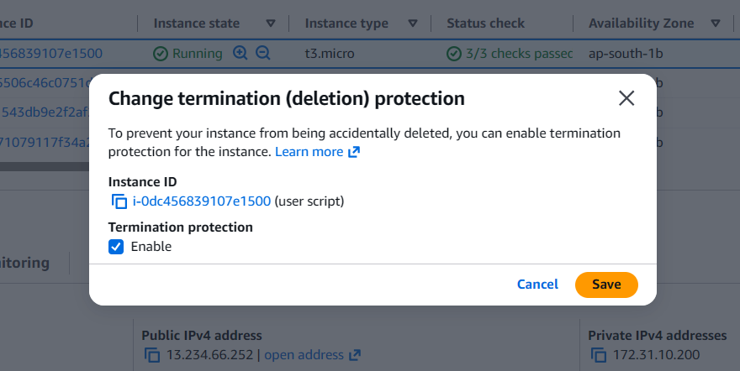

Verify
Go to:
EC2 → Instances
Select your Ubuntu instance.
Under Instance details, you should now see:
Termination protection: Enabled
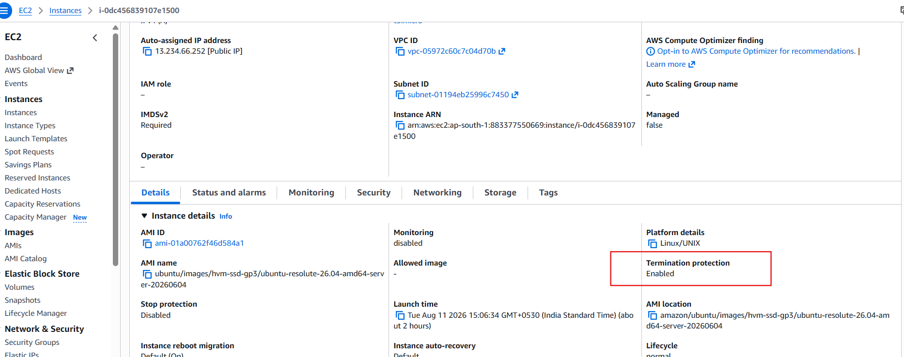

8. Launch one EC2 using AWS CLI.

Objective
Launch an Amazon Linux 2023 EC2 instance using the AWS CLI.

Step 1: Open Git Bash
Open Git Bash on your Windows system.

Step 2: Verify AWS CLI Configuration
Run:
aws configure list
Expected output:
NAME VALUE TYPE LOCATION
profile <not set> None None
access_key ****************XXXX shared-credentials-file
secret_key ****************XXXX shared-credentials-file
region ap-south-2 config-file

Step 3: Verify Your AWS Account
Run:
aws sts get-caller-identity
Expected output:
{
"UserId": "AIDXXXXXXXXXXXX",
"Account": "123456789012",
"Arn": "arn:aws:iam::123456789012:user/your-user"
}
If this command works, your AWS CLI is ready.

Step 4: Get the Latest Amazon Linux 2023 AMI ID
Run:
aws ec2 describe-images \
--owners amazon \
--filters "Name=name,Values=al2023-ami-*" \
--query "sort_by(Images,&CreationDate)[-1].ImageId" \
--output text
From your output:
ami-0fbea88b076e96323

Step 5: Get the Security Group ID
Run:
aws ec2 describe-security-groups \
--query "SecurityGroups[*].[GroupName,GroupId]" \
--output table
From your output, use:
launch-wizard-5
sg-070dfa3bcad2adde6

Step 6: Get the Subnet ID
Run:
aws ec2 describe-subnets \
--query "Subnets[*].[SubnetId,AvailabilityZone]" \
--output table
From your output, we'll use:
subnet-029ce41021826077b

Step 7: Launch the EC2 Instance
Run this command exactly as shown:
aws ec2 run-instances \
--image-id ami-0fbea88b076e96323 \
--instance-type t3.micro \
--key-name key1 \
--security-group-ids sg-070dfa3bcad2adde6 \
--subnet-id subnet-029ce41021826077b \
--count 1 \
--tag-specifications 'ResourceType=instance,Tags=[{Key=Name,Value=cli-instance}]'
If successful, AWS returns JSON similar to:
{
"Instances": [
{
"InstanceId": "i-0abc123456789def0",
"State": {
"Name": "pending"
}
}
]
}

Step 8: Verify the Instance
Run:
aws ec2 describe-instances \
--filters "Name=tag:Name,Values=cli-instance" \
--query "Reservations[*].Instances[*].
[InstanceId,State.Name,PublicIpAddress]" \
--output table
Expected output:
------------------------------------------------
| DescribeInstances |
+---------------------+---------+---------------+
| i-0abc123456789def0 | running | 18.xx.xx.xx |
+---------------------+---------+---------------+
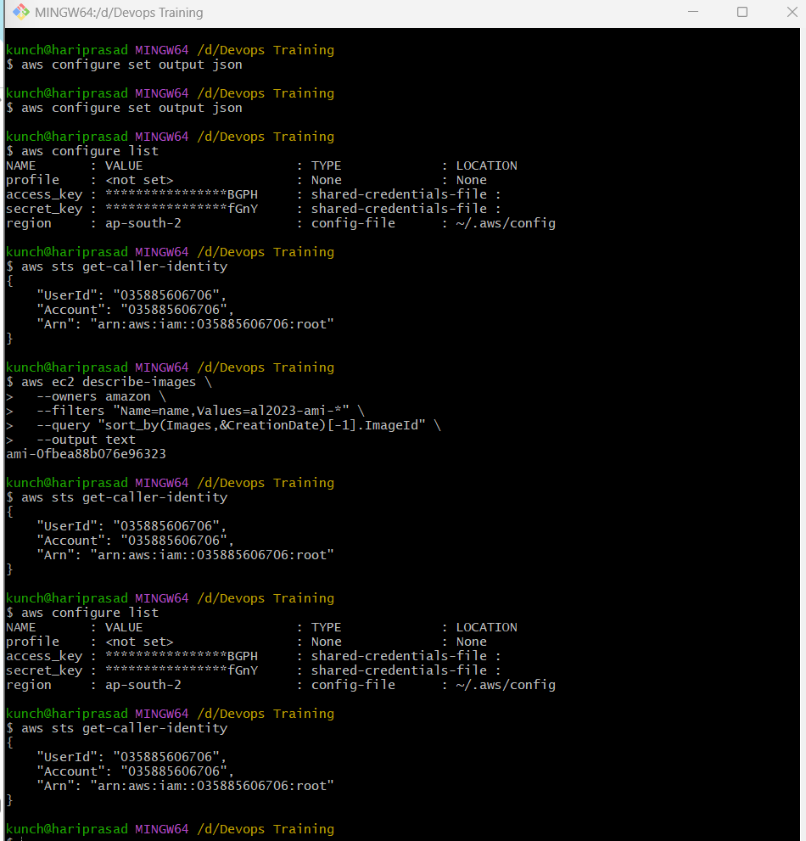
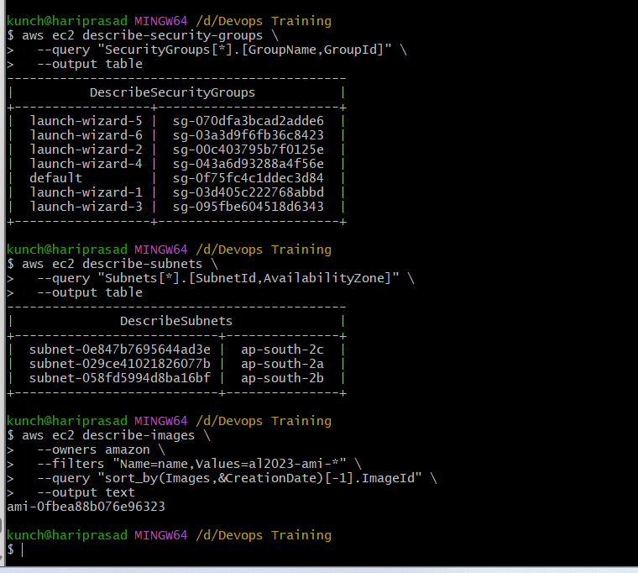
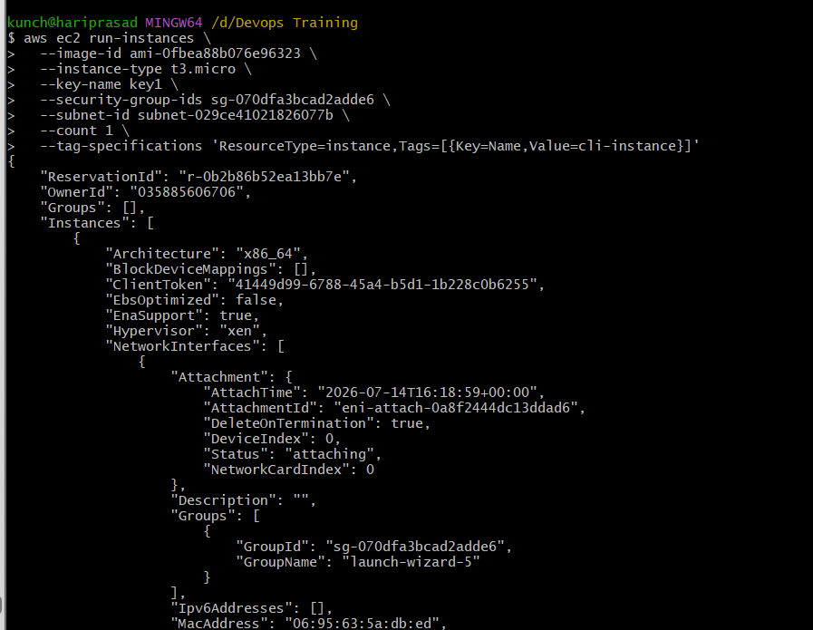
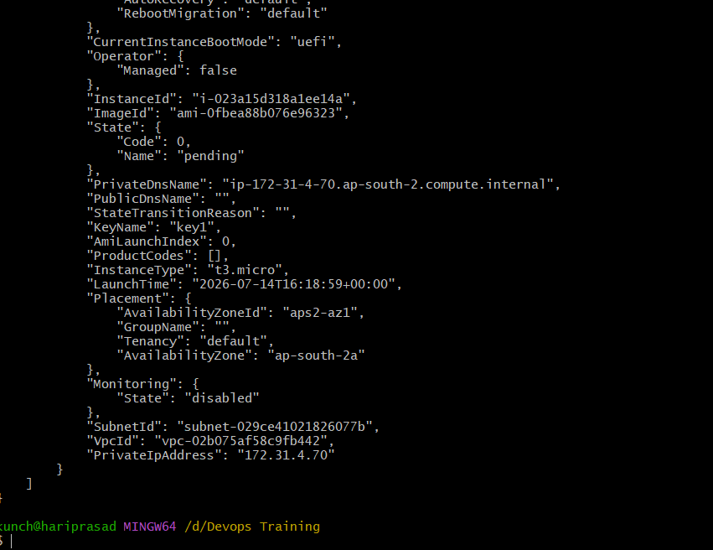
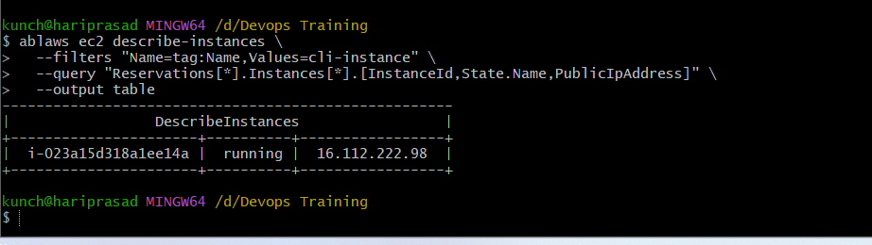

Step 9: Verify in the AWS Console
- Open AWS Console.
- Go to EC2 → Instances.
- You should see a new instance named:
cli-instance
Its state should be:
Running
