Custom Domain + CDN
Static Website on S3, CloudFront & Route 53

Tasks Covered
1. Configure VPC peering across Regions.
2. Purchase one domain from GoDaddy.
3. Deploy a static website in S3.
4. Create a CDN and attach one SSL certificate.
5. Create a Route 53 hosted zone and map the domain with the CDN.
6. Update the index.html in the S3 bucket and ensure the updated file is accessible using the domain name.
7. Share the domain name in Slack to test connectivity.

Prerequisites
- An AWS account with console access to VPC, S3, CloudFront, ACM (Certificate Manager), and Route 53.
- A payment method to purchase a domain on GoDaddy (external to AWS).
- A Slack workspace where you (and teammates) can post a message and click links.
- Naming used throughout: domain example — mylabsite2026.com; primary Region — ap-south-1; peered Region — us-east-1.

TASK 1: Configure VPC Peering in Cross Regions
Goal: Peer a VPC in ap-south-1 with a VPC in us-east-1 so resources in both Regions can communicate over private IP addresses.

Step 1.1 — Create the First VPC (ap-south-1)
1. Log in to the AWS Management Console and set the region selector (top-right) to Asia Pacific (Mumbai) ap-south-1.
2. Open the VPC console → Your VPCs → Create VPC.
3. Select VPC only. Name tag: VPC-Mumbai. IPv4 CIDR block: 10.0.0.0/16. Click Create VPC.
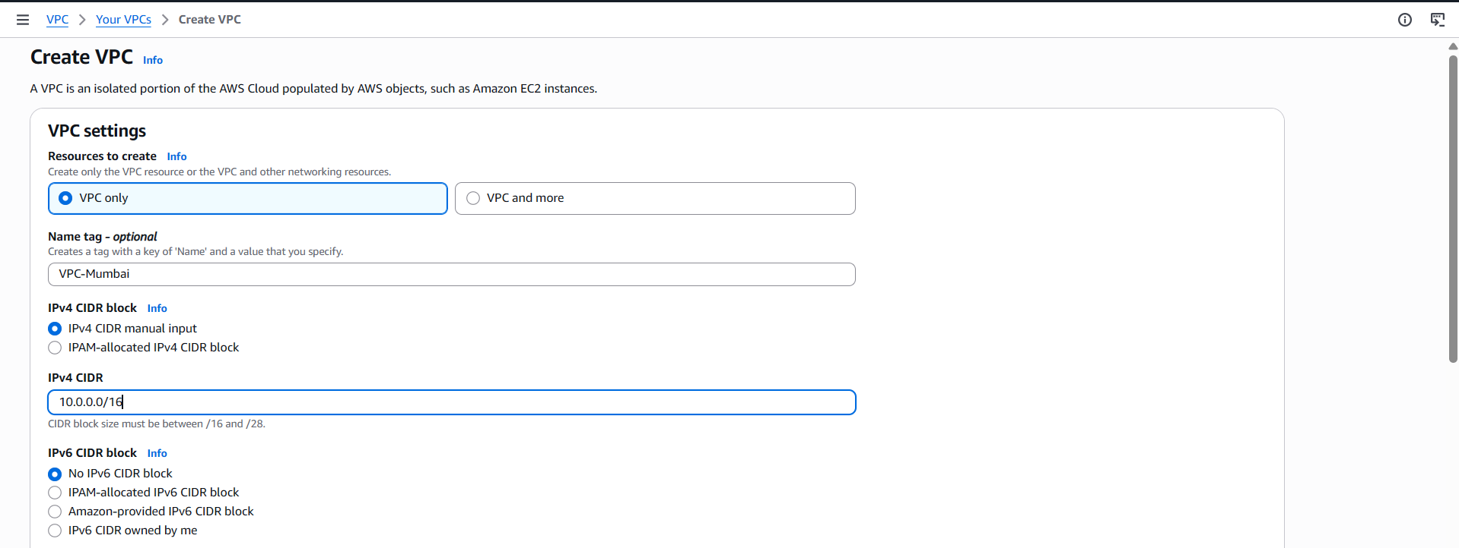
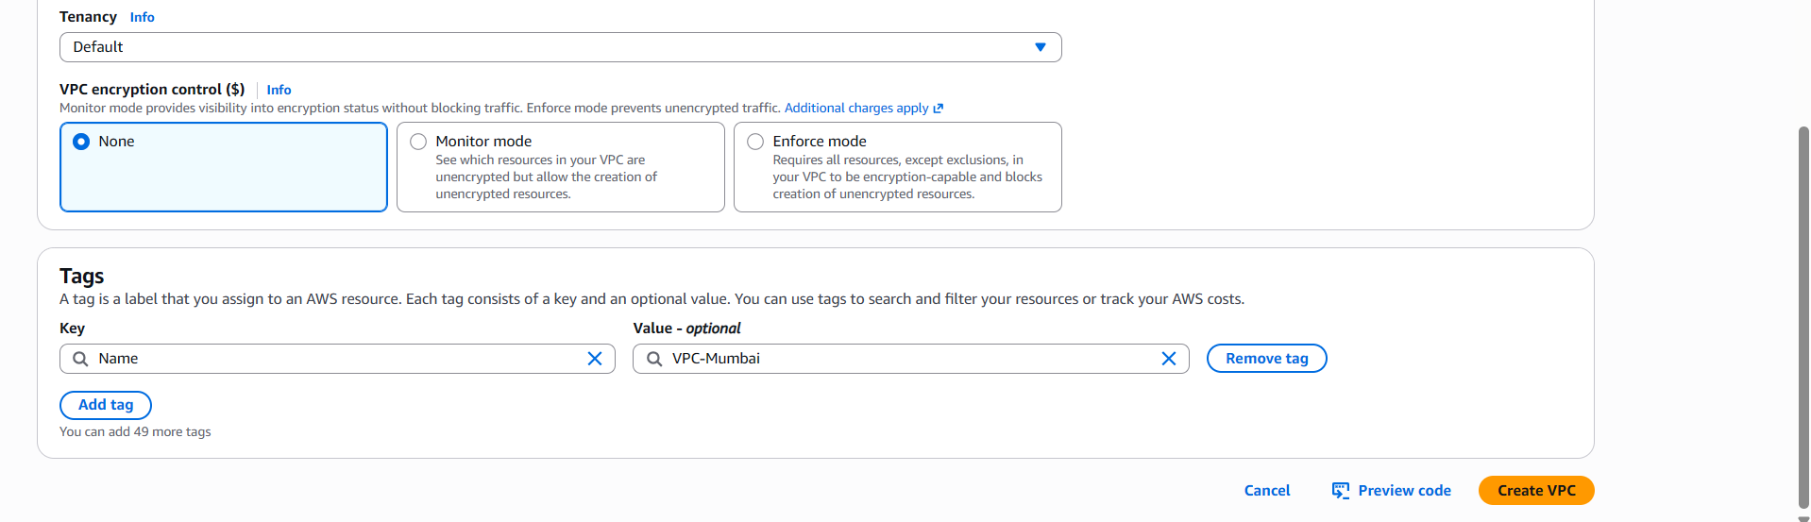
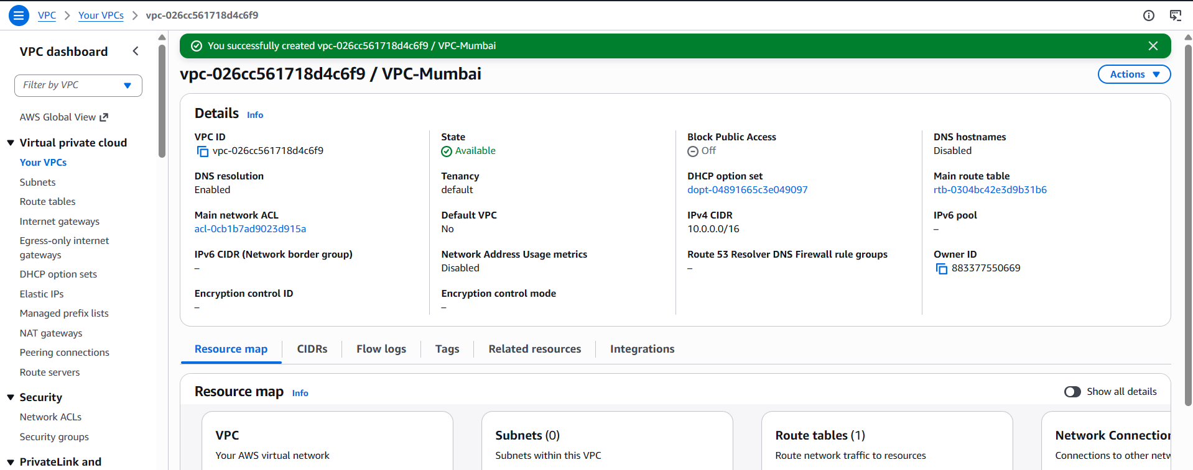
4. Subnets → Create subnet → VPC: VPC-Mumbai → name: Mumbai-Subnet → AZ: ap-south-1a → CIDR: 10.0.1.0/24 → Create subnet.
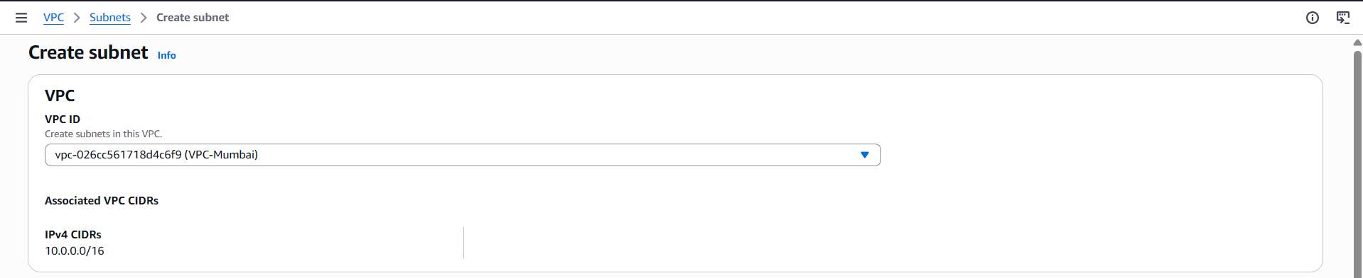
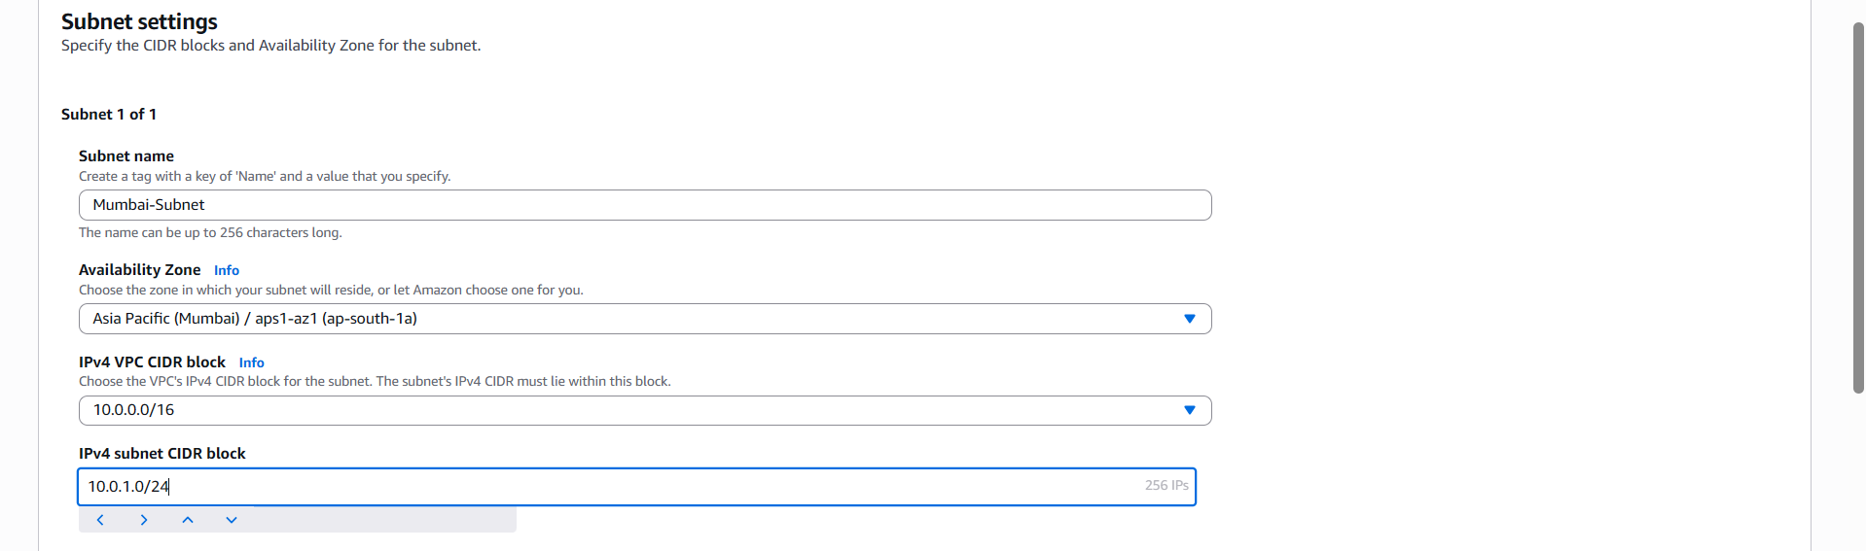
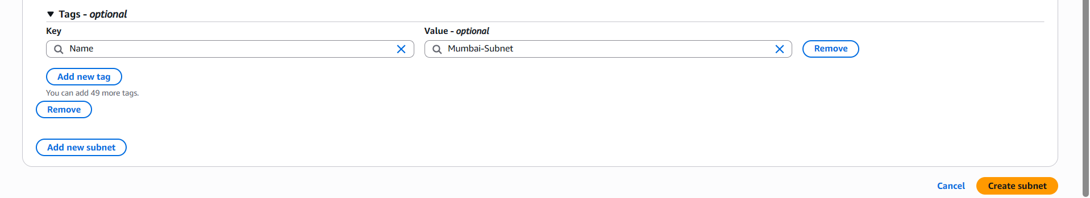
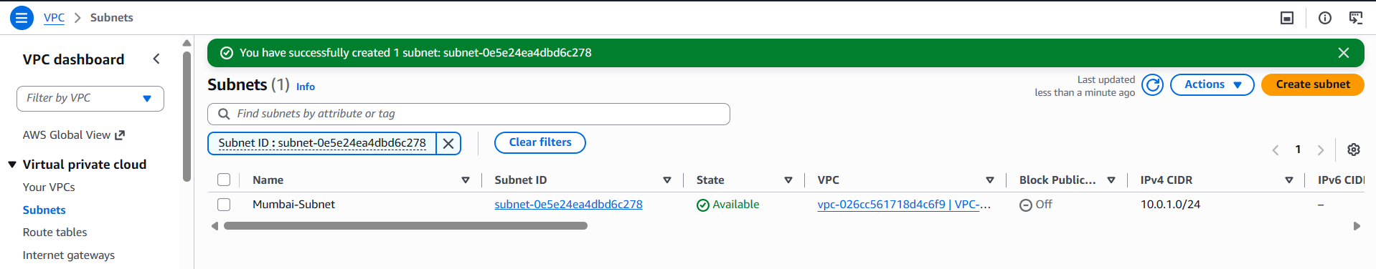

Step 1.2 — Create the Second VPC (us-east-1)
1. Switch region (top-right) to US East (N. Virginia) us-east-1.
2. VPC console → Your VPCs → Create VPC → VPC only. Name tag: VPC-Virginia. IPv4 CIDR block: 10.1.0.0/16. Click Create VPC.
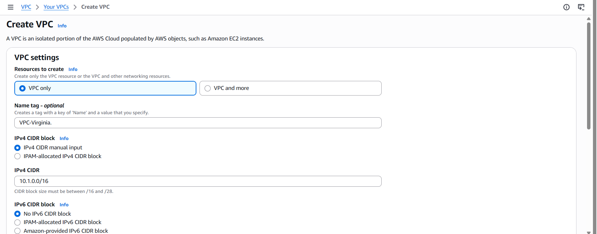
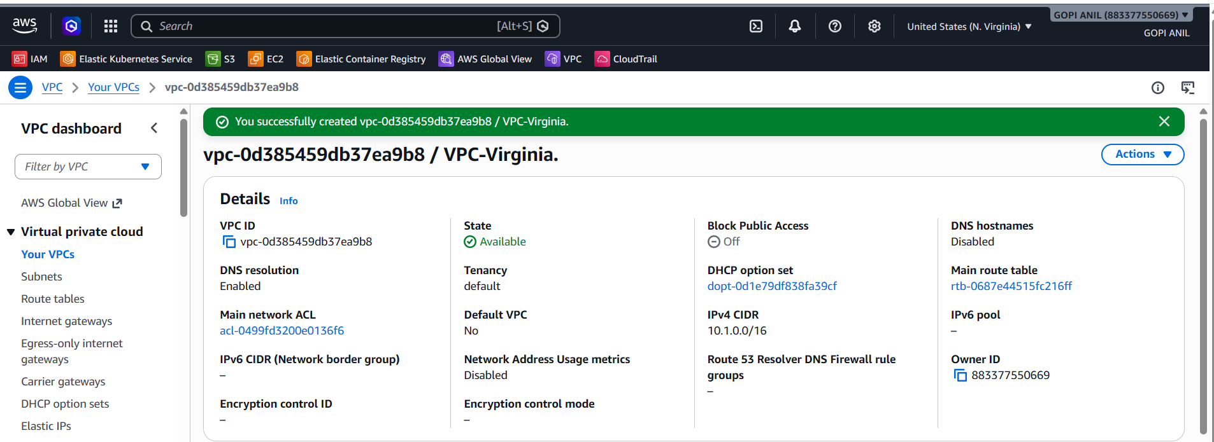

3. Subnets → Create subnet → VPC: VPC-Virginia → name: Virginia-Subnet → AZ: us-east-1a → CIDR: 10.1.1.0/24 → Create subnet.
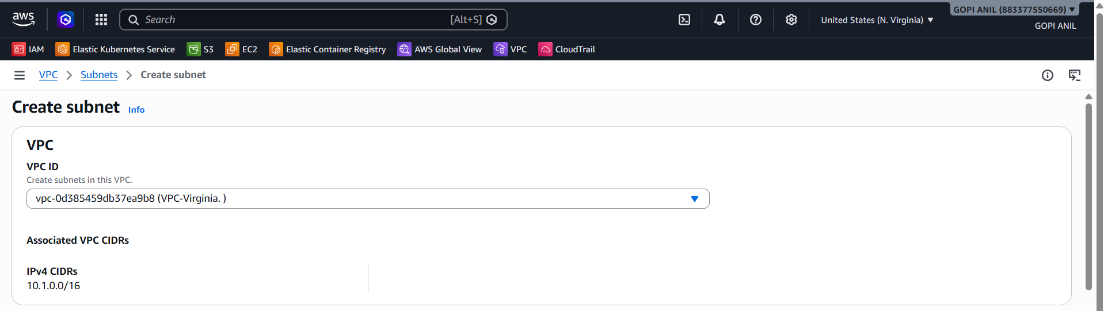
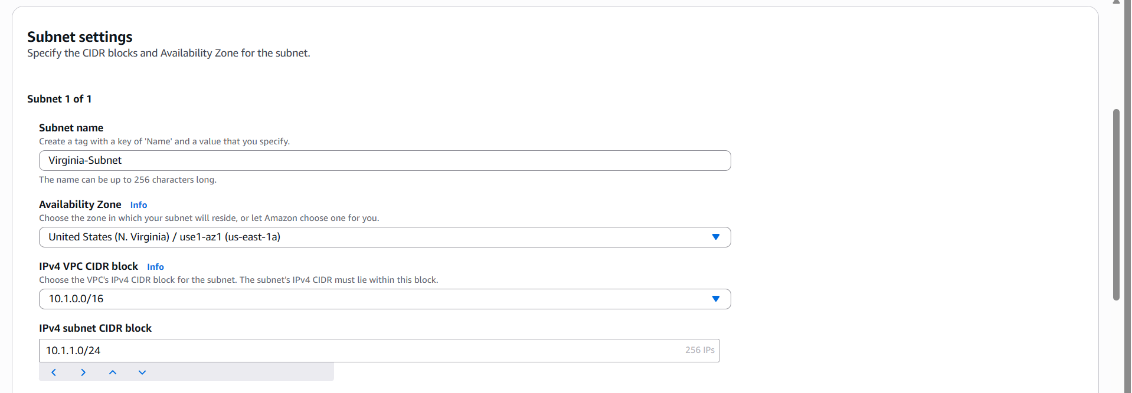
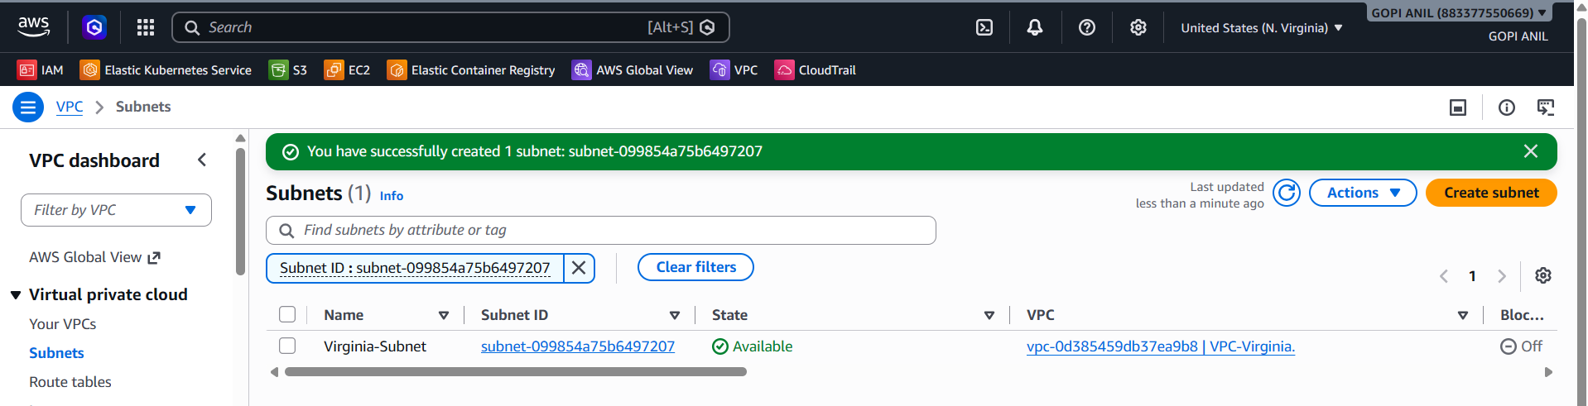

Step 1.3 — Create the Peering Connection
1. Switch region back to ap-south-1 (the requester side).
2. VPC console → Peering Connections → Create peering connection.
3. Name tag: Mumbai-to-Virginia-Peering. VPC (Requester): VPC-Mumbai. Account: My account.
4. Region: Another Region → us-east-1. VPC (Accepter): paste the VPC ID of VPC-Virginia.
5. Click Create peering connection. Status shows Pending Acceptance.
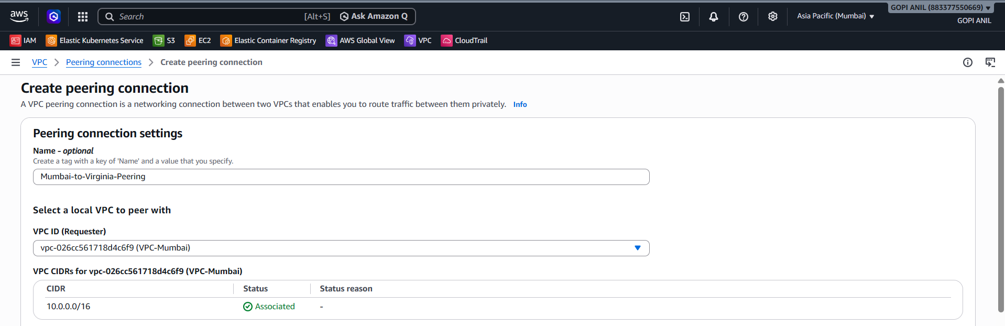
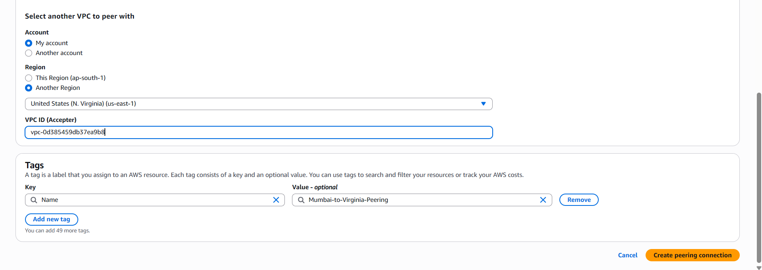

Step 1.4 — Accept the Peering Connection
1. Switch region to us-east-1 → VPC console → Peering Connections.
2. Select the pending request → Actions → Accept request → confirm. Status changes to Active.
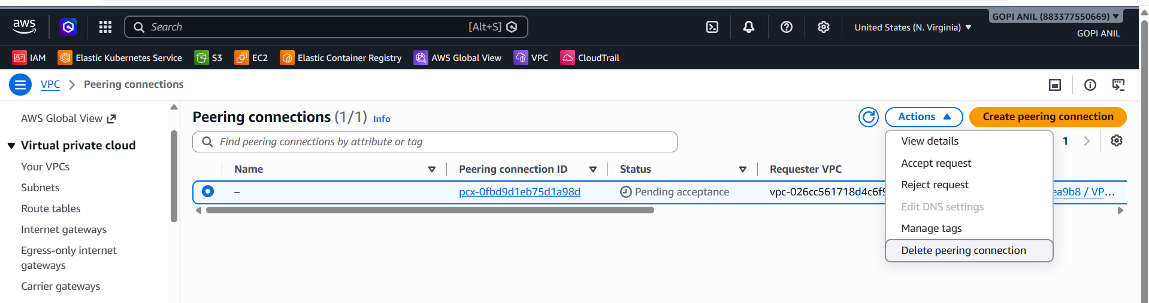
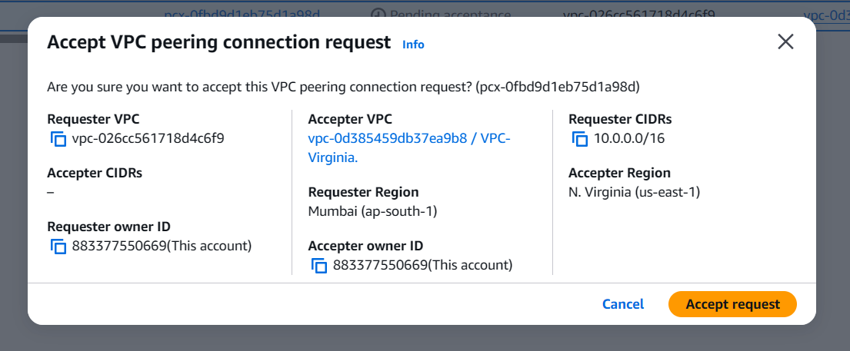
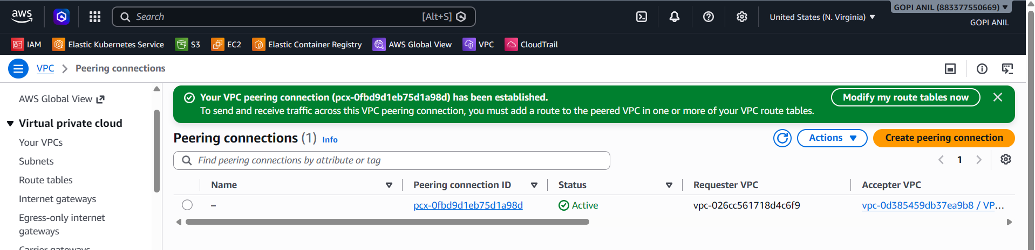

Step 1.5 — Update Route Tables on Both Sides
- In ap-south-1: Route Tables → select the route table for Mumbai-Subnet → Edit routes → Add route: Destination 10.1.0.0/16, Target = the peering connection → Save.
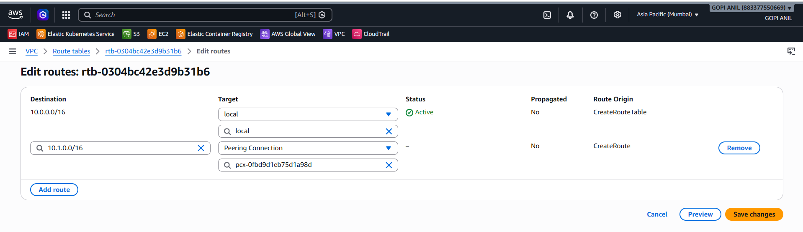
- In us-east-1: Route Tables → select the route table for Virginia-Subnet → Edit routes → Add route: Destination 10.0.0.0/16, Target = the same peering connection → Save.
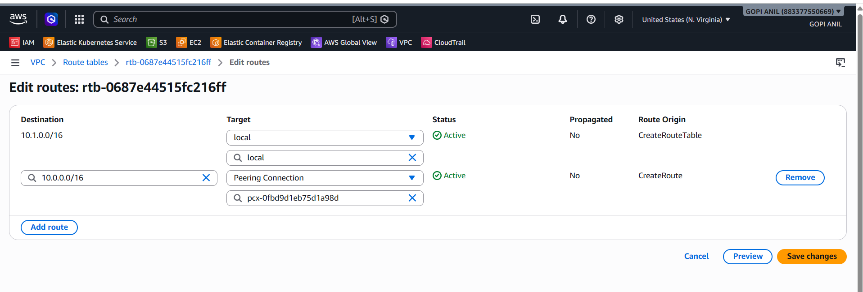
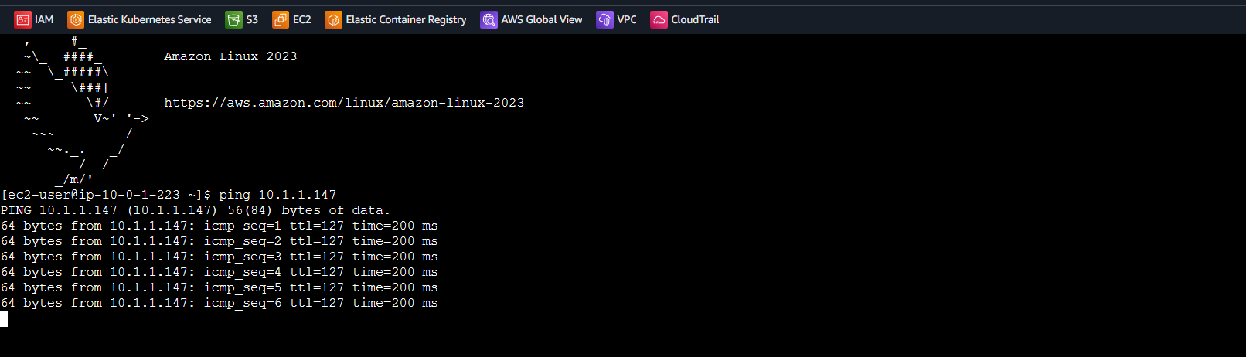

TASK 2: Purchase One Domain from GoDaddy
Goal: Register a domain name that will later be pointed at the CloudFront distribution. This step happens entirely on GoDaddy's website, outside the AWS Console.

Step 2.1 — Search for a Domain
1. Go to https://www.godaddy.com in a browser.
2. In the search bar on the homepage, type the desired domain, e.g., mylabsite2026.com, and click Search.
3. Review the list of available extensions (.com, .in, .net, etc.) and pricing shown for each.

Step 2.2 — Add the Domain to Cart
1. Click Add to Cart next to the desired domain.
2. On the cart page, review/deselect any optional add-ons GoDaddy suggests (privacy protection, hosting, email) — for this lab, only the domain itself is required, though WHOIS/domain privacy is recommended.
3. Click Continue to Cart, then Proceed to Checkout.

Step 2.3 — Create/Sign in to a GoDaddy Account
1. If you don't have a GoDaddy account, click Create Account and fill in your name, email, and password.
2. If you already have one, click Sign In and enter your credentials.

Step 2.4 — Complete Payment
1. Enter billing/contact information required for domain registration (ICANN requires accurate registrant contact details).
2. Choose the registration length (e.g., 1 year).
3. Enter payment details and click Complete Purchase / Place Order.
4. GoDaddy sends a confirmation email once the domain is registered.

Step 2.5 — Verify
1. Log in to the GoDaddy account → My Products → Domains.
2. Confirm the new domain (e.g., mylabsite2026.com) is listed with a status of Active.
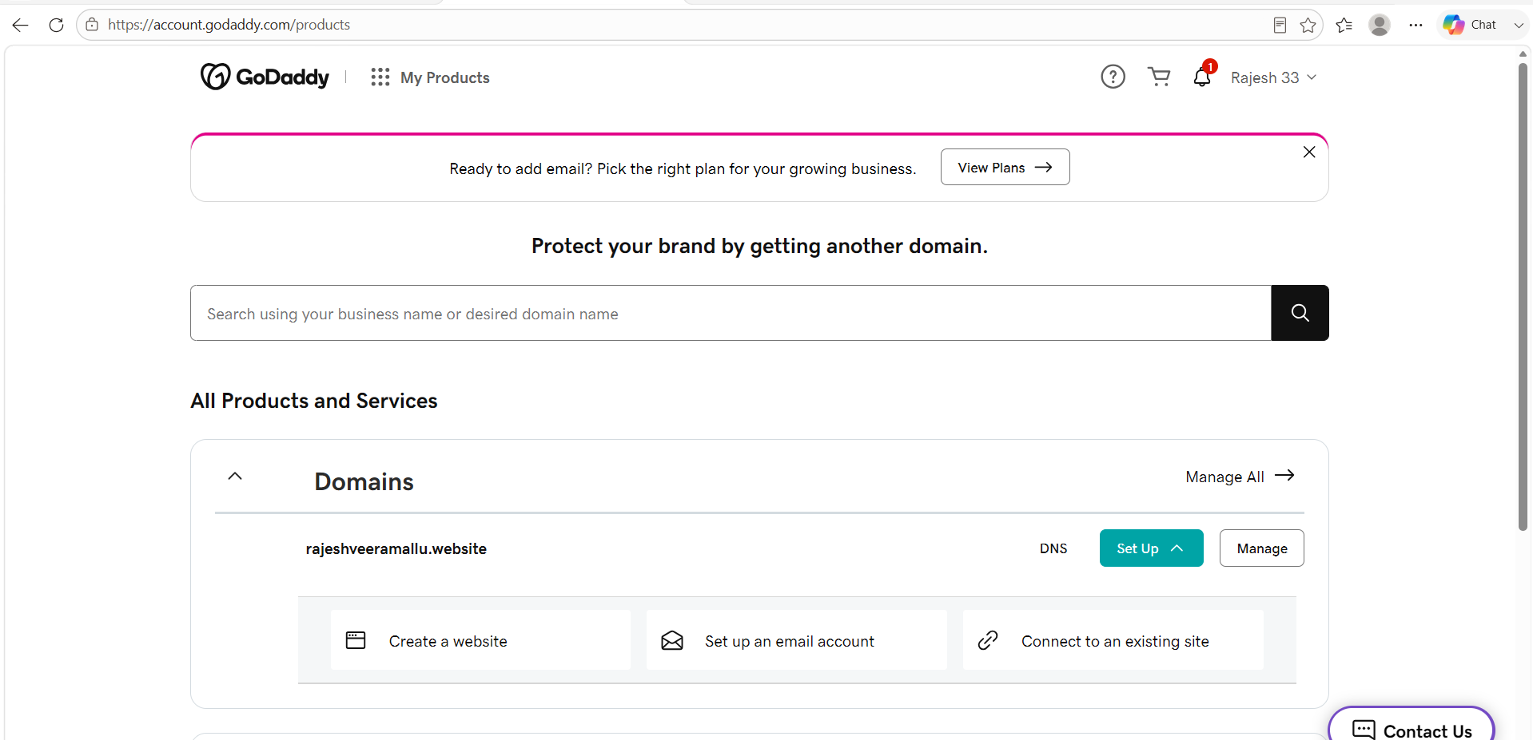

TASK 3: Deploy a Static Website in S3
Goal: Host the website's HTML/CSS/JS files in an S3 bucket configured for static website hosting, which CloudFront will sit in front of in Task 4.

Step 3.1 — Create the Website Bucket
1. S3 Console → Create bucket.
2. Bucket name: rajeshveeramallu.website (must be globally unique; adjust as needed — using a name close to the domain is a common convention but not required).
3. Region: ap-south-1.
4. Object Ownership: ACLs disabled.
5. Block Public Access settings: uncheck Block all public access and check the acknowledgement box (a public website bucket needs public reads).
6. Leave remaining defaults and click Create bucket.
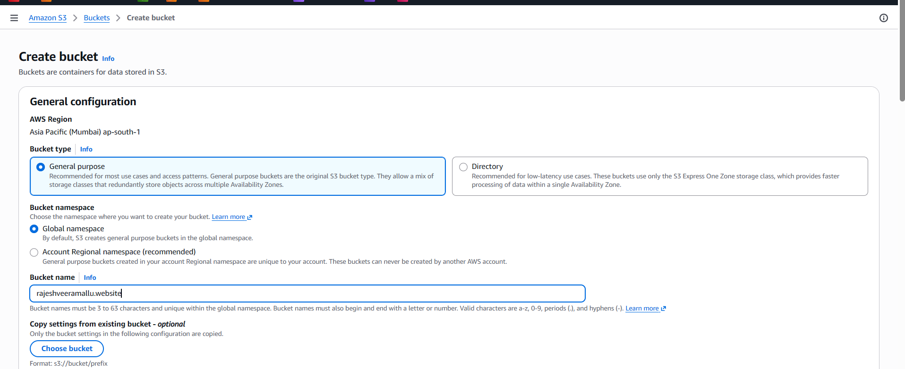
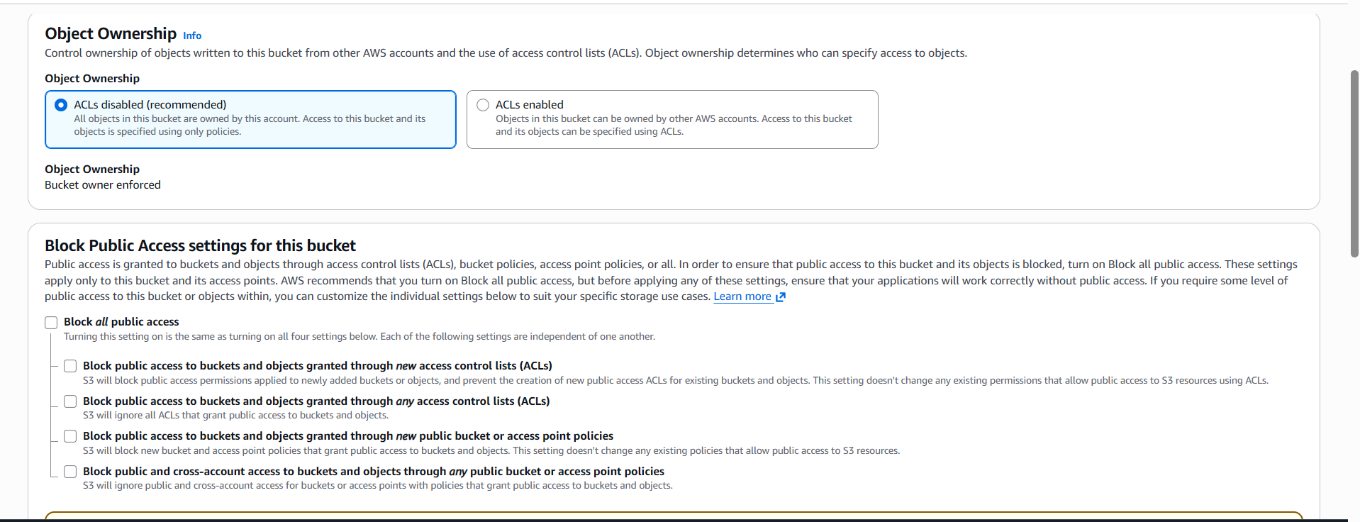
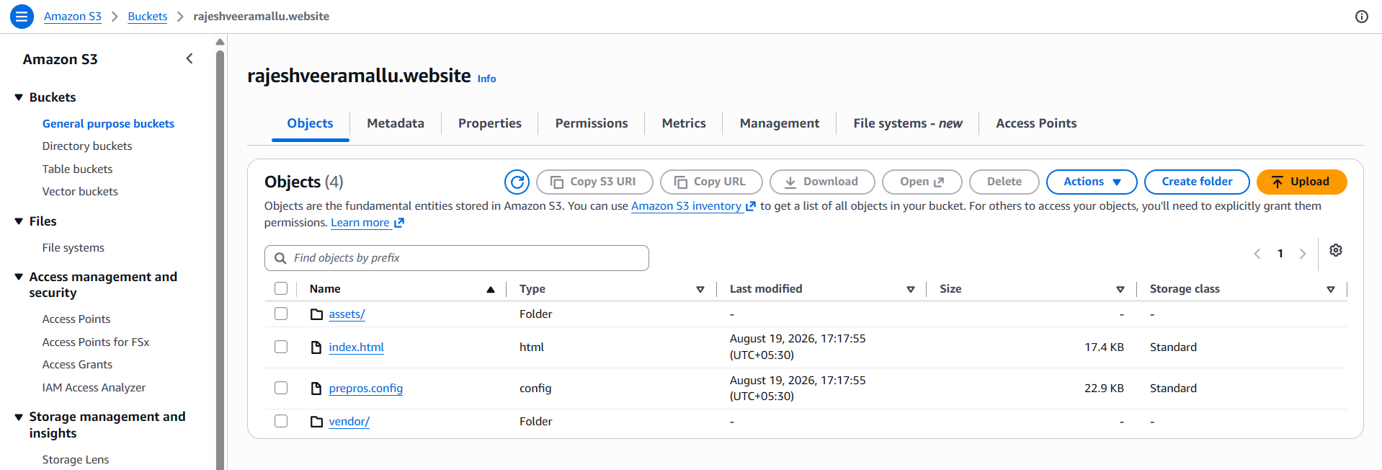

Step 3.2 — Upload Website Files
1. Open the bucket → Upload → Add files.
2. Select index.html and error.html (create simple placeholder pages locally first if needed) plus any CSS/JS/image assets.
3. Click Upload.
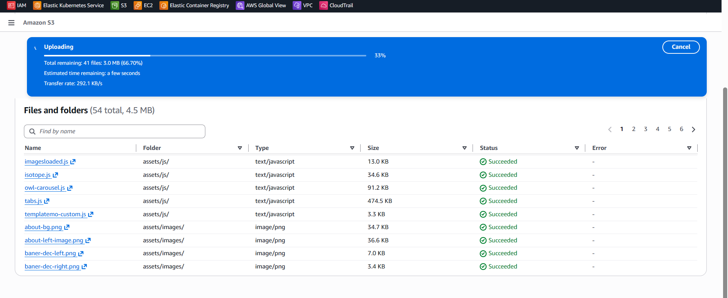

Step 3.3 — Enable Static Website Hosting
1. Properties tab → scroll to Static website hosting → Edit.
2. Static website hosting: Enable. Hosting type: Host a static website.
3. Index document: index.html. Error document: error.html.
4. Click Save changes and note the Bucket website endpoint shown.
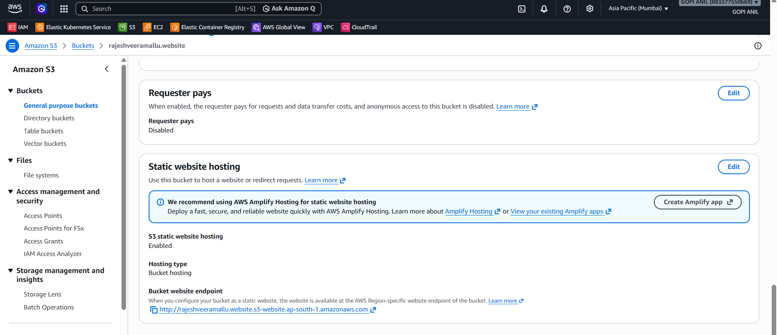

Step 3.4 — Attach a Public-Read Bucket Policy
1. Permissions tab → Bucket policy → Edit.
{
"Version": "2012-10-17",
"Statement": [
{
"Sid": "PublicReadForWebsite",
"Effect": "Allow",
"Principal": "*",
"Action": "s3:GetObject",
"Resource": "arn:aws:s3:::rajeshveeramallu.website/*"
}
]
}
- Click Save changes.
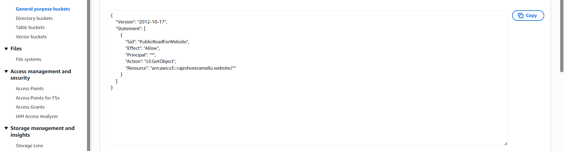
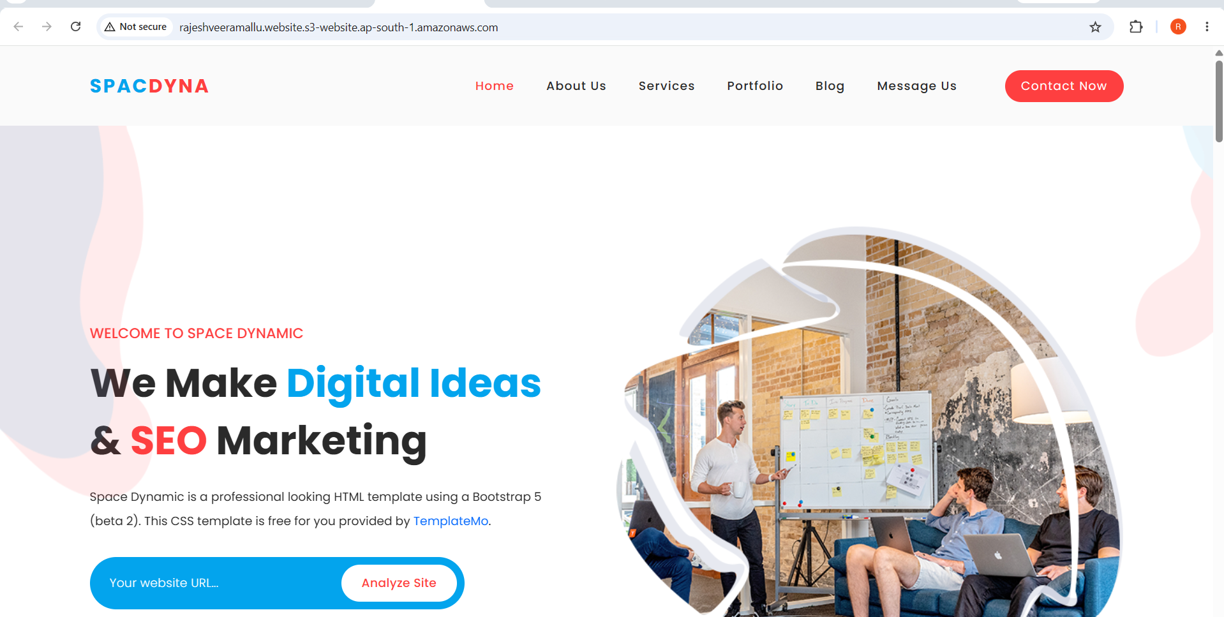

TASK 4: Create a CDN and Attach One SSL Certificate
Goal: Front the S3 website with an Amazon CloudFront distribution for HTTPS, caching, and global edge delivery, using a free public certificate from AWS Certificate Manager (ACM).

Step 4.1 — Request a Public SSL Certificate in ACM
1. Switch region to US East (N. Virginia) us-east-1 — CloudFront requires ACM certificates to be requested in this Region regardless of where your other resources live.
2. Open the AWS Certificate Manager (ACM) console → Request → Request a public certificate → Next.
3. Fully qualified domain name: enter mylabsite2026.com and add another name www.mylabsite2026.com (click Add another name to this certificate).
4. Validation method: DNS validation (recommended).
5. Click Request.
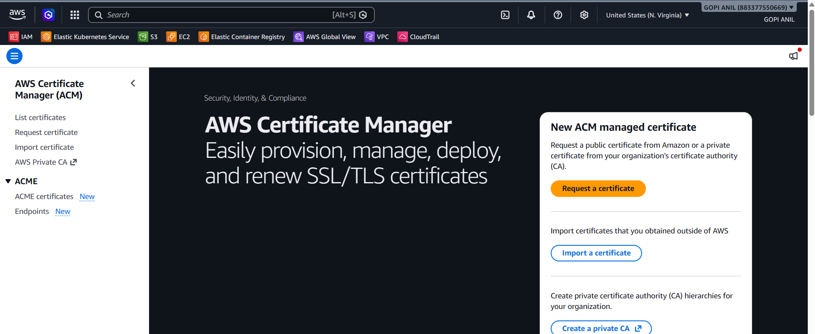
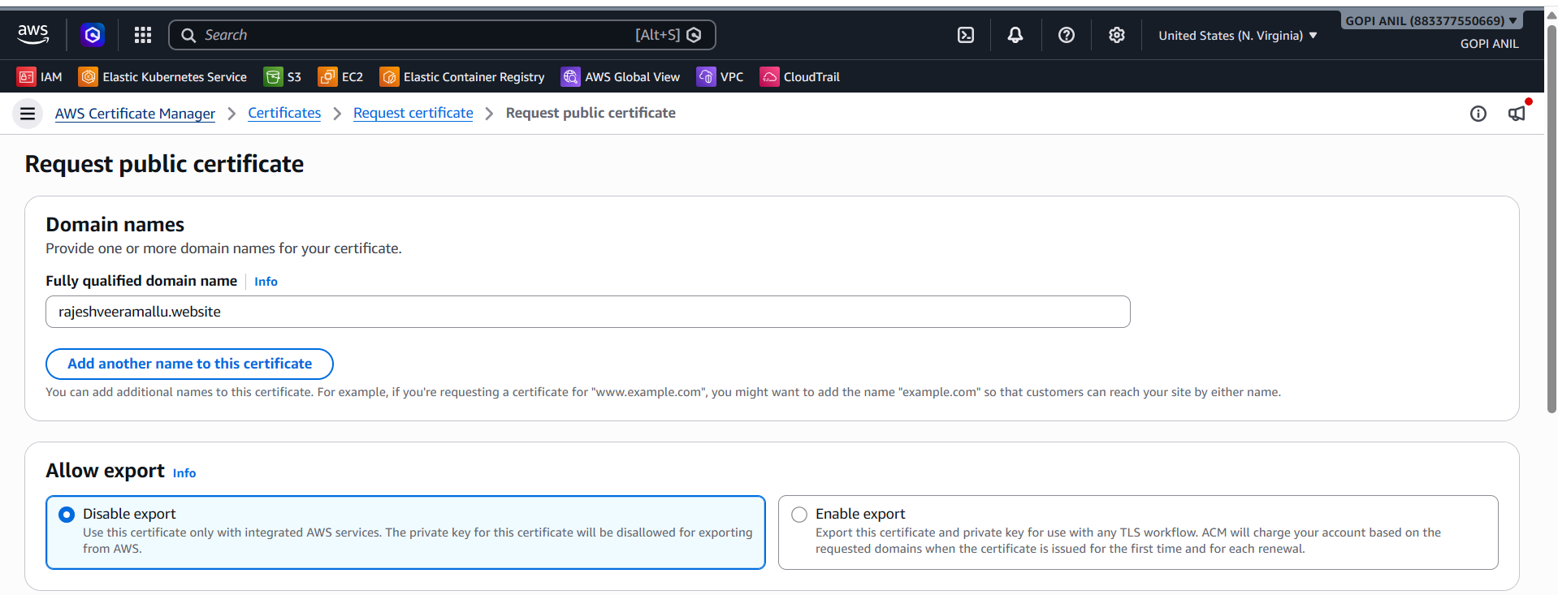
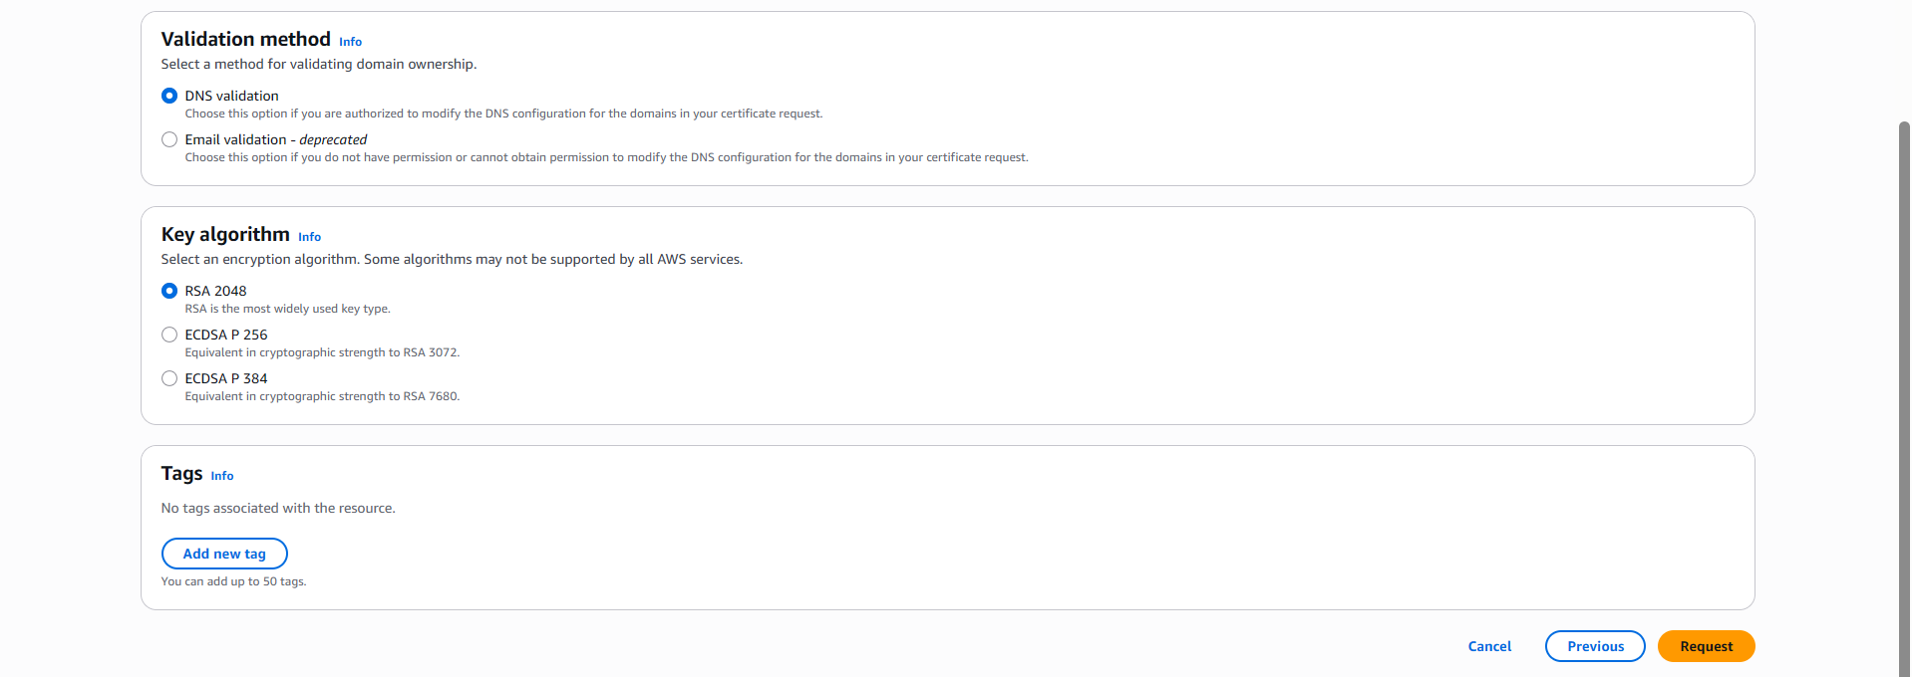

Step 4.2 — Validate the Certificate
1. Open the newly requested certificate → note the CNAME name and CNAME value shown for each domain under Domains.
2. These CNAME records will be added to Route 53 in Task 5 (or directly at GoDaddy if Route 53 isn't set up yet) to prove domain ownership.
3. Once the CNAME record is in place and DNS propagates, the certificate Status automatically changes from Pending validation to Issued (can take a few minutes to a few hours).
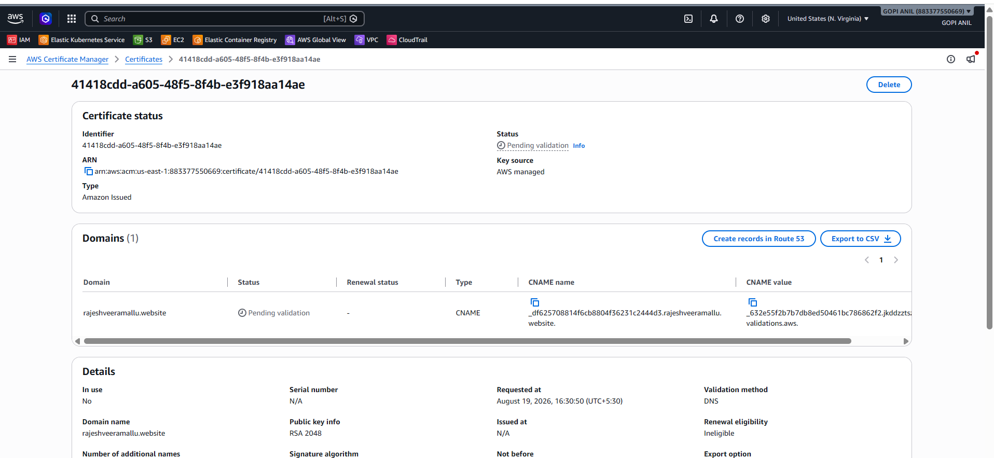

Step 4.3 — Create the CloudFront Distribution
1. Open the CloudFront console → Create distribution.
2. Origin domain: click into the field and select the S3 website endpoint for mylabsite2026-website (use the Static website hosting endpoint URL from Task 3, not the S3 bucket's REST API endpoint, so that index/error documents work correctly).
3. Origin protocol policy: HTTP only (S3 static website endpoints only serve HTTP).
4. Viewer protocol policy: Redirect HTTP to HTTPS.
5. Allowed HTTP methods: GET, HEAD (default, sufficient for a static site).
6. Alternate domain name (CNAME): add mylabsite2026.com and www.mylabsite2026.com.
7. Custom SSL certificate: select the ACM certificate issued in Step 4.2.
8. Default root object: index.html.
9. Click Create distribution.
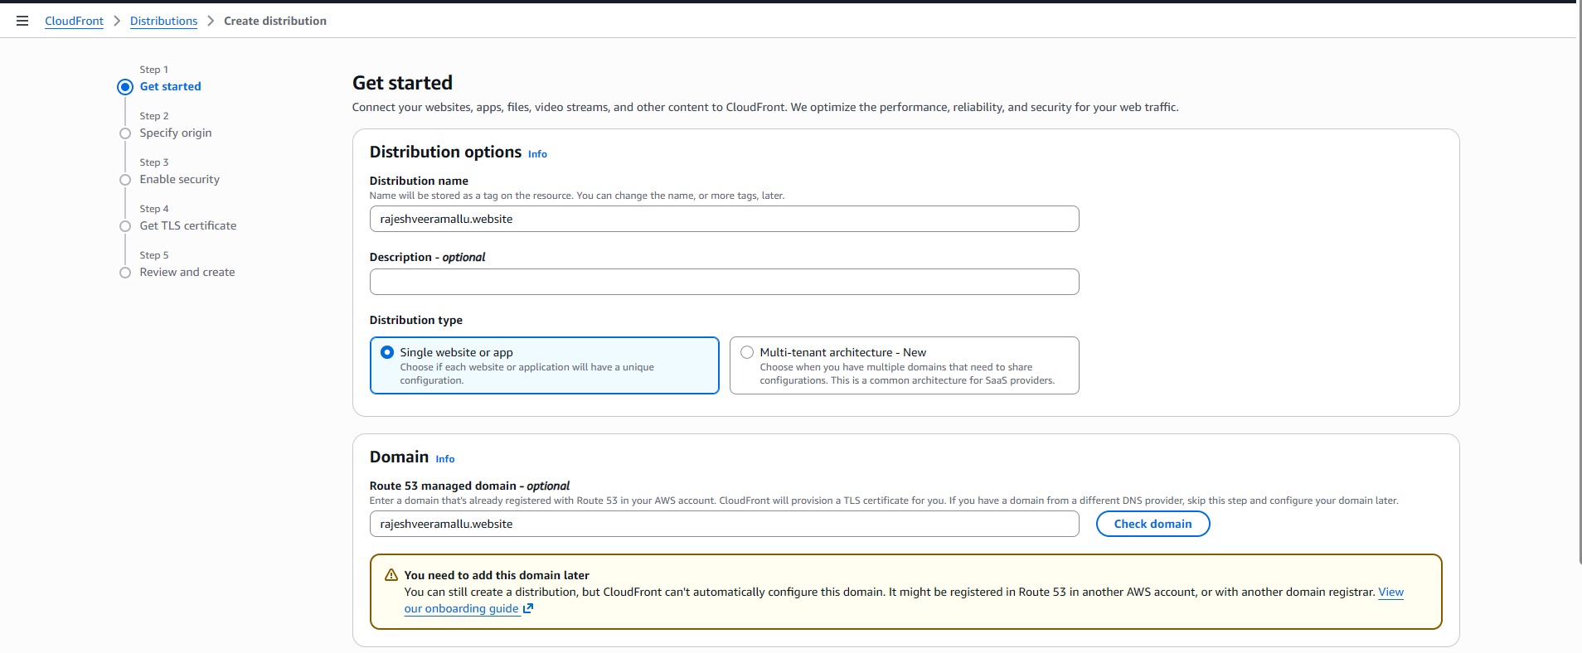
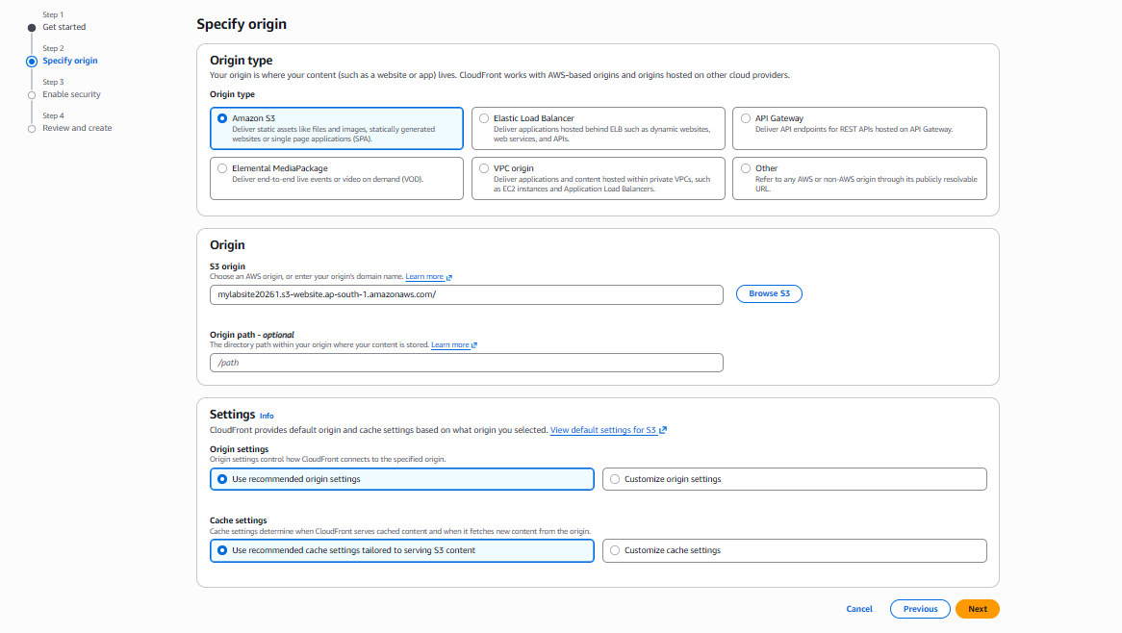
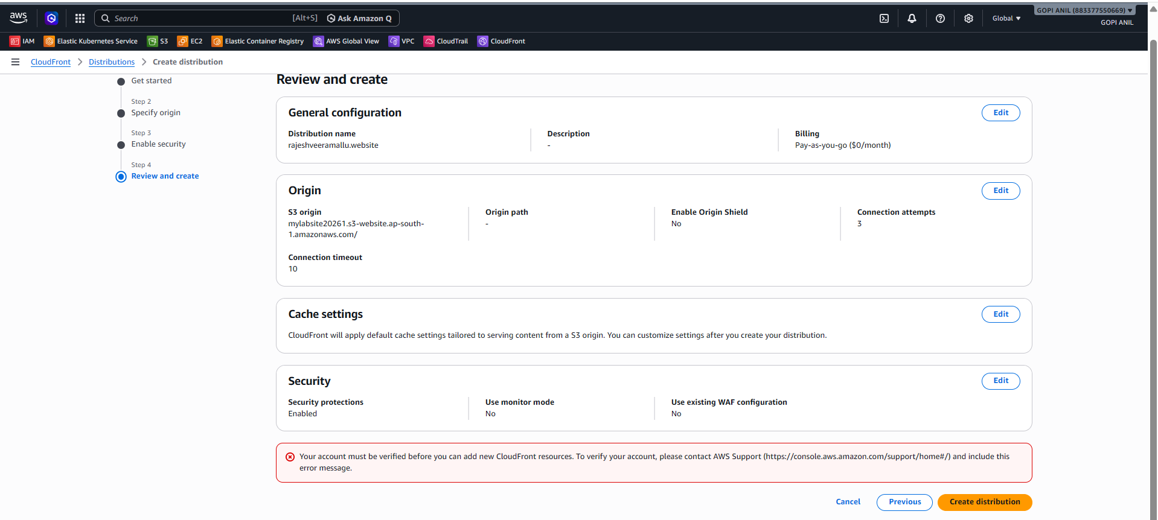

TASK 5: Create a Route 53 Hosted Zone and Map the Domain with the CDN

Step 5.1 — Create the Hosted Zone
1. Open the Route 53 console → Hosted zones → Create hosted zone.
2. Domain name: mylabsite2026.com.
3. Type: Public hosted zone.
4. Click Create hosted zone.
5. Note the four NS (name server) records automatically created, e.g., ns-123.awsdns-45.com, ns-678.awsdns-90.net, etc.
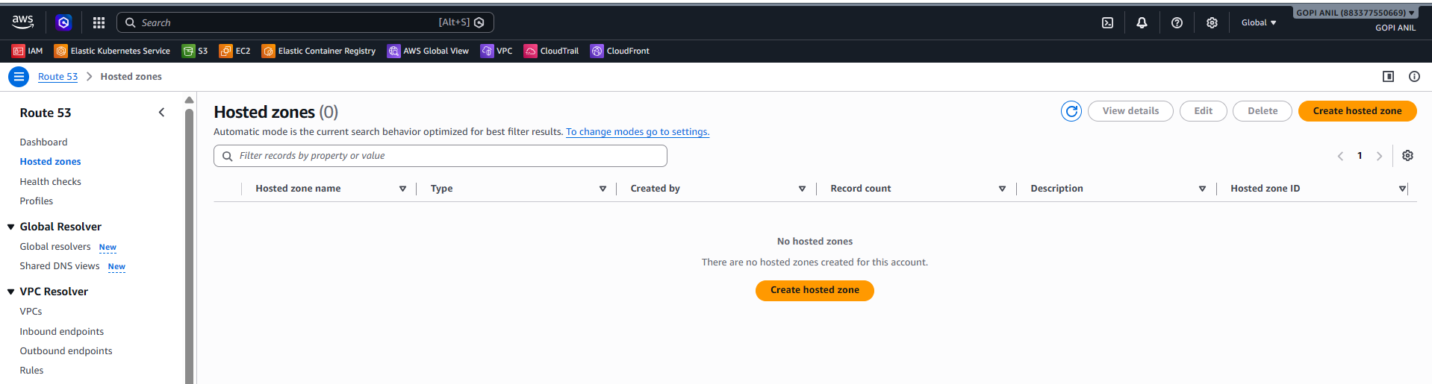
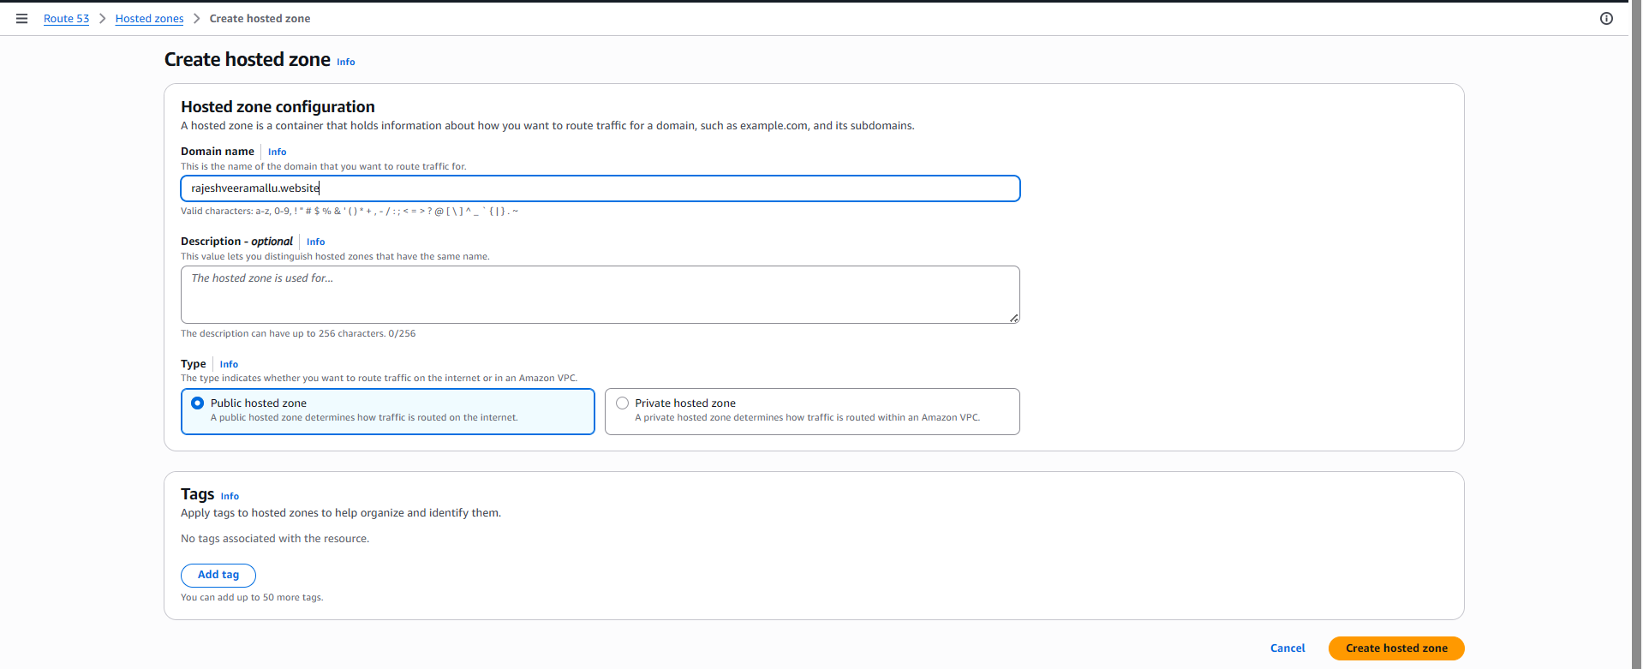
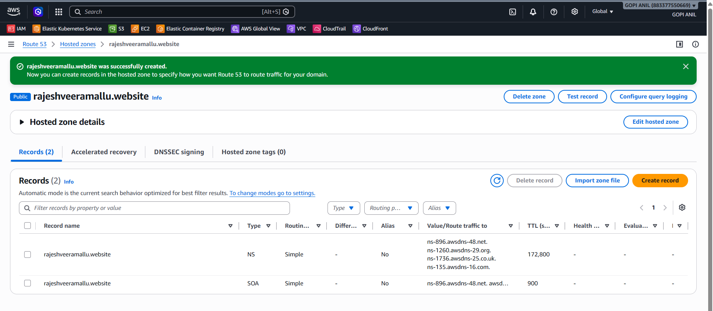

Step 5.2 — Point GoDaddy's Name Servers at Route 53
1. Log in to GoDaddy → My Products → Domains → select rajeshveeramallu.website → DNS → Nameservers → Change.
2. Select Enter my own nameservers (custom) / I'll use my own nameservers.
3. Enter the four NS values copied from Step 5.1, one per field.
4. Save the changes. Propagation can take anywhere from a few minutes to 24–48 hours.
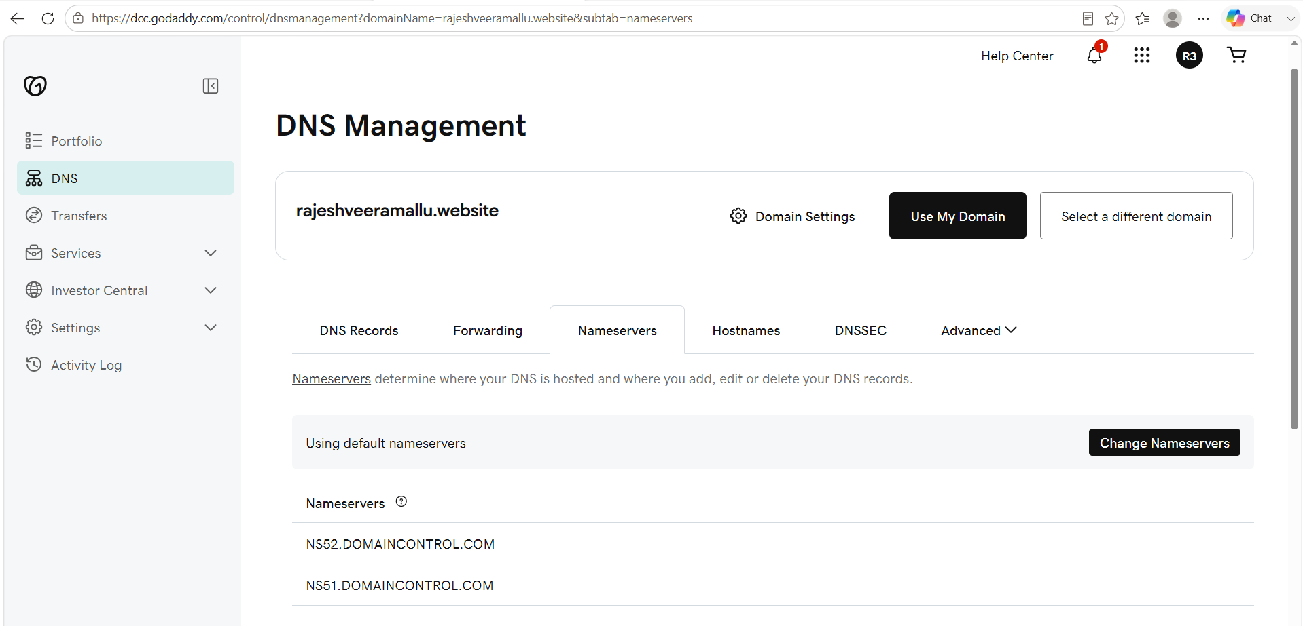
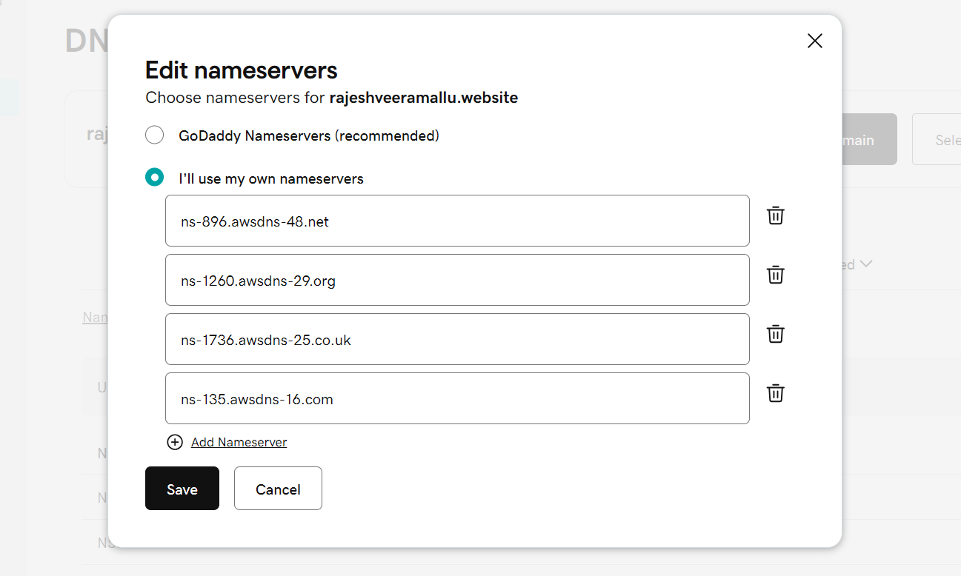

Step 5.3 — Add the ACM Validation CNAME Record (if not already added)
1. In the Route 53 hosted zone, click Create record.
2. Record name/value: paste the CNAME name and CNAME value shown on the ACM certificate from Task 4, Step 4.2.
3. Record type: CNAME. Click Create records.
4. Return to the ACM console after a few minutes and confirm the certificate Status shows Issued.
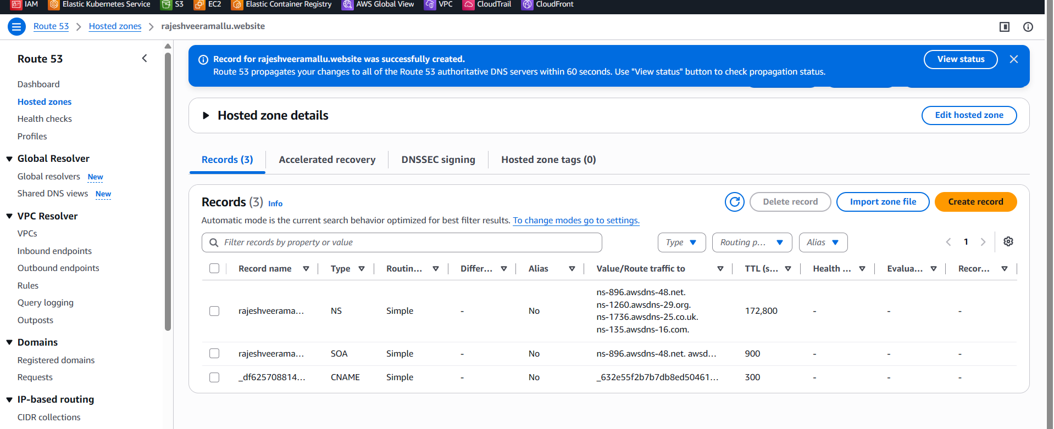
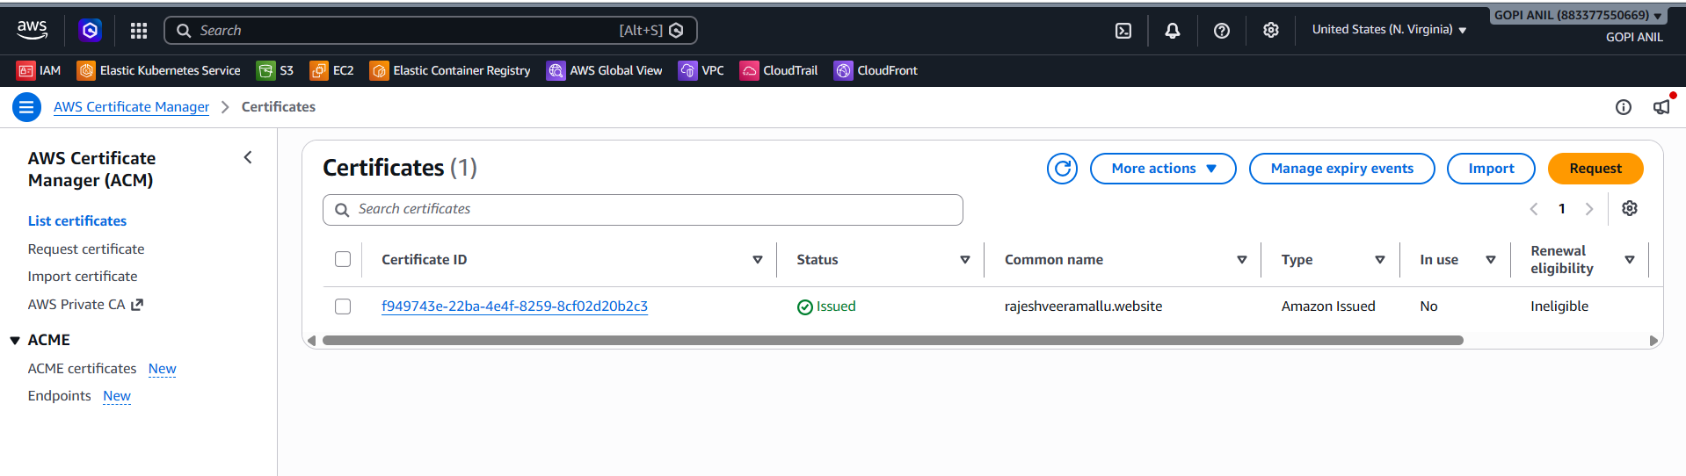

Step 5.4 — Create Alias Records Pointing to CloudFront
1. In the hosted zone, click Create record.
2. Record name: leave blank (for the root domain mylabsite2026.com).
3. Record type: A.
4. Toggle Alias to ON.
5. Route traffic to: Alias to CloudFront distribution → select the distribution created in Task 4.
6. Click Create records.
7. Repeat, this time with Record name: www and the same Alias to CloudFront distribution target, to cover the www subdomain.

Step 5.5 — Verify
1. Wait for DNS propagation, then run: dig mylabsite2026.com (or nslookup mylabsite2026.com) and confirm it resolves to CloudFront's IP addresses.
2. Open https://mylabsite2026.com in a browser and confirm the static site loads over HTTPS using the custom domain.
✅ Task 5 Complete: mylabsite2026.com and www.mylabsite2026.com both resolve through Route 53 to the CloudFront distribution, serving the site over HTTPS.

TASK 6: Update index.html in S3 and Confirm It's Accessible via the Domain

Step 6.1 — Edit and Re-upload index.html
1. Edit the local index.html file to include a visible change (e.g., an updated heading or timestamp) so the update is easy to confirm.
2. S3 Console → mylabsite2026-website bucket → Upload → Add files → select the updated index.html → Upload (this overwrites the existing object of the same key).

Step 6.2 — Invalidate the CloudFront Cache
1. CloudFront caches objects at edge locations, so the old version may still be served until the cache expires or is invalidated.
2. CloudFront console → select the distribution → Invalidations tab → Create invalidation.
3. Object paths: enter /index.html (or /* to invalidate everything).
4. Click Create invalidation and wait for its status to show Completed (usually under a minute).

Step 6.3 — Verify via the Domain Name
1. Open https://mylabsite2026.com in a browser (use a private/incognito window, or hard-refresh, to bypass local browser cache).
2. Confirm the visible change made in Step 6.1 now appears when loading the site through the custom domain.
✅ Task 6 Complete: The updated index.html is live and accessible at https://mylabsite2026.com after the S3 upload and CloudFront cache invalidation.
Note: Any future content update follows this same two-step pattern: upload the new object to S3, then invalidate the corresponding CloudFront path so viewers see the change immediately instead of waiting for the cache TTL to expire.

TASK 7: Share the Domain Name in Slack to Test Connectivity

Step 7.1 — Open Slack
1. Open the Slack desktop app, mobile app, or https://slack.com in a browser and sign in to the relevant workspace.

Step 7.2 — Post the Domain in a Channel
1. Select a channel (e.g., #general or a dedicated #website-testing channel), or open a direct message with a teammate.
2. Type a message including the full HTTPS URL, e.g.: Please check the new site: https://mylabsite2026.com
3. Press Enter to send. Slack will typically auto-generate a link preview (unfurl) showing the page title if the site is reachable, giving a first visual confirmation.

Step 7.3 — Ask Teammates to Confirm Connectivity
1. Ask at least one teammate in the channel to click the link from their own network/device and reply confirming whether the page loaded successfully and over HTTPS (padlock icon, no certificate warnings).
2. If anyone reports an error, check: (a) DNS propagation status from Task 5, Step 5.5, (b) CloudFront distribution Status = Enabled, and (c) ACM certificate Status = Issued.

Step 7.4 — Verify
1. Confirm at least one teammate has replied in the Slack thread confirming the site loaded correctly from their own connection, proving the domain resolves and serves content outside of your own machine/network.
✅ Task 7 Complete: The domain was shared in Slack, and connectivity was independently confirmed by at least one other person, validating the full path from GoDaddy DNS → Route 53 → CloudFront → S3.

Summary Table
# | Task | Key Resource(s) | Verified By
1 | Cross-region VPC peering | VPC-Mumbai, VPC-Virginia, Peering Connection | Cross-region ping
2 | Domain purchase | GoDaddy domain: mylabsite2026.com | GoDaddy “My Products” shows Active
3 | S3 static website | S3 bucket + website hosting + public policy | S3 website endpoint loads index.html
4 | CDN + SSL | CloudFront distribution, ACM certificate | HTTPS loads at *.cloudfront.net
5 | Route 53 + domain mapping | Hosted zone, NS records at GoDaddy, Alias A records | Domain resolves to CloudFront
6 | Content update | Updated index.html, CloudFront invalidation | Change visible at custom domain
7 | Slack connectivity test | Slack message with the HTTPS URL | Teammate confirms page loads

Cleanup (Recommended After Lab Completion, to Avoid Charges)
1. Disable and delete the CloudFront distribution (must be disabled first, then deleted once status shows Deployed/Disabled).
2. Delete the ACM certificate once no distribution references it.
3. Delete the Route 53 records and hosted zone (note: hosted zones incur a small monthly charge until deleted).
4. Empty and delete the S3 website bucket.
5. Delete the VPC peering connection and both test VPCs/instances from Task 1.
6. If the domain itself is no longer needed, either let it lapse at renewal or keep it and simply repoint DNS elsewhere — GoDaddy domain purchases are not refundable/cancelable the way AWS resources are.
Document prepared as a hands-on AWS + GoDaddy domain lab guide. All console paths reflect AWS and GoDaddy as of 2026 and may shift slightly with future UI updates.

