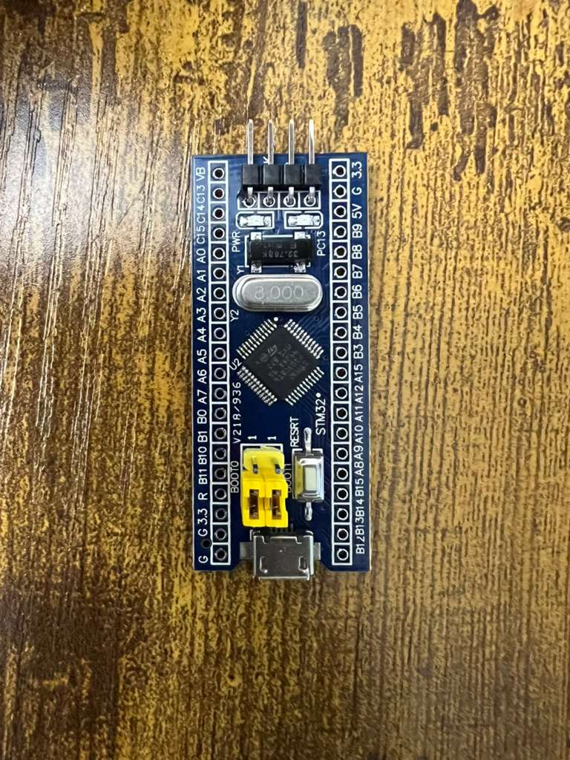
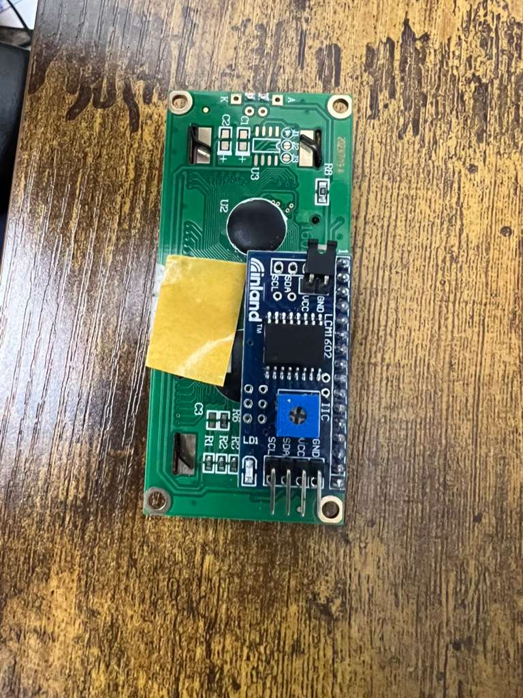
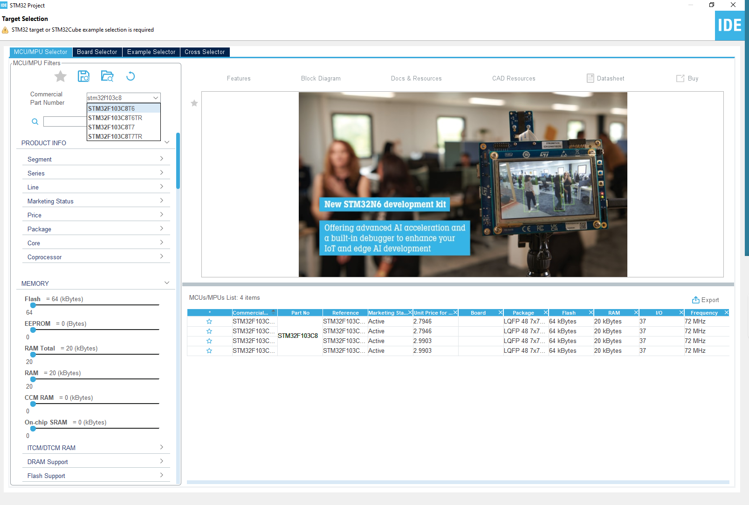

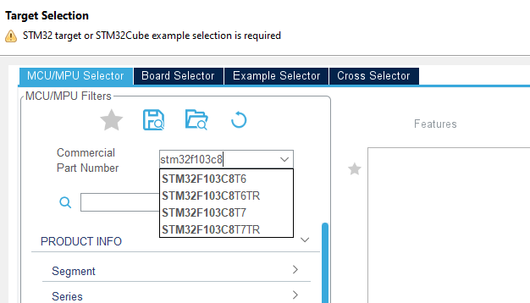
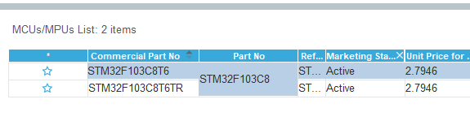

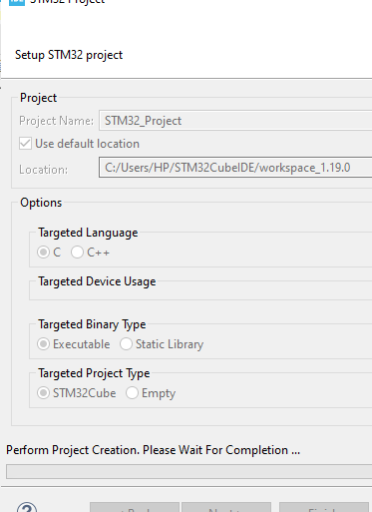

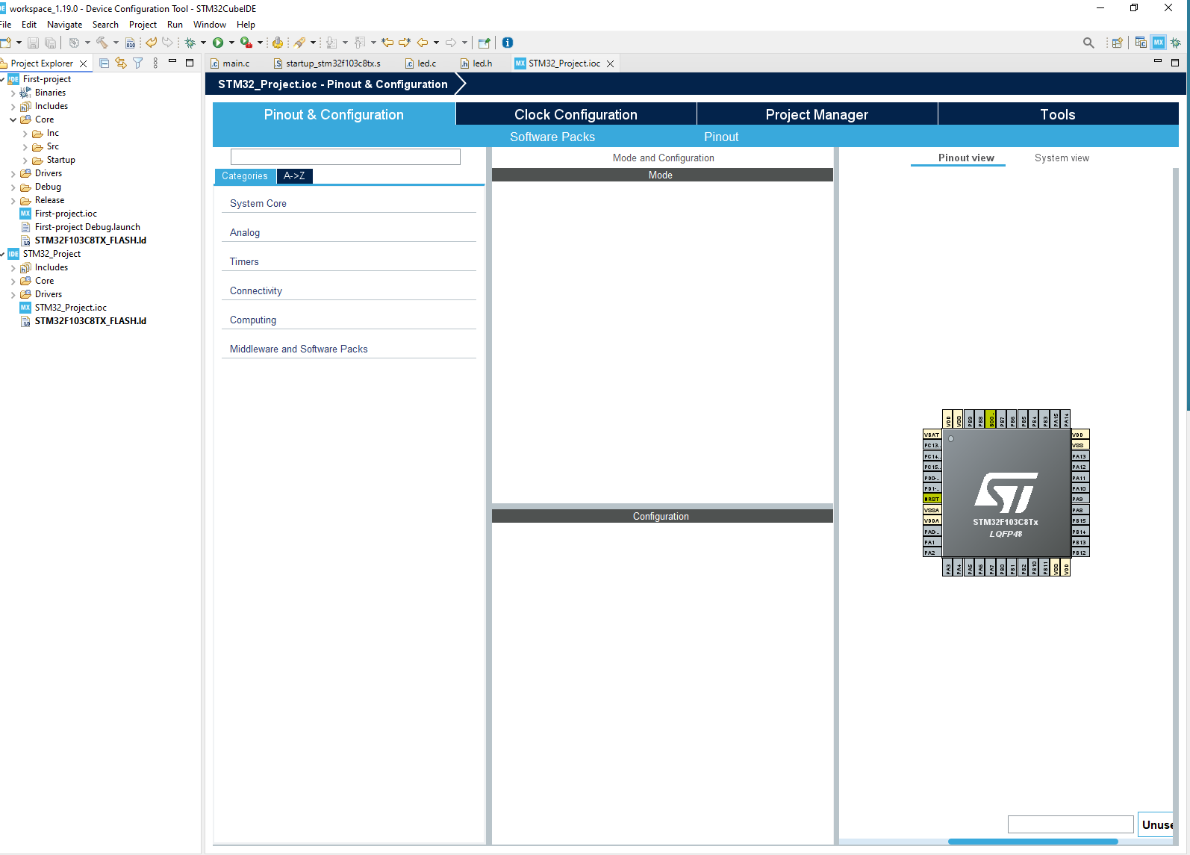

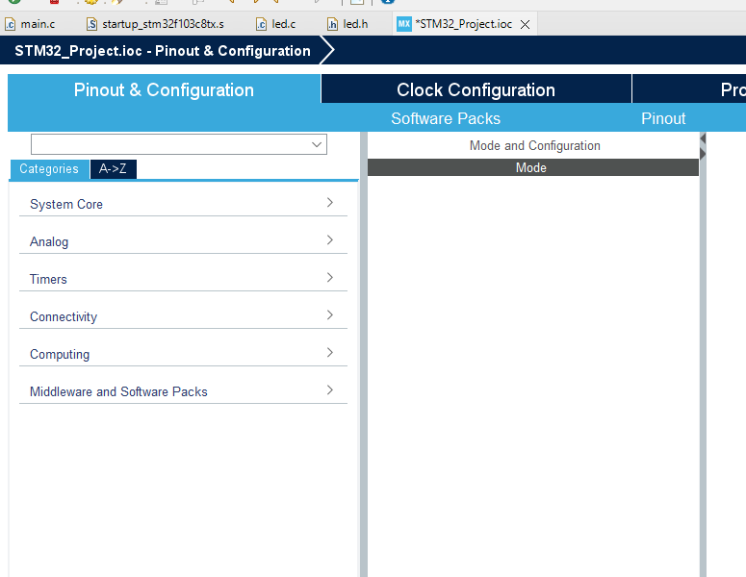
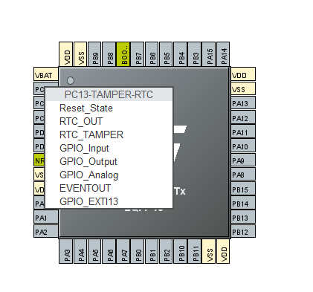

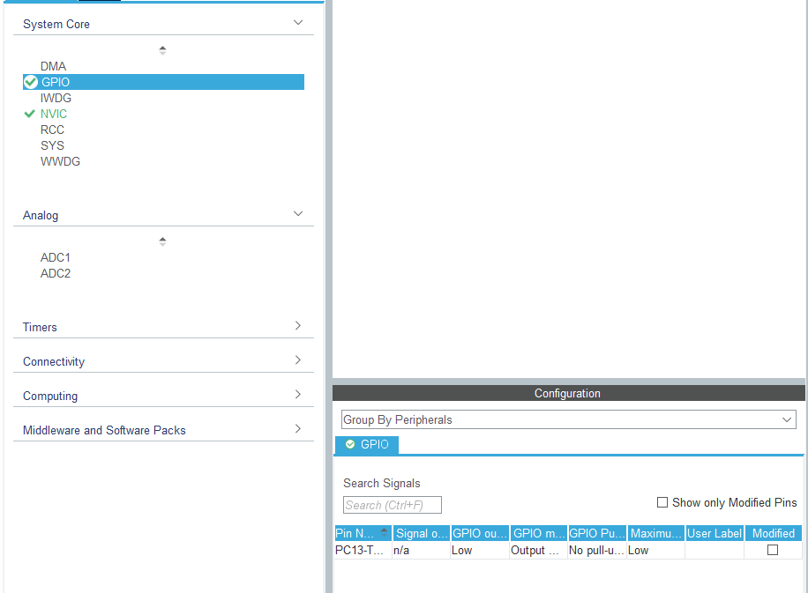







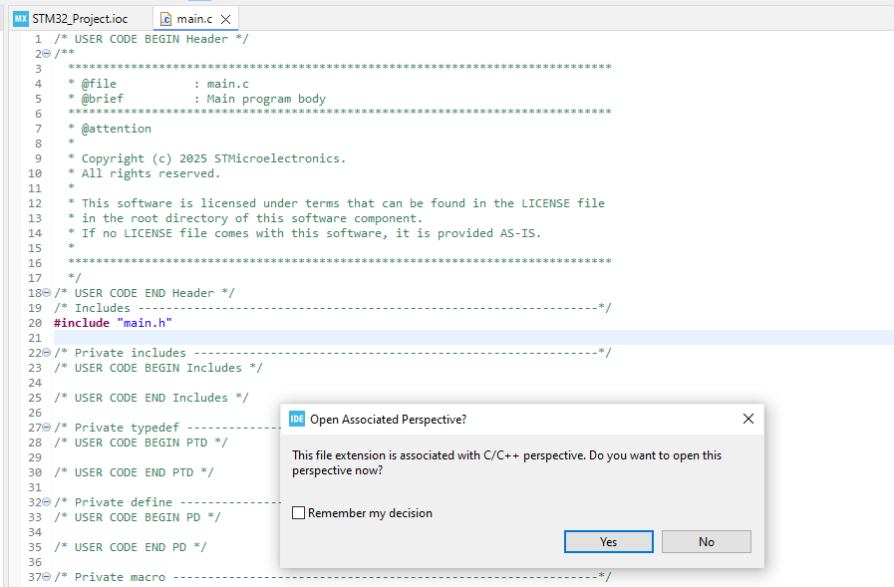



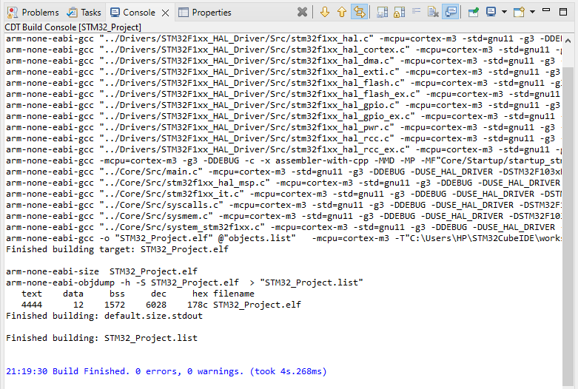
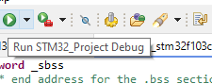


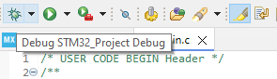
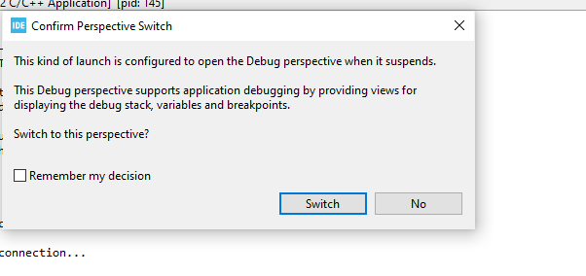

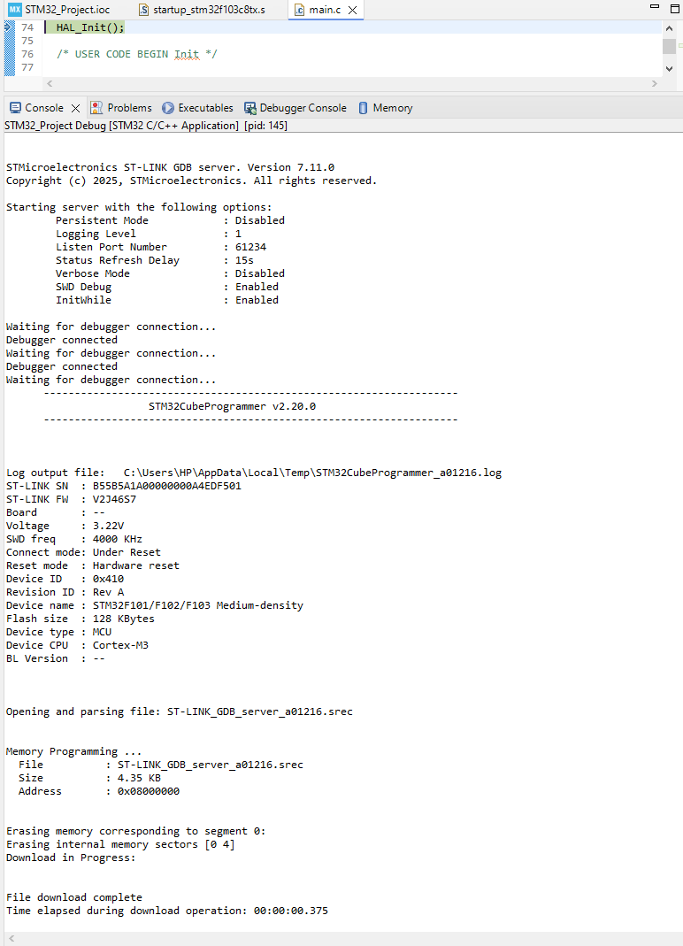



LED Blinking:
******************LED.h*************
#ifndef LED_H
#define LED_H
#include "main.h"
void LED_Init(void);
void LED_Blink(void);
#endif
***************************LED.c**************
#include "led.h"
void LED_Init(void)
{
GPIO_InitTypeDef GPIO_InitStruct = {0};
__HAL_RCC_GPIOC_CLK_ENABLE(); // Enable GPIOC clock
// PC13 LED OFF initially (active-low)
HAL_GPIO_WritePin(GPIOC, GPIO_PIN_13, GPIO_PIN_SET);
GPIO_InitStruct.Pin = GPIO_PIN_13;
GPIO_InitStruct.Mode = GPIO_MODE_OUTPUT_PP;
GPIO_InitStruct.Pull = GPIO_NOPULL;
GPIO_InitStruct.Speed = GPIO_SPEED_FREQ_LOW;
HAL_GPIO_Init(GPIOC, &GPIO_InitStruct);
}

void LED_Blink(void)
{
HAL_GPIO_TogglePin(GPIOC, GPIO_PIN_13);
HAL_Delay(2000);
}

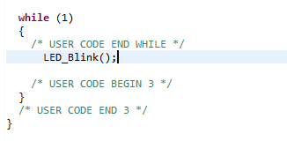

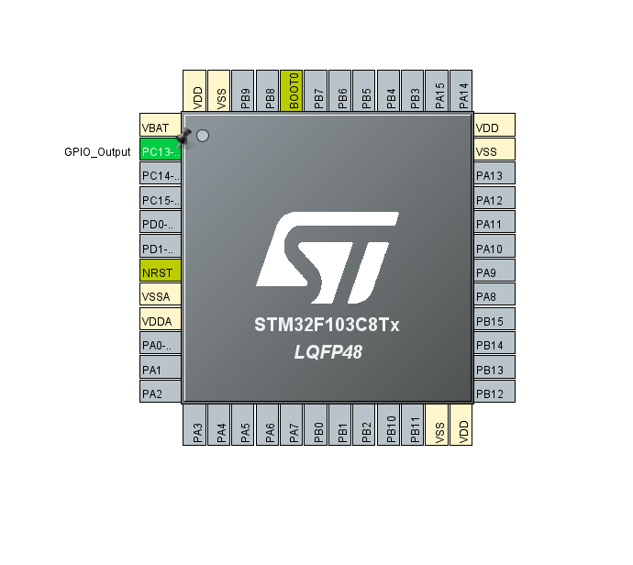

Status on I2C, with LED Blink:
