**Creating instances and installing nginx and apply to ALB**

* Creating 3 instances and installing nginx in 3 servers

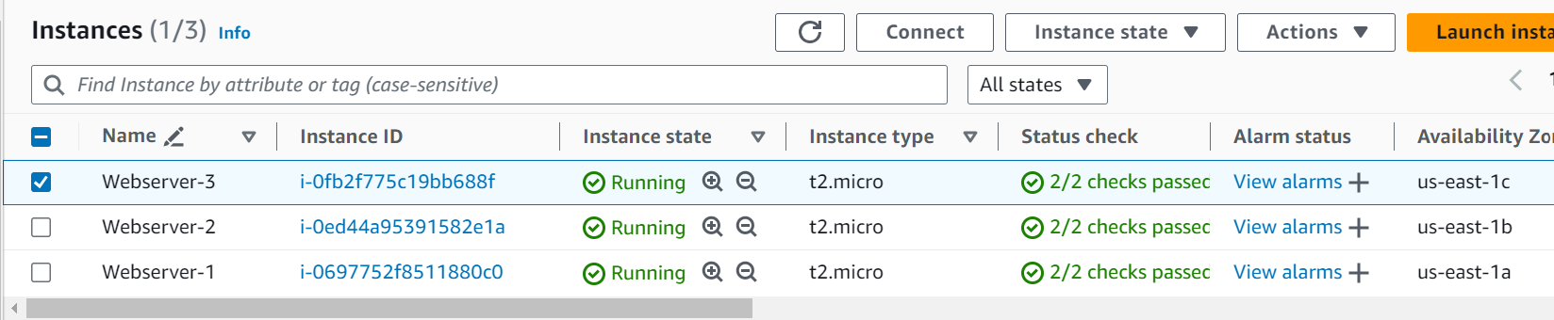

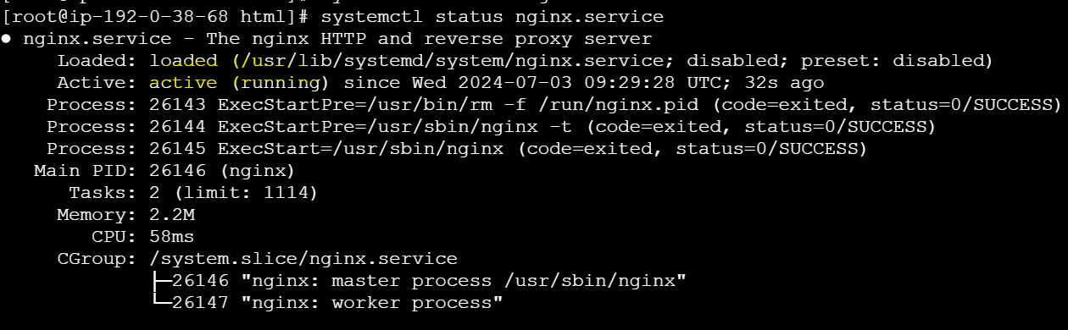

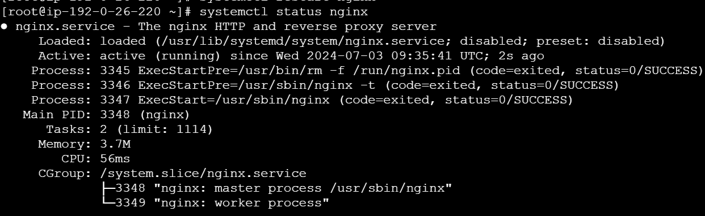

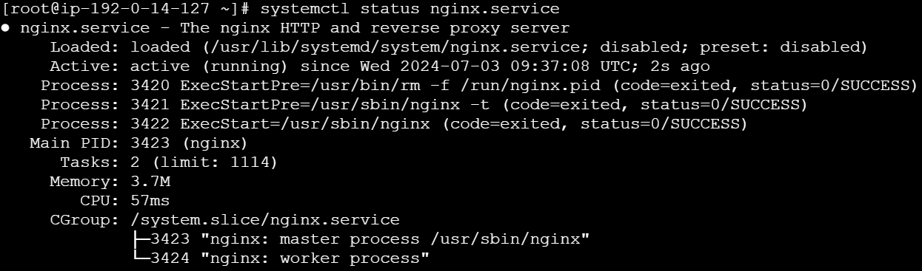

* Creating target Group.

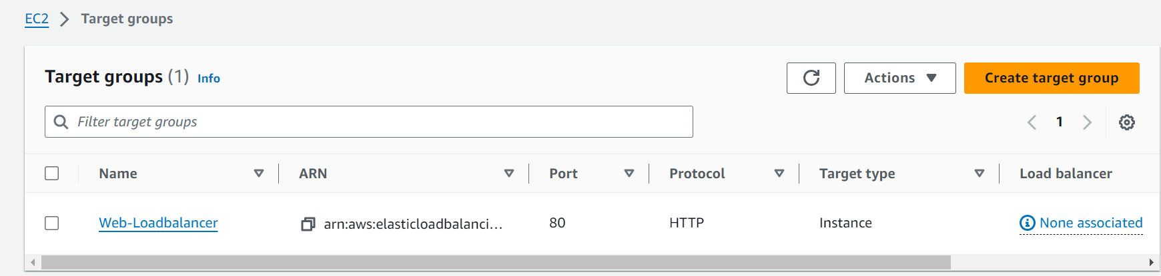

* Creating Load balancer and adding target group to Load balancer.

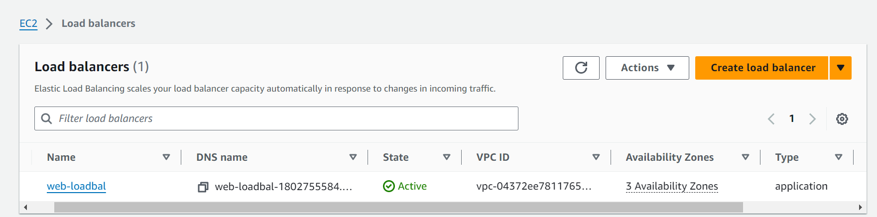

Testing Loadbalancer with DNS: web-loadbal-1802755584.us-east-1.elb.amazonaws.com

