**Creation and attaching EBS Volume to EC2**

* Creating EC2 Instances

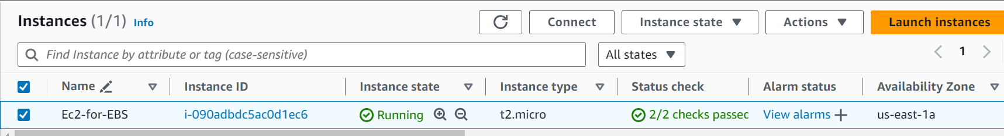

* EC2 server launched and checking volume using df -h

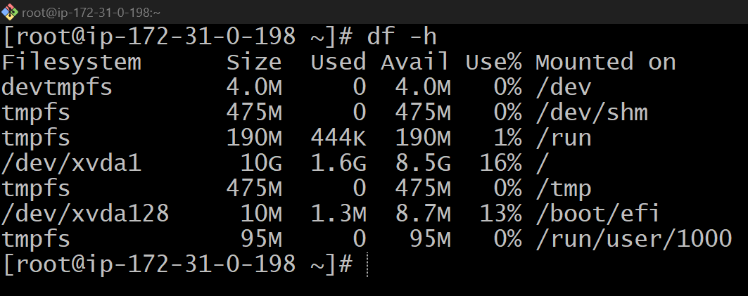

* Creating EBS Volume of 20GB and attaching to the server.

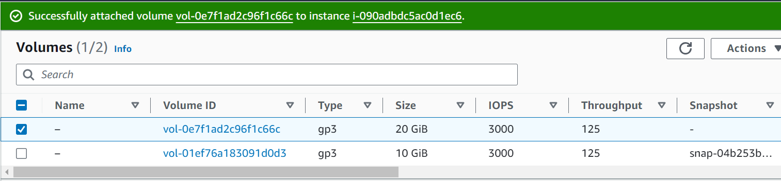

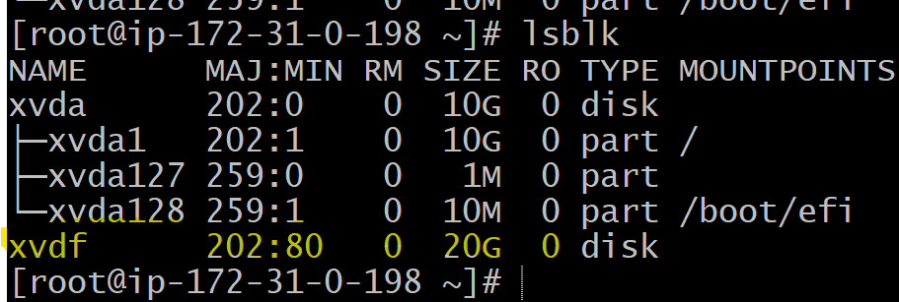

* EBS Volume of 20GB attached to /rajesh/ebsstorage

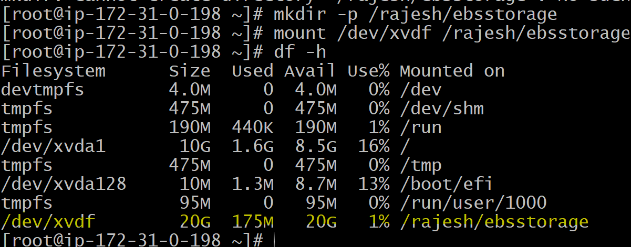

* One EBS Volume cannot be attached to multiple instances, but multiple EBS can attached to one EC2.

**Creating EFS and Adding EFS to 2 EC2 Instances**

* Creating EFS

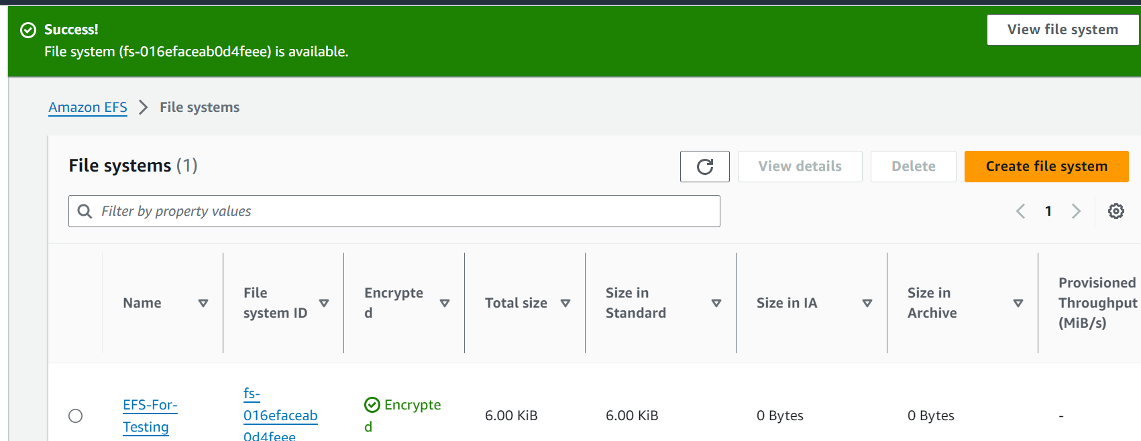

* Creating 2 ec2 instances and adding efs filesystem to the instances that are in different availability zones

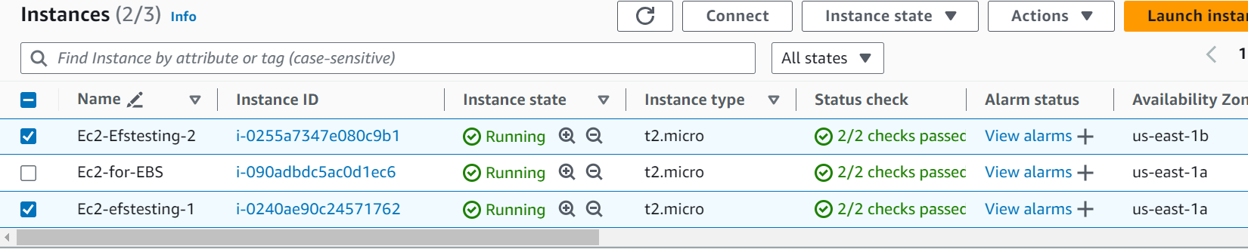

* Testing of EFS by creating 2 different files in 2 servers under cd /mnt/efs/fs1

Server-1

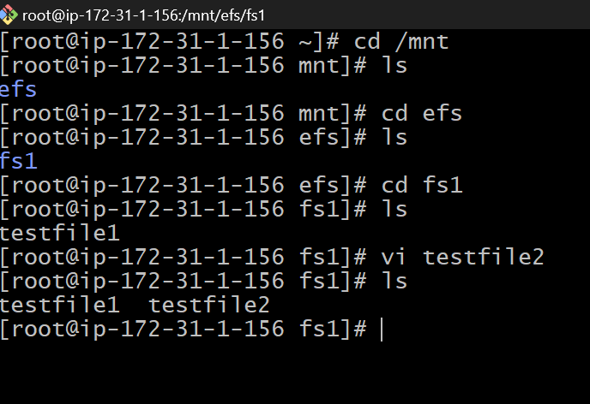

Server-2

