**ECW Suppressing Claim**

**Customer Name: ECW** SOP # WL-STR-06292021-001

**Version:** 1.0 Prepared by: Rakesh

**Date:** 29th Jun 2021 Approved by: Director – Sharath

**FLOW CHART FOR PROCESS AUTOMATION**

**Customer Name: XIFIN** SOP # WL-XFN-08032020-001

**Version:** 1.0 Prepared By: Sr. Business Analyst (0014)

**Date:** 03th Aug 2020 Approved By: Director – Revenue Cycle (0010)

**Updating ECW Claim Suppressing record**

**ECW**

**Project: ECW**

The Objective of this document is to list down details of ECW Updating claim Suppressing record project on the following Topics.

* Confidentiality & Compliance Policy.
* Scope of work
* Training Manual

**FLOW CHART FOR AUTOMATION PROCESS - V1.0**

|  |  |
| --- | --- |
| **Author** | Rakesh S |
| **Sponsor** | Sharath Shankar – Director – RCM |
| **Sign-Off Authority** |  |
| **Sign-off Date** |  |

|  |  |  |  |  |  |
| --- | --- | --- | --- | --- | --- |
| **Version** | **Effective Date** | **Change Description** | **Pages** | **Author** | **Approved By** |
| **V 1.0** | **06/29/2021** | **First Release** | **12** | **Rakesh S** | **Sharath Shankar** |
|  |  |  |  |  |  |
|  |  |  |  |  |  |
|  |  |  |  |  |  |
|  |  |  |  |  |  |

**Confidentiality & Compliance Policy**

All patient information is confidential and should not be discussed outside of the office.

Remember that we cannot mail out any information without having the patient’s signature or the signature of the Power of Attorney, or guardian on a release form.

**Compliance Policy:**

**To ensure that all patient information remains confidential, employees are required to comply with the following guidelines:**

* Employees shall not discuss any patient in an external or internal environment (such as an elevator or cafeteria) where unauthorized individuals could hear such information.
* If asked about a patient by anyone other than an employee, other healthcare provider directly involved in the care or treatment of the patient, or billing for services rendered to that patient, immediate family members, or the patient’s legal guardian, an employee will not disclose information unless first obtaining the written consent of the patient or the patient’s legal guardian or other person authorized by law to grant such consent.
* An employee may not have access to the computerized or hardcopy records of any patient unless they are involved in the care and treatment of that patient, or billing for services rendered to the patient, or a legal reason exists requiring them to have access to those documents or computerized records.
* All documents containing identified patient information, such as name, social security number, address, etc., must be disposed of in a secure fashion. All computerized systems containing identifiable patient information must have a security system requiring a password. Access must be granted to only those employees where access to the information is necessary to perform their jobs.
* All employees with access to patient information shall be required to sign a Patient Confidentiality Statement at time of employment. If an employee suspects that another employee has breached this Policy, the concerns must be reported to the appropriate person.
* **ECW Suppressing claim:**  Project is to remove Errors from software and submit claim to insurance and to this we need to follow the below steps.
* **Step 1:** Proceed with **HVD URL**: [https://strivant.dincloud.com](https://strivant.dincloud.com/) post entering to mentioned URL it will take us to Below image and need to update desired username/password.

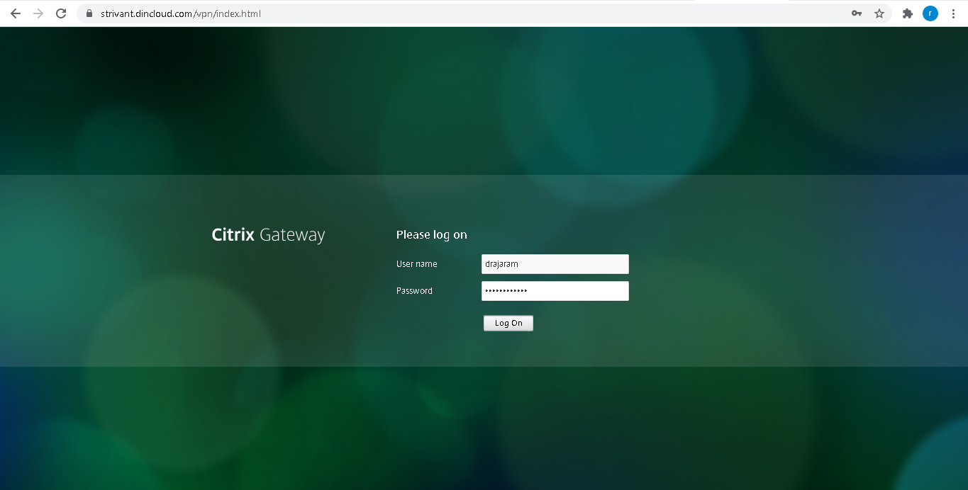

* **Step 2:** Following image is the main page post login. Click on Strivant Health desktop Icon

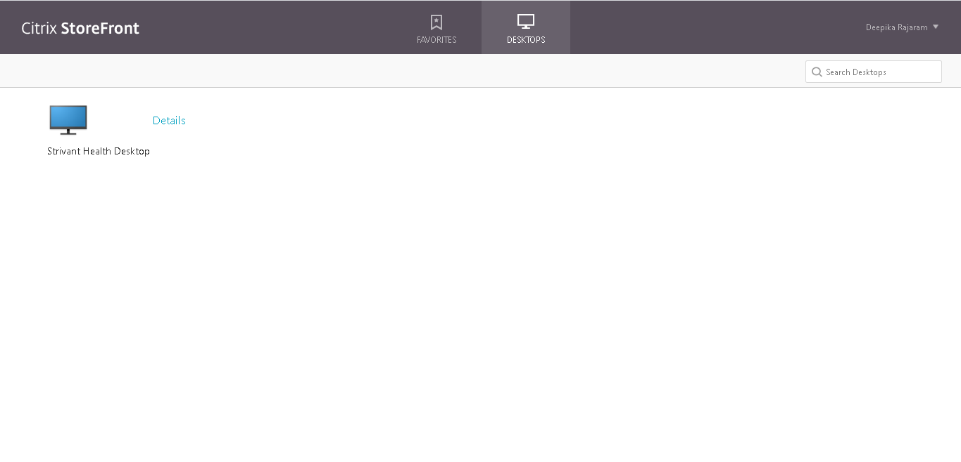

* **Step 3:** Post selection of Strivant it will take us to client desk top as shown in below image.

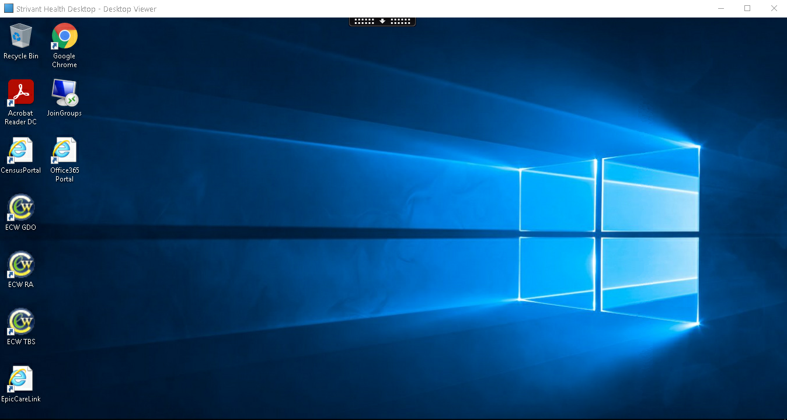

* **Step 4:** Once we enter to client desk top need to open Chrome Browser and enter mentioned URL: [https://nyretoapp.ecwcloud.com/mobiledoc/jsp/webemr/index.jsp#/mobiledoc/jsp/webemr/jellybean/officevisit/officeVisits.jsp](https://nyretoapp.ecwcloud.com/mobiledoc/jsp/webemr/index.jsp" \l "/mobiledoc/jsp/webemr/jellybean/officevisit/officeVisits.jsp)

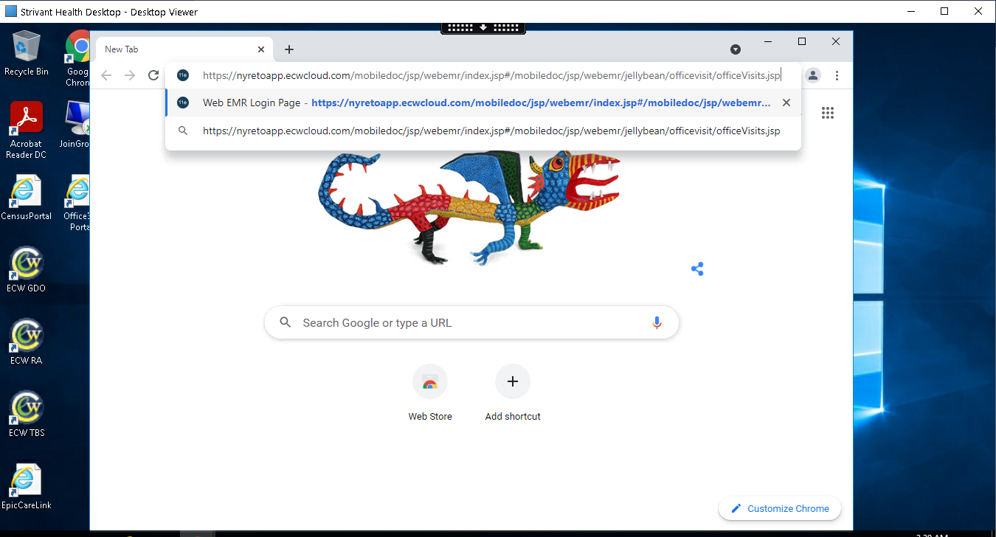

* **Step 5:** When we enter URL, this will take us to main login page, were we need to enter desired user name password as shown in below image.

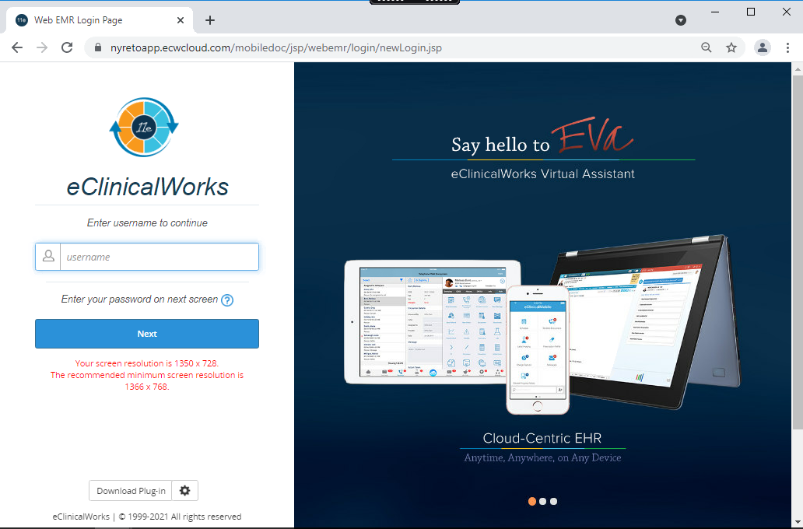

* **Step 6:** After entering username password when we enter on login, we get 2 pop of errors that need to Exit out of that error occur.

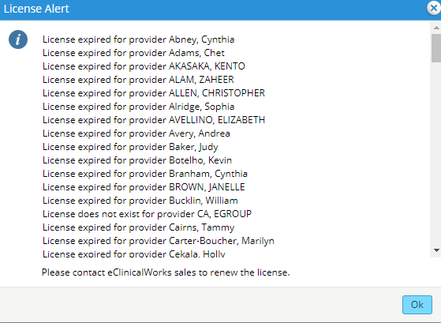

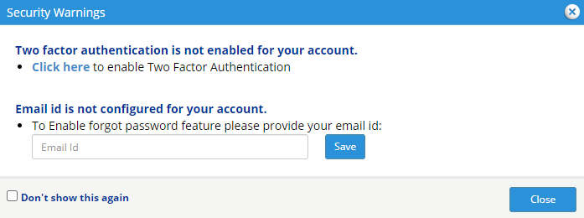

* **Step 7:** Once we close error Pop ups, now we can see main page and need to Hit the button on the top left with blue background and 3 white lines and then select the side tab BILLING

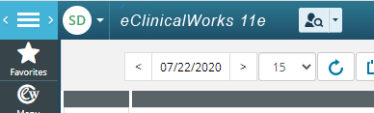



* **Step 8:** When we click on billing you will get new pop up under that we need to click on claims as mention in below image.

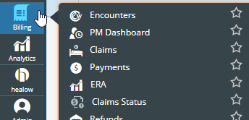

* **Step 9:** Post clicking on claims button this will take us to main page, where in we need to enter Claim number which we are correcting and this claim number will be in spreadsheet. Below are 2 images.

**Image – 1:** Spreadsheet and claim number.

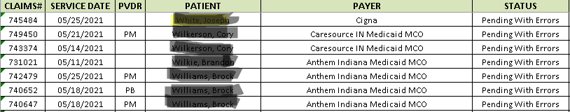

**Image 2:** Claim No Box where we need to enter claim#.

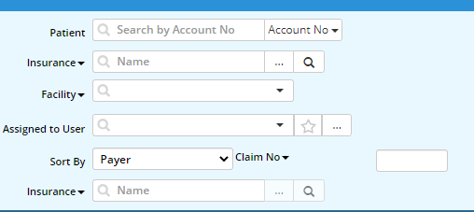

* **Step 10:** Post pasting claim# in box when we click on enter it will take us to patient page where we can able to see Errors for the following below errors on the claim.
* **Step 10.1:** Below are the following errors on the claim, whenever we open each claim and if one of these examples is the **ONLY Errors** on the claim which we need to work.

**Image 1**

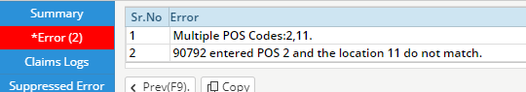

**Image 2**

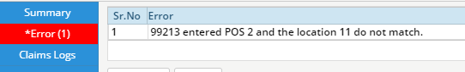

**Image 3**

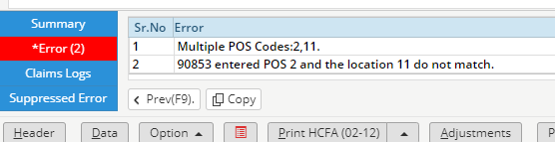

**Image 4**

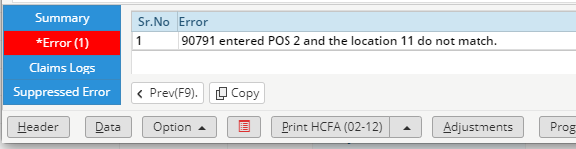

**Image 5**

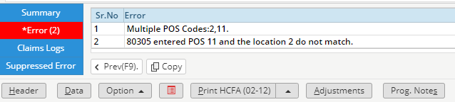

* **Step 11:** When we find above mentioned errors. please suppress them by selecting each error so that it highlights blue and then hit the Suppress button each time to suppress the error. The errors will then be removed.

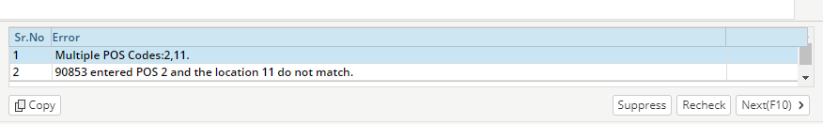

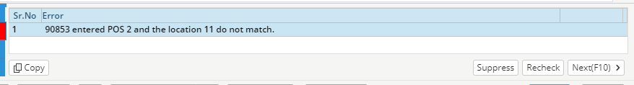

* **Step 11. 1:** When we Suppress below image, we can see empty in Error box.

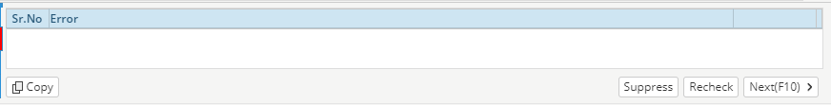

* **Step 12:** Once all the errors are cleared, we need to change claim status to ‘Ready to Submit (Electronic)’ under claim status tab as show in below image.

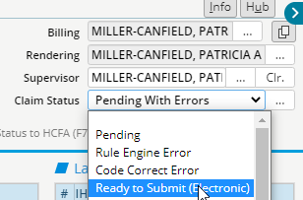

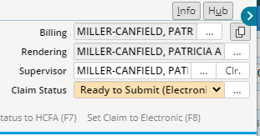

* **Step 13:** Hit Okay at the bottom of the claim and then the action will be completed



* **Step 14:** Updating spreadsheet.

1. If the action was completed and you were able to suppress the above errors and put the claim to ready to submit, **write COMPLETED**.
2. If the action could not be completed because there were other errors on the claim in addition to the above errors, **write REVIEW**