**VELAMMAL COLLEGE OF ENGINEERING AND TECHNOLOGY, MADURAI.**

**AUTONOMOUS**

**DEPARTMENT OF COMPUTER SCIENCE AND ENGINEERING**

**21CS209- INTERNET PROGRAMMING**

**ASSIGNMENT-I ON CSS**

**Due date: 19-2-2023 Marks:20**

1. **Write a CSS rule that makes all text 3 times larger than the base font of the system and colors the text green.**

**Code:**

<html>

<head>

<title> basefont </title>

<style>

p{

color:green;

font-size:300%;

}

</style>

</head>

<body>

<center>

<h1>Paragraph color is green and 3 times bigger.</h1>

</center>

<P>CSS rule that makes all text 3 times larger than the base font of the system and

colors the text green.</P>

</body>

</html>

**Output:**

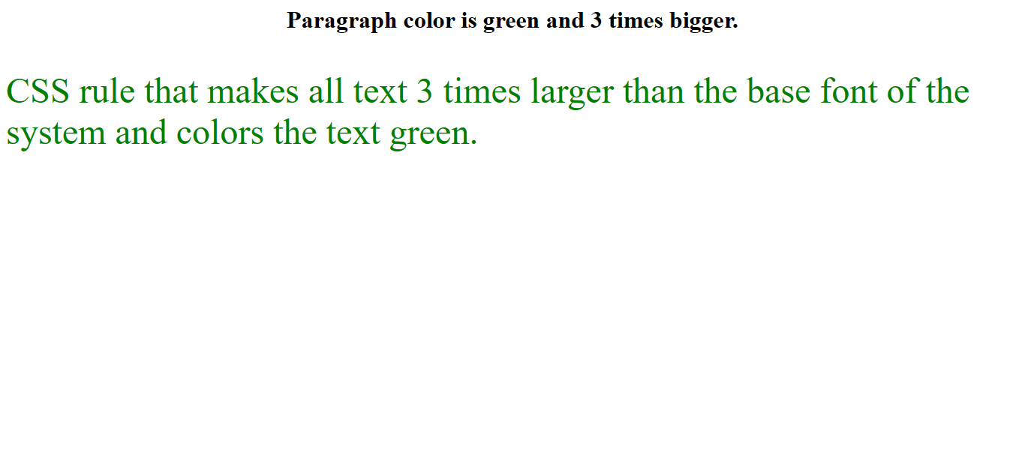

1. **Write a CSS rule that places a background image at the bottom right of the page with no repeat option. The image should remain in place when the user scrolls up or down.**

**Code:**

<html>

<head>

<title> Images </title>

<style>

body

{

background-image: url("one.jpeg");

background-repeat: no-repeat;

background-attachment: fixed;

background-position: right bottom;

}

</style>

</head>

<body>

<h1>Image At Right Bottom</h1>

</body>

</html>

**Output:**

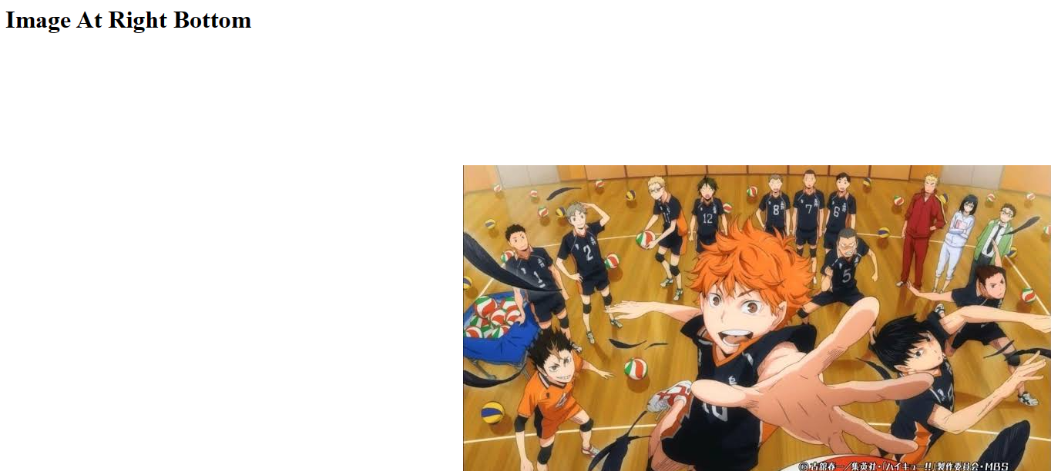

1. **Write a CSS rule that gives all h2 and h3 elements a padding of 0.7 ems, a solid border style and a margin of 0.7 ems**

**Code:**

<html>

<head>

<style>

h2,h3

{

padding:0.7em;

margin: 0.7em;

border: 1px solid black;

}

</style>

<head>

<body>

<h1> Heading 1</h1>

<h2> Heading 2 with the CSS Rule</h2>

<h3> Heading 3 with the CSS Rule</h3>

<p>CSS rule that gives all h2 and h3 elements a padding of 0.7 ems, a solid border

style and a margin of 0.7 ems</p>

</body>

</html>

**Output:**

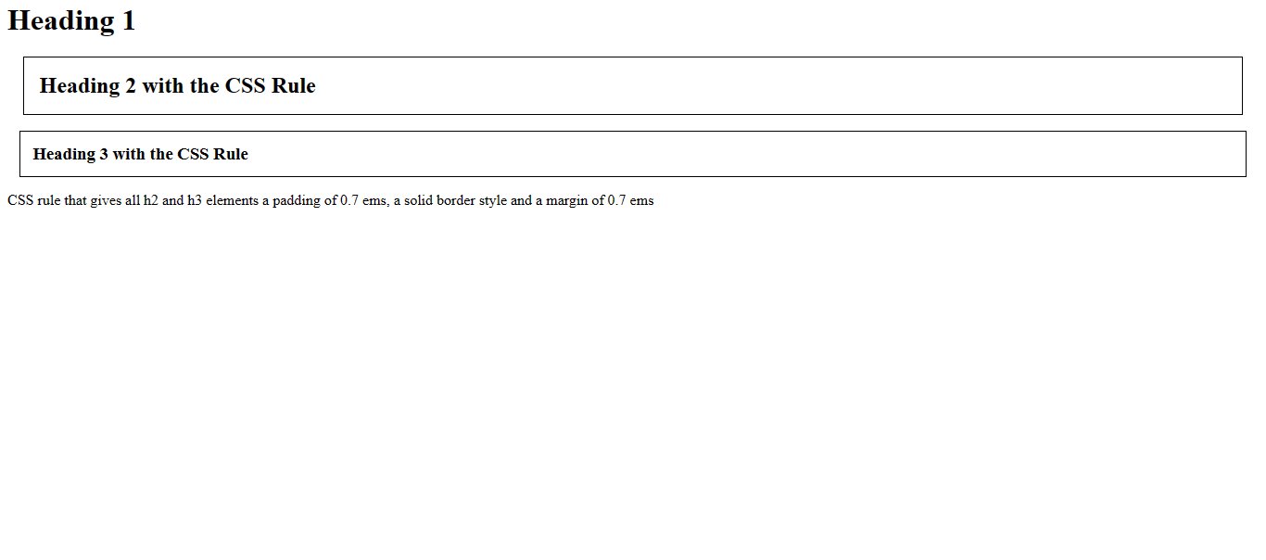

1. **Write a CSS rule that changes the color of all elements containing attribute class = "red-Move" to red and shifts**

**Code:**

<html>

<head>

<style>

.redMove

{

color:red;

}

</style>

</head>

<body>

<h1 class="redMove"> Changes the color of all elements containing attribute class = "redMove"</h1>

<p class="redMove">This is a paragraph</p>

<p>this is without RedMove class</p>

</body>

</html>

**Output:**

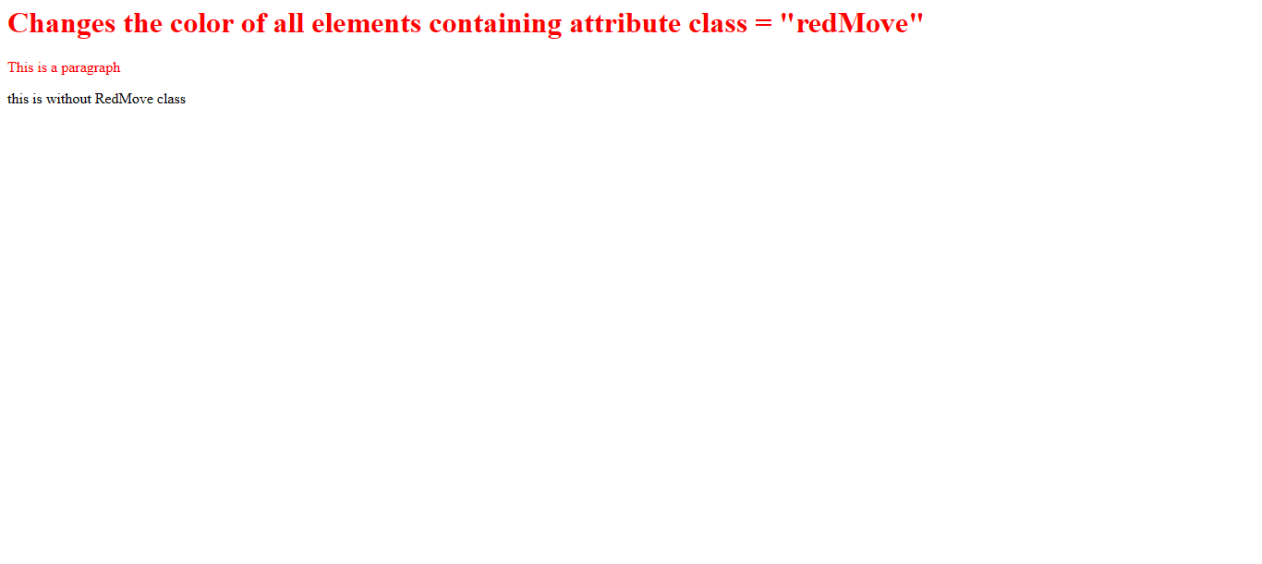

1. **Create a Circular shape with pure CSS**

**Code:**

<html>

<head>

<style>

.circle

{

background: rgb(228, 114, 228);

border-radius: 50%;

width: 200px;

height: 200px;

}

</style>

<head>

<body>

<h1>CIRCLE</h1>

<div class="circle"></div>

</body>

</html>

**Output:**

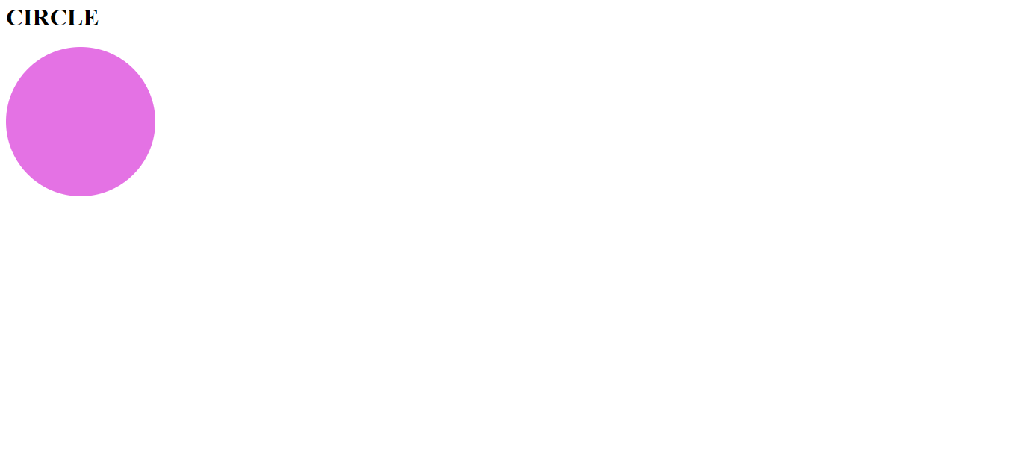

1. **Using CSS , Change the styling of selection i.e when one sentence is selected, the selection should be in yellow color and text color should be black , when the next sentence is selected , selection should be in blue color and the text color should be white**

**Code:**

<html>

<head>

<style>

.para::-moz-selection

{

color:black;

background-color:yellow;

}

.para::selection

{

color:black;

background-color:yellow;

}

.para1::-moz-selection

{

color:white;

background-color:blue;

}

.para1::selection

{

color:white;

background-color:blue;

}

</style>

</head>

<body>

<p class="para">This is a first sentence</p>

<p class="para1">This is second sentence</p>

</body>

</html>

**Output:**

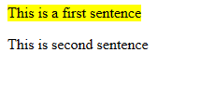

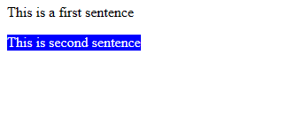

1. **Create a zoom-in zoom -out animation using CSS**

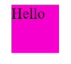

**Code:**

<html>

<head>

<style>

.zoom-in-out-box

{

margin: 24px;

width: 100px;

height: 100px;

background: #f500cc;

animation: zoom-in-zoom-out 1s ease innite;

}

@keyframes zoom-in-zoom-out

{

0%

{

transform: scale(1px, 1px);

}

50%

{

transform: scale(10px, 10px);

}

100%

{

transform: scale(1px, 1px);

}

}

</style>

<title> CSS zoom in zoom out animation</title>

</head>

<body>

<div class="zoom-in-out-box">HELLO</div>

</body>

</html>

**Output:**

