1. Create a web page with a button and a heading, and add the following functionality:  
   • When the button is clicked, change the text of the heading to say "Hello,   
   World!".  
   • When the button is clicked again, change the text of the heading back to its   
   original text.

OUTPUT:

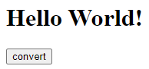

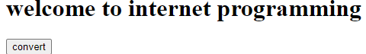

2. Write a JQuery script to count the number of vowels in a string. Get the string input   
through a textbox.

