# NSECA GPU VM Setup Guide

Generated on: 2025-07-10 04:29:10

This document provides step-by-step instructions to set up the full NSECA GPU environment on any new virtual machine.

## 1. Clone Your GitHub Repository

Run the following command to clone the setup repository:

git clone https://github.com/RajeshGit001/nseca-gpu-setup.git

## 2. Run the Setup Script

Navigate into the cloned folder and run the shell script:

cd nseca-gpu-setup  
bash setup_nseca_env.sh

This will:

- Install Python 3.10 and necessary system packages  
- Create and activate the virtual environment  
- Download requirements file from GitHub  
- Install all dependencies via pip  
- Confirm if GPU is correctly detected by Paddle

## 3. Confirm PaddleOCR Installation with GPU

You can run the following test script to confirm that PaddleOCR is working with your GPU.

### test_paddleocr_gpu.py

from paddleocr import PaddleOCR  
  
ocr = PaddleOCR(use_angle_cls=True, lang='en', use_gpu=True)  
result = ocr.ocr('Table.png', cls=True)  
for line in result[0]:  
 print(f"{line[1][0]} (score: {line[1][1]:.2f})")

Ensure the image file `Table.png` is present in the same folder or provide the full path.

## 4. Screenshot for Testing Reference

This is the reference table used to verify OCR output:

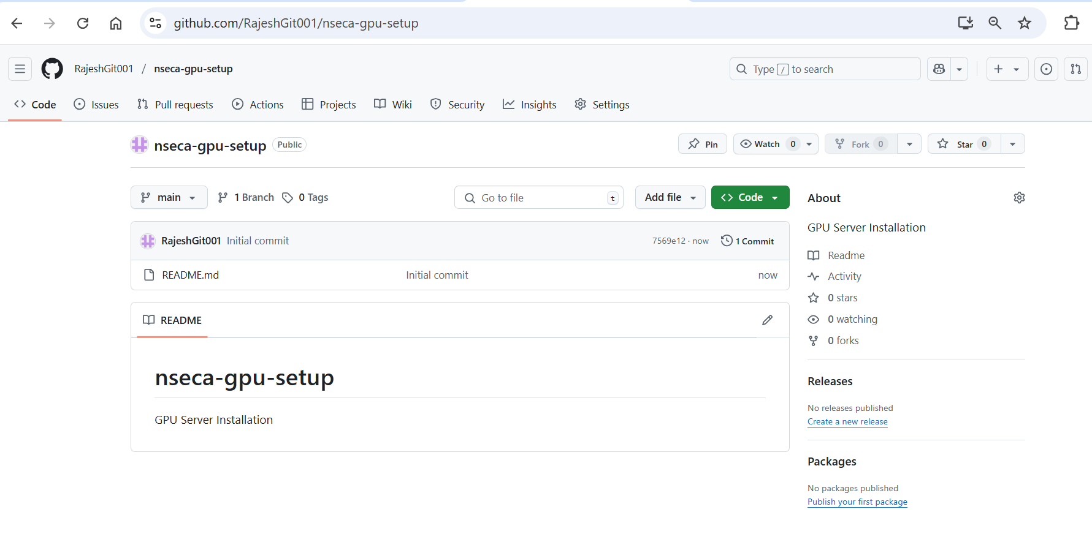

## 5. Reuse Instructions

You can reuse this entire setup anytime by just cloning the GitHub repo and running the script again.