Lab 1(session 1):
Assignment Folder: - Webservices-assignments\Assgn1
OBJECTIVE: - To understand
- following concepts in web services
  - Message Part
  - Operation
  - Port Type
  - Binding
  - Port
Steps:-
Present a paper which will describe Message Part, Operation, Port Type, Binding, Port concepts and their relations with each other

Lab 2(session 2):
Assignment Folder: - Webservices-assignments\Assgn2
OBJECTIVE: - To understand the WSDL file
Steps:-
Study the SimpleService.wsdl file created during demo session. Make sure that you understood the WSDL thoroughly.

Lab 3(session 3):
Assignment Folder: - Webservices-assignments\Assgn3
OBJECTIVE: - To understand
- How to deploy an Axis2 Webservice in Tomcat
- The process of Deployment
Steps:-
  - Using a Top down approach generate the required artifacts from SimpleService.wsdl
  - Deploy the web service SimpleService created in the demo session on Tomcat.
  - Write a web application which will take the two strings to be concatenated through UI, and invoke a concatenation service provided by the SimpleService
  - Display the concatenated string on UI.
Lab 4(session 4):
Assignment Folder: - Webservices-assignments\Assgn4
OBJECTIVE: - To understand
- AXIOM API
- Pros and Cons of the AXIOM API
Steps:-
  - After studying the Client implemented using AXIOM API and a normal client; What are the advantages and disadvantages of each of one with respect to other?
Note: - The whole Eclipse project will be provided to the candidate.

Lab 5(session 5):
Assignment Folder: - Webservices-assignments\Assgn5
OBJECTIVE: - To understand
- Wrapped web services
Steps:-
  - Using a Top down approach generate the required artifacts.
  - Deploy the web service WrappedService created in step 1 above on tomcat
  - Implement two web applications acting as the clients of the above step 2 service, where one will use the wrapped convention and the other one won’t use the wrapped convention
Note: - The WSDL file and Ant Build file will be provided to the candidates
to start with this assignment

Lab 6(session 6):
Assignment Folder: - Webservices-assignments\Assgn6
OBJECTIVE: - To understand
- How to design a web service which can handle the complex data
Steps:-

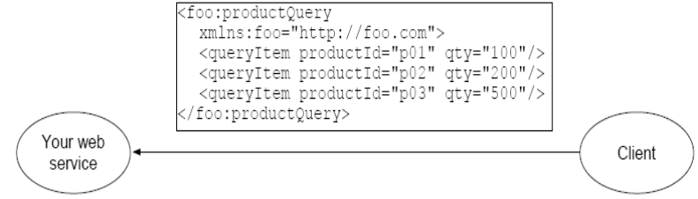
- Client is going to make a request as shown above
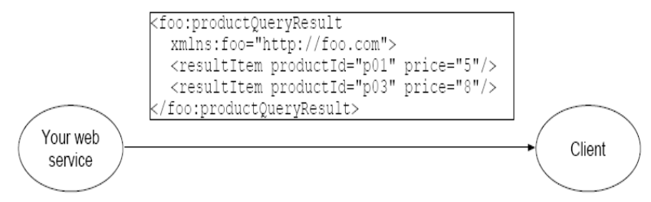
- A web service is going to send a response as shown above
- Implement a web service which will search the prices of the products from a Database and send a response as shown in point 2)
- If the product is not listed then a web service should send a fault to the client
- Develop a web application which will be used by the user as an interface for the web service. This web application should provide following functionality
  - A UI for entering The ProductId and Quantity of the product
  - A UI for the response from the Web service.
  - If there is a fault raised by the service then give appropriate message to the client.
Note: - The WSDL file and Ant Build file will be provided to the candidates to start with this assignment

Lab 7(session 7):
Assignment Folder: - Webservices-assignments\Assgn7
OBJECTIVE: - To understand
- MTOM mechanism in web services
Steps:-

- Given a wsdl and an Ant build file create an ImageUpload web service which will provide a service of uploading a product image to the server
- Expose this web service as a web application on Tomcat
- Assuming that above web service is deployed and running write a web application which will provide a UI to the user through which the user will enter the file to be uploaded to the server
Note: - The WSDL file and Ant Build file will be provided to the candidates to start with this assignment

