First, create a new Java project named SimpleService

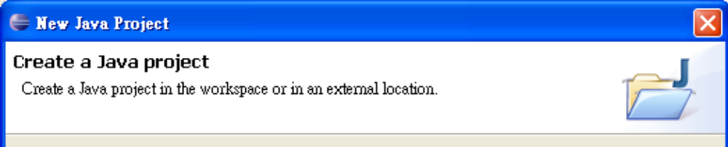

Make sure you use separate folders for sources and class files. Then go ahead
and complete the creation of the project. Next, right click the project and choose
"New | Other" and then "Web Services | WSDL":

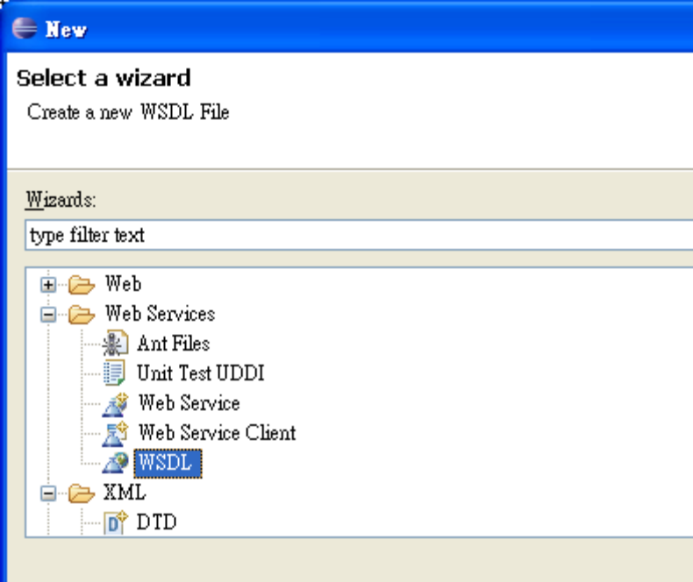

If you don't see this option, it means that you haven't installed the Java EE
version of Eclipse. If it is working, click "Next" and enter SimpleService.wsdl as
the filename:

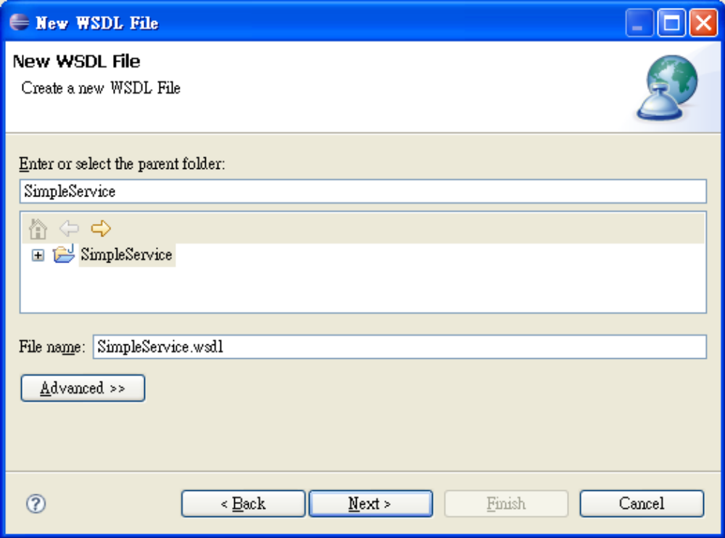

Click "Next". Then input as shown below:

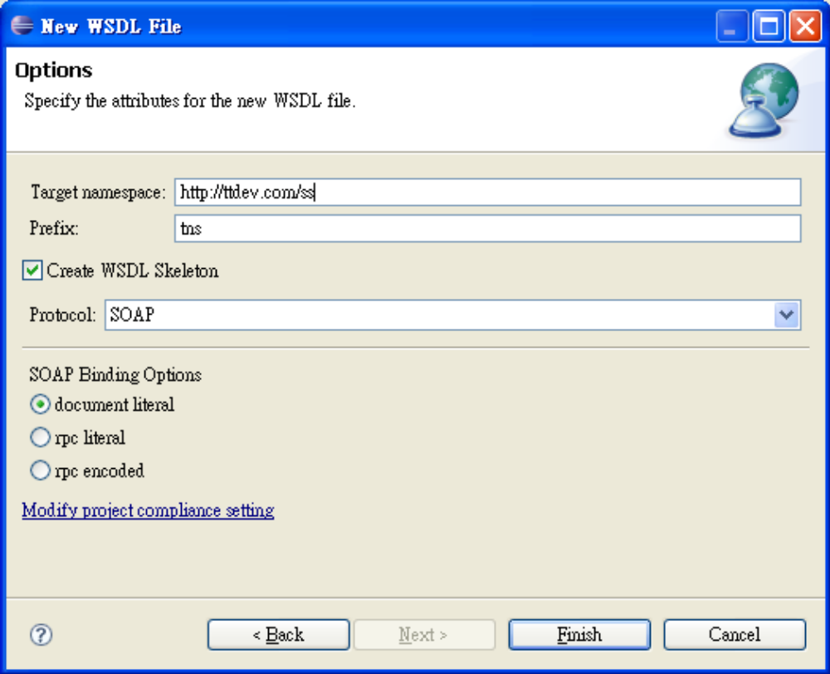

Click "Finish". Then you will see something like:

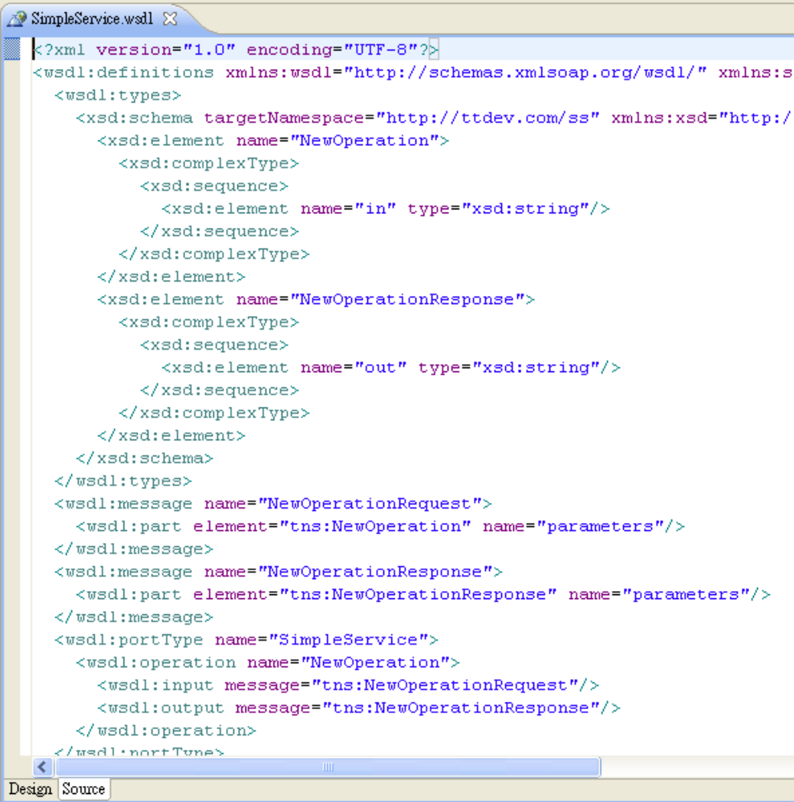

This is the WSDL code. To edit it visually, click the "Design" tab at the bottom of
the editor window. Then you'll see:

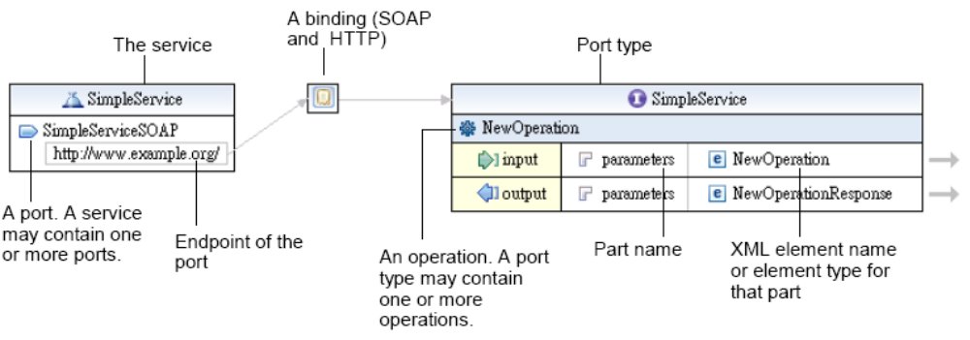

Double click on the endpoint to change it to http://localhost:8080/axis2/services/SimpleService
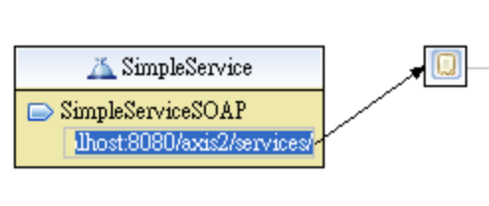

Double click on the name of operation and change it to "concat":

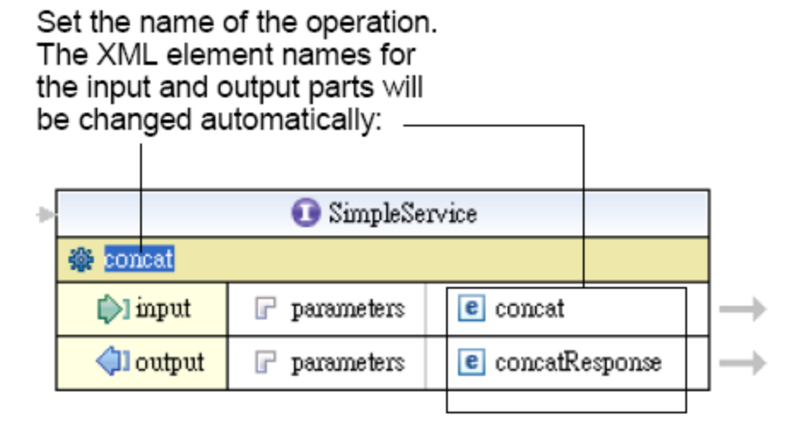
For the moment, the input part is an <concat> element. You'd like to change it
to <concatRequest>. But for now, put the cursor on the arrow to its right first.
The arrow will turn into blue color. Wait a couple of seconds then a preview
window will appear showing the definition of the <concat> element:

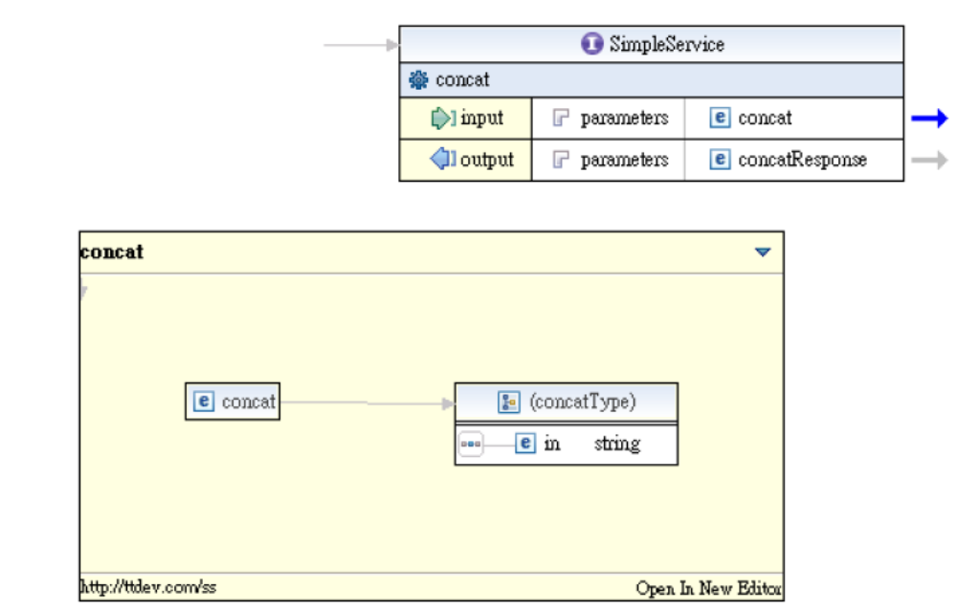

Clicking anywhere else will make that preview window disappear. To edit the
schema definition, click on the blue arrow. A new editor window will appear:

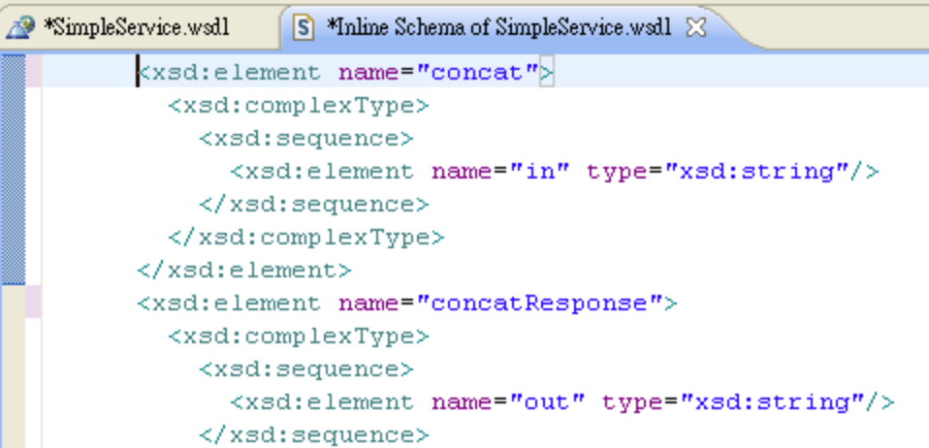

To edit it visually, click the "Design" tab at the bottom, you'll see:

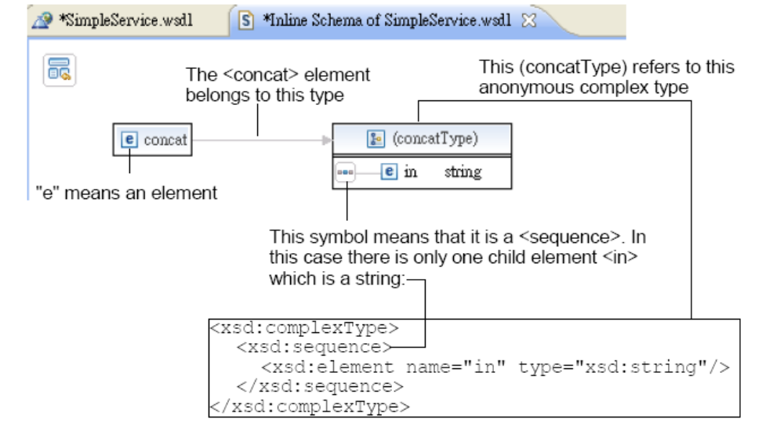

Double click on "in" and change it to "s1":

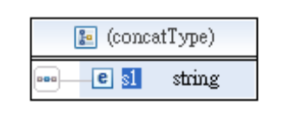

Right click it and choose "Add Element" and set the name to "s2":
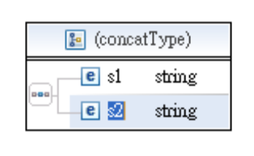
By default the type is already set to string. If you wanted it to be say an int
instead, you would double click on the type and it would become a combo box and then you could choose "int":
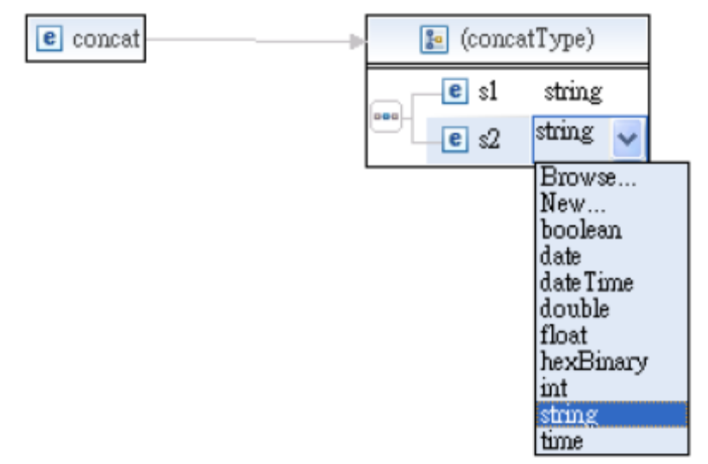

If you wanted s2 to appear before s1 in the sequence, you could drag it and
drop it before s1:

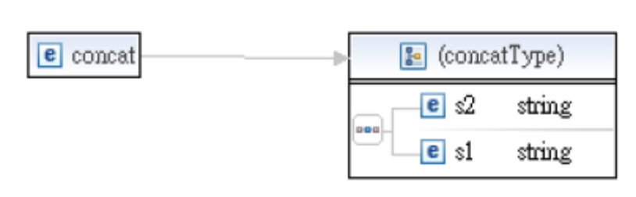

But for now, make sure it is s1 first and then s2. Next, right click on the
<concat> element and choose "Refactor | Rename", then change its name to
concatRequest:

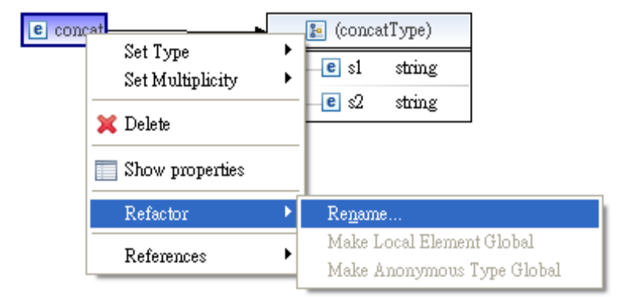

You're done with the <concatRequest> element. Now return to the WSDL editor
to work on the response message. For the moment, the <concatResponse> is
like:

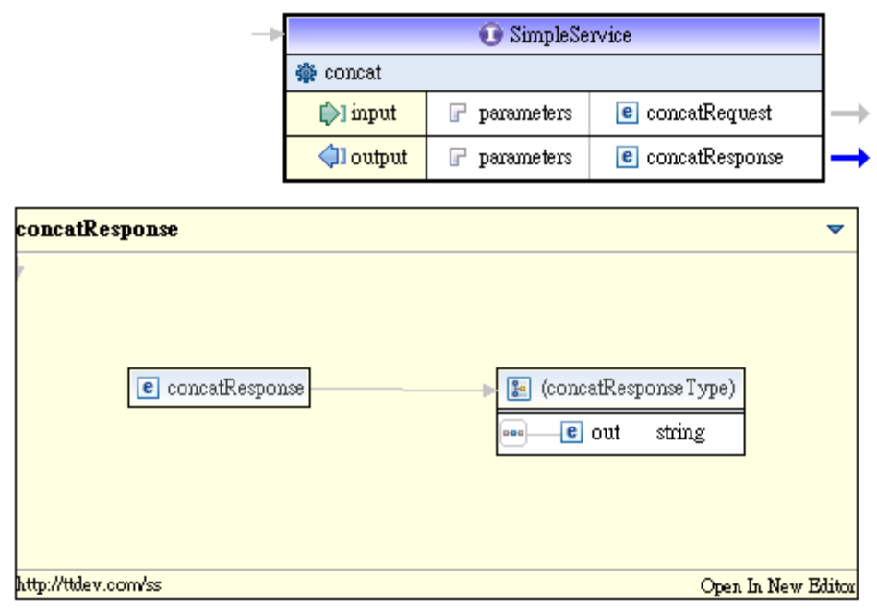

That is, it is an element that contains a sequence of <out> element:

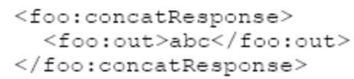

However, in your design, the response is simple type element, not a complex
type element:

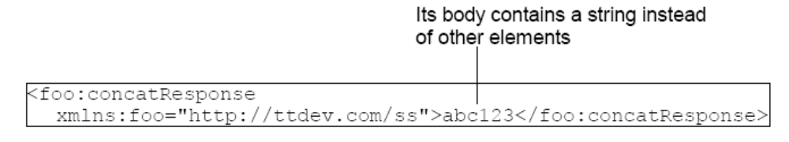

To do that, go into the schema editor to edit the <concatResponse> element:

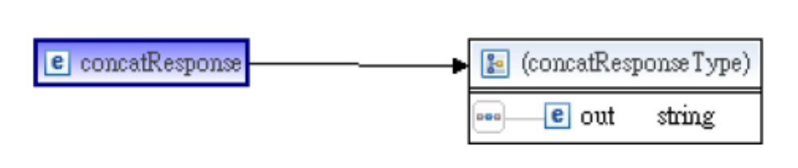

Right click it and choose "Set Type | Browse":

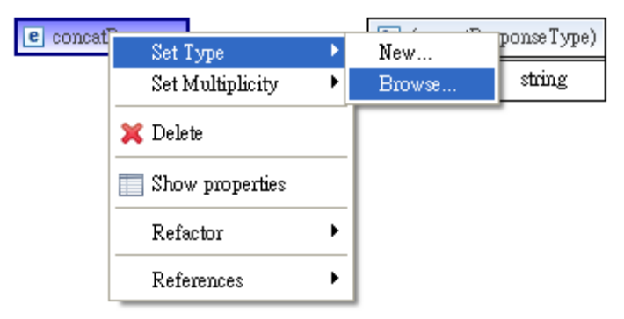

Choose "string":
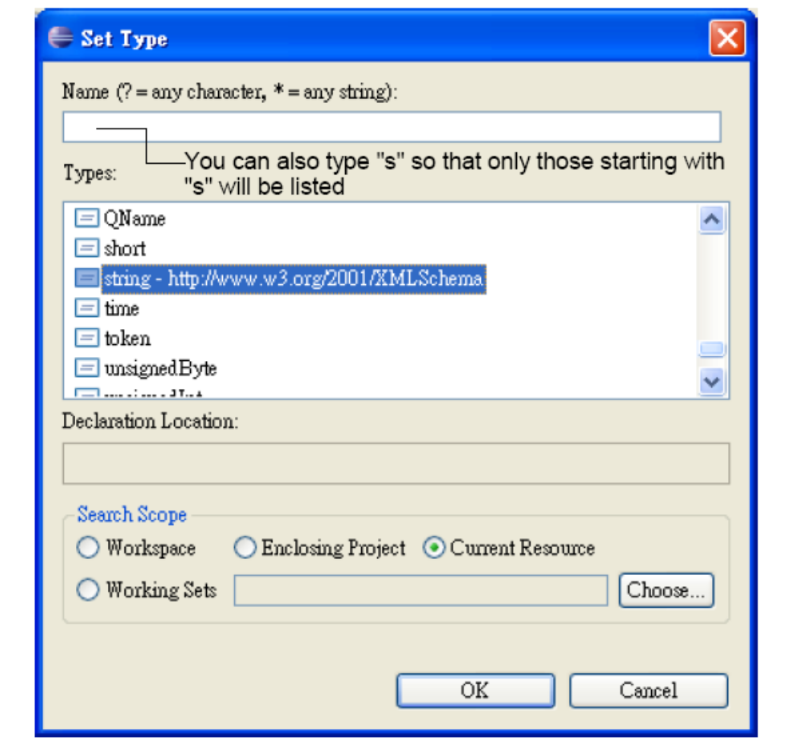

Then it will be like:



That's it. To review the whole schema, click on the icon at the upper left corner:

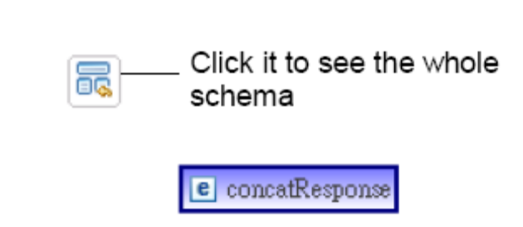

Then you'll see:

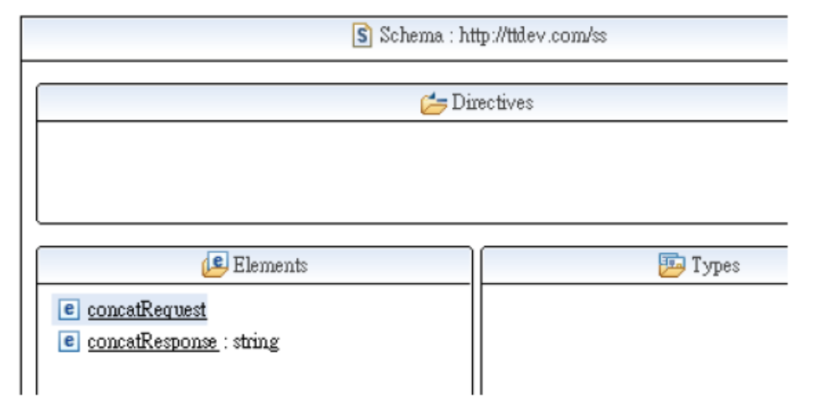

This looks fine. Now, save the file.

Generating a service stub

in Eclipse choose "File | New | Other" and choose
"Axis2 Code Generator" (see below). The default is to generate Java code from
WSDL. This is what you want:

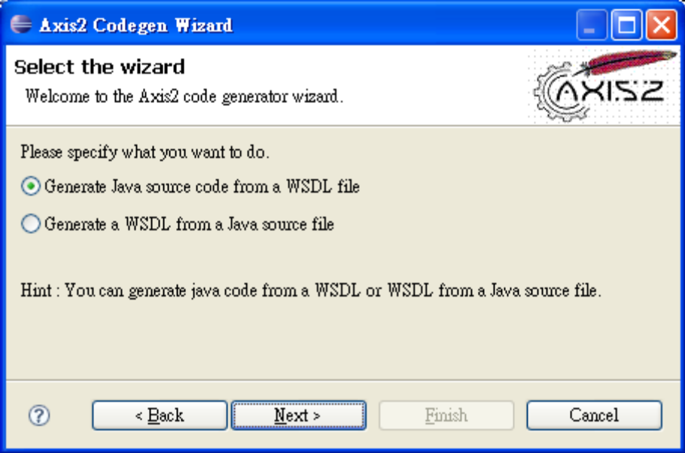

Click "Next" (see below). Click "Browse" to locate your SimpleService.wsdl file:

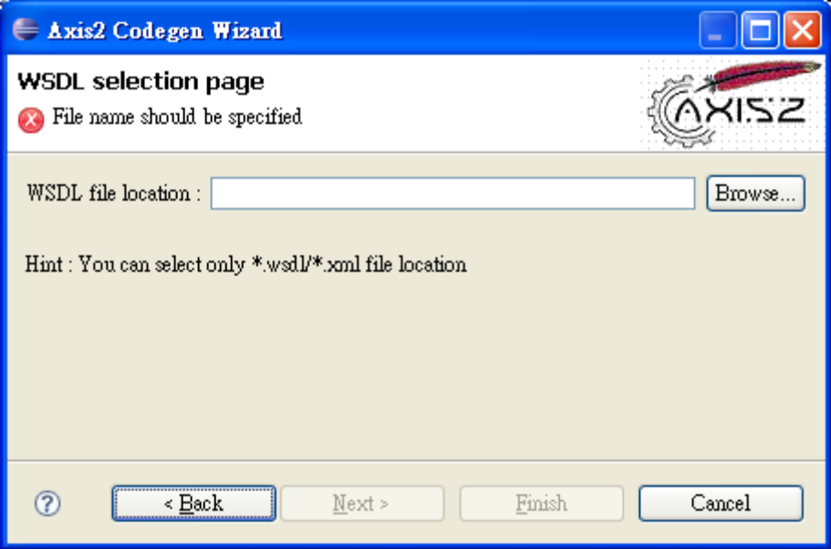

Click "Next" (see below). Set the options as shown below:
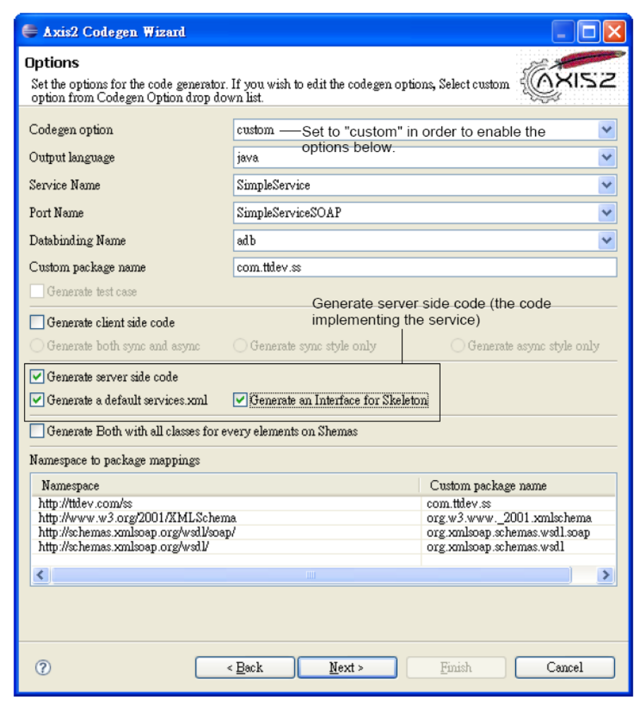

Note that by default how the namespaces will be mapped to Java packages.
For example, your SimpleService port type in http://ttdev.com/ss namespace will
be mapped to a SimpleService Java interface in the com.ttdev.ss Java
package

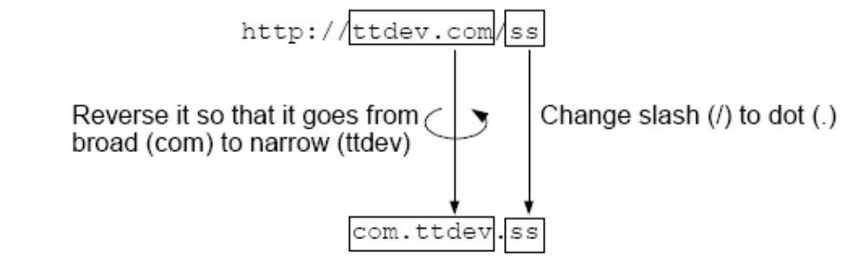

Of course this is just the default. You can change the Java package names in the dialog box above. But for our purpose the default mapping is just fine. So, click "Next" (see below) and enter the information as shown below:

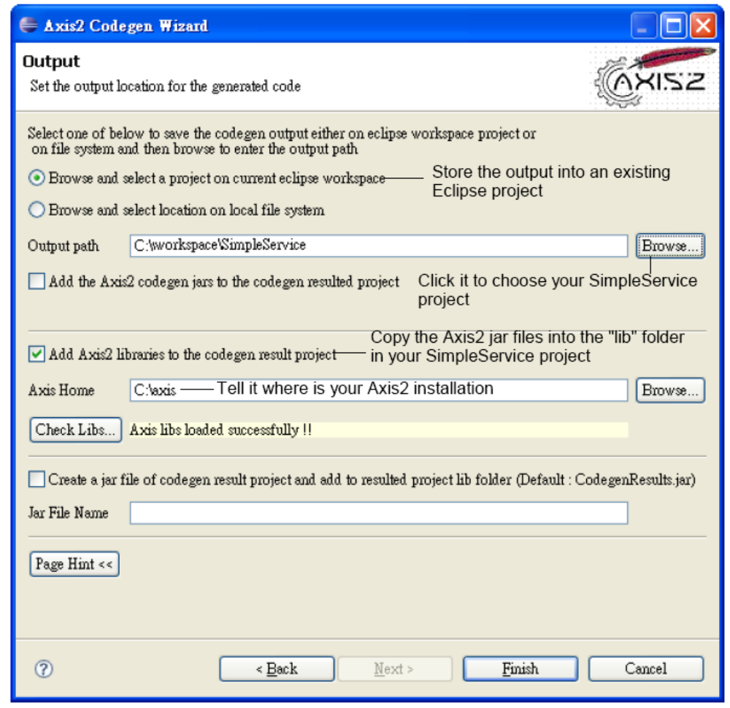

Click "Finish". Right click your project and choose "Refresh". Then you'll see
some files have been generated:

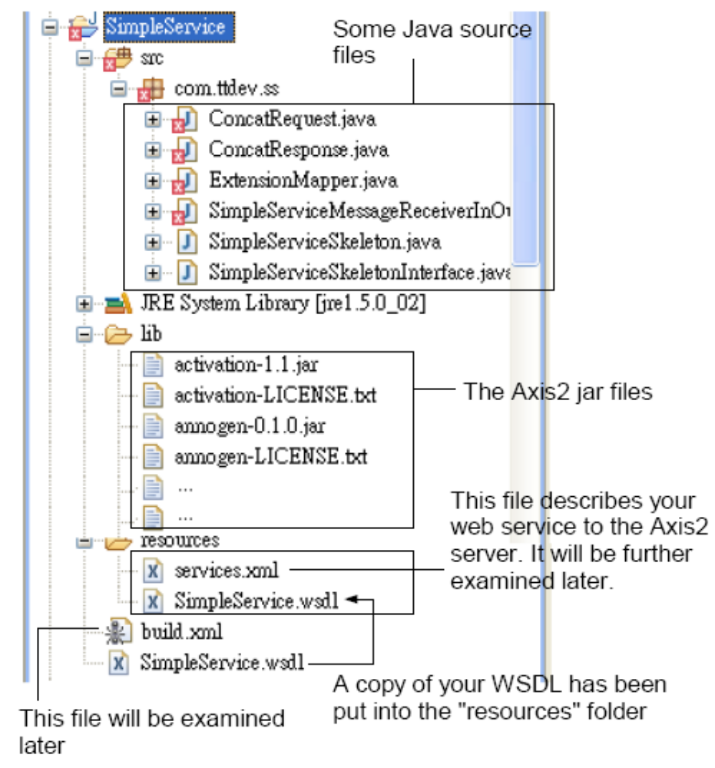

The Java source files are in errors because they are referring to the Axis2 jar
files but they are not on the build path. So, go to the build path dialog and click
"Add JARs":

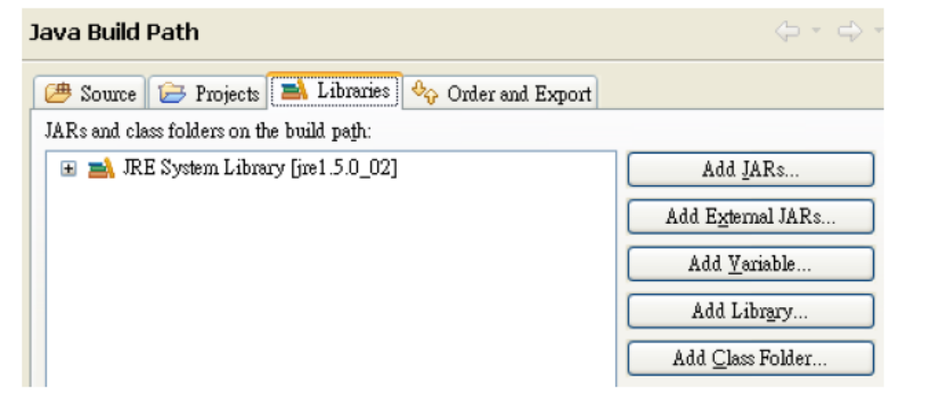

Choose all the jar files in the "lib" folder in your project:

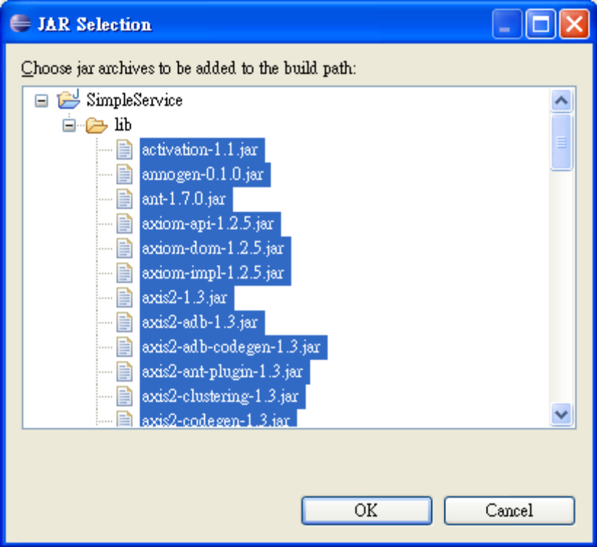

Then the errors will disappear.

Implementing the web service
To implement the web service, modify the SimpleServiceSkeleton.java which is
the service skeleton:

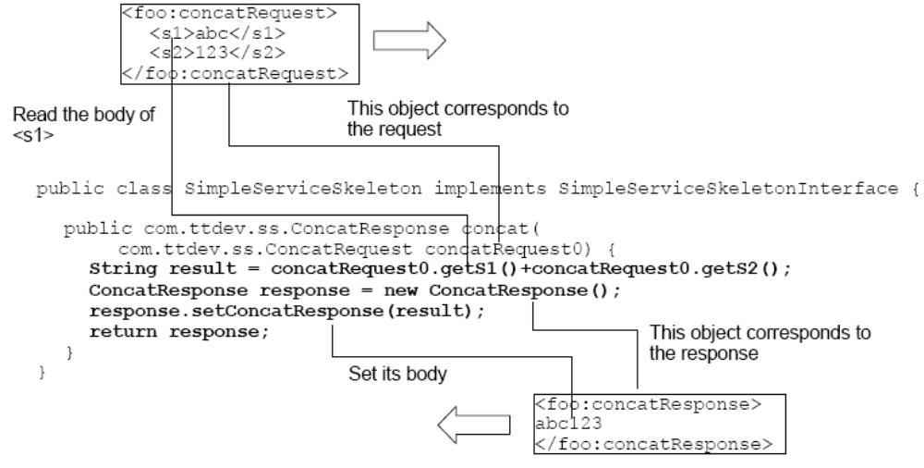

Deploying a web service

To deploy the web service with the Axis2 server, copy the files as shown below:

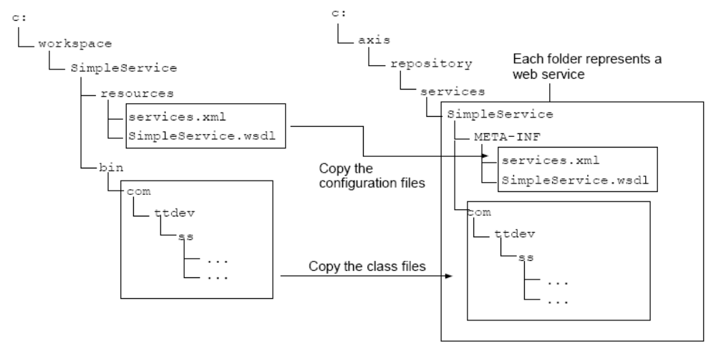
Now, start the Axis2 server by running c:\axis\bin\axis2server.bat. You should
see that it is picking up your SimpleService: (You might have to set JAVA_HOME pointing to appropriate location)

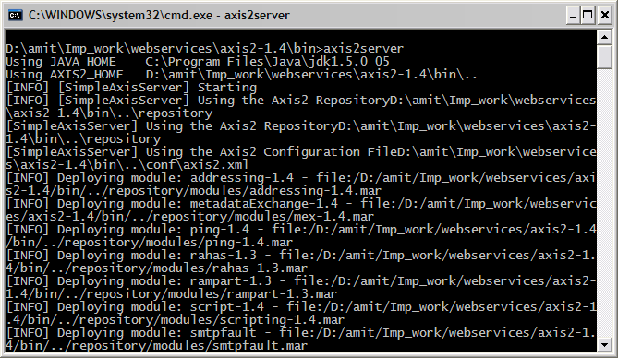

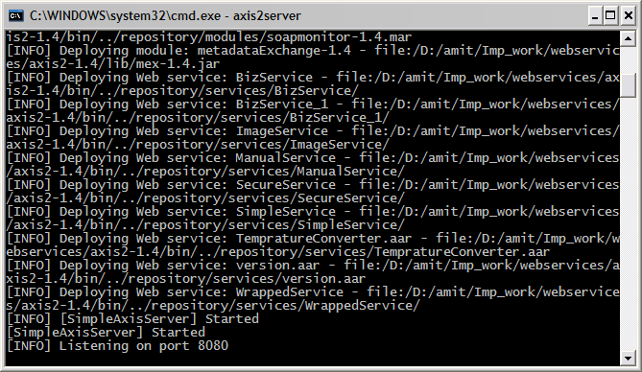

Go to http://localhost:8080/axis2/services and you should see your SimpleService listed:

To see its WSDL file, just click the "SimpleService" link:

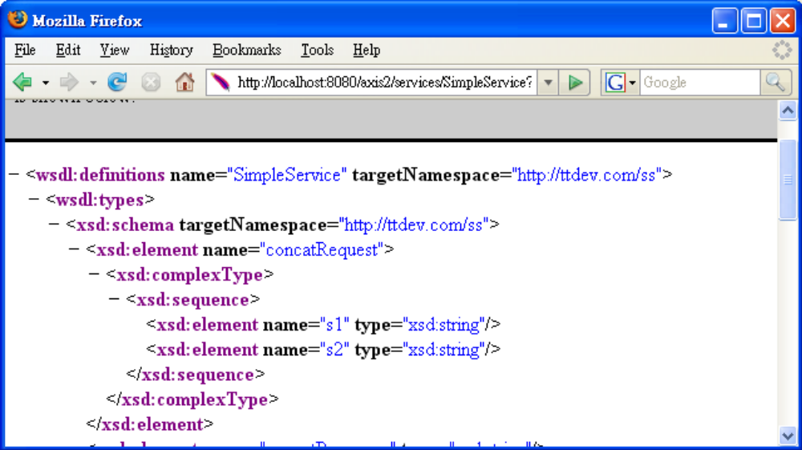

Creating a client using a client stub
To implement this idea, run the Axis2 Code Generator Wizard as before until
you see the follow screen. Then tell it to generate client side code instead of
server side code:

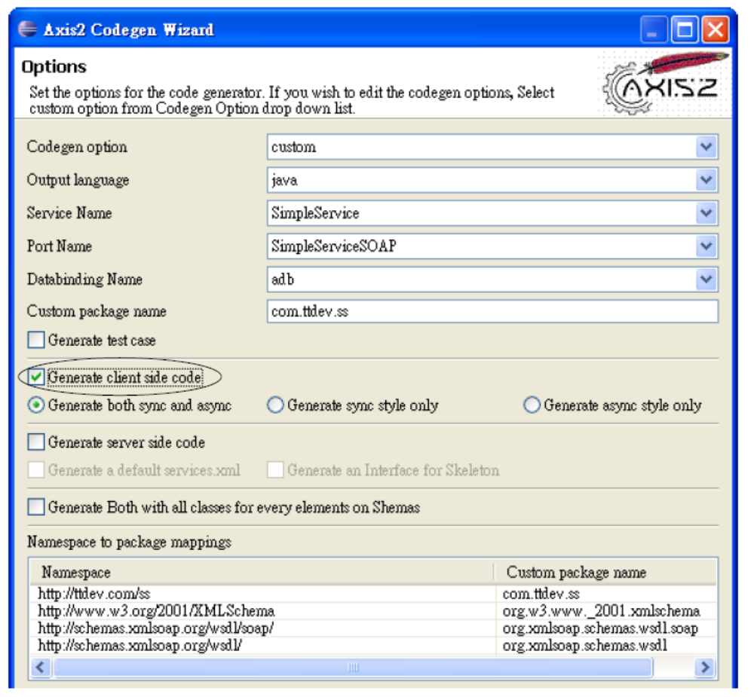

Then tell it to put the code into your SimpleService project. This time, no need to
copy the Axis2 jar files again:

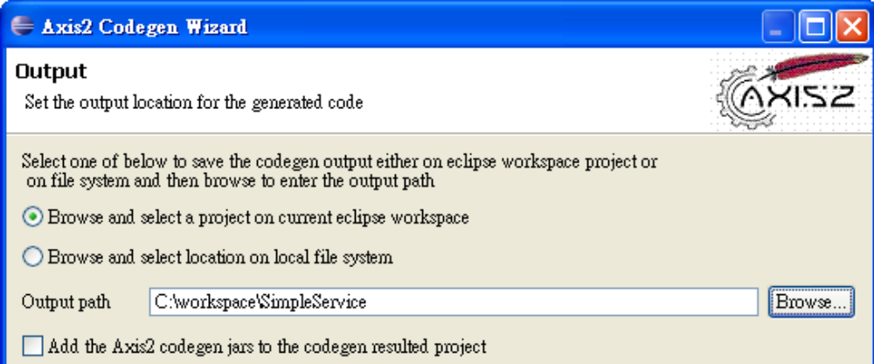

Click "Finish" and then refresh the project. You'll see a couple of new Java source files:

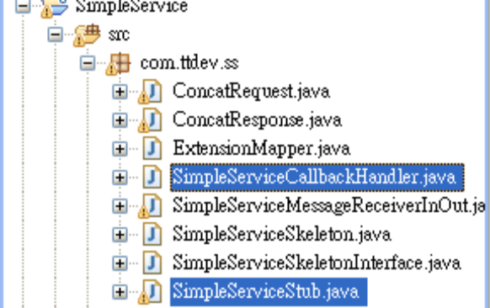

Among them, SimpleServiceStub.java is the client stub. As you're simulating
someone else calling your web service, they should not be mixed with the code
implementing the web service. Therefore, move them into another package
such as com.ttdev.ss.client.
Next, create a SimpleClient.java file in the com.ttdev.ss.client package:

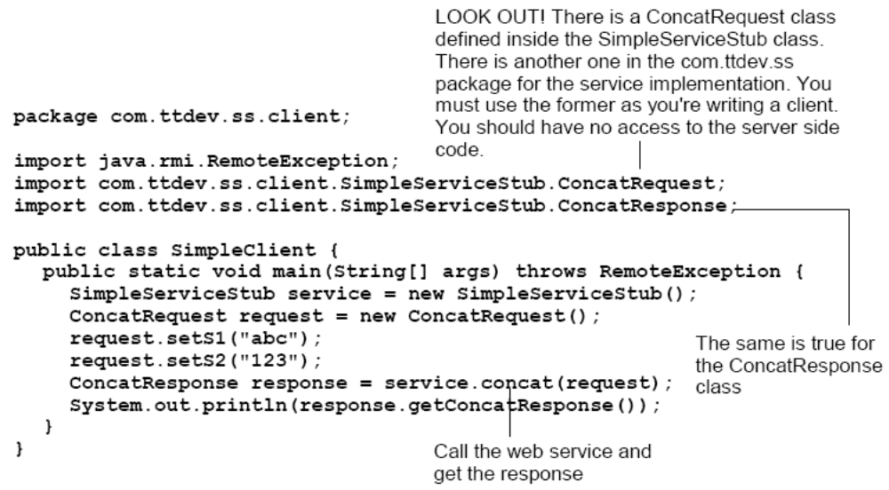

Run it and it should work:

