**Environmental monitoring**

**Introduction**:

The Internet of Things (IoT) has revolutionized the way we collect and analyze data, offering a seamless connection between physical devices and the digital world. In the realm of environmental monitoring, IoT devices play a crucial role in providing real-time data that empowers us to make informed decisions, mitigate environmental risks, and promote sustainability. This article will explore the concept of using IoT devices to send real-time environmental data to a monitoring platform, highlighting its significance, applications, and benefits

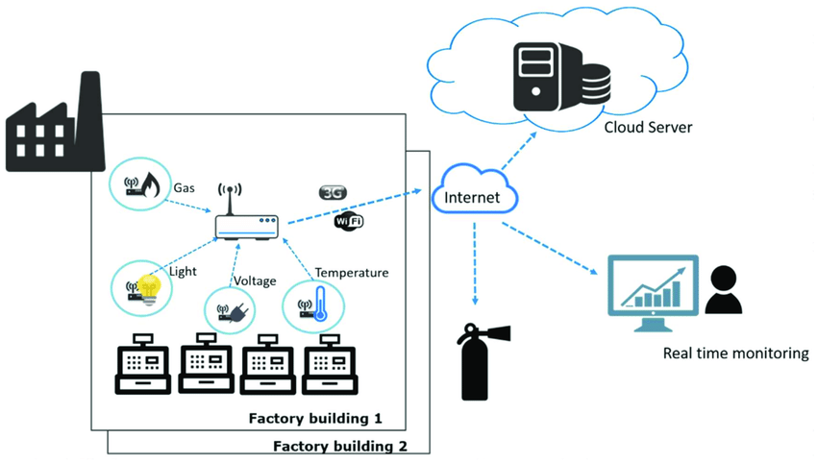

**Python program**

import paho.mqtt.client as mqtt

import time

import random

# Set up MQTT parameters

mqtt_broker = "mqtt.monitoring-platform.com"

mqtt_port = 1883

mqtt_topic = "environmental_data"

mqtt_client_id = "IoT_Device_1"

# Function to simulate environmental data

def get_environmental_data():

temperature = random.uniform(20, 30)

humidity = random.uniform(40, 60)

return {"temperature": temperature, "humidity": humidity}

# Callback when the client connects to the MQTT broker

def on_connect(client, userdata, flags, rc):

if rc == 0:

print("Connected to MQTT broker")

else:

print("Connection failed with code: " + str(rc))

# Create an MQTT client

client = mqtt.Client(mqtt_client_id)

client.on_connect = on_connect

# Connect to the MQTT broker

client.connect(mqtt_broker, mqtt_port, keepalive=60)

# Start the MQTT client loop

client.loop_start()

try:

while True:

# Get environmental data

data = get_environmental_data()

# Convert data to JSON format

payload = json.dumps(data)

# Publish data to the MQTT topic

client.publish(mqtt_topic, payload)

print(f"Published: {payload}")

# Sleep for a specific interval (e.g., 5 seconds)

time.sleep(5)

except KeyboardInterrupt:

print("Script terminated by user")

client.disconnect()

client.loop_stop()

**Key component**

**Sensors**:

These devices need various sensors (e.g., temperature, humidity, air quality) to collect environmental data.

**Microcontroller:**

A microcontroller (e.g., Arduino, Raspberry Pi) processes data from sensors and manages communication.

**Connectivity**:

IoT devices typically require Wi-Fi, cellular, or other connectivity options to transmit data.

**Data Processing**:

IoT devices may perform some data processing (e.g., filtering) before sending information to the platform.

**Protocols**:

Devices must use IoT protocols (e.g., MQTT, HTTP) for data transmission.

**Security**:

Encryption and authentication are crucial to protect data during transmission.

**Power Source:**

Power management is essential, and some devices use batteries or energy harvesting.