**TASK – 8**

**1. Choose a Reputable Free VPN**

**ProtonVPN Free**

* No data limits
* Strong encryption
* No ads or logs

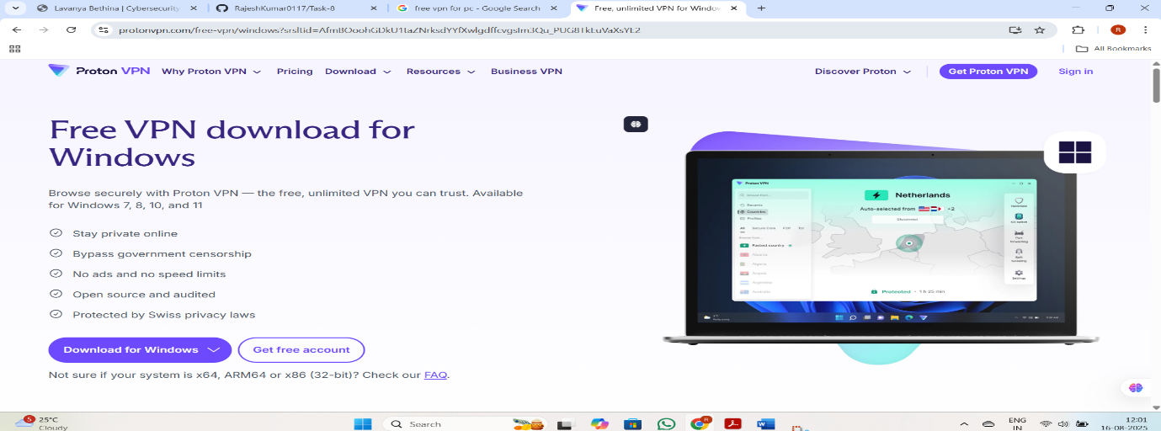

**3. Connect to a VPN Server**

* Open ProtonVPN
* Use “Quick Connect” or choose a nearby server manually
* Wait for the connection confirmation

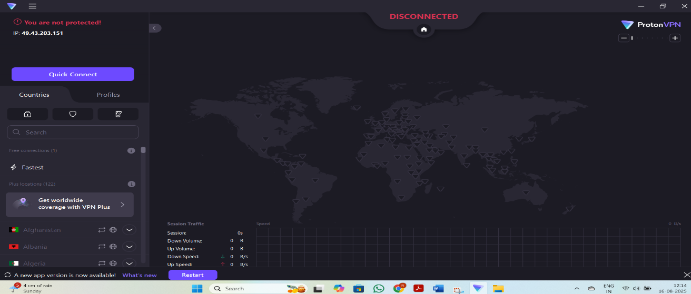

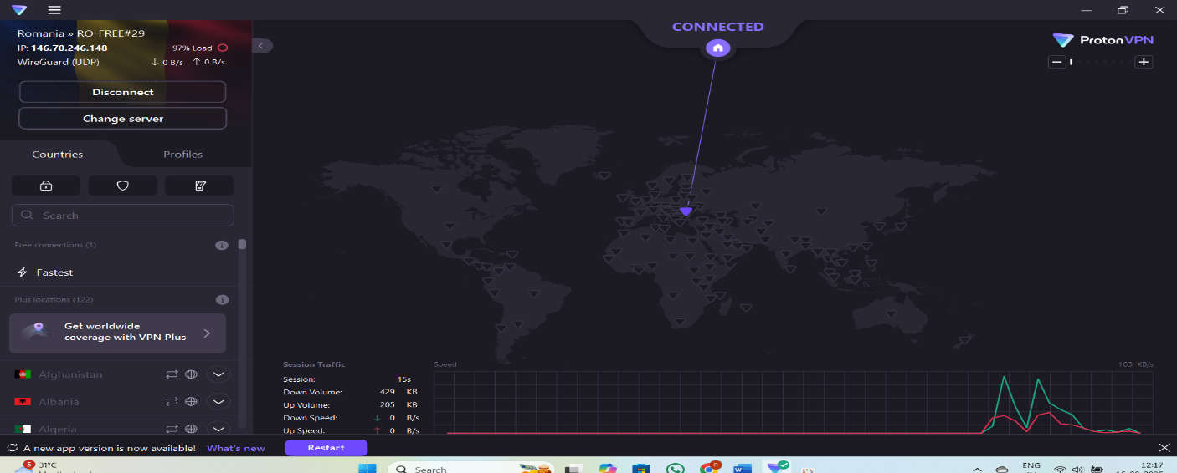

**4. Verify Your IP Address Has Changed**

* Visit <https://whatismyipaddress.com>

**Before connect to VPN:**

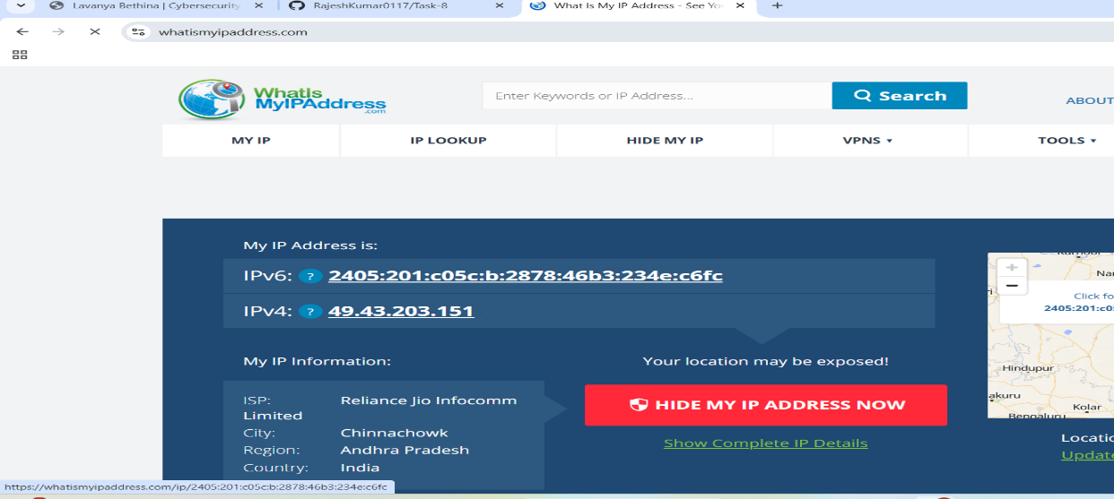

**After connect to VPN:**

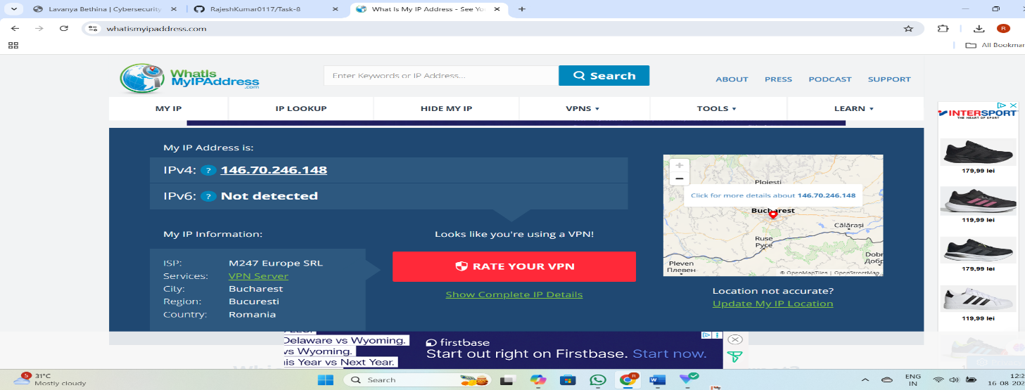

**5. Browse a Website to Confirm Encryption**

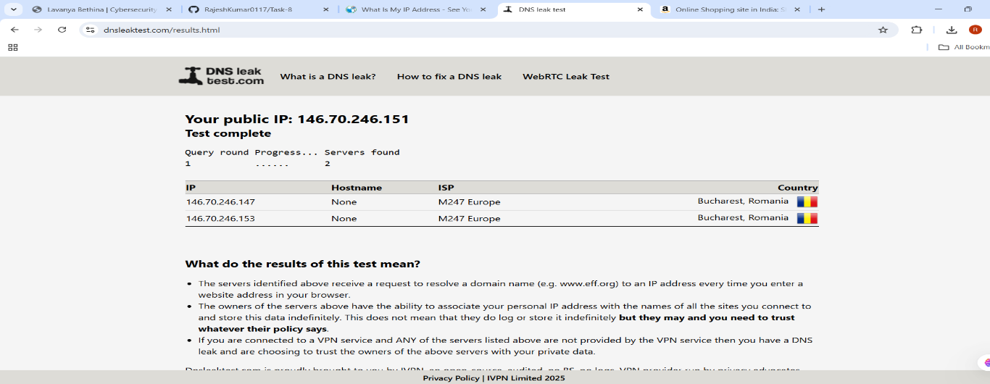

**6. Disconnect VPN and Compare Speed & IP**

Before VPN connects:

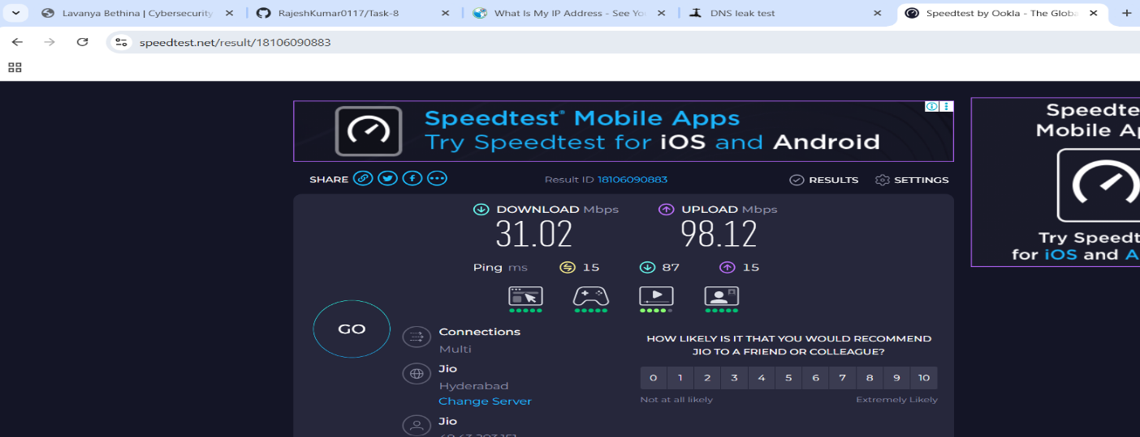

After VPN connects:

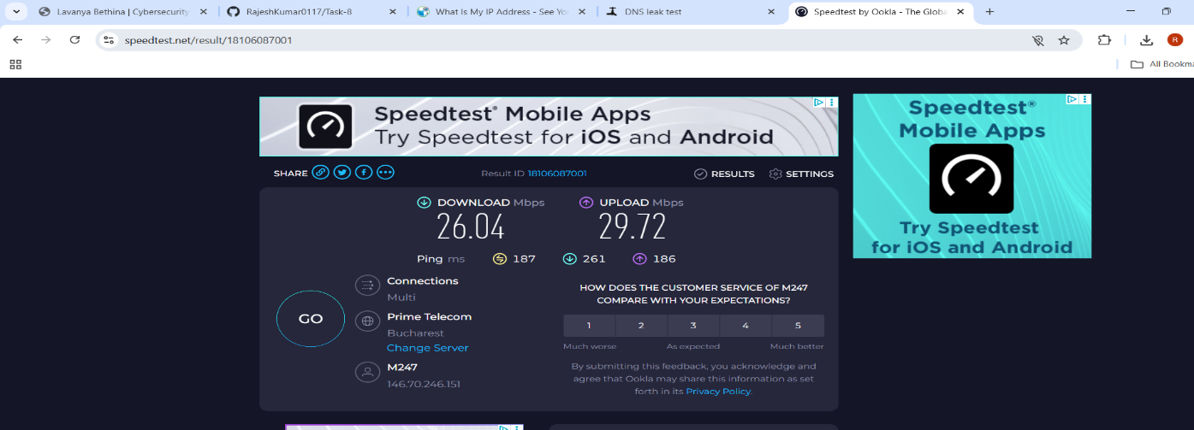

**7. Research VPN Encryption & Privacy Features**

* ProtonVPN uses AES-256 encryption
* Offers Secure Core, Kill Switch, and NetShield (ad/tracker blocker)

**8. Summary: VPN Benefits & Limitations**

**Benefits**

* **IP Masking**: Protects identity and location
* **Encrypted Traffic**: Secures data on public Wi-Fi
* **Geo-Unblocking**: Access restricted content
* **No Logs**: ProtonVPN doesn’t track user activity

**Limitations**

* **Speed Drops**: Due to encryption overhead
* **Limited Servers**: Free plan has fewer options
* **No Streaming Access**: Free plan doesn’t support Netflix or Hulu