Copyright © Anil R. Dhasal
All rights are reserved. No part of this book may be reproduced or transmitted in any form or by any means, electronic or mechanical, including photocopying, recording, or by any information storage or retrieval system, without written permission from author,

Re-print rights for India and abroad with author
First edition printed in Sep 2013

If you have any query or comment concerning this book,
please write to the author & publisher at anil.dhasal@gmail.com or mail at

A.R. Dhasal
#13, Rosewood Sahayognagar
Garkheda Parisar
Aurangabad 431005
Maharashtra, India

Printed in India by:
Catalyst
# 13 Rosewood Sahayognagar
Garkheda Parisar
Aurangabad 413005
Maharashtra India

Designed by: Virendra A. Dhasal

Shape
Your Children
To beat the
Rat Race

Guide them to right track, right from teen age!
By Anil Dhasal

With the help of...
Good Habits & Soft Skills

To all friends,
Those who decided to,
Spend not only money, but also quality time with their Children!

Preface

Day-by-day it is becoming tedious to choose the right changes happening in today’s world & influencing our loving once to make them ready for their happy future in changing world.

We shall not shut our doors & windows to stop the bad things from entering in to our house, if we shut it, then from where the good things will come to us.
We can read spoiling & encouraging literature from same eyes, if we close our eyes to avoid spoiling things, then we will not able to read encouraging & inspiring literature also.

Closing eyes or ears is not the solution to stop being influenced by disturbing changes happening in today’s world, but to choose correct one, out of these changes for shaping our children would be the correct choice.

The ten habits for teen from this book, guide the reader to choose right changes happening in today’s world to shape their loving once to beat the rat race. This would also help parents & teen ager to enhance their awareness of changing scenario in today’s corporate world.

What we should do is not an only thing that matters nurturance of children; it is also important what we should not do to achieve results.
If this book inspires & initiates actions within the parents those wish to shape their children by spending quality time with their children, then the purpose of this book is served.
Dhasal Anil

Index
- Need of this Book 6

- Facts in Practice 10

- Ways to be adapted for shaping 12

- Habits to be cultivated 14
- Not to rely only on Textbooks 16
- Deal with Wrong Beliefs (Blind Faith) 18
- Reading other than Textbooks & gaining experience 24
- Grasping through media 27
- Understand the concept of time pass 30
- Effective Time Management 32
- Listen Attentively 33
- “Not my way or your way , do it in a better way” type thinking 38
- Teaming - a Skill 41
- Never Give up 47

- Soft skills – 51
- Importance & need of soft skills
- Way to develop

- Know the Difference between Hard Skill & Soft skill. 58

- Tips to improve soft skills 60 to 62

- Note 63 to 65

Need of this Book:
Book’s name itself explains that, this book is for those who are in rat race. It is not only for those who wish to help their children to become an employee, but also for those who wish to see their children became an entrepreneur. Purposely, this book is intended for those who are in rat race of life.

It is debatable, what shall we choose our children, to become an employee or an entrepreneur? What we observe is that, there is wide gap between the percentages of entrepreneurs to employed people in society; it shows that there are more vacancies in employee category than employer category. Our goal should be an ART (Achievable, Realistic & Time bound). Success rate is definitely remarkable in case of achieving a goal of becoming an employee than an entrepreneur. To become a happy employed person is also an ART (Achievable, Realistic, Time bound), similar as that of a successful entrepreneur. An entrepreneur is also an employee. On the contrary, every now and then he has to face interviews & interact with people.
Hence this book is useful for both, who wish to see their children became an employed person or an entrepreneur.

During our academic career, we never come across the subjects related to soft skill, no academic syllabus gives an importance to this topics. Education & examination system emphasize particularly on “Memorization.” at the most, it focuses on understanding of information from textbooks. Even after becoming an expert in “memorization” or understanding academic subjects, we fail to crack interviews & finally we feel that all our education is in vain.

Our education system is not oriented to get fit to perform; it may help to prepare you, to get information of various branches, this information needs to convert in to knowledge. Unless & until we convert this information (learnt in academic tenure) into knowledge and this knowledge into skill & eventually skill to deskill, it remains only information.

No organization including government is willing to rely only on academic performance of applicant. In some of the organizations, this was happening in 1970’s. Now a day every organization sets their own procedure to find out, at what level the applicant would succeed to convert this information into solutions to help their organization.

To find out this answer, each & every organization conduct their own exams, tests, orals, group discussions, or job trials is known as Interviews. They try their best, to view your internal ability by applying various means discussed above. All what they want to know is “How much Information you could succeed to convert into knowledge.” The ability to covert information into knowledge to find way out is main asset of particular person.

Information is volatile, where as knowledge is forever. One can apply knowledge and not information. By applying & practicing this information one can convert it into knowledge.
e.g., swimming coach will give you a set of instructions, but for learning swimming, one has to apply & practice the set of information to become a good swimmer. Once you learn swimming you will never forget it in your lifetime.

In an another example, an instructor of a gym can share information, using this information you have to build your body, here instructions are set of information received from his knowledge,. Unless & until you apply the same, it would not help to build your body.

In case of maintaining health, doctors can give information through their knowledge but finally you have to exercise regularly to be healthy. Similarly, during academic tenure, teachers, instructors & guides of various courses can deliver information to you through their knowledge, this is not sufficient to face an interview; you have to convert these sets of information in to knowledge.

In coming chapters, you will come across some basic tips to convert information into knowledge, to be ready to face an interview by developing soft skills to grab the opportunities.
If we do not initiate right thing at right time, that the shaping of the young’s mind in their teen age, not only will their career, but also entire life will be in doldrums.

Abundant books are available in market on this subject in one or other form, this book will explain you the important aspects in lucid language & whenever required in form of stories.
While surfing on internet, we may came across some important information, we read it & forget, some time we listen, read, and exchange the quotes & phrases, which eventually we forget with time span. We do not preserve & follow these important & valuable inputs.
Information in hard format, always act as leader in our day-to-day life. That is why; this book is required in every home for parents & children to ensure success while interacting with people.

Last but not the least,
Even though everything is available with Google & Wikipedia, we are unable to use it due to net-illiteracy, unavailability of resources, time, guidance & failing to identify our requirements.
This hardcopy will compensate the need of learning of good habits, from the literature available in soft form.


Facts in Practice
Before going towards actual preparation for interview, end in mind must be clear regarding what, when, how & why one shall initiate the preparation process for interview. Those who fail to crack interviews, often blame the interview panel for asking questions, which are not related to day-to-day work, here the candidate fails due to the misperceptions that, only hard skills & textbook information are sufficient to crack interviews.

Those who initiate preparation for interview, after completion of education, bound to focus only on the topics related to their favorite subjects. They will never go to basic fundamentals, never try to understand , instead would emphasis only on memorization, never read literature other than academic syllabus, never try to be participate in sports, never take part in social events, never participate in debates, never learn the application of knowledge and put efforts only to get expertise in collecting information through textbooks. (Bookish)

Some parents also think that, physical fitness is not that important for managers & executives, it relates only to players & athletes, this is also one of the basic misconceptions among people. Parents ask their loving ones, only to concentrate on textbooks to get good marks in exam, they forget that the textbook information may enable their child to get good marks but this information fails to enhance understanding. Textbook may teach some rules, theorem but they never teach one how to solve practical problems.

Parents fail to arrange exposure for their children to learn, Leadership, collaboration, harmony, preserving, analyze risk, communication skill, listening ability, dedication, multi-functioning, team work, importance of personality, and similar, essential & vital abilities called as soft skills ,required to beat the rat race.

No textbook will help your child to get these vital abilities. Now a day’s, only mark in exam will never help to crack interviews. Due to this ignorance, candidates bound to fail in interview.
Those who do not get exposure are exposed.

Failure to understand the importance of these abilities, leads to the situation beyond repair. The misperception that these abilities need not to develop intentionally, it comes automatically.

Every organization needs a battalion who will solve problems & take their organization to next level. No organization needs a person with information that is not useful to solve problems. e.g. in case of an electrical engineer, you may be knowing relation between voltage, current, resistance, but if you don’t know what to do when there is short circuit & how to restore situation then it is not of use for organization. Similarly, for a mechanical engineer one may know the principle on which diesel engine works, but not able to monitor diesel generator set, then it is of no use at all for an organization. These facts are got ignored, due to misperception that the information received during academic education will solve all the problems.

Textbooks only help you to secure marks by memorizing temporarily, whatever we have “learnt” through these textbooks, is hardly applicable in day-to-day life. Many of us experienced this in our professional tenure, even though we insist our loving one to emphasize on mugging the content of textbooks. The information in textbook is like stagnant water. It is a static source of knowledge.
Normally preparation for interview & acquiring necessary skill begins after completion of education part, would not get success.

What is actually needed?
Academic curriculum takes care of gaining information of subject, which is extremely useful for examinations, but skills & competencies required for any level of competitive exam & for successful career are hardly get developed during school & college tenure.

Those who fail to crack interviews, in most of the cases, are from the category Dig the well, when you are thirsty. Interestingly this fact has not been realized through generations. If we ask ourselves, when did we start preparation for interview? The answer is self-explanatory.

The skill sets & qualities required to crack interviews are not even thought of before completion of education. Actually these skill set are needed to be nurtured during school days itself.

While learning various subjects as per school syllabus, simultaneously one must learn these skill sets like communication skill, teamwork, leadership, behavior aspects, presentation, listening, manners and etiquettes.

These skill sets cannot acquired within short time, it is like farming. Acquiring these skills is a gradual process. It requires systematic planning & actions.
It needs Special efforts, otherwise, a “Normal action normal result” is experienced & that carries frustration within candidates & their parents.

While pursuing academic education, simultaneously initiate actions towards acquiring personality skill sets & develop attributes. such as, planning and priorities an activity based on importance & urgency, be a good team member, Understand leadership, sharpening of saw ¹ (renewal of personal ability), importance of listening, thinking the way other think & most importantly improve fast reading with fluency in English speaking and writing.

To acquire these skill sets, children shall purposely inculcate few important habits in their day-to-day life, as discussed these qualities cannot be built in short period, the life style needs to be changed accordingly.

1 Read Book from Stephen Covey “The Seven Habits of Highly effective people

TEN
HABITS
FROM
TEEN-AGE
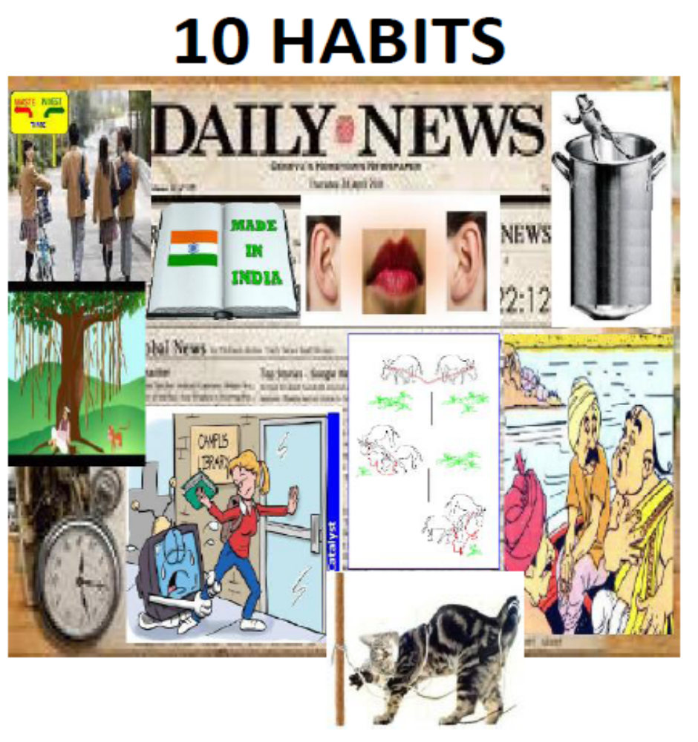
2
1
4
3
6
5
Trying to detach you from watching too much television is much harder than setting aside a certain time to read an identified book.
8
7
9
10

10 Habits to be Cultivated from Childhood
Habit 1: Not to rely only on Textbooks
First & foremost if we think, textbooks are the only source of knowledge, then we are grossly wrong. Textbooks only help to understand concepts, theorems, rules & laws stated by scientist. This only discovers what happened in past; and what will happen in given conditions.

We forget in tenth class, what we learnt in fifth, this is natural phenomenon because we are human being & not a god. As these concepts, theorems, rules & laws are not “experienced” by us. Those were studied & “experienced” by them & jotted down for reference.
Practical knowledge mean, knowledge gained by doing our self, is long lasting, whereas, theoretical knowledge help to understand concept & is volatile.

No doubt, textbook knowledge is also useful, but it is not sufficient to survive, progress & grow. Encourage children to collect, read books other than textbooks. Learn practical skills by practicing it under supervision of seniors.

Textbooks information would help getting mark in exam, these marks may help to get admission to higher education, this higher education may help getting employment. Practical knowledge & soft skill comes in picture hereafter. Though necessity of application of practical experience & soft skill arises after employment, it needs to be cultivated since teen age. Because the ability of learner is reduces as the age increases in case of human.

Practical experience & learning of soft skill must start from teen age

A famous story of gyani Pundit &sailor by Ramakrishna elaborates
1 Importance of practical knowledge in day –to -day life
2 Difference between textbook information & practical experience.

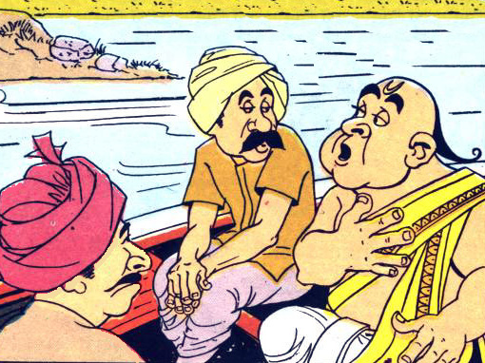
One day several men were crossing the river on a ferryboat. One of them was a learned Pundit. The Pundit decided to discuss the Hindu scriptures with a fellow passenger in order to pass the time and show off his knowledge. So he turned to one of them and began, I presume you have read the Upanishad? The passenger humbly replied, "No Sir, I have not!" You did not! Pundit said in surprise. A quarter of your life wasted! Then you must have read Shashtras! The Pundit continued. No Sir, I cannot say that I have! The passenger replied feeling quite distressed. Well then, half of your life is wasted! The Pundit said arrogantly. Then the Pundit asked What about the six systems of Hindu philosophy? In a final effort to begin, an intellectual discourse. I am afraid I have not even heard of them, Sir! The passenger replied. Not heard of them, then, my friend, three-fourths of your life is wasted. Just as the Pundit said this, he found the boat suddenly began to pitch in increasing violent waves. It is going to capsize! Jump overboard and swim to the shore! The Pundit looked terrified. You do not know how to swim? The fellow passenger asked. No, I never learnt swimming! The Pundit moaned. You never learnt swimming! Then your whole life is gone, Punditji, the passenger replied smugly as he jumped out of the sinking boat.

Habit 2: Stop Wrong Beliefs (Blind Faith)
Somebody set the rule for situations created at that point of time, it may be correct in that situation, but without verifying hold goodness of that rule in present situation, we follow the same without any meaning.

Many of the blind faiths get birth through this phenomenon only. Following story will help to understand this fact.
Once up on time there was an ashram. In this ashram, daily morning, the guru & shishya used to utter a prayer together by closing their eyes. After few days, a cat arrived in ashram, as a love to animal; they fed this small cat with milk. Gradually it become big cat & started creating nuisance in morning & evening prayer, it mingle at the feet of asharamis.

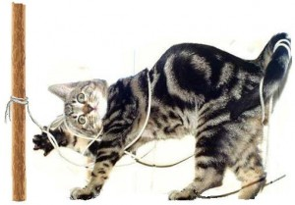
To overcome this situation, guruji ordered to tie the cat to a pole near his asana during prayer. After few month, guruji & shishyas got used to this cat-tying episode, they felt in love with that small animal. Within few years or so, the cat died. Now all asharmis decided to bring a new cat. Naturally same tying episode continued.
After some years, guruji passed away, new guruji came & asked about cat tying phenomenon. shishyas explained him that, this is our tradition & we feel happy during prayer, if we tie the cat. New guruji also accepted this “Tradition” & allowed them to continue. One day that pole fell down, they erected new pole to tie the cat.
After years gradually all shishyas were replaced by new & guruji was also new, they continued the cat tying episode.

One fine morning, the king of that town ordered, not to have pet animals in any temple or ashram. Now they brought a statue of cat. Place it near guruji’s asana while praying. After some days third guruji came & he ordered “golden cat statue to be installed near his asana” so that they would conduct prarthana with concentration.
This storey is a typical example of, how we carried away with old traditions (Which may be correct at that point of time) which are now not relevant with today’s scenario. Question is who will bell the cat?
Ask yourself,
Are you still tying the cats?
Then ask your friends same question.

Following experiment carried out by scientist, explains why we continue to do what we are doing, even though it pains us & we know better way to do the same thing without pain.

Monkey and banana experiment
Even our fear responses are behaviors with lost meaning if they belong to an outmoded story or someone else’s experience. Why take on inherited fears when we do not even know what the cause was? Most of the “stuff” that sabotages us comes into this category.
The story of the monkeys and the banana (taken from an experiment by G.R. Stephenson in 1967 I believe) which illustrates the point.

There are some monkeys in an experimental cage. The researcher hangs a banana on a string at the top of some stairs in the cage. Whenever a monkey climbs the stairs to get the banana he sets off a cold-water hose, which drenches all the monkeys in the cage. So, pretty soon, the monkeys prevent any single monkey from climbing the stairs and setting off the hose in an attempt to reach the banana.
The researcher turns off the water so that it is now safe to approach the banana. However, the monkeys continue to stop each other from approaching the stairs. One by one, new monkeys replace the monkeys. As each new monkey enters the cage, it attacked by the other monkeys when it attempts to climb the stairs, so it learns not to.

Eventually, every monkey in the cage replaced, so no monkey now has ever experienced the soaking. However, no monkey ever approaches the stairs again. That is just the way things are. Another ‘religious’ ritual is born; another thought virus.

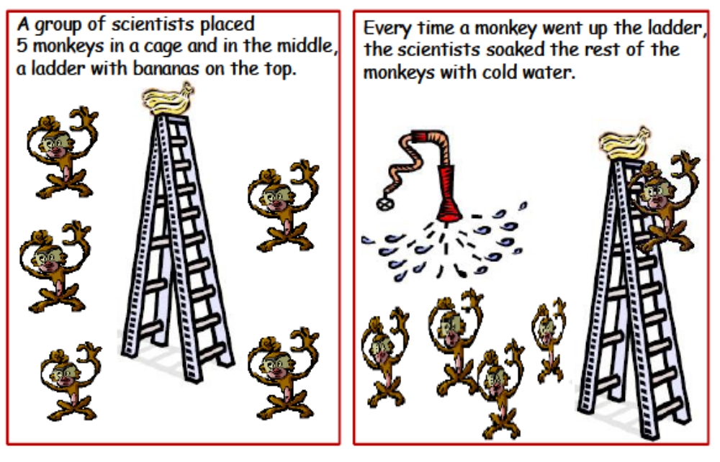

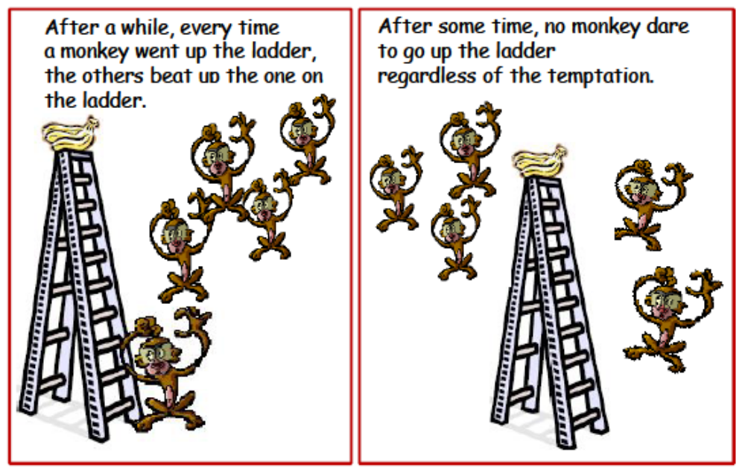

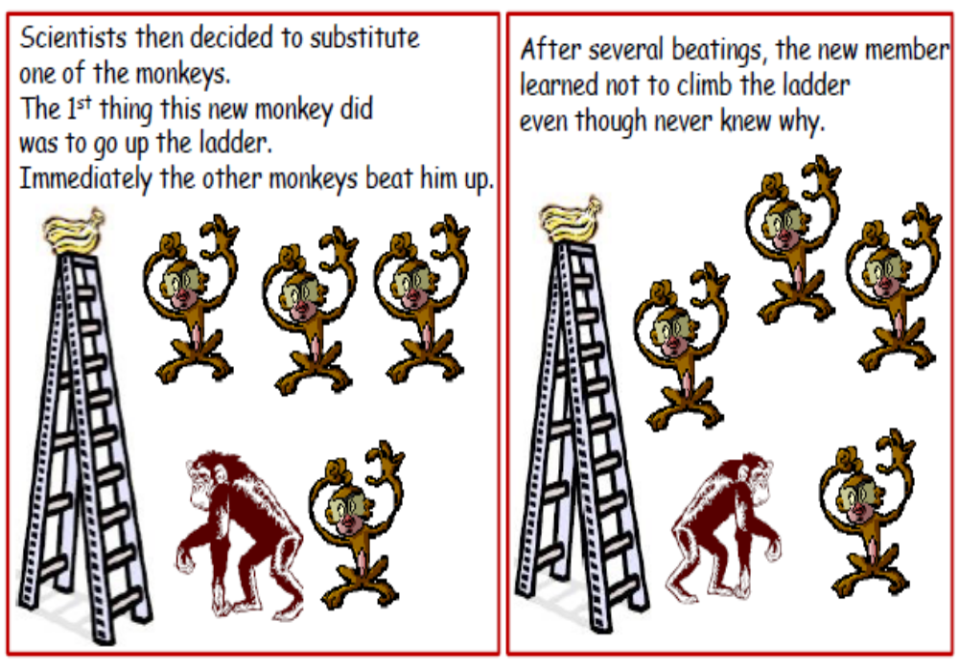
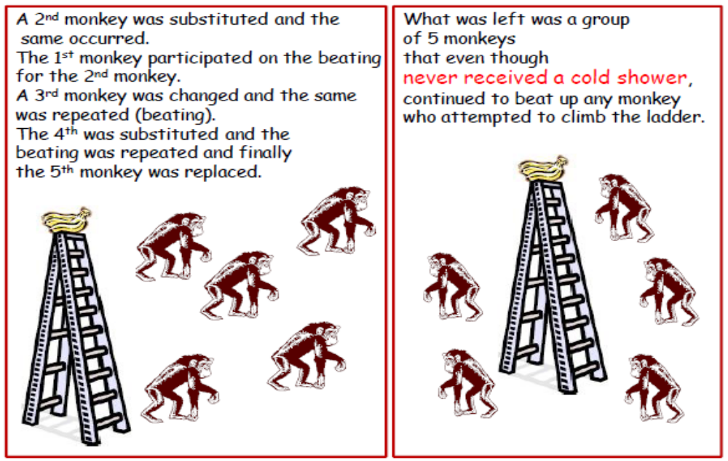
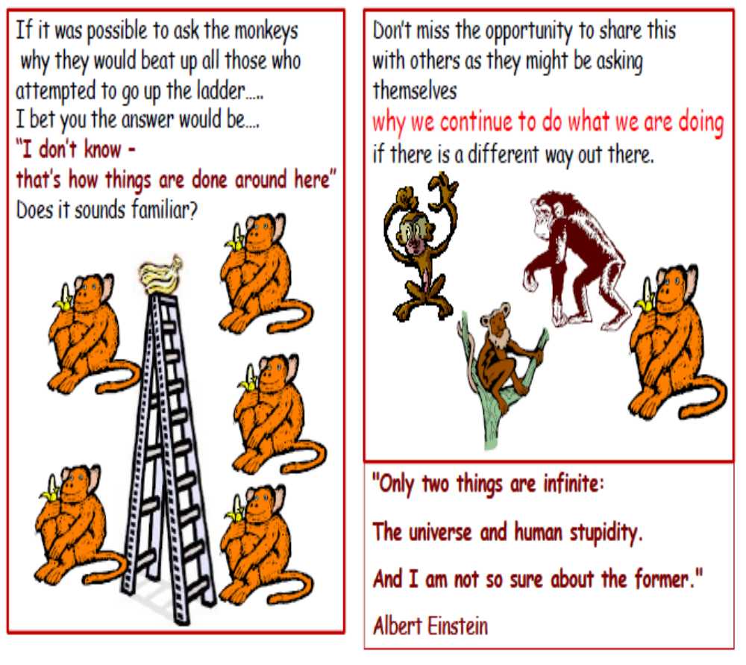

Let us start using our known solution to reduce our pains, instead of adapting the blind faith.

Be a trendsetter & not follower!

Habit 3: Reading other than Textbook & gaining virtual Experience
Right from school days, habit of reading books in addition to the textbooks must be cultivated within student by creating reading ambience at home. By demonstrating, by purchasing books regularly whenever we go to shops & malls, by reducing their interest in watching TV, by stopping discussion & appreciating filmy characters & celebrities during discussion. Instead, parents & relatives shall discuss & appreciate the articles, which they read about creative, innovative subject in front of children. They shall admire industrialist, scientist World leaders & philosophers.

For every child, his parents are the idols.
Knowingly / unknowingly, they try to follow them.
While planning expenses, the priority shall given to spending on study room, facility to store books, purchasing of books on various subjects, providing writing board in children room.

Just imagine the difference between effects of watching film on TV & watching it in theatre, the pictures seen on bigger screen remembered than the pictures seen on small TV screen. Similarly, the letters written on bigger screen remembered easily & for long time, than the letters written on small notebook with tiny pencil or pen.

Encourage them to purchase books & create library in study room, discuss with their friend regarding reading, initiate discussion with their friends about new arrivals of books instead of new serials & game shows aired on TV. Gift them books on the eve of their & own birthday. Insist children to present books to their friends on birthday.
Discuss & explain the difficulty arises while understanding the subjects of these books & its’ importance in life ahead.
Because, we understand what we like & we like what we understand.

Textbook of history may help in understanding the experience of others, how they faced & found a solution on difficulties in different situation, it may inspire you. The book of science & math may help in solving problems on paper, seldom it help to solve problems in life. Here, travelling, other relevant readings & observations help a lot to learn, how to tackle with practical problems.
Student learns by either reading or travelling extensively. While travelling, they come across different cultures, situations, incidences & experiences.
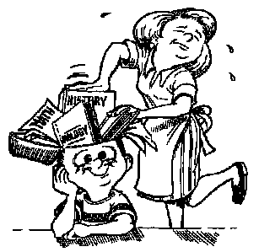
These compel them to find out solution in current situation & using whatever available resources at that point of time. That is what expected from them in future life & not remembering the concept, theorems, rules & laws stated by scientist.
Do not insert only textbook information in children’s’ brain.
Also, remember,
“Each time same solution may not work in same situation”. Following complete story will help to understand this statement well.
All of us know the story of cap seller, some of us might know the half-truth. This story is modified, extended to elicit the entire truth that, each time, same solution may not work in same situation.

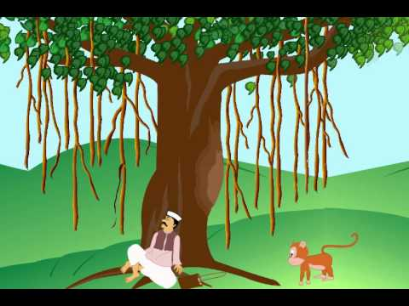
Story of Cap seller: (Modfied)
Cap-seller was going to sell his caps in a village market. He was going through a forest. He was carrying a basket of caps on his head. He got tired in the heat of the sun. He lay down under a tree to take rest. He put his basket on the ground. He fell asleep.
There were monkeys on that tree. They came down and took the caps. Then they climbed on the tree. When the cap-seller woke up, he was surprised to see that monkeys were wearing his caps. He became sad. He thought of a plan. He threw his own cap on the ground. The monkeys also threw down their caps. He collected his caps and went away.

This is half story; further, this story extended as below: After reaching home cap-seller told the tact (solution), he tried & got success to his son. After few years his son was going to sell caps, he was going through forest, carrying basket of caps on head, got tired, lay down under same tree & fell asleep. There were some monkeys on the tree. They came down, took the caps and climbed on tree. When the cap-seller’s son woke up, he threw his cap on ground. However, this time no monkey threw down their caps, instead, they replied, “Similar to your father, our parent also told us their experience & advised not to repeat your action”
Moral of the complete storey, “Same solution may not work for same problem”
That is why; Chatrapati Shivaji maharajah never tried same tact for two problems, every time he invented new solution.
If you learn some solution via textbook in classroom, it may not work for same problem in real world.

Habit 4: Grasping through Television, News Papers & Other Publications (Daily, Weekly, Fortnightly, Monthly) on regular basis
Don’t make them read, make them to understand! If you tell, they remember, if you teach, they will learn & understand

The children who fail to update themselves are from those houses, in which newspapers are used only to read headlines, police diary, new film arrival, personal life of so called celebrities, cricket & to some extent horoscope. Coverage in news regarding these four aspects politics, cricket, film & personal life of celebrities are spoiling our young generation, these news hardly add any value, it is our job to take initiative to divert their attention from such non value adding activities & focus on technical, scientific, financial, innovative & creative aspects by setting an examples.

The articles on technical, scientific, financial, innovative & creative also being published, in these newspapers, unfortunately they are ignored. Once they ignored, gradually newspapers stop publishing & thinker stops writing. This leads to publish some of the newspaper with full of non-value adding information. Ironically, their circulation is surprisingly high.

Ask yourself, can you list five poets, five authors & five economists who are alive. However, definitely you can list down many poet, authors & economists who are not with us. This has happen due to above phenomenon.

If we are convinced that, the literature plays vital role in building social values in society, let us initiate, cultivate the habit of reading in the next generation, to save them from danger of leaving value less life.

Parents should set an example in front of their children by demonstrating interest in value adding information from these media, instead of showing interest in non-value adding contents.
If we are watching vulgar repetitively aired news, destructive soap opera then we cannot stop children from viewing similar non-value adding stuff like cartoon & game shows for hours together. In late 80 ’s children used to view idiot box 2 Hrs a day max & use to spend max time with parents when they were at home.
Just verify how much time your children spend with you & idiot box when they are at home.
Guide & encourage them to collect value-adding articles & prepare an album so that they can refer it, whenever they find leisure time. The habits & liking generate during age of 5 to 10 remains throughout the life, after age of 10 to 12 years, it is damn difficult to change bad habit or incorporate good habits. Understand the difference between need & wish of your children; try to fulfill their needs on priority and not the wish.
Remember, English is the language of today’s world, though experts say, one can generate new thoughts in mother tongues only. They are forgetting the fact that, to generate new thought, one must read variety of literature, collect information of various aspects and get knowledge. Unfortunately, this all is not available easily, in language other than English, on large scale & variety. Secondly, one must be able to sell his ideas. To sell your ideas, you must be able to explain it in the language, which people understand. Considering this fact of life, make your family English language friendly.
Read English, write English, speak English, eat English and sleep English, English, English & only English.
To learn a language means, consistently top-up the stock of words of that language with you. Enhance this stock by listening, speaking, reading the language.



Habit 5: Understand the concept of
Time Pass, Wasting Time & investing time

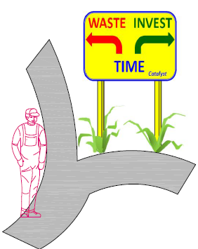
In our day-to-day conversation, if we ask anybody, what you are doing in leisure time. Hundred percent the answer is “time pass”. Here we forget human being is not responsible, authorized to pass the time. Human can either waste or invest the most important thing he received. Normally when we say, I am doing time pass, hidden meaning is “I am wasting my time.” The time will pass any way, irrespective of what we are doing or not doing.

We can only waste or invest our time. E.g., when we sleep in night for 6 to 7 hrs, we are investing time to be energized for next day, but if we sleep more than this, it is a waste of time.
The people, who invest their time, get returns with interest in the form of their nicely constructed future, the people who waste their time loose the important gift & at the end no future for them. It is very important to understand & categorise our activities in, time wasting type activity or time investing type activity. Sometime same activity could be investing type to somebody & wasting type for another one.

e.g. for professional player playing game is a time investing type, at the same time, it may be time wasting activity for others.
While allotting time slot for watching cricket, playing games, watching TV, shopping, outing, reading non value adding material, surfing etc. one must justify the time spent on an activity is of wasting type or of investing type.
If we ask anybody why you are not, reading, doing exercise, meeting the neighbors & friends, spending time with family, answer is, I do not have time. If we categorise all these activities, they all are of time investing type. There is phrase “Busy man always finds time.” This is because he is always cautious about wasting & investing time.
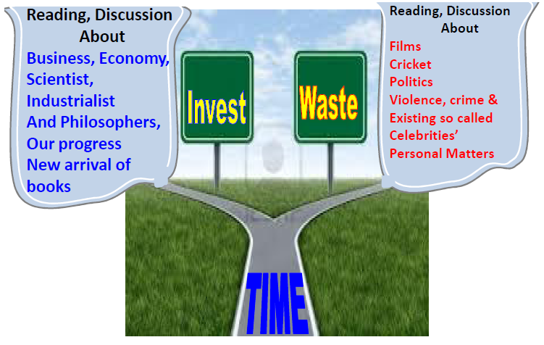
If we concentrate on, defining all our activities in two types, time wasting type & time investing type. Moreover, avoid cautiously time wasting type activities we will be able to find time for our interview preparation, which is most ‘time investing type’ of activity for our life.
Habit 6: Effective Time Management
If not guided correctly, unknowingly children spend time exactly in reverse way of actual need to utilize it correctly. Parent must monitor and guide them, to fix up the priorities to spend time. In the universe, all of us whether rich, poor, tall, short and appearance wise smart or dull, we get equal time to spend. Everybody has 24 Hrs a day. This is the only thing, which is same for all, that is why it is precious. Those who manage time effectively get success in life.

Stephan Covey gives universal guideline for time management. If all of us follow it, definitely success is ours. In one of the books, he elaborated the same. He says the priority of time spending shall be as follow
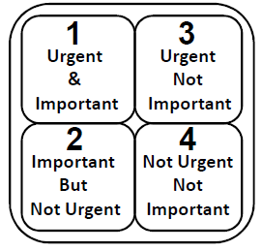
First priority shall given to the activity, which is,
-Important & Urgent
Second priority to the activity, which is,
-Important but not urgent
Third Priority to the activity, which is,
-Urgent but not important
Last priority shall given to the activity, which is,
-Neither important nor urgent
Most difficult thing here we fail to categorize the importance of activities or we are not aware of this.
Before allotting time for any activities, ask self, is it important & urgent?

For your reference, few examples of all categories are as below:
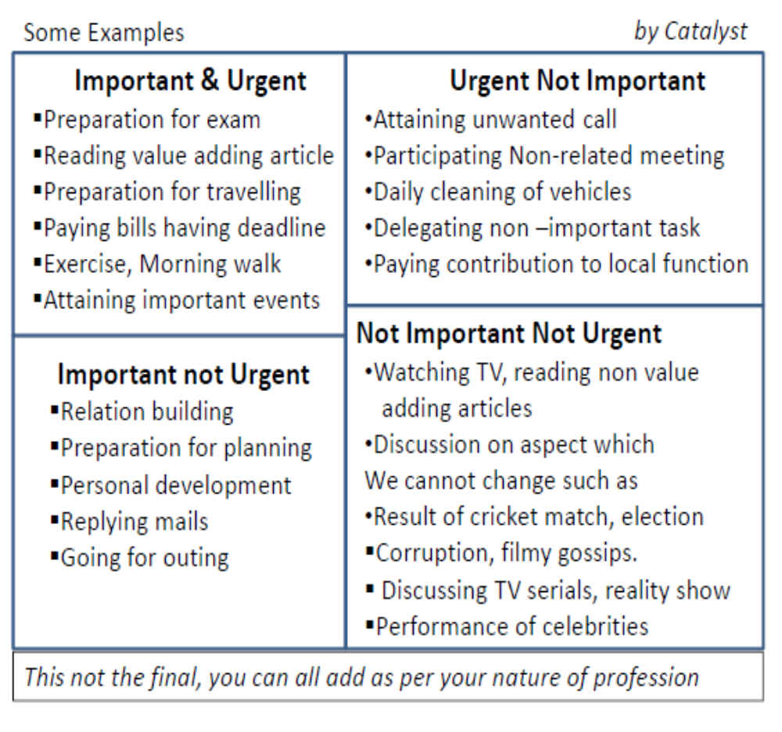
Parent shall demonstrate & set an example, in front of their children. If parents are spending their time on “non important & non urgent activity, naturally they will try to follow the same.

Habit 7: Listening – An Important soft skill
During school & college tenure, teacher teaches about how to read, how to write, how to speak, but nobody teaches about How to Listen? This important aspect remains untouched & in later part of life, we fail to listen & that creates barrier between information & us. This leads to stop the inputs of important knowledge. Reduces capacity to understand others, adds confusion, creates communication gap & finally results in to wrong decisions and misunderstanding between friends, colleagues, superiors & relatives.

Somebody said, “God has given us TWO ears & ONE mouth so that we shall listen more & speak less.” We can shut our mouth but cannot shut ears. This arrangement is to listen more & speak less; unfortunately, we speak more & listen less if not trained to listen.

My purpose is not to scare you by tailing this fact, but to create an awareness what could happen if we ignore listening. Hearing is different from listening. e.g. we hear lot of sounds on road but we listen only sounds of our interest, similarly when we go to market there are so many sound we bound to hear but we listen what the shop keeper speaks, with whom we are dealing. Listening means, processed sound transformed to brain to take decision, to remember & retrieve.

“Most of the people do not listen with the intent to understand;
They listen with the intent to reply.”

Have you done this, ask yourself, and admit it. In conversation with someone, you stop listening because you focused on what you are going to say next. I have done it myself often.
Not listening means stopping somebody who wishes to help you in better manner.
Types of listening:
- Ignoring
- Pretending to listening
- Selective Listening
- Attentive Listening
- Active Listening
- Empathetic Listening

Ignoring/Neglecting type listening
This is worst type of listening, never practice this, if you are practicing, stop it immediately.
When somebody talking to you, and you are watching TV or inserting your head in news paper, watching outside, playing with paper weight, looking in computer monitor & pressing keys on keyboard or mouse & asking the person to continue his speech. This type of behavior is called as ignoring type listening. This is most destructive part in relation built up process. If you have to perform an activity important than the subject the speaker is talking about, then say so politely & ask the speaker to wait.

Pretending to listening
Here Listener is acting as if he is paying attention, but his body language gives away the fact that he is really thinking about himself or different subject; he might also interrupt the speaker or walk away in this stage.

In this case probable listener is not “ignoring or neglecting” by doing any physical activity, but pretending that he is listening just sitting idle, but his mind is engaged on different subject & waiting speaker to finish his content & once he finishes probably listener will say ok.

If you want check this behavior ask him reference about a sentence just you asserted, he will garble & will not able to recall & would request you to repeat it again politely, this is symptoms of pretending listeners. This is worst than neglecting type.

If you came across a situation that, mentally you are engaged somewhere else, then ask the speaker, can we discuss it afterwards, as I am not in position to concentrate on this subject at this point of time with due respect to his feeling.

Selective type listening
In this listening process, listener intentionally does not want to hear something, he responds only to the part of conversation which is of his own interest and ignore purposely what else speaker is telling about. This happens when listener of an attitude, that he is better than speaker or judging the speaker, normally this happens when junior talks to seniors, learner talks to experts. This type of listening creates a permanent dent on relationship between speaker & listener. When you are in role of listener never, do this.
Attentive Listening
Paying attention without actually working at listening, this is what most students in class and most untrained people believe that listening means. In meetings, juniors will pay attention but they will not take notes, they will not intend to remember what they were listening, if they are not convinced about the contents of speech. Only due to pressure, they will pretend that they are “listening”

Active Listening
Actually working, to understand the speaker; feedback is provided, questions are asked, notes are taken in this type of listening. At the end of conversation, an action plan is decided. Normally this happens, when a seniors talk to juniors in convincing tone. This is one of the good types of listening. This helps to build long-term healthy relationship in professional & personal life.

To acquire this skill,

Observe & be focused:
This is non verbal activity, keep eye contact with speaker, don’t do any other activity like cleaning of organ, passing fingers through hair, giving or taking instruction, playing with cell phone or similar things. Stay focused, ask question with polite intervention with permission of speaker.
Feedback Acknowledge the message even if you do not agree at that point of time.
Reflect Restate in your word what you understood but after speaker finishes his speech. Try to state in positive way.
Respect: Let speaker finish his sentence. Do not interrupt in between.

Empathic Listening
The highest level of listening, where you try to understand the thoughts and feelings of the speaker; you pay attention to non-verbal clues, such as facial expression and tone of voice, to understand the speaker as well as the message spoken. Note that, you do not have to agree with the speaker to understand, and you do not need to feel sympathy in order to be empathic. Understanding the person is not the same as, feeling exactly the way they do.

This is listening to the hurt or pain of another individual & providing support & understanding. This is passionate, heartfelt style of listening. Here listener’s body language & attention create emotional bond. Though difficult, we shall learn & practice this type of listening for success in career.

Habit 8:
“Not my way or your way, let us do it in better way” type thinking
There are always ‘n’ numbers of ways to resolve difficulties, to solve complicated problems. When there is lone person, then the outcome depends on individual experience, expertise, strength, thinking ability on particular subject, hard & soft skill level of individuals.

But, when more than one person are involved in finding way out & if they are trained to work with,
“Not my way or your way, let us do it in better way” type thinking.
The combined effect would be greater than the sum of their individual effort.
If all concerned individuals or groups, interact, respect, appreciate, integrate with each other & then implement the solution, most of the time, it’s combined effect would be greater than the sum of their individual efforts.
To arrive at this type of situation, it needs to develop within us, a
“Not my way or your way let us do it in better way” type thinking.
This type of thinking can be developed, only when we enhance our listening capacity, start respecting others & by convincing ourselves that, it is not necessary that, other should see the world ,the way I see.

There are many optical illusions available to get convinced that there is not only one-way to see the world, various meaning can drawn by looking at same thing in different angle.
Following famous illusion is sufficient to know how we are thinking & what others can see.
Look at the picture and write down immediately what you see in it!


N.B.
See on page number 50 & come again back to this page & write down your observation
Do not see before writing your opinion.

A simple example of result achieved by two bullocks by,
- Interacting
- Respecting each other thinking
- Appreciating
- Integrating
- And implementing the thought.
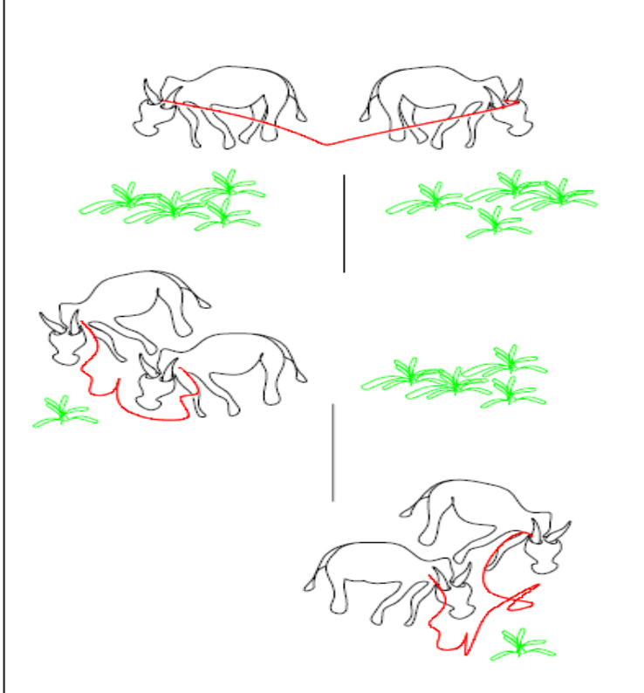
Two bullock were tied with one common rope by farmer & left them near bunches of grass kept apart. Initially both were pulling each other with full strength to eat the grass, which they could see. One bull saw left side pile of grass & another saw right side pile of grass and after lot of effort; they could not eat a single leaf of grass even after putting lot of effort.

Finally, one of them asked this difficulty to other one. Even after viewing, he could not reach to the grass. Bull replied it, finally one of them suggested that, let us eat left side grass first & then both of us will eat right side. Another bull respected his thought & appreciated the idea & integrates this thought to his original thought & agreed to implement.
Result was, with zero effort both could eat sufficient grass.
The combined effect was greater than the sum of their individual efforts. This was possible only because of,
“Not my way or your way, do it in better way” type thinking
Habit 9: Perform with team
- Team makes you part of success & it help to overcome your failures.
- This gives you an excellent platform to add your own ideas and work together for a common goal.
- Mistakes are more likely to be identified, when more than one person is responsible for spotting oversights
- You enjoy the intellectual stimulation of sharing ideas and learning from others.
- It is rewarding to solve problem, as part of a team where ideas shared, examined, evaluated and expanded upon.
- You benefit from the opportunity to see things from other perspectives and from challenged to see alternate points of view that otherwise might not have been considered.
- Due to working in a team, you get benefit of shared knowledge, which enhances your decision-making ability.
- You find it beneficial to break tasks into smaller & easy to achieve.
- You can complete tasks faster, when working together.
- Opportunities for leaves of absence more easily granted to members of a team.
- You receive team support and encouragement.

- Becoming a team player in your organization, will boost your own career success and help to build your reputation of being a valued employee.

Last but not least,
You can succeed with pride, even if you are having any deficiency, by compensating it with your other capabilities, which are useful for team.
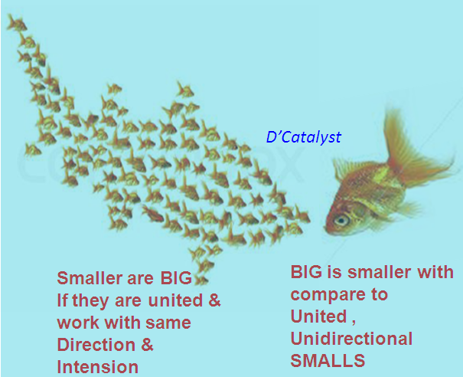
Also always remember,

After understanding all above benefits, no need to discuss the drawbacks of working as an individual.

Once, we are convinced that, working in team is always beneficial, then, it is our duty to be a good team member first & eventual good team leader.
To begin with, let us go through the functions of members & qualities required to become a good team member in next chapter.

Team members & their functions in team
Type of Team Member | Their function
Shaper | Challenge the team to improve.
Implementer | Get things done.
Completer-Finisher | See that projects are completed.
Coordinator | Take on the traditional team leader role.
Team Worker | Negotiators, and make sure the team is working together.
Monitor-Evaluators | Analyze and evaluate ideas that other people come up with.
Specialist | People with specialist knowledge that needed to get the job done.
Plants | Come up with new ideas and approaches.

Select suitable role as per your existing knowledge, competency, experience & capability to handle role. You may choose any role; you have to prove as an acceptable team member by demonstrating following abilities:

9.1 Be an acceptable team member: Listens actively
For teams to function effectively good listeners are most important in team. You shall learn to absorb, understand and consider ideas and points of view from other people without debating and arguing every point. Most important, for effective communication one needs the discipline to listen first and speak second for meaningful dialogue.

Functions as an active participant
Always go prepared for team meetings and listen actively in meeting. Listen first & then speak, take part in discussions. Try to remain fully engaged in the work (goal) of team. Do not seat passively. Do not be carried away, just because of you are not the only responsible team member. Take the initiative to help make things happen, and they volunteer for assignments.

Shares openly and willingly
Share your information, knowledge and experience. Take the initiative to keep other team members informed.
Feel comfortable talking with others, and pass on important news and information. Keep other team members in the loop with information and help to get the job done & prevents surprises. Do not hide anything, if you try to hide sometime, it is going to unveiled by other & people will notice this & avoid you to involve in team.

Cooperates and find way out for keeping team interest at top
Cooperation is the act of working with others to accomplish a job. Despite differences with other team members’ concerning style and perspective, find out ways to work together to solve problems and get work done. Keep your ego out of meeting room or working place.

Exhibits flexibility
Whenever there is change in schedule, plan, sequence, priorities do not get frustrated, adapt to ever-changing situations. Do not complain or are stressed out because something new is tried or some new direction is being set. Change yourself accordingly.
In addition, consider different points of views and compromise when needed. Do not hold rigidly to a point of view and argue it to death, especially when the team needs to move forward to make a decision. Be firm in your thoughts yet open to what others have to offer flexibility at its best.

Shows commitment to the team
Give priority to actions committed in team meeting & care about your part of work. Demonstrate this care and commitment up front. Feel happy & enthusiastic to take a good effort, and help other team members to do the same.

Works as a problem-solver
Be ready to deal with all kinds of problems in a solutions-oriented manner. Be a problem-solvers, not a problem-blamers, or problem-avoider. Do not simply rehash a problem; do not look for others to fault, and do not put off dealing with issues. Get problems out in the open for discussion and then collaborate with others to find solutions and form action plans.
See at least your solution, shall not become a problem. e.g. Sometime after getting medicine allergy arises.

Demonstrates reliability
Consistency is the key, get work done and do your fair share to work hard and meet commitments. Follow through on assignments. Deliver good performance all the time, not just some of the time.

Communicates constructively
You shall speak up and express your thoughts and ideas clearly, directly, honestly and with respect for others and for the work of the team. That is what it means to communicate constructively.
Build bridge & not walls between team members & groups.
To understand teaming & effective leadership, carefully watch the movie “The Bridge on the River kwai”
Which own Alec Guinness the Best Actor Award

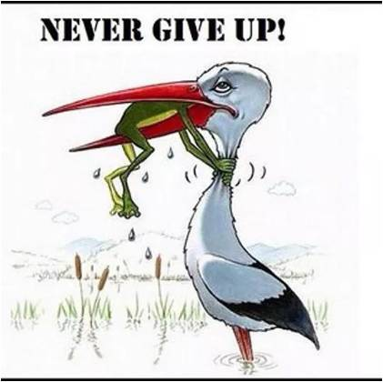
Habit 10: Do not give up
“Do not give-up until you have done.
Do not give-up until you have won.”
You need to keep doing whatever you are doing your efforts will create a boom.
There is famous quote, “When going gets tough, tough gets going.”

To cultivate this habit, preserving nature is very essential & this will acquired through experience in day–to–day life, if children get what they demand within no time, then it is difficult to cultivate preserving nature. In Chinese they say “Don’t give them the fish, teach them how to catch fish” this is to enhance preserving habit within children. Along with preserving nature, the patience is also equally important & need to develop within children to have attributed of not giving up.

Only preserving in nature & patience will not help to come out with the solution to solve difficult situation, it also require
- Ability to accept that, it is not necessary that, others also see the world, the way you see.
- Analyzing
- Out of box thinking
- Risks assess ability risk, while trying alternative solutions.
To tackle though situation one shall be tough enough.
On next page, the storey of frogs illustrates to understand, how the “not to give up type thinking” helps to come out with solution & those do not having this ability simply die without trying even.
Three young frogs playing with each other suddenly fell into a pot of milk, accidently left open at a farmer’s house. The pot was only half filled and the walls of the pot were too high for the frogs, to jump out of the pot. With the passage of time as the night became dark, the milk started to become freezing cold. Moreover, three frogs started shivering with cold. The first frog who was bravest of all, suggested that they should start swimming along the walls of the pot as that will keep their bodies warm. The third frog, which was weakest of all, submitted right away saying, “This is our destiny and we will die tonight” and refused to swim.

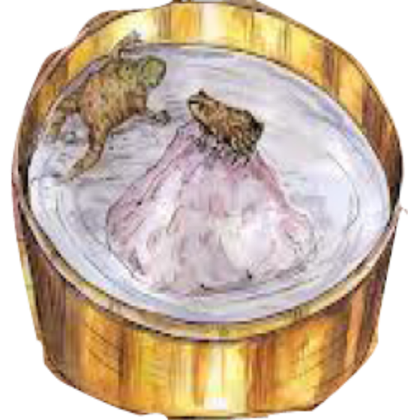
However, the second frog, which had a little beat of courage and was motivated, by first frog’s wordings decided to swim. Nevertheless, as the night progressed and milk became colder, the third frog died of cold and two frogs that were swimming started to fatigue. When our bodies are fatigued, our mental strength keeps us moving.

The second frog, which otherwise was equally strong and equally brave as the first frog, lacked the mental strength. He said to the first frog “It is of no use, the third frog was right, we should submit to destiny” and he stopped swimming. However, the first frog said, “Don’t give up, my friend. Please continue swimming.”
However, the second frog did not listen to him and submitted, within a matter of time he too died of cold. However, the first frog was determined to live; he continued swimming along the walls.

With all this circular movement, the churning of milk had been taking place. Moreover, as the first frog continued swimming, with passage of time a chunk of butter formed in the milk. Surely, the frog did not know this scientific process but he had one thing in mind, “Don’t Give Up.” The chunk of butter, though very small, was product of his determination and firm belief. It gave him the platform upon which he could sit upon and rest without the fear of drowning. He sat on the butter, waiting for the sun to rise and arrival of opportunity to escape. The farmer came in the morning and saw the pot open and with three frogs in it, immediately spilled the milk and first frog that was still alive could feel its feet on ground now. He leapt into the nearby fields with leaps higher than ever.

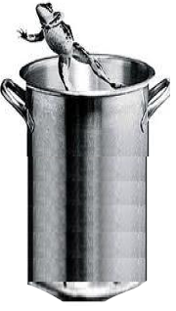

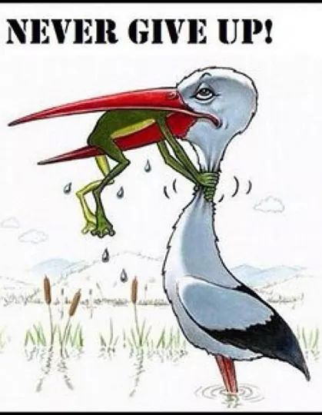

Good habits developed now, will last a lifetime!
These are good habits; you need to set in concrete now. The quicker you make the habits that you live by, the better life you will experience. If you are a parent, then print this list and work on it with your children. Back to school is an excellent time to focus on new habits that will last a lifetime!
The most valuable lessons of life cannot be taught, must be experienced.



Look at the centre of dotted circle you will able to see, there is a girl & a boy sitting in garden, as shown separately.
Now go to back, page 39 & after seeing this page check your earlier view.

Soft
Skill
Soft Skill
Soft skill is a combination of personality, social graces, communication skill, personal habits, friendliness and optimism that influence relationships with other people to achieve result.
OR
Simplest Definition:
Personal attributes that enhance an individual’s interaction, job performance & career prospects.
The ten habits discussed in this book, from starting to this page would help you in developing the most needed ammunition & soft skill to enter, sustain & grow in competitive scenario.

Special Attention is required to develop these soft skills:
In the initial years of your career, your technical abilities are important to get good assignments. However, when it comes to growing, matters more so when several people with similar technical expertise will compete over personality for a promotion.
Training on soft skills becomes all the more relevant where the education system does not deal into personality development.
"Soft skills training are essential because we do not have it in our academic curricula. Therefore, it requires special attention of our own efforts.

Technical/ job-related skills are not enough
Technical and job-related skills are necessary, but they are NOT sufficient when it comes to progressing up the ladder.
With the traditional paternalistic style of leadership becoming passé, professional managers expect their teams to be proactive and communicate openly.
"Soft skills are very important in business. It is essential to be technically sound, but one should also have the ability to convey the idea to the masses in the simplest possible manner,"

With the boom in outsourcing taking root across industries, many professionals and subject matter experts directly deal with their operating personnel on a regular basis.

"Planning is necessary but execution is also equally important. In addition, it takes soft skills to execute any idea because it involves dealing with people directly.

Soft skills "are as important, if not more important, than traditional hard skills to an employer looking to hire, regardless of industry or job type.

Organization could find workers who have "hard skills" i.e. the capability to operate machinery or fulfill other tasks, but many potential hires lack the "soft skills" that a company needs.

Organizations’ are ready to hire workers who demonstrate a high level of "soft skills" and then train them for the specific jobs available. The ever-changing impact of technology has given hard-skills-very short shelf life.

List of Soft skill
This list is endless there are more than hundred soft skills required to perform, out of these all need not be focused & need not call for special attention. In this book only those soft skills are discussed which required special attention right from teen age to develop.
- Listening
- Working with team
- Time Management
- Communication skill
- Good attitudes
- Willingness to learn
- Understand the way other may look at situation/event
Out of these seven soft skills, first three already discussed in detail somewhere in this book earlier.

Communication skill
Simplest way of defining this skill is, this is clear & pure expression of thoughts & actions to achieve desired result with available resources & means.
Without effective communication, correct exchange of thoughts would not be possible.
Communication is a vast subject itself & cannot discuss thoroughly in the scope of this book. Dedicated books, training programs, articles & presentations are available to know, learn & acquire this skill.
Briefly, it is not a simple exchange of thought. Important aspect of communication is first to understand & then expect to be understood by others.
After listening & processing your thought, while speaking, mind your three ‘P’s Pause, Punch & pitch. Try to learn to take sufficient pause even between the words if necessary. Assert important word with punch & change pitch accordingly.
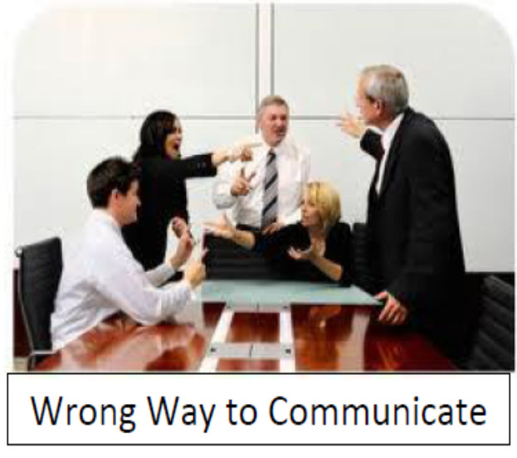
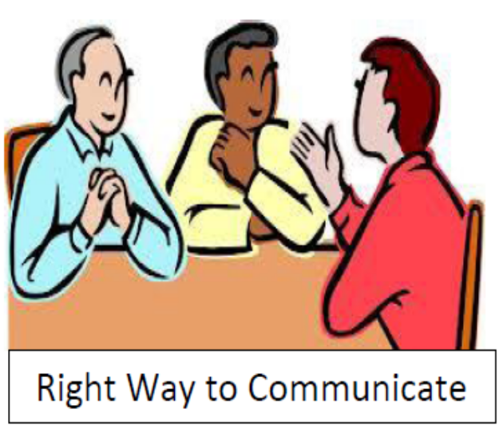
Mind your body language to communicate your thoughts & action in pure form.

Good Attitudes
"It is a behavioral skill, which cannot be taught. However, it can develop through continuous training. It represents the reactive nature of the individual and is about looking at things with the right perspective.
You must be ready to solve problems proactively and create win-win situations. Learn to take ownership i.e. responsibility for your actions and lead from the front without calling it quits at the most critical moment.

Willingness to learn
It is a part of human nature to resist change. We call it a comfort zone for a reason and typically do not want to get out of it.
Willingness to learn is an ability to perceive that there could be

New things to learn and improve our knowledge in the specific area.
The more you know, the more you find there is to know.

Admitting that, we cannot know all. May well be the first step toward knowing more.
Build trust by saying “I don’t know. This trust puts us on the road to greater learning.
Get rid of the word, which stops you from learning
I CAN’T…I CAN’T…I CAN’T…I CAN’T…I CAN’T…
If you think that you have learnt enough and that there is nothing new to be learn, a stagnation will set, in which you will eventually outdated and even useless in the organization & your circle of society.

The world in which we live is moving so fast. There are new applications and ideas. This simply sweeps away the dirt of the accumulated years.

To stick to old and tried method is of course good. Nothing is wrong with this. However equally important is, to keep our eyes and ears open so that new better alternatives can be learnt to enrich our knowhow. New ideas can lighten the present burden.

We can always discard the new ideas if they are not as effective as the older ones, but after learning & trying.

It enhances our wisdom, understanding and knowledge every time when we learn new things.

Not to learn new things means inviting walking on pins and needles

Understand the way rest of the world looking at Situations:
It is not necessary that, others would see the world, the way you see and visa-a-versa. To remove the parallax between your view & others’ view, a habit of openness needs to be developed to see the world through eyes of others. To achieve this we should come out of our own perception. Try to see other side of coin.
This skill will help to remove communication gap, after asserting your view, get confirmation from listeners that he also perceived the sentence in same manner as that of you.

Difference between Hard skill & Soft skill
Hard Skills
Hard skills are skills where the rules stay the same regardless of which company, circumstance or people you work with. In contrast,
hard skills are specific, teachable abilities based on fact.
Hard skills can learned in school and from books. There are usually designated level of competency and a direct path as to how to excel with each hard skill. For example, accounting is a hard skill. You can take basic accounting and then advanced accounting courses. You can then work to get experience and then take an exam and certified as a CA, etc.
examples include:
• Speaking a foreign language
• Typing speed
• A degree or a certificate
• Proficiency in computer programming
• Customer service experience
• Operating machinery

Soft Skills
Soft skills are self-management skills and people skills where the rules changes depending on the company culture and people you
Work with.
There is no simple path to learn soft skills. Most of the soft skills not taught well in school and have to learn on the job by trial and error.
Soft skills are subjective. They are often associated with personal attributes and character. Some examples include:
• Motivated team player
• Strong communication skills
• Time management
• Organizational skills • Reliable, responsible, committed
Tip to improve soft skill.
Read this book from start to end, discuss with your parents, teachers & most important,
Be your own trainer!
Some input for students, to initiate the process.

- Be a part of team activities
It could be either as a part of your local youth circle.
Observe your own behavior in the group and the way you relate to others.

ii. Ask family members or close friends to write down your best and worst
Have at least four to five people do this for you.
Evaluate the common trends all of them have mentioned.
Thus, you can be aware of your strengths and work improving your weaknesses.

III. How well do you manage your time?
Prioritize your activities as explained in habit 6 in this book. Avoid non-urgent, non-important activities from schedule.
Can you do more in life? Alternatively, is your day too crammed with activities?
iv. Introspect on how you react to feedback.
This skill comes to surface, when there is feedback given be it for an idea, an executed project.
Others judge you by the way, you respond to feedback.
Do you get defensive? Do you insist you were right?
Positively accept criticism & improve upon.

v. How good are you at analyzing?
While responding to feedback is one side of the coin, giving feedback is the other side.
Are you aggressive? Do you believe in constructive criticism? Alternatively, prefer to be the yes-man.

In addition to above
1 Build self-awareness – Understand why you react to certain situation & people in a certain way, why you become, stressed, irritated, angry & shy etc. In order to develop any self-management skills, first need to understand yourself.

2 Understand other people’s motivations – with any interaction with people, what you are dealing with is your motivation. Any action that causes conflict in motivation or triggers your or other person’s insecurity will create a difficult or unexpected situation. By proactively trying to put yourself in their shoes before any interaction, you could communicate better and can better manage your reaction to unexpected situations
3 Do not try to chew at a time more than your mouth’s capacity – This means do not try to achieve too much in one-step. You will set yourself up for failure and end up feeling defeated. You cannot improve all your soft skills over night, so identify one soft skill you want to start with. Start researching (books, blogs, etc…) and practice on that one skill.

- It is all about changing yourself not others – Some people may think, improving soft skills can help you manipulate/change others’ actions. It is not true. Improving soft skills is all about changing yourself, your perception, your approach to situations. Only when you change, will people’s reaction to you also change.

- Practice, Practice, Practice – soft skills are not something you can just study in a book to get better, improvement takes practice over the time. Fundamentally, improving soft skills is about changing your behavior and thought patterns toward yourself and others. So every next interaction you have with people at work is an opportunity to practice a soft skill.
Practice makes man perfect!
It is important not to pretend to be something you are not

Be a happy and successful person!
Anil Dhasal

