Steps for Auto Regression

1.Clone the repo <https://github.com/RajeshKumarMishra/Auto-Regression-Tool.git> to your build machine or PC.

2. Update the BinaryTool.json as per requirement.

3.Clone the repo <https://github.com/intel-innersource/firmware.boot.iot.uefi.tools.ubit.git> in the Host Machine connected to SUT.

4. Install python from bat/ReadMe/Installer/python-3.8.0-amd64.exe .

5. Run bat/PackageInstaller.bat from cmd prompt to install modules and resolve dependencies.

6. Update the HostConfig details at bat/Configs/EAGLESTREAM/HostConfig/HostConfig.json

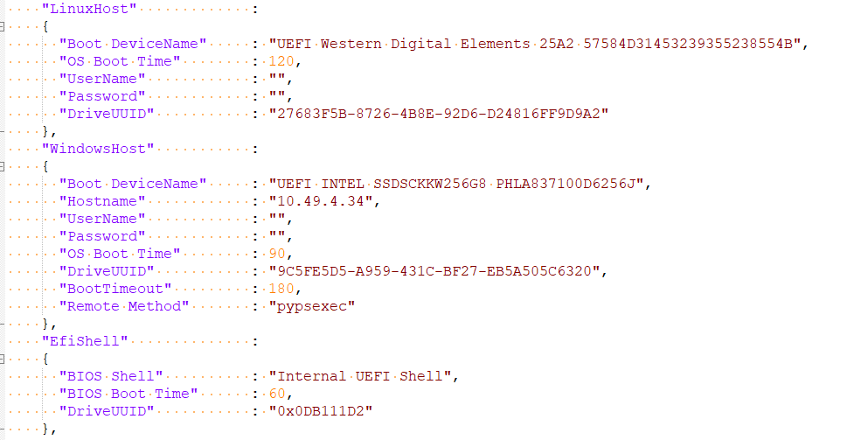  
The Linux Host/WindowsHost/EfiShell entries are the possible booting devices in the SUT

7. In the Host Machine Create a folder Samples, subfolder Current Execution and a batch file Execution.bat

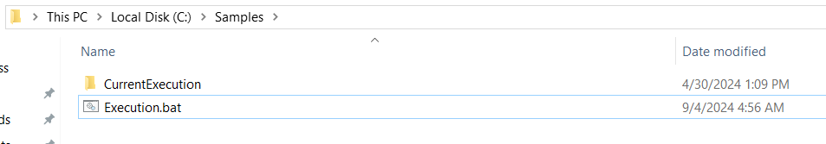

8. The content inside Execution.bat is “py bat/main.py -icf CORP_BG5_PS_INT_REL -hcf bat/Configs/EAGLESTREAM/HostConfig/HostConfig.json -tcf BinaryTool.json”

9. Copy AutoTest.py from Build Machine to Host Machine ‘s bat/TestCases folder  
Note: Steps 3 through 9 are part of a one-time update process

10. Run BiosRegression.py from your Build Machine/PC