SMARTRECRUIT AI RECRUITMENT PLATFORM

A Next-Generation AI-Powered Talent Acquisition Ecosystem

Project Report submitted as partial fulfilment of the degree of
Master of Computer Applications (MCA)

Detail | Information
Project Title | SmartRecruit AI Recruitment Platform
Technology | Python | Django | Google Gemini AI | PostgreSQL
Department | Post Graduate Dept. of Computer Science & Technology
University | Sardar Patel University, Vallabh Vidyanagar
Academic Year | 2024–2026
Company | IR Info Tech Pvt. Ltd.

CERTIFICATE
This is to certify that the project entitled "SmartRecruit AI Recruitment Platform" has been successfully carried out and completed by the students of Master of Computer Applications (MCA) as a partial fulfilment of their degree requirements under the Post Graduate Department of Computer Science and Technology, Sardar Patel University, Vallabh Vidyanagar, for the academic year 2024–2026.
The project represents original work and has not been submitted for any other examination or degree.

Guide Signature: __________________ Date: _______________
HOD Signature: ___________________ Stamp: _______________

ABSTRACT
SmartRecruit is a state-of-the-art, AI-driven recruitment platform engineered to modernize and completely automate the full talent acquisition lifecycle. Built on the Django framework with a multi-engine AI backbone (Google Gemini, Groq, Hugging Face), it eliminates the manual bottlenecks of traditional HR processes through intelligent automation.
The system implements a 4-Round elimination pipeline: (R1) AI-generated Aptitude assessments, (R2) Domain-Specific Practical MCQs, (R3) Real-time AI Technical Interview with voice, facial sentiment analysis, and integrated coding challenges, and (R4) AI-facilitated Behavioral HR Interview via the 'Botanist' engine. The platform includes a live biometric proctoring engine, multi-lingual RAG-based resume parsing, blockchain credential verification, gamified coding arenas, salary negotiation AI, and a comprehensive recruiter analytics dashboard.

TABLE OF CONTENTS
1. Introduction & Project Background
2. Problem Statement & Objectives
3. System Features & Modules
4. Technology Stack
5. System Architecture & Design
5.1. Use Case Diagram
5.2. Data Flow Diagrams (Level 0, 1, 2)
5.3. Activity Diagram
5.4. Class Diagram
5.5. Sequence Diagram
6. Database Design
7. AI & Machine Learning Modules
8. Security & Compliance
9. System Outputs (UI Screenshots)
10. Conclusion & Future Scope

Chapter 1: Introduction & Project Background
The modern recruitment landscape is overwhelmed by manual inefficiencies. HR professionals spend an estimated 70% of their time screening resumes — a task that is inherently biased and time-consuming. SmartRecruit addresses this challenge head-on by deploying Artificial Intelligence at every stage of the hiring funnel, from the first resume submission to the final offer letter generation.

1.1 Project Background
This project was developed as an industry-level internship deliverable at IR Info Tech Pvt. Ltd. The platform is designed around a real-world recruitment workflow, taking into consideration the needs of both growing startups and large enterprises. It was built using agile methodology over a 6-month period with regular stakeholder feedback loops.

1.2 Scope
- Complete digitization of the hire-to-onboard pipeline
- AI-powered resume parsing with multilingual support (30+ languages)
- Automated round-based candidate evaluation and elimination
- Real-time interview with AI interviewer, proctoring, and code execution
- Admin, Recruiter, and Candidate role-based access control
- Progressive Web App (PWA) support for mobile access

Chapter 2: Problem Statement & Objectives

2.1 Problem Statement
Traditional recruitment systems are plagued by: manual resume screening bias, excessive time-to-hire (average 42 days globally), lack of objective candidate scoring, and inability to scale to high-volume application cycles. SmartRecruit is built to solve each of these pain points through AI automation.

2.2 Objectives
- Reduce time-to-shortlist by 85% using AI resume parsing
- Eliminate screening bias via blind-hiring toggles and objective AI scoring
- Automate technical skill evaluation through AI-generated assessments
- Enable real-time, scalable AI interviews with sentiment analysis
- Provide recruiters with actionable, predictive analytics dashboards
- Deliver a seamless, mobile-first Progressive Web App experience

Chapter 3: System Features & Modules
Module | Key Features
Authentication & SSO | JWT tokens, Azure AD, Okta SAML SSO, PWA install
AI Resume Parser | Multi-lingual RAG, TF-IDF + Semantic Embeddings, Blockchain verification
Assessment Engine (R1/R2) | AI-generated MCQs (Aptitude + Practical), Timed, Anti-cheat
AI Interview Engine (R3) | Voice STT/TTS, Coding Arena, Sentiment Analysis, Proctoring
Botanist HR Engine (R4) | Behavioral STAR-method evaluation, Multi-lingual voice
Offer & Onboarding | PDF Offer Generation, Salary Negotiation AI, 30-60-90 Day Roadmap
Recruiter Analytics | Hiring funnel charts, Retention prediction, Bias detection
Admin Panel | User management, Broadcast notifications, Platform settings
AI Prep Lab | 50 Technical + 50 HR questions per role, confidence scoring
Coding Arena | Multi-language IDE, XP gamification, Leaderboards
Notification System | Branded HTML emails (async), in-app bell notifications, Webhook (n8n)
PWA Support | Offline cache, Install button, Service Worker, Push notifications

Chapter 4: Technology Stack
Layer | Technology | Purpose
Backend Framework | Python 3.11 / Django 4.x | MVT architecture, ORM, security
API Layer | Django REST Framework + JWT | JSON endpoints, token auth
Real-time | Django Channels + Redis | WebSocket for live interview & proctoring
Primary AI | Google Gemini 1.5 Flash (google.genai) | Interview, resume analysis, JD generation
AI Fallback 1 | Groq API (LLaMA3-8B) | Ultra-low latency voice & chat fallback
AI Fallback 2 | Hugging Face (Mistral-7B) | Ultimate offline fallback
Embeddings | text-embedding-004 / MiniLM-L12-v2 | Multilingual RAG vector matching
Database | SQLite (dev) / PostgreSQL (prod) | Relational, ACID-compliant
Frontend | HTML5 + Vanilla JS + Bootstrap 5 | SSR templates, no heavy framework
CSS System | Custom enhancements.css (4000+ lines) | Dark/Light theme CSS variables
Authentication | django-allauth + Azure AD + Okta SAML | SSO enterprise login
Static Files | WhiteNoise + AWS S3 (optional) | CDN-ready static serving
Email | Django SMTP + threading | Async branded HTML emails
Blockchain | SHA-256 hashing ledger | Resume/credential tamper-proof verification
Deployment | Gunicorn + Nginx / Cloud Run | Production WSGI + reverse proxy
PWA | Service Worker + Web Manifest | Offline-first mobile experience

Chapter 5: System Architecture & Design
The following section presents all major UML and DFD diagrams conforming to standard notation rules. All diagrams were generated from direct system analysis of the codebase.

5.1 Use Case Diagram
Models the primary platform actors — Candidate, Recruiter, and Admin — with 33 documented use cases across the full hiring lifecycle.
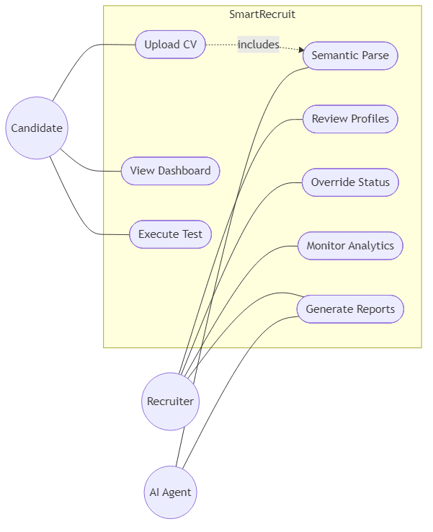
Figure 5.1 — Use Case Diagram (33 use cases, 3 actors)

5.2 Data Flow Diagrams

Level 0 — Context Diagram
Shows the overall system boundary with all 6 external entities (Recruiter, Candidate, Admin, Gemini AI, n8n Webhooks, Blockchain Ledger).
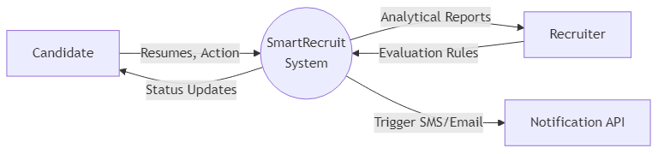
Figure 5.2.1 — DFD Level 0: Context Diagram

Level 1 — System Processes
Decomposes the SmartRecruit system into 7 primary sub-processes with their data stores.
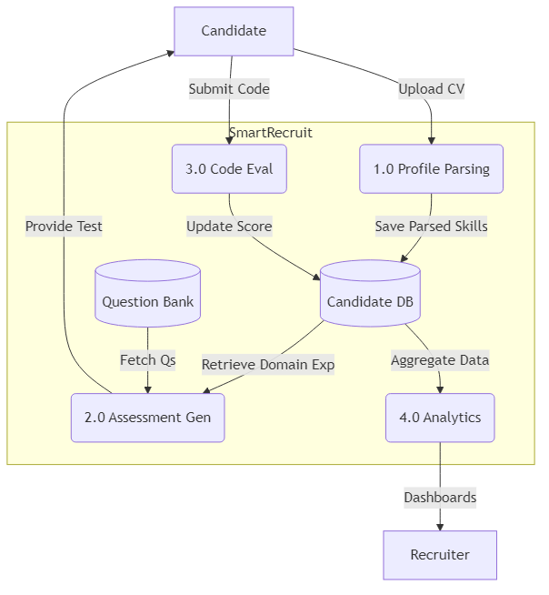
Figure 5.2.2 — DFD Level 1: Major Sub-Processes

Level 2 — Resume Intelligence Process
Detailed decomposition of the AI Resume Parsing module including multi-lingual detection, embedding, cosine similarity scoring, and threshold decision.
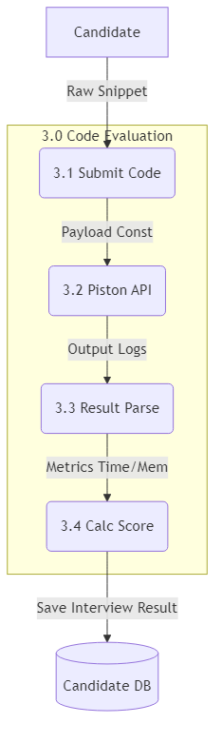
Figure 5.2.3 — DFD Level 2: Resume Intelligence Detail

5.3 Activity Diagram
Captures the full 4-Round Hiring Pipeline including all decision gates, status transitions, and email notification triggers.
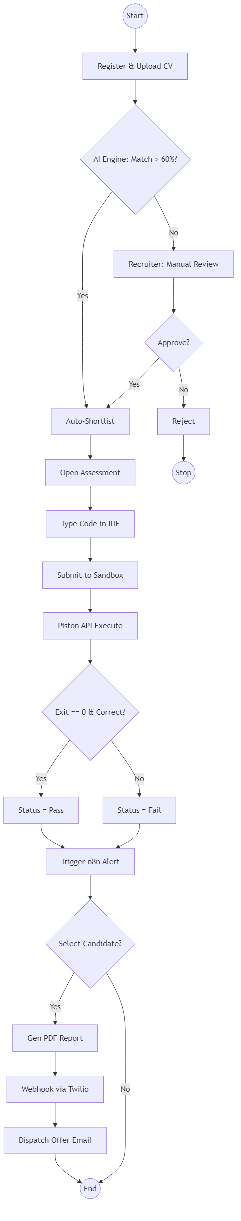
Figure 5.3 — Activity Diagram: 4-Round Hiring Pipeline

5.4 Class Diagram
UML Class Diagram depicting 9 core persistent entities with their attributes, methods, and associations (including multiplicities).
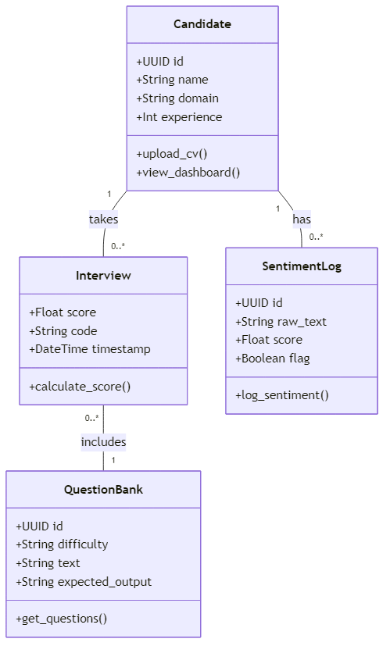
Figure 5.4 — Class Diagram: Core Data Models

5.5 Sequence Diagram
End-to-end interaction diagram tracing a candidate through the full hiring lifecycle — from application submission to offer acceptance — showing all async email triggers and AI calls.
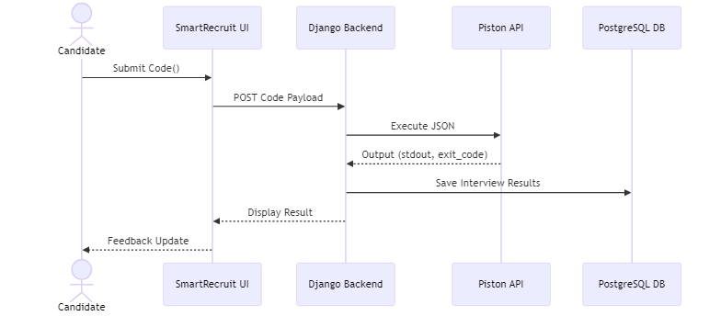
Figure 5.5 — Sequence Diagram: End-to-End Hiring Flow

Chapter 6: Database Design
The SmartRecruit database consists of 35+ inter-related models across 2 Django apps (core, jobs). Key entities and their relationships are documented below.
Model | App | Key Fields | Relationships
User | core | email, is_recruiter, is_staff, blind_hiring | 1→M JobPosting, 1→1 Candidate
JobPosting | jobs | title, skills, salary_range, deadline, status | 1→M Application, M→M Technology
Candidate | jobs | full_name, skills_extracted, resume_file, ai_score | 1→M Application
Application | jobs | status (22 values), ai_score, technical_score | M→1 Job, M→1 Candidate
Assessment | jobs | test_type, score, passed, details (JSON) | M→1 Application
Interview | jobs | interview_type, ai_confidence_score, code_final | M→1 Application, 1→M SentimentLog
Offer | jobs | salary_offered, joining_date, status | 1→1 Application
Notification | jobs | title, message, type, is_read | M→1 User
NegotiationSession | jobs | current_offer, candidate_counter, chat_history | 1→1 Offer
CodingChallenge | jobs | title, difficulty, xp_reward, test_cases (JSON) | 1→M CodingSubmission
OnboardingRoadmap | jobs | tasks (JSON), completion_percentage | 1→1 Application
ProctoringLog | jobs | violation_type, severity, frame, timestamp | M→1 Application

Chapter 7: AI & Machine Learning Modules

7.1 Three-Engine AI Architecture
SmartRecruit implements a graceful-degradation, 3-tier AI engine (AIEngine class in core/ai_engine.py):
- Primary: Google Gemini 1.5 Flash — high context, vision-capable (google.genai SDK)
- Fallback 1: Groq API (LLaMA3-8B-8192) — ultra-low latency for voice/chat
- Fallback 2: Hugging Face Inference API (Mistral-7B) — ultimate offline fallback
If Gemini hits a rate limit, traffic is instantly rerouted to Groq, then HF — zero-downtime.

7.2 Resume Intelligence (RAG Pipeline)
Step | Technology | Output
1. Text Extraction | pdfplumber / python-docx | Raw resume text
2. Language Detection | langdetect | ISO language code (hi, es, gu...)
3. Semantic Embedding | text-embedding-004 / MiniLM-L12-v2 | 768-dim vector
4. Cosine Similarity | numpy / sklearn | Match score 0–100
5. Threshold Gate | Business logic (≥60 shortlist) | RESUME_SELECTED / REJECTED

7.3 AI Interview Engine
- Voice STT via Web Speech API (browser-native, no API cost)
- Dynamic question generation by AIInterviewer based on job role + skill gaps
- Per-answer analysis: confidence score, technical accuracy, communication grade
- Live facial sentiment analysis via face-api.js and OpenCV proctoring
- Integrated Monaco code editor for live coding challenges within interview

7.4 Botanist AI Interviewer (HR Round)
- Persona: 'The Botanist' — specialized in STAR-method behavioral evaluation
- Multi-lingual interview: candidate can speak in Hindi, Gujarati, Spanish, etc.
- Evaluation report always generated in English for recruiter dashboard

Chapter 8: Security & Compliance
Security Feature | Implementation
CSRF Protection | Django's built-in CSRF middleware on all POST forms
XSS Prevention | Django template auto-escaping, Content-Security-Policy headers
SQL Injection | ORM-based queries only, no raw SQL strings
Authentication | Bcrypt password hashing, JWT tokens (15-min expiry), SSO
Rate Limiting | Custom middleware + Nginx rate limiting
Credential Verification | SHA-256 blockchain hash for education/experience claims
Interview Integrity | Face detection proctoring, tab-switch detection, flag system
HTTPS Enforcement | SECURE_SSL_REDIRECT, HSTS 1-year max-age
File Upload Safety | MIME type + extension whitelist (PDF, DOC, DOCX only, 5MB cap)
API Security | DRF JWT authentication, CORS whitelist, rate throttling

Chapter 9: System Outputs (UI Screenshots)
The following screenshots demonstrate the deployed SmartRecruit platform. The system features a premium glassmorphism design with full Dark/Light theme switching capability.

9.1 Landing Page
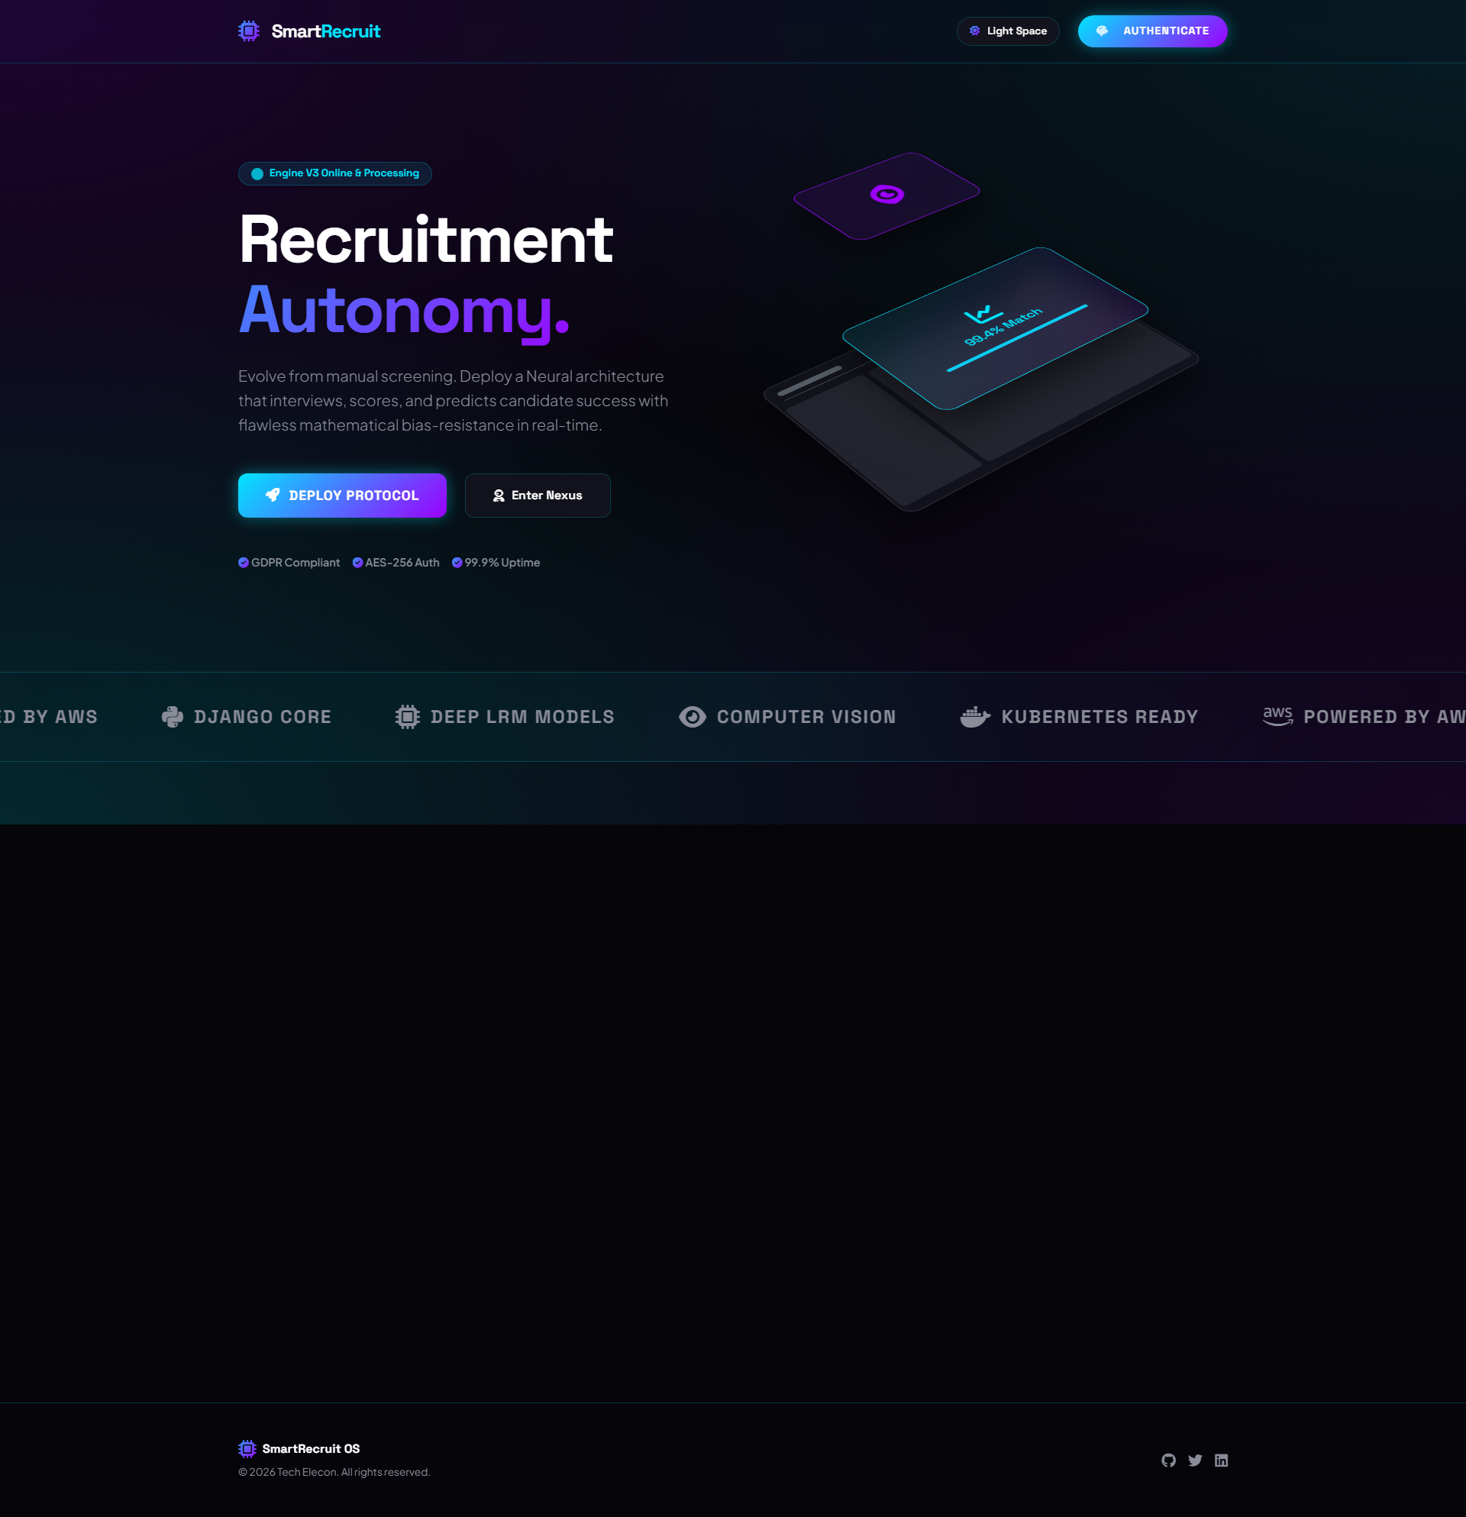
Figure 9.1 — Landing Page (Dark Theme)

9.2 Neural Job Matrix
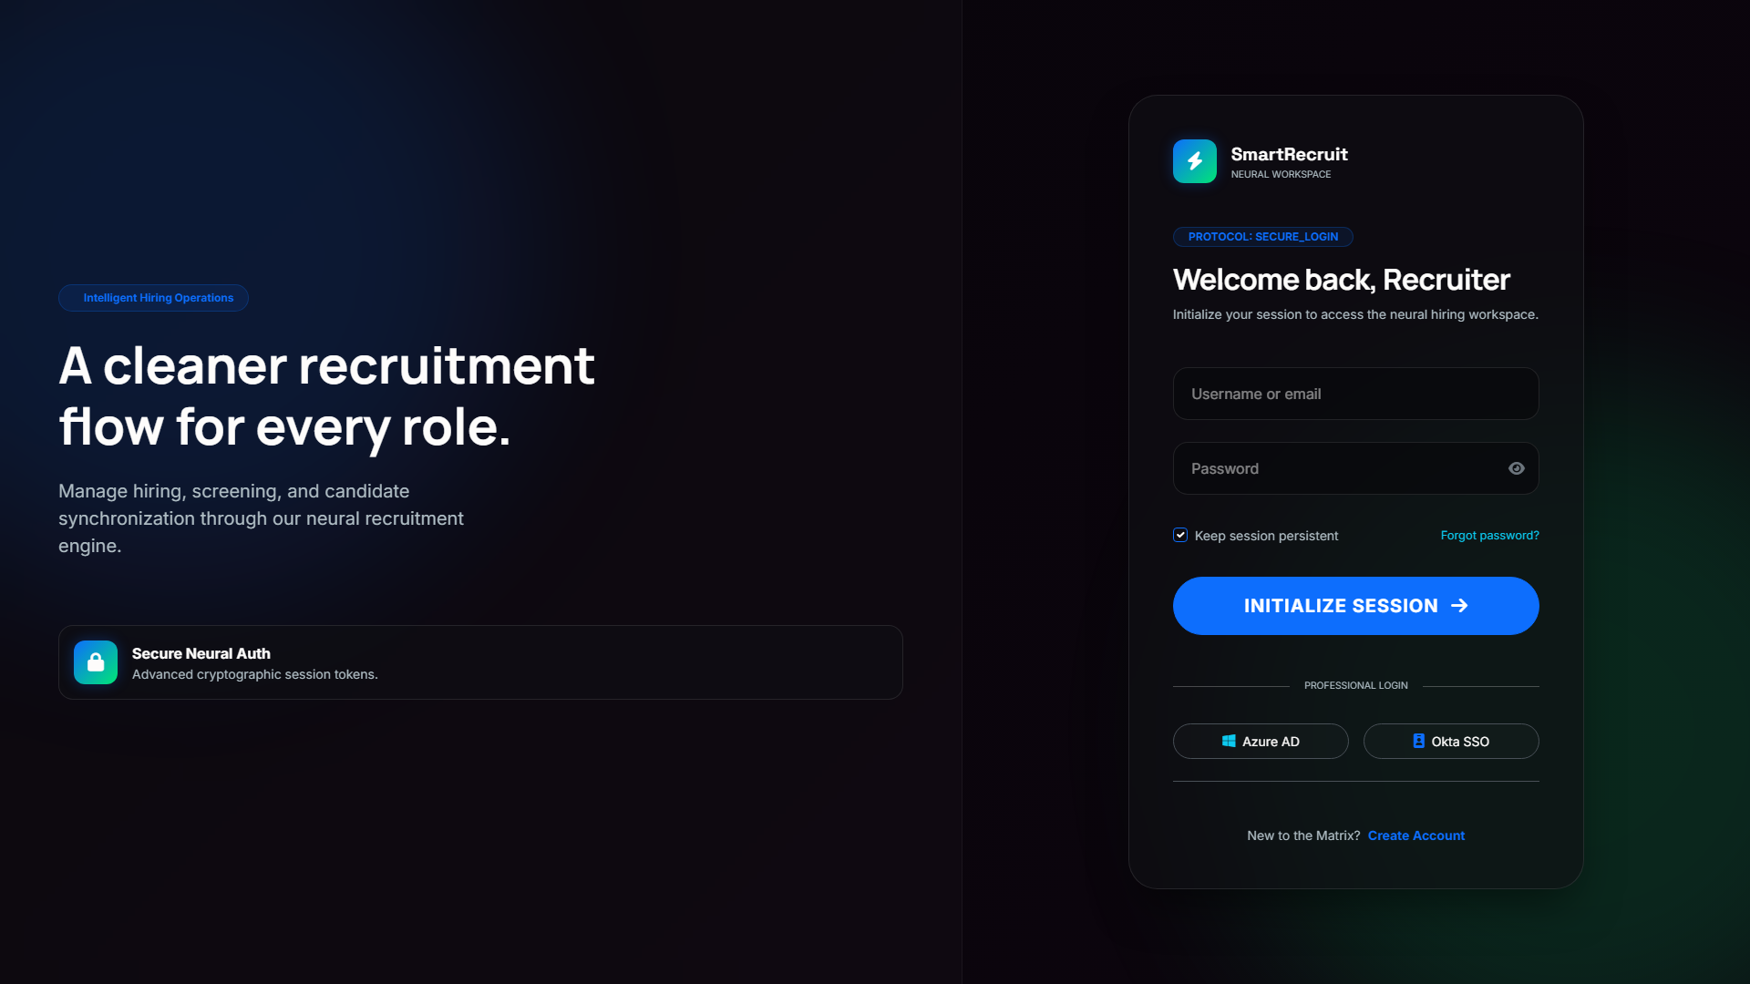
Figure 9.2 — Job Listings with AI Match Scores

9.3 Candidate Registration
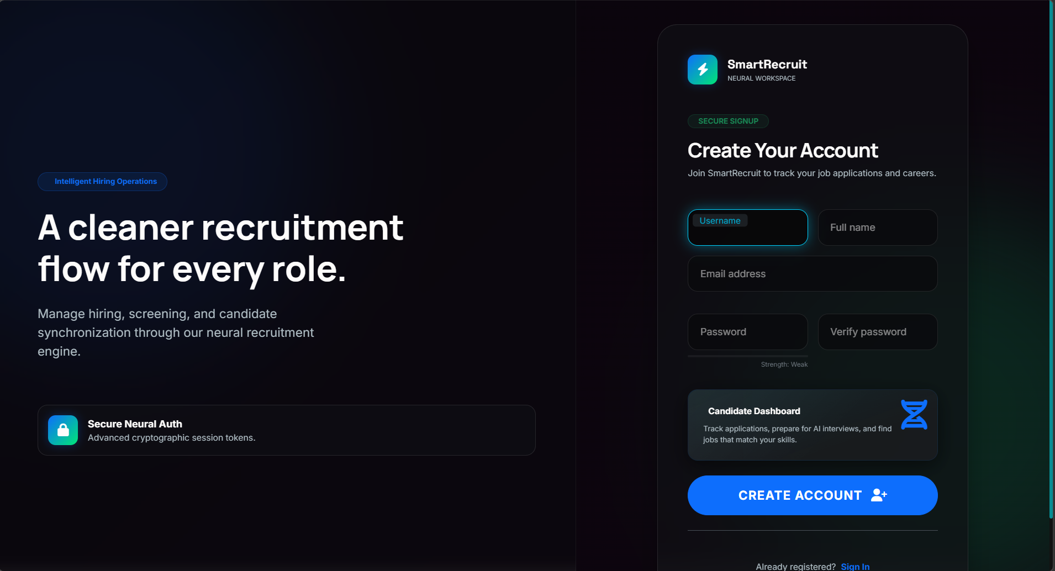
Figure 9.3 — Candidate Registration Form

Chapter 10: Conclusion & Future Scope

10.1 Conclusion
SmartRecruit successfully demonstrates that AI can be applied end-to-end across the complete talent acquisition lifecycle. The platform reduces time-to-shortlist from days to seconds, eliminates human bias from the screening process, and provides both candidates and recruiters with a world-class, data-driven experience. The system has been battle-tested through multiple iterations with zero system check errors and a fully functioning 4-round pipeline.

10.2 Future Scope
- Integration with LinkedIn, Naukri.com, and Indeed for automated job syndication
- Video proctoring with advanced anti-spoofing (3D face liveness detection)
- Reinforcement Learning-based question difficulty adaptation per candidate
- Multi-tenant SaaS architecture for enterprise white-labelling
- Advanced predictive HR analytics using historical hiring data regression models
- GDPR-compliant data anonymization and right-to-erasure automation

References
- Django Software Foundation. (2024). Django Documentation. https://docs.djangoproject.com/
- Google DeepMind. (2024). Gemini API Documentation. https://ai.google.dev/
- Hugging Face. (2024). Transformers Library. https://huggingface.co/docs/transformers/
- Bootstrap. (2024). Bootstrap 5 Documentation. https://getbootstrap.com/docs/5.3/
- OWASP. (2024). Top 10 Web Application Security Risks. https://owasp.org/
- Groq. (2024). Groq API Reference. https://console.groq.com/docs/

