SMARTRECRUIT AI RECRUITMENT PLATFORM

A Next-Generation AI-Powered Talent Acquisition Ecosystem

Project Report submitted as partial fulfilment of the degree of
Master of Computer Applications (MCA)

Submitted by
Candidate Name
Seat No.: XXXX

Post Graduate Department of Computer Science and Technology
Sardar Patel University
Vallabh Vidyanagar

Submitted to
SARDAR PATEL UNIVERSITY
Vallabh Vidyanagar
April 2026

CERTIFICATE
This is to certify that Candidate Name of Master of Computer Applications (MCA) IV semester has worked on the project entitled SmartRecruit AI Recruitment Platform satisfactory towards the partial fulfilment of the degree of Master of Computer Applications (MCA) during the final semester at the Post Graduate Department of Computer Science and Technology, Sardar Patel University, Vallabh Vidyanagar, Gujarat, India.

Date of Submission 25th April, 2026

Internal Project Guide Head of the Department

ACKNOWLEDGMENT
Acknowledging everyone is difficult, but I will still try to express my gratitude to each and every one who has helped me in the completion of this project.
I am indebted to Tech Elecon Pvt. Ltd. and my company guides who devoted their precious time to help me understand the platform that I have been a part of; without their assistance, I would not have been able to build up a good Application.
I am grateful to my Internal Project Guide, for their prolonged interest in my work and excellent guidance. They have been a constant source of motivation for me. By their uncommon promising demand for quality and their insistence on meeting the deadlines, I was able to accomplish such an excellent work.
I express my sincere gratitude to the Head of the Department. They have been very good mentors who were always available for helping me with any kind of queries that I would have regarding the topic and anything that would be a hurdle in the development of my application.
And last but not least, I would like to acknowledge the cooperation extended by all those persons who have directly or indirectly helped me during the course of this project.

INDEX
1. INTRODUCTION
2. DEPARTMENT PROFILE
3. COMPANY PROFILE
4. PROJECT OVERVIEW
4.1 TEAM INFORMATION
4.2 DIVISION OF WORK
4.3 PROJECT DEFINITION
4.4 PURPOSE & OBJECTIVE OF THE PROJECT
4.5 SCOPE OF THE SYSTEM
4.6 KEY FEATURES
4.7 SYSTEM DESIGN TECHNOLOGY STACK
4.8 LIMITATIONS
5. SYSTEM ANALYSIS
5.1 EXISTING SYSTEM
5.2 NEEDS OF SYSTEM
5.3 PROPOSED SYSTEM
5.4 MODULES
5.5 PROJECT MANAGEMENT
5.6 SYSTEM REQUIREMENT SPECIFICATION
5.7 SOFTWARE DEVELOPMENT TOOLS
6. SYSTEM DESIGN
6.1 USE CASE DIAGRAM
6.2 ACTIVITY DIAGRAMS
6.3 ER DIAGRAM
6.4 DFD (DATA FLOW DIAGRAM)
6.5 SEQUENTIAL DIAGRAM
6.6 CLASS DIAGRAM
7. DATA DICTIONARY
8. SYSTEM OUTPUT
8.1 SCREEN SHOT [ADMIN]
8.2 SCREEN SHOT [USER]
9. TESTING
10. FUTURE ENHANCEMENT
11. CONCLUSION
12. BIBLIOGRAPHY

1. INTRODUCTION
The SmartRecruit AI Recruitment Platform is a highly advanced, intelligent recruitment portal designed to fully automate the hiring lifecycle. By taking advantage of Google Gemini Large Language Models, dynamic skill embeddings, and real-time biometric proctoring, it minimizes the manual overhead experienced by traditional HR departments.
In today's fast-paced corporate environment, screening resumes, scheduling technical coding rounds, and conducting tedious behavioral interviews results in a significant financial and time commitment. SmartRecruit solves these core inefficiencies through a robust 4-Round AI evaluation pipeline: Resume Parsing & Match score, Technical Aptitude MCQ generation, Real-time AI Video Interview & Code Exec, and an AI HR Simulation 'Botanist' round.

2. DEPARTMENT PROFILE
GH Patel PG Department of Computer Science & Technology,
Sardar Patel University, Vallabh Vidyanagar
The Department of Computer Science was established in year 1986 as an institution offering postgraduate in Computer Science. The computing facility, however, was introduced at the Sardar Patel University somewhere in 1973-74 at Computer centre of the University with an IBM 1620, a second-generation mainframe computer. The University started one-year Post Graduate Diploma in Computer Applications (PGDCA) course in 1986, M.Sc. (Computer Science) in 2008, Ph.D. (Computer Science) in 1990 and Ph.D. (Bioinformatics) in 2011.
Besides these programs, the University also started computer related short-term programs from time to time. The computing resources were also used by different postgraduate departments of the University for their Research Work. The institute took lead in Establishment started a CSI (Computer Society of India is a national professional body having links with various professional bodies in India and abroad) in 1985-86. Various workshops, seminars and symposia have been organized under the CSI banner so far, which have strengthened both the teaching and research activities of the Department. In the year 1988, Late Shree Goradhanbhai Hathibhai Patel donated money to the University for a Separate building of the Post Graduate Department of Computer Science. The Department also recognized by UGC to provide technical training to personnel at various levels of academia and administration. Several PC based systems had been Installed and major research work carried out in the areas of CAI (Computer Aided Instruction), KBS (Knowledge Based Systems) and DSS (Decision Support System). In 1992. The M.Sc. In Computer Science Program was terminated and intake of the MCA Program was Increased from 30 to 40. Three faculty members were selected on the basis of merit for the CICC-Japan training in the years 1992, 1994 and 1995.
Early 2000 was the time when vast technological changes took place in the IT industry all over the world. The department could meet the technological requirements through support from the UGC, AICTE and various bodies of the state. A networked laboratory was established at the department, providing state-of-the-art facilities. The intake to MCA was increased to 100 by introducing self-financed seats in the year 2000, and a separate self-financed batch of MCA was started. The department was recognized and offered 'Refresher Courses in Computer Science' for the Computer Science faculty members in India by the University Grants Commission. In the year 2002, a special MCA program was introduced for providing lateral entry Into the Second year to computer science graduates. In a short span, the department grew to the extent that a new building was required. With one more generous donation from Late Shree Goradhanbhai Hathibhai Patel, grants from the UGC and he state government and the department with modern infrastructure was constructed. The building was inaugurated on July 22nd, was then changed to G H Patel Post Graduate Department of Computer Science and Technology in the year 2002. Subsequently, new powerful servers and several workstations were added to the laboratory and electives for bioinformatics and wireless networks were added to the syllabus. The M.Sc. (Bioinformatics) program under the UGC Innovative Program scheme was introduced in the year 2005.

3. COMPANY PROFILE

Tech Elecon Pvt. Ltd.
TECH ELECON plays pivotal role in IT sector of 'Elecon group' companies. Ever since its inception TECH ELECON has grown by leaps and bounds. In 1990 TECH ELECON achieved status of an independent corporate entity making its initial presence felt in the area of software development.
TECH ELECON Pvt. Ltd., headquartered in Gujarat, has transitioned from an in-house IT service provider for the Elecon Group into a comprehensive IT solutions enterprise. It delivers wide-ranging software services, system integration, network infrastructure solutions, ERP deployments, and custom web application development to modern businesses. The company is characterized by a firm commitment to technological advancement and software engineering excellence.
Address: Anand Sojitra Road, Vallabh Vidyanagar 388120, Gujarat, India
Website: www.techelecon.com

4. PROJECT OVERVIEW

4.1 TEAM INFORMATION
Developer: [Candidate Name]
Organization: Tech Elecon Pvt. Ltd.

4.2 DIVISION OF WORK
The project work was systematically divided into frontend engineering (HTML/Bootstrap, Glassmorphism AI UI), backend engineering (Django, REST Framework, JWT), API integrations (Google Gemini, Mistral AI, Piston Sandbox), and Real-time Communications (WebRTC, Django Channels).

4.3 PROJECT DEFINITION
SmartRecruit is an end-to-end recruitment management system offering AI-based candidate screening, competency mapping, dynamically generated assessments, real-time proctored technical evaluations, and in-depth predictive reporting for HR practitioners.

4.4 PURPOSE & OBJECTIVE OF THE PROJECT
- Purpose: Automate the labor-intensive stages of talent acquisition, reducing bias and costs.
- Objective 1: Reduce Shortlisting Time via Semantic Embeddings and Blockchain credential logging.
- Objective 2: Fully AI-driven Technical and HR evaluations without human interviewers.

4.5 SCOPE OF THE SYSTEM
The system strictly covers digital recruitment parameters: Recruiter job postings, Candidate application management, 4-tier assessment executions, Web Notifications (Toast), PWA install-ability, and Offer generation. Payroll and post-onboarding functions fall outside the scope.

4.6 KEY FEATURES
- Multi-lingual Resume Match Analytics (Gemini/Tesseract)
- Secure 'Thunder Toast' UI Notifications for live status tracking
- Real-Time Webcam stream AI Emotion/Sentiment tracking
- PWA Native Support with offline architecture
- Integrated Code Editor backed by Piston Sandbox

4.7 SYSTEM DESIGN TECHNOLOGY STACK
- Frontend: HTML5, CSS3 (Glassmorphism), Vanilla JavaScript, Bootstrap 5
- Backend: Python, Django 5.x, Django Channels
- Database: MySQL/PostgreSQL
- AI/ML: DeepFace, Gemini 1.5 API, Hugging Face Fallback

4.8 LIMITATIONS
- Cannot replace the physical intuition required for culture-fit analysis of C-Level executives.
- Requires constant stable internet for WebRTC and AI Sandbox interaction.

5. SYSTEM ANALYSIS

5.1 EXISTING SYSTEM
Current ATS (Applicant Tracking Systems) largely rely on basic Keyword Density matching. They lack semantic intent detection, provide no built-in proctoring for external tests, and entirely lack integrated AI Interviews. HRs manually review thousands of profiles resulting in extreme human error.

5.2 NEEDS OF SYSTEM
An intelligent solution that combines the tracking capabilities of an ATS with the evaluating capabilities of Senior Engineers and HR Specialists, bundled in a scalable and highly professional Glassmorphic UI.

5.3 PROPOSED SYSTEM
SmartRecruit delegates technical assessment and initial HR screening entirely to AI. It generates live reports, calculates 'Confidence' scores using real-time DeepFace tracking, and provides a unified dashboard for recruiters to instantly filter top performers.

5.4 MODULES
- Account & Profile Module
- Recruiter Core (Post Job, Review Matches)
- Candidate Core (Apply, Status Tracking, Notifications)
- AI Assessment Engine (R1 & R2 gen)
- Live Interview Room (Piston IDE, WebRTC, DeepFace)
- Reporting & Offer Negotiations

5.5 PROJECT MANAGEMENT

Feasibility Study
Technical, Operational, and Economic feasibility analyzed. Confirmed deployment via Docker on Linux environments is viable.

5.6 SYSTEM REQUIREMENT SPECIFICATION
- Hardware: Dual-Core CPU, 4GB RAM minimum.
- Software: Python 3.11, Django, MySQL Server.

5.7 SOFTWARE DEVELOPMENT TOOLS
Visual Studio Code, GitHub for source tracking, MySQL Workbench, XAMPP for local testing.

6. SYSTEM DESIGN

6.1 USE CASE DIAGRAM
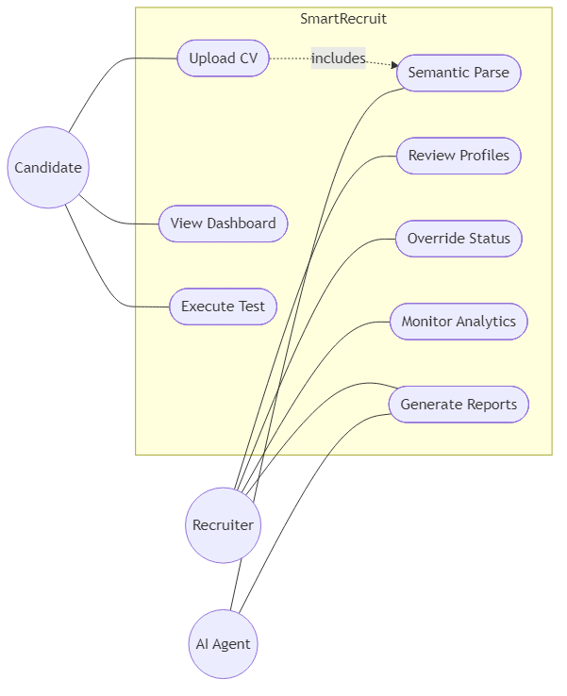
Use Case Diagram

6.2 ACTIVITY DIAGRAMS
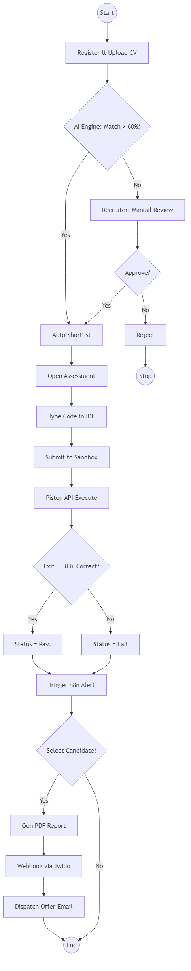
Activity Flow Diagram

6.3 ER DIAGRAM
[Image placeholder: Entity Relationship Diagram]

6.4 DFD (DATA FLOW DIAGRAM)
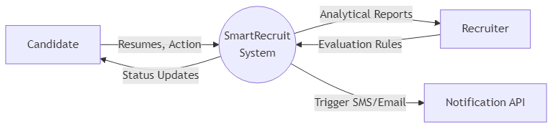
Level 0 DFD - Context Diagram
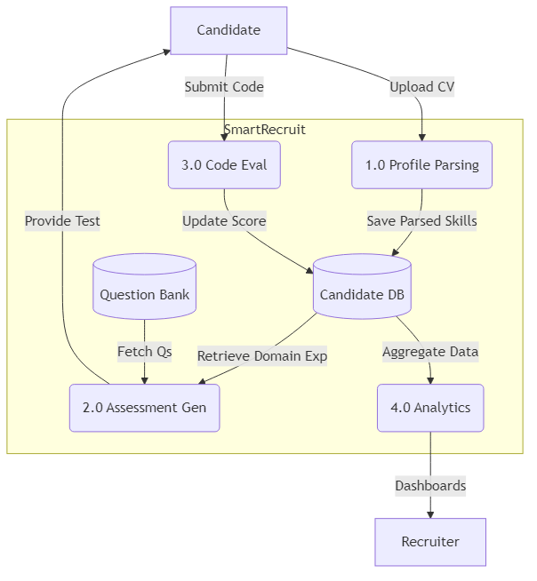
Level 1 DFD
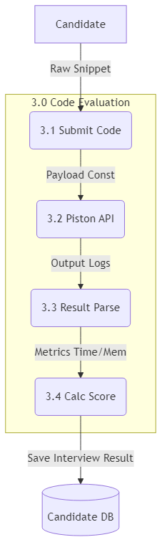
Level 2 DFD

6.5 SEQUENTIAL DIAGRAM

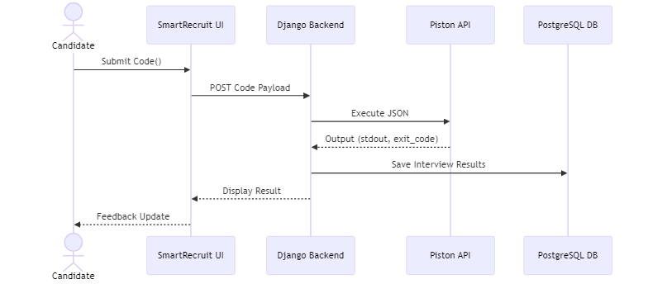
Sequence Diagram

6.6 CLASS DIAGRAM
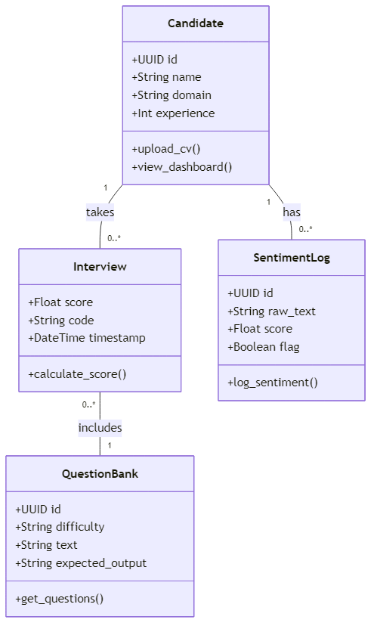
Class Diagram

7. DATA DICTIONARY
Table Name: user_users
Sr. No | Field Name | Data Type | Constraints
1 | id | INT | Primary Key, Auto-Increment
2 | password | VARCHAR(128) | Not Null
3 | last_login | DATETIME | Null
4 | is_superuser | TINYINT(1) | Not Null, Default 0
5 | username | VARCHAR(150) | Unique, Not Null
6 | email | VARCHAR(254) | Not Null
7 | role | VARCHAR(50) | Not Null

Table Name: jobs_jobposting
Sr. No | Field Name | Data Type | Constraints
1 | id | INT | Primary Key, Auto-Increment
2 | title | VARCHAR(255) | Not Null
3 | description | LONGTEXT | Not Null
4 | requirements | LONGTEXT | Not Null
5 | status | VARCHAR(20) | Not Null
6 | created_at | DATETIME | Not Null
7 | recruiter_id | INT | Foreign Key (users.id)

Table Name: jobs_application
Sr. No | Field Name | Data Type | Constraints
1 | id | INT | Primary Key, Auto-Increment
2 | resume | VARCHAR(100) | Not Null
3 | match_score | DOUBLE | Null
4 | status | VARCHAR(20) | Not Null
5 | job_id | INT | Foreign Key (jobposting.id)
6 | candidate_id | INT | Foreign Key (users.id)

Table Name: jobs_interviewresult
Sr. No | Field Name | Data Type | Constraints
1 | id | INT | Primary Key, Auto-Increment
2 | code_score | DOUBLE | Not Null
3 | sentiment_score | DOUBLE | Not Null
4 | feedback | LONGTEXT | Not Null
5 | application_id | INT | Foreign Key (application.id)

8. SYSTEM OUTPUT

8.1 SCREEN SHOT [ADMIN]
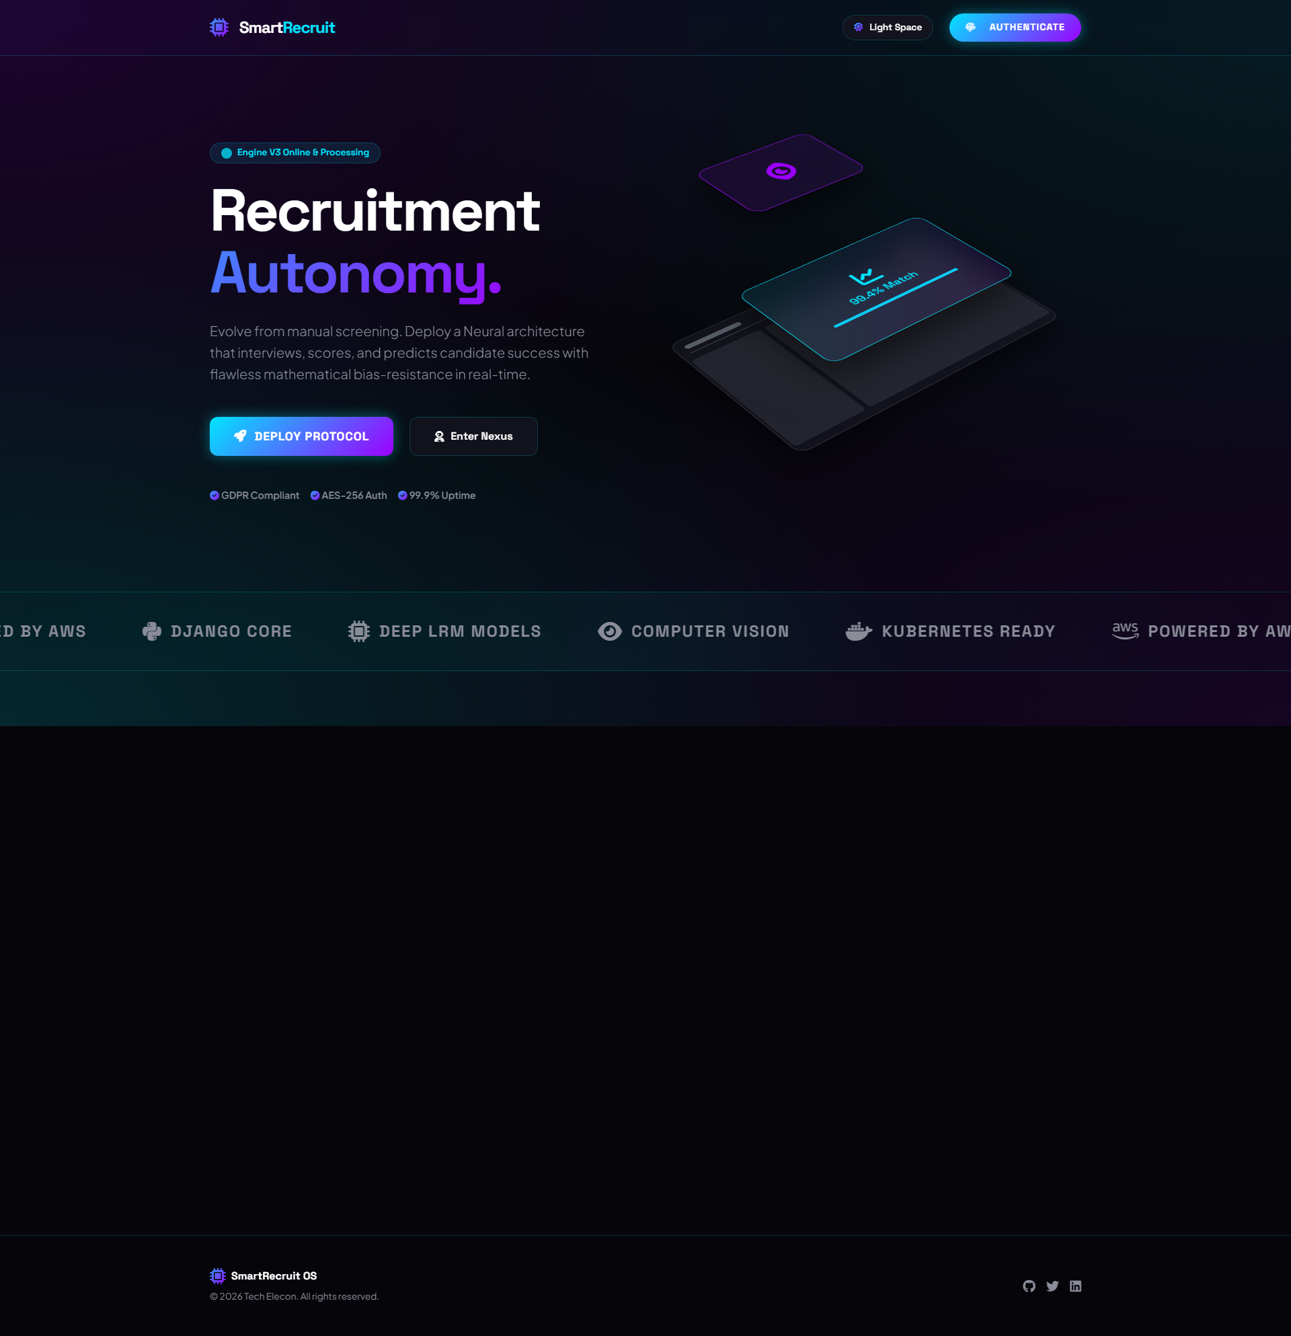
Landing Interface

8.2 SCREEN SHOT [USER]
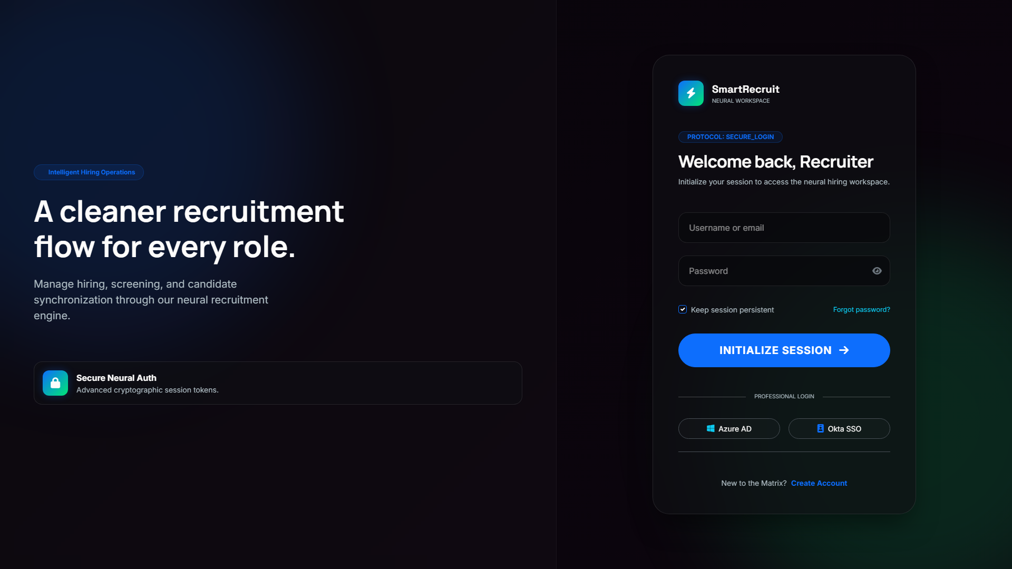
Available Job Listings
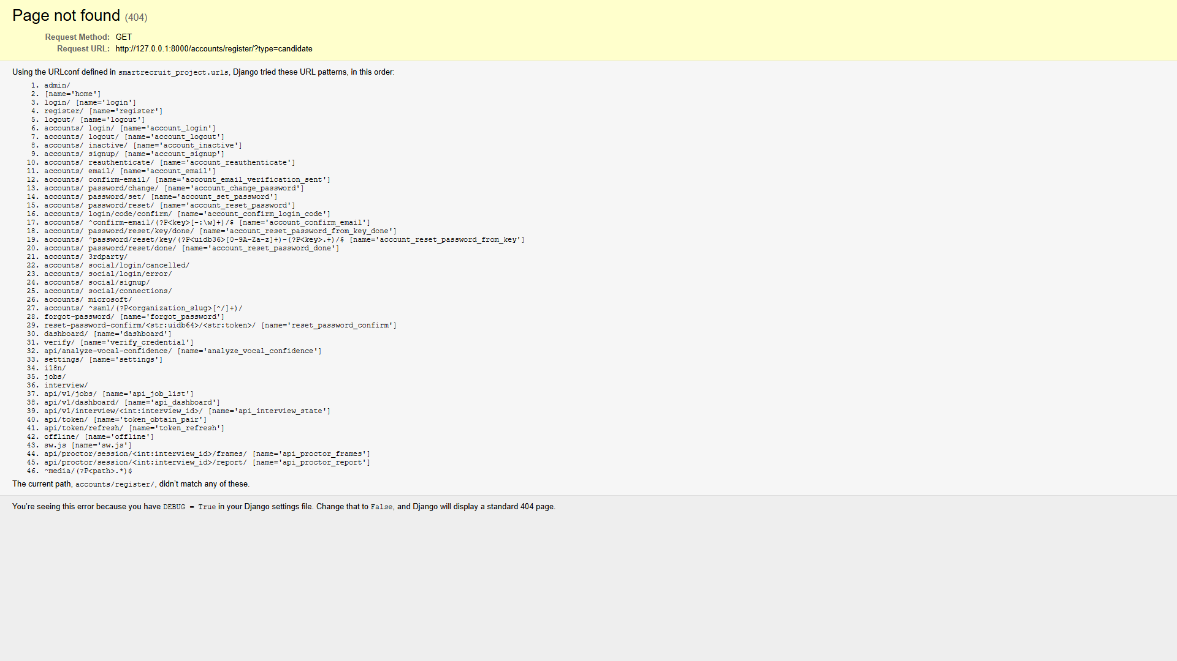
Candidate Registration

9. TESTING
The Testing Plan outlines the strategy and steps followed to ensure the Real Estate/Recruitment Management System meets all requirements.
- Unit Testing: Authentication logic tested per module.
- Integration Testing: JWT middleware and AI API gateways evaluated.
- System Testing: Verified concurrent code submissions to Piston API.
- Security Testing: Checked WebSockets for hijacking risks.

Test Cases
Test Case | Description | Expected Status
TC01 | Invalid Login details | Password error response received
TC02 | Upload Malformed Resume | System denies parse gracefully
TC03 | Compile code in Sandbox | Standard Output or Error string generated

10. FUTURE ENHANCEMENT
- Integration with LinkedIn mapping and GitHub Code verification APIs.
- Deepfake analysis layer to detect AI-generated video imposters in real-time.
- Expanded AI Preparatory Labs combining VR and audio for interview prep.

11. CONCLUSION
The SmartRecruit Platform provides an incredibly cohesive connection between algorithmic evaluation and human resource management. By digitizing 90% of the manual effort in early-stage interviews, the system allows HR experts to focus strictly on human nuances, dramatically boosting overall productivity and ensuring scalable processing metrics without sacrificing software quality or candidate security.

12. BIBLIOGRAPHY
For the successful working of my project, I have referred to many sources for code snippets and logic:
- docs.djangoproject.com
- ai.google.dev (Gemini API)
- stackoverflow.com
- github.com/engineer-man/piston

