Project Documantation

What software Eng SE ?

* state of the art of **developing quality software on time and**

**within budget**

* Trade-off between perfection and physical constraints
* SE has to deal with real-world issues
* State of the art!
* Community decides on best practice + life-long education

What are **SDLC(Software Development Life Cycle)** & its **rules**?

* For project development rules & regulation need to be followed for best quality output at defined time limit
* Rules are Software Development Life Cycle – SDLC
* It‘s part of software engineering
* Six rules to be followed…

Project Rules & Regulation (SDLC) Software deve life cycle

6 RULES

1. Requirement

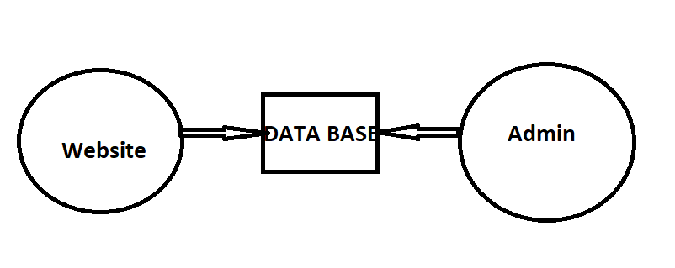

1. Analysis

Requirement analysis

Time requirement

Budget

How many users

**Step 1 : Find total no of user**

Guest

Customer    ->  website

Admin -> admin panel            customer task & employee

Artist ->  Artist panel    customer task manage

**Step 2 : define each task of user**

**Guest**

View location

View artist

Contact us

**Customer**

Signup

Login

View location

View artist

View artist profile/service

Send Request

Manage Service Appointment

Feedback

Contact us

Logout

======================

Admin

login

Manage Customer

Manage location (add/upd/del)

Manage artist (add/upd/del)

View artist profile/service

View Request

View Service Appointment

Manage Feedback

Manage Contact us

Logout

Artist

Login

Manage Profile/service

Manage Request

Manage Service Appointment

View Feedback

Logout

================================================================

1. Step : 3 Define Diagram
2. Use case Diagram

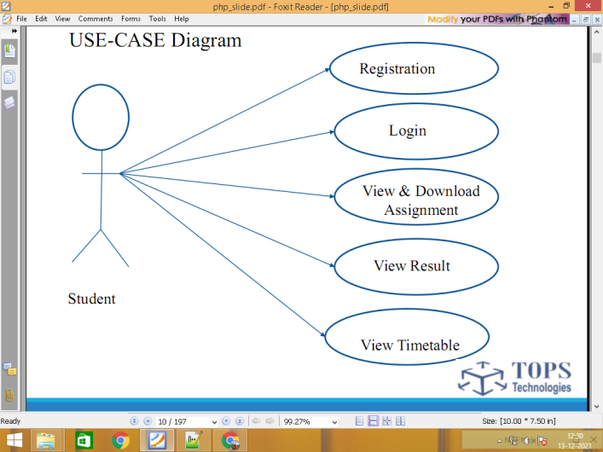

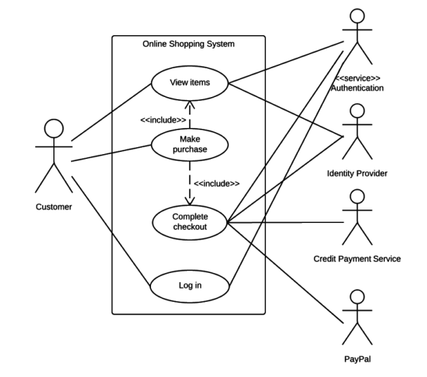

1. DFD Data flow diagram

0 level

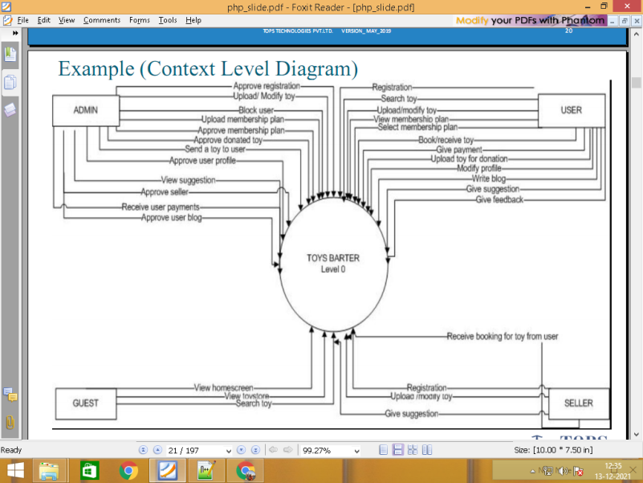

Level 1

\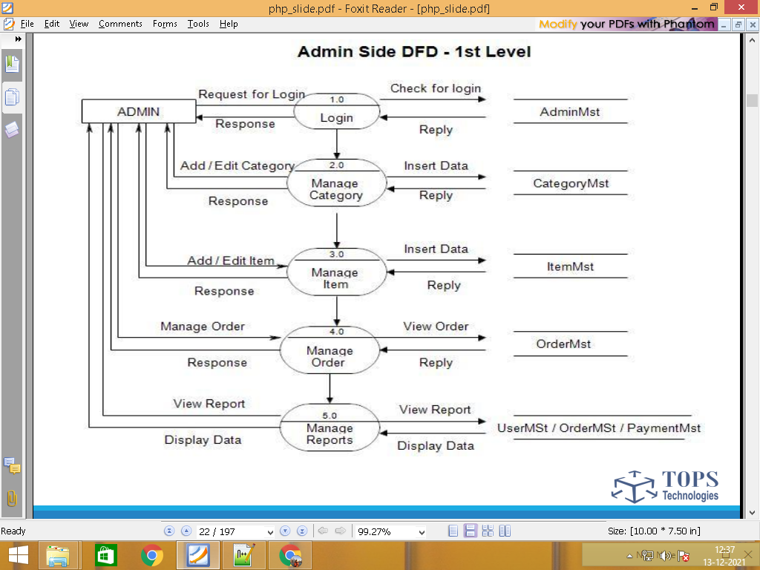

1. Define Database Table

**Customer**

Signup customer.tbl

Login customer.tbl

View location location.tbl

View artist artist.tbl

**Customer** View artist profile/service services.tbl

Send Request request.tbl

Man Ser Appointment appointment.tbl

Feedback feedback.tbl

Contact us contact.tbl

Logout customer.tbl

======================

Admin

Login admin.tbl F

DASHBOARD

Manage Customer customer.tbl T

Manage location (add/upd/del) location.tbl F/T

Manage artist (add/upd/del) artist.tbl F/T

Admin View artist profile/service services.tbl T

View Request request.tbl T

View Service Appointment appointment.tbl T

Manage Feedback feedback.tbl T

Manage Contact us contact.tbl T

Logout admin.tbl

Artist

Login artist.tbl

Manage Profile/service services.tbl

Manage Request request.tbl

Artist Manage Service Appointment appointment.tbl

View Feedback feedback.tbl

Logout artist.tbl

1. Find Total no of table

admin.tbl

customer.tbl

location.tbl

artist.tbl

services.tbl

request.tbl

appointment.tbl

feedback.tbl

contact.tbl

1. Find column of each table

admin.tbl      table column 4 /  form  3

**id   Primary Key (unique)  Aauto_Increement**

name

email

password

img_profile

customer.tbl

id

name

email

password

mobile

img_profile

status

**location.tbl**

id

loc_name

artist.tbl

id pk

title

name

loc_id foreign key

address

area

mobile

gender

exp

profile_img

status

**services.tbl**

id pk

artist_id fk

serv_name

description

price

work_gallery.tbl

id

artist_id

title

img

========================

request.tbl

id

cust_id

artist_id

comment

appointment.tbl

id

cust_id

artist_id

serv_id

app_date

time

remarks

status

feedback.tbl

id

cust_id

appo_id

comment

contact.tbl

id

name

mobile

comment

**===================================================**

**Start Create DATABASE AND TABLE**

**3) Designing html form / Database /**

**4) Coding / implementation**

**5) Testing**

1. **Maintenance**

**====================================================================**

Admin/Backend Panel

**Login**

**Dashboard**

**Add Product / Form**

**Manage Products / Table**

================================================================