Database

What is DBMS & RDBMS and also Difference ?
- Database management system is a software which is used to manage the database. For example: MySQL, Oracle, etc are a very popular commercial database which is used in different applications.
- DBMS provides an interface to perform various operations like database creation, storing data in it, updating data, creating a table in the database and a lot more.
- It provides protection and security to the database. In the case of multiple users, it also maintains data consistency.
Rdbms
RDBMS stands for Relational Database Management Systems..
All modern database management systems like MYsql,SQL, MS, SQL Server, IBM DB2, ORACLE, My-SQL and Microsoft Access are based on RDBMS.
It is called Relational Database Management System (RDBMS) because it is based on relational model introduced by E.F. Codd.

DBMS + DR. E.F. Codd 12 Rules = RDBMS.

Requirement :

PHP Requirement : Server / mySql / php

XAMPP https://www.apachefriends.org/download.html
X CROSS PLATFORM
A APATCH SERVER
M MYSQL
P PERL
P PHP

- Xampp-control
Xampp/xampp-control -> open
Apache / Mysql -> start
Google :
Database Mysql : localhost/phpmyadmin
Php file Run : localhost/htdocts_foldername
=====================================================================================
- Htdocs

Create all php file & pages in htdocs
Google : localhsot/filename.php

=====================================================================================

SQL What is SQL & TYPES?
- SQL stands for Structured Query Language
- SQL lets you access and manipulate databases
4 Types
- DDL Data Definition Language -----> 4 Commands create / alter / drop / truncate

- It is used to define the structure of databases and tables.
- We can create, modify or delete the structure of tables.

Create :

=>create database database_name

=>create table customers(id int PRIMARY key AUTO_INCREMENT, cust_name varchar(100),user_name varchar(100), password varchar(100),email varchar(100), mob bigint(11), address varchar(255), pincode bigint(11),dob date)

===================================================================
1 foreign key

=>create table feedbacks(id int PRIMARY key AUTO_INCREMENT, fed_comment varchar(100), fed_date date, cust_id int(11), FOREIGN key(cust_id) REFERENCES customers(id));

2 foreign key

=>create table feedback_product(id int PRIMARY key AUTO_INCREMENT, fed_comment varchar(100), fed_date date, cus_id int(11),FOREIGN key(cus_id) REFERENCES customers(id), pro_id int(11), FOREIGN key(pro_id) REFERENCES product(id));

End
=============================================================
alter:

  - Column add
ALTER TABLE customer add gender varchar(100) AFTER ‘password’; // add column

  - Column name change
ALTER TABLE `customers` CHANGE `oldname` `newname` VARCHAR(255)

  - Column delete
ALTER TABLE `customer` DROP `gender`; // column delete
===================================================================
drop: // Delete

drop database database_name // drop database delete
drop table tbl_name // drop table delete
ALTER TABLE `customer` DROP `gender`; // table column delete

===================================================================
truncate: / delete all data from table /empty table
truncate table tabl_name // delete all table data not table

=====================================================================
- DML Data Manipulation Language 3 command insert / delete / update
- insert:
insert into customer(cust_name,user_name,pass,email,mobile,address,pincode,gender) values("Akshay","akashay701","12 34","akashay@gmail.com","5646944","Ahmedabad","325874","Male")

INSERT INTO customers (cust_name,user_name,password,email,mob,gender,dob,address,pincode) VALUES ("Raj","raj@gmail.com","1234","raj@gmail.com","123467891","Male","1990-11-17","Chandlodia","382481");

- update: data update as per id
- UPDATE customer set name="pavan Nagar" , password="abc" where id=3

- delete: data delete as per id
delete from customer where id=2

============================================================

- DQL Data Query Language : Select
- Select Description: This will select ‘n‘ columns from the table. Or To select all records from the database.

Select * from customer // get all data with all column

Select cus_id,cust_name from customer // get all data with particular column

Select * from customer where cus_id=2

Select cus_id,cust_name from customer where cus_id=2
=====================================================================
- TCL Transaction Control Language
=> rollback ctl+z undo
=> commit ctl+s save as

Total basic command
DDL : create ,alter , drop , truncate
DML: insert , update, delete
DQL : select
TCl : roleback , commit
==============================================================================

8 COMMAND QUERIES 10 TIMES WRITE IN BOOK
https://www.w3schools.com/MySQL/default.asp

Advance SQL
SELECT * FROM TABLENAME

1) DISTINCT ( UNIQ COLUM DATA GET )
SELECT DISTINCT COUNTRY FROM Customers;

2) ORDER BY
SELECT * FROM Products ORDER BY ProductName ASC
SELECT * FROM Products ORDER BY ProductName DESC

3) AND OR NOT
SELECT * FROM Customers WHERE Country="Germany" AND City="Berlin"
SELECT * FROM Customers WHERE Country="Germany" OR Country =" Mexico "
SELECT * FROM Customers WHERE Not Country="Germany”
SELECT * FROM Customers WHERE City NOT IN ('Paris', 'London');
SELECT * FROM products WHERE NOT price > 50;

4) BETWEEN
SELECT * FROM products WHERE price BETWEEN 10 AND 60;
SELECT * FROM order WHERE ord_date BETWEEN “2024-06-01” AND “2024-06-31”;

5)NUL / NOT NULL
SELECT * FROM Customers WHERE Address IS NULL;
SELECT * FROM Customers WHERE Address IS NOT NULL;
6) LIMIT
SELECT * FROM Customers LIMIT 10;
SELECT * FROM Customers FETCH FIRST 3 ROWS ONLY;

SELECT TOP 50 PERCENT * FROM Customers;
SELECT TOP 3 * FROM Customers WHERE Country='Germany';
SELECT TOP 3 * FROM Customers ORDER BY CustomerName DESC;

7) Aggregate Function
- MIN() - returns the smallest value within the selected column
- MAX() - returns the largest value within the selected column
- COUNT() - returns the number of rows in a set
- SUM() - returns the total sum of a numerical column
- AVG() - returns the average value of a numerical column
SELECT MIN(Price) FROM Products;
SELECT MIN(Price) AS MIN_PRICE FROM Products;

SELECT MAX(Price) FROM Products;
SELECT COUNT(ProductID) FROM Products;

8) Like
SELECT * FROM Customers WHERE CustomerName LIKE 'Ra%'; start with raj
SELECT * FROM Customers WHERE CustomerName LIKE '%Ra; end with raj
SELECT * FROM Customers WHERE CustomerName LIKE '%Ra%'; start or middle or end with raj
============================================================================================

9) Aliases / AS

SELECT CustomerID FROM Customers;
SELECT CustomerID AS ID FROM Customers;
SELECT min(price) as minimum_price FROM Products;

=====================================================================================
10) Join
A JOIN clause is used to combine rows from two or more tables, based on a related column between them.
Types Of Join : 3 Types 1) inner join / join 2) outer join 3) cross join
1) Inner Join /Join
customer Feedabck
cust_id PK fed_id PK
cust_name cust_id FK
pass msg

- select * from customer inner join / join feedback on customer.cust_id = feedback.cust_id
- select feedback.*,customers.name from customer join feedback on customer.cust_id = feedback.cust_id

With where
- select * from customer inner join / join feedback on customer.cust_id = feedback.cust_id where customer.country=”india”

customer order product

cust_id order_id prod_id
cust_name cust_id fk pro_name
pass prod_id fk pro_price
ord_date

select * from order join customer on order.cust_id=customer.cust_id
join product on order.prod_id=product.prod_id

select order.*,customer.cust_name, product.pro_name from order join customer on order.cust_id=customer.cust_id
join product on order.prod_id=product.prod_id
=====================================================================

2) Outer Join
- Left Outer Join
select * from user_tbl left outer join feedback on user_tbl.uid=feedback.uid

- Right Outer Join
select * from user_tbl right outer join feedback on user_tbl.uid=feedback.uid

- Full join
select * from user_tbl full join feedback

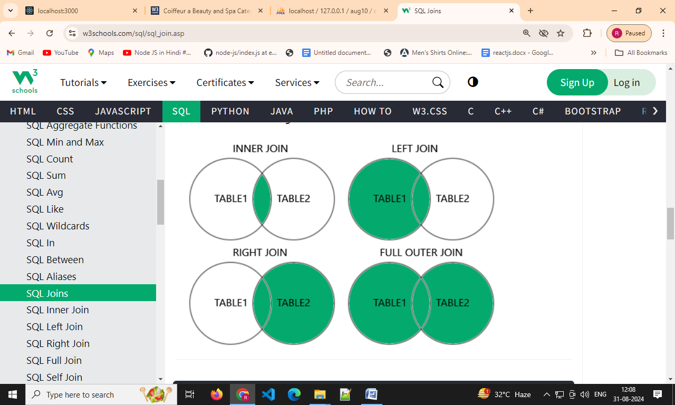

3) Cross Join
select * from user_tbl cross join feedback

2 data customer * 3 data order = 6 data matrix data

==================================================================================

11) index in SQL
INDEX
The CREATE INDEX statement is used to create indexes in tables. Indexes are used to retrieve data from the database more quickly than otherwise.
The users cannot see the indexes, they are just used to speed up searches/queries 100 times faster. (SBI BANK find Account Number)

Type : 2 type

Simple: on only one table column
Composite : on more than 1 column in table
Syntex :CREATE INDEX custindex ON customer(cus_id,mobile)

Views (Security Concept/ sub table virtual table) Exa: (BANK DUPLICATE TABLE)
In SQL, a view is a virtual table based on the result-set of an SQL statement.
A view contains rows and columns, just like a real table. The fields in a view are fields from one or more real tables in the database.

You can add SQL functions, WHERE, and JOIN statements to a view and present the data as if the data were coming from one single table.

CREATE VIEW customer_view AS SELECT cus_id,cust_name,mobile,address,pincode FROM customer
====================================================================================

12) Cursor /Procedure/Trigger
Cursor
A cursor is a temporary work area created in the system memory when a SQL
statement is executed
Two Type :
Implicit : DML statement insert/update/delete/ Select only one row
Explicit : Select more than one row data

Procedure
function abc (aid,aname,aemail)
{
“insert in to customer (id,name,email) value (aid, aname, aemail)”
}
abc(“1”,”nagar”,”nagar@gmail.com”);
abc(“2”,”raj”,”raj@gmail.com”)
abc(“3”,”akash”,”akash@gmail.com”)

Procedure :
A stored procedure is a prepared SQL code that you can save, so the code
can be reused over and over again.So if you have an SQL query that you write over
and over again, save it as a stored procedure, and then just call it to execute it.

Create procedure insert_cust(
In cust_name varchar(255),
In user_name varchar(255),
In password varchar(255),
In email varchar(255),
In mobile bigint(11),
in address varchar(255),
in pincode bigint(11)
)
Begin
insert into customer(cust_name,user_name,password,email,mobile,address,pincode) values(cust_name,user_name,password,email,mobile,address,pincode);
End
//
than
=>call insert_cust('janak','janak@123','1234','janak@gmail.com','21231541','Maninagar','123456')
=>call insert_cust('raj','raj@123','1234','janak@gmail.com','21231541','Maninagar','123456')

Trigger :
A MySQL trigger is a stored program (with queries) which is executed automatically to respond to a specific event such as insertion, updation or deletion occurring in a table.
BEFORE INSERT – activated before data is inserted into the table.
AFTER INSERT- activated after data is inserted into the table.
BEFORE UPDATE – activated before data in the table is updated.
AFTER UPDATE - activated after data in the table is updated.
BEFORE DELETE – activated before data is removed from the table.
AFTER DELETE – activated after data is removed from the table
=>create table reg_log( uid int(100),unm varchar(100),pass varchar(100),gen varchar(100),lag varchar(100),cid varchar(100),img varchar(100),status varchar(100),entry_date_time datetime);

=>CREATE TRIGGER insert_trigger_reg BEFORE INSERT ON reg FOR EACH ROW
BEGIN
insert into reg_log(uid,unm,pass,gen,lag,cid,img,status,Entry_date_time) values (new.uid,new.unm,new.pass,new.gen,new.lag,new.cid,new.img,new.status,now());
END//

