Project Documantation

What software Eng SE ?

* state of the art of **developing quality software on time and**

**within budget**

* Trade-off between perfection and physical constraints
* SE has to deal with real-world issues
* State of the art!
* Community decides on best practice + life-long education

What are **SDLC(Software Development Life Cycle)** & its **rules**?

* For project development rules & regulation need to be followed for best quality output at defined time limit
* Rules are Software Development Life Cycle – SDLC
* It‘s part of software engineering
* Six rules to be followed…

Project Rules & Regulation (SDLC) Software deve life cycle

6 RULES

1. Requirement

1. Analysis

Requirement analysis

Time requirement

Budget

How many users

**Step 1 : Find total no of user**

Guest

Customer    ->  website

Admin -> admin panel                customer task & employee

Artist ->  Artist panel    customer task manage

**Step 2 : define each task of user**

**Guest**

View location

View artist

Contact us

**Customer**

Signup

Login

View location

View artist

View artist profile/service

Send Request

Manage Service Appointment

Feedback

Contact us

Logout

======================

Admin

login

Manage Customer

Manage location (add/upd/del)

Manage artist (add/upd/del)

Manage artist profile/service

View Request

View Service Appointment

Manage Feedback

Manage Contact us

Logout

Artist

Login

Manage Profile/service

Manage Request

Manage Service Appointment

View Feedback

Logout

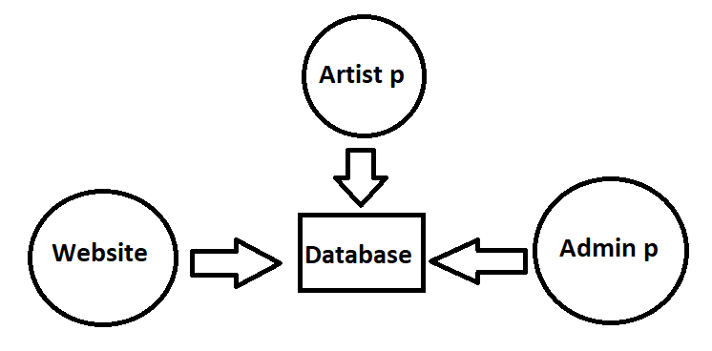

===================================================================

1. Step : 3 Define Diagram
2. Use case Diagram

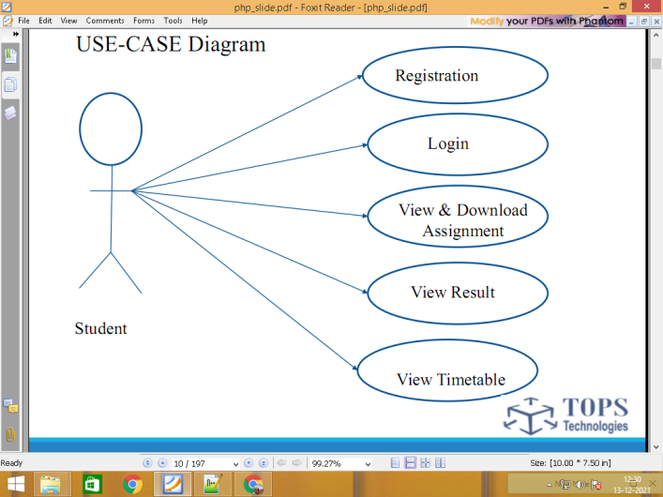

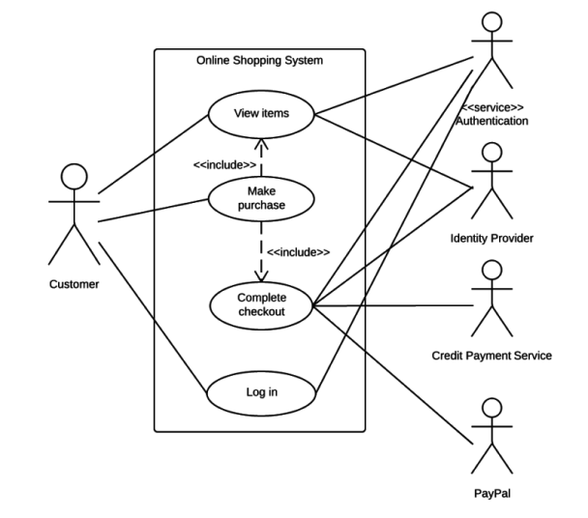

1. DFD Data flow diagram

0 level

1 level

2 level

0 level

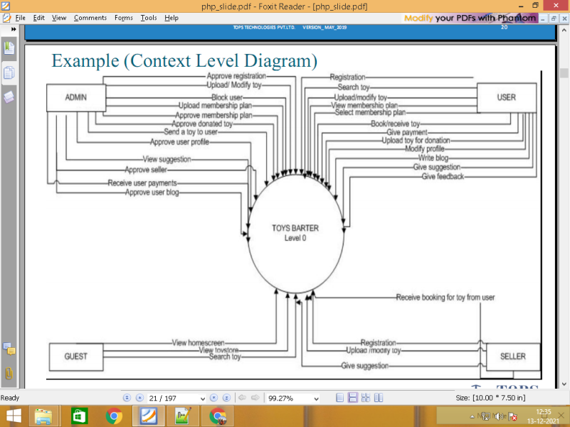

Level 1

\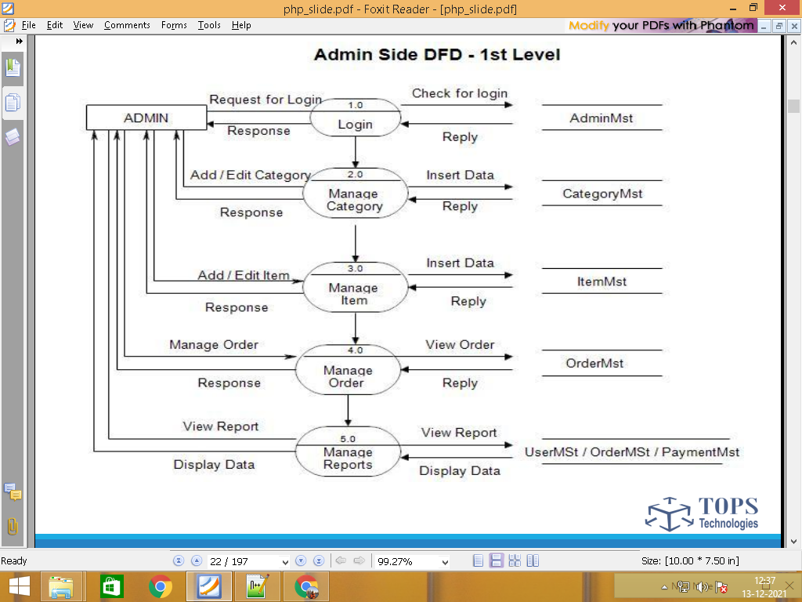

**Customer**

Signup customer.tbl

Login customer.tbl

View location location.tbl

View artist artist.tbl

**Customer** View artist profile/service service.tbl

**View work work.tbl**

Send Request request.tbl

Manage Service Appointment appointment.tbl

Feedback feedback.tbl

Contact us contact.tbl

Logout customer.tbl

======================

Admin

Login admin.tbl

Manage Customer customer.tbl

Manage location (add/upd/del) location.tbl

Admin Manage artist (add/upd/del) artist.tbl

Manage artist profile/service service.tbl

**View work work.tbl**

View Request request.tbl

View Service Appointment appointment.tbl

Manage Feedback feedback.tbl

Manage Contact us contact.tbl

Logout admin.tbl

Artist

Login artist.tbl

Manage Profile/service service.tbl

Artist Manage work work.tbl

Manage Request request.tbl

Manage Service Appointment appointment.tbl

Feedback feedback.tbl

Logout artist.tbl

1. Find Total no of table

Admin

customer.tbl

location.tbl

artist.tbl

service.tbl

**work.tbl**

request.tbl

appointment.tbl

feedback.tbl

contact.tbl

1. Find column of each table

Admin column 4 = login form 2

**Id primary key(Unique) Auto_increement**

Name

Email

Password

customer.tbl table 7 == signup form 5

**Id primary key(Unique) Auto_increement**

Name

Email

Password

Mobile

Profile_img

**Status**

location.tbl

**Id primary key(Unique) Auto_increement**

Loca_name

artist.tbl column =10 / form 8

Id primary key(Unique) Auto_increement

Name

Shop_name

Password

Mobile

Email

**Loc_id Foreign key**

Address

Profile_img

**Status**

service.tbl

**Id primary key(Unique) Auto_increement**

**Artist_id foreign key**

Ser_name

Price

Description

**work.tbl**

**Id primary key(Unique) Auto_increement**

**Artist_id foreign key**

Work_title

Work_Img

Work_description

request.tbl

**Id primary key(Unique) Auto_increement**

Cust_id

Artist_id

Comment

Mobile

appointment.tbl

Id primary key(Unique) Auto_increement

Serv_id

Cust_id

Artsist_id

App_date

App_time

Remark

feedback.tbl

**Id primary key(Unique) Auto_increement**

App_id

rating

Comment

contact.tbl

**Id primary key(Unique) Auto_increement**

Name

Mobile

Email

Comment

Data Dictionary

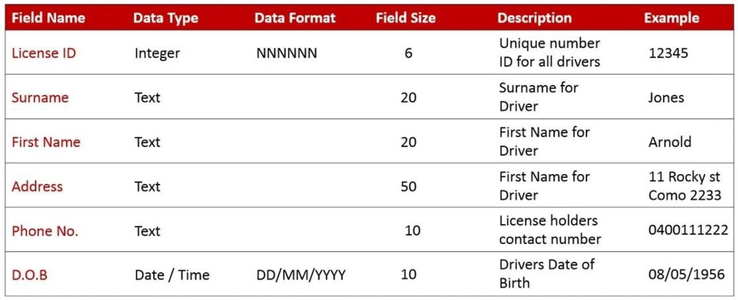

**========================================================================**

**Start Create DATABASE AND TABLE**

**3) Designing / Database**

**4) Coding / implementation**

**5) Testing**

1. **Maintenance**

**====================================================================**

Admin/Backend Panel

**Login**

**Dashboard**

**Add Product / Form**

**Manage Products / Table**

================================================================