Next Js

Next.js is a React-based framework for building web applications. It's an open-source tool that provides additional features to React, such as server-side rendering, static generation, and optimization strategies. Unlike React, Next.js has the capability to build full-stack web applications using API routes. To create a better user interface, you can stick with React, but Next.js is for additional features and customizations.

React -> Front-end Web app
Next -> Fullstack Web app

Advantages of Next.js over ReactJS
- Hot Code Reload Next.js server detects modified files and reloads them automatically.
- Automatic Routing: No need to configure any url for routing. files are to be placed in pages folder. All urls will be mapped to file system. Customization can be done.

- Component specific styles: The styled-jsx provides support for global as well as component specific styles.
- Server side rendering: React components are pre-rendered on server hence loads faster on client.
- Node Ecosystem: Next.js being react based gels well with Node ecosystem.
- Automatic code split: Next.js renders pages with libraries they need. Next.js instead of creating a single large JavaScript file, creates multiples resources. When a page is loaded, only required JavaScript page is loaded with it.
- Prefetch: Next.js provides Link component which is used to link multiple components supports a prefetch property to prefetch page resources in background.
- Dynamic Components: Next.js allows to import JavaScript modules and React Components dynamically.
- Export Static Site: Next.js allows to export full static site from your web application.
- Built-in Typescript Support: Next.js is written in Typescripts and provides excellent Typescript support.

Why to Use Next.js?
Next.js is capable of configuring tools needed in React applications, so you can be more productive and focus on development rather than the configurations. Next.js solved the common application requirements like routing, data fetching, and caching and improved the development experience.

Key Features of Next.js

Feature | Description
Advanced Routing | Next.js uses file-system based router. Whenever we add any page to the pages directory, it is automatically available via url.
Multiple Renderings | Next.js supports on two side rendering(client and server side) on user's browser and the server. So this makes faster by pre-building some pages and creating others as per requirements.
Data Fetching | Server Components can now fetch data more easily using async/await, and have better ways to save, cache, and update data using an improved fetch API.
Styling Support | Next.js supports tailwind css and inbuilt css-in-js library for styling. It allows to write CSS within a React component and these styles will be scoped to component.
Optimizations | Next.js have builtin optimization tools to optimize images, fonts, and scripts, that will help your app to perform better and improve the SEO of your web applications.
TypeScript Support | Next.js support TypeScript, so there is better type checking and more efficient compilation compared to JavaScript.

Next.js Work?
Next.js supports both Server-Side-Rendering and Client-Side-Rendering. So you can decide which one is required in your application. Depending on the situation it helps with SEO and quick access to your application.
Please check the below diagram to get the idea of - "How Next.js works under the hood?" We will explain all these steps in this tutorial.
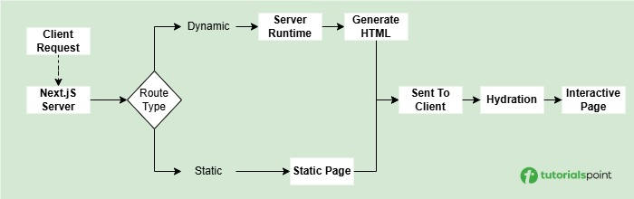

===============================================

Setup Next.js?

Step 1: Create a New Next.js Application

Next.js runs on Node.js server, so to setup a Next.js project, first you need to install Node.js (version 14.6.0 or newer) on your system. To create a application, open your terminal/powershell in the folder where you want to build app. Then run the following command

npx create-next-app@latest

After running this, you will be prompted to give a name for your project. Enter a suitable name, and then you will be asked to select tools to be installed along with Next.js. Using the left arrow, right arrow and enter key, select Typescript, Tailwind CSS and ESlint. Use the image below as a reference.

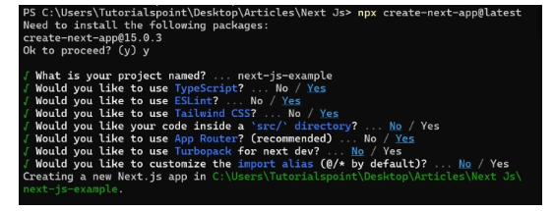

Step 2: Understand The Project Structure
After successfully create new Next.js app, you can see a new folder with lots of file in the directory you selected. Now in the terminal, navigate to this directory using following command. (Replace name of your app in command)
cd next-js-example

This will open project directory in terminal. The "next-js-example" folder will look something like this.

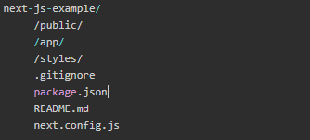

Here is overview some of important files and folders.
- /public/: Folder that contains static files like images and fonts
- /app/: Folder that stores all the React components.
- /styles/: Folder that contains CSS files for styling.
- package.json: A file that lists project dependencies and scripts.

Step 3: Run the Development Server
Now, we can run the Next.js development server using following command. (Make sure you are in project directory, ie next-js-example)
npm run dev

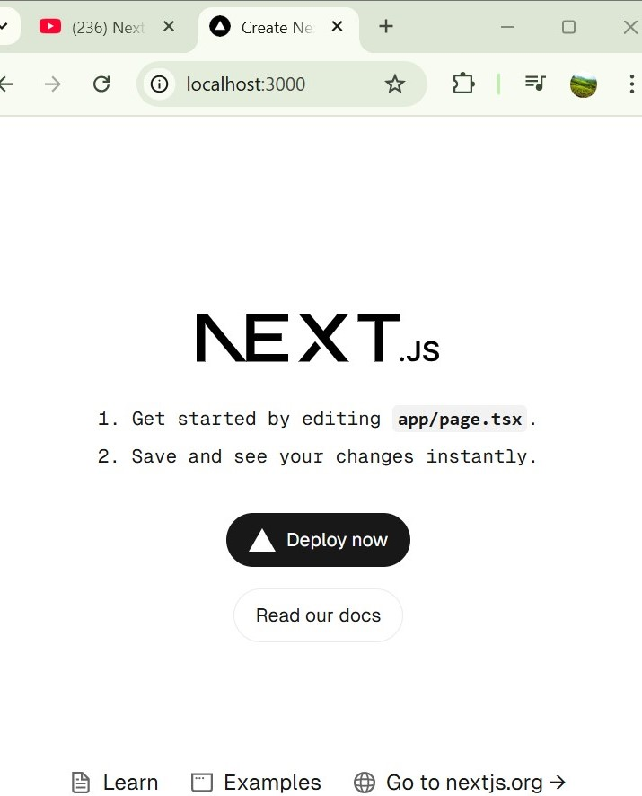

Step 4: Setup Development Environment

ES7 React Snippet
JavaScript and TypeScript Nightly
Tailwind CSS Intellisense:

React app : run on client-side
Next-app : Run of server side so you can see all backend code

Folder Structure
Next.js folder structure is based on routing system. The routing system in Next.js is file-based, which means the file structure inside the pages/ or app/ directory determines the application routes automatically. Following diagram shows basic structure of Next.js App router project.

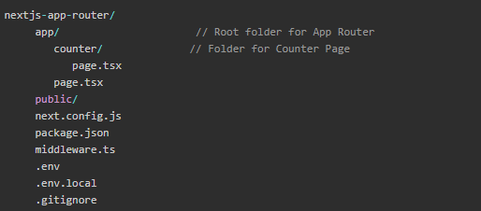

app/page.tsx : This is home page of Next.js app. It can be accessed by 'localhost:3000/'
app/counter/page.tsx : This define a component section in app. It can be accessed by 'localhost:3000/counter'

Top Level Folders
The top level folders in Next.js are used to organize application's root level code and static assets.
- /app: This is the root folder for App Router. The page.tsx file inside this folder will be rendered at the root of the application.
- /pages: This is the root folder for Page Router. The index.tsx file inside this folder will be rendered at the root of the application.
- /public: This folder contains static assets such as images, fonts, and stylesheets.
- /src: This is an optional folder that contains the source code of the application. It is used to organize the codebase and separate the application's logic from the presentation layer.

Top Level Files
The top level files in Next.js are stored at root folder and are used to configure the application's environment and define the application's routes.
- next.config.js: This file is used to configure the application's environment.
- package.json: This file is used to define the application's dependencies and scripts.
- instrumentation.ts: This file is used to instrument the application's code for performance monitoring.
- middleware.ts : This file is used to define the application's middleware.
- .env : This file is used to define the application's environment variables.
- .env.local : This file is used to define the application's environment variables for local development.
- .gitignore : This file is used to define the files and directories that should be ignored by git.
- tsconfig.json : This file is used to define the TypeScript configuration for the application.

Routing Files
The routing files in Next.js are stored inside the /app/ or /pages/ directory and are used to define the application's routes.
- layout.tsx: This file is used to define the application's layout such a navigation bar, header etc.
- loading.tsx: This file is used to define the application's loading screen.
- error.tsx: This file is used to handle the application's errors such as 404, 500 etc.
- index.tsx: This file is used to define the application's home page.
- route.ts: This file is used to define API routes.
- not-found.tsx : This file is used render a 404 page when any route is not found.

===============================================

Next.js App Router
Next.js version 13 and after started using app router setup, in which the structure of your app/ directory determines the routes of your application. This system is known as the App Router in Next.js. In this chapter, we will learn how to setup and use the app router system in Next.js.

Setup App Router

Step 1: Create a Next js Project

Step 2: Understanding the App Router System
In Next.js, every file inside the app/ directory automatically becomes a route. For example, if we have a file called app/about/page.tsx, it will become the /about route.
The app/page.tsx file is the default route. If you don't specify a route, it will be the default route.

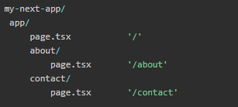

Step 3: Setup Nested Routes
Nested routing refers to defining routes within other routes, to create a hierarchical structure of routes in a web application.
To create a nested About page, create a new folder named 'about' inside the /app/ directory and inside that add a file page.tsx with following code.
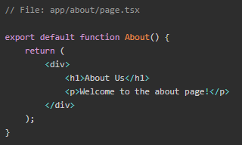
To see output, visit "http://localhost:3000/about". It will look like this.

Step 4: Setup Dynamic Routes
Dynamic routing refers to defining routes that can accept parameters. For example, we can create a route that accepts a parameter like /users/:id. Where :id is a dynamic parameter chosen by the user.

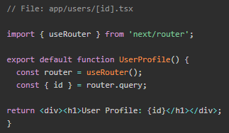

Now, visiting http://localhost:3000/users/123 will display User Profile: 123.

Step 5: API Routes
API Routes are used to create simple API endpoints inside Next.js applications. The API Routes are defined in the app/api directory. For example, we can create a route that accepts a POST request to /api/hello and returns a JSON response.

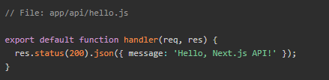

Note : Page reload due to header.jsx

Navabar created by <a href=”/about”>

Load Link from ‘next/link’;

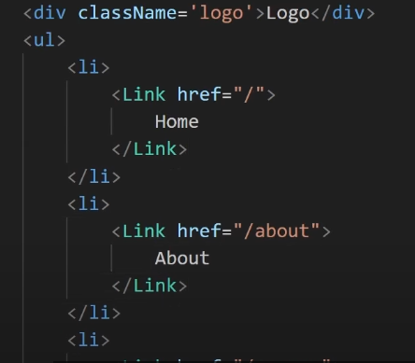

===============================================

Images In Next Js
Use of Image component in next.js provide optimization & securities

The Next.js <Image> component extends the HTML <img> element to provide:
- Size optimization: Automatically serving correctly sized images for each device, using modern image formats like WebP.
- Visual stability: Preventing layout shift automatically when images are loading.
- Faster page loads: Only loading images when they enter the viewport using native browser lazy loading, with optional blur-up placeholders.
- Asset flexibility: Resizing images on-demand, even images stored on remote servers.
To start using <Image>, import it from next/image and render it within your component.

Baisc

public/slide1.jpg

Use direct in Component :

<img src="slide1.jpg" width={"100%"} alt="" />

============================================

Type 1

Store : src/images/image.jpg

Import : Import image from “@/images/image.jpg”

Use : <img src={image.src}>

Type 2

Import : import Image from ‘next/image’

Use :

<Image src={image.src} width={400} height={400} />

<Image src={image.src} fill />

Type 3 : Image display from lie path / third party

https://nextjs.org/docs/app/getting-started/images

Set image config 👍

Next.config.mjs

const nextConfig = {

images: {
remotePatterns: [
{
protocol: 'https',
hostname: 's3.amazonaws.com',
port: '',
pathname: '/my-bucket/**',
search: '',
},],
},

};

<Image src=”https://adocmedi.in/Frontend/assets/img/shlok.jpg” fill />

===============================================

Now use All React js Hooks in Next

useState() => gives an error in jsx component

Note : all next js component work in Ser ver side instead of client side

Note : when you want to use client side react functionality that time have to add

“Use Client” => first line of component

==============================================

