Project

Software Eng.

What are SDLC & its rules?

* For project development rules & regulation need to be followed for best quality output at defined time limit
* Rules are Software Development Life Cycle – SDLC
* It‘s part of software engineering
* Six rules to be followed…

1. Requirement Gathering / collection information

Categories wise movies display

1. Analysis & SRS

Time limit

Budget

How many users

* 1. Step 1 Define Total Numbers of User

User

Admin

Employee

* 1. Step 2 Define each user task

**User**

View Type categories

View sub type categories

View clip/videos

Signup

Login

Watchlist

Download

Comment/ Feedback

Logout

**Employee**

Signup by admin

Login

Manage categories ADD/UPDATE/DELETE

Manage sub type categories ADD/UPDATE/DELETE

Manage clip/videos ADD/UPDATE/DELETE

Logout

Admin

Login

Manage categories ADD/UPDATE/DELETE

Manage sub type categories ADD/UPDATE/DELETE

Manage clip/videos ADD/UPDATE/DELETE

Manage User

Manage Employee

View Watch list Reports

View Download Reports

Manage Comment

Logout

* 1. Step 3 Define All diagram

1. Use case Diagram

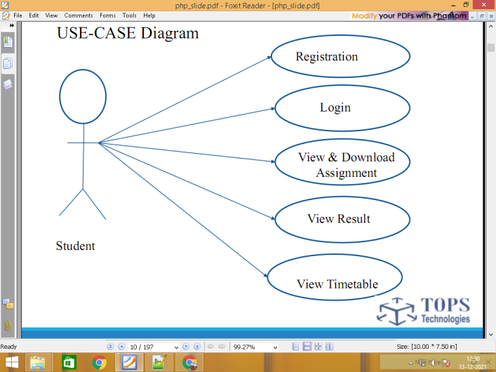

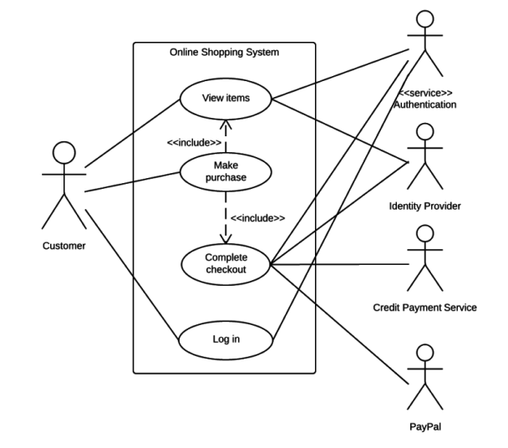

1. DFD Data flow diagram

0 level

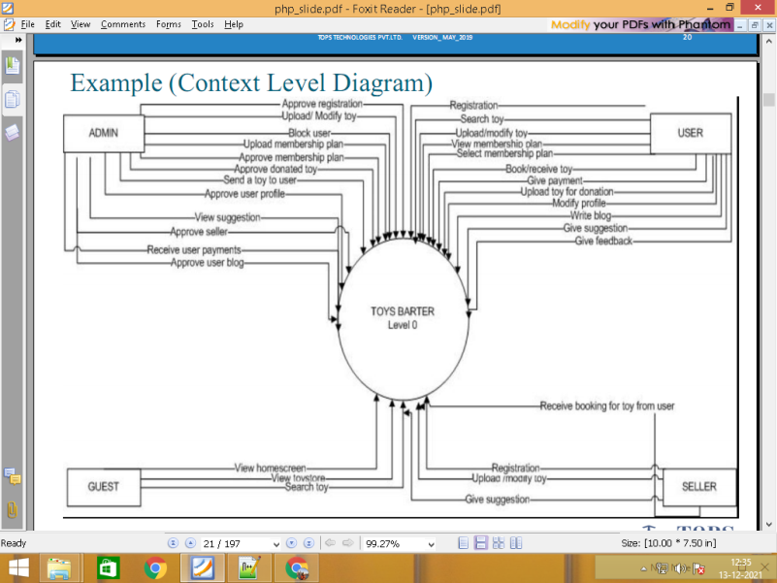

Level 1

\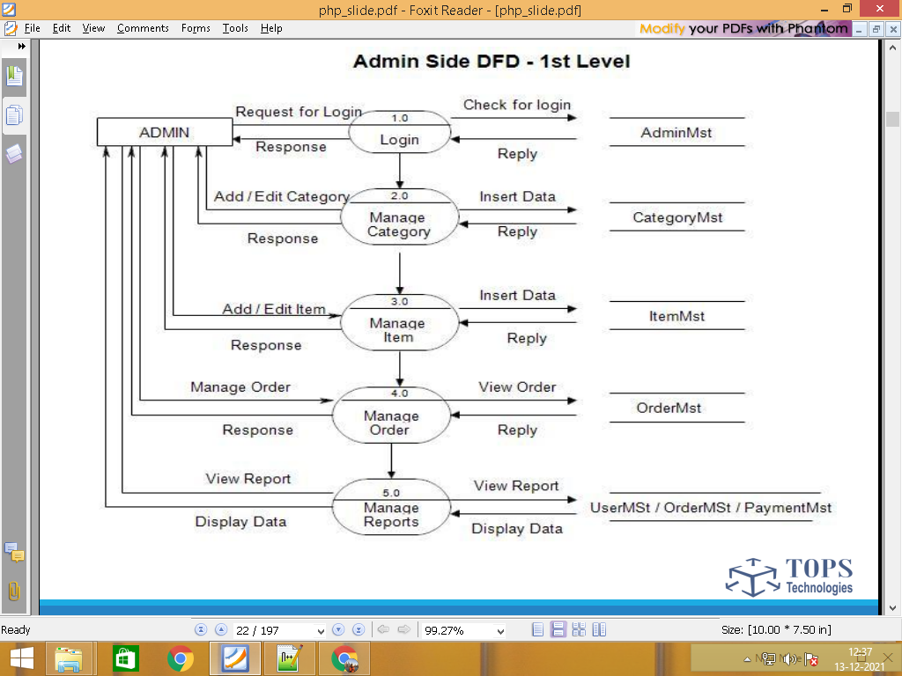

View Main Type categories main_categories.tbl

View sub type categories sub_categories.tbl

View clip/videos videos.tbl

Signup user.tbl

**User** Login user.tbl

Watchlist watchlist.tbl

Download download.tbl

Comment/ Feedback feedback.tbl

Logout user.tbl

Signup by admin employee.tbl

Login employee.tbl

Manage Main categories main_categories.tbl

**Employee** Manage sub type categories sub_categories.tbl

Manage clip/videos videos.tbl

Logout employee.tbl

Login admin

Manage main categories main_categories.tbl

Manage sub type categories sub_categories.tbl

Manage clip/videos videos.tbl

Admin Manage User user.tbl

Manage Employee employee.tbl

View Watch list Reports watchlist.tbl

View Download Reports download.tbl

Manage Comment feedback.tbl

Logout admin.tbl

* 1. Step 4 Define All table

main_categories.tbl

sub_categories.tbl

videos.tbl

user.tbl

watchlist.tbl

download.tbl

feedback.tbl

employee.tbl

admin.tbl

* 1. Step 5 Define Each table column

main_categories.tbl

**id pk**

title animation/carton/avengers/spiderman

img

sub_categories.tbl

**id pk**

title movies / news /series

img

videos.tbl

id

main_cat_id FK

sub_cat_id FK

title

short_desc

long_desc

lag

length

3. Designing

4. Implementation (Coding)

5. Testing

6. Maintenance

===================================================================================