# Wordpress Assignments

**Diploma in Digital Marketing Assignment**

**Term-1**

## Module -1 PHP – Introduction

## Module – 2 PHP - Programming Fundamentals

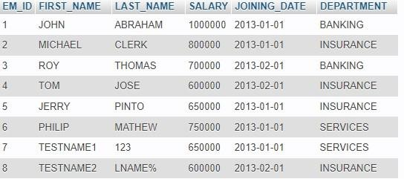TABLE: - Employee

ABLE: - Incentives

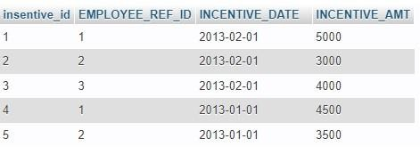

TABLE: - Incentives

Solve SQL Task

* Get FIRST_NAME, Joining year, Joining Month and Joining Date from employee table.
* Get employee details from employee table whose joining month is “January”.
* Get department wise maximum salary from employee table order by salary ascending?
* Create View OF Employee table in which store first name, last name and salary only.
* All Incentive for more than 2000.
* All Incentive except those with 0 or NULL value in Incentive amt field.
* Return the average Salary by Employee Category.
* Add the Employee (using store procedure)
* Write an SQL query that returns the employee numbers and salaries of all employees in the “Insurance” department ordered by descending salary.
* Write an SQL query that returns the project name, department name, and budget for all projects with a budget < $50,000.

## Module -3 PHP - Core PHP

## Module-4 Wordpress - Getting started

