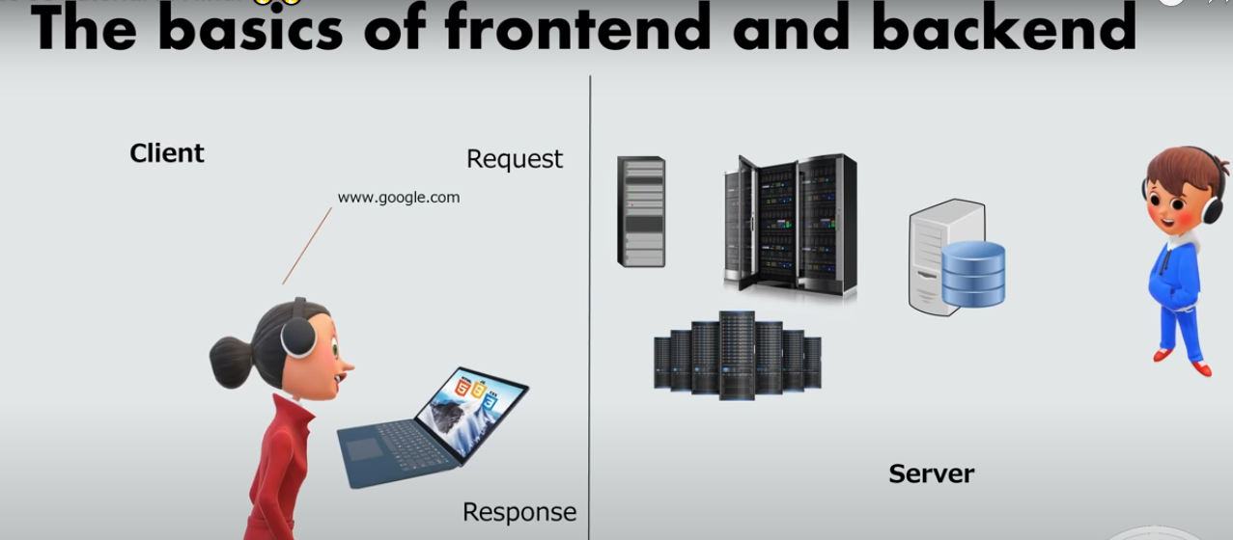

Node Js

What is Node.js?
- Node is not a Languages
- Node.js is an open source server environment
- Node can connect with database but Javascript Not direct
- Code & syntex is very similar to javascript but Not exactly same
- Node.js is free
- Node.js runs on various platforms (Windows, Linux, Unix, Mac OS X, etc.)
- Node.js uses JavaScript on the server
- Node.js runs the chrome V8 JavaScript engine, the core of Google Chrome, outside of the browser.
- Written in c,c++,javascript
==============================================================

- It is a popular tool for almost any kind of project!
- Most useful for create api and also create website
- A Node.js app is run in a single process, without creating a new thread for every request.

- Node.js provides a set of asynchronous I/O primitives in its standard library that prevent JavaScript code from blocking and generally, libraries in Node.js are written using non-blocking paradigms, making blocking behavior the exception rather than the norm.

- When Node.js needs to perform an I/O operation, like reading from the network, accessing a database or the filesystem, instead of blocking the thread and wasting CPU cycles waiting, Node.js will resume the operations when the response comes back.

Why do we use Node.js?
- Node Mostly used for api create (Fast API WORK)
- So we can connect the same database with web app, Mobile App
- Node easy because who know javascript
- Node create super fast for APIs
- With Node & Javascript , you can become full stack Developer / Mern Stack

====================================================================

Javascript and Node are same?
- Javascript and Node.js code syntax is same
- If you know javascript then you can learn node very easily
- But Both are note same
- You can not connect javascript with database
- Node js run on server side
- Javascript run on browser side

===================================================================
Node.js uses asynchronous programming!
A common task for a web server can be to open a file on the server and return the content to the client.
Here is how PHP or ASP handles a file request:
- Sends the task to the computer's file system.
- Waits while the file system opens and reads the file.
- Returns the content to the client.
- Ready to handle the next request.
Here is how Node.js handles a file request:
- Sends the task to the computer's file system.
- Ready to handle the next request.
- When the file system has opened and read the file, the server returns the content to the client.
Node.js eliminates the waiting, and simply continues with the next request.
Node.js runs single-threaded, non-blocking, asynchronous programming, which is very memory efficient.
=================================================

What Can Node.js Do?
- Node.js can generate dynamic page content
- Node.js can create, open, read, write, delete, and close files on the server
- Node.js can collect form data
- Node.js can add, delete, modify data in your database

=================================================

What is a Node.js File?
- Node.js files contain tasks that will be executed on certain events
- A typical event is someone trying to access a port on the server
- Node.js files must be initiated on the server before having any effect
- Node.js files have extension ".js"

=================================================

Install and Setup Node JS
- Download Node
The official Node.js website has installation instructions for Node.js: https://nodejs.org
- Install NPM AND NODE => node js
- Code Editors
VS CODE
Sublime
========================================================================

First Script with Node

Node.js Console/REPL Terminal
Node.js comes with virtual environment called REPL (aka Node shell). REPL stands for Read-Eval-Print-Loop. It is a quick and easy way to test simple Node.js/JavaScript code.

To launch the REPL (Node shell), open command prompt (in Windows) or terminal (in Mac or UNIX/Linux) and type node as shown below. It will change the prompt to > in Windows and MAC.
Run : start => node.js

You can also define variables and perform some operation on them.
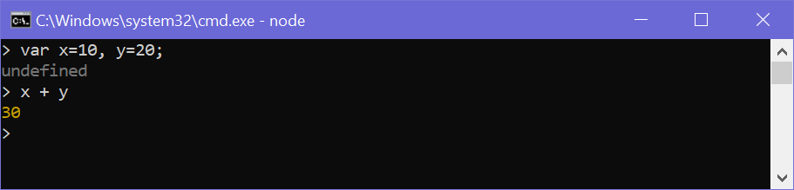

You can execute an external JavaScript file by executing the node fileName command. For example, the following runs mynodejs-app.js on the command prompt/terminal and displays the result.
mynodejs-app.js Copy
console.log("Hello World");
Now, you can execute mynodejs-app from command prompt as shown below.
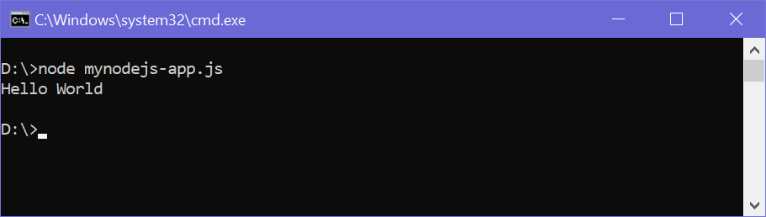

=================================================
Create a Node.js file named "myfirst.js", and add the following code:

Myfirst.js
Code : console.log(‘Hello World’);
Run : node Myfirst
Output : Hello World’

===========================================
The following table lists important REPL commands.
REPL Command | Description
.help | Display help on all the commands
tab Keys | Display the list of all commands.
Up/Down Keys | See previous commands applied in REPL.
.save filename | Save current Node REPL session to a file.
.load filename | Load the specified file in the current Node REPL session.
ctrl + c | Terminate the current command.
ctrl + c (twice) | Exit from the REPL.
ctrl + d | Exit from the REPL.
.break | Exit from multiline expression.
.clear | Exit from multiline expression.

Interview Que

Que :why its error come in cmd like undefined :
Ans : Not return anything

Que :how to different node console & javascript console
Ans : We write console in cmd its Node build in module & we write in js file console its javascript browser functionality

in node module provide console for debugging

console.log()
console.error()
console.warn()

======================

With File script

Step: 1 Create file index.js

Code file : console.log(‘Hello world’);

Run cmd : node index.js

Node.js Basics
- Node.js supports JavaScript. So, JavaScript syntax on Node.js is similar to the browser's JavaScript syntax.
- Javascript Fundamental for Node.js
- Condition , Loop , Array
- The Import Function and variables from another file

Now you can write JavaScript code directly.
Example:
> let name = "Rajesh"
> console.log(name)
Rajesh
Step 2: Type the following code directly into the REPL:
let a = 10;
let b = 20;

let sum = a + b;

console.log("First Number:", a);
console.log("Second Number:", b);
console.log("Addition:", sum);

if...else Statement
Objective: Check whether a number is even or odd.
let num = 7;

if (num % 2 == 0) {
console.log("Even Number");
} else {
console.log("Odd Number");
}

Task 1: for Loop — Print 1 to 10
Objective: Print numbers from 1 to 10.
for (let i = 1; i <= 10; i++) {
console.log(i);
}

Task 2: Function with a Parameter
Objective: Pass a name to a function.
function welcome(name) {
console.log("Welcome " + name);
}

welcome("Rajesh");
welcome("Amit");

Primitive Types
Node.js includes following primitive types:
- String
- Number
- Boolean
- Undefined
- Null
- RegExp
Everything else is an object in Node.js.
Object literal syntax is same as browser's JavaScript.
Example: Object Copy
var obj = { authorName: 'Ryan Dahl', language: 'Node.js' }

Functions
Functions are first class citizens in Node's JavaScript, similar to the browser's JavaScript. A function can have attributes and properties also. It can be treated like a class in JavaScript.
Example: Function Copy

function Display(x) { console.log(x); } Display(100);

Buffer
Node.js includes an additional data type called Buffer (not available in browser's JavaScript). Buffer is mainly used to store binary data, while reading from a file or receiving packets over the network

Access Global Scope
In a browser, global scope is the window object. In Node.js, global object represents the global scope.
To add something in global scope, you need to export it using export or module.export. The same way, import modules/object using require() function to access it from the global scope.
For example, to export an object in Node.js, use exports.name = object.
exports.raj = {
console: function(msg)
{
console.log(msg);
},
file: function(msg)
{
// log to file here
}
}

App.js

module.exports={
x:10,
y:20,
z:function(){
return 10;
}
}

Now, you can import log object using require() function and use it anywhere in your Node.js project.

Index.js

const app=require('./app');
console.log(app);
console.log(app.x);
console.log(app.z());

var arr=[5,7,8,9,10];
arr.filter((item)=>{
console.log(item);
// return item>4;
})

=========================

