DA / DS
Introduction to Data Analytics

1. What is Data Analytics?
Data Analytics is the process of collecting, cleaning, organizing, and analyzing data to find useful information and make better decisions.
Example: A shop has sales records for 1,000 products. Data analytics helps identify the
best-selling products,
low-performing products,
and ways to increase sales.

Data vs Information vs Insight
Term | Simple meaning | Example
Data | Raw facts | Daily sales: ₹500, ₹800, ₹300
Information | Organized data | Total sales = ₹1,600
Insight | Useful understanding | The second transaction contributed 50% of sales
Simple task: Write three examples of raw data from a college, hospital, or supermarket. Convert them into information and identify one insight.

2. Types of Data Analytics
There are four major types of analytics.
1. Descriptive Analytics — What happened?
Summarizes past data using totals, averages, reports, and charts.
Example: Sales were ₹5 lakh last month.
Task: Calculate last month's total sales.
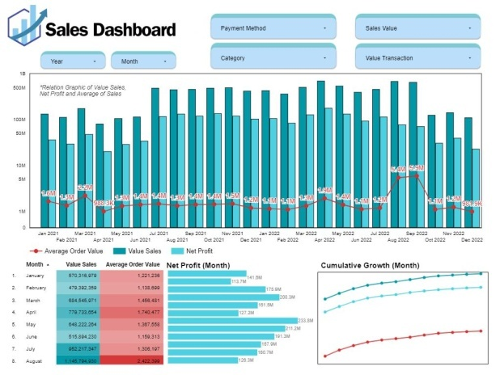
2. Diagnostic Analytics — Why did it happen?
Investigates causes, patterns, and relationships.
Example: Sales fell because fewer customers visited the shop.
Task: Find why sales dropped compared with the previous month.
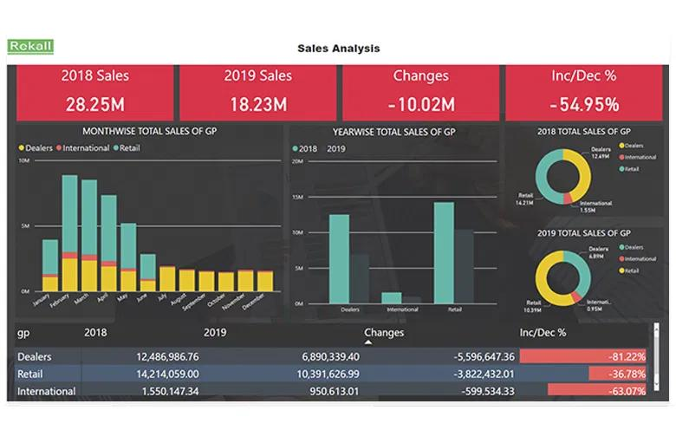
3. Predictive Analytics — What might happen?
Uses historical data and statistical or machine-learning models to estimate future outcomes.
Example: Next month's sales may reach ₹6 lakh.
Task: Estimate next month's sales from previous sales records.
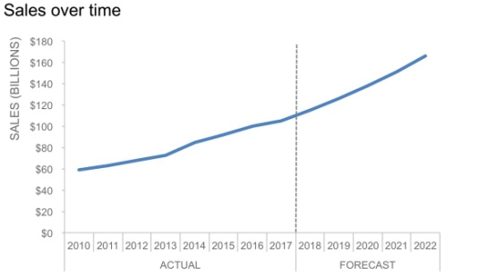
4. Prescriptive Analytics — What should we do?
Recommends actions based on predictions, objectives, and constraints.
Example: Increase stock for products expected to sell more.
Task: Recommend two actions to improve sales and reduce inventory waste.
Remember:
What happened → Why it happened → What might happen → What should we do?

3. Industry Roles in Data and Analytics
1. Data Analyst (DA)
Analyzes data, prepares reports, creates dashboards, and finds trends.
- Tools: Excel, SQL, Power BI, Python
- Example: Identify which products generate the highest sales.
2. Business Analyst (BA)
Understands business problems, gathers requirements, and recommends improvements.
- Tools: Excel, SQL, Power BI, documentation tools
- Example: Find why customer orders are decreasing.
3. Data Engineer (DE)
Builds and maintains systems that collect, transform, and deliver data.
- Tools: SQL, Python, ETL tools, cloud platforms
- Example: Build a pipeline that collects sales data from multiple stores.
4. Data Scientist (DST)
Uses statistics, programming, and machine learning to investigate complex questions and build predictive models.
- Tools: Python, SQL, statistics, machine-learning libraries
- Example: Predict future sales or customer churn.

Simple comparison
Role | Main question | Typical output
DA | What does the data tell us? | Reports and dashboards
BA | What business problem must we solve? | Requirements and recommendations
DE | How do we deliver reliable data? | Data pipelines and data systems
DST | What patterns or outcomes can we model? | Statistical and ML models
Note: Job responsibilities overlap, and the exact tools depend on the company.

4. Tools Mapping — Excel, SQL, Python, Power BI
- Excel — Spreadsheet analysis
Use formulas, filters, PivotTables, charts, and data-cleaning features.
Best for: Small-to-medium datasets, quick calculations, and reports.


- SQL — Database querying
Retrieve, filter, group, and combine data stored in databases.
Best for: Getting accurate subsets and summaries from business databases.
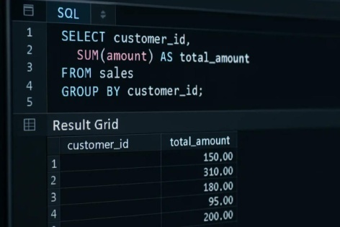

- Python — Programmatic analysis
Clean data, automate repetitive tasks, perform statistical analysis, and build models. The pandas library supports tabular data, filtering, grouping, and calculations.
Best for: Automation, large or complex analyses, and machine learning.
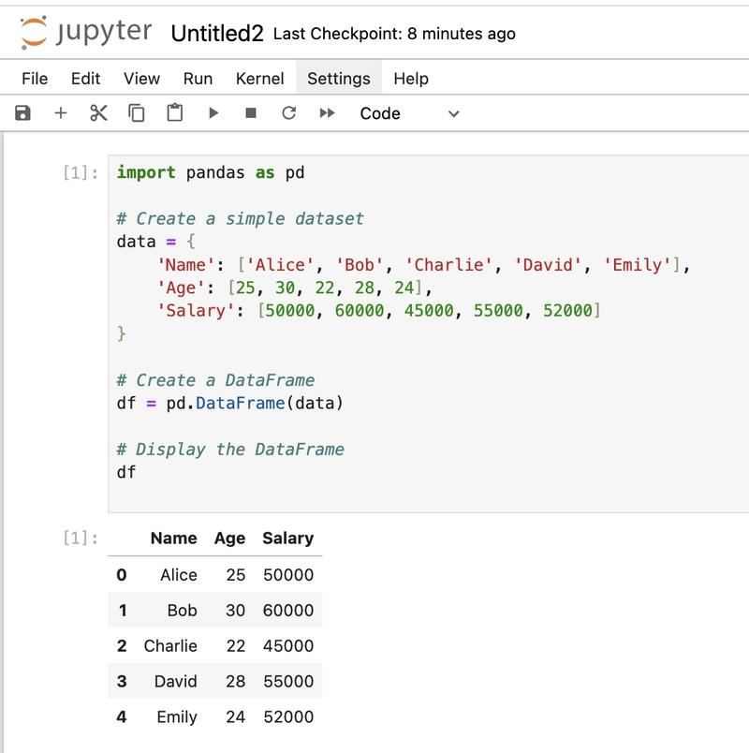

- Power BI — Business intelligence and visualization
Connects to data, builds interactive reports, and presents business metrics through charts and dashboards.
Best for: Management reports, interactive dashboards, and tracking KPIs.

2. Data & Databases

- What is Data?
Data means raw facts and values collected from different sources, such as customer details, sales transactions, website clicks, student records, and hospital reports.
There are two major categories of data.
Structured vs Unstructured Data
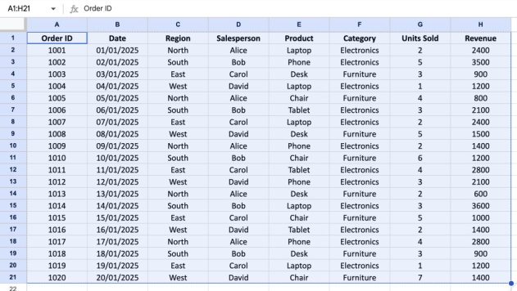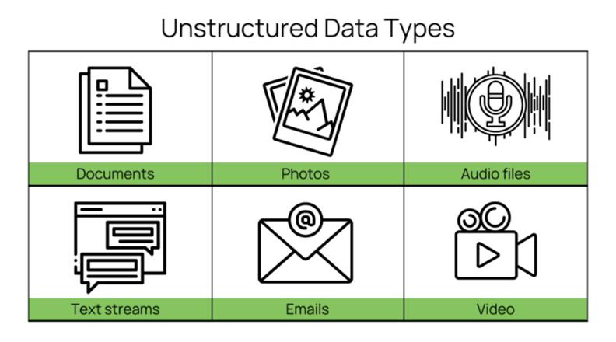
- Structured Data
Data arranged in a predefined format, usually rows and columns.
Examples:
- Excel tables
- SQL database tables
- Student records
- Unstructured Data
Data without a fixed tabular structure.
Examples:
- Photos and videos
- Audio recordings
- Emails and free-form documents
2. Common Data Formats
1. CSV — .csv
Stores tabular data as text separated by commas.
Name,City,Marks
Amit,Ahmedabad,85
Neha,Surat,92
Use: Data exchange, exports, and simple datasets.
Task: Create a CSV file containing 5 student records.
2. XLSX — .xlsx
Excel workbook format supporting sheets, formulas, formatting, and charts.
Use: Business reports, calculations, and PivotTables.
Task: Create a sales workbook with Product, Quantity, Price, and Total columns.
3. JSON — .json
Stores data using key-value pairs and arrays.
{
"name": "Amit",
"city": "Ahmedabad",
"marks": 85
}
Use: Web applications, APIs, and data exchange.
Task: Create a JSON file containing 3 products.
4. SQL — Database language
SQL is a language used to create, query, and manage relational database data. It is not itself a file format.
SELECT * FROM students
WHERE marks > 80;
Use: Retrieve and analyze database records.
Task: Write a query to find students scoring above 70.
5. APIs — Application Programming Interfaces
APIs allow software systems to exchange data. They often return JSON, although other formats are possible.
Example response:
{
"product": "Laptop",
"price": 45000
}
Use: Fetch live or remote data, such as weather, products, or orders.
Task: Find a public API that returns JSON and identify its fields.
3. Databases: RDBMS vs Data Warehouse

What is a database?
A database is an organized collection of data that can be stored, searched, updated, and managed.

RDBMS — Relational Database Management System
An RDBMS stores data in related tables made up of rows and columns.
Examples: MySQL, PostgreSQL, SQL Server, Oracle.

Data Warehouse
A data warehouse collects and organizes data from multiple sources for reporting and historical analysis.
Examples of cloud data warehouses include Google BigQuery, Snowflake, and Amazon Redshift.

4. ETL vs ELT
Both are processes for moving and preparing data for analysis.

ETL
Extract → Transform → Load
- Extract data from sources.
- Clean and transform it.
- Load it into the destination.
Example: Clean an Excel sales file before loading it into a database.

ELT
Extract → Load → Transform
- Extract data.
- Load it into the destination.
- Transform it there.
Example: Load raw sales data into a cloud warehouse and clean it using SQL.
Simple difference: ETL transforms data before loading; ELT loads data before transforming it.

5. OLTP vs OLAP
OLTP — Online Transaction Processing
Handles everyday transactions such as placing orders, payments, and updating inventory.
- Focus: Fast, accurate transactions.
- Example: A customer purchases a laptop online.
- Typical system: E-commerce application database.
OLAP — Online Analytical Processing
Analyzes large amounts of data to discover trends and support decisions.
- Focus: Reporting and analysis.
- Example: Compare laptop sales across five years.
- Typical system: Analytical database or data warehouse.

3. What is Domain Understanding?
Domain understanding means understanding a particular industry, its business processes, customers, problems, and goals before analyzing its data.

For example, if you analyze sales data for a retail shop, you should understand revenue, profit, customer behavior, product demand, and returns.
Why is domain knowledge important?
- Helps identify the correct business problem.
- Helps select meaningful KPIs.
- Helps understand what the data actually represents.
- Helps avoid incorrect conclusions.
- Helps businesses make better decisions.
Example:
A retail shop's sales increased from ₹1,00,000 to ₹1,50,000.
- Without domain knowledge: Sales increased by ₹50,000.
- With domain knowledge: Check whether profit also increased, whether discounts increased, and whether more products were sold.
Higher sales do not always mean higher profit!
Domain Examples in Data Analytics
1. Retail Analytics
Analyzes product sales, customer purchases, stock, and revenue.
Example KPIs: Revenue, Profit Margin, Average Order Value (AOV), Customer Acquisition Cost (CAC).
2. Finance Analytics
Analyzes income, expenses, profitability, budgets, and cash flow.
Example KPIs: Net Profit, Operating Expenses, Return on Investment (ROI), Cash Flow.
3. HR Analytics
Analyzes employee performance, attendance, recruitment, and retention.
Example KPIs: Employee Turnover Rate, Absenteeism Rate, Time to Hire.
4. Banking Analytics
Analyzes loans, transactions, customer accounts, and financial risk.
Example KPIs: Loan Default Rate, Non-Performing Asset (NPA) Ratio, Fraud Detection Rate.
5. Healthcare Analytics
Analyzes patient visits, hospital resources, waiting times, and outcomes.
Example KPIs: Patient Waiting Time, Bed Occupancy Rate, Readmission Rate.

What are KPIs and Business Metrics?
A business metric is a measurable value used to understand business performance.
A KPI (Key Performance Indicator) is a particularly important metric used to measure progress toward a specific business goal.
Example: A shop tracks 20 different metrics, but its main goal is to increase profitability. Profit Margin could be one of its most important KPIs.
Business metric | Meaning
Total Orders | Number of orders received
Revenue | Total income from sales before deducting costs
Profit | Revenue minus applicable costs
Profit Margin | Profit as a percentage of revenue
AOV | Average revenue per order
CAC | Average cost to acquire one new customer
Conversion Rate | Percentage of visitors who complete a desired action

SESSION 4 – Data Analytics Workflow

1. What is a Data Analytics Workflow?
A Data Analytics Workflow is a step-by-step process used to convert raw data into meaningful insights that help a business make better decisions.
For example, an online shopping company wants to know why its sales have decreased. A data analyst collects sales data, cleans it, analyzes it, creates reports, and recommends actions to improve sales.
Step-by-Step Explanation

Step 1: Requirement Gathering
Understand what the business wants to solve before starting the analysis.
Example: An online shopping company reports that its monthly sales have decreased.
Questions to ask:
- What is the business problem?
- Which months should we compare?
- Which products or regions are affected?
- What KPIs should we measure?
- Who will use the analysis?
Output: A clear problem statement and list of KPIs.

Step 2: Data Collection
Collect the required data from different sources.
Common sources:
- Excel and CSV files
- MySQL or PostgreSQL databases
- APIs
- Website and application logs
- CRM and ERP systems
Example: Collect order data, product data, customer data, and website traffic data.
Tools: SQL, Python, Excel, APIs.

Step 3: Data Cleaning
Raw data may contain missing values, duplicate records, incorrect data types, and inconsistent values.
Example of unclean data:
Order ID | Product | Sales
101 | Laptop | 50000
102 | Mobile | 20000
102 | Mobile | 20000
103 | Laptop | —
104 | mobile | 15000
Problems include a duplicate order, missing sales, and inconsistent capitalization.
Possible cleaning actions:
- Remove verified duplicate records.
- Investigate missing sales values instead of guessing them.
- Standardize product names.
- Convert sales values into numeric data types.
Important: Do not automatically delete missing or duplicate-looking records. First confirm what each row represents and whether the records are genuinely duplicates.

Step 4: Data Transformation
Convert cleaned data into a format suitable for analysis.
Examples:
- Calculate revenue from quantity and unit price.
- Convert dates into month and year.
- Combine first and last names if needed.
- Group sales by product, region, or month.
- Standardize currency or units.
Formula:
Example: 5 products × ₹2,000 = ₹10,000 revenue.

Step 5: Data Modeling and Analysis
Create relationships between tables and calculate the metrics needed to answer the business questions.
Example tables:
- Customers: customer details
- Orders: order date, customer ID, total amount
- Products: product ID, product name, category
An analyst may connect these tables using customer IDs and product IDs, then calculate:
- Total revenue
- Monthly sales growth
- Average Order Value (AOV)
- Repeat customer rate
- Product-wise profitability
Tools: SQL, Python, Excel, Power BI.

Step 6: Reporting and Visualization
Present the results in a clear and understandable format.
Useful visualizations include:
- Line chart — monthly sales trends
- Bar chart — product-wise revenue
- Pie or donut chart — category share, when appropriate
- KPI cards — total revenue, profit, and AOV
- Tables — detailed comparisons
Tools: Power BI, Tableau, Excel, Python visualization libraries.

Step 7: Insights and Presentation
Explain what the analysis means and recommend what the business should do next.
Example:
- Finding: Sales fell by 20% in one region.
- Further analysis: A key product was frequently out of stock.
- Recommendation: Improve inventory planning for that product.
- Measurement: Track stock availability and regional revenue next month.
An insight explains the significance of a result. A recommendation suggests what action to take.

SESSION 5 – Exploratory Data Analysis (EDA Overview)

1. What is EDA?
EDA (Exploratory Data Analysis) is the process of examining, summarizing, and visualizing data to understand its patterns, relationships, trends, and unusual values before performing advanced analysis or building machine learning models.
EDA helps answer questions such as:
- What does the dataset contain?
- Which products have the highest sales?
- Is there a relationship between price and sales?
- Are any values missing or unusual?
- Are sales increasing or decreasing over time?

Types of EDA
There are three common types of EDA.
1. Univariate Analysis
Analyzes one variable at a time.
Examples:
- Average product price
- Distribution of customer ages
- Total sales distribution
Common techniques: Mean, median, mode, histogram, box plot.
2. Bivariate Analysis
Examines the relationship between two variables.
Examples:
- Price vs quantity sold
- Advertising spend vs revenue
- Age vs salary
Common techniques: Scatter plot, correlation, grouped bar chart.
3. Multivariate Analysis
Examines three or more variables together.
Examples:
- Price, discount, quantity, and revenue
- Customer age, income, and spending
- Advertising spend, region, and sales
Common techniques: Correlation matrix, pair plot, grouped comparisons, and multivariable charts.
Understanding Trends, Relationships, and Outliers
1) trend
A trend is a general pattern of change in data over time or across an ordered sequence.
Example: Monthly revenue increases from ₹20,000 to ₹25,000 to ₹30,000.

2)Identifying relationships
A relationship describes how two or more variables change in relation to each other.
For example:
- Advertising spend increases and sales also increase: a possible positive relationship.
- Product price increases and quantity sold decreases: a possible negative relationship.
3). outlier
An outlier is a value that is unusually far from most other observations.
Example: Product sales are ₹500, ₹550, ₹600, ₹580, and ₹15,000.
Possible reasons include:
- Data entry error
- Duplicate transaction
- Bulk customer order
- Genuine unusual business activity

=============================================
NumPy Foundations — Part 1: Arrays & Creation

1. What is NumPy?
NumPy stands for Numerical Python.
It is a Python library designed for efficient numerical computation and working with multidimensional arrays.
NumPy is a Python library used for working with arrays.
It also has functions for working in domain of linear algebra, fourier transform, and matrices.
NumPy was created in 2005 by Travis Oliphant. It is an open source project and you can use it freely.

- In normal Python, you can store numbers in a list:
marks = [70, 80, 90, 85]
print(marks) # [70, 80, 90, 85]

- Suppose you want to add 5 marks to every student.
With a Python list, you typically use a loop:
marks = [70, 80, 90, 85]

updated_marks = []

for mark in marks:
updated_marks.append(mark + 5)

print(updated_marks) # [75, 85, 95, 90]

- With NumPy, the same operation is simpler:

import numpy as np

marks = np.array([70, 80, 90, 85])

updated_marks = marks + 5

print(updated_marks) # [75, 85, 95, 90]

NumPy applies the addition to every array element automatically. This behavior is called vectorized computation.

Why is NumPy essential for Data Science?
- In Python we have lists that serve the purpose of arrays, but they are slow to process.
- NumPy aims to provide an array object that is up to 50x faster than traditional Python lists.
- The array object in NumPy is called ndarray, it provides a lot of supporting functions that make working with ndarray very easy.
- Arrays are very frequently used in data science, where speed and resources are very important.
- Efficient calculations on large collections of numbers.
- Multidimensional arrays for structured numerical data.
- Mathematical operations without writing explicit Python loops for every calculation.

Why is NumPy Faster Than Lists?
- NumPy arrays are stored at one continuous place in memory unlike lists, so processes can access and manipulate them very efficiently.
- This behavior is called locality of reference in computer science.
- This is the main reason why NumPy is faster than lists. Also it is optimized to work with latest CPU architectures.

Which Language is NumPy written in?
- NumPy is a Python library and is written partially in Python, but most of the parts that require fast computation are written in
C or C++.

Python list vs NumPy array
Feature | Python list | NumPy array
Data types | Can mix types | Usually one common dtype
Numerical addition | Concatenates lists | Adds values element-wise
Memory layout | Stores references to objects | Often stores homogeneous values in a compact data buffer
Numerical workloads | Often need loops | Supports vectorized operations

2. Installing and importing NumPy

Step 1: Check Python and PIP

If you have Python and PIP already installed on a system, then installation of NumPy is very easy.

python --version
Example output:
Python 3.12.4

Step 2: Install NumPy

python -m pip install numpy
- If you are using Jupyter Notebook:
%pip install numpy
- If you use Anaconda, NumPy is often already installed.

Step 3: Import NumPy

import numpy as np

print(np.__version__) # output : 2.3.0

- Important: np is the standard alias for NumPy. It lets you write np.array() instead of numpy.array().

1)Basic Array Creation

1. np.array()

import numpy as np

arr = np.array([10, 20, 30])

print(arr) # [10 20 30]

print(type(arr)) # <class 'numpy.ndarray'>

Note : ndarray means N-dimensional array, the main array object provided by NumPy.

Note : To create an ndarray, we can pass a list, tuple or any array-like object into the array() method, and it will be converted into an ndarray

import numpy as np
arr = np.array((1, 2, 3, 4, 5))
print(arr) # [1 2 3 4 5]

NumPy Array Indexing
Array indexing is the same as accessing an array element. 0,1,2,3
You can access an array element by referring to its index number.

import numpy as np
arr = np.array([1, 2, 3, 4])
print(arr[0]) # 1

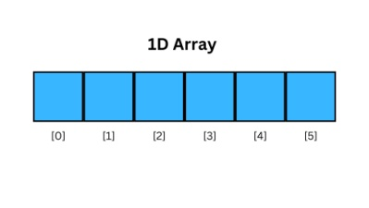

Access 2-D Arrays

arr = np.array([[1,2,3,4,5], [6,7,8,9,10]])

print('2nd element on 1st row: ', arr[0, 1]) $ 2

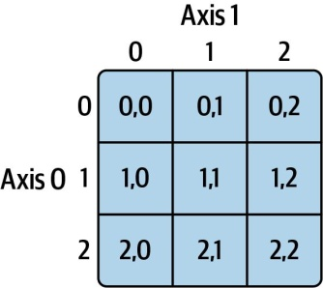

Access 3-D Arrays
import numpy as np
arr = np.array([[[1, 2, 3], [4, 5, 6]], [[7, 8, 9], [10, 11, 12]]])
print(arr[0, 1, 2]) # 6

Explanation : [[[ ]]] 0 1
0 means first element ([[[1, 2, 3], [4, 5, 6]], [[7, 8, 9], [10, 11, 12]]])

0 1
1 means second element [[1, 2, 3], [4, 5, 6]]

0 1 2
2 means third element [4, 5, 6]

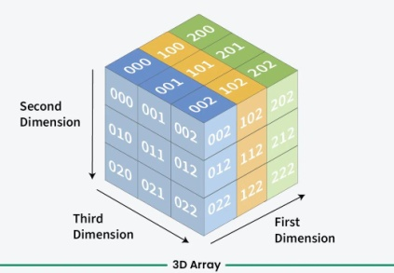

Negative Indexing
import numpy as np
arr = np.array([[1,2,3,4,5], [6,7,8,9,10]])
print('Last element from 2nd dim: ', arr[1, -1]) # 10

Specify a data type dtype=np.float64 float64/

numbers = np.array([1, 2, 3, 4], dtype=np.float64)

print(numbers) [1. 2. 3. 4.]
print(numbers.dtype) float64

Family | Common Options | Character Code | Memory Footprint
Integers | int8, int16, int32, int64 | 'i1', 'i2', 'i4', 'i8' | 1 to 8 bytes
Unsigned Ints | uint8, uint16, uint32, uint64 | 'u1', 'u2', 'u4', 'u8' | 1 to 8 bytes (Positive only)
Floating Point | float16, float32, float64 | 'f2', 'f4', 'f8' | 2 to 8 bytes
Booleans | bool_ | '?' | 1 byte
Strings | str_ (Unicode) | 'U' + length | Dynamic based on longest string
Python Objects | object | 'O' | Fallback for mixed/arbitrary Python objects

=============================================================================

2. Creating arrays using np.arange()
np.arange() generates values within a specified range using a step size.

np.arange(start, stop, step)

arr = np.arange(5) # [0 1 2 3 4] 0 to 4 last number not count
arr = np.arange(2, 10) # [2 3 4 5 6 7 8 9] 2 to 10
arr = np.arange(2, 11, 2) # [ 2 4 6 8 10] step 2
arr = np.arange(10, 0, -2) # [10 8 6 4 2] descending values

3.Creating arrays using np.linspace()

Expert tip: Floating-point steps can introduce rounding surprises. For a specific number of samples between two endpoints, np.linspace() is often more suitable.

arr = np.linspace(0, 10, 5)

print(arr) # [ 0. 2.5 5. 7.5 10. ]

arr = np.linspace(1, 6, 6)

print(arr) # [1. 2. 3. 4. 5. 6.]

Exclude the endpoint
arr = np.linspace(0, 10, 5, endpoint=False)

print(arr) # [0. 2. 4. 6. 8.]

np.arange() vs np.linspace()
Feature | np.arange() | np.linspace()
Main parameter | Step size | Number of values
Stop value | Excluded by default | Included by default
Best for | Integer sequences | Fixed-size sample sets
Example | np.arange(0, 10, 2) | np.linspace(0, 10, 6)

print(np.arange(1, 8, 3)) # [1 4 7]

print(np.linspace(1, 8, 3)) # [1. 4.5 8. ]

Notice that arange() excludes 8, whereas linspace() includes it by default.

4.np.logspace()
Meaning: Creates numbers spaced evenly on a logarithmic scale. By default, values are powers of 10.
arr = np.logspace(1, 3, 3)
print(arr)
Output: [10. 100. 1000.]
Task: Generate 4 values using np.logspace() from exponent 1 to 4.

Quick Revision Table
Function | Example purpose
np.concatenate() | Join two arrays along an axis
np.vstack() | Add rows
np.hstack() | Add columns or join 1D arrays end-to-end
np.dstack() | Join arrays along depth
np.split() | Divide into equal sections
np.array_split() | Divide into possibly unequal sections
np.insert() | Insert at a specified position
np.append() | Add elements at the end
np.delete() | Remove elements or rows/columns

np.insert(),
Inserts elements at a specified index and returns a new array.
a = np.array([10, 20, 30, 40])
result = np.insert(a, 2, 99) # print(np.insert(a, 2, [99, 88]))
print(result)
Output:
[10 20 99 30 40]

np.append()
Adds elements to the end of an array.
a = np.array([10, 20, 30])
result = np.append(a, 40)
print(result)
Output:
[10 20 30 40]

np.delete()
Deletes an element or a specified section and returns a new array.
a = np.array([10, 20, 30, 40, 50])
result = np.delete(a, 2)
print(result)
Output:
[10 20 40 50]

2. Zero, One and Empty Arrays

5. np.zeros()
Meaning: Creates an array filled with zeros.
arr = np.zeros(4)
print(arr)
Output: [0. 0. 0. 0.]
Task: Create a 3 × 3 array filled with zeros.

6. np.ones()
Meaning: Creates an array filled with ones.
arr = np.ones(5)
print(arr)
Output: [1. 1. 1. 1. 1.]
Task: Create a 2 × 4 array filled with ones.

7. np.empty()
Meaning: Creates an array without initializing its values. The values may be unpredictable because the memory can contain existing data.
arr = np.empty(3)
print(arr)
Output: Values are unpredictable.
Task: Create an empty NumPy array with 6 elements.

3. Identity and Diagonal Arrays

8. np.eye()
Meaning: Creates a 2D array with ones on the main diagonal and zeros elsewhere.
arr = np.eye(3)
print(arr)
Output:
[[1. 0. 0.]
[0. 1. 0.]
[0. 0. 1.]]
Task: Create a 4 × 4 diagonal array using np.eye().

9. np.identity()
Meaning: Creates a square identity matrix. The number specifies both rows and columns.
arr = np.identity(2)
print(arr)
Output:
[[1. 0.]
[0. 1.]]
Task: Create a 5 × 5 identity matrix.
Remember: np.eye() allows different row and column counts, while np.identity() creates only square matrices.

4. Random Arrays

10. np.random.rand()
Meaning: Generates random decimal numbers between 0 and 1, excluding 1.
arr = np.random.rand(3)
print(arr)
Example output: [0.23 0.76 0.41]
Task: Generate 5 random decimal numbers.

11. np.random.randn()
Meaning: Generates random numbers from a standard normal distribution, centered around 0.
arr = np.random.randn(3)
print(arr)
Example output: [-0.45 0.82 1.13]
Task: Generate a 2 × 3 array of normally distributed random numbers.

12. np.random.randint()
Meaning: Generates random integers. The upper limit is excluded.
arr = np.random.randint(1, 11, size=5)
print(arr)
Example output: [3 9 1 7 5]
Task: Generate 10 random integers between 1 and 100.

13. np.random.choice()
Meaning: Randomly selects values from a given list or array.
arr = np.random.choice([10, 20, 30, 40], size=2)
print(arr)
Example output: [20 40]
Task: Randomly select 3 names from a list of 5 student names.

14. np.random.seed()
Meaning: Makes random results reproducible when you use the same seed and the same random operations.
np.random.seed(10)
print(np.random.randint(1, 100, size=5))

output: [10 16 65 29 90]

Run the code again with the same seed and you will get the same sequence of numbers.

SESSION 3 – NumPy Array Attributes & Properties

Array Attributes
1. ndim — Number of dimensions
Tells how many dimensions an array has.
import numpy as np

arr = np.array([[10, 20, 30],
[40, 50, 60]])

print(arr.ndim)# Output: 2

Task: Create a 1D array and a 3D array. Print their dimensions.
2. shape — Rows and columns
Returns the size of each dimension.
import numpy as np

arr = np.array([[10, 20, 30],
[40, 50, 60]])

print(arr.shape)# Output: (2, 3)
This means 2 rows and 3 columns.
Task: Create a 3 × 4 array and print its shape.
3. size — Total number of elements
import numpy as np

arr = np.array([[10, 20, 30],
[40, 50, 60]])

print(arr.size)# Output: 6
Task: Create an array containing 10 numbers and print its size.
4. dtype — Data type
Tells the type of values stored in the array.
import numpy as np

arr = np.array([[10, 20, 30],
[40, 50, 60]])

print(arr.dtype)# Output: int64
The exact integer type can vary by system.
Task: Create arrays of integers, floats, and strings. Print their data types.
5. itemsize — Bytes per element
Tells how many bytes one array element uses.
import numpy as np

arr = np.array([[10, 20, 30],
[40, 50, 60]])
print(arr.itemsize)# Output: commonly 8
For example, an int64 element uses 8 bytes.
Task: Create an int32 array and print its item size.
6. nbytes — Total array data memory
Tells how many bytes the array elements occupy.
import numpy as np

arr = np.array([[10, 20, 30],
[40, 50, 60]])
print(arr.nbytes)# Output: commonly 48
Calculation: 6 elements × 8 bytes = 48 bytes.
Task: Create an array of 5 int32 elements and print nbytes.

2. Reshaping Arrays
Use this array for the following examples:
a = np.array([1, 2, 3, 4, 5, 6])

7. reshape() — Change the array's shape
Changes the dimensions without changing the number of elements.
a = np.array([1, 2, 3, 4, 5, 6])
b = a.reshape(2, 3)
print(b)
Output:
[[1 2 3]
[4 5 6]]
Task: Reshape an array of 12 numbers into 3 rows and 4 columns.

8. ravel() — Convert to a 1D array

b = np.array([[1, 2], [3, 4]])
print(b.ravel())
Output: [1 2 3 4]
Usually returns a view when possible, so changes may affect the original array.
Task: Convert a 3 × 3 array into a 1D array using ravel().

9. flatten() — Make a 1D copy

b = np.array([[1, 2], [3, 4]])
print(b.flatten())
Output: [1 2 3 4]
Unlike ravel(), flatten() returns a copy.
Task: Convert a 2 × 3 array into 1D using flatten().

10. resize() — Change array dimensions
np.resize() returns a new array of the requested shape. If more elements are needed, it repeats the original values.
a = np.array([1, 2, 3, 4])
b = np.resize(a, (2, 3))
print(b)
Output:
[[1 2 3]
[4 1 2]]
Task: Use np.resize() to convert [10, 20, 30] into a 2 × 3 array.
Note: a.resize() is a different method that modifies the original array in place.

3. Transpose Arrays
Use this array:
a = np.array([[1, 2, 3],[4, 5, 6]])

11. .T — Transpose shortcut
Meaning: Converts rows into columns and columns into rows.
a = np.array([[1, 2, 3],[4, 5, 6]])
print(a.T)
Output:
[[1 4]
[2 5]
[3 6]]
Task: Create a 2 × 4 array and print its transpose.

12. np.transpose() — Transpose function
It performs the same basic operation as .T for a 2D array.
a = np.array([[1, 2, 3],[4, 5, 6]])
print(np.transpose(a))
Output:
[[1 4]
[2 5]
[3 6]]
Task: Create a 3 × 2 array and transpose it using np.transpose().

SESSION 4 – NumPy Array Operations

1. Arithmetic Operations
Arithmetic operations perform calculations on array elements element by element.
a = np.array([10, 20, 30])
b = np.array([2, 4, 5])
1. Addition +
print(a + b)# [12 24 35]
Task: Add [5, 10, 15] and [2, 3, 4].
2. Subtraction -
print(a - b)# [ 8 16 25]
Task: Subtract [2, 4, 6] from [10, 20, 30].
3. Multiplication *
print(a * b)# [20 80 150]
Task: Multiply [2, 3, 4] by [5, 6, 7].
4. Division /
print(a / b)# [5. 5. 6.]
Task: Divide [20, 40, 60] by [2, 4, 5].
5. Floor division //
Divides and rounds down to the nearest integer value.
print(np.array([7, 10]) // 3)# [2 3]
Task: Perform floor division on [15, 22, 31] by 4.
6. Power **
Raises each element to a power.
print(np.array([2, 3, 4]) ** 2)# [ 4 9 16]
Task: Calculate the cube of [2, 3, 5].
7. Modulus %
Returns the remainder after division.
print(np.array([10, 15, 20]) % 3)# [1 0 2]
Task: Find the remainder when [12, 17, 25] is divided by 5.

2. Comparison Operators
Comparison operators compare corresponding elements and return True or False.
a = np.array([10, 20, 30])
b = np.array([15, 20, 25])

Operator | Meaning | Example
== | Equal to | a == b → [False True False]
!= | Not equal to | a != b → [True False True]
> | Greater than | a > b → [False False True]
< | Less than | a < b → [True False False]
>= | Greater than or equal | a >= b → [False True True]
<= | Less than or equal | a <= b → [True True False]
Example:
marks = np.array([45, 75, 90, 30])
print(marks >= 50)
Output:
[False True True False]
Practice tasks:
- Find all marks greater than 60.
- Find all values not equal to 10.
- Check which numbers in [5, 10, 15, 20] are less than or equal to 15.

3. Logical Operations
Logical operations combine or reverse conditions.

1. np.logical_and()
Returns True when both conditions are true.
marks = np.array([35, 55, 75, 95])
print(np.logical_and(marks >= 40, marks <= 80))
Output:
[False True True False]
Task: Find marks between 50 and 90, inclusive.

2. np.logical_or()
Returns True when at least one condition is true.
marks = np.array([25, 45, 65, 85])
print(np.logical_or(marks < 30, marks > 80))
Output:
[ True False False True]
Task: Find numbers that are less than 10 or greater than 50.

3. np.logical_not()
Reverses a Boolean result: True becomes False and vice versa.
a = np.array([True, False, True])
print(np.logical_not(a))
Output:
[False True False]
Task: Reverse the Boolean array [False, True, True, False].

4. Broadcasting
Meaning: Broadcasting allows NumPy to perform operations between arrays of compatible shapes, even when their dimensions differ.

Example 1: Array and single number

a = np.array([10, 20, 30])
print(a + 5)
Output:
[15 25 35]
NumPy adds 5 to every element.

Example 2: 2D array and 1D array
a = np.array([[1, 2, 3],[4, 5, 6]])
b = np.array([10, 20, 30])

print(a + b)
Output:
[[11 22 33]
[14 25 36]]
The 1D array is applied to each row.
Task 1: Add 100 to every element in a 3 × 3 array.
Task 2: Add [10, 20, 30] to each row of [[1, 2, 3], [4, 5, 6]].
Remember: for broadcasting, dimensions must match or one of them must be 1 when compared from right to left.

5. Element-wise vs Aggregate Operations

Element-wise operations
Perform an operation separately on every element.
a = np.array([10, 20, 30])
print(a * 2)
Output:
[20 40 60]

Aggregate operations
Calculate a summary from multiple elements.
a = np.array([10, 20, 30, 40])
print(np.sum(a)) # 100
print(np.mean(a)) # 25.0
print(np.min(a)) # 10
print(np.max(a)) # 40
print(np.std(a)) # 11.180...
Common aggregate functions:
Function | Purpose
np.sum() | Total
np.mean() | Average
np.min() | Smallest value
np.max() | Largest value
np.std() | Standard deviation
np.var() | Variance
Task: For [10, 20, 30, 40, 50], calculate the sum, average, minimum, maximum, and standard deviation.

Bonus: Aggregate operations with 2D arrays
a = np.array([[1, 2, 3],[4, 5, 6]])

print(np.sum(a, axis=0)) # [5 7 9]
print(np.sum(a, axis=1)) # [ 6 15]
- axis=0: calculate down the rows, producing column totals.
- axis=1: calculate across the columns, producing row totals.
SESSION 5 – NumPy Mathematical & Statistical Functions

1. Mathematical Functions
These functions perform calculations on array elements.
a = np.array([10, 20, 30])
b = np.array([2, 4, 5])

Function | Simple meaning | Example
np.add() | Addition | np.add(a, b) → [12, 24, 35]
np.subtract() | Subtraction | np.subtract(a, b) → [8, 16, 25]
np.multiply() | Multiplication | np.multiply(a, b) → [20, 80, 150]
np.divide() | Division | np.divide(a, b) → [5., 5., 6.]
np.power() | Raise to a power | np.power(a, 2) → [100, 400, 900]
np.mod() | Remainder | np.mod(a, b) → [0, 0, 0]
np.sqrt() | Square root | np.sqrt([4, 9, 16]) → [2., 3., 4.]
np.exp() | Calculate \(e^x\) | np.exp([0, 1]) → [1., 2.718...]
np.log() | Natural logarithm | np.log([1, np.e]) → [0., 1.]
np.log10() | Base-10 logarithm | np.log10([10, 100]) → [1., 2.]

2. Trigonometric Functions
These functions are used in mathematics, geometry, engineering, and scientific calculations. NumPy's trigonometric functions use radians, not degrees, unless you convert the angles first.
Function | Meaning
np.sin() | Sine of an angle
np.cos() | Cosine of an angle
np.tan() | Tangent of an angle
np.arcsin() | Finds an angle from a sine value
np.degrees() | Converts radians to degrees
np.radians() | Converts degrees to radians
Example:
angles = np.array([0, 30, 90])
r = np.radians(angles)

print(np.sin(r))
print(np.cos(r))
Output (approximately):
[0. 0.5 1. ]
[1. 0.8660254 0.]
Example of inverse sine:
print(np.degrees(np.arcsin(0.5))) # 30.0

NumPy Array Slicing
Slicing in python means taking elements from one given index to another given index.
We pass slice instead of index like this: [start:end].
We can also define the step, like this: [start:end:step].
If we don't pass start its considered 0
If we don't pass end its considered length of array in that dimension
If we don't pass step its considered 1

arr = np.array([1, 2, 3, 4, 5, 6, 7])
print(arr[1:5]) # [2 3 4 5]
print(arr[4:]) # [5 6 7]
print(arr[:4]) # [1 2 3 4]

Negative Slicing
arr = np.array([1, 2, 3, 4, 5, 6, 7])
print(arr[-3:-1]) # [5 6]

STEP Use the step
arr = np.array([1, 2, 3, 4, 5, 6, 7])
print(arr[1:5:2]) # [2 4]

print(arr[::2]) # [1 3 5 7] step 2 start from 1

Slicing 2-D Arrays

arr[row_start:row_end, col_start:col_end]

arr = np.array([
[1, 2, 3, 4, 5], 2 row & 5 column
[6, 7, 8, 9, 10]
])
print(arr[1, 1:4]) # [7 8 9]
print(arr[0:2, 2]) # [3 8]

Expression | Meaning
arr[0, 2] | One element: 3
arr[:, 2] | Third column from all rows: [3 8]
arr[0, :] | All columns from the first row
arr[0:2, 2] | Third column from rows 0 and 1
arr[0:2, 1:4] | Rows 0–1 and columns 1–3

NumPy Data Types

Data Types in Python
By default Python have these data types:
- strings - used to represent text data, the text is given under quote marks. e.g. "ABCD"
- integer - used to represent integer numbers. e.g. -1, -2, -3
- float - used to represent real numbers. e.g. 1.2, 42.42
- boolean - used to represent True or False.
- complex - used to represent complex numbers. e.g. 1.0 + 2.0j, 1.5 + 2.5j

Data Types in NumPy
NumPy has some extra data types, and refer to data types with one character, like i for integers, u for unsigned integers etc.
Below is a list of all data types in NumPy and the characters used to represent them.
- i – integer
- S - string
- b - boolean
- u - unsigned integer
- f – float
- c - complex float
- m - timedelta
- M - datetime
- O - object
- U - unicode string
- V - fixed chunk of memory for other type ( void )
arr = np.array([1, 2, 3, 4])
print(arr.dtype) int64

arr = np.array(['apple', 'banana', 'cherry'])

print(arr.dtype) <U6

Creating Arrays With a Defined Data Type
arr = np.array([1, 2, 3, 4], dtype='i4')

print(arr) # [1,2,3,4]
print(arr.dtype ) # int32

Change data type from float to integer by using int as parameter value:

arr = np.array([1.1, 2.1, 3.1])
newarr = arr.astype(int)
print(newarr) # [1 2 3]
print(newarr.dtype) #int64

The Difference Between Copy and View
The copy owns the data and any changes made to the copy will not affect original array, and any changes made to the original array will not affect the copy.

arr = np.array([1, 2, 3, 4, 5])
x = arr.view() just view full array in x & if any changes then also affect in x
y = arr.copy() just copy full array in x & if any changes then not affect in original x
arr[0] = 42
print(arr)
print(x)

NumPy Array Shape
The shape of an array is the number of elements in each dimension.
NumPy arrays have an attribute called shape that returns a tuple with each index having the number of corresponding elements.

arr = np.array([[1, 2, 3, 4], [5, 6, 7, 8]])
print(arr.shape) # (2, 4)

Create an array with 5 dimensions using ndmin using a vector with values 1,2,3,4 and verify that last dimension has value 4:

arr = np.array([1, 2, 3, 4], ndmin=5) # [[[[[1 2 3 4]]]]]
print(arr)
print('shape of array :', arr.shape) # (1, 1, 1, 1, 4)

Note : In the example above at index-4 we have value 4, so we can say that 5th ( 4 + 1 th) dimension has 4 elements.

NumPy Array Reshaping
Reshaping means changing the shape of an array.
The shape of an array is the number of elements in each dimension.
By reshaping we can add or remove dimensions or change number of elements in each dimension.

Reshape From 1-D to 2-D
import numpy as np
arr = np.array([1, 2, 3, 4, 5, 6, 7, 8, 9, 10, 11, 12])
newarr = arr.reshape(4, 3)
print(newarr)

output :

[[ 1 2 3]
[ 4 5 6]
[ 7 8 9]
[10 11 12]]

Reshape From 1-D to 3-D
arr = np.array([1, 2, 3, 4, 5, 6, 7, 8, 9, 10, 11, 12])
newarr = arr.reshape(2, 3, 2)
print(newarr)

[
[[ 1 2][ 3 4][ 5 6]]
[[ 7 8][ 9 10] [11 12]]
]

NumPy Array Iterating

Iterating Arrays
Iterating means going through elements one by one.
arr = np.array([1, 2, 3])
for x in arr:
print(x)

1
2
3

Iterating 2-D Arrays
arr = np.array([[1, 2, 3], [4, 5, 6]])
for x in arr:
print(x)

[1 2 3]
[4 5 6]

Iterate on each scalar element of the 2-D array:

arr = np.array([[1, 2, 3], [4, 5, 6]])
for x in arr:
for y in x:
print(y)

1
2
3
4
5
6

arr = np.array([[[1, 2, 3], [4, 5, 6]], [[7, 8, 9], [10, 11, 12]]])

for x in arr:
for y in x:
for z in y:
print(z)

Iterating Arrays Using nditer()

The function nditer() is a helping function that can be used from very basic to very advanced iterations. It solves some basic issues which we face in iteration, lets go through it with examples.

arr = np.array([[[1, 2], [3, 4]], [[5, 6], [7, 8]]])
for x in np.nditer(arr):
print(x)

Joining NumPy Arrays concatenate()
Joining means putting contents of two or more arrays in a single array

arr1 = np.array([1, 2, 3])
arr2 = np.array([4, 5, 6])
arr = np.concatenate((arr1, arr2))
print(arr)

#[1 2 3 4 5 6]

Join two 2-D arrays along rows (axis=1):

arr1 = np.array([[1, 2], [3, 4]])
arr2 = np.array([[5, 6], [7, 8]])
arr = np.concatenate((arr1, arr2), axis=1)
print(arr)

[[1 2 5 6]
[3 4 7 8]]

Joining Arrays Using Stack Functions stack(),hstack() horizontal ,vstack() verticle

arr1 = np.array([1, 2, 3])

arr2 = np.array([4, 5, 6])

arr = np.stack((arr1, arr2), axis=1)

print(arr)

[[1 4]
[2 5]
[3 6]]

Hstack()

arr1 = np.array([1, 2, 3])
arr2 = np.array([4, 5, 6])
arr = np.hstack((arr1, arr2))
print(arr)

[1 2 3 4 5 6]

vstack()

arr1 = np.array([1, 2, 3])
arr2 = np.array([4, 5, 6])
arr = np.vstack((arr1, arr2))
print(arr)

[[1 2 3]
[4 5 6]]

Splitting NumPy Arrays
Splitting is reverse operation of Joining.

np.split()
Splits an array into a specified number of equal-sized sections.
a = np.array([10, 20, 30, 40, 50, 60])
result = np.split(a, 3)
print(result)
Output:
[array([10, 20]), array([30, 40]), array([50, 60])]

array_split()
import numpy as np
arr = np.array([1, 2, 3, 4, 5])
newarr = np.array_split(arr, 3)
print(newarr)

[array([1, 2]), array([3, 4]), array([5])]

Important: np.split() raises a ValueError if the array cannot be divided equally into the requested number of sections.

NumPy Searching Arrays where() / searchsorted()
ou can search an array for a certain value, and return the indexes that get a match.
To search an array, use the where() method.
arr = np.array([1, 2, 3, 4, 5, 4, 4])
x = np.where(arr == 4) # Find the indexes where the value is 4:
print(x)

Ans : The example above will return a tuple: (array([3, 5, 6],)

Search Sorted searchsorted()

arr = np.array([6, 7, 8, 9])
x = np.searchsorted(arr, 7)
print(x)
1

arr = np.array([6, 7, 8, 9])
x = np.searchsorted(arr, 7, side='right') # Find the indexes where the value 7 should be inserted, starting from the right:
print(x)

2

Sorting Arrays
Sorting means putting elements in an ordered sequence.

arr = np.array([3, 2, 0, 1])
print(np.sort(arr))
[0 1 2 3]

arr = np.array(['banana', 'cherry', 'apple'])
print(np.sort(arr))

['apple' 'banana' 'cherry']

Sorting a 2-D Array
arr = np.array([[3, 2, 4], [5, 0, 1]])
print(np.sort(arr))

[[2 3 4]
[0 1 5]]

NumPy Filter Array
In NumPy, you filter an array using a boolean index list.

Task - 1:
arr = np.array([41, 42, 43, 44])
x = [True, False, True, False]
newarr = arr[x]
print(newarr)

[41 43]
Task - 2:

arr = np.array([41, 42, 43, 44])
# Create an empty list
filter_arr = []
# go through each element in arr
for element in arr:
# if the element is higher than 42, set the value to True, otherwise False:
if element > 42:
filter_arr.append(True)
else:
filter_arr.append(False)
newarr = arr[filter_arr]
print(filter_arr)
print(newarr)

[False, False, True, True]
[43 44]

Filter Directly From Array
arr = np.array([41, 42, 43, 44])
filter_arr = arr > 42
newarr = arr[filter_arr]
print(filter_arr)
print(newarr)

[False False True True]
[43 44]

Quick Revision Table
Function | Purpose
np.unique() | Find distinct values
np.sort() | Sort values
np.argsort() | Get indices that sort values
np.where() | Find positions or select values conditionally
np.nonzero() | Find nonzero positions
np.any() | Check whether any condition is true
np.all() | Check whether all conditions are true
np.isnan() | Detect NaN values
np.isinf() | Detect infinite values
np.isfinite() | Detect finite values
np.clip() | Restrict values to a range
np.nan | Represent a missing numeric value
np.nanmean() | Mean ignoring NaN
np.nanstd() | Standard deviation ignoring NaN
np.nansum() | Sum ignoring NaN

Working with Pandas

What is Pandas?
Pandas is a Python library used for data manipulation, data analysis, and working with structured data.
It helps us work with data in the form of tables, similar to Microsoft Excel spreadsheets or SQL database tables.
Pandas is commonly used for:
- Reading CSV and Excel files.
- Creating and modifying tables.
- Cleaning missing or duplicate data.
- Filtering and sorting records.
- Calculating totals, averages, and statistics.
- Preparing data for visualization and machine learning.
Example: Suppose a company has 1,000 student records containing names, marks, and fees. Pandas helps us calculate average marks, find students who scored above 80, and identify missing values.

2. Install and Import Pandas
Install Pandas in your terminal or command prompt:
pip install pandas
Import it into your Python program:
import pandas as pd
Here, pd is the standard short alias for Pandas.

