**Jenkins Pipeline for Java based application using Maven, SonarQube, Argo CD, Helm and Kubernetes**

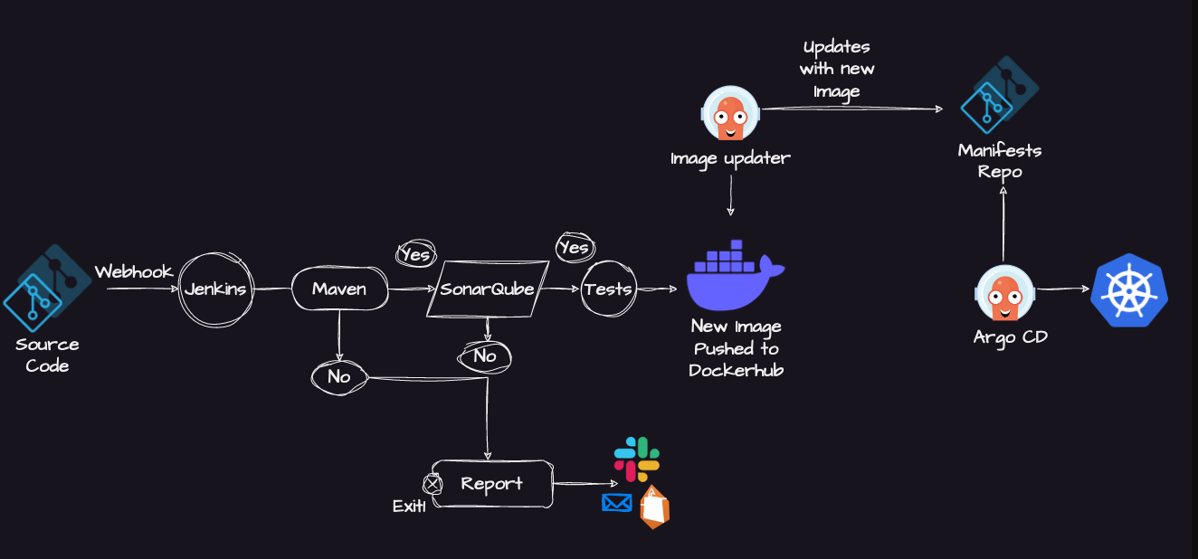

Installation on EC2 Instance:

* Go to AWS Console
* Instances(running)
* Launch instances

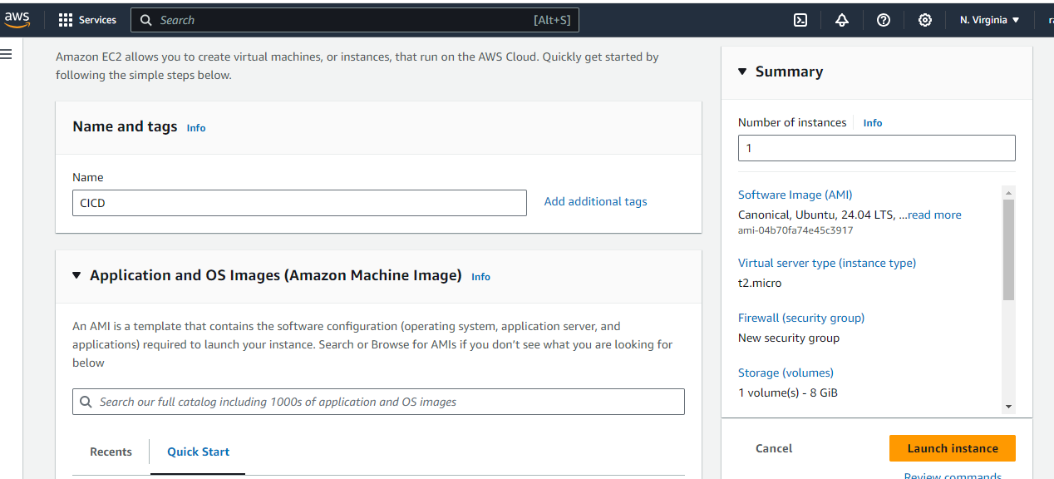

Install Java:

1. Update package lists: sudo apt update
2. Install OpenJDK 11: sudo apt install openjdk-11-jre
3. Verify Java installation: java -version

**Install Jenkins:**

* Import Jenkins repository key: curl -fsSL https://pkg.jenkins.io/debian/jenkins.io-2023.key | sudo tee /usr/share/keyrings/jenkins-keyring.asc > /dev/null
* Add Jenkins repository: echo deb [signed-by=/usr/share/keyrings/jenkins-keyring.asc] https://pkg.jenkins.io/debian binary/ | sudo tee /etc/apt/sources.list.d/jenkins.list > /dev/null
* Update package lists: sudo apt-get update
* Install Jenkins: sudo apt-get install jenkins

Note: Ensure inbound traffic rules allow TCP 8080.

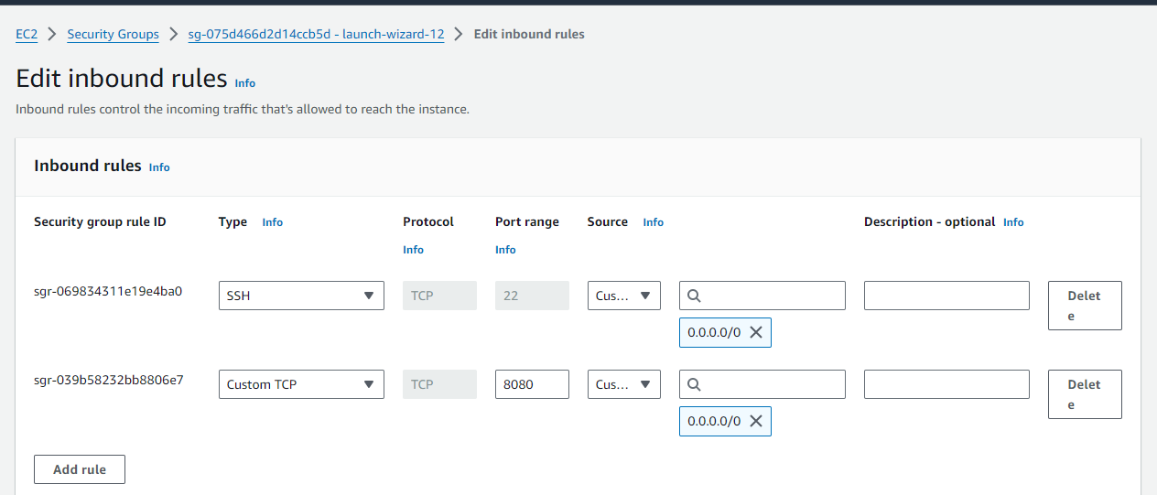

* Access Jenkins:
* Login using: http://<ec2-instance-public-ip>:8080

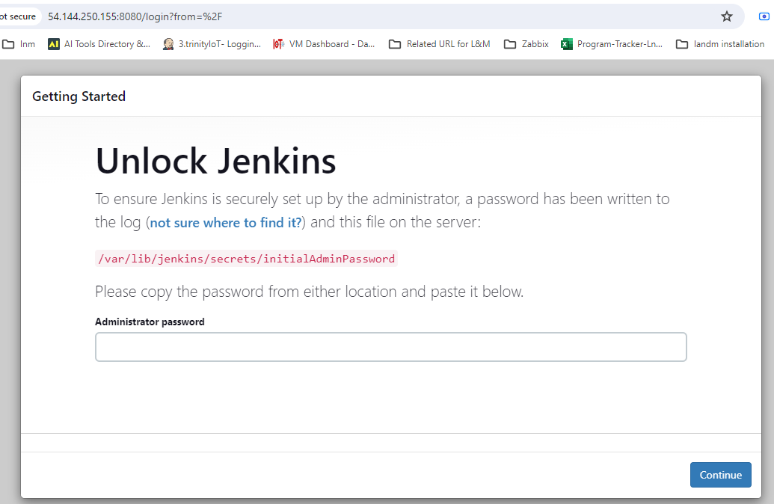

* Retrieve admin password: sudo cat /var/lib/jenkins/secrets/initialAdminPassword

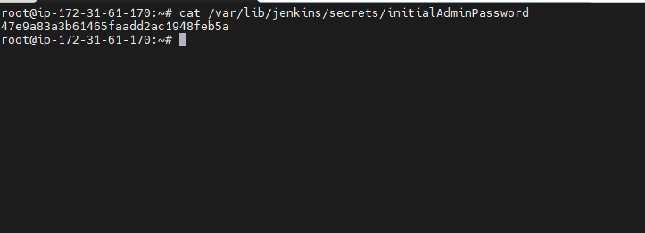

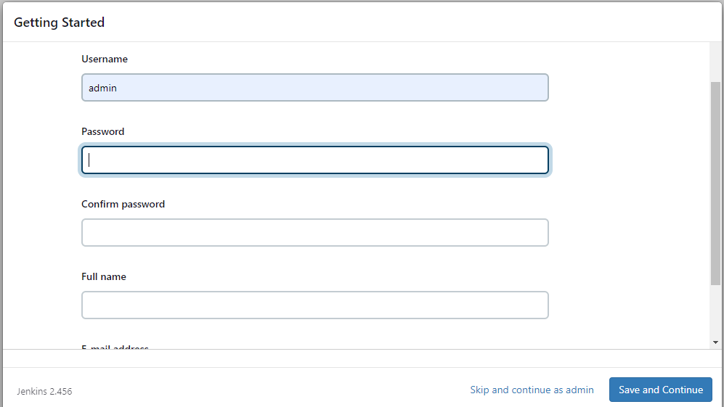

**------------->create admin user------------>**

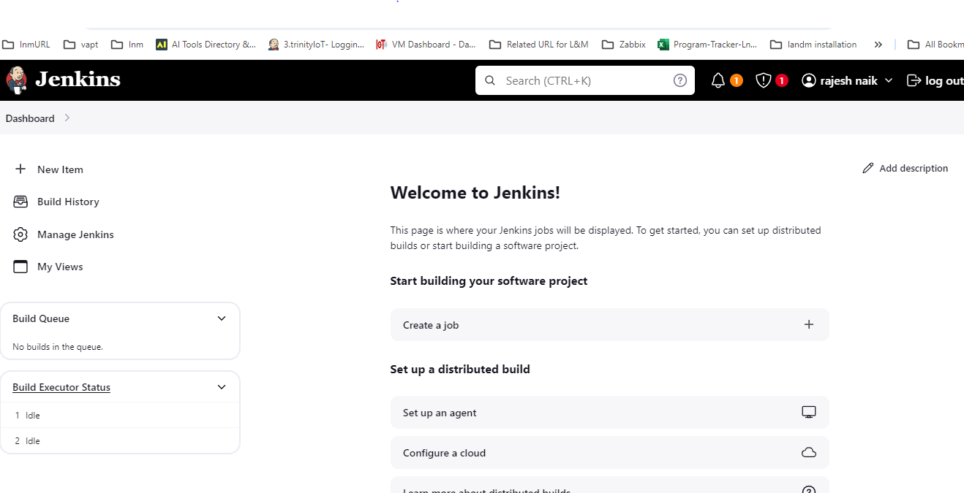

**------------->Jenkins Installation is Successful.------------>**

**create pipeline**

* Navigate to your Jenkins dashboard.
* Click on New Item.
* Enter a name for your pipeline and select Pipeline as the project type.
* Click OK to proceed.

In the pipeline configuration page:

* Scroll down to the Pipeline section.
* In the Definition dropdown, select Pipeline script from SCM.
* Choose your preferred SCM (Git, GitHub, etc.).
* Enter the repository URL where your Jenkinsfile is stored.
* If needed, specify the branch or tag.
* Save the configuration.

**Note: Ensure that your Jenkins server has the necessary permissions to access the repository.**

v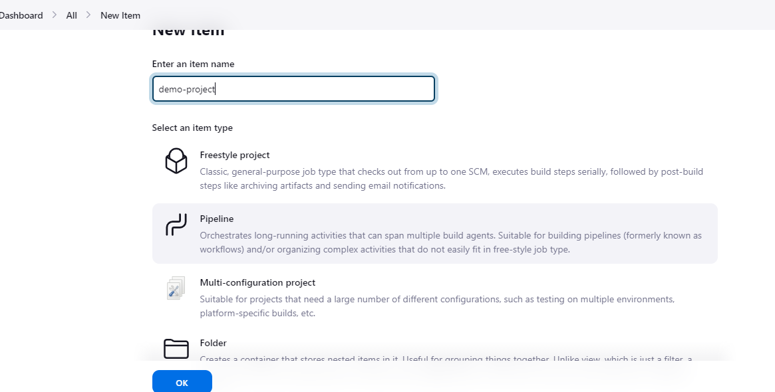

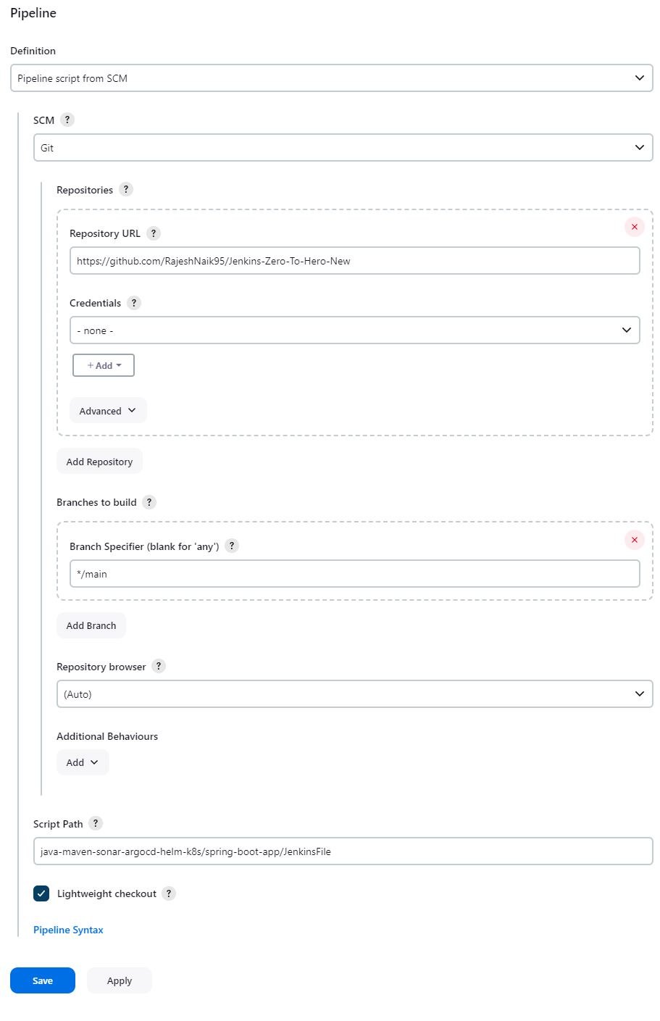

In this pipeline we are using docker as agent so for that need to install docker pluggin and docker in jenkins server

**Install Docker Plugin:**

* + Go to the Jenkins dashboard.
  + Click on Manage Jenkins in the sidebar.
  + Select Manage Plugins.
  + Go to the Available tab.
  + Search for "Docker" in the filter box.
  + Check the box next to Docker Plugin.
  + Click Install without restart.

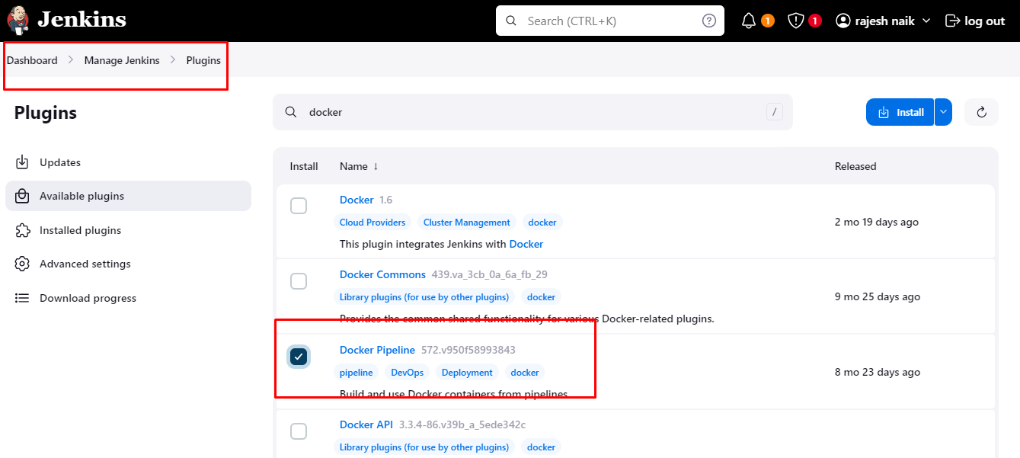

install docker in jenkins server

**Install Docker:**

sudo apt update

sudo apt install docker.io

**Grant Permissions:**

sudo su -

usermod -aG docker jenkins

usermod -aG docker ubuntu

systemctl restart docker

Once you are done with the above steps, it is better to restart Jenkins.

http://<ec2-instance-public-ip>:8080/restart

**Install SonarQube:**

* Install SonarQube Scanner Plugin: Jenkins Dashboard -> Manage Jenkins -> Plugins -> Install SonarQube Scanner.

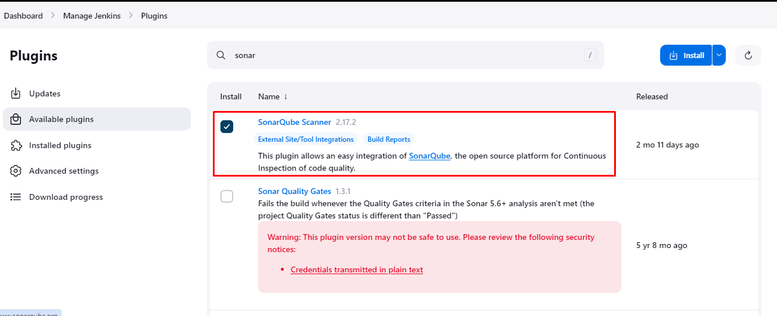

**Install and Configure SonarQube Server**

$apt install unzip

$adduser sonarqube

su - sonarqube

wget <https://binaries.sonarsource.com/Distribution/sonarqube/sonarqube-9.4.0.54424.zip>

unzip *

chmod -R 755 /home/sonarqube/sonarqube-9.4.0.54424

chown -R sonarqube:sonarqube /home/sonarqube/sonarqube-9.4.0.54424

cd sonarqube-9.4.0.54424/bin/linux-x86-64/

./sonar.sh start

sonar kube installed it will access in 9000 port

<https://ec2> instance ip :9000

* Add 9000 port in EC2 inbond rule

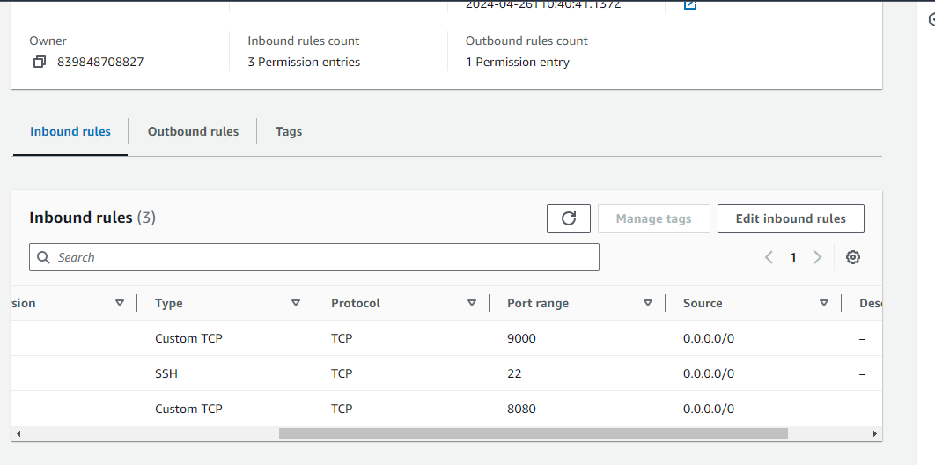

**Connect Jenkins with SonarQube:**

Now we can acess sonarqkube url

Default User name and password is admin --- admin

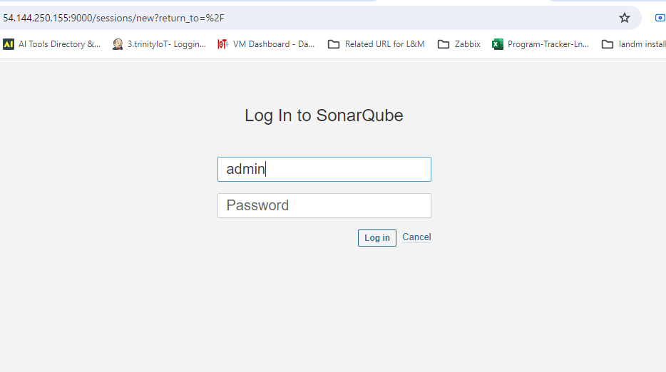

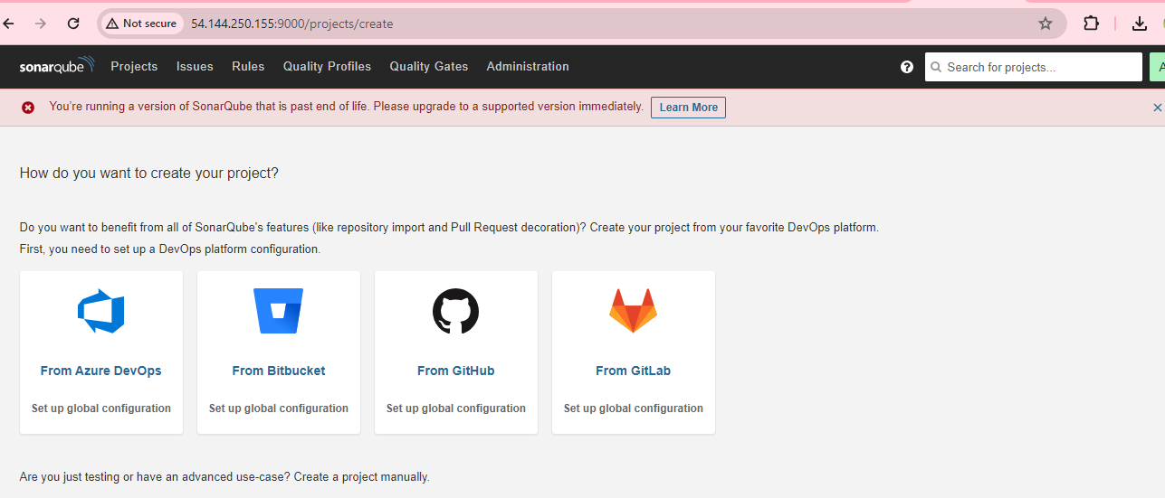

**Connect SonarQube with Jenkins:**

1. Generate API Token in SonarQube:

* Log in to your SonarQube instance.
* Navigate to your profile settings.
* Click on Security or My Account.
* Select Security.
* Scroll down to the Generate Tokens section.
* Provide a name for your token and click Generate.
* Copy the generated token.

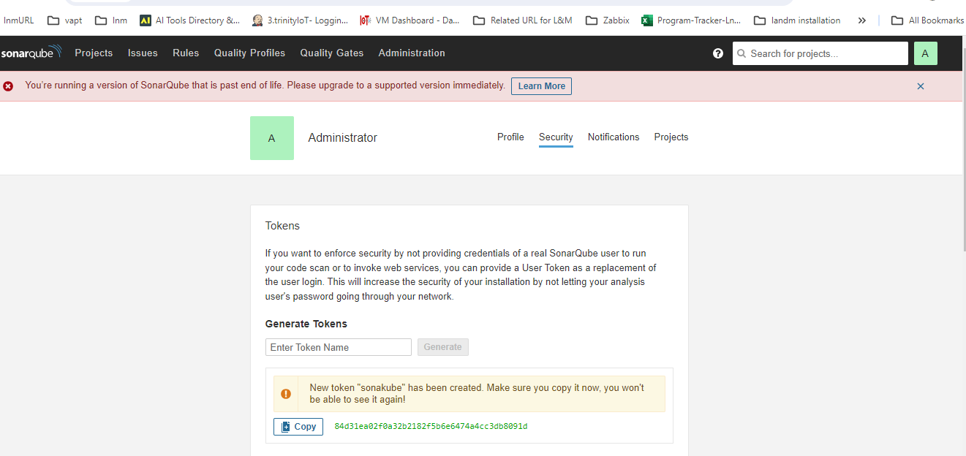

Add API Token to Jenkins Credentials:

* Go to your Jenkins dashboard.
* Click on Manage Jenkins in the sidebar.
* Select Manage Credentials.
* Click on (global) or the appropriate domain.
* Click on Add Credentials.
* Choose Secret text as the kind.
* Paste the copied API token in the Secret field.
* Optionally, provide an ID and description.
* Click OK to save the credentials.

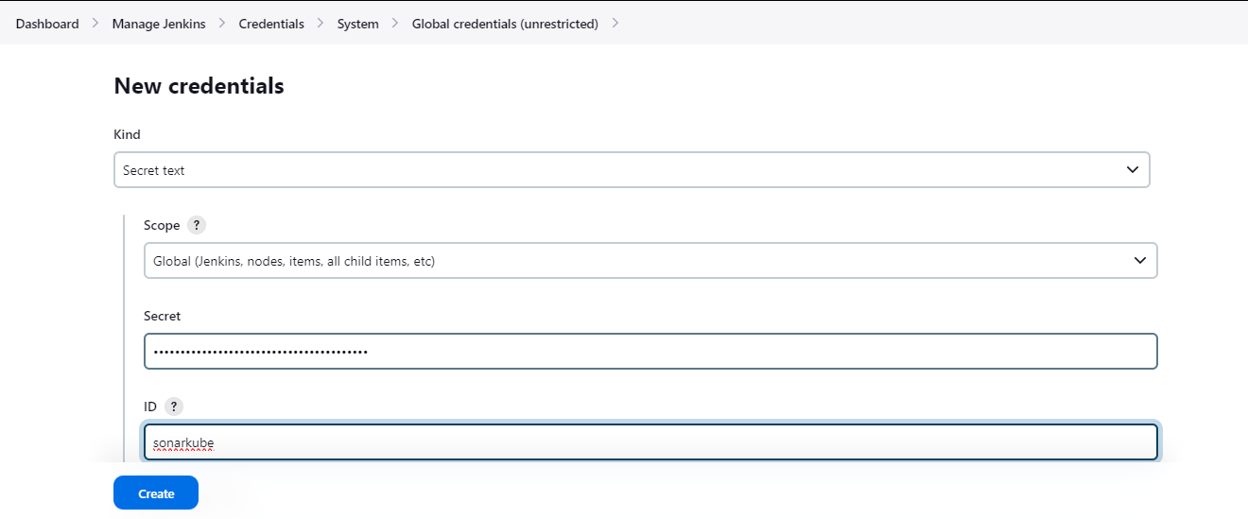

Continuous Integration (CI) Setup Complete.

**Continuous Deployment (CD) Setup:**

**Install MiniKube on a new EC2 instance:**

**Installing Docker:**

**Update package lists:**

sudo apt-get update

**Install Docker:**

sudo apt-get install docker.io -y

sudo usermod -aG docker $USER && newgrp docker

**Update system packages and install MiniKube dependencies:**

sudo apt update && sudo apt upgrade

sudo apt install -y curl wget apt-transport-https

**Download the latest MiniKube release:**

curl -LO https://storage.googleapis.com/minikube/releases/latest/minikube-linux-amd64

**Install MiniKube:**

sudo install minikube-linux-amd64 /usr/local/bin/minikube

**Verify the installation by checking the MiniKube version:**

minikube version

**You should see an output similar to:**

minikube version: v1.32.0

commit: 8220a6eb95f0a4d75f7f2d7b14cef975f050512d

**Download kubectl:**

curl -LO https://storage.googleapis.com/kubernetes-release/release/$(curl -s https://storage.googleapis.com/kubernetes-release/release/stable.txt)/bin/linux/amd64/kubectl

**Make kubectl executable:**

chmod +x kubectl

**Move kubectl to /usr/local/bin to make it available system-wide:**

sudo mv kubectl /usr/local/bin/

**Check the kubectl version:**

kubectl version -o yaml

**Start MiniKube with Docker driver:**

minikube start --driver=docker --force

**Check the status of MiniKube:**

minikube status

minikube

type: Control Plane

host: Running

kubelet: Running

apiserver: Running

kubeconfig: Configured

**Setup Argo CD:**

* Install Operator Lifecycle Manager (OLM).

curl -sL <https://github.com/operator-framework/operator-lifecycle-manager/releases/download/v0.27.0/install.sh> | bash -s v0.27.0

• Install Argo CD Operator.

$ kubectl create -f <https://operatorhub.io/install/argocd-operator.yaml>

$ kubectl get csv -n operators

* Deploy Argo CD controller.
* Access Argo CD UI using generated credentials.

Deploy Argo CD Controller:

Create a YAML file named argocd-basic.yml with the following content:

apiVersion: argoproj.io/v1alpha1

kind: ArgoCD

metadata:

name: example-argocd

labels:

example: basic

spec: {}

Apply the YAML file to create the Argo CD instance:

$kubectl apply -f argocd-basic.yml

Check the status of the Argo CD pods:

$kubectl get pod

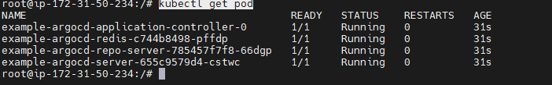

Check the services to get the URL for accessing Argo CD:

$kubectl get svc

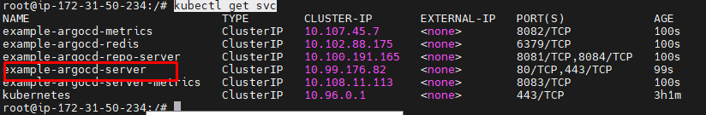

Edit the service to change the cluster IP to node port for browser access:

$kubectl edit svc example-argocd-server

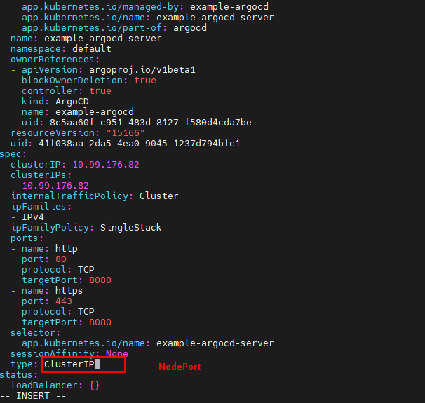

Access Argo CD UI:

Use port-forwarding to access the Argo CD UI:

$kubectl port-forward svc/example-argocd-server -n default --address 0.0.0.0 8080:443

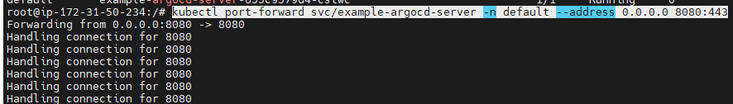

Use the following credentials to login:

* Username: admin
* Password: (Decrypt the encrypted password using the command below)

echo dlAzcDBaeFJmWUw4RGFuaEd1U0pGYjlYano1Z1dIY3M= | base64 -d

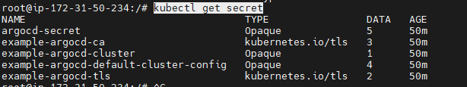

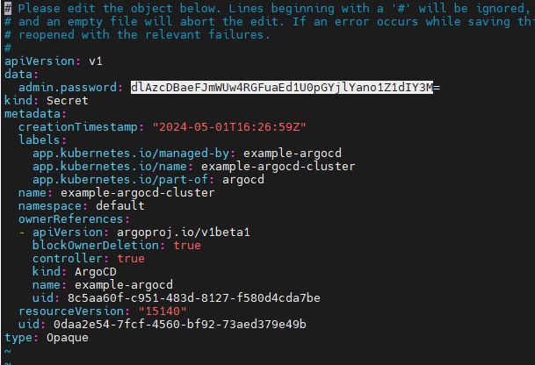



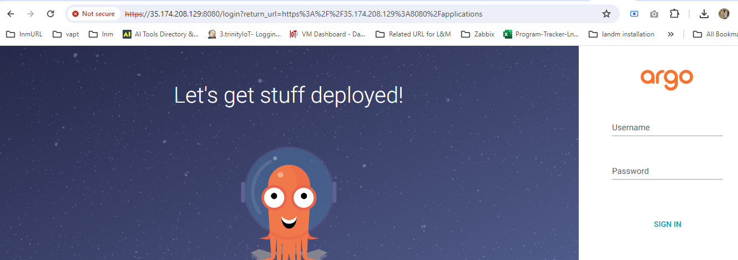

Add Docker Hub and GitHub Credentials in Jenkins:

Docker Hub Credentials:

* Navigate to your Jenkins dashboard.
* Click on Manage Jenkins in the sidebar.
* Select Manage Credentials.
* Click on (global) or the appropriate domain.
* Click on Add Credentials.
* Choose Username with password as the kind.
* Enter your Docker Hub username and password.
* Optionally, provide an ID and description.
* Click OK to save the credentials.

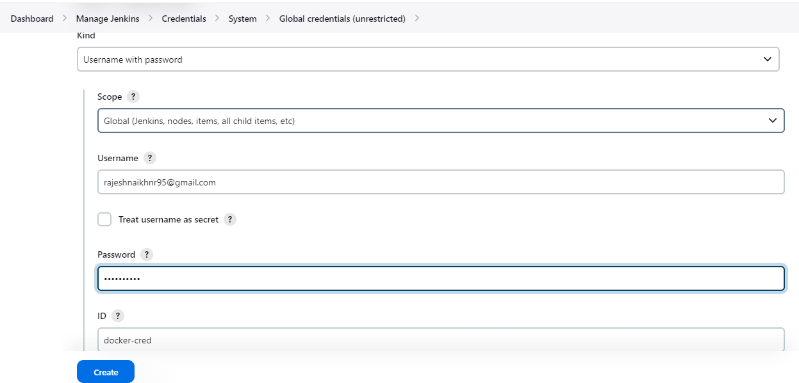

GitHub Credentials:

* Follow the same steps as above but choose Secret text as the kind.
* Enter your GitHub personal access token or password.
* Optionally, provide an ID and description.
* Click OK to save the credentials.

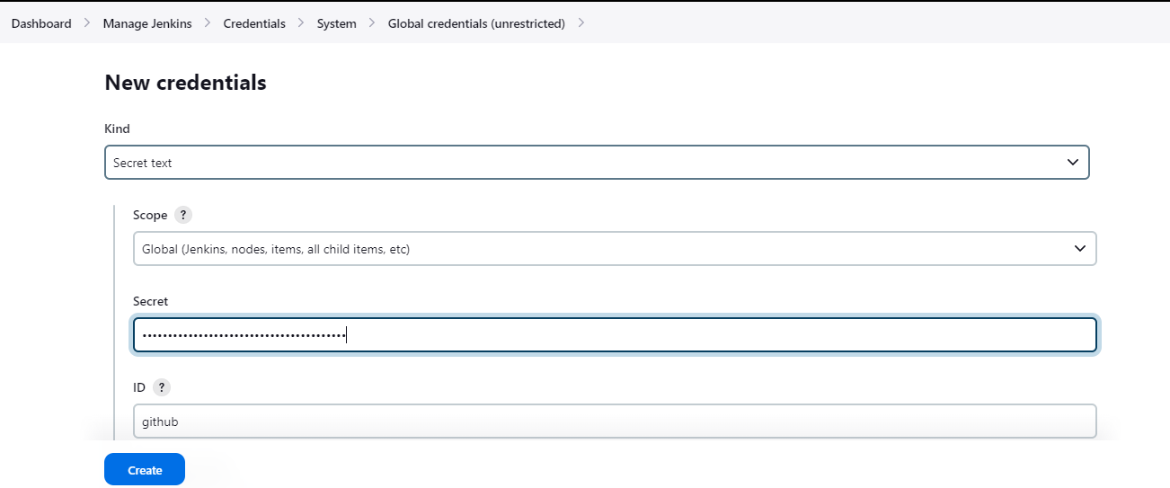

**Build Pipeline:**

* Ensure all configurations, including linking your Jenkinsfile, setting up Docker and Maven plugins, and defining stages, are completed.
* Once the pipeline is set up, go to the Jenkins dashboard.
* Click on your pipeline project.
* Click on Build Now to trigger a build.
* Jenkins will start the build process. You can monitor the progress in the Jenkins interface.
* Upon successful completion, you should see "Build Success" in the build history.

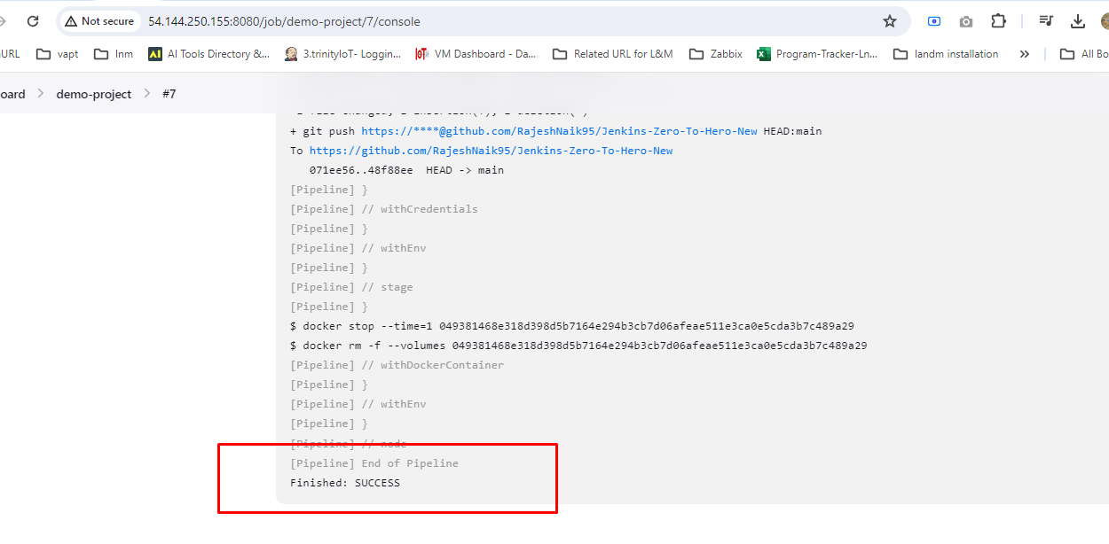

**Build Success............................................................................................**

**Post-Build Actions:**

* Verify that Docker images have been updated in your Docker Hub repository.
* Check the build artifacts and logs for any errors or warnings.
* If everything looks good, proceed with further deployment steps as per your pipeline configuration.

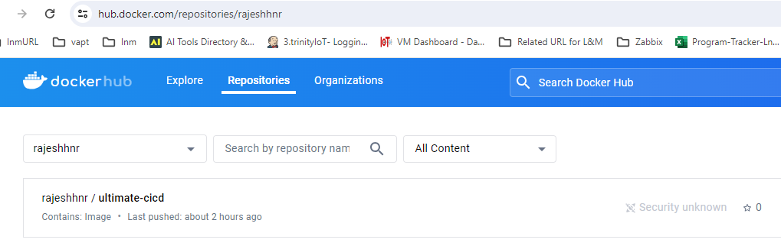

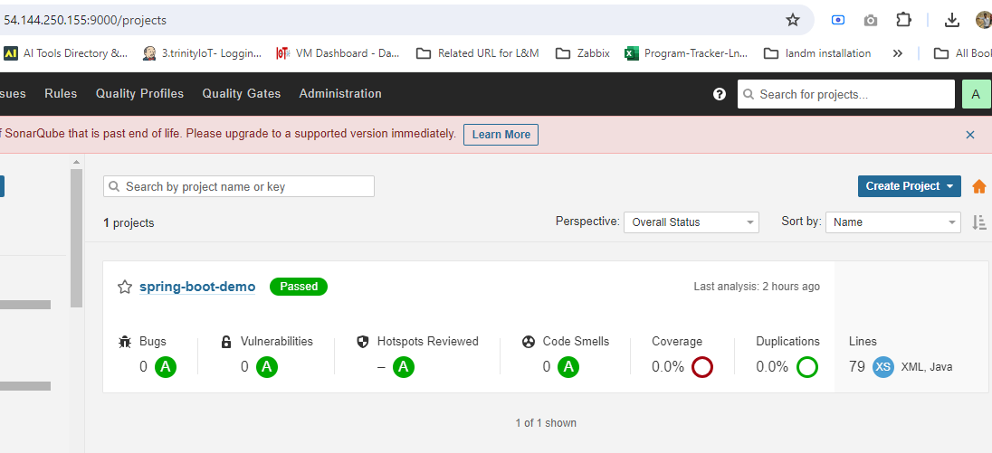

**Deploy Application to Minikube Cluster using Argo CD:**

Configure Argo CD Application:

* Open the Argo CD UI in your browser.
* Log in using your credentials.
* Navigate to the Applications tab.
* Click on Create Application.
* Fill in the application details, including the Git repository URL, target revision, and sync policy.
* Click on Create to add the application.

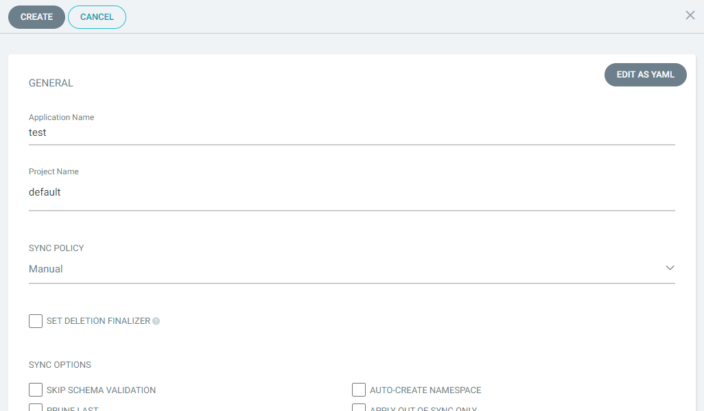

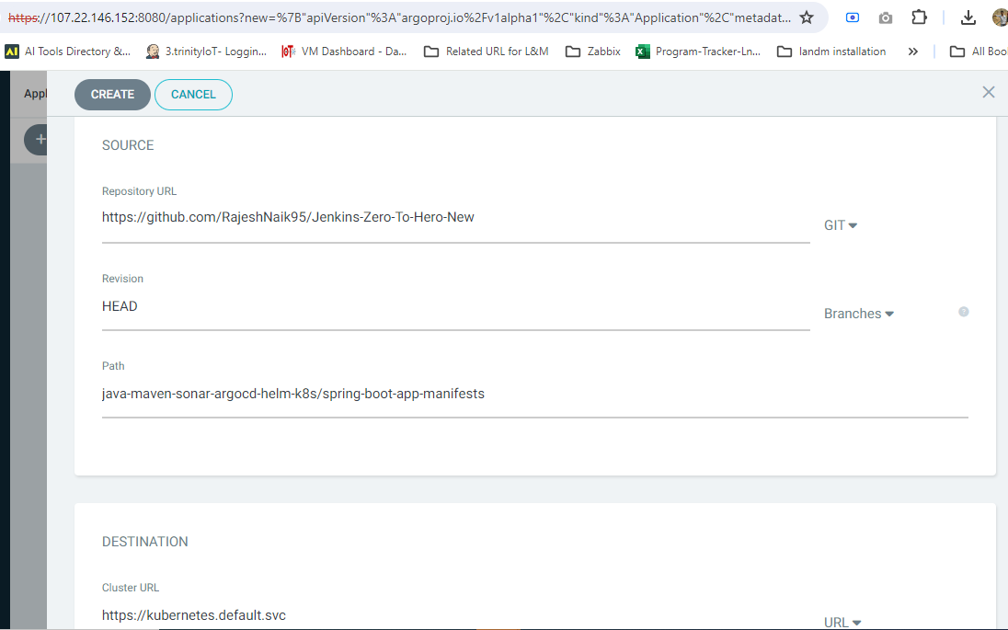

**Trigger Synchronization:**

* Once the application is created, Argo CD will automatically synchronize with the Git repository.
* You can also manually trigger synchronization by clicking on the Sync button next to the application.

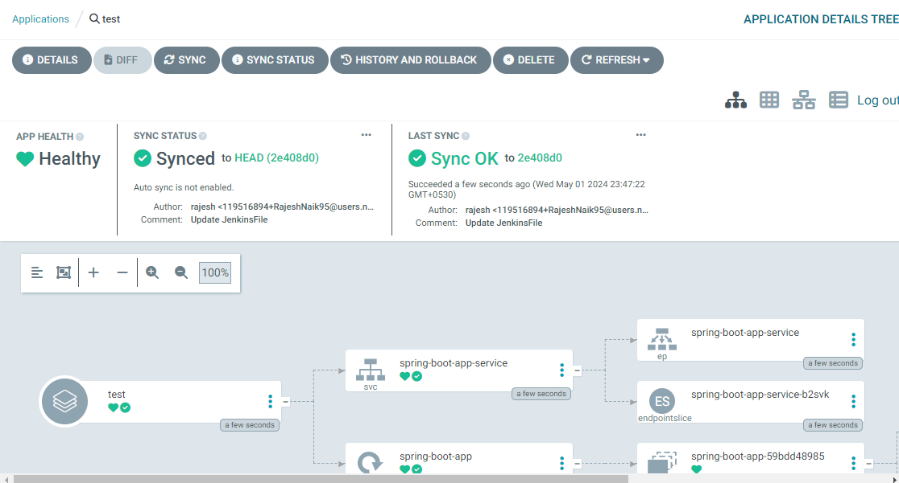

Monitor Deployment:

* Monitor the deployment progress in the Argo CD UI.
* Wait for the application to be deployed successfully.

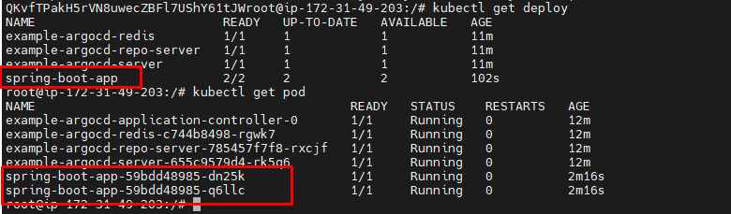

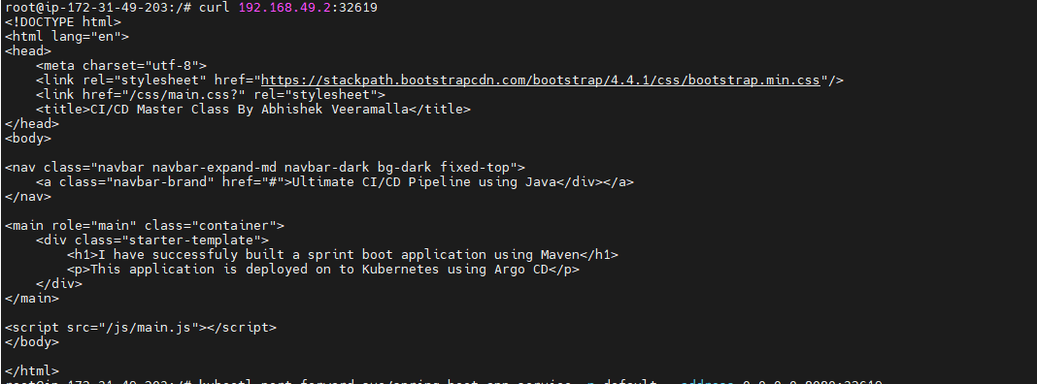

**Access Application:**

* Once the deployment is complete, you can access your application.
* To access a service running in the Minikube cluster, you can use port-forwardin

$kubectl get svc

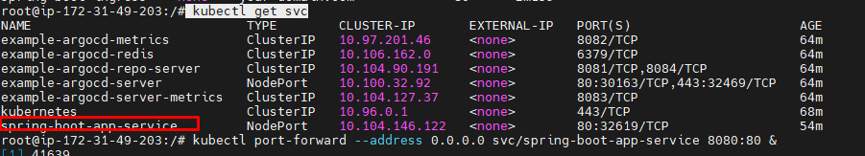

kubectl port-forward --address 0.0.0.0 svc/<service-name> 8080:80

Replace <service-name> with the name of your service.

* Open your browser and navigate to http://localhost:8080 to access your application.

**Now we can able to access in browser**.................................

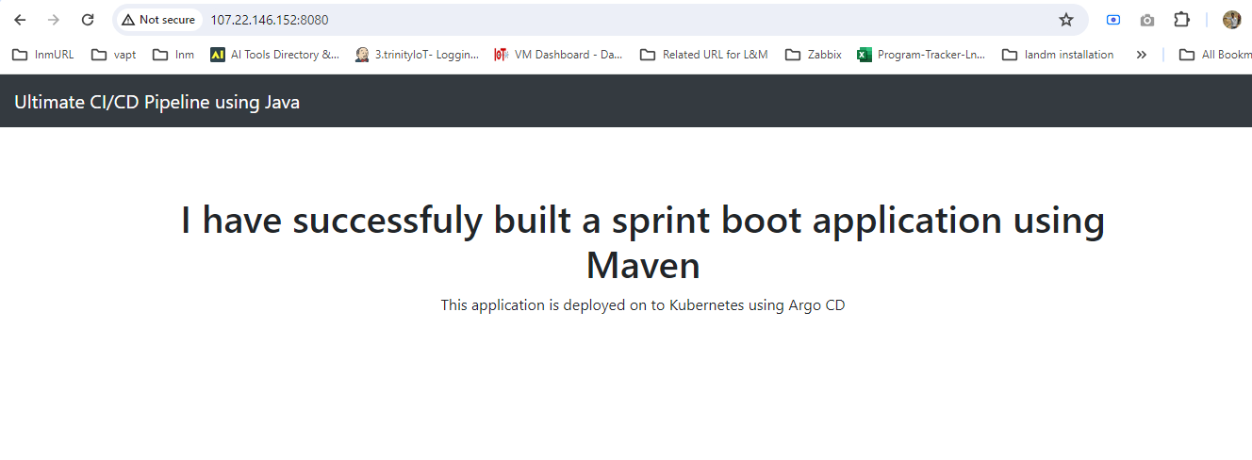

**THANK You……**