MODEL PROBABILITIES OBSERVATIONS

- STANDALONE SECOND MODEL OBSERVATIONS

- On a globallevel, total clients whose predicted probability is greater than or equal to 0.5 is 71.3% and below 0.5 is 28.7%

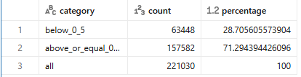

- Category-wise:

- Retirement: greater than or equal to 0.5 – 86.3%, below 0.5 – 13.7%
- Disability: greater than or equal to 0.5 – 20%, below 0.5 – 80%
- Life Insurance: greater than or equal to 0.5 – 59.5%, below 0.5 – 40.5%
- Investment: greater than or equal to 0.5 – 39.4%, below 0.5 – 60.6%
- Network Products: greater than or equal to 0.5 – 87.1%, below 0.5 – 12.9%
- Other: greater than or equal to 0.5 – 30.8%, below 0.5 – 69.2%
- Health: greater than or equal to 0.5 – 0%, below 0.5 – 100%

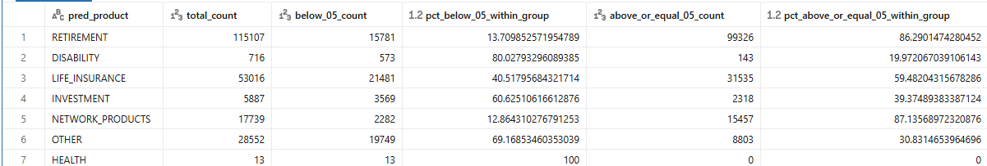

- Global category-wise:
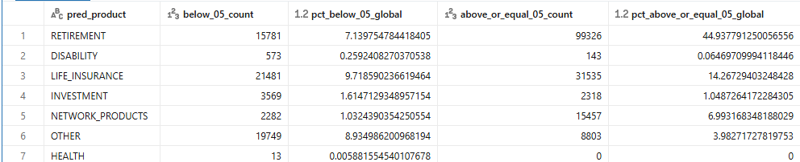

- COMBINED FIRST AND SECOND MODEL PIPELINE

- On a global level, clients whose cross-sale probability >= 0.5 and predicted probability >= 0.5 are 17.1% and whose cross-sale probability >= 0.5 and predicted probability < 0.5 are 82.9%

- Clients whose cross-sale probability < 0.5 and predicted probability < 0.5 are 63,8% and whose cross-sale probability < 0.5 and predicted probability >= 0.5 are 12.4%

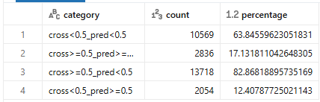

- Category-wise
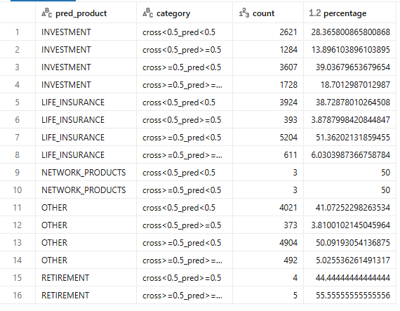

Other Observations:
- Total clients in branch 83 and business month 202511: 262,816
- Clients with single policy in branch 83 and business month 202511: 235,615

