**Tittle: Payment Gateway integration**

BRD Created at: 3/11/2017 v.1

Jira:

|  |  |  |  |  |
| --- | --- | --- | --- | --- |
| Date | JIRA | Notes | Updated By | Version |
|  | [link](https://docs.google.com/spreadsheets/d/1-KSfs9A3M-Xo8apk7gr4Dvw4SWiMBNgRMEKX6Lv95n4/edit#gid=0&range=C24) |  |  | 1.0.0.0 |

Business Requirements

Written by: Cansu Salkıç, José Pedro Teles, Marina Camilo, Rajesh Ghosh, Victor Padi

Feature Objective: This feature is going to connect the customer to the payment portal and check when the payment is done in the portal.

Business Logic

* Feature Definition and Scope

With this feature a customer must be redirect to the payment portal in order to pay for its shopping cart. It must allow the customer to chose from a variety of payment platforms.

* Wish List

(Future steps)

# Process Flow

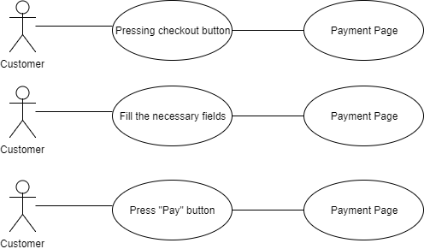

# Use Cases

|  |  |  |  |  |
| --- | --- | --- | --- | --- |
| Use case Id | Action Taken | Principal actor | Expected Result | Error Result |
| 01 | Press the checkout button | Customer | Redirect to payment page | User doesn’t has permission to access this page |
| 02 | Fill all the fields necessary to make the payment | Customer | Display a message saying that all the fields have the correct information format | Display a message saying in the field that has an error |
| 03 | Press “Pay” button | Customer | Redirect to profile page | Reload the page to allow the user to fill the fields with new data |

# Interface Design

# temp.PNG

# Data Description

The data between systems will be secure using SSL and TLS protocols. It should contain three blocks of characters, and three blocks of numbers.

# Integration with other systems

* **Internal :** User information will be validated by our internal database at first then it will forward to the required external payment gateway type.
* **External** : Based on user information, Payment details will be validated by the payment processor by sending them through the credit or debit card networks (Visa, MasterCard, American Express, Discover), which forward them to the card-issuing bank to be authorized.

# Client environment to use

Client will access to the this feature via browser on a computer. System has to be intuitive for every kind of person. It also should contain references for blind and color blind people. It has to be support by images when necessary.

# Reports

End of the transaction, it will generates two reports as a PDF. User will able to download or save their bill and another one will get the company. In future company can check the all bills and also users can check or complain about their products.

# Reference Material

Find more about in the link: <https://drive.google.com/drive/u/0/folders/0B1JvzMFVEdwxd3R6Tk9yX3dnN1U>

# Existing Application Impact

Not applicable.

# Security Permissions Impact

Not applicable.

# De-scope Requirements