Key Objective (Fashion industry use case) – Guidance through Pluralsight training course
- Build a smart contract on Solidity that takes vital body parameters , rendered through NodeJS (Backend)
- Host the smart contract on Sepolia Blockchain (Procure Sepolia ETH through alchemy faucet or google cloud)
- Create a reactJS UI application that provides a front-end experience and interacts with the smart
- Application should have the ability to host on sepolia test net through Metamask (create credentials)
- Use Mocha for testing the compiled contract
Software’s Required
Winget (Package manager)
- Install Winget from Microsoft Store (from start menu on windows)
- Install NodeJS from Winget through powershell (Run as administrator) Command is “winget install OpenJS.NodeJS.LTS”
- Make sure VS code is installed. If not available, install from powershell using the winget command - “winget install Microsoft.VisualStudioCode -e”
- Make sure chrome is installed, if not installed, install from powershell using the winget command – “winget install –id=Google.Chrome -e”
- Enable remote signed command to make sure execution scripts can be executed correctly. Run the command from powershell – “set-executionpolicy remotesigned”
Npm (Package manager)
- npm install -g create-react-app
Chrome
- Got to Chrome->Extensions->OpenChrome Web Store and add “MetaMask” – Create wallet as this is required for hosting blockchain in sepolia (other options like ganache needs to be explored). Pin MetaMask to browser
- Once MetaMask is pinned and available, go to advanced settings and make sure that “Test Networks” are available
- Go to Sepolia alchemy faucet to get free SepoliaETH coins that can be used in MetaMask. Provide contract address to move coins to wallet. This will require ‘sign up’ in sepolia alchemy faucet -Go ahead and do that.
- Once you get money, it will help you with hosting the blockchain on Sepolia (as ETH is needed for gas fees to host contract)
- You can also get free sepolia ETH from google (screenshot provided below)- https://cloud.google.com/application/web3/faucet/ethereum/sepolia
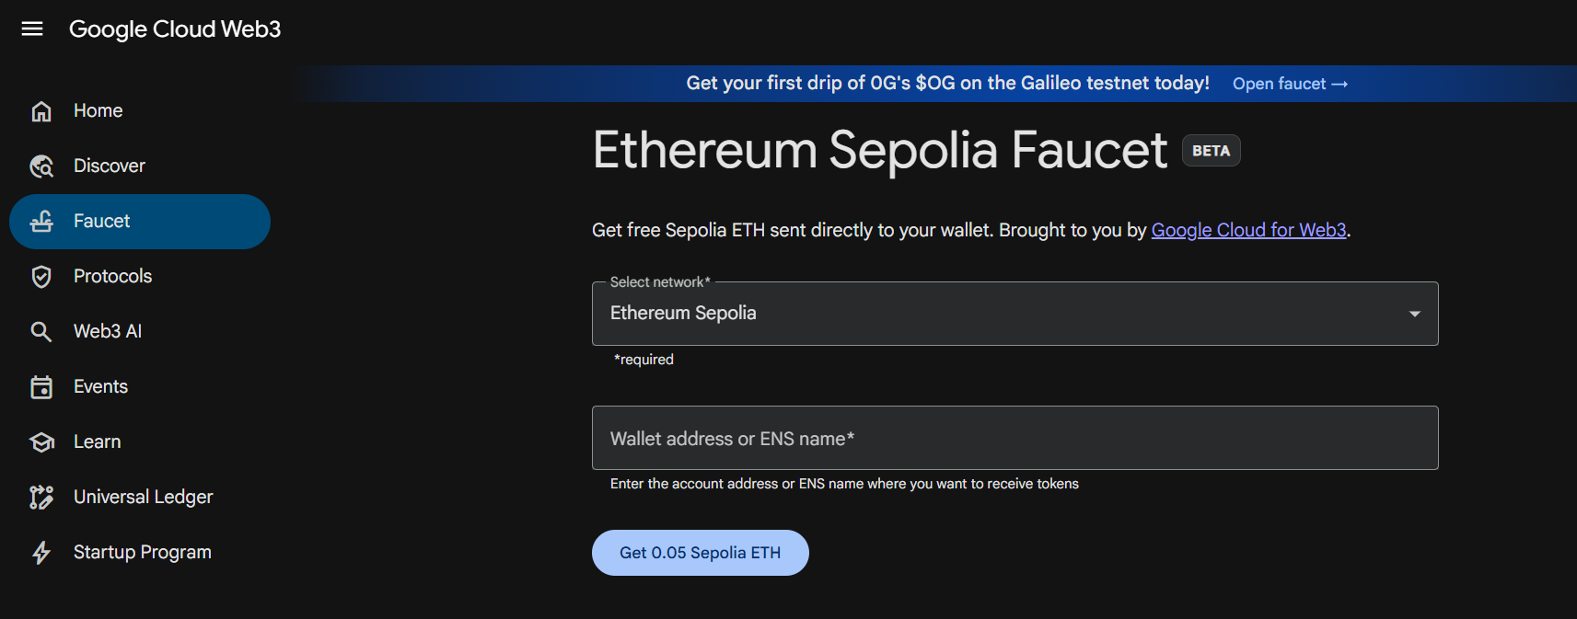

Other installations – To be executed on bodymap\bodymap-server

Copy the files from git repo to the folder structure before running the below steps

1. web 3 - npm install web3@4.16.0
2. Solidity compiler – npm install solc@0.8.19
3. ganache (Private Blockchain for dev purposes) – npm install ganache-cli@6.12.2
4. mocha for testing contract using assertions - npm install mocha@10.2.0
5. Node Express web server – npm install express@4.18.2

Other installations – To be executed on bodymap\bodymap-react
- Web 3 - npm install web3@1.9.0
- Crypto – npm install crypto-js@4.1.1

Key commands for running application
For bodymap-server
- Use Mocha for testing the compiled contract (Command->npm run test) in the backend (execute from bodymap-server folder)
- Use command “node compile.js” to compile the contract in the backend (execute from bodymap-server folder)
- Use command ‘npm run start’ to start and keep the server running in the backend (execute from bodymap-server folder)– This internally compiles and runs the server.js file and provides a running service – Make sure that the contract is running in localhost:8000 (screenshot given below)
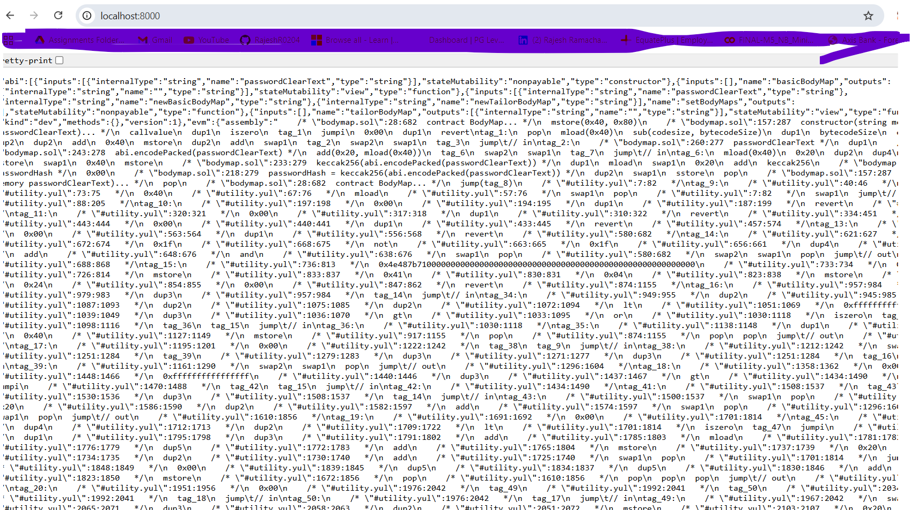

Run Command npm run test on bodymap\bodymap-server folder – This runs the bodymap.test file) for mocha test assertions – The ganache-cli is a private blockchain that is used through the Web 3 framework and the accounts are picked from the ganache cli account list (first account is used). The smart contract is hosted on ganache-cli and the contract number is highlighted below
The above command automatically executes the contract test – File->Test\Bodymap.test.js
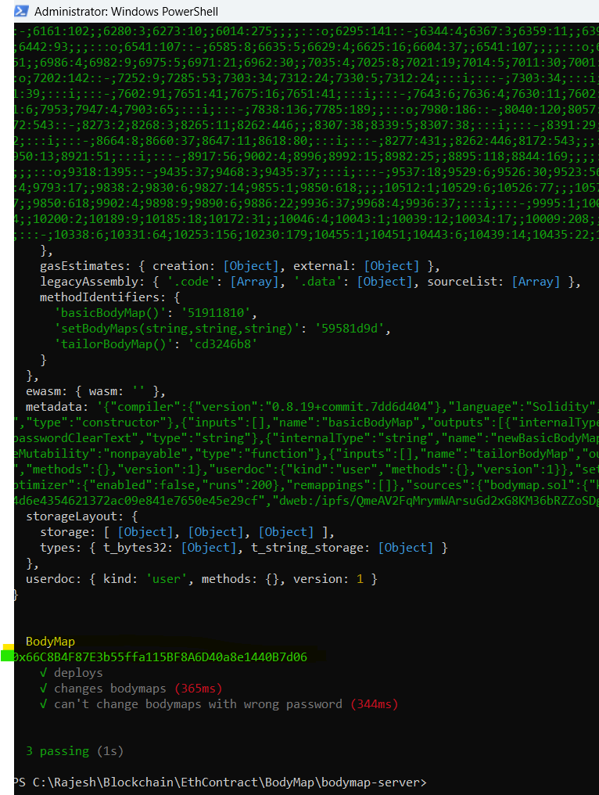

You can run the command “node compile.js” to check the bytecode value of contract. Run this from backend – bodymap\bodymap-server folder“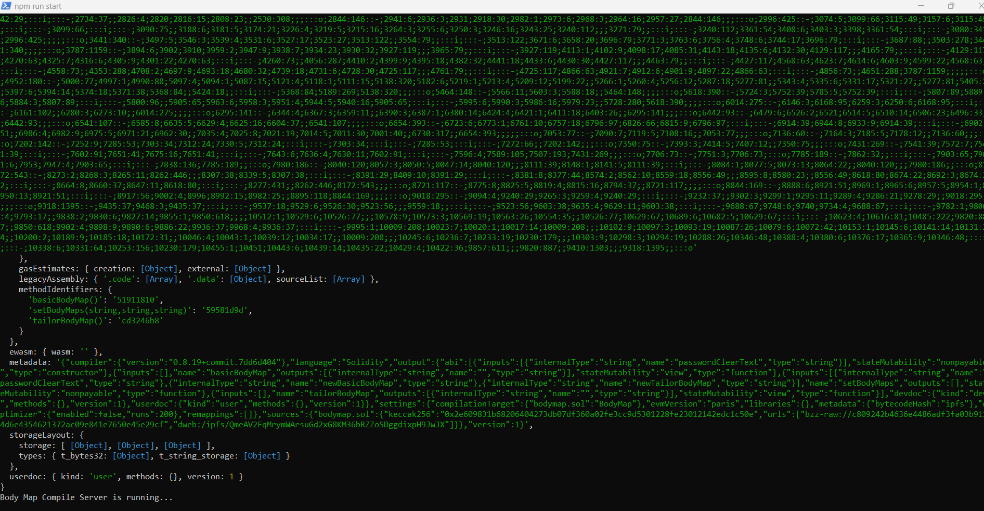
Finally – The UI
For UI
Pre-requisite – Make sure that server is running in separate powershell window as the reactUI refers to the server running at http://localhost:8000 for UI to work correctly
- Navigate to bodymap\bodymap-react folder and run the command ‘npm run start’ – This will start the UI application
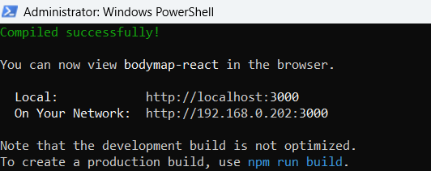

UI Experience – As can be observed system prompts for hosting on sepolia (make sure to have a Metamask wallet)
