**Project Report**

**Deep Learning Model Analyzer**

**Master’s in computer science**

Student: Rajesh Kumar Ramadas

rajesh-kumar.ramadas@iu-study.org

Matriculation: 92125100

Course name                      Project: Software Engineering

(DLMCSPSE01)

University: International University of Applied Sciences

Juri-Gagarin-Ring 152 · D-99084 Erfurt

University Supervisor: Dr. Holger Klus

oezdemir.cetin@iu.org

Submission Date:  November 2024

Contents

1. PROJECT OVERVIEW 2

2. PROJECT GOALS 3

3. FEATURES 4

4. TECHNOLOGICAL STACK 5

6. TARGET USERS 6

7. LIMITATIONS 7

8. REPOSITORY & PREREQUISITES 7

9. STEPS TO USE APPLICATION. 9

10. TOOL PERFORMANCE 12

11. CONCLUSION 12

12. ACKNOWLEDGEMENTS 12

## 1. PROJECT OVERVIEW

## The Deep Learning Model Analyzer is a tool designed to streamline the process of evaluating and analyzing deep learning models, particularly those based on the YOLOv8 architecture. This project aims to provide a comprehensive solution for researchers, data scientists, and developers who need to perform real-time video processing and model evaluation.

## Efficiency: Streamlines the process of model evaluation, saving time and effort for researchers and developers.

## Accessibility: The user-friendly GUI makes the tool accessible to a broader audience, including those with limited programming skills.

## Flexibility: Supports various video sources and adjustable settings, catering to different evaluation needs and environments.

## Real-Time Feedback: Provides immediate visual feedback on model performance, facilitating quick iterations and improvements.

## The Deep Learning Model Analyzer is a robust and versatile tool designed to meet the evolving needs of the deep learning community. By combining real-time video processing with a user-friendly interface, it empowers users to efficiently evaluate and improve their models, driving advancements in the field of computer vision.

## Core Components of Design

## Main Application: The entry point of the application, responsible for initializing the GUI and managing the overall workflow.

## GUI: Built using PyQt6, this component provides a user-friendly interface for interacting with the application. It includes features for loading models, adjusting video settings, and capturing snapshots.

## Video Processing: Utilizes OpenCV to handle video streams, apply real-time predictions, and adjust video settings.

## Model Handling: Integrates with the Ultralytics YOLOv8 library to load and evaluate models, ensuring compatibility with the latest advancements in object detection.

## 2. PROJECT GOALS

## The Deep Learning Model Analyzer is designed with several key goals in mind to ensure it meets the needs of its users effectively. These goals focus on enhancing the usability, functionality, and performance of the tool, making it a valuable asset for researchers, data scientists, and developers working with deep learning models.

## 2.1. Facilitate Model Evaluation

## Objective: Provide a seamless process for loading and evaluating deep learning models, particularly YOLOv8 models.

## Details: Users should be able to easily load their models into the application and run evaluations on various datasets. The tool should support different model formats and provide detailed performance metrics.

## 2.2. Enable Real-Time Video Processing

## Objective: Allow users to process video streams in real-time and apply model predictions.

## Details: The application should capture video from various sources (e.g., webcam, video files) and apply the loaded model to each frame in real-time. This enables users to see immediate results and make quick adjustments as needed.

## 2.3. Offer Adjustable Video Settings

## Objective: Allow users to customize video settings to optimize the evaluation process.

## Details: Users should be able to adjust parameters such as brightness, contrast, and frame rate directly from the GUI. These adjustments help in creating the best possible conditions for model evaluation and can be tailored to specific use cases.

## 2.4. Ensure Compatibility with YOLOv8

## Objective: Maintain compatibility with the latest YOLOv8 models and annotation formats.

## Details: The tool should support YOLOv8 models out-of-the-box, ensuring that users can leverage the latest advancements in object detection. It should also handle YOLOv8-compatible annotation formats for seamless integration.

## 2.5. Enable Snapshot Capture

## Objective: Provide functionality for capturing and saving snapshots from video streams.

## Details: Users should be able to capture snapshots at any point during video processing. These snapshots can be saved for further analysis, documentation, or reporting purposes.

## 3. FEATURES

* **Video Playback:** The application enables users to load, play, pause, and stop video files, providing flexible control over video playback for effective analysis. This feature supports common video formats and allows users to navigate frame-by-frame, ensuring precision during tasks like annotation and detection.
* **Camera Input:** Users can start and stop real-time video input from an attached camera. This feature allows for live analysis, enabling the YOLOv8 model and other processing tools to work directly on real-time data streams, making it ideal for applications requiring immediate feedback, such as surveillance or monitoring.
* **Edge Detection:** The tool includes three edge detection algorithms—Sobel, Canny, and Laplace of Gaussian:
  + **Sobel:** A simple gradient-based algorithm ideal for highlighting vertical and horizontal edges.
  + **Canny:** A multi-stage detector that reduces noise and preserves high-contrast edges, making it useful for precise boundary detection.
  + **Laplace of Gaussian:** Combines Gaussian smoothing with Laplace filtering to detect edges and reduce noise simultaneously, providing refined edge outlines.
* **YOLOv8 Model Integration:** Users can load YOLOv8 models to perform object detection within video frames. The tool allows for filtering detections based on specific object classes and confidence thresholds, helping users to focus on relevant detections and achieve tailored results. This customization supports diverse applications, from tracking specific objects to analyzing motion in crowded scenes.
* **Brightness and Contrast Adjustment:** This feature enables users to modify the brightness and contrast of video frames, improving visibility and making details more discernible. These adjustments are particularly useful for enhancing low-light videos or emphasizing objects with low contrast relative to the background.
* **Cropping and Resizing:** Users can crop and resize video frames to focus on regions of interest or adjust dimensions for compatibility with other processing requirements. Cropping isolates specific parts of the frame, while resizing ensures consistency across datasets, making it easier to work with video in downstream processes.
* **Snapshot and Recording:** Users can capture snapshots of video frames at any moment, as well as save segments or entire video streams as recordings. Snapshots facilitate quick image export for further analysis or documentation, while recording provides a means of saving processed video segments for later review or reporting purposes.

## 4. TECHNOLOGICAL STACK

Tool leverages a robust technological stack:

* 1. **Programming Language: Python**  
     Chosen for its simplicity and strong compatibility with machine learning libraries, Python facilitates ease of development and integration with YOLOv8 models.
  2. **GUI Framework: PyQt6**  
     PyQt6 allows for the creation of a cross-platform, user-friendly interface. Its extensive set of widgets enables smooth navigation and customization.
  3. **Image Processing Libraries: OpenCV or PIL**
* **OpenCV:** Offers fast image manipulation functions ideal for large datasets.
* **PIL:** Provides a simpler alternative for basic image processing and format conversion tasks.
  1. **Deep Learning: Ultralytics YOLOv8**

Ultralytics YOLOv8 is an advanced object detection model known for speed and accuracy, ideal for real-time applications. It integrates easily with Python, allowing for both training from scratch and fine-tuning on custom datasets. With pre-trained weights and comprehensive documentation, YOLOv8 streamlines deployment and adapts efficiently to various detection tasks.

**5. ALGORITHM SUPPORTED**

## 6. TARGET USERS

* **Data Scientists and Machine Learning Engineers:** Professionals working with deep learning models who need an efficient, versatile tool to handle video data and run object detection or other model-based analyses.
* **Researchers and Developers:** Individuals engaged in video processing, computer vision, and model evaluation who require reliable methods to assess and improve the accuracy and performance of detection models.
* **Educators and Students:** Academics and learners in the fields of computer vision and deep learning who benefit from hands-on tools for exploring video processing and model application in real-world scenarios. This tool provides a practical framework to gain experience in these domains.

## 7. LIMITATIONS

## 7.1. Limited to YOLOv8 Models

## Description: The current version of the tool is specifically designed to work with YOLOv8 models.

## Impact: Users who wish to evaluate models based on other architectures (e.g., YOLOv5, Faster R-CNN, SSD) will not be able to use this tool without significant modifications.

## 7.2. Dependency on Specific Python Packages

## Description: The tool relies on specific Python packages such as PyQt6 for the GUI and OpenCV for video processing.

## Impact: Users must ensure that these dependencies are correctly installed and compatible with their system. Any issues with these packages can affect the functionality of the tool.

## 7.3. Performance Variability Based on Hardware

## Description: The performance of the tool can vary significantly based on the hardware capabilities of the user's system.

## Impact: Users with lower-end hardware may experience lag or reduced performance, especially when processing high-resolution video streams or large datasets.

## 7.4. Lack of Advanced Analytics and Visualization

## Description: The current version of the tool focuses primarily on real-time video processing and model evaluation.

## Impact: Users looking for advanced analytics and visualization tools (e.g., confusion matrices, precision-recall curves) will need to use additional software or tools.

### 8. REPOSITORY & PREREQUISITES

### 8.1. <https://github.com/RajeshRamadas/Deep-Learning-Model-Analyzer.git>

### 8.2. Prerequisites

**Before installing the Yolo8 Annotation Tool, make sure you have the following installed on your system:**

* + **Python 3.9+**: **Ensure Python is installed. You can download it from** [python.org](https://www.python.org/downloads/).
  + **pip**: **Python package manager, usually installed with Python**.

### 8.3. Installation Steps & Execution

### 8.3.1. Clone the repository:

### 

### 8.3.2. Install the required dependencies:

### 

### 8.3.3. Run the application:

### 

### 

**Fig 8.3.1:** Model Analyzer

## 9. STEPS TO USE APPLICATION.

* 1. **Load a video**:

Click on "Add Video MP4" to load a video file.

[Deep-Learning-Model-Analyzer/demo/video/sample1.mp4 at main · RajeshRamadas/Deep-Learning-Model-Analyzer · GitHub](https://github.com/RajeshRamadas/Deep-Learning-Model-Analyzer/blob/main/demo/video/sample1.mp4)

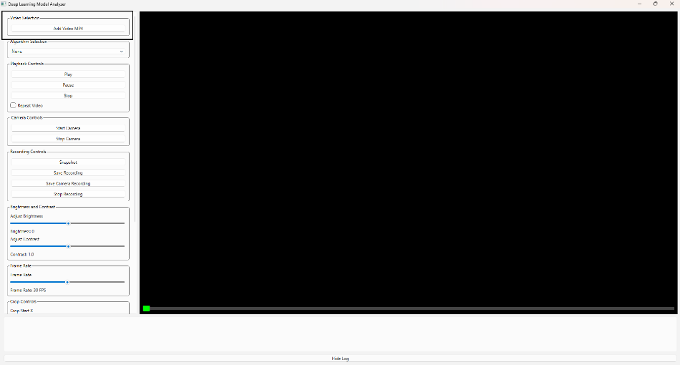

**Fig 9.1.1:** add video for verification of model

* 1. **Select an algorithm**:

Choose an edge detection algorithm or "Load YOLOv8 Model" from the "Algorithm Selection" dropdown.

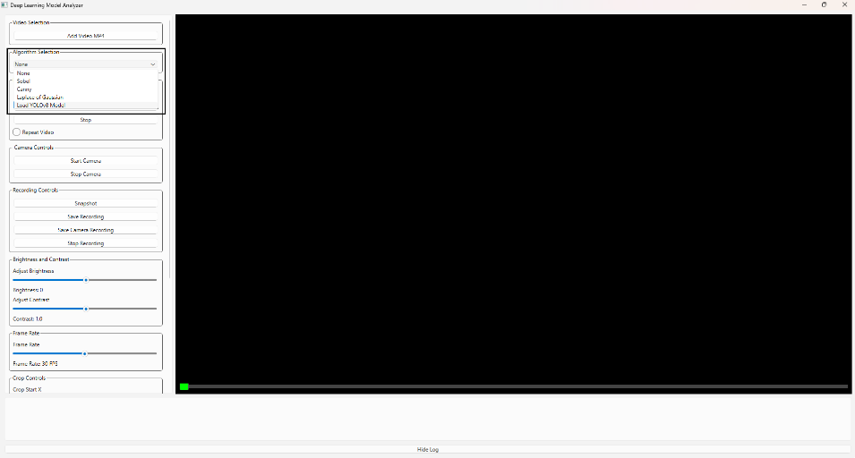

**Fig 9.2.1:** Select algo example [YOLO]

* 1. **Load a YOLOv8 model**:

If "Load YOLOv8 Model" is selected, click on "Load YOLOv8 Model" to load a model file. Sample default yolov8 model : [Deep-Learning-Model-Analyzer/demo/model/yolov8n.pt at main · RajeshRamadas/Deep-Learning-Model-Analyzer · GitHub](https://github.com/RajeshRamadas/Deep-Learning-Model-Analyzer/blob/main/demo/model/yolov8n.pt)

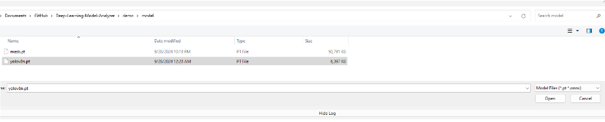

**Fig:** Select YOLO model

Enter the classes to detect and the confidence threshold when prompted.

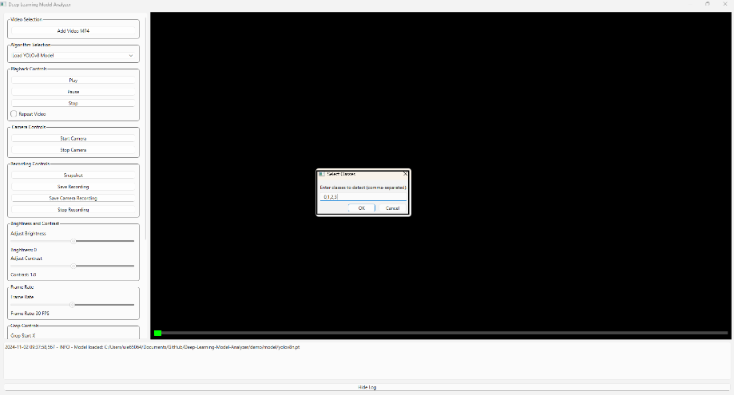

**Fig 9.3.1:** Add class ID for object detection with comma separator.

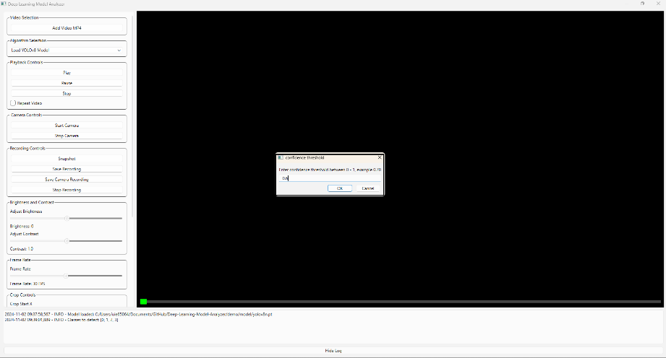

**Fig 9.3.2:** Confidence threshold between [0-1]

* 1. **Adjust settings**:

Use the sliders to adjust brightness, contrast, cropping, and resizing settings.

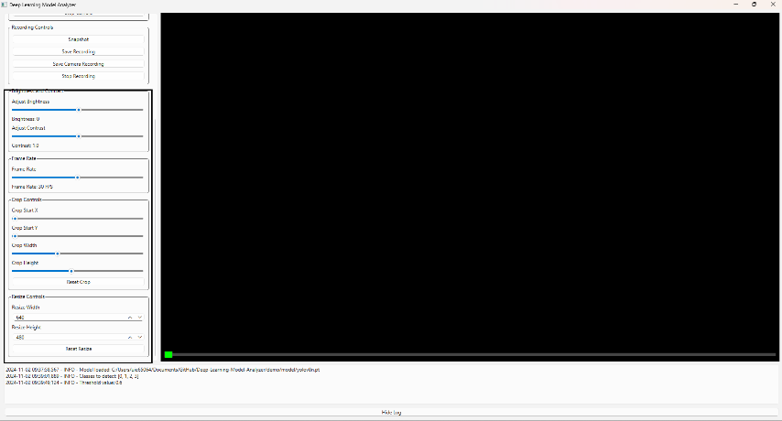

**Fig 9.4.1:** Adjust brightness, contrast, cropping.

* 1. **Control playback**:

Use the "Play", "Pause", and "Stop" buttons to control video playback.

Check "Repeat Video" to loop the video.

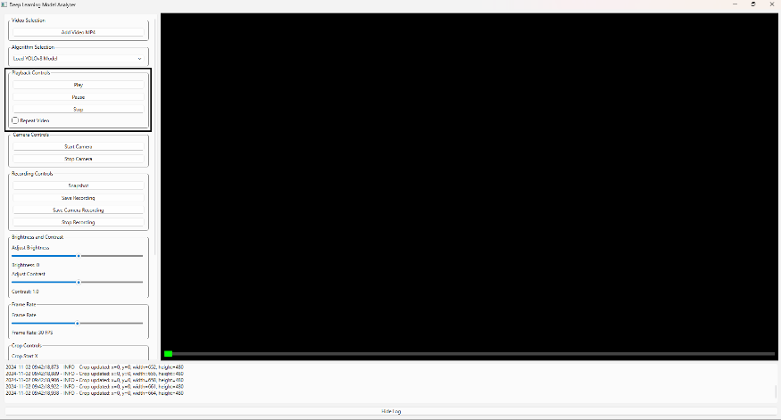

**Fig 9.5.1:** "Play", "Pause", and "Stop" buttons.

* 1. **Capture snapshots and recordings**:

Click on "Snapshot" to capture a snapshot of the current frame.

Click on "Save Recording" or "Save Camera Recording" to save video recordings.

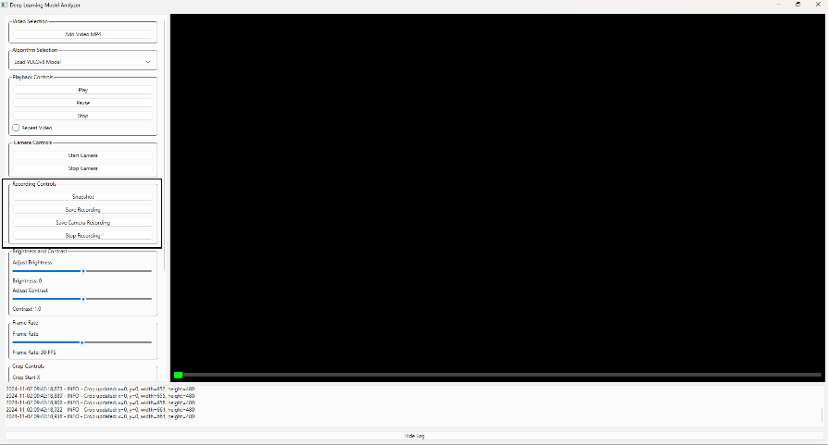

**Fig 9.6.1:** Recording option for snapshot and video.

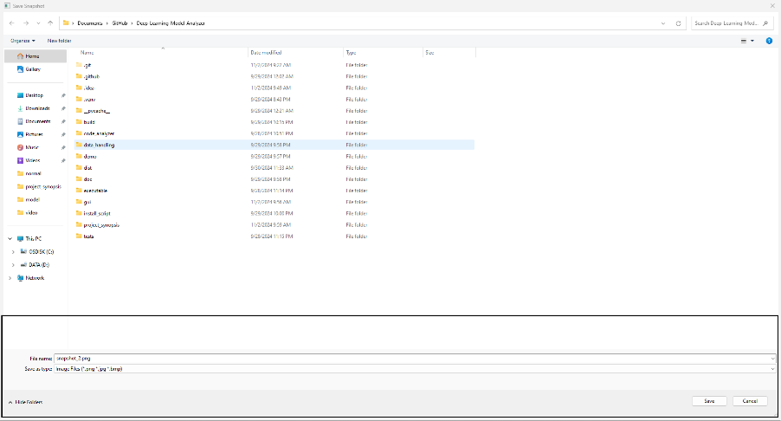

**Fig 9.6.2:** Snapshot save location.

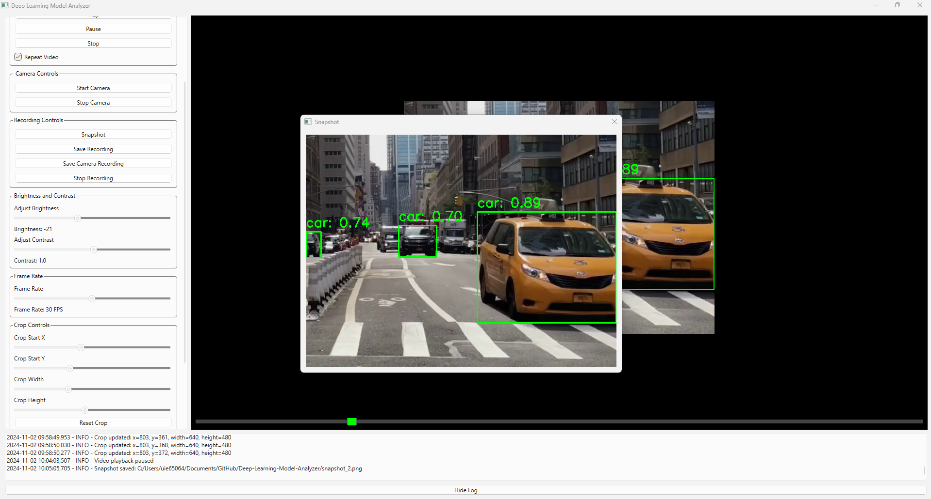

**Fig 9.6.3:** Saved snapshot pop-up.

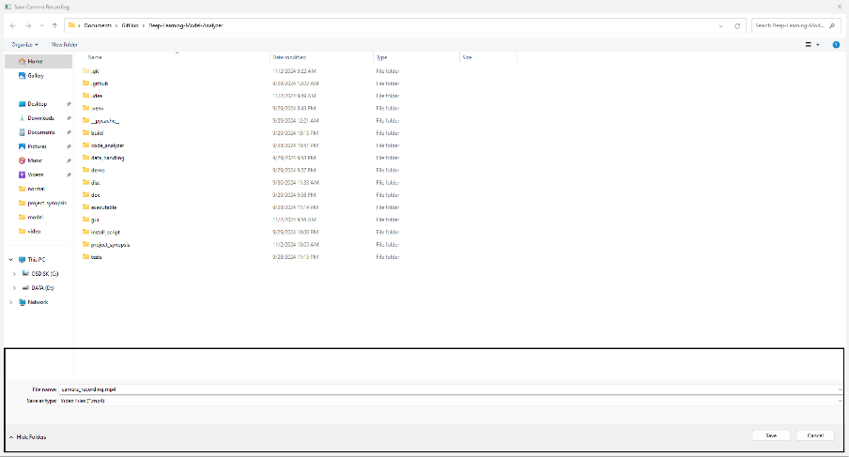

**Fig 9.6.4:** Video recording saving.

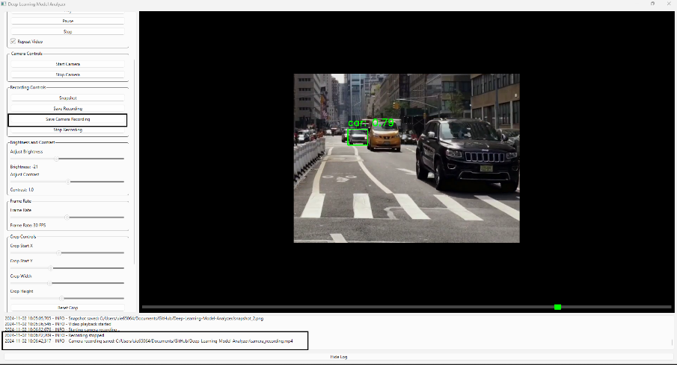

**Fig 9.6.5:** Recording saving log confirmation with path.

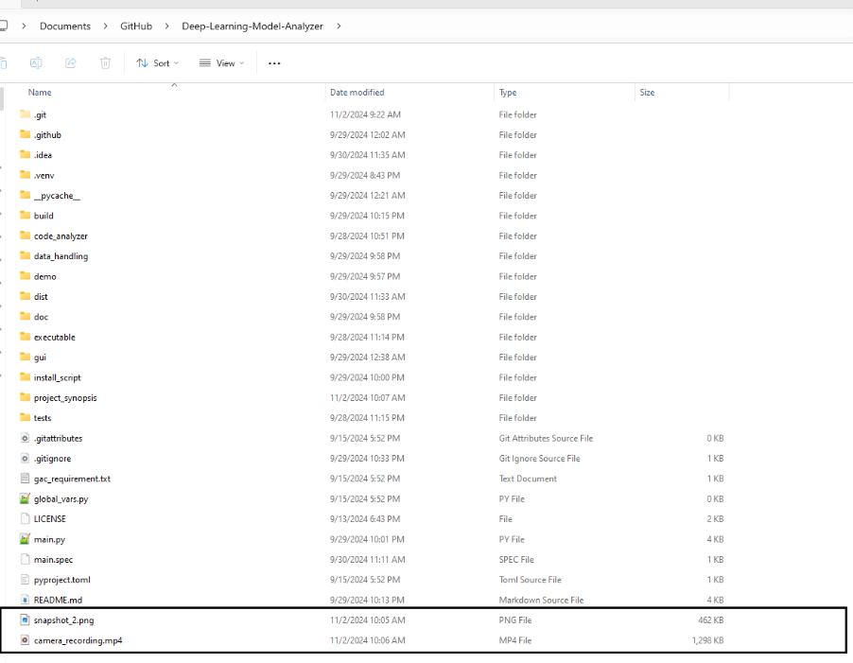

**Fig 9.6.6:** Saved recording and snapshot.

## Sample Recording: [Deep-Learning-Model-Analyzer/demo/yolo8_video/camera_recording.mp4 at main · RajeshRamadas/Deep-Learning-Model-Analyzer · GitHub](https://github.com/RajeshRamadas/Deep-Learning-Model-Analyzer/blob/main/demo/yolo8_video/camera_recording.mp4)

## TOOL PERFORMANCE

## 

**Fig 10.1:** Object detection with bounding box.

* 1. **Real-Time Processing**

The tool leverages OpenCV for real-time video processing, enabling immediate application of YOLOv8 model predictions on video streams.

Users can see real-time results, which is essential for applications requiring instant feedback, such as surveillance, autonomous driving, and interactive systems.

* 1. **Efficient Model Loading**

The tool efficiently loads YOLOv8 models, ensuring minimal delay between model selection and evaluation.

Quick model loading enhances user experience by reducing wait times and allowing for rapid iterations and testing.

* 1. **Adjustable Video Settings**

Users can adjust video settings such as brightness, contrast, and frame rate to optimize the evaluation process.

Customizable settings help in creating the best possible conditions for model evaluation, improving the accuracy and relevance of the results.

## 11. CONCLUSION

**The Deep Learning Model Analyzer is a robust and versatile tool designed to meet the needs of researchers, data scientists, and developers working with deep learning models, particularly those based on the YOLOv8 architecture. This project has been developed with a focus on providing a comprehensive solution for model evaluation, real-time video processing, and user-friendly interaction.**

* 1. **Key Achievements**
* **Model Evaluation:**
* **Real-Time Video Processing**
* **User-Friendly Interface**
* **Adjustable Video Settings**
* **Snapshot Capture**
* **Real-Time Feedback**
  1. **Limitations and Future Enhancements**

**While the Deep Learning Model Analyzer offers significant benefits, it also has some**

* **Model Compatibility: Currently limited to YOLOv8 model.**
* **Dependency Management: Ensuring compatibility with specific Python packages.**
* **Performance Variability: The tool's performance based on hardware capabilities.**
* **Advanced Features: Adding advanced analytics, visualization tools, and cloud integration can enhance the tool's functionality and scalability.**
* **Unable to create exe due to dependency of yolov8 module.**

**Future Directions**

**To address these limitations and further enhance the tool, the following future directions are proposed:**

* **Extended Model Support: Expand compatibility to include other popular deep learning models and architectures, making the tool more versatile.**
* **Advanced Analytics and Visualization: Integrate advanced analytics and visualization features to provide deeper insights into model performance.**

**Final Thoughts**

**The Deep Learning Model Analyzer represents a significant step forward in the field of model evaluation and real-time video processing. By combining powerful functionalities with a user-friendly interface, it empowers users to efficiently evaluate and improve their deep learning models. As the tool continues to evolve, addressing its current limitations and incorporating user feedback will be crucial for its ongoing success and adoption.**

**In conclusion, the Deep Learning Model Analyzer is an asset for anyone working with deep learning models, offering a comprehensive and accessible solution for model evaluation and real-time video processing. With continued development and enhancement, it has the potential to become an indispensable tool in the deep learning community.**

## 12. ACKNOWLEDGEMENTS

* [PyQt6](https://www.riverbankcomputing.com/software/pyqt/intro) for the GUI components.
* [OpenCV](https://opencv.org/) for video processing.
* [Ultralytics YOLO](https://github.com/ultralytics/yolov5) for the YOLOv8 model.