Highway Vehicle Tracker Application Analysis
Executive Summary
The Highway Vehicle Tracker is a web-based application designed for real-time vehicle detection and counting using computer vision technology. The system leverages YOLO (You Only Look Once) object detection models to identify and track vehicles in video streams, providing statistical analysis of traffic flow. This report examines the architecture, features, and implementation of the application.
System Architecture
The Highway Vehicle Tracker follows a client-server architecture with WebSocket communication for real-time video processing:
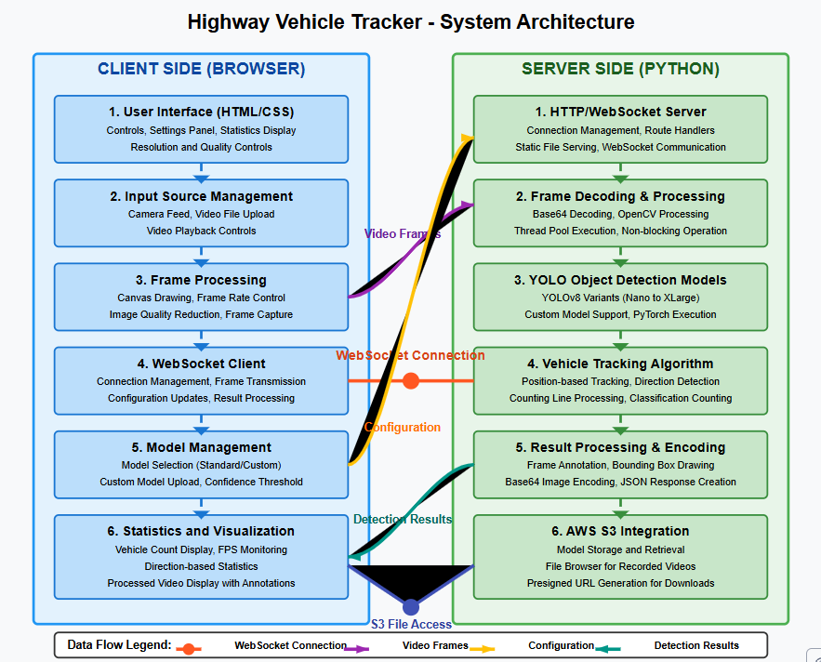
Key Components:
- Client-Side:
  - Web interface built with HTML, CSS, and JavaScript
  - Video capture and display functionality
  - WebSocket client for real-time communication
  - Configuration controls for model selection and processing parameters
  - Statistics display for vehicle counting
- Server-Side:
  - Python-based WebSocket server built with aiohttp
  - Multiple YOLO model options for object detection
  - Thread pool for non-blocking video processing
  - Vehicle tracking and counting algorithm
  - AWS S3 integration for model storage and retrieval
- Communication:
  - WebSocket protocol for bidirectional real-time data transfer
  - Base64 encoding for video frame transmission
  - JSON message format for configuration and results
Feature Analysis
1. Object Detection
The application uses YOLOv8 models for object detection, providing options ranging from lightweight (nano) to high-accuracy (XLarge) variants. This allows users to balance performance against accuracy based on their hardware capabilities.
Key capabilities:
- Pre-trained models for detecting 80 object categories
- Support for custom models via upload functionality
- Confidence threshold adjustment
- Real-time visual detection display
2. Vehicle Tracking and Counting
A distinctive feature is the ability to track vehicles across video frames and count them based on their movement direction:
- Virtual counting line placed across the video frame
- Directional counting (vehicles moving in/out)
- Classification-based counting (cars, trucks, buses, etc.)
- Real-time statistics display
- Count reset functionality
3. Input Options
The application supports multiple video input sources:
- Live camera feed
- Local video file upload
- Adjustable resolution and quality settings
- Video playback controls for uploaded files
4. Performance Optimization
Several features help optimize processing performance:
- Adjustable frame rate to balance processing load
- Quality settings to reduce data transmission size
- Resolution control
- Model selection based on performance requirements
- Processing on dedicated thread pool to prevent UI blocking
5. AWS Integration
The application includes integration with AWS S3:
- S3 file browser for accessing stored videos and models
- Model download functionality
- Credentials management via environment variables
Technical Implementation
Server Implementation (Python)
The server is built using:
- aiohttp for WebSocket and HTTP server functionality
- Ultralytics YOLO for object detection
- OpenCV for image processing
- ThreadPoolExecutor for non-blocking processing
- boto3 for AWS S3 integration
The vehicle tracking algorithm works by:
- Detecting objects in each frame
- Tracking objects across consecutive frames based on position overlap
- Determining direction of movement relative to a virtual counting line
- Maintaining counts based on object class and direction
Client Implementation (JavaScript)
The client-side code handles:
- Video capture from camera or file
- Frame rate control and quality settings
- Frame processing via WebSocket communication
- User interface interaction
- Statistics display and updates
- Real-time visualization of detections
Recommendations for Enhancement
- Database Integration: Add a database to store historical count data for trend analysis.
- Advanced Analytics: Implement speed estimation, vehicle size classification, and anomaly detection.
- Multi-Camera Support: Add capability to monitor multiple video streams simultaneously.
- Export Functionality: Enable exporting statistics in common formats (CSV, Excel).
- Authentication System: Implement user authentication for security and personalized settings.
- Edge Computing Option: Create a version that can run on edge devices for standalone operation.
- Automated Alerts: Add notification system for specific events (traffic jams, unusual traffic patterns).
Conclusion
The Highway Vehicle Tracker application provides a comprehensive solution for vehicle detection and counting using modern computer vision techniques. Its modular architecture allows for flexibility in deployment and scalability. The combination of real-time processing, configurable parameters, and statistical analysis makes it suitable for traffic monitoring, security applications, and transportation planning.

OUTPUT:
