Git & GitHub - DevOps Assignment
Git and GitHub Assignment Using Flask
Name: Rajesh
GitHub: RajeshReddy999
Repository: https://github.com/RajeshReddy999/Devops-TuteDude-Assignments

Objective
To practise SSH, branches, merges, conflicts, commits, reset, and rebase using a Flask project.

Task 1 - Repository Setup and First Branch

1. SSH Key Setup
I created an SSH key to connect my laptop to GitHub.
Command:
ssh-keygen -t ed25519 -C "rajeshreddysingireddy97@gmail.com"
I cleared the first output by mistake. I used these commands to check the key files and fingerprint:
Get-ChildItem "$env:USERPROFILE\.ssh\id_ed25519*"
ssh-keygen -lf "$env:USERPROFILE\.ssh\id_ed25519.pub"
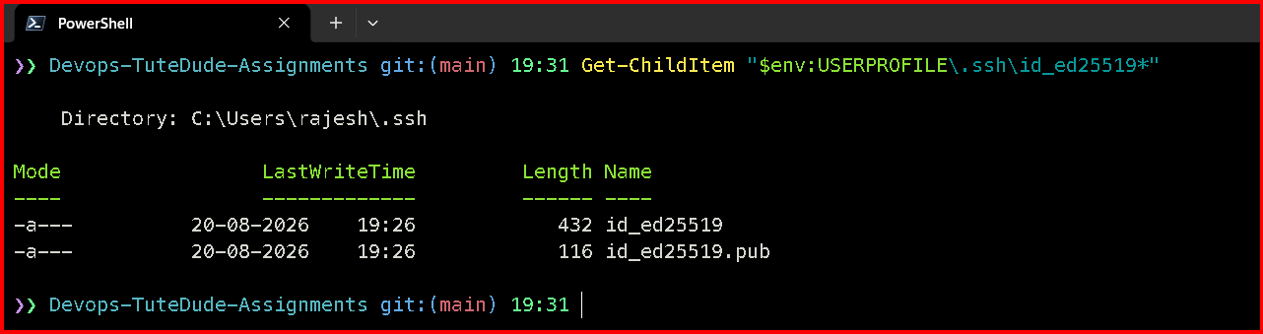
Figure 1: SSH key files
Figure 2: SSH key fingerprint
I checked the GitHub connection using:
ssh -T git@github.com
Figure 3: GitHub SSH connection was successful

2. Connecting the Existing Repository Through SSH
The repository was using HTTPS. I changed the remote URL to SSH.
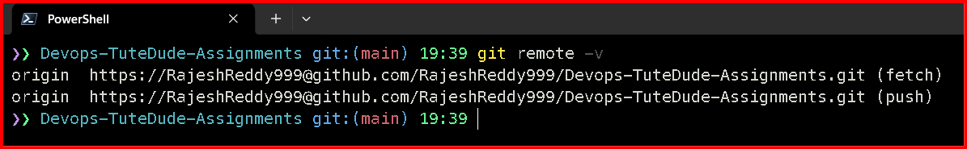
Figure 4: Remote URL before the change
Commands:
git remote set-url origin git@github.com:RajeshReddy999/Devops-TuteDude-Assignments.git
git remote -v
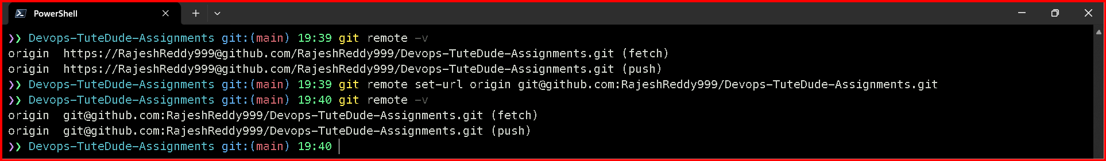
Figure 5: Remote URL changed to SSH
I checked the remote connection and Git status using:
git fetch origin
git status
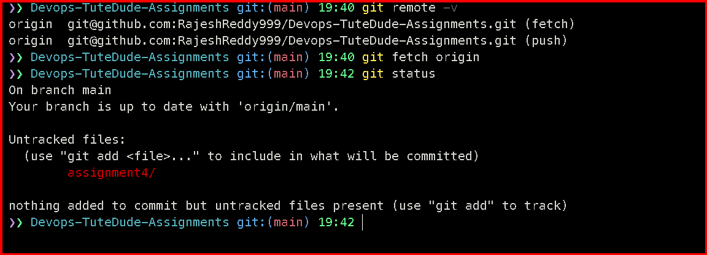
Figure 6: Git fetch and status output

3. Creating the Username Branch
I created a new branch using my GitHub username.
git switch -c RajeshReddy999
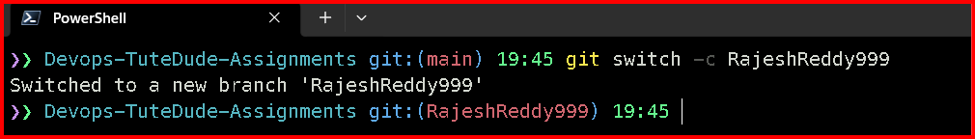
Figure 7: New branch created
git branch
git branch --show-current
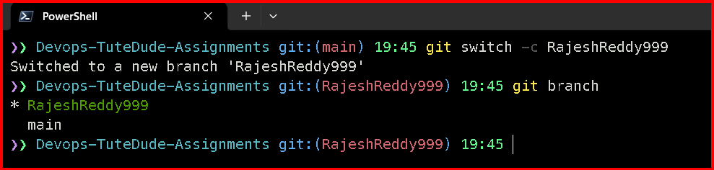
Figure 8: Current branch checked

4. Adding the Flask Project Files
I copied my Assignment 3 Flask project into the Assignment 4 folder. The old Assignment 3 files were not changed.
Copy-Item -Path "assignment3\backend\*" -Destination "assignment4\Git_and_GitHub_Rajesh\backend" -Recurse -Force
Copy-Item -Path "assignment3\frontend\*" -Destination "assignment4\Git_and_GitHub_Rajesh\frontend" -Recurse -Force
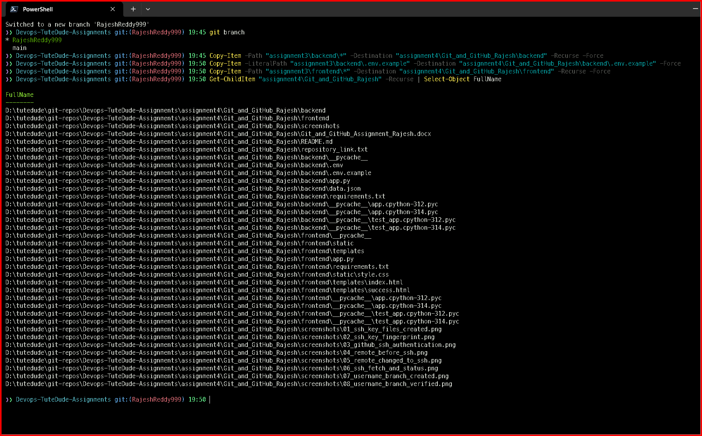
Figure 9: Flask files copied into Assignment 4
git status --short
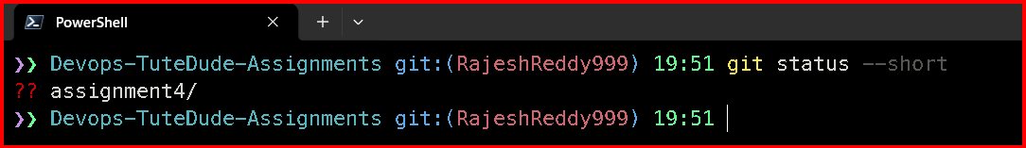
Figure 10: New files shown by Git status

Current Progress
Completed: SSH setup, SSH remote, username branch, and Flask project copy. The files are not committed yet.

