**E-Commerce-Analysis Report:**

**Introduction**

As a new analyst for the client, tasked with analyzing their ecommerce dataset and leveraging Power BI to create engaging dashboard-style pages, the primary goal of this project is to drive increased sales and customer satisfaction while simultaneously reducing operational costs for the online pet supply store.

**Analytical Approach**

The client has two primary business goals. The first is to serve as many customers as possible and increase sales. The second is to reduce its operating expenses. For sales growth, you will focus on upsell and cross-sell opportunities. In a cross-sell, you promote a relevant product at the point of purchase. For shipping cost reductions, we can explore some of the following alternatives. Consolidating multiple shipments into a single one. Reducing package size dimensions and weight. And, finally, shipping a higher quantity of a product. Also, we can implement market basket analysis. A market basket analysis aims to find products frequently bought together in a single checkout. One way this is can be achieved is by determining the correlation coefficient between purchased quantities.

**Data Source:**

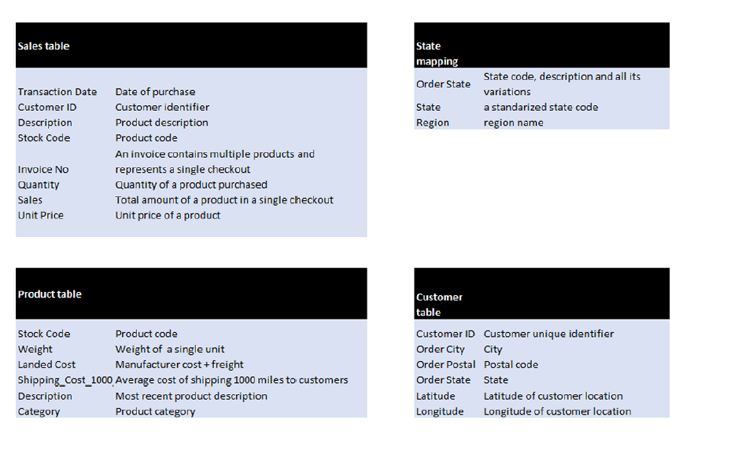

**Data Cleaning:**  
The data cleaning process involved filtering out invoices with zero transactions from the sales table. To ensure consistency in the state column, a state mapping table was uploaded, standardizing state values such as "fl", "Florida", and "florida" to "Florida". This standardization was also applied to countries, regions, and state abbreviations. The state column was categorized as "State/Province" under the data category. A relationship was established between the sales table and the state mapping table using the order state columns. These steps were undertaken as part of the data cleanup task.

**Customer Info:**  
To gain insights into the company's customer base and their overall business, two key metrics were developed:

1. **Number of Customers**: This metric was calculated using the DISTINCTCOUNTNOBLANK function applied to the Customer ID column in the Sales table.
2. **Customer Lifetime Value (Avg)**: This metric represents the average Customer Lifetime Value (LTV) and was derived by dividing the total sales revenue by the number of customers.

The following visualization was generated to illustrate the top 20 states based on Customer Lifetime Value (LTV). This bar chart provides a clear understanding of the states contributing the most to the company's business in terms of customer lifetime value.

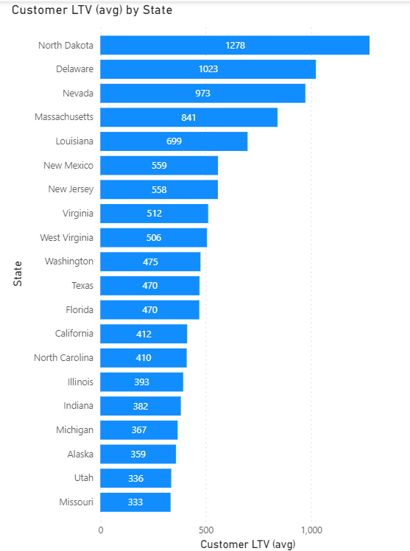Insights:  
﻿At 1,277.80, North Dakota had the highest Customer LTV and was 283.40% higher than Missouri, which had the lowest Customer LTV at 333.28.﻿﻿ ﻿﻿ Across all 20 State, Customer LTV ranged from 333.28 to 1,277.80.﻿﻿ ﻿﻿ ﻿

Key Findings:

Significant regional disparities in Customer Lifetime Value (LTV) were observed, with North Dakota having the highest LTV and Missouri the lowest.

The variation in LTV across states suggests potential growth opportunities in regions with higher LTV, like North Dakota, while highlighting areas for improvement in states with lower LTV, such as Missouri. The range of LTV ($333.28 to $1,277.80) underscores the diverse customer behaviours and preferences across different markets.

**Product info:**

As well as overall sales information, it is important to know what products sell well and the type of costs associated with those products.

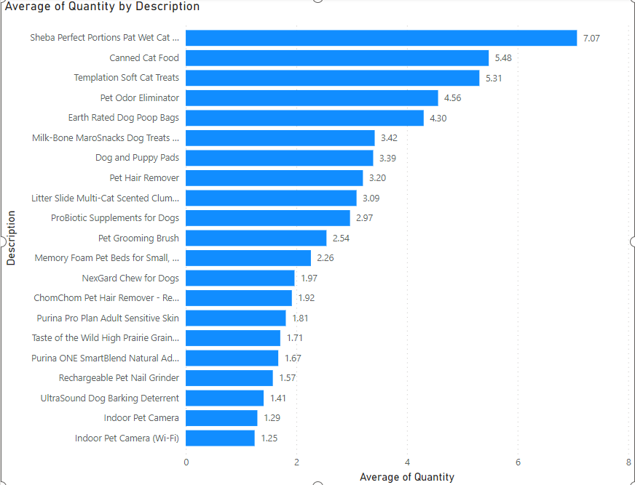

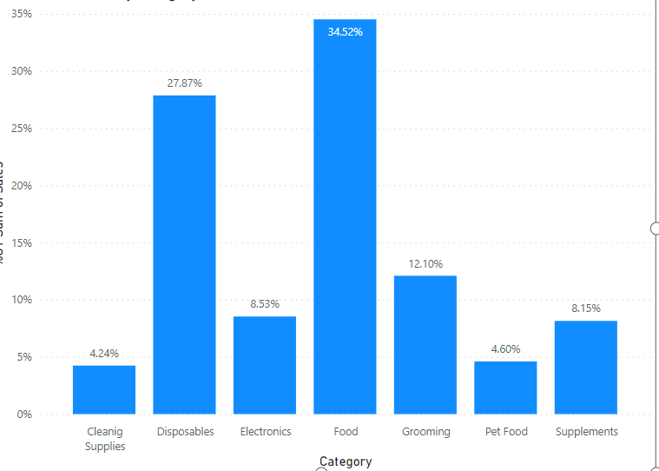

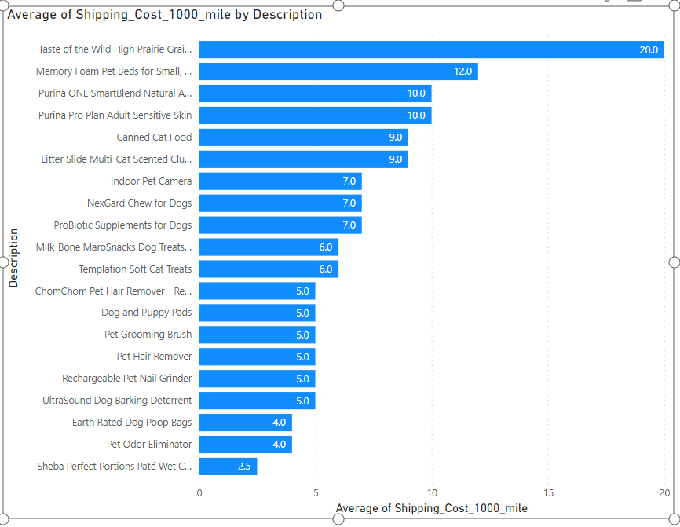

**Insights and Key Findings:**

1. **Product Performance:**
   * Sheba Perfect Portions Paté Wet Cat Food had the highest average quantity sold, indicating strong demand for this product.
   * Taste of the Wild High Prairie Grain-Free Dry Dog Food 40lb had the highest average shipping cost per 1000 miles, suggesting potential profitability but also potential impact on pricing strategy due to higher shipping costs.
2. **Variation in Product Performance:**
   * The range of average quantities sold across products was substantial, from 1.25 to 7.07. This indicates varying levels of popularity and demand among different product offerings.
   * Similarly, the range of average shipping costs per 1000 miles varied widely from $2.50 to $20, suggesting differences in shipping logistics, product weight, or packaging requirements.
3. **Cost Analysis:**
   * Products with higher shipping costs, such as Taste of the Wild High Prairie Grain-Free Dry Dog Food 40lb, may yield higher profits but require careful consideration of pricing strategies to maintain competitiveness.
   * Understanding the relationship between product sales volume and associated costs, including shipping, is crucial for optimizing profitability and resource allocation.
4. **Strategic Implications:**
   * Products with high average quantities sold, like Sheba Perfect Portions Paté Wet Cat Food, present opportunities for maximizing sales revenue and market share.
   * Balancing product performance with associated costs is essential for developing effective pricing strategies and managing operational expenses to enhance overall profitability.
5. **Competitive Positioning:**
   * Analysing both product sales performance and associated costs provides insights into competitive positioning within the market, guiding decisions on product pricing, promotions, and inventory management.

6. **Dominant Categories:**

* + The food category emerges as the top contributor, accounting for 34% of total sales. This indicates a substantial demand for food-related products among customers, suggesting potential opportunities for expansion or investment in this segment.
  + Disposables follow closely behind, comprising 27% of total sales. This suggests a significant market share for disposable products, indicating consistent consumer demand for items in this category.

**7.Underperforming Categories:**

* + Cleaning supplies and pet food represent the lowest contributors, each accounting for approximately 4% of total sales. This suggests relatively lower demand or market saturation in these categories compared to food and disposables.

Quantity Info: Many customers buy a single quantiy of product but combine that with other product types. The average quantity differs when calculated at the invoice level vs across the entire business.

To address the variation in average quantity between invoice-level and total business calculations, we aggregated data at the invoice level, grouping by invoice number. The total quantity and total sales were aggregated using the SUM function.

The clustered column chart below illustrates the relationship between total quantity and total sales. Additionally, we've converted the sales values to percentages of the grand total to provide a clearer understanding of their relative contributions.

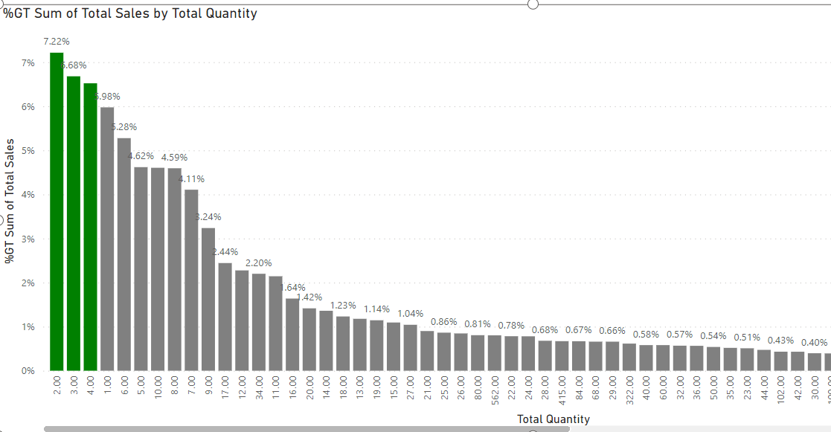

The following chart shows the relationship between the total quantity and total sales ( non-aggregated data)

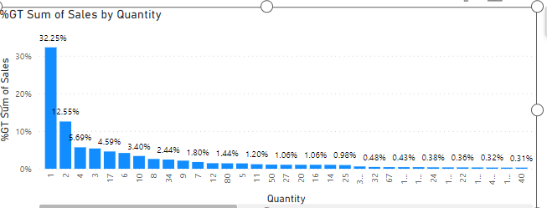

* **Insights:**  
  In the first chart, where data is aggregated by invoice number, we observe that invoices with a total quantity of 2 have the highest sales percentage of 7.22%, followed by invoices with a quantity of 3 at 6.68%. This indicates that transactions with moderate quantities contribute significantly to overall sales.
* Conversely, in the second chart representing non-aggregated data, invoices with a quantity of 1 have the highest sales percentage at 32.25%, suggesting that single-item purchases account for a significant portion of total sales. Additionally, invoices with a quantity of 2 follow closely behind at 12.55%. The comparison between the two charts underscores the influence of quantity on sales percentage. While moderate quantities contribute prominently to total sales when aggregated by invoice number, single-item purchases emerge as the primary driver of sales when considering individual transactions.
* This suggests that while larger orders may boost sales volume, smaller transactions, particularly those involving single items, play a significant role in overall revenue generation.

**Optimizing Sales Strategies:**

Understanding the relationship between quantity and sales percentage is essential for optimizing sales strategies. Businesses may leverage insights from both aggregated and non-aggregated data to tailor marketing efforts, pricing strategies, and inventory management practices to capitalize on different purchasing behaviours.

For instance, targeting promotions or upselling strategies towards customers with moderate order quantities may help maximize sales revenue, while also focusing on attracting and retaining customers making single-item purchases can enhance overall profitability.

**Market Basket Analysis:**

Implemented a simplified version of Market Basket Analysis to identify which products are purchased more often in combination with a specific product they select.



**RFM analysis:**

* Calculated recency, frequency, and monetary value scores for each customer.
* Generated RFM Table: Summarize the RFM scores to create an RFM table.
* Created Segmentation Rules: Define rules or thresholds for categorizing customers into segments based on their RFM scores.
* Categorize Customers: Assign customers to segments according to the defined rules.

**Customer Segments:**

Champions: High scores across all three dimensions (Recency, Frequency, Monetary Value).

Loyal: High frequency and monetary value, relatively recent purchases.

Hibernate Customers: Low frequency and monetary value, relatively old purchases.

Lost Customers: Low scores across all three dimensions.

Already Lost: Lowest scores across all three dimensions, indicating customers who haven't made purchases in a long time.

At Risk: Moderate scores across all three dimensions, but showing signs of decline.

Promising: Moderate scores across all three dimensions, showing potential for future growth.

Colour Representation:

Champions: Gold

Loyal: Green

Hibernate Customers: Gray

Lost Customers: Orange

At Risk: Red

Promising: Blue

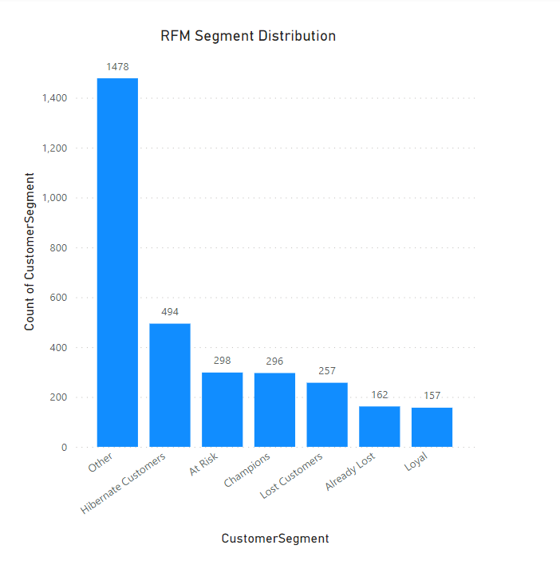

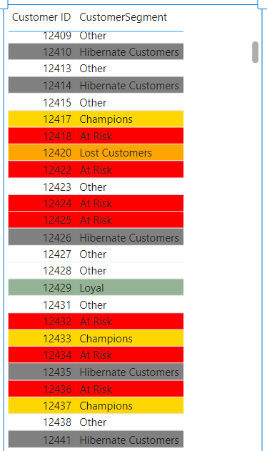

1. **Quantity Upsell Strategy Overview**:
   * The management at Client is interested in exploring quantity upsell strategies to increase sales and save on shipping costs.
   * The strategy involves incentivizing customers to purchase larger quantities by offering reduced shipping costs per unit as the quantity increases.
   * This approach has proven effective in other industries and is now being considered for Client's pet food business.
2. **Shipping Cost Analysis**:
   * Currently, Client does not capture shipping costs at the transaction level, but the management is keen on monitoring shipping costs closely.
   * A fictitious example illustrates how shipping costs decrease per unit as the quantity increases, resulting in potential savings for the business.
   * These savings can be utilized as extra profit or passed on to customers as discounts, contributing to a win-win scenario for both the business and its customers.
3. **Dashboard-style Pages**:
   * Dashboard-style pages will be created to visualize shipping costs by region and product.
   * These dashboards will provide insights into how shipping costs vary across different regions and product categories, aiding in strategic decision-making.
4. **What-If Analysis Dashboard**:
   * A what-if analysis dashboard will be developed to allow users, particularly management, to explore the impact of changing parameters, such as average shipped quantity, on business operations.
   * Users will be able to visualize the potential shipping cost savings at the individual product level and across the entire business by adjusting relevant parameters interactively.

**What-if analysis metrics:**

Due to lack of automatic shipping cost capture at transaction level, the client’s shipping department relies on spreadsheets. The shipping department has informed us that shipping more than one quantity of an item costs, on an average 70% cost of a single unit shipment. There are variances based on the products.

We have established a shipping baseline measure that dynamically adjusts shipping costs based on the quantity of items being shipped. Here's how it works:

1. **Baseline Shipping Calculation**:
   * If the quantity of items in a sale is one, the regular shipping cost is applied.
   * However, if the quantity is greater than one, the shipping cost per item increases by 70% for each additional item beyond the first one. This encourages bulk purchases by offering reduced shipping costs per item for larger quantities.
2. **Parameter for What-If Analysis**:
   * We have also introduced a parameter called "What-If Quantity" to facilitate dynamic changes to the quantity value.
   * This parameter allows users to experiment with different quantity values and observe the corresponding impact on shipping costs in real-time.

**Blended Shipping Cost Factor Measure**: This measure dynamically adjusts the shipping cost factor based on the quantity specified in the "What-if Quantity" parameter. It allows users to experiment with different shipping rates for varying quantities of items in a sale.

**Shipping (What-if) Measure**: This measure calculates the shipping cost for each sale considering the quantity of items being shipped and the blended shipping cost factor determined by the "What-if Quantity" parameter. It offers a more flexible approach to shipping cost calculation compared to using a fixed rate.

**Shipping (Difference) Measure**: This measure computes the difference between the shipping costs calculated using the baseline shipping calculation and the shipping costs derived from the dynamic "What-if Quantity" parameter. It provides insights into the impact of adjusting the shipping rates on overall shipping expenses, facilitating better decision-making regarding quantity upsell strategies.

The line and clustered column chart provides a visual representation of shipping costs and differences between the baseline and "What-if" scenarios, organized by product.

* **X-Axis: Products**
  + Each product is listed along the x-axis, allowing for easy comparison of shipping costs and differences across different product categories.
* **Y-Axis (Column): Shipping Baseline and Shipping (What-if)**
  + The clustered column chart displays shipping costs for each product under both the baseline scenario and the "What-if" scenario, represented by different colored columns.
  + The baseline shipping costs remain constant, while the "What-if" shipping costs dynamically adjust based on the chosen quantity in the "What-if Quantity" parameter.
* **Y-Axis (Line): Shipping Difference**
  + The line chart overlays the shipping difference between the baseline and "What-if" scenarios. It shows how the shipping costs change when the quantity is adjusted using the "What-if Quantity" parameter.
* Users can interactively adjust the quantity using the "What-if Quantity" parameter to observe real-time changes in shipping costs and differences for different products.
* This interactivity allows for scenario analysis and facilitates decision-making regarding quantity upsell strategies and their impact on shipping costs and profitability.

**Insight Generation**

* The visualization enables users to identify products with significant shipping cost differences between the baseline and "What-if" scenarios, highlighting opportunities for optimization.
* Users can pinpoint products where adjusting the quantity leads to substantial cost savings or increases, guiding strategic decisions on pricing, promotions, and inventory management.

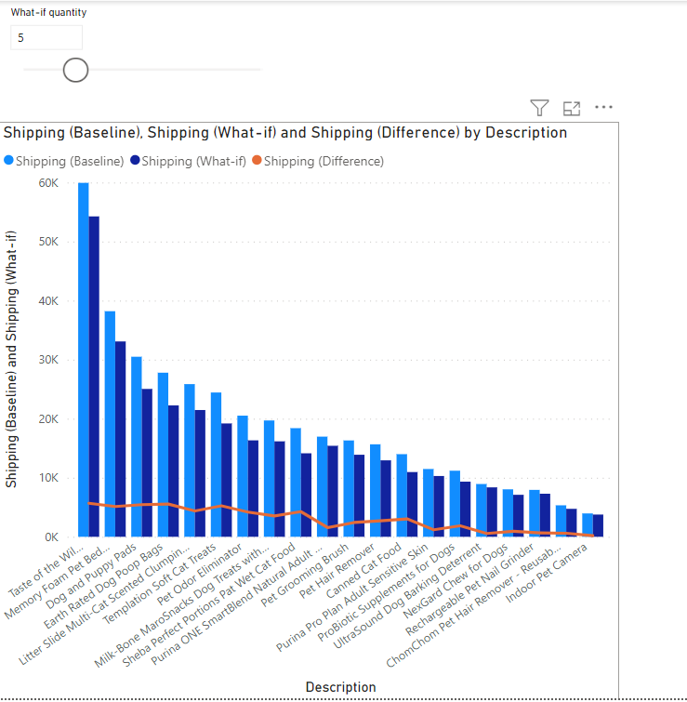

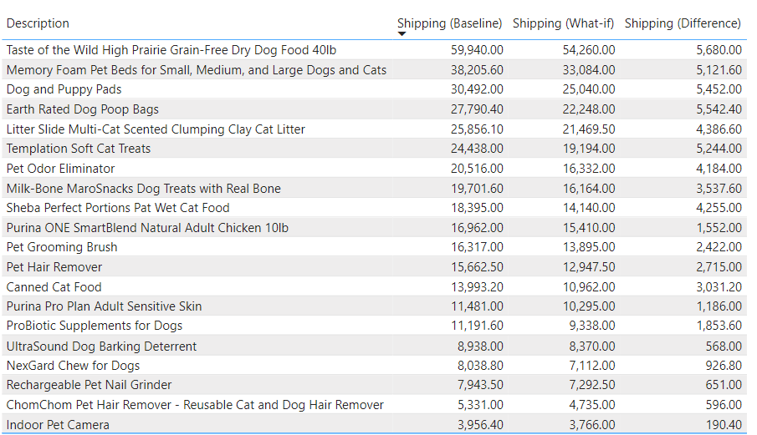

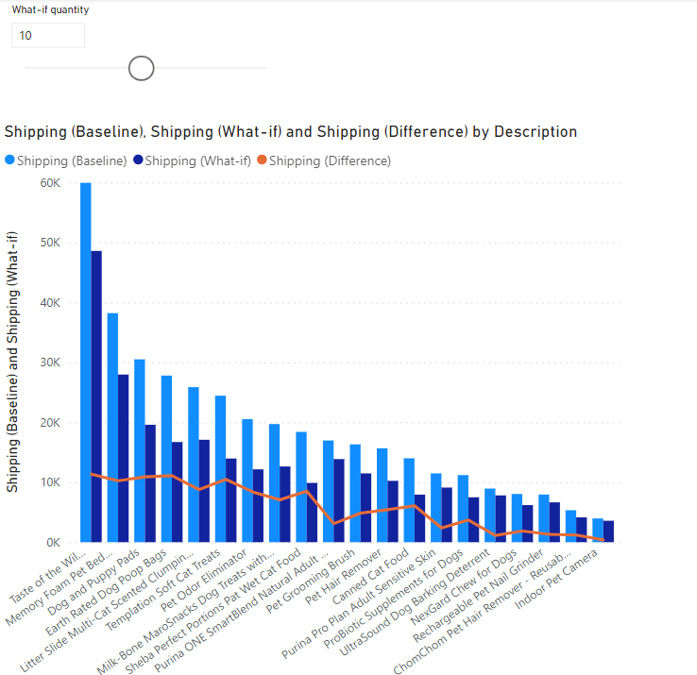

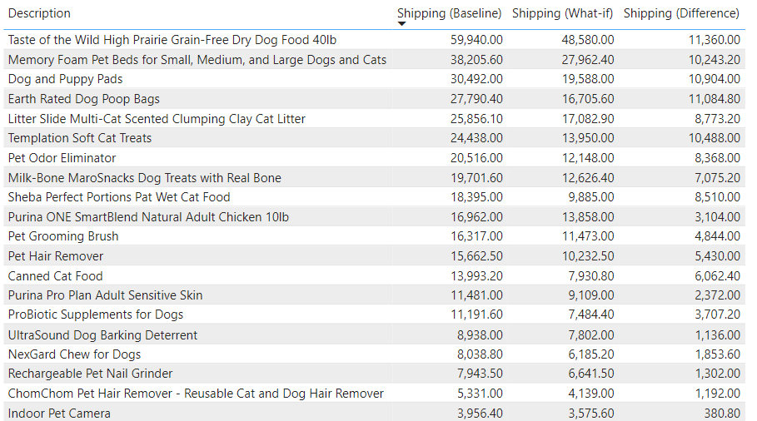

**Insights**:

1. **Impact of Quantity on Shipping Costs**:
   * Across all products, there is a noticeable decrease in shipping costs when the quantity increases from 5 to 10.
   * The shipping cost reductions range from a few hundred dollars to several thousand dollars per product, highlighting the significant cost savings associated with higher quantities.
2. **Variability in Cost Reduction**:
   * While all products experience a decrease in shipping costs with higher quantities, the magnitude of the reduction varies across different items.
   * Products such as "Taste of the Wild High Prairie Grain-Free Dry Dog Food 40lb" and "Memory Foam Pet Beds" exhibit substantial decreases in shipping costs, indicating a higher potential for cost savings on bulk orders.
3. **Potential for Profitability Improvement**:
   * The observed reductions in shipping costs highlight opportunities for businesses to enhance profitability by encouraging customers to purchase larger quantities.
   * By leveraging quantity upsell strategies and promoting bulk purchases, businesses can optimize shipping costs and increase profit margins, thereby improving overall financial performance.

Findings:

For the product "Taste of the Wild High Prairie Grain-Free Dry Dog Food 40lb”, when the quantity increases from 5 to 10, the shipping costs for the product decrease notably. The shipping cost reduction is substantial, amounting to $11,360. Encouraging customers to purchase larger quantities of this product can lead to significant savings on shipping costs, thereby improving overall profitability.

For easy and consolidated view of the shipping metrics we created a dashboard style page which includes some KPIs and shipping metrics over time and against product names.



Next task is to find to determine the profitability of our products, we utilize key metrics derived from sales data.

1. **Cost of Goods Sold (COGS):**
   * COGS is calculated as the product of quantity and landing cost.
2. **Profit (Baseline):**
   * Profit (Baseline) is determined by subtracting the COGS and baseline shipping costs from sales revenue.
3. **Profit Percentage:**
   * Profit Percentage represents the proportion of profit relative to sales revenue.
   * This metric provides insight into the overall profitability of our products, indicating the efficiency of our operations in generating profit from sales.

Now we build a dashboard for the executive summary that provides a quick pulse of business operations and displays metrics like sales, profit and expenses with ability to drill down and slice the data.

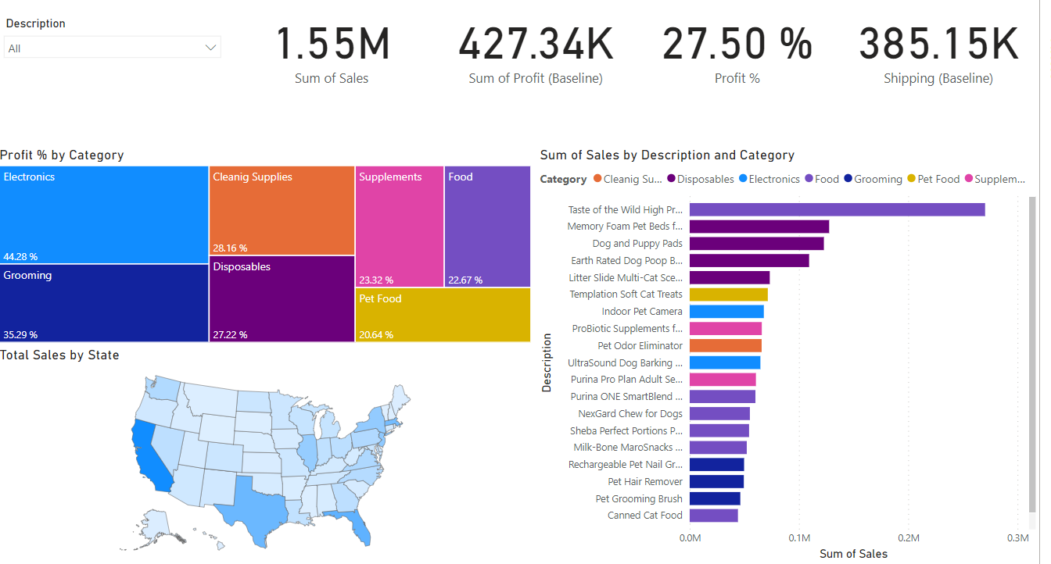

Next task is to find the highest selling product and the product they need to recommend for a cross sell promotion with the highest selling product.

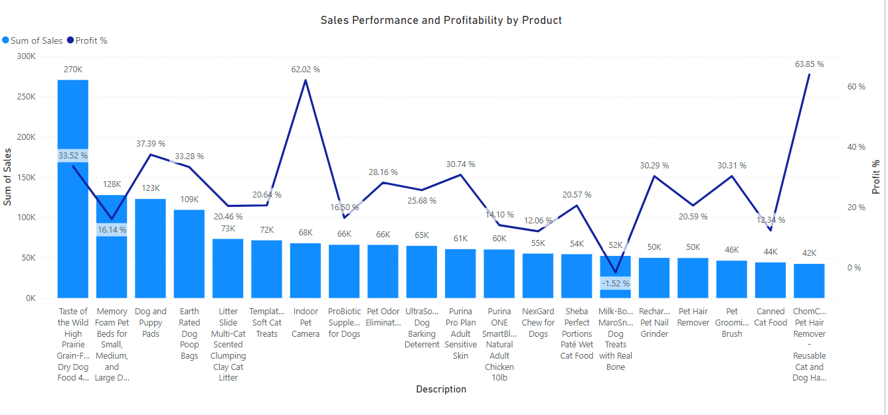

From the above line chart we infer that "Taste of the Wild High Prairie Grain-Free Dry Dog Food 40lb” is the highest selling product.

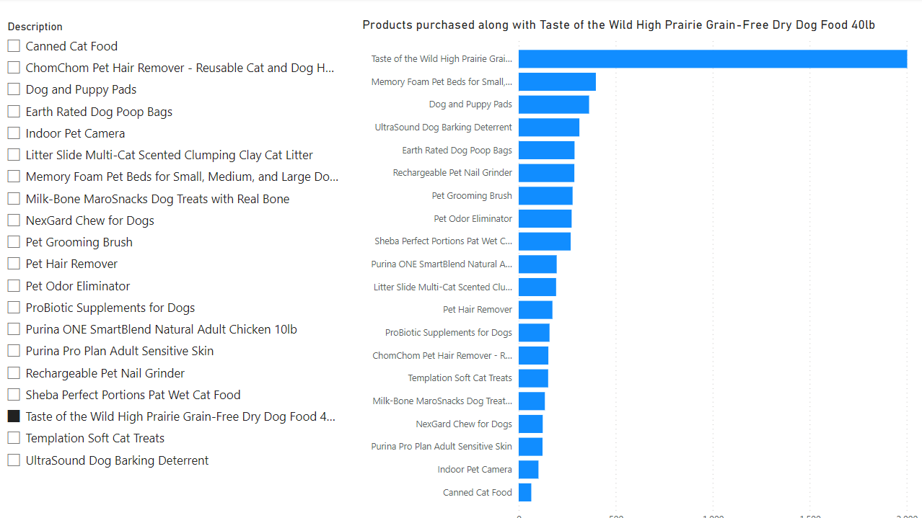

From the market basket analysis view, we can infer that “Memory foam pet beds” was the most often bought combination with the highest selling product "Taste of the Wild High Prairie Grain-Free Dry Dog Food 40lb”. So, this will be a great cross sell promotion strategy.

Next task is to provide comprehensive suggestions for savings on shipping costs. We will visualize shipping costs breakdown by geography and we will provide our recommendations on quantity upsell strategies.

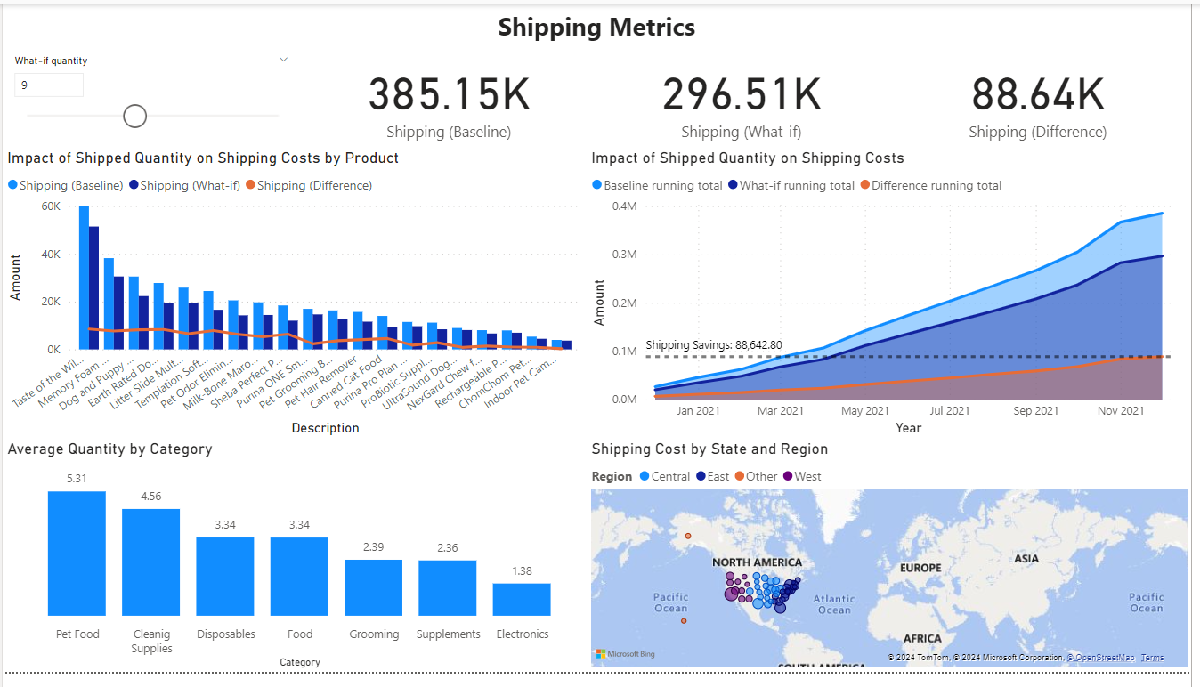

The marketing team should pick up the electronics product for a quantity upsell promotion as its average quantity is too low.

**Final Recommendations:**

1. **Regional Analysis:**
   * California in the West region contributes significantly to shipping costs, indicating a high volume of shipments from this area. Targeting this region for upselling quantity promotions could yield significant results due to its substantial contribution to shipping costs.
2. **Average Shipping Costs by Region:**
   * The West region has the highest average shipping cost. Implementing strategies to reduce shipping costs in this region, such as negotiating better rates with carriers or optimizing logistics routes, can lead to cost savings.
3. **Product Category Insights:**
   * Pet Food has the highest average quantity, indicating strong demand for this category. Upselling promotions on related products or bundling offers with pet food items could capitalize on this demand.
   * Electronics, with the lowest average quantity, may benefit from targeted promotions aimed at increasing sales volume. Bundle offers, discounts on related accessories, or loyalty programs could incentivize customers to purchase more electronics items.

**Promotional Strategies:**

Implement quantity-based promotions such as "Buy One, Get One" deals, volume discounts, or bundle offers across all categories to encourage customers to purchase more items per transaction.

Leverage data analytics to identify customer buying patterns and preferences to tailor promotions effectively. For example, offering discounts on complementary products or items frequently purchased together can drive higher sales volume.

**Shipping Optimization Strategies:**

Consolidate orders or offer free shipping thresholds to encourage customers to increase their order sizes. Communicate these thresholds clearly to customers to incentivize them to add more items to their carts to qualify for free shipping.

Explore alternative shipping methods or partners to negotiate better rates or utilize more cost-effective shipping options, such as ground shipping over express delivery, where feasible.

**Customer Engagement and Loyalty Programs:**

Implement loyalty programs that reward customers for purchasing larger quantities or reaching certain spending thresholds. Offer perks such as exclusive discounts, early access to promotions, or free shipping for loyal customers to encourage repeat purchases and increase order sizes over time.