Assignment 1(Home Assignment: Primitive Data Types):
userName // String
organization // String
contactNumber // Number
knowsAutomation // Boolean
usesPlaywright // Undefined (not assigned)

Code:
let userName = "Rajesh_S";
console.log(typeof userName);

let organization = "BANK";
console.log(typeof organization);

let contactNumber = 9840515460;
console.log(typeof contactNumber);

let knowsAutomation = true;
console.log(typeof knowsAutomation);

let knowsAutomation1 = "true";
console.log(typeof knowsAutomation1);

let usesPlaywright ;
console.log(typeof usesPlaywright);

let usesPlaywright1 = null;
console.log(typeof usesPlaywright1);

Result:
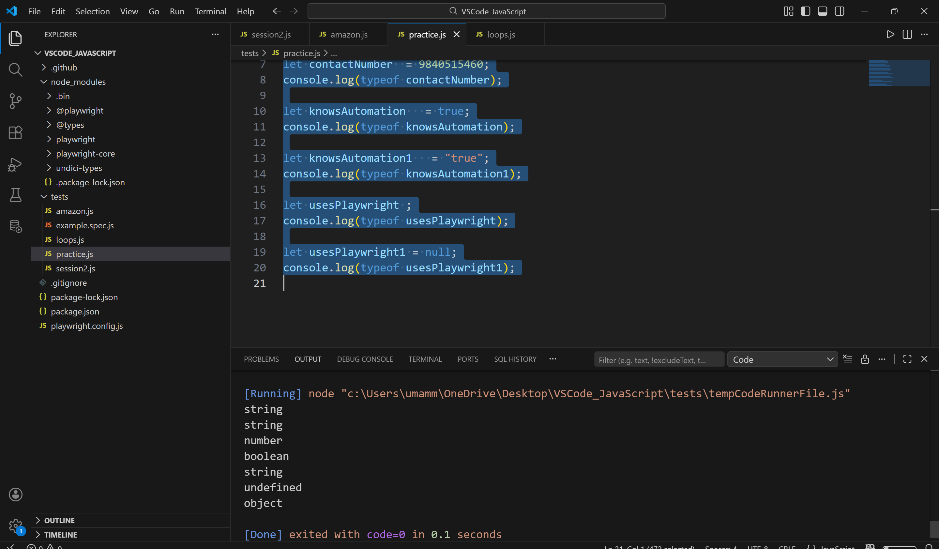
Assignment 2(Classroom Assignment: Number Type):

let num = -0.29;
function numidentifier(num)
{
if(num >0)
{
console.log(num +" is a positive number");
} else if(num < 0)
{
console.log(num +" is a negative number");
} else
{
console.log(num +" value of the number is zero");
}
}
numidentifier(num);
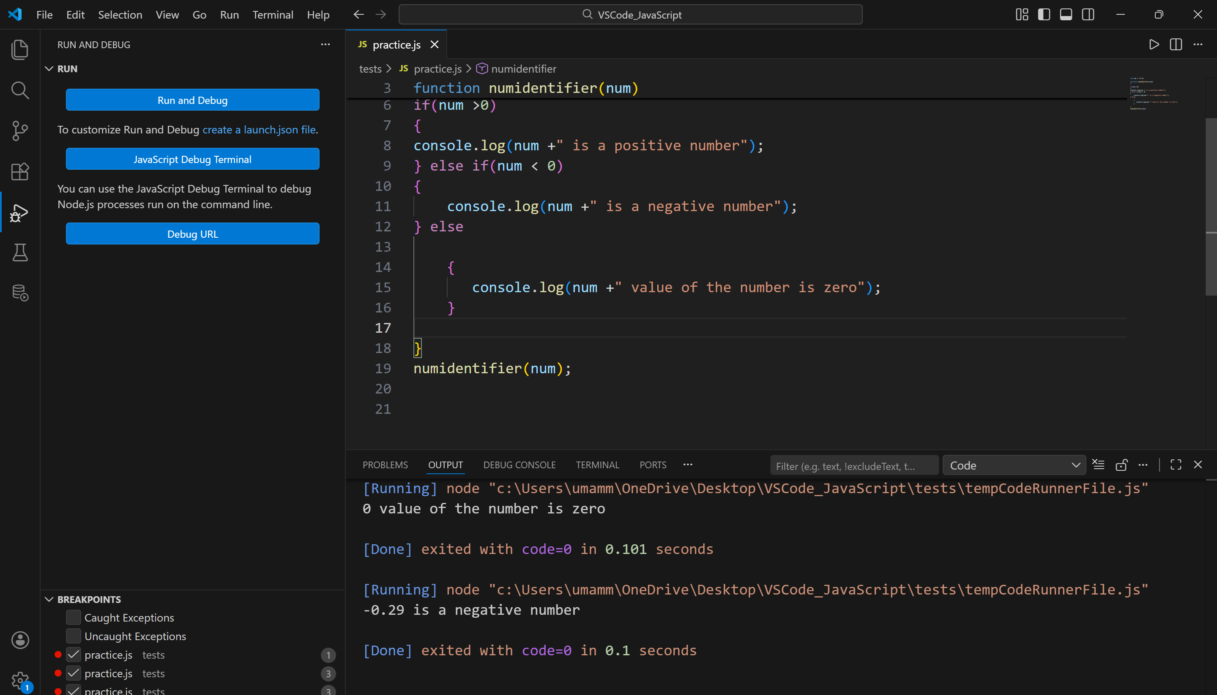
Assignment 3:(Classroom Assignment: Conditional Statements):
let browser = "Chrome";
let RunTests = "Regression";
function launchBrowser(browser)
{
if(browser == "Chrome")
{
console.log(browser +" is the Launched browser");
} else if(browser == "Firefox")
{
console.log(browser +" is the Launched browser");
} else if(browser == "Edge")
{
console.log(browser +" is the Launched browser");
} else
{
console.log(browser +" is the Launched Unknown/new browser");
}
}
launchBrowser(browser);
function runTests(RunTests)
{
switch(RunTests){
case "Regression":
console.log(RunTests +" is the chosen test type for the browser tests");
break;
case "Functional":
console.log(RunTests +" is the chosen test type for the browser tests");
break;
case "Sanity":
console.log(RunTests +" is the chosen test type for the browser tests");
break;
default:
console.log("Smoke Test is chosen");
}
}
runTests(RunTests);
Output:
