**Univariate Analysis**

* **Central tendency**
* **Mean, median, mode**
* **Bar graph**
* **Histograms**
* **Pie charts**
* **Box Plot**

**Bivariate Analysis**

* **Correlations**
* **Scatter Plot**

**BOX PLOT**

**Drawing a box and whisker plot**

***Example :***

Construct a box plot for the following data:

12, 5, 22, 30, 7, 36, 14, 42, 15, 53, 25

***Solution:***

**Step 1:** Arrange the data in ascending order.

**Step 2:** Find the median, lower quartile and upper quartile

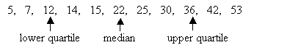

Median (middle value) = 22   
Lower quartile (middle value of the lower half) = 12   
Upper quartile (middle value of the upper half) = 36

(If there is an even number of data items, then we need to get the average of the middle numbers.)

**Step 3:** Draw a number line that will include the smallest and the largest data.

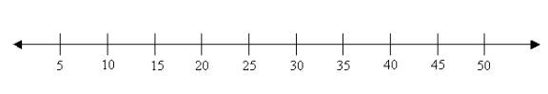

**Step 4:** Draw three vertical lines at the lower quartile (12), median (22) and the upper quartile (36), just above the number line.

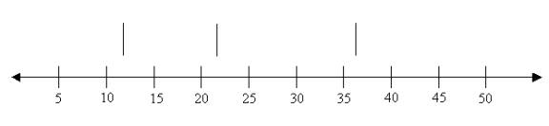

**Step 5:** Join the lines for the lower quartile and the upper quartile to form a box.

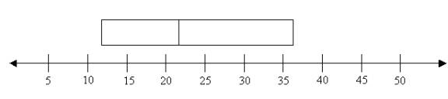

**Step 6:** Draw a line from the smallest value (5) to the left side of the box and draw a line from the right side of the box to the biggest value (53).

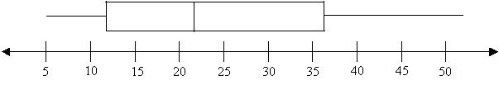

[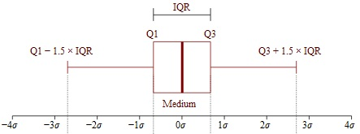](https://www.google.co.in/url?sa=i&rct=j&q=&esrc=s&source=images&cd=&cad=rja&uact=8&ved=2ahUKEwiT0N_86-LdAhUGeCsKHY7hC1IQjRx6BAgBEAU&url=http://www.statisticshowto.com/probability-and-statistics/interquartile-range/&psig=AOvVaw3o9jiT0WT74q3Vu0Ms5lN-&ust=1538400824629826)

For Outliers,

[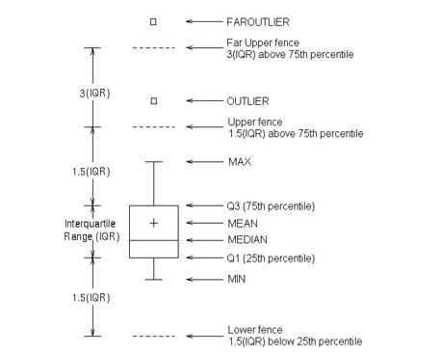](https://www.google.co.in/url?sa=i&rct=j&q=&esrc=s&source=images&cd=&cad=rja&uact=8&ved=2ahUKEwiNxZ_Z7OLdAhXKZCsKHfX_AEUQjRx6BAgBEAU&url=http%3A%2F%2Fsupport.sas.com%2Fdocumentation%2Fcdl%2Fen%2Fgrstatgraph%2F65377%2FHTML%2Fdefault%2Fp0ou4qi2jfcokkn1ks5mx1ct5cmw.htm&psig=AOvVaw1-JyLoeFCqjHlDv5-nx10g&ust=1538401024606301)