Name: Rajesh Nalla

700 number: 700747145

Video link: https://drive.google.com/drive/folders/1G6fJFwsYqHDqXUuor4FBlRgv1YN3PG2k?usp=sharing

Github link: https://github.com/RajeshUCM/ML_Assignment

1.

a) Using NumPy create random vector of size 15 having only Integers in the range 1-20.

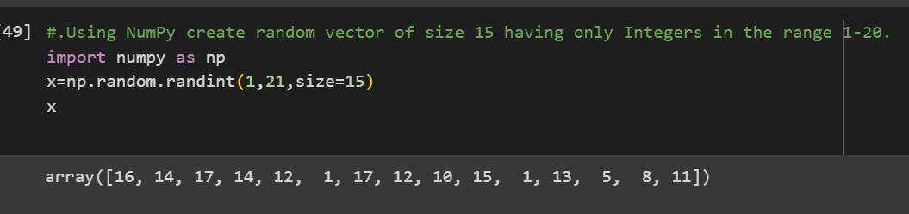

i) Reshape the array to 3 by 5, we use numpy.reshape function

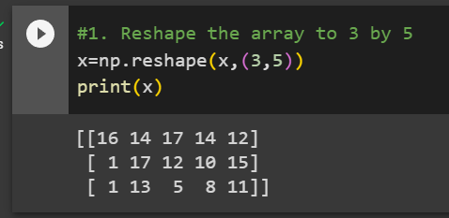

ii) Print array shape

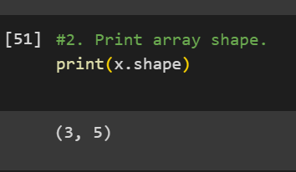

iii)

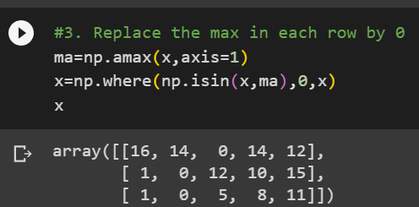

Create a 2-dimensional array of size 4 x 3 (composed of 4-byte integer elements), also print the shape, type and data type of the array.

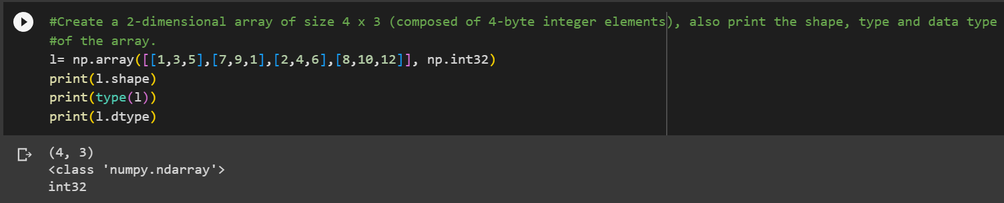

b) program to compute the eigenvalues and right eigenvectors of a given square array

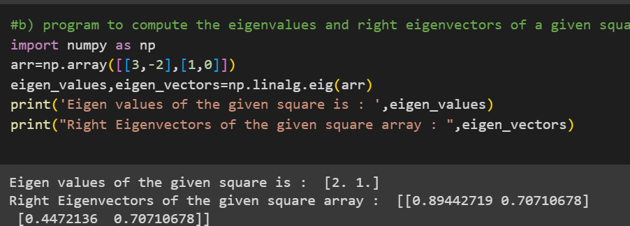

c) the sum of the diagonal element

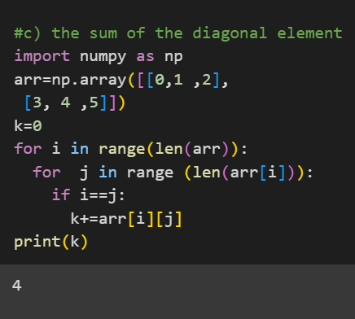

d) NumPy program to create a new shape to an array

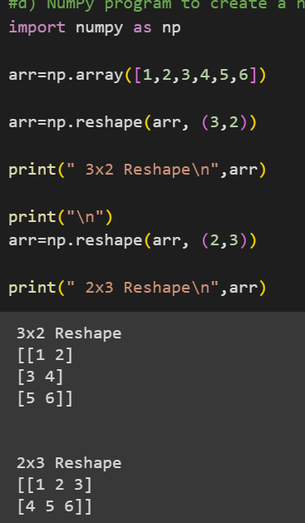

2)

