**ACKNOWLEDGMENT**

This research work would not have been possible without the kind support of many people. I take this opportunity to acknowledge that who has been great sense of support and inspiration thought the research work successful.

There are lots of people who inspired me and helped, worked for me in every possible way to provide the details about various related topics thus making research and report work success.

My first gratitude goes to our Guide **Mr. Jemish V. Maisuria** &Co-guide **Mr. Chintan H. Desai** for their guidance, encouragement and support during my semester. Despite their busy schedule, they are always available to give me advice, support and guidance during the entire period of my semester. Their insight and creative ideas are always the inspiration for me during the research.

I would like to thank my parents for their valuable support and encouragement.

I would like to express my sincere thanks to my H.O.D., Director Sir & all members of

Electronics & communication department.

Last, but not the least my special thanks go to our institute, **C.G.PATEL INSTITUTE OF TECHNOLOGY,** for giving me this opportunity to work in the great environment.  
Above all, we want to thank god for providing us with all that we wished for and more..!! Thankful to all we ever remain.

Patel Darshak S.

Tank Chandresh N.

Vala Rajesh S.

Modi Mitesh K.

Danak Jugal A.

**ABSTRACT**

Electricity is a major driving force especially in a country like India because agriculture and power have worked in tandem to help us to reach where we are today. The existing system for the metering of electricity bills poses certain inconveniences to the end user. In the existing system the EB deputes officials to manually note the meter reading. This process not only involves a huge labour force but also the cumbersome process of door to door monitoring. In India the payment dues are accepted only on weekdays during working hours. The consumer thus has to take time off his busy schedule and personally make payments at the EB office. Consumers have to face incorrect billing due to human error and wait in long queues to pay their bills, causing a lot of inconvenience to the customer & the utility. Present system is also not protected against fraud related to electrical energy theft and also our unpaid bills may lead to power cut off. A scheme of Electricity billing system called **“ SMART PREPAID ENERGY METER ”** can facilitate in improved cash flow management in energy utilities and can reduces problem associated with billing consumer living in isolated area and reduces deployment of manpower for taking meter readings.

TABLE OF CONTENTS

|  |  |  |
| --- | --- | --- |
|  | Acknowledgement | 1 |
|  | Abstract | 2 |
|  | List Of Contents | 3 |
|  | List Of Figure | 5 |
| **Chapter 1** | Introduction | 6 |
| **Chapter 2** | Smart Prepaid Energy Meter | 8 |
| **Chapter 3** | Literature Survey | 9 |
| **Chapter 4** | Hardware Description | 11 |
|  | 4.1 Technical Specification | 11 |
|  | 4.2 Block Diagram & Description | 11 |
|  | 4.3 Flow Charts | 13 |
| **Chapter 5** | Project Module | 14 |
|  | 5.1 ARM Processor | 14 |
|  | 5.1.1 Introduction | 14 |
|  | 5.1.2 General description | 14 |
|  | 5.1.3 Architectural Overview | 15 |
|  | 5.1.4 Pin Connect Block | 17 |
|  | 5.1.5 System Control | 19 |
|  | 5.2 ENERGY METER | 20 |
|  | 5.2.1 Types of Energy Meter | 20 |
|  | 5.2.2 Relay | 22 |
|  | 5.3 LCD  5.3 LIQUID CRYSTAL DISPLAY (LCD) | 23 |
|  | 5.3.1 | 23 |
|  | 5.4 GSM Module | 24 |
|  | 5.4.1 Introduction | 24 |
|  | 5.4.2 GSM Network | 24 |
|  | 5.4.3 GSM AT Commands | 25 |
|  | 5.4.4 Interfacing GSM with LPC2148 | 26 |
|  | 5.4.5 Serial Communication | 26 |
|  |  |  |
| **Chapter 6** | Progress and Result |  |
|  | 6.1 Project work done | 28 |
|  | 6.2 Advantages | 28 |
|  | 6.3 Conclusion | 29 |
|  | 6.4 Future Scope | 29 |
| **Reference** |  | 30 |
| **Appendix** |  | 31 |
|  |  |  |
|  |  |  |
|  |  |  |

LIST OF FIGURES

|  |  |  |
| --- | --- | --- |
|  |  |  |
| **Figure No.** | **Figure Description** | **Page No.** |
| Figure 4.2 | Block Diagram of System | 12 |
| Figure 4.3 | Flow chart of System | 13 |
| Figure 5.1.3 | LPC2148 Functional Diagram | 16 |
| Figure 5.1.4 | LPC2148 Pin Diagram | 17 |
| Figure 5.2.1(a) | Electro Mechanical Energy Meter | 21 |
| Figure 5.2.1(b) | Electronic Energy Meter | 21 |
| Figure 5.3.1 | Pin connections of LCD | 23 |
| Figure 5.4.2 | GSM System Architecture | 25 |
| Figure 5.4.4 | Interfacing GSM with LPC2148 | 26 |
| Figure 9 | Schematic Diagram to Interface GSM with LPC2148 | 41 |
|  |  |  |

**CHAPTER 1**

**INTRODUCTION**

**1.1 Aim of the Project**

The main objective of this project is to present the idea of a fully “Automatic Energy

Meter” having capabilities like tele-metering and regulating the supply to the energy meter and the simple recharge system using the GSM module sending a Recharge SMS code through Mobile.

**1.2 Introduction**

Electricity is one of the vital requirements for sustainment of comfortable life. It should be used judiciously for its proper utilization. In our country consumers are not satisfied with the services of power distribution companies like Torrent, GEB; because of traditional meter billing methods adopted which requires huge number of labour and long working hours to collect complete data and billing. Human operator billing method is prone to erroneous. Sometimes the energy meter is placed in a location where it is not easily accessible. Manual billing is sometimes restricted and slowed down by various reasons. Printed billing has the tendency of losing in the mailbox. The increased population and industrialization in the countries like India, to facilitate easy and trusted service with minimum operating cost, a better method of billing procedure is proposed in this project. Various methods and technologies such as internet, Ethernet, embedded RF module, Wi-Fi, Bluetooth were established and developed to provide and demonstrate the solution of efficiency, reliability and effectiveness of Automatic Energy Meter system. The abovementioned methods are either too expensive to implement and operate, require complex setup of infrastructure, short operating distant and still require field intervention of human operators. With the rapid development of global system for mobile (GSM) infrastructure in the past few decades has made Automatic Energy Meter system more reliable and possible. The GSM automatic energy meter system presented in this project takes advantage of the available GSM infrastructure, nationwide coverage in the country and the short message service (SMS), cell broadcasting feature to send the power consumption bill to the customer.

**1.3 History/ Problems Faced By Postpaid System**

The main drawback of this (post-paid) system is that person has to go area by area and he has to read the meter of every house and handover the bills. The Electricity board has to give privileges for these people to do their duty monthly. The thing is Government will not appoint any particular persons for this duty. Earlier the system of energy billing was error prone and also time and labor consuming. The drawback of Post-Paid system is that there is no control of usage from consumer’s side, and there is lot of wastage of power due to lack of planning of electricity consumption in an efficient way. Since the supply of power is limited, as a responsible citizen there is a need to utilize electricity in a better and efficient way. Visiting every consumer’s home is something that causes a bit of inconvenience. Sometimes the room/houses are found locked and this comes as an embarrassment of an employee on duty. Moreover the distribution company has to receive a huge amount in the form of pending bills, which results in substantial revenue losses.

**1.4 Significance of Work**

Usually traditional billing requires huge number of human labour and long working hours.

Sometimes the energy meter may be placed in location where it is not accessible. So our System is used in such situations. It is used to reduce manual power. It also provides fast recovery of dues to the Electricity department. By using this system the bill is sent to the customer directly through SMS there is no need for paper billing which saves paper. If the bill is not paid we can automatically stop the supply to the customer. So there is no need for the person to go andre move the fuses. Hence this system is cost efficient. In this System the customer will be receive the massages from disturber when the account balance was low.

**CHAPTER 2**

**SMART PREPAID ENERGY METER**

In the present metering system there is the chances of incorrect reading to be taken by human being. Also is somebody stays away from home for a long time it is customary to inform to the regional electricity centre for commercial. In spite of false billing, the bill has to be paid every month compulsorily. So to avoid this, there comes the **“ SMART PREPAID ENERGY METER”** , this project gives relief from the human efforts and also the correct billing ratings. This application will also give benefits in paying the bill as per yr required usage as just same in your mobile recharging system. This project can be easily be compatible with the domestic digital energy meter used in majority of houses. This system is fastest also because of the use of ARM7 in it to interface with the GSM module. This system can be interfaced with many other subsystems as LCD display etc. There is also many facilities as to make user to be verified about its constantly increasing energy meter ratings and decreasing balance which paid in advance. This application also saves time of the customers through that they have to go nearby electricity house centre to fill bill payment at regular interval of time. Also, the company those providing the electricity power also got profit by this application of smart prepaid energy meter by which there no need to make an employee to work of going home to home at regularly interval to check the electricity usage of each every home, though as it become it becomes easy and precise. This application also is faster then conventional system of today. Also, it is very useful to the larger firms in which the electricity is constant and main factor to use, so its beneficial for them to paid in advance the bill rather then to pay monthly it. In this we have use the flash magic for making the message to be display on the LCD by changing the baud rate. We can also change the baud rate according to our requirement for different purpose. One SIM (subscriber identity module) is to be insert in the GSM module and other SIM is also used as user to be notify.

**CHAPTER 3**

**LITERATURE SURVEY**

**3.1 Introduction**

This chapter describes about a literature survey, or literature review, which means reading and reporting on what the literature in the field has to say about the topic or subject. So, the goal is to show that one has to read and understand the positions of other academics who have studied the problem/issue that you are studying and include that in the paper or project. This can be done by the way of comparing and contrasting, simple summarization, or any number of ways that show that you've done the research.

**3.2 Literature Survey**

The development of a GSM automatic power meter reading system (GAPMR) is presented in this paper. GAPMR System consists of GSM Digital power Meters installed in every consumer unit and Electricity e-billing system at every provider side. It consists of standard compliance digital kWh power meter with embedded GSM modem which utilizes the GSM network to send its power usage reading using SMS back to energy provider wirelessly. At the power provider side an e-billing system is used to manage all received SMS meter reading, compute the billing cost, update the database, and to publish the billing notification to its respective consumer through SMS [1].

The remedy for all the problems like is labour consuming, errors with electro-mechanical meters, human errors while noting down the meter readings etc, is the GPMC GSM based power meter and control system. In this system the track of the meter reading of each day and the reading with the user identification number send to the user as well as to the electricity department and Electricity e-billing system associated with electricity department will keep the track of each SMS meter reading and the appropriate bill get generated at the last day of the month and the bill is forwarded to user from the server. So there is no chance of confusion to the user for paying the bill [2].

The paper design a Wireless Prepayment Energy Meter, which is used to measure single-phase energy with 50/60Hz rated frequency. It realizes the functions of prepayment management and load control that pay of energy first & use it afterwards, the data can be exchanged between Energy meters and Energy supplying department by RF cards. The information can be transmitted in a non-contact way. In this way, the purpose of automatic identification can be achieved. The paper describes hardware design firstly, then software designs. [3].

**3.3 Conclusion**

Literature review is a description of the literature relevant to a particular topic. This chapter gives us the brief explanation of previously done projects.

**CHAPTER 4**

**HARDWARE DESCRIPTION**

**4.1 Technical Specification**

Over 40 countries have implemented prepaid meters in their markets. In United Kingdom the system, has been in use for well over 70 years with about 3.5 million consumers. The prepaid program in South Africa was started in 1992, since then they have installed over 6 million meters. Other African counties such as Sudan, Madagascar are following the South African success. The concept has found ground in Argentina and New Zealand with few thousands of installations. The Sabah Electricity (SESB), Malaysia, has awarded a contract to a local manufacturer to supply 1,080 prepaid meters.

Countries such as Thailand, Bangladesh, Singapore, and Iran have been showing increased interest in adopting prepaid system. In India, the State of West Bengal has decided to introduce the smart card operated prepaid energy meters in remote islands of Sunder bans. In Mumbai, pre-paid power is provided by the Brihan mumbai Electricity Supply and Transport (BEST) Undertaking. Tata Power plans to introduce pre-paid electricity in Delhi. Tata Steel is likely to install prepaid electricity meters at its employee township in Jamshedpur.

Pay-as-you-go systems with some form of display allow customers to be more in charge of their electricity use. Savings of 10-20% are quoted for North American systems. A full evaluation of the keypad pay-as-you-go meter in Northern Ireland is under way; figures from small-scale earlier studies show savings of around 3% compared with previous usage.

**4.2 Block Diagram & Description**

The proposed idea is not to replace the existing energy meter and chalk out a completely new prepaid meter but up-grade the available energy meters to prepaid meters. Thus, our design primarily has an energy meter, a prepaid card and the communication module encapsulated and provided as an upgrading attachment along with a contactor and a liquid crystal display (LCD).

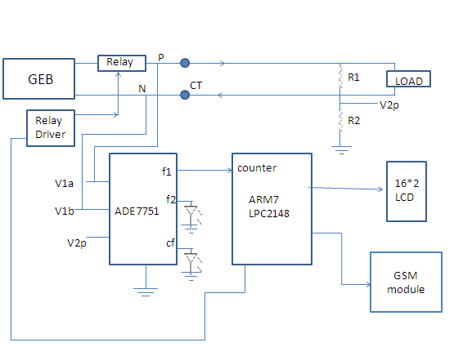

Figure 4.2 : Block Diagram of System

**Description**

Prepaid energy meter is a scheme of electricity billing system which can facilitate in improved cash flow management in energy utilities and can reduce the problem associated with billing consumer living in isolated areas and reduce the deployment of manpower for taking meter reading. It works on principle of first pay and then use. In this system, prepaid energy meter works on single phase and single neutral.

Pre-paid energy meter, is a basically state of the art design concept based on SMART card technology. The system encompasses the integration of the SMART card based pre-paid concept into the electronic energy meter design, so that energy distribution, monitoring and billing can be automated at the meter side itself. Also consumer can check its balance in LCD attached with the module and be prepare for the next recharge in advance.

**4.3 Flow Charts**

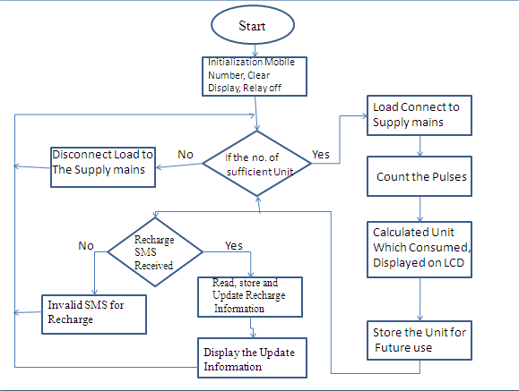

Figure 4.3 : Flow chart of System

First we have to start the system and have to clear all displayed things on the LCD. Then, if there is less than the sufficient amount of balance in our prepaid account then the load is directly disconnected from the system (means no power supply). So if sufficient balance then it proceeds further as to connect load to mains supply. It counts the pulse to be used and calculate according to it. This is because for further future use and it also continuously checks the decrement of our balance. If then also somehow balance over system is shut down so there must be some balance to be fill in advance to make to system run continuously. The constant decreasing of balance and increasing of pulses is shown on LCD for future use. If the balance is beyond the critical limit then the message is send to user to making balance for it to run system smoothly without interrupt.

**CHAPTER 5**

**PROJECT MODULE**

**5.1 ARM Processor**

**5.1.1 Introduction**

A complex instruction set computer, commonly known as CISC, is a complete contrast to the reduced instruction set computer, commonly known as RISC. Both stands for two entirely different philosophies in modern computer architecture. Some microcontrollers supports the RISC architecture some microcontrollers supports the CISC architecture. This simplicity results in a high instruction throughput and impressive real time interrupt response from a small and cost effective chip.

**5.1.2 General description**

The LPC2148 microcontrollers are based on a 16-bit/32-bit ARM7TDMI-S CPU with real-time emulation and embedded trace support that combine microcontrollers with embedded high-speed flash memory ranging from 32 kB to 512 kB. A 128-bit wide memory interface and unique accelerator architecture enable 32-bit code execution at the maximum clock rate. For critical code size applications, the alternative 16-bit Thumb mode reduces code by more than 30% with minimal performance penalty. Due to their tiny size and low power consumption, LPC2148 are ideal for applications where miniaturization is a key requirement, such as access control and point-of-sale. Serial communications interfaces ranging from a USB 2.0 Full-speed device, multiple UARTs, SPI,SSP to I2C-bus and on-chip SRAM of 8 kB up to 40 kB, make these devices very well suited for communication gateways and protocol converters, soft modems, voice recognition and low end imaging, providing both large buffer size and high processing power. Various 32-bit timers, single or dual 10-bit ADCs, 10-bit DAC, PWM channels and 45 fast GPIO lines with up to nine edge or level sensitive external interrupt.

-16-bit/32-bit ARM7TDMI-S microcontroller in a tiny LQFP64 package.

-8 KB to 40 KB of on-chip static RAM and 32 KB to 512 KB of on-chip flash memory.128-bit wide interface/accelerator enables high-speed 60 MHz operation.

-USB 2.0 Full-speed compliant device controller with 2 KB of endpoint RAM. In addition, the LPC2148 provides 8 KB of on-chip RAM accessible to USB by DMA.

- One or two (LPC2141/42 Vs, LPC2144/46/48) 10-bit ADCs provide a total of 6/14analog inputs, with conversion times as low as 2.44 ms per channel.

- Single 10-bit DAC provides variable analog output (LPC2148 only)

-Two 32-bit timers/external event counters (with four capture and four compare channel search), PWM unit (six outputs) and watchdog.

**5.1.3 Architectural Overview**

The ARM7TDMI-S is a general purpose 32-bit microprocessor, which offers high performance and very low power consumption. The ARM architecture is based on Reduced Instruction Set Computer (RISC) principles, and the instruction set and related decode mechanism are much simpler than those of micro programmed Complex Instruction Set Computers (CISC). This simplicity results in a high instruction throughput and impressive real time interrupt response from a small and cost-effective processor core. Pipeline techniques are employed so that all parts of the processing and memory systems can operate continuously. Typically, while one instruction is being executed, its successor is being decoded, and a third instruction is being fetched from memory. The ARM7TDMI-S processor also employs a unique architectural strategy known as Thumb, which makes it ideally suited to high-volume applications with memory restrictions, or applications where code density is an issue. The key idea behind Thumb is that of a super-reduced instruction set.

Essentially, the ARM7TDMI-S processor has two instruction sets:

• The standard 32-bit ARM set

• A 16-bit Thumb set

The Thumb set’s 16-bit instruction length allows it to approach twice the density of standard ARM code while retaining most of the Arm’s performance advantage over a traditional 16-bit processor using 16-bit registers. This is possible because Thumb code operates on the same 32-bit register set as ARM code. Thumb code is able to provide up to 65 % of the code size of ARM, and 160 % of the performance of an equivalent ARM processor connected to a 16-bitmemory system. The particular flash implementation in the LPC2148 allows for full speed execution also in ARM mode. It is recommended to program performance critical and short code sections (such as interrupt service routines and DSP algorithms) in ARM mode. The impact on the overall code size will be minimal but the speed can be increased by 30 % over Thumb mode.

**On-Chip Flash Program Memory**

The LPC2141/42/44/46/48 incorporates a 32 kB, 64 kB, 128 kB, 256 kB and 512 kB flash memory system respectively. This memory may be used for both code and data storage. Programming of the flash memory may be accomplished in several ways. It may be programmed In System via the serial port. The application program may also erase and/or program the flash while the application is running, allowing a great degree of flexibility for data storage field firmware upgrades, etc. Due to the architectural solution chosen for an on-chip boot loader, flash memory available for user’s code on LPC2141/42/44/46/48 is 32 kB, 64 kB, 128 kB, 256 kB and 500 kB respectively. The LPC2141/42/44/46/48 flash memory provides a minimum of 100000 erase/write cycles and 20 years of data-retention.

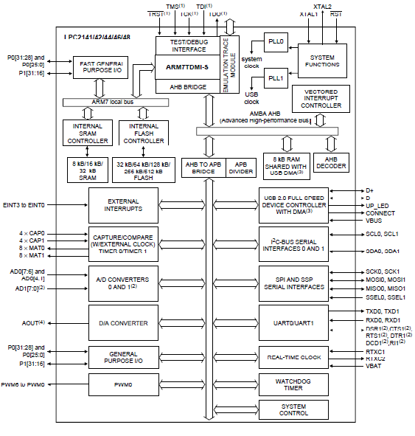

Figure 5.1.3: LPC2148 Microcontroller Functional Diagram

**On-Chip Static RAM**

On-chip static RAM may be used for code and/or data storage. The SRAM may be accessed as 8-bit, 16-bit, and 32-bit. The LPC2141, LPC2142/44 and LPC2146/48 provide 8 kB, 16 kB and 32 kB of static RAM respectively. In case of LPC2146/48 only, an 8 kB SRAM block intended to be utilized mainly by the USB can also be used as a general purpose RAM for data storage and code storage and execution.

**5.1.4 Pin Connect Block**

The pin connect block allows selected pins of the microcontroller to have more than one function. Configuration registers control the multiplexers to allow connection between the pin and the on chip peripherals. Peripherals should be connected to the appropriate pins prior to being activated, and prior to any related interrupt(s) being enabled. Activity of any enabled peripheral function that is not mapped to a related pin should be considered undefined. The Pin Control Module with its pin select registers defines the functionality of them controller in a given hardware environment. After reset all pins of Port 0 and Port 1 are configured as input with the following exceptions: If debug is enabled, the JTAG pins will assume their JTAG functionality; if trace is enabled, the Trace pins will assume their trace functionality. The pins associated with the I2C0 and I2C1 interface are open drain.

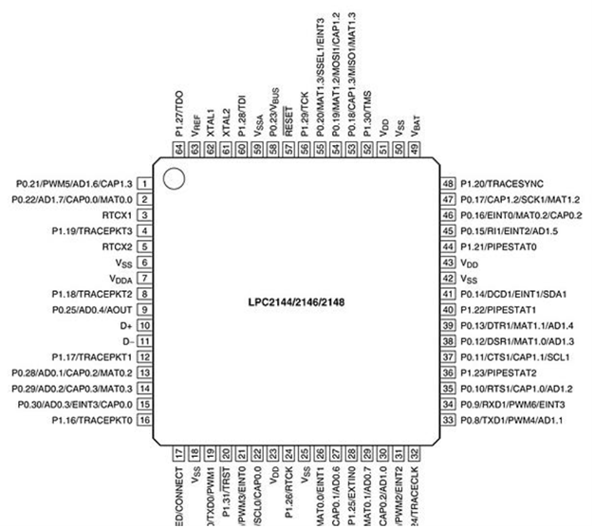

Figure 5.1.4: LPC2148 Microcontroller Pin Diagram

**Fast General Purpose Parallel I/O**

Device pins that are not connected to a specific peripheral function are controlled by the GPIO registers. Pins may be dynamically configured as inputs or outputs. Separate registers allow the setting or clearing of any number of outputs simultaneously. The value of the output register may be read back, as well as the current state of the port pins. LPC2141/42/44/46/48 introduces accelerated GPIO functions over prior LPC2000 devices:

• GPIO registers are relocated to the ARM local bus for the fastest possible I/O timing

• Mask registers allow treating sets of port bits as a group, leaving other bits unchanged

• All GPIO registers are byte addressable

• Entire port value can be written in one instruction

• Bit- level set and clear registers allow a single instruction to set or clear any number of bit sin one port.

• Direction control of individual bits

**USB 2.0 Device Controller**

The USB is a 4-wire serial bus that supports communication between a host and a number of peripherals. The host controller allocates the USB bandwidth to Attached devices through a token based protocol. The bus supports hot plugging, unplugging, and dynamic configuration of the devices. All transactions are initiated by the host controller. The LPC2141/42/44/46/48 is equipped with a USB device controller that enables 12 Mb/s data exchange with a USB host controller. It consists of a register interface, serial interface engine, endpoint buffer memory and DMA controller. The serial interface engine decodes the USB data stream and writes data to the appropriate end point buffer memory. The status of a completed USB transfer or error condition is indicated via status registers. An interrupt is also generated if enabled. A DMA controller (available in LPC2146/48 only) can transfer data between an endpoint buffer and the USB RAM.

**UARTS**

The LPC2141/42/44/46/48 each contains two UARTs. In addition to standard transmit and receive data lines, the LPC2144/46/48 UART1 also provide a full modem control handshake interface. Compared to previous LPC2000 microcontrollers, UARTs in LPC2141/42/44/46/48introduce a fractional baud rate generator for both UARTs, enabling these microcontrollers to achieve standard baud rates such as 115200 with any crystal frequency above 2 MHz. In addition, auto-CTS/RTS flow-control functions are fully implemented in hardware (UART1 inLPC2144/46/48 only).

**Real Time Clock**

The RTC is designed to provide a set of counters to measure time when normal or idle operating mode is selected. The RTC has been designed to use little power, making it suitable for battery powered systems where the CPU is not running continuously (Idle mode).

**5.1.5 System Control**

**Crystal Oscillator**

On-chip integrated oscillator operates with external crystal in range of 1 MHz to 25 MHz. The oscillator output frequency is called **f**osc and the ARM processor clock frequency is referred to as **C**clk for purposes of rate equations, etc. **F**osc and **C**clk are the same value unless the PLL is running and connected.

**Code Security**

This feature of the LPC2141/42/44/46/48 allows an application to control whether it can be debugged or protected from observation. If after reset on-chip boot loader detects a valid checksum in flash and reads 0x8765 4321 from address 0x1FC in flash, debugging will be disabled and thus the code in flash will be protected from observation. Once debugging is disabled, it can be enabled only by performing a full chip erase using the ISP.

**External Interrupt Inputs**

The LPC2141/42/44/46/48 include up to nine edge or level sensitive External Interrupt Inputs as selectable pin functions. When the pins are combined, external events can be processed as four independent interrupt signals. The External Interrupt Inputs can optionally be used to wake-up the processor from Power-down mode. Additionally capture input pins can also be used as external interrupts without the option to wake the device up from Power-down mode.

**Memory Mapping Control**

The Memory Mapping Control alters the mapping of the interrupt vectors that appear beginning at address 0x0000 0000. Vectors may be mapped to the bottom of the on-chip flash memory, or to the on-chip static RAM. This allows code running in different memory spaces to have control of the interrupts.

**Power Control**

The LPC2141/42/44/46/48 supports two reduced power modes: Idle mode and Power down mode. In Idle mode, execution of instructions is suspended until either a reset or interrupt occurs. Peripheral functions continue operation during idle mode and may generate interrupts to cause the processor to resume execution. Idle mode eliminates power used by the processor itself, memory systems and related controllers, and internal buses. In Power-down mode, the oscillator is shut down and the chip receives no internal clocks. The processor state and registers, peripheral registers, and internal SRAM values are preserved throughout Power-down mode and the logic levels of chip output pins remain static. The Power down mode can be terminated and normal operation resumed by either a reset or certain specific interrupts that are able to function without clocks.

**5.1.6 Conclusion**

The architecture and features of the ARM are explained in this chapter. In this project it is used for counting the units, sending the data to the service provider and sending the bill to the user. It plays an important role in this project.

**5.2 ENERGY METER**

Energy meters for smaller services (such as small residential customers) can be connected directly in- line between source and customer. For larger loads, more than about 200 Amps of load, current transformers are used, So that the meter can be located other than in line with the service conductors. The meters fall into two basic categories they are:

**5.2.1 Types of Energy Meter**

(a) Electromechanical Energy meter.

(b) Electronic Energy meter.

**5.2.1(a) Electromechanical Energy Meter**

The most common type of energy meter is the electromechanical induction watt-hour meter. These meters were used up to some years back but at present we are using digital meters. The electromechanical induction meter operates by counting the revolutions of an aluminium disc which is made to rotate at a speed proportional to the power. The number of revolutions is thus proportional to the energy usage. It consumes a small amount of power, typically around 2 watts. The metallic disc is acted upon by two coils. One coil is connected in such a way that it produces a magnetic flux in proportion to the voltage and the other produces a magnetic flux in proportion to the current. The field of the voltage coil is delayed by 90° using a lag coil. This produces eddy currents in the disc and the effect is such that a force is exerted on the disc in proportion to the product of the instantaneous current and voltage. A permanent magnet exerts an opposing force proportional to the speed of rotation of the disc.

The equilibrium between these two opposing forces results in the disc rotating a speed proportional to the power being used. The disc drives a register mechanism which integrates the speed of the disc over time by counting revolutions, much like the odometer in a car, in order to render a measurement of the total energy used over a period of time. The type of meter described above is used on a single-phase AC supply.

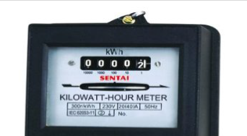

Figure 5.2.1(a): Electro Mechanical Energy Meter

Different phase configurations use additional voltage and current coils. The aluminium disc is supported by a spindle which has a worm gear which drives the register. The register is a series of dials which record the amount of energy used. Above Figure 4.1shows the Electromechanical Energy Meter. The electricity company will normally require a visit by a company representative at least annually in order to verify customer-supplied readings and to make a basic safety check of the meter. In an induction type meter, creep is a phenomenon that can adversely affect accuracy that occurs when the meter disc rotates continuously with potential applied and the load terminals open circuited. A test for error due to creep is called a creep test.

**5.2.1(b) Electronic Energy Meter**

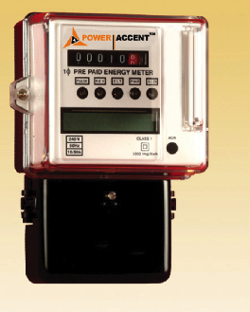

Figure 5.2.1(b): Electronic Energy Meter

Remote meter reading is a practical example of telemetry. It saves the cost of a human meter reader and the resulting mistakes, but it also allows more measurements, and remote provisioning. Many smart meters now include a switch to interrupt or restore service. In an Electronic Energy meters interface, KYZ wires are interfaced such that the Y and Z wires are switch contacts, shorted to K for half of a rotor's circumference. To measure the rotor direction, the Z signal is offset by 90° from the Y. When the rotor rotates in the opposite direction, showing export of power, the sequence reverses. The time between pulses measures the demand. The number of pulses is total power usage.KYZ outputs were historically attached to "tantalizer relays "feeding a "totalizes" so that many meters could be read all at once in one place.KYZ outputs are also the classic way of attaching electric meters to programmable logic controllers HVACs or other control systems. Some modern meter s also supply a contact closure that warns when the meter detects a demand near a higher tariff. The below Figure 5.2 shows the digital energy meter. Now-a-days this digital energy meter is mostly used in industrial applications as well as in domestic applications to measure the amount of power used.

**5.2.2Relay**

A relay is an electrically operated switch. Many relays use an electromagnet to operate a switching mechanism mechanically, but other operating principles are also used. Relays are used where it is necessary to control a circuit by a low-power signal(with complete electrical isolation between control and controlled circuits), or where several circuits must be controlled by one signal. The first relays were used in long distance telegraph circuits, repeating the signal coming in from one circuit and retransmitting it to another. Relays were used extensively in telephone exchanges and early computers to perform logical operations.

A type of relay that can handle the high power required to directly control an electric motor or other loads is called a contractor. Solid-state relays control power circuits with no moving parts, instead using a semiconductor device to perform switching.

**5.2.3 Conclusion**

This explains about the different kinds of meters and their operation. In this chapter we are using electronic meter. It also explains the functioning and features of the relay. In this project relay is used to regulate the supply to the user.

**5.3 LIQUID CRYSTAL DISPLAY (LCD)**

A liquid crystal display **(**LCD) is a flat panel display, electronic visual display, or video display that uses the light modulating properties of liquid crystals (LCs). LCs does not emit light directly. LCDs are more energy efficient and offer safer disposal than CRTs. Its low electrical power consumption enables it to be used in battery-powered electronic equipment. It is an electronically modulated optical device made up of any number of segments filled with liquid crystals and arrayed in front of a light source (backlight) or reflector to produce images in colour or monochrome. The most flexible ones use an array of small pixels. The earliest discovery leading to the development of LCD technology, the discovery of liquid crystals. A 2 × 16 LCD is there which will display all necessary information on screen which will make the system user friendly. The LCD will display the information like count, available units, remaining units, low units message, when to recharge your RFID card or when to show your card to the reader.

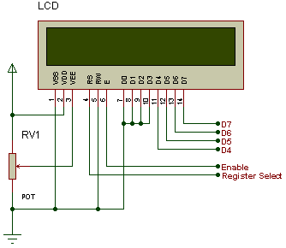

Figure 5.3: Pin connections of LCD display

**5.3.1 Basic Commands of LCD**

**Set Cursor Move Direction**

04h – Shift cursor to the left

06h – Shift cursor to the right

80h – force cursor to the beginning of the first line

C0h – force cursor to the beginning of second line

02h – return home

**Enable Display/Cursor**

0Ch - Turn Display On, cursor off

0ah - Turn Cursor On, Display off

08h - Cursor off, Display off

0eh/0fh- display on, cursor blinking

**Shift Display**

18h – 1Ch - Display Shift to left, right respectively

**5.3.2 Conclusion**

The features, pin configuration and specifications of LCD are explained in this chapter. We have also explained the interfacing of LCD with LPC2148 and its working. This LCD is used to display the number of units consumed.

**5.4 GSM MODULE**

Global system for mobile communication (GSM) is a globally accepted standard for digital cellular communication. GSM is the name of a standardization group established in 1982 to create a common European mobile telephone standard that would formulate specifications for a pan-European mobile cellular radio system operating at900 MHz. It is estimated that many countries outside of Europe will join the GSM partnership.

**5.4.1 Specifications:**

Mobile Frequency Range **:**Rx: 925-960; Tx: 880-915

Multiple Access Method **:**TDMA/FDM

Duplex Method **:**FDD

Number of Channels1 **:**24 (8 users per channel)

Channel Spacing **:**200 kHz

Modulation **:**GMSK (0.3 Gaussian Filter)

Channel Bit Rate **:**270.833Kb

**5.4.2 GSM Network**

GSM provides recommendations, not requirements. The GSM specifications define the functions and interface requirements in detail but do not address the hardware. The reason for this is to limit the designers as little as possible but still to make it possible for the operators to buy equipment from different suppliers. The GSM network is divided into three major systems: the switching system (SS), the base station system (BSS), and the operation and support system (OSS). The basic GSM network elements are shown.

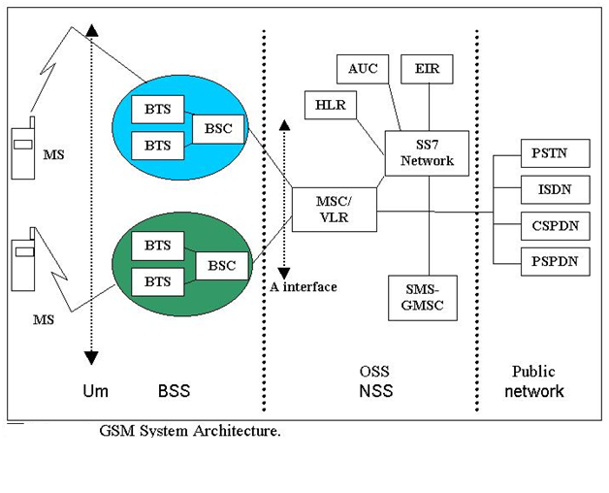

Figure 5.4.2: GSM System Architecture

**5.4.3 GSM AT Commands**

1. **SENDING SMS USING AT COMMANDS**

We suggest try sending a few SMS using the Control Tool above to make sure

your GSM modem can send SMS before proceeding. Let's look at the AT commands

involved.

AT+CMGF=1 To format SMS as a TEXT message

AT+CSCA="+xxxxx" Set your SMS centre number. Check with your provider.

1. **RECEIVINGSMS USING AT COMMANDS**

The GSM modem can be configured to response in different ways when it

receives an SMS.

**a) Immediate-**when a SMS is received, the SMS's details are immediately sent to the

host computer (DTE) via the +CMT command.

AT+CMGF=1 To format SMS as a TEXT message

AT+CNMI=1,2,0,0,0 Set how the modem will response when a SMS is received

**b) Notification** - when a SMS is received, the host computer ( DTE ) will be notified of

the new message. The computer will then have to read the message from the indicated

memory location and clear the memory location.

**A project Report on Smart Prepaid Energy Meter using GSM Technology**

AT+CMGF=1 To format SMS as a TEXT message

AT+CNMI=1,1,0,0,0 Set how the modem will response when a SMS is received

1. **USING A COMPUTER PROGRAM TO SEND AND RECEIVE SMS**

Once we are able to work the modem using AT commands, we can use high-level

programming (eg: VB, C, Java) to send the AT ASCII commands to and read messages

from the COM serial port that the GSM modem is attached to.

**5.4.4 Interfacing GSM with LPC2148**

Display a text in mobile from LPC2148 Primer Board by using GSM module

through UART. In LPC2148 Primer Board contains two serial interfaces that are

UART0 & UART1. Here we are using UART0. The GSM modem is being interfaced

with the microcontroller LPC2148 Primer Board for SMS communication. The SMS can

be sending and receiving for the data sharing and situation information and control.

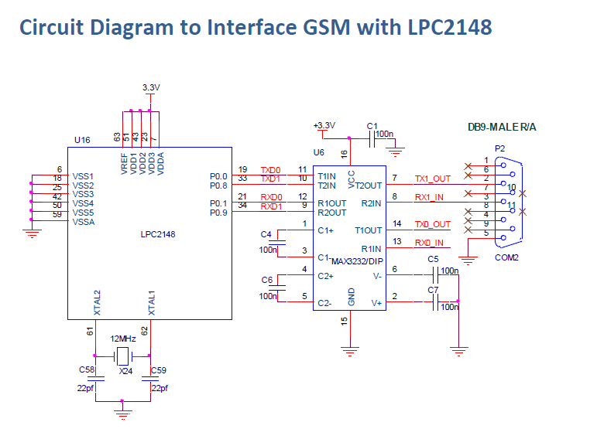

Figure 5.4.4:Interfacing GSM with LPC2148

**5.4.5 Serial Communication**

RS-232 (Recommended Standard - 232) is a telecommunications standard for binary serial communications between devices. It supplies the roadmap for the way devices speak to each other using serial ports. The devices are commonly referred to as a DTE (data terminal equipment) and DCE (data communications equipment); for example, a computer and modem, respectively.RS232 is the most known serial port used in transmitting the data in communication and interface. The RS232 is the communication line which enables the data transmission by only using three wire links. The three links provides ‘transmit’, ‘receive’ and common ground. The ‘transmit’ and ‘receive’ line on this connecter send and receive data between the computers. The two pins are TXD & RXD. There are other lines on this port as RTS, CTS, DSR, DTR, and RTS, RI. The ‘1’ and ‘0’ are the data which defines a voltage level of 3V to 25V and -3V to -25V respectively. The RS-232D has existed in two types. i.e., D-TYPE 25 pin connector and D-TYPE 9 pin connector, which are male connectors on the back of the PC. You need a female connector on your communication from Host to Guest computer. The pin outs of both D-9 & D-25 are shown below. When communicating with various micro processors one needs to convert theRS232 levels down to lower levels, typically 3.3 or 5.0 Volts. Here is a cheap and simple way to do that. Serial RS-232communication works with voltages -15V to +15Vfrom high and low. Modern low power consumption logic operates in the range of 0Vand +3.3V or even lower.

**5.4.5.1 Voltage Levels of Rs-232 and TTL Logic:**

Thus the RS-232 signal levels are far too high **TTL electronics,** and the negative

RS-232 voltage for high can’t be handled at all by computer logic. To receive serial data from an RS-232 interface the voltage has to be reduced. Also the low and high voltage.

**RS232 TTL LOGIC**

-15V to -3V +2V to +5V High

+3V to +15V 0V to +0.8V Low

**5.4.6 Conclusion**

Various communication devices like ZigBee and GSM are explained in this chapter. We have explained the significance of each device and its working in our project. Also the interfacing of each device with the microcontroller is explained in this chapter. Usually the GSM works with the help of AT commands. These commands are listed in this chapter. All the communication devices will communicate by using communication interfaces. In our project we have used MAX-232 interface. So, in this chapter we have explained its interfacing with LPC2148.ZigBee is used to send the data between User and Service Provider ends.GSM is used to send the SMS to the customer

**CHAPTER 6**

**PROGRESS AND RESULT**

**6.1 Project Work Done**

We had interface the GSM module , the ARM7 module with laptop. We had use RS232 serial port to interface it and had started to sending and receiving the messages to and from laptop to ARM7 through GSM module using AT COMANDS. We had send a small sample the protocol of word as “GROUP 19” from the laptop to the mobile interface through using GSM module and also displayed on the LCD display. We have learnt many types of different types of other AT commands which can useful such as DELETE ALL such like. We also make the codes for recharging the unit price balance as well for more amount digits which is as follow:

For making a unit price of Rs. 2.50 –

1. Insert the card into programmer
2. Dial 1*0250#

The format is:

1 for unit price

“ * “ for start process

1. The red light will blink for every press key
2. If the programming done successfully then the green light will blink finaly.
3. If system fails red light will blink for long time.

For making recharge of Rs. 400 –

1. Insert the card into the programmer.
2. Dial 2*0400#
3. The red light will blink for every press key
4. If the programming done successfully then the green light will blink finally.
5. If system fails red light will blink for long time.

**6.2 Advantages**

* It is 100% certain that each used kWh will be paid. There will be no need for personnel to collect unpaid bills.
* The meter display will give information about the credit that has been used and how much is left.
* Consumers have to face incorrect billing due to human error and wait in long queues to pay their bills, causing a lot of inconvenience to the customer & the utility.
* All meters are protected against fraud with an internal contact. If someone opens the cover, the relay will switch off.
* The systems are easy to use and no expensive training is needed.
* Price changes can be programmed very easily in the programmer and/or software.
* The meter warns the user before the electricity reaches zero so they will have enough time to buy new credit.

**6.3 Conclusion**

* Advanced electricity meters that generate consumption data enabling customers to see when they are using energy, to manage that use more efficiently.
* It not only solve the problem of manual meter reading but also provide additional feature such as power disconnect, power connect , power cut alert and Data base server can store the current month data and also all previous month data for future use. So it saves a lot of time and energy.
* To save money by adjusting energy use in response to price signals.
* To save money, the consumed energy corresponding price is displayed for the consumer benefits.
* This project work has been taken up which serves the purpose of energy monitoring and controlling by implementing prepaid system.
* It is hoped that this work helps the electrical engineers for better energy management and its utility in the distribution system for economic liability of the electrical companies.
* Employees list can be decreased by the system.
* There is no need to pay the electricity bill on a specified place and time.
* Problems associated with billing a consumer living in isolated areas reduces.
* This system is of great advantage for the electricity department as this unit can be

utilized effectively for preventing power theft, non-payment of electricity bills etc.

* The whole process of billing can be centralized.
* Cost of manpower for billing / collection is reduced.

**6.4 Future Scope**

* The system can be made by using online.
* Further work can be done in reading the consumed energy from energy

meter wirelessly using Bluetooth technology.

* At present this project is only single phase distribution system. It can be further designed for a 3 phase distribution system by obtaining the pulses from the 3 phase energy meter output.
* The technology can be transferred to entrepreneurs interested in manufacturing such energy meters.
* With additional software, the customer can be acknowledged with an alarm about the bill payment, the amount can be directly deducted from the customer account, etc.

**REFERENCES & BIBLIOGRAPHY**

**[1]** H.G.Rodney, Tan IEEE, C.H.Lee and V.H.Mok, IEEE “Automatic Power Meter Reading system using GSM Network” Proceeding of the 8th international Power Engineering Conference (IPEC-07) 2007, pp:465-469.

**[2]** Mr.Rahul Ganesh Sarangle, Prof.Dr.UdayPanditKhot and Prof. JayenModi, IEEE "GSM Based Power Meter Reading and Control System"

Renewable and Sustainable Energy Conference (IRSEC) 2013 International, pp: 515-520.

**[3]** Luo Yonggang, IEEE "The design of Prepayment Energy Meter" Mechatronic Science, Electric Engineering and Computer (MEC), 2011 International Conference on 19-22 Aug. 2011 pp: 1679-1682

**[4]** Theodore S. Rappaport , 2nd edition Wireless Communication Principles & Practice

**[5] SIM900A GSM MODEM:** <http://www.simcom.us/product_detail.php?cid=1&pid=37>

http://en.wikipedia.org/wiki/gsm

**[7] Research Paper**

[www.ijetae.com/files/Volume2Issue5/IJETAE_0512_76.pdf](http://www.ijetae.com/files/Volume2Issue5/IJETAE_0512_76.pdf)

<http://www.ijert.org/browse/may-2012-edition?download=115%3Asmart-and> intelligent-gsm-based-automatic-meter-reading-system&start=8

www.ijera.com/papers/Vol2_issue4/DB24664671.pdf

iasir.net/AIJRSTEMpapers/AIJRSTEM13-271.pdf?

**[8] Data-sheets**

http://www.datasheetsarchive.com/datasheets

http://www.alldatasheets.com/view.jsp?Searchword=8051

**APPENDIX**

**Schematic Diagram**

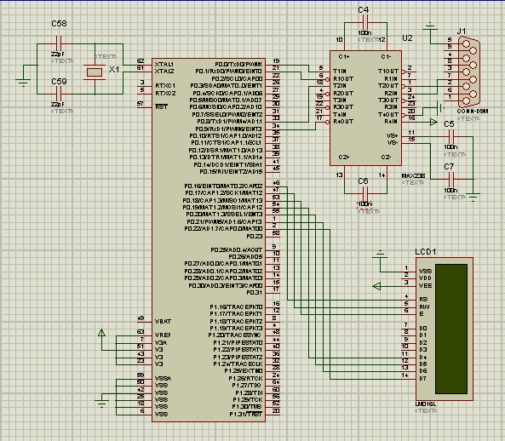

Figure 9: Schematic Diagram to Interface GSM with LPC2148